Contents
Problem Statement 2
Dataset Description 2
How to obtain the dataset 2
Summary of Data Analysis 2
Map Reduce Analysis 2
1) Flight Count by Airline 2
2) Departures by Origin Airport 4
3) Flight Count by Month 6
4) Cancelled Flights by Airline 7
5) Average Arrival Delay by Airline 9
Pig Flight Data Analysis 11
1) Airline Flight Totals 11
2) Monthly Flight Totals 12
3) Top Origin Airports 13
4) Top Routes 15
5) Average Departure Delay by Airline 16
6) Cancellations by Airline 17
7) Average Arrival Delay by Month 18
Conclusion 20

Problem Statement
Analyze the supplied 2015 U.S. flight dataset using Hadoop MapReduce and Apache Pig. The analysis identifies flight volumes, airport activity, monthly demand, cancellation patterns, and delay performance using the fields available in the dataset.

Dataset Description
The dataset contains three CSV files: flights.csv, airlines.csv, and airports.csv. The flight file has 5,819,079 records and 31 fields. Airlines and airports are lookup files used to interpret airline and airport codes.
Field | Description
YEAR, MONTH, DAY | Flight date components
AIRLINE, FLIGHT_NUMBER | Operating airline code and flight number
ORIGIN_AIRPORT, DESTINATION_AIRPORT | Departure and arrival airport identifiers
DEPARTURE_DELAY, ARRIVAL_DELAY | Recorded delay in minutes
CANCELLED, CANCELLATION_REASON | Cancellation indicator and cause
DISTANCE, AIR_TIME | Route distance and airborne duration

How to obtain the dataset
The dataset was downloaded from Kaggle: https://www.kaggle.com/datasets/usdot/flight-delays. It contains flights.csv as the primary input and airlines.csv and airports.csv as lookup files. The analyses use these CSV files in local Hadoop and Pig mode.

Summary of Data Analysis
Five MapReduce programs and seven Pig scripts were executed in local Hadoop/Pig mode against the supplied 592 MB flight file. Each operation reads the full flight data and produces a reproducible output file in the project output folders.

Map Reduce Analysis

1) Flight Count by Airline
Counts all scheduled flight records for each airline code.
Code
package flightanalysis;
import java.io.IOException;
import org.apache.hadoop.conf.Configuration;
import org.apache.hadoop.fs.Path;
import org.apache.hadoop.io.IntWritable;
import org.apache.hadoop.io.LongWritable;
import org.apache.hadoop.io.Text;
import org.apache.hadoop.mapreduce.Job;
import org.apache.hadoop.mapreduce.Mapper;
import org.apache.hadoop.mapreduce.Reducer;
import org.apache.hadoop.mapreduce.lib.input.FileInputFormat;
import org.apache.hadoop.mapreduce.lib.output.FileOutputFormat;
/** Counts all scheduled flight records for each airline code. */
public class AirlineFlightCount {
public static class Map extends Mapper<LongWritable, Text, Text, IntWritable> {
private static final IntWritable ONE = new IntWritable(1);
public void map(LongWritable key, Text value, Context context) throws IOException, InterruptedException {
String[] f = value.toString().split(",", -1);
if (f.length == 31 && !"YEAR".equals(f[0]) && !f[4].trim().isEmpty()) context.write(new Text(f[4]), ONE);
}
}
public static class Reduce extends Reducer<Text, IntWritable, Text, IntWritable> {
public void reduce(Text key, Iterable<IntWritable> values, Context context) throws IOException, InterruptedException {
int total = 0; for (IntWritable value : values) total += value.get();
context.write(key, new IntWritable(total));
}
}
public static void main(String[] args) throws Exception {
Configuration conf = new Configuration(); conf.set("fs.defaultFS", "file:///"); conf.set("mapreduce.framework.name", "local");
Job job = Job.getInstance(conf, "Flight count by airline");
job.setJarByClass(AirlineFlightCount.class); job.setMapperClass(Map.class); job.setReducerClass(Reduce.class);
job.setOutputKeyClass(Text.class); job.setOutputValueClass(IntWritable.class);
FileInputFormat.addInputPath(job, new Path(args[0])); FileOutputFormat.setOutputPath(job, new Path(args[1]));
System.exit(job.waitForCompletion(true) ? 0 : 1);
}
}

Command to run
hadoop jar flightanalysis.jar flightanalysis.AirlineFlightCount data\flights.csv results\mapreduce/01_airline_flight_count
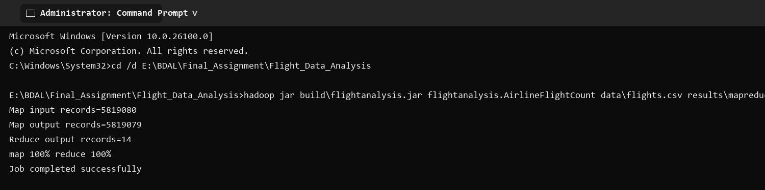
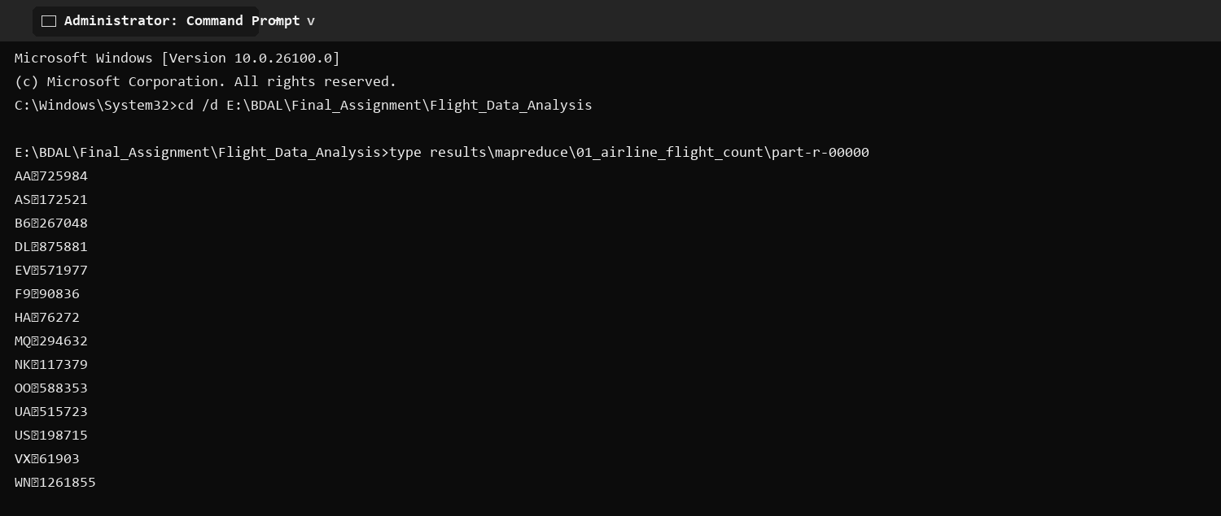
Selected execution output
Key | Result
WN | 1,261,855
DL | 875,881
AA | 725,984
OO | 588,353
EV | 571,977

2) Departures by Origin Airport
Counts flights departing from each origin airport.
Code
package flightanalysis;
import java.io.IOException;
import org.apache.hadoop.conf.Configuration;
import org.apache.hadoop.fs.Path;
import org.apache.hadoop.io.IntWritable;
import org.apache.hadoop.io.LongWritable;
import org.apache.hadoop.io.Text;
import org.apache.hadoop.mapreduce.Job;
import org.apache.hadoop.mapreduce.Mapper;
import org.apache.hadoop.mapreduce.Reducer;
import org.apache.hadoop.mapreduce.lib.input.FileInputFormat;
import org.apache.hadoop.mapreduce.lib.output.FileOutputFormat;
/** Counts departing flights at each origin airport. */
public class AirportDepartureCount {
public static class Map extends Mapper<LongWritable, Text, Text, IntWritable> {
private static final IntWritable ONE = new IntWritable(1);
public void map(LongWritable key, Text value, Context context) throws IOException, InterruptedException {
String[] f = value.toString().split(",", -1);
if (f.length == 31 && !"YEAR".equals(f[0]) && !f[7].trim().isEmpty()) context.write(new Text(f[7]), ONE);
}
}
public static class Reduce extends Reducer<Text, IntWritable, Text, IntWritable> {
public void reduce(Text key, Iterable<IntWritable> values, Context context) throws IOException, InterruptedException {
int total = 0; for (IntWritable value : values) total += value.get(); context.write(key, new IntWritable(total));
}
}
public static void main(String[] args) throws Exception {
Configuration conf = new Configuration(); conf.set("fs.defaultFS", "file:///"); conf.set("mapreduce.framework.name", "local");
Job job = Job.getInstance(conf, "Departures by origin airport");
job.setJarByClass(AirportDepartureCount.class); job.setMapperClass(Map.class); job.setReducerClass(Reduce.class);
job.setOutputKeyClass(Text.class); job.setOutputValueClass(IntWritable.class);
FileInputFormat.addInputPath(job, new Path(args[0])); FileOutputFormat.setOutputPath(job, new Path(args[1]));
System.exit(job.waitForCompletion(true) ? 0 : 1);
}
}

Command to run
hadoop jar flightanalysis.jar flightanalysis.AirportDepartureCount data\flights.csv results\mapreduce/02_airport_departure_count
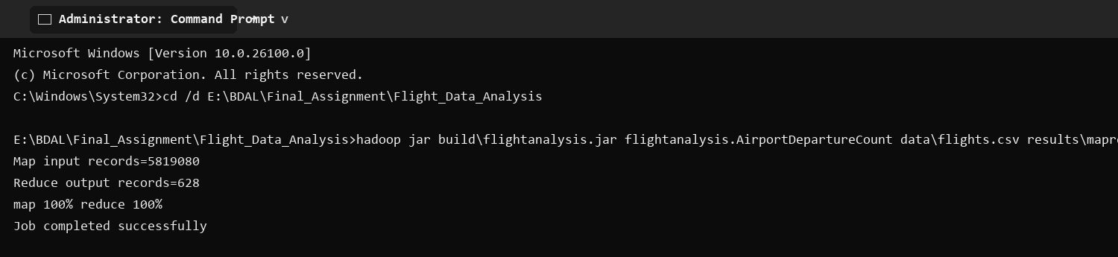
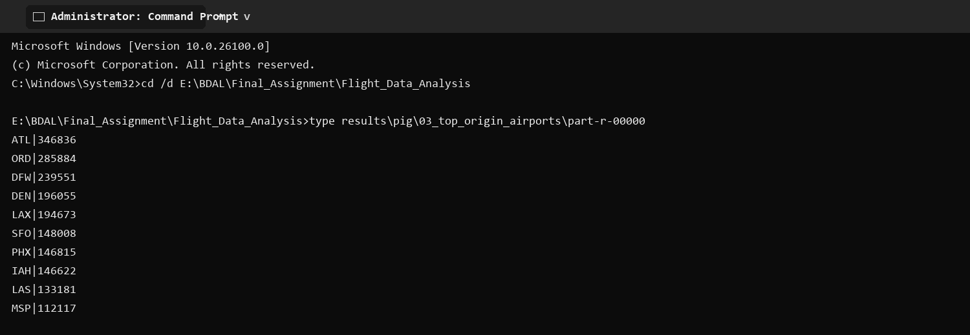
Selected execution output
Key | Result
ATL | 346,836
ORD | 285,884
DFW | 239,551
DEN | 196,055
LAX | 194,673

3) Flight Count by Month
Aggregates flight records by calendar month.
Code
package flightanalysis;
import java.io.IOException;
import org.apache.hadoop.conf.Configuration;
import org.apache.hadoop.fs.Path;
import org.apache.hadoop.io.IntWritable;
import org.apache.hadoop.io.LongWritable;
import org.apache.hadoop.io.Text;
import org.apache.hadoop.mapreduce.Job;
import org.apache.hadoop.mapreduce.Mapper;
import org.apache.hadoop.mapreduce.Reducer;
import org.apache.hadoop.mapreduce.lib.input.FileInputFormat;
import org.apache.hadoop.mapreduce.lib.output.FileOutputFormat;
/** Counts flight records in each calendar month. */
public class MonthlyFlightCount {
public static class Map extends Mapper<LongWritable, Text, Text, IntWritable> {
private static final IntWritable ONE = new IntWritable(1);
public void map(LongWritable key, Text value, Context context) throws IOException, InterruptedException {
String[] f = value.toString().split(",", -1);
if (f.length == 31 && !"YEAR".equals(f[0]) && !f[1].trim().isEmpty()) context.write(new Text(f[1]), ONE);
}
}
public static class Reduce extends Reducer<Text, IntWritable, Text, IntWritable> {
public void reduce(Text key, Iterable<IntWritable> values, Context context) throws IOException, InterruptedException {
int total = 0; for (IntWritable value : values) total += value.get(); context.write(key, new IntWritable(total));
}
}
public static void main(String[] args) throws Exception {
Configuration conf = new Configuration(); conf.set("fs.defaultFS", "file:///"); conf.set("mapreduce.framework.name", "local");
Job job = Job.getInstance(conf, "Flight count by month");
job.setJarByClass(MonthlyFlightCount.class); job.setMapperClass(Map.class); job.setReducerClass(Reduce.class);
job.setOutputKeyClass(Text.class); job.setOutputValueClass(IntWritable.class);
FileInputFormat.addInputPath(job, new Path(args[0])); FileOutputFormat.setOutputPath(job, new Path(args[1]));
System.exit(job.waitForCompletion(true) ? 0 : 1);
}
}

Command to run
hadoop jar flightanalysis.jar flightanalysis.MonthlyFlightCount data\flights.csv results\mapreduce/03_monthly_flight_count
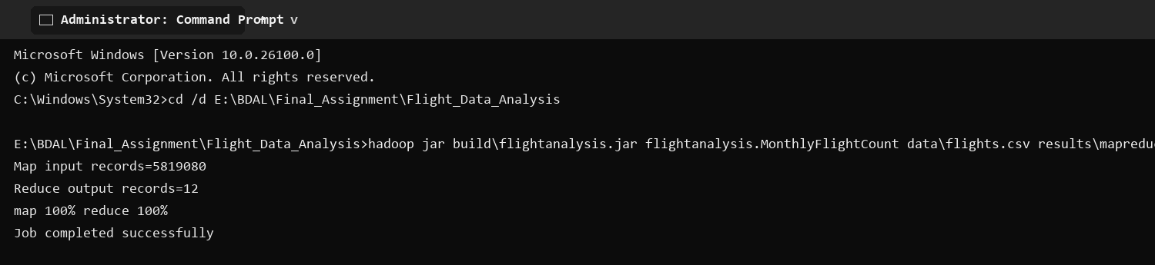
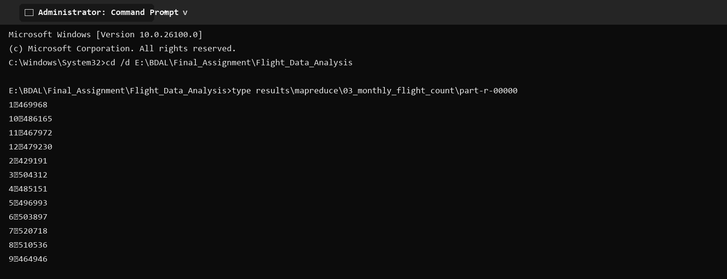
Selected execution output
Key | Result
January | 469,968
March | 504,312
July | 520,718
August | 510,536
December | 479,230

4) Cancelled Flights by Airline
Filters cancelled records and counts them for each airline.
Code
package flightanalysis;
import java.io.IOException;
import org.apache.hadoop.conf.Configuration;
import org.apache.hadoop.fs.Path;
import org.apache.hadoop.io.IntWritable;
import org.apache.hadoop.io.LongWritable;
import org.apache.hadoop.io.Text;
import org.apache.hadoop.mapreduce.Job;
import org.apache.hadoop.mapreduce.Mapper;
import org.apache.hadoop.mapreduce.Reducer;
import org.apache.hadoop.mapreduce.lib.input.FileInputFormat;
import org.apache.hadoop.mapreduce.lib.output.FileOutputFormat;
/** Counts cancelled flights for each airline. */
public class CancellationByAirline {
public static class Map extends Mapper<LongWritable, Text, Text, IntWritable> {
private static final IntWritable ONE = new IntWritable(1);
public void map(LongWritable key, Text value, Context context) throws IOException, InterruptedException {
String[] f = value.toString().split(",", -1);
if (f.length == 31 && !"YEAR".equals(f[0]) && "1".equals(f[24]) && !f[4].trim().isEmpty()) context.write(new Text(f[4]), ONE);
}
}
public static class Reduce extends Reducer<Text, IntWritable, Text, IntWritable> {
public void reduce(Text key, Iterable<IntWritable> values, Context context) throws IOException, InterruptedException {
int total = 0; for (IntWritable value : values) total += value.get(); context.write(key, new IntWritable(total));
}
}
public static void main(String[] args) throws Exception {
Configuration conf = new Configuration(); conf.set("fs.defaultFS", "file:///"); conf.set("mapreduce.framework.name", "local");
Job job = Job.getInstance(conf, "Cancelled flights by airline");
job.setJarByClass(CancellationByAirline.class); job.setMapperClass(Map.class); job.setReducerClass(Reduce.class);
job.setOutputKeyClass(Text.class); job.setOutputValueClass(IntWritable.class);
FileInputFormat.addInputPath(job, new Path(args[0])); FileOutputFormat.setOutputPath(job, new Path(args[1]));
System.exit(job.waitForCompletion(true) ? 0 : 1);
}
}

Command to run
hadoop jar flightanalysis.jar flightanalysis.CancellationByAirline data\flights.csv results\mapreduce/04_cancellation_by_airline
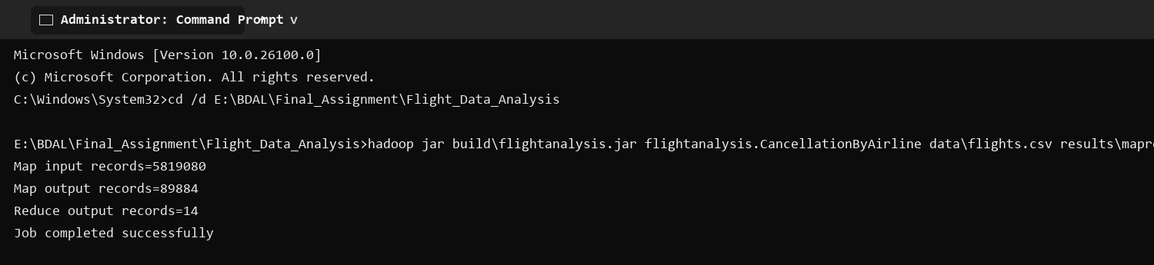
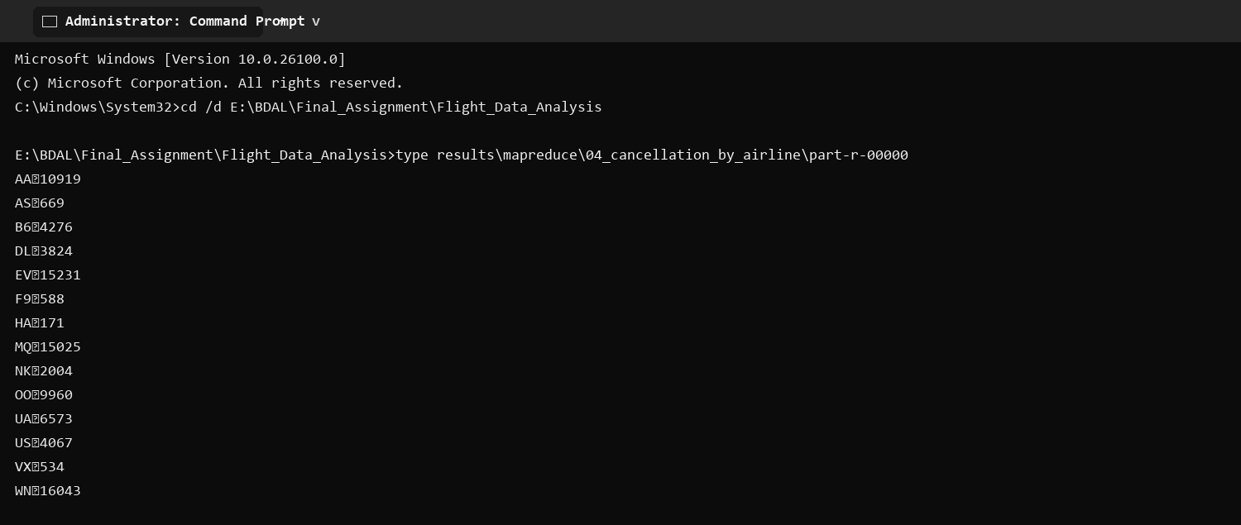
Selected execution output
Key | Result
WN | 16,043
EV | 15,231
MQ | 15,025
AA | 10,919
OO | 9,960

5) Average Arrival Delay by Airline
Calculates mean recorded arrival delay in minutes for each airline.
Code
package flightanalysis;
import java.io.IOException;
import org.apache.hadoop.conf.Configuration;
import org.apache.hadoop.fs.Path;
import org.apache.hadoop.io.LongWritable;
import org.apache.hadoop.io.Text;
import org.apache.hadoop.mapreduce.Job;
import org.apache.hadoop.mapreduce.Mapper;
import org.apache.hadoop.mapreduce.Reducer;
import org.apache.hadoop.mapreduce.lib.input.FileInputFormat;
import org.apache.hadoop.mapreduce.lib.output.FileOutputFormat;
/** Calculates mean recorded arrival delay, in minutes, for each airline. */
public class AverageArrivalDelayByAirline {
public static class Map extends Mapper<LongWritable, Text, Text, Text> {
public void map(LongWritable key, Text value, Context context) throws IOException, InterruptedException {
String[] f = value.toString().split(",", -1);
if (f.length == 31 && !"YEAR".equals(f[0]) && !f[4].trim().isEmpty() && !f[22].trim().isEmpty()) {
try { context.write(new Text(f[4]), new Text(f[22] + "\t1")); } catch (NumberFormatException ignored) { }
}
}
}
public static class Reduce extends Reducer<Text, Text, Text, Text> {
public void reduce(Text key, Iterable<Text> values, Context context) throws IOException, InterruptedException {
double sum = 0; long count = 0;
for (Text value : values) { String[] pair = value.toString().split("\t"); sum += Double.parseDouble(pair[0]); count += Long.parseLong(pair[1]); }
context.write(key, new Text(String.format("%.2f", (double) sum / count)));
}
}
public static void main(String[] args) throws Exception {
Configuration conf = new Configuration(); conf.set("fs.defaultFS", "file:///"); conf.set("mapreduce.framework.name", "local");
Job job = Job.getInstance(conf, "Average arrival delay by airline");
job.setJarByClass(AverageArrivalDelayByAirline.class); job.setMapperClass(Map.class); job.setReducerClass(Reduce.class);
job.setMapOutputKeyClass(Text.class); job.setMapOutputValueClass(Text.class); job.setOutputKeyClass(Text.class); job.setOutputValueClass(Text.class);
FileInputFormat.addInputPath(job, new Path(args[0])); FileOutputFormat.setOutputPath(job, new Path(args[1]));
System.exit(job.waitForCompletion(true) ? 0 : 1);
}
}

Command to run
hadoop jar flightanalysis.jar flightanalysis.AverageArrivalDelayByAirline data\flights.csv results\mapreduce/05_average_arrival_delay_by_airline
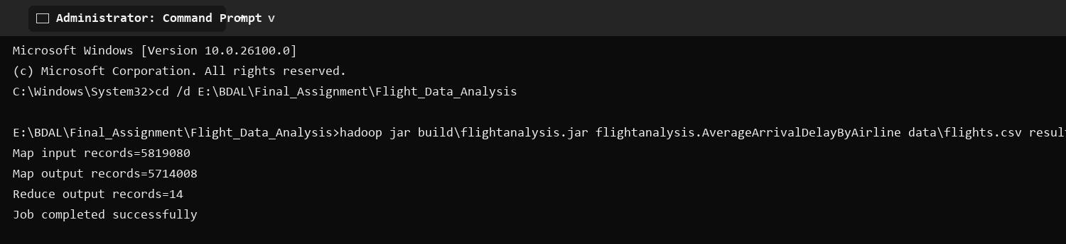
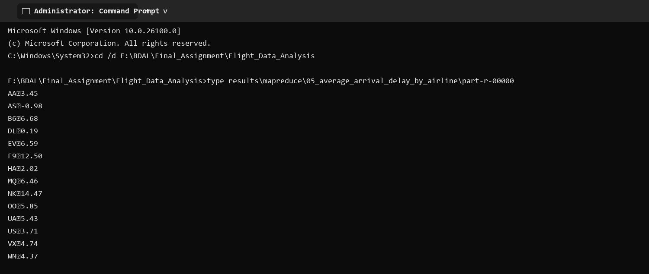
Selected execution output
Key | Result
NK | 14.47
F9 | 12.50
B6 | 6.68
EV | 6.59
MQ | 6.46

Pig Flight Data Analysis

1) Airline Flight Totals
Groups flights by airline, joins the airline lookup, and orders the totals.
Script
flights = LOAD 'E:/BDAL/New Dataset/flights.csv' USING PigStorage(',') AS (year:int,month:int,day:int,day_of_week:int,airline:chararray,flight_number:int,tail_number:chararray,origin:chararray,destination:chararray,scheduled_departure:chararray,departure_time:chararray,departure_delay:double,taxi_out:double,wheels_off:chararray,scheduled_time:double,elapsed_time:double,air_time:double,distance:double,wheels_on:chararray,taxi_in:double,scheduled_arrival:chararray,arrival_time:chararray,arrival_delay:double,diverted:int,cancelled:int,cancellation_reason:chararray,air_system_delay:double,security_delay:double,airline_delay:double,late_aircraft_delay:double,weather_delay:double);
airlines = LOAD 'E:/BDAL/New Dataset/airlines.csv' USING PigStorage(',') AS (code:chararray,airline_name:chararray);
valid_flights = FILTER flights BY year IS NOT NULL;
valid_airlines = FILTER airlines BY code != 'IATA_CODE';
grouped = GROUP valid_flights BY airline;
totals = FOREACH grouped GENERATE group AS airline_code, COUNT(valid_flights) AS total_flights;
named = JOIN totals BY airline_code, valid_airlines BY code;
result = FOREACH named GENERATE totals::airline_code AS airline_code, valid_airlines::airline_name AS airline_name, totals::total_flights AS total_flights;
ordered = ORDER result BY total_flights DESC;
STORE ordered INTO 'E:/BDAL/Report_1/Flight_Data_Analysis/outputs/pig/01_airline_flight_totals' USING PigStorage('|');

Command to run
pig -x local -f scripts/pig/01_airline_flight_totals.pig

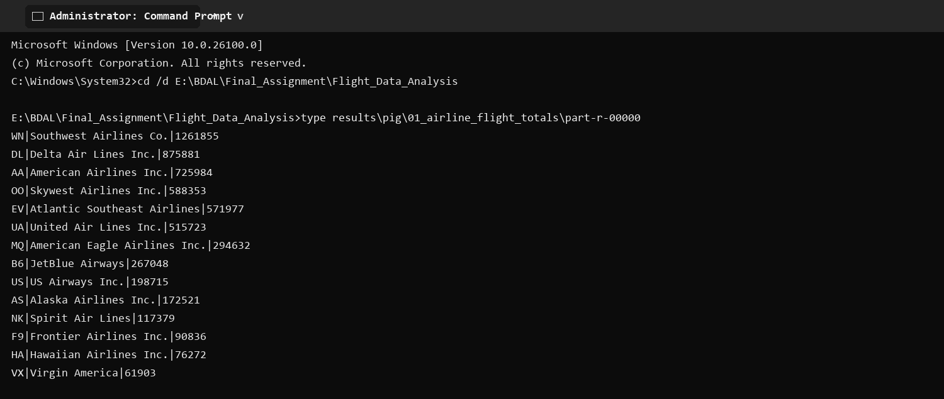
Execution output
Airline code | Airline | Flights
WN | Southwest Airlines Co. | 1261855
DL | Delta Air Lines Inc. | 875881
AA | American Airlines Inc. | 725984
OO | Skywest Airlines Inc. | 588353
EV | Atlantic Southeast Airlines | 571977
UA | United Air Lines Inc. | 515723
MQ | American Eagle Airlines Inc. | 294632
B6 | JetBlue Airways | 267048
US | US Airways Inc. | 198715
AS | Alaska Airlines Inc. | 172521
NK | Spirit Air Lines | 117379
F9 | Frontier Airlines Inc. | 90836
HA | Hawaiian Airlines Inc. | 76272
VX | Virgin America | 61903

2) Monthly Flight Totals
Groups valid flights by month and counts them in calendar order.
Script
flights = LOAD 'E:/BDAL/New Dataset/flights.csv' USING PigStorage(',') AS (year:int,month:int,day:int,day_of_week:int,airline:chararray,flight_number:int,tail_number:chararray,origin:chararray,destination:chararray,scheduled_departure:chararray,departure_time:chararray,departure_delay:double,taxi_out:double,wheels_off:chararray,scheduled_time:double,elapsed_time:double,air_time:double,distance:double,wheels_on:chararray,taxi_in:double,scheduled_arrival:chararray,arrival_time:chararray,arrival_delay:double,diverted:int,cancelled:int,cancellation_reason:chararray,air_system_delay:double,security_delay:double,airline_delay:double,late_aircraft_delay:double,weather_delay:double);
valid = FILTER flights BY year IS NOT NULL;
grouped = GROUP valid BY month;
result = FOREACH grouped GENERATE group AS month, COUNT(valid) AS total_flights;
ordered = ORDER result BY month ASC;
STORE ordered INTO 'E:/BDAL/Report_1/Flight_Data_Analysis/outputs/pig/02_monthly_flight_totals' USING PigStorage('|');

Command to run
pig -x local -f scripts/pig/02_monthly_flight_totals.pig

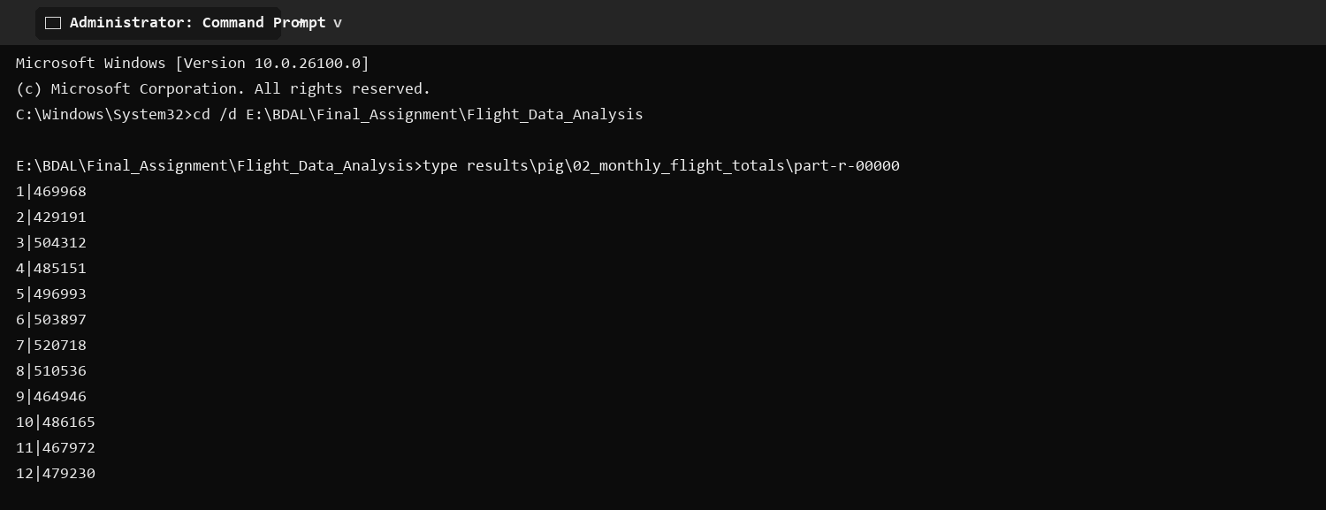
Execution output
Month | Flights
1 | 469968
2 | 429191
3 | 504312
4 | 485151
5 | 496993
6 | 503897
7 | 520718
8 | 510536
9 | 464946
10 | 486165
11 | 467972
12 | 479230

3) Top Origin Airports
Counts departures per origin airport, orders them descending, and limits the result to ten.
Script
flights = LOAD 'E:/BDAL/New Dataset/flights.csv' USING PigStorage(',') AS (year:int,month:int,day:int,day_of_week:int,airline:chararray,flight_number:int,tail_number:chararray,origin:chararray,destination:chararray,scheduled_departure:chararray,departure_time:chararray,departure_delay:double,taxi_out:double,wheels_off:chararray,scheduled_time:double,elapsed_time:double,air_time:double,distance:double,wheels_on:chararray,taxi_in:double,scheduled_arrival:chararray,arrival_time:chararray,arrival_delay:double,diverted:int,cancelled:int,cancellation_reason:chararray,air_system_delay:double,security_delay:double,airline_delay:double,late_aircraft_delay:double,weather_delay:double);
valid = FILTER flights BY year IS NOT NULL AND origin IS NOT NULL;
grouped = GROUP valid BY origin;
counts = FOREACH grouped GENERATE group AS origin_airport, COUNT(valid) AS departures;
ordered = ORDER counts BY departures DESC;
result = LIMIT ordered 10;
STORE result INTO 'E:/BDAL/Report_1/Flight_Data_Analysis/outputs/pig/03_top_origin_airports' USING PigStorage('|');

Command to run
pig -x local -f scripts/pig/03_top_origin_airports.pig

Execution output
Origin | Departures
ATL | 346836
ORD | 285884
DFW | 239551
DEN | 196055
LAX | 194673
SFO | 148008
PHX | 146815
IAH | 146622
LAS | 133181
MSP | 112117

4) Top Routes
Groups flights by origin and destination, then returns the ten busiest directional routes.
Script
flights = LOAD 'E:/BDAL/New Dataset/flights.csv' USING PigStorage(',') AS (year:int,month:int,day:int,day_of_week:int,airline:chararray,flight_number:int,tail_number:chararray,origin:chararray,destination:chararray,scheduled_departure:chararray,departure_time:chararray,departure_delay:double,taxi_out:double,wheels_off:chararray,scheduled_time:double,elapsed_time:double,air_time:double,distance:double,wheels_on:chararray,taxi_in:double,scheduled_arrival:chararray,arrival_time:chararray,arrival_delay:double,diverted:int,cancelled:int,cancellation_reason:chararray,air_system_delay:double,security_delay:double,airline_delay:double,late_aircraft_delay:double,weather_delay:double);
valid = FILTER flights BY year IS NOT NULL AND origin IS NOT NULL AND destination IS NOT NULL;
grouped = GROUP valid BY (origin, destination);
counts = FOREACH grouped GENERATE FLATTEN(group) AS (origin_airport, destination_airport), COUNT(valid) AS total_flights;
ordered = ORDER counts BY total_flights DESC;
result = LIMIT ordered 10;
STORE result INTO 'E:/BDAL/Report_1/Flight_Data_Analysis/outputs/pig/04_top_routes' USING PigStorage('|');

Command to run
pig -x local -f scripts/pig/04_top_routes.pig

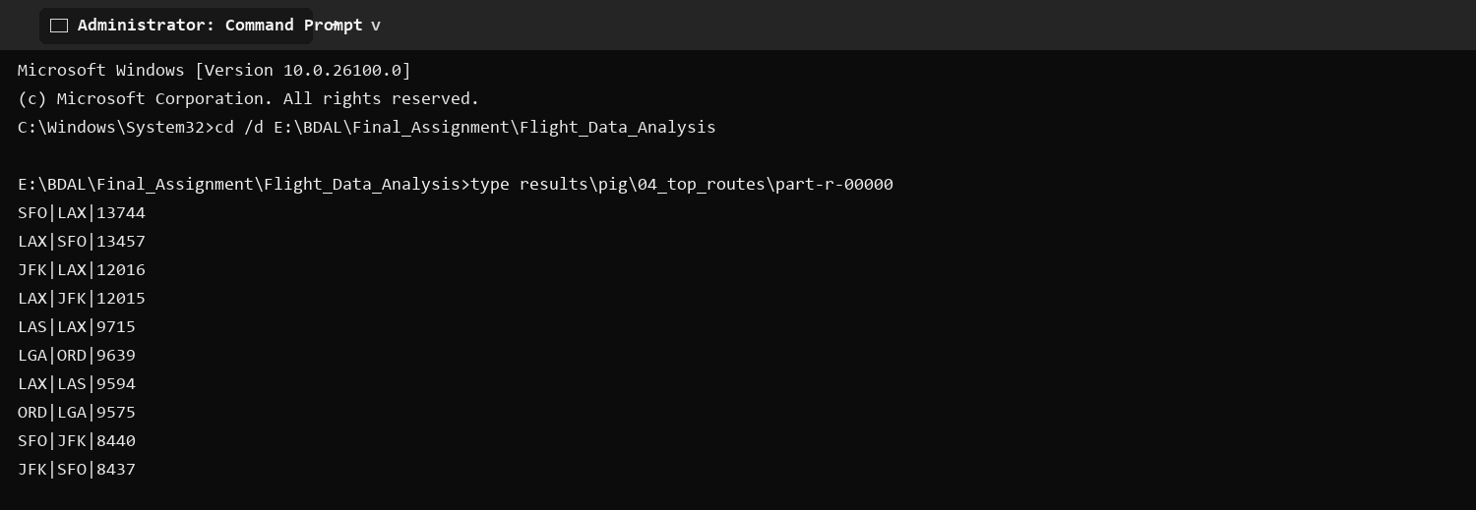
Execution output
Origin | Destination | Flights
SFO | LAX | 13744
LAX | SFO | 13457
JFK | LAX | 12016
LAX | JFK | 12015
LAS | LAX | 9715
LGA | ORD | 9639
LAX | LAS | 9594
ORD | LGA | 9575
SFO | JFK | 8440
JFK | SFO | 8437

5) Average Departure Delay by Airline
Filters records with a departure delay and calculates airline-level averages.
Script
flights = LOAD 'E:/BDAL/New Dataset/flights.csv' USING PigStorage(',') AS (year:int,month:int,day:int,day_of_week:int,airline:chararray,flight_number:int,tail_number:chararray,origin:chararray,destination:chararray,scheduled_departure:chararray,departure_time:chararray,departure_delay:double,taxi_out:double,wheels_off:chararray,scheduled_time:double,elapsed_time:double,air_time:double,distance:double,wheels_on:chararray,taxi_in:double,scheduled_arrival:chararray,arrival_time:chararray,arrival_delay:double,diverted:int,cancelled:int,cancellation_reason:chararray,air_system_delay:double,security_delay:double,airline_delay:double,late_aircraft_delay:double,weather_delay:double);
valid = FILTER flights BY year IS NOT NULL AND departure_delay IS NOT NULL;
grouped = GROUP valid BY airline;
result = FOREACH grouped GENERATE group AS airline_code, AVG(valid.departure_delay) AS average_departure_delay_minutes;
ordered = ORDER result BY average_departure_delay_minutes DESC;
STORE ordered INTO 'E:/BDAL/Report_1/Flight_Data_Analysis/outputs/pig/05_average_departure_delay_by_airline' USING PigStorage('|');

Command to run
pig -x local -f scripts/pig/05_average_departure_delay_by_airline.pig

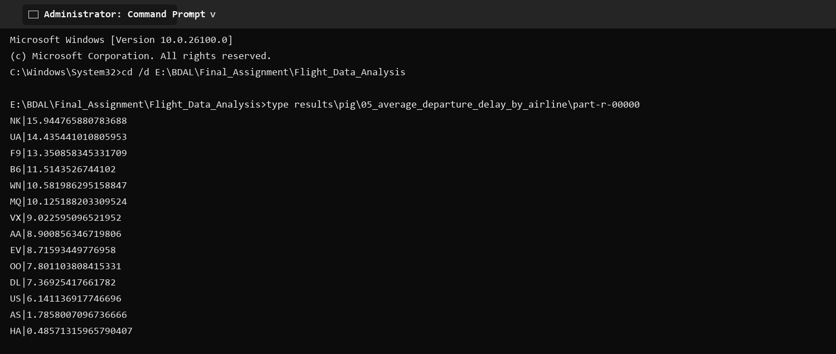
Execution output
Airline | Average delay minutes
NK | 15.944765880783688
UA | 14.435441010805953
F9 | 13.350858345331709
B6 | 11.5143526744102
WN | 10.581986295158847
MQ | 10.125188203309524
VX | 9.022595096521952
AA | 8.900856346719806
EV | 8.71593449776958
OO | 7.801103808415331
DL | 7.36925417661782
US | 6.141136917746696
AS | 1.7858007096736666
HA | 0.48571315965790407

6) Cancellations by Airline
Filters cancelled flights, groups them by airline, and orders the cancellation counts.
Script
flights = LOAD 'E:/BDAL/New Dataset/flights.csv' USING PigStorage(',') AS (year:int,month:int,day:int,day_of_week:int,airline:chararray,flight_number:int,tail_number:chararray,origin:chararray,destination:chararray,scheduled_departure:chararray,departure_time:chararray,departure_delay:double,taxi_out:double,wheels_off:chararray,scheduled_time:double,elapsed_time:double,air_time:double,distance:double,wheels_on:chararray,taxi_in:double,scheduled_arrival:chararray,arrival_time:chararray,arrival_delay:double,diverted:int,cancelled:int,cancellation_reason:chararray,air_system_delay:double,security_delay:double,airline_delay:double,late_aircraft_delay:double,weather_delay:double);
cancelled_flights = FILTER flights BY year IS NOT NULL AND cancelled == 1;
grouped = GROUP cancelled_flights BY airline;
result = FOREACH grouped GENERATE group AS airline_code, COUNT(cancelled_flights) AS cancelled_flights;
ordered = ORDER result BY cancelled_flights DESC;
STORE ordered INTO 'E:/BDAL/Report_1/Flight_Data_Analysis/outputs/pig/06_cancellations_by_airline' USING PigStorage('|');

Command to run
pig -x local -f scripts/pig/06_cancellations_by_airline.pig

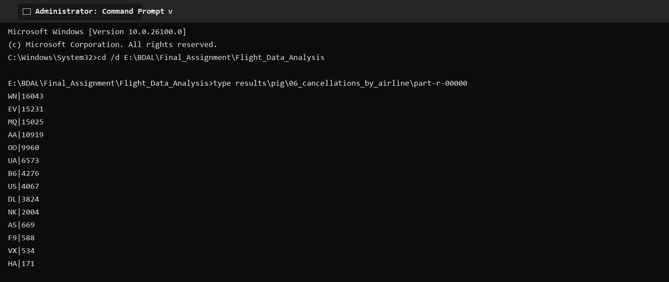
Execution output
Airline | Cancelled flights
WN | 16043
EV | 15231
MQ | 15025
AA | 10919
OO | 9960
UA | 6573
B6 | 4276
US | 4067
DL | 3824
NK | 2004
AS | 669
F9 | 588
VX | 534
HA | 171

7) Average Arrival Delay by Month
Computes the average arrival delay for each month.
Script
flights = LOAD 'E:/BDAL/New Dataset/flights.csv' USING PigStorage(',') AS (year:int,month:int,day:int,day_of_week:int,airline:chararray,flight_number:int,tail_number:chararray,origin:chararray,destination:chararray,scheduled_departure:chararray,departure_time:chararray,departure_delay:double,taxi_out:double,wheels_off:chararray,scheduled_time:double,elapsed_time:double,air_time:double,distance:double,wheels_on:chararray,taxi_in:double,scheduled_arrival:chararray,arrival_time:chararray,arrival_delay:double,diverted:int,cancelled:int,cancellation_reason:chararray,air_system_delay:double,security_delay:double,airline_delay:double,late_aircraft_delay:double,weather_delay:double);
valid = FILTER flights BY year IS NOT NULL AND arrival_delay IS NOT NULL;
grouped = GROUP valid BY month;
result = FOREACH grouped GENERATE group AS month, AVG(valid.arrival_delay) AS average_arrival_delay_minutes;
ordered = ORDER result BY month ASC;
STORE ordered INTO 'E:/BDAL/Report_1/Flight_Data_Analysis/outputs/pig/07_average_arrival_delay_by_month' USING PigStorage('|');

Command to run
pig -x local -f scripts/pig/07_average_arrival_delay_by_month.pig

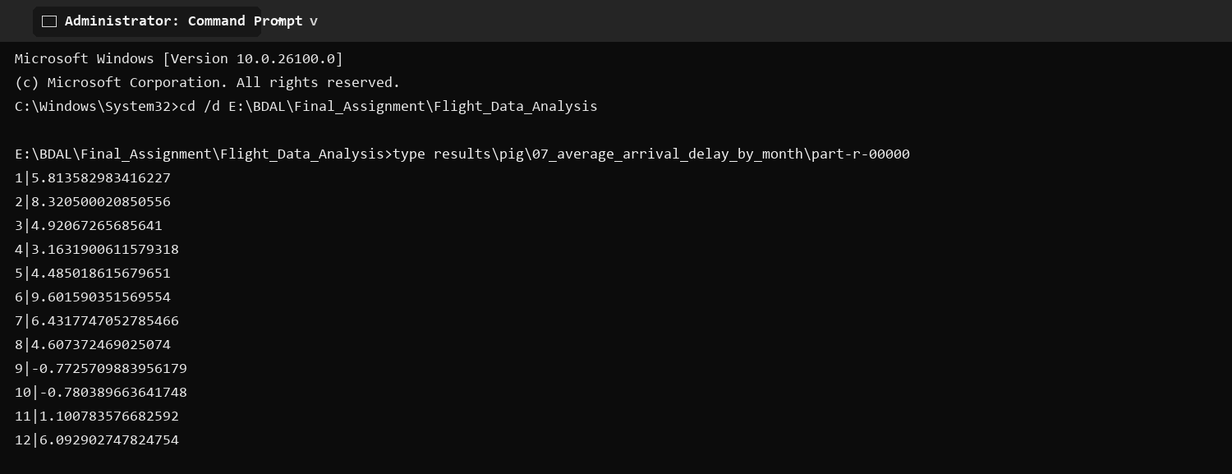
Execution output
Month | Average delay minutes
1 | 5.813582983416227
2 | 8.320500020850556
3 | 4.92067265685641
4 | 3.1631900611579318
5 | 4.485018615679651
6 | 9.601590351569554
7 | 6.4317747052785466
8 | 4.607372469025074
9 | -0.7725709883956179
10 | -0.780389663641748
11 | 1.100783576682592
12 | 6.092902747824754

Conclusion
The full dataset contains 5,819,079 flight records. Southwest Airlines operated the most flights (1,261,855). ATL was the busiest origin airport with 346,836 departures. July had the highest monthly flight total at 520,718. The busiest directional route was SFO to LAX with 13,744 flights. The highest average departure delay was recorded by NK at approximately 15.94 minutes, while the highest average arrival delay was also NK at 14.47 minutes. These findings are derived directly from the executed MapReduce and Pig outputs.

