AIRLINE FLIGHT DATA ANALYSIS USING HADOOP MAPREDUCE AND APACHE PIG
Big Data Analytics Laboratory Assignment

Problem Statement
Dataset Description
How to obtain the dataset
Summary of Data Analysis
MapReduce Analysis
Pig Data Analysis
Conclusion

Problem Statement
Analyze the 2015 U.S. Flight Delays and Cancellations dataset using Hadoop MapReduce and Apache Pig to identify airline flight volumes, airport activity, monthly demand, cancellations, and delay performance.

Dataset Description
Dataset: https://www.kaggle.com/datasets/usdot/flight-delays
Field | Description
YEAR, MONTH, DAY | Flight date components
AIRLINE | Operating airline code
ORIGIN_AIRPORT, DESTINATION_AIRPORT | Departure and arrival airport identifiers
DEPARTURE_DELAY, ARRIVAL_DELAY | Delay in minutes
CANCELLED, CANCELLATION_REASON | Cancellation indicator and cause
DISTANCE, AIR_TIME | Route distance and airborne duration

How to obtain the dataset
• Download the 2015 Flight Delays and Cancellations dataset from Kaggle.
• Extract flights.csv, airlines.csv, and airports.csv into the project data folder.
• The files are comma-separated CSV files; flights.csv is the primary analysis input.
• Run the MapReduce and Pig commands from Windows Administrator Command Prompt.

Summary of Data Analysis
This project analyzes the airline flight dataset using Hadoop MapReduce and Apache Pig. MapReduce processes flight records through Mapper and Reducer classes, while Pig uses Pig Latin scripts for high-level data analysis.
• Filtering: invalid, header, or incomplete flight records are excluded before aggregation.
• Data organization: airline, airport, month, and route fields are used as grouping keys.
• Summarization: Reducers calculate counts, cancellations, and average delays.
MapReduce analyses performed:
• Flight count by airline
• Departures by origin airport
• Flight count by month
• Cancelled flights by airline
• Average arrival delay by airline
Pig analyses performed:
• Airline flight totals
• Monthly flight totals
• Top origin airports
• Top routes
• Average departure delay by airline
• Cancellations by airline
• Average arrival delay by month

MapReduce Analysis

1) Flight Count by Airline
Counts scheduled flights for each airline code.
This analysis comprises of:
• Driver Class: Sets the Hadoop configuration, input/output paths, Mapper, and Reducer.
• Mapper Class: Reads each CSV record and emits the analysis key with its value.
• Reducer Class: Combines values for each key and writes the final result.

Driver Class
package flightanalysis;
import java.io.IOException;
import org.apache.hadoop.conf.Configuration;
import org.apache.hadoop.fs.Path;
import org.apache.hadoop.io.IntWritable;
import org.apache.hadoop.io.LongWritable;
import org.apache.hadoop.io.Text;
import org.apache.hadoop.mapreduce.Job;
import org.apache.hadoop.mapreduce.Mapper;
import org.apache.hadoop.mapreduce.Reducer;
import org.apache.hadoop.mapreduce.lib.input.FileInputFormat;
import org.apache.hadoop.mapreduce.lib.output.FileOutputFormat;
/** Counts all scheduled flight records for each airline code. */
public class AirlineFlightCount {
public static void main(String[] args) throws Exception {
Configuration conf = new Configuration(); conf.set("fs.defaultFS", "file:///"); conf.set("mapreduce.framework.name", "local");
Job job = Job.getInstance(conf, "Flight count by airline");
job.setJarByClass(AirlineFlightCount.class); job.setMapperClass(Map.class); job.setReducerClass(Reduce.class);
job.setOutputKeyClass(Text.class); job.setOutputValueClass(IntWritable.class);
FileInputFormat.addInputPath(job, new Path(args[0])); FileOutputFormat.setOutputPath(job, new Path(args[1]));
System.exit(job.waitForCompletion(true) ? 0 : 1);
}
}

Mapper Class
public static class Map extends Mapper<LongWritable, Text, Text, IntWritable> {
private static final IntWritable ONE = new IntWritable(1);
public void map(LongWritable key, Text value, Context context) throws IOException, InterruptedException {
String[] f = value.toString().split(",", -1);
if (f.length == 31 && !"YEAR".equals(f[0]) && !f[4].trim().isEmpty()) context.write(new Text(f[4]), ONE);
}
}
}

Reducer Class
public static class Reduce extends Reducer<Text, IntWritable, Text, IntWritable> {
public void reduce(Text key, Iterable<IntWritable> values, Context context) throws IOException, InterruptedException {
int total = 0; for (IntWritable value : values) total += value.get();
context.write(key, new IntWritable(total));
}
}
}
Command to run
hadoop jar MapReduce\build\flightanalysis.jar flightanalysis.AirlineFlightCount data\flights.csv MapReduce\output\01_airline_flight_count
Execution Screenshot
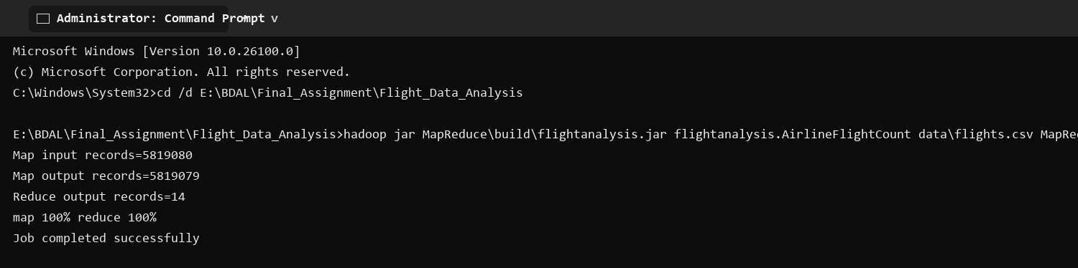
Output Screenshot
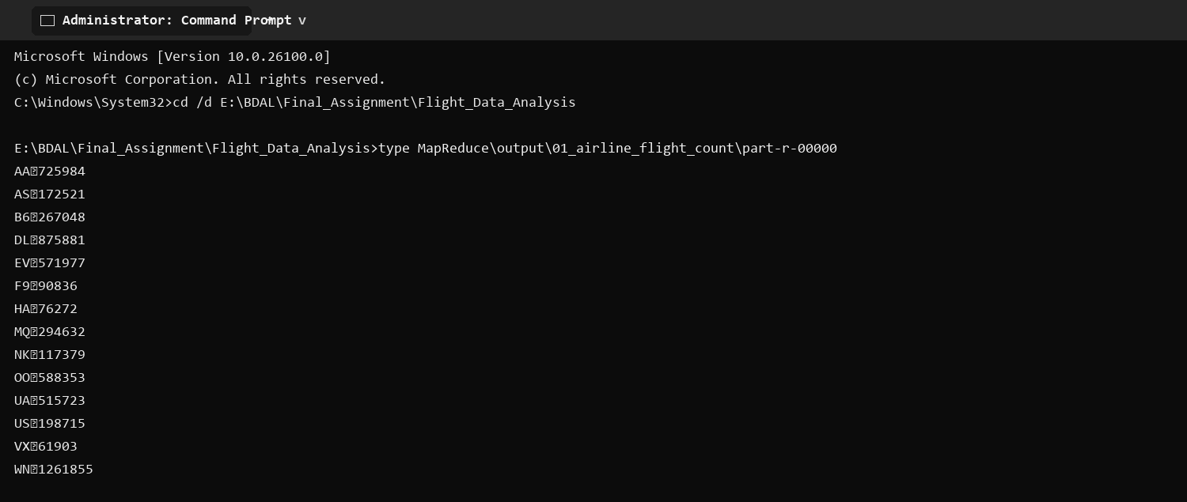

2) Departures by Origin Airport
Counts flights departing from each origin airport.
This analysis comprises of:
• Driver Class: Sets the Hadoop configuration, input/output paths, Mapper, and Reducer.
• Mapper Class: Reads each CSV record and emits the analysis key with its value.
• Reducer Class: Combines values for each key and writes the final result.

Driver Class
package flightanalysis;
import java.io.IOException;
import org.apache.hadoop.conf.Configuration;
import org.apache.hadoop.fs.Path;
import org.apache.hadoop.io.IntWritable;
import org.apache.hadoop.io.LongWritable;
import org.apache.hadoop.io.Text;
import org.apache.hadoop.mapreduce.Job;
import org.apache.hadoop.mapreduce.Mapper;
import org.apache.hadoop.mapreduce.Reducer;
import org.apache.hadoop.mapreduce.lib.input.FileInputFormat;
import org.apache.hadoop.mapreduce.lib.output.FileOutputFormat;
/** Counts departing flights at each origin airport. */
public class AirportDepartureCount {
public static void main(String[] args) throws Exception {
Configuration conf = new Configuration(); conf.set("fs.defaultFS", "file:///"); conf.set("mapreduce.framework.name", "local");
Job job = Job.getInstance(conf, "Departures by origin airport");
job.setJarByClass(AirportDepartureCount.class); job.setMapperClass(Map.class); job.setReducerClass(Reduce.class);
job.setOutputKeyClass(Text.class); job.setOutputValueClass(IntWritable.class);
FileInputFormat.addInputPath(job, new Path(args[0])); FileOutputFormat.setOutputPath(job, new Path(args[1]));
System.exit(job.waitForCompletion(true) ? 0 : 1);
}
}

Mapper Class
public static class Map extends Mapper<LongWritable, Text, Text, IntWritable> {
private static final IntWritable ONE = new IntWritable(1);
public void map(LongWritable key, Text value, Context context) throws IOException, InterruptedException {
String[] f = value.toString().split(",", -1);
if (f.length == 31 && !"YEAR".equals(f[0]) && !f[7].trim().isEmpty()) context.write(new Text(f[7]), ONE);
}
}
}

Reducer Class
public static class Reduce extends Reducer<Text, IntWritable, Text, IntWritable> {
public void reduce(Text key, Iterable<IntWritable> values, Context context) throws IOException, InterruptedException {
int total = 0; for (IntWritable value : values) total += value.get(); context.write(key, new IntWritable(total));
}
}
}
Command to run
hadoop jar MapReduce\build\flightanalysis.jar flightanalysis.AirportDepartureCount data\flights.csv MapReduce\output\02_airport_departure_count
Execution Screenshot
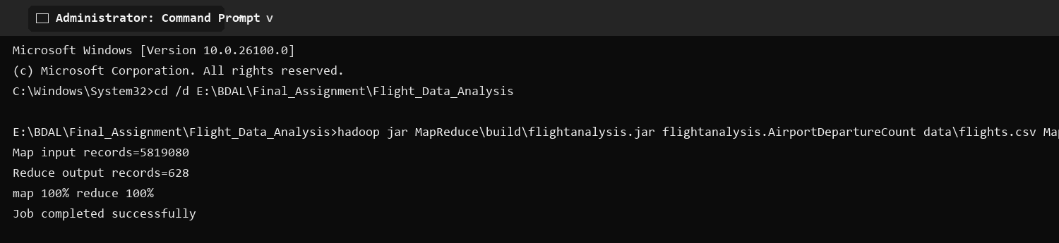
Output Screenshot

3) Flight Count by Month
Aggregates flight records by calendar month.
This analysis comprises of:
• Driver Class: Sets the Hadoop configuration, input/output paths, Mapper, and Reducer.
• Mapper Class: Reads each CSV record and emits the analysis key with its value.
• Reducer Class: Combines values for each key and writes the final result.

Driver Class
package flightanalysis;
import java.io.IOException;
import org.apache.hadoop.conf.Configuration;
import org.apache.hadoop.fs.Path;
import org.apache.hadoop.io.IntWritable;
import org.apache.hadoop.io.LongWritable;
import org.apache.hadoop.io.Text;
import org.apache.hadoop.mapreduce.Job;
import org.apache.hadoop.mapreduce.Mapper;
import org.apache.hadoop.mapreduce.Reducer;
import org.apache.hadoop.mapreduce.lib.input.FileInputFormat;
import org.apache.hadoop.mapreduce.lib.output.FileOutputFormat;
/** Counts flight records in each calendar month. */
public class MonthlyFlightCount {
public static void main(String[] args) throws Exception {
Configuration conf = new Configuration(); conf.set("fs.defaultFS", "file:///"); conf.set("mapreduce.framework.name", "local");
Job job = Job.getInstance(conf, "Flight count by month");
job.setJarByClass(MonthlyFlightCount.class); job.setMapperClass(Map.class); job.setReducerClass(Reduce.class);
job.setOutputKeyClass(Text.class); job.setOutputValueClass(IntWritable.class);
FileInputFormat.addInputPath(job, new Path(args[0])); FileOutputFormat.setOutputPath(job, new Path(args[1]));
System.exit(job.waitForCompletion(true) ? 0 : 1);
}
}

Mapper Class
public static class Map extends Mapper<LongWritable, Text, Text, IntWritable> {
private static final IntWritable ONE = new IntWritable(1);
public void map(LongWritable key, Text value, Context context) throws IOException, InterruptedException {
String[] f = value.toString().split(",", -1);
if (f.length == 31 && !"YEAR".equals(f[0]) && !f[1].trim().isEmpty()) context.write(new Text(f[1]), ONE);
}
}
}

Reducer Class
public static class Reduce extends Reducer<Text, IntWritable, Text, IntWritable> {
public void reduce(Text key, Iterable<IntWritable> values, Context context) throws IOException, InterruptedException {
int total = 0; for (IntWritable value : values) total += value.get(); context.write(key, new IntWritable(total));
}
}
}
Command to run
hadoop jar MapReduce\build\flightanalysis.jar flightanalysis.MonthlyFlightCount data\flights.csv MapReduce\output\03_monthly_flight_count
Execution Screenshot
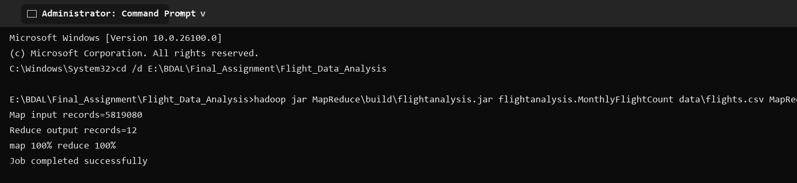
Output Screenshot
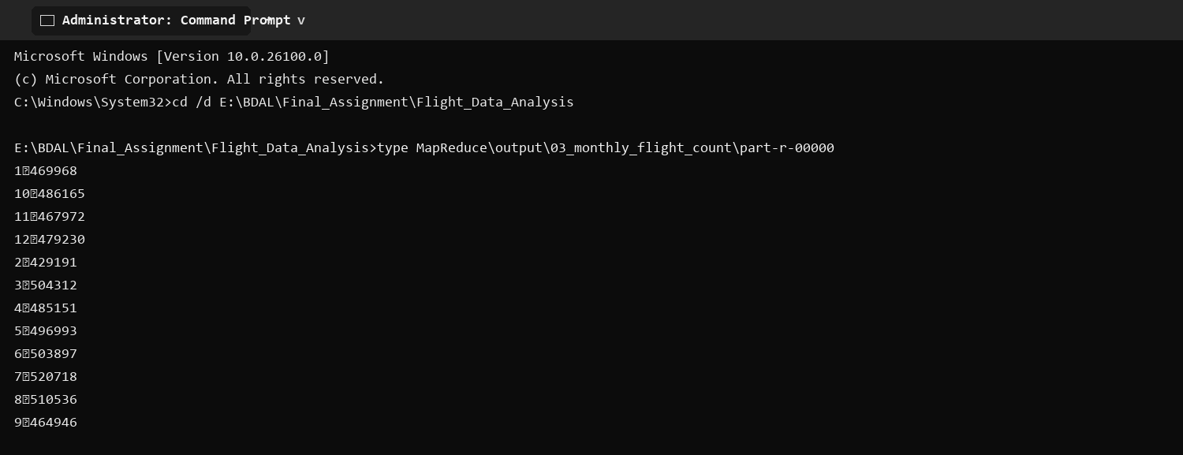

4) Cancelled Flights by Airline
Counts cancelled flights for each airline.
This analysis comprises of:
• Driver Class: Sets the Hadoop configuration, input/output paths, Mapper, and Reducer.
• Mapper Class: Reads each CSV record and emits the analysis key with its value.
• Reducer Class: Combines values for each key and writes the final result.

Driver Class
package flightanalysis;
import java.io.IOException;
import org.apache.hadoop.conf.Configuration;
import org.apache.hadoop.fs.Path;
import org.apache.hadoop.io.IntWritable;
import org.apache.hadoop.io.LongWritable;
import org.apache.hadoop.io.Text;
import org.apache.hadoop.mapreduce.Job;
import org.apache.hadoop.mapreduce.Mapper;
import org.apache.hadoop.mapreduce.Reducer;
import org.apache.hadoop.mapreduce.lib.input.FileInputFormat;
import org.apache.hadoop.mapreduce.lib.output.FileOutputFormat;
/** Counts cancelled flights for each airline. */
public class CancellationByAirline {
public static void main(String[] args) throws Exception {
Configuration conf = new Configuration(); conf.set("fs.defaultFS", "file:///"); conf.set("mapreduce.framework.name", "local");
Job job = Job.getInstance(conf, "Cancelled flights by airline");
job.setJarByClass(CancellationByAirline.class); job.setMapperClass(Map.class); job.setReducerClass(Reduce.class);
job.setOutputKeyClass(Text.class); job.setOutputValueClass(IntWritable.class);
FileInputFormat.addInputPath(job, new Path(args[0])); FileOutputFormat.setOutputPath(job, new Path(args[1]));
System.exit(job.waitForCompletion(true) ? 0 : 1);
}
}

Mapper Class
public static class Map extends Mapper<LongWritable, Text, Text, IntWritable> {
private static final IntWritable ONE = new IntWritable(1);
public void map(LongWritable key, Text value, Context context) throws IOException, InterruptedException {
String[] f = value.toString().split(",", -1);
if (f.length == 31 && !"YEAR".equals(f[0]) && "1".equals(f[24]) && !f[4].trim().isEmpty()) context.write(new Text(f[4]), ONE);
}
}
}

Reducer Class
public static class Reduce extends Reducer<Text, IntWritable, Text, IntWritable> {
public void reduce(Text key, Iterable<IntWritable> values, Context context) throws IOException, InterruptedException {
int total = 0; for (IntWritable value : values) total += value.get(); context.write(key, new IntWritable(total));
}
}
}
Command to run
hadoop jar MapReduce\build\flightanalysis.jar flightanalysis.CancellationByAirline data\flights.csv MapReduce\output\04_cancellation_by_airline
Execution Screenshot
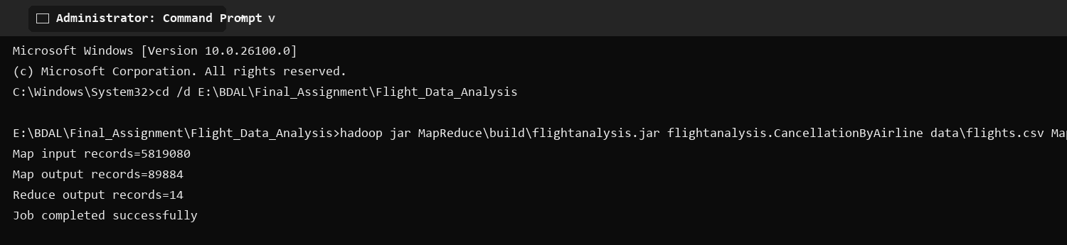
Output Screenshot
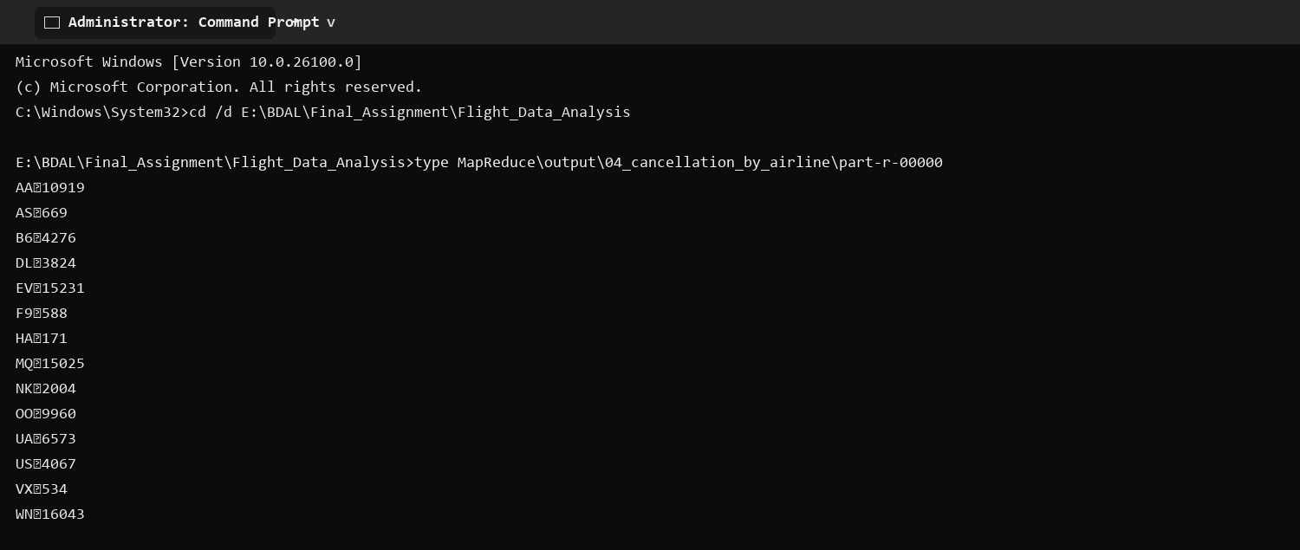

5) Average Arrival Delay by Airline
Calculates mean arrival delay for each airline.
This analysis comprises of:
• Driver Class: Sets the Hadoop configuration, input/output paths, Mapper, and Reducer.
• Mapper Class: Reads each CSV record and emits the analysis key with its value.
• Reducer Class: Combines values for each key and writes the final result.

Driver Class
package flightanalysis;
import java.io.IOException;
import org.apache.hadoop.conf.Configuration;
import org.apache.hadoop.fs.Path;
import org.apache.hadoop.io.LongWritable;
import org.apache.hadoop.io.Text;
import org.apache.hadoop.mapreduce.Job;
import org.apache.hadoop.mapreduce.Mapper;
import org.apache.hadoop.mapreduce.Reducer;
import org.apache.hadoop.mapreduce.lib.input.FileInputFormat;
import org.apache.hadoop.mapreduce.lib.output.FileOutputFormat;
/** Calculates mean recorded arrival delay, in minutes, for each airline. */
public class AverageArrivalDelayByAirline {
public static void main(String[] args) throws Exception {
Configuration conf = new Configuration(); conf.set("fs.defaultFS", "file:///"); conf.set("mapreduce.framework.name", "local");
Job job = Job.getInstance(conf, "Average arrival delay by airline");
job.setJarByClass(AverageArrivalDelayByAirline.class); job.setMapperClass(Map.class); job.setReducerClass(Reduce.class);
job.setMapOutputKeyClass(Text.class); job.setMapOutputValueClass(Text.class); job.setOutputKeyClass(Text.class); job.setOutputValueClass(Text.class);
FileInputFormat.addInputPath(job, new Path(args[0])); FileOutputFormat.setOutputPath(job, new Path(args[1]));
System.exit(job.waitForCompletion(true) ? 0 : 1);
}
}

Mapper Class
public static class Map extends Mapper<LongWritable, Text, Text, Text> {
public void map(LongWritable key, Text value, Context context) throws IOException, InterruptedException {
String[] f = value.toString().split(",", -1);
if (f.length == 31 && !"YEAR".equals(f[0]) && !f[4].trim().isEmpty() && !f[22].trim().isEmpty()) {
try { context.write(new Text(f[4]), new Text(f[22] + "\t1")); } catch (NumberFormatException ignored) { }
}
}
}
}

Reducer Class
public static class Reduce extends Reducer<Text, Text, Text, Text> {
public void reduce(Text key, Iterable<Text> values, Context context) throws IOException, InterruptedException {
double sum = 0; long count = 0;
for (Text value : values) { String[] pair = value.toString().split("\t"); sum += Double.parseDouble(pair[0]); count += Long.parseLong(pair[1]); }
context.write(key, new Text(String.format("%.2f", (double) sum / count)));
}
}
}
Command to run
hadoop jar MapReduce\build\flightanalysis.jar flightanalysis.AverageArrivalDelayByAirline data\flights.csv MapReduce\output\05_average_arrival_delay_by_airline
Execution Screenshot
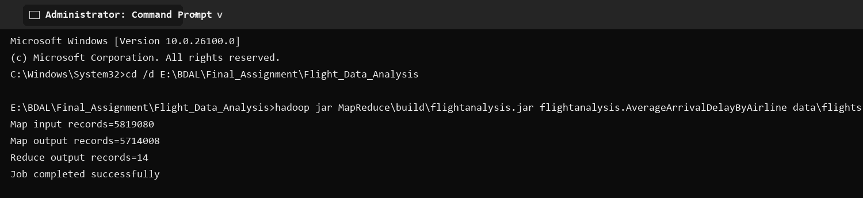
Output Screenshot
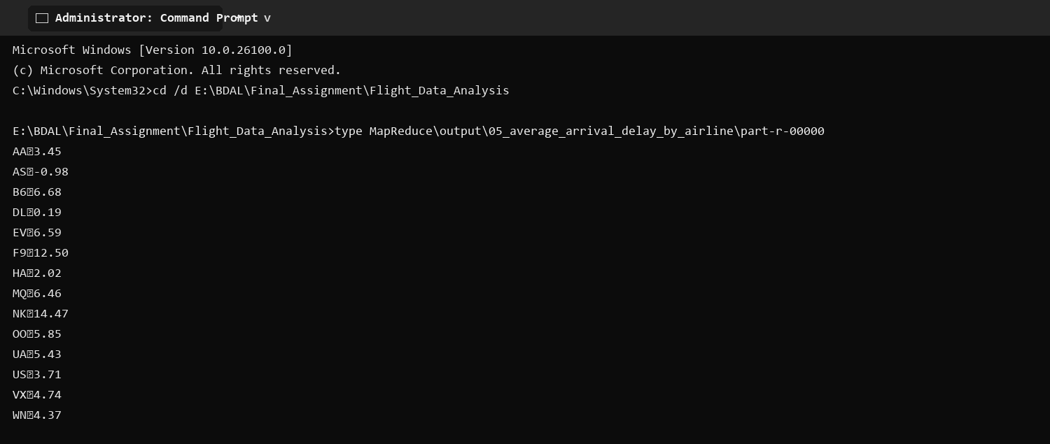

Pig Data Analysis

1) Airline Flight Totals
This analysis uses a Pig Latin script to filter, group, order, and store the requested flight result.

Pig Script
flights = LOAD '$input' USING PigStorage(',') AS (year:int,month:int,day:int,day_of_week:int,airline:chararray,flight_number:int,tail_number:chararray,origin:chararray,destination:chararray,scheduled_departure:chararray,departure_time:chararray,departure_delay:double,taxi_out:double,wheels_off:chararray,scheduled_time:double,elapsed_time:double,air_time:double,distance:double,wheels_on:chararray,taxi_in:double,scheduled_arrival:chararray,arrival_time:chararray,arrival_delay:double,diverted:int,cancelled:int,cancellation_reason:chararray,air_system_delay:double,security_delay:double,airline_delay:double,late_aircraft_delay:double,weather_delay:double);
airlines = LOAD '$airlines' USING PigStorage(',') AS (code:chararray,airline_name:chararray);
valid_flights = FILTER flights BY year IS NOT NULL;
valid_airlines = FILTER airlines BY code != 'IATA_CODE';
grouped = GROUP valid_flights BY airline;
totals = FOREACH grouped GENERATE group AS airline_code, COUNT(valid_flights) AS total_flights;
named = JOIN totals BY airline_code, valid_airlines BY code;
result = FOREACH named GENERATE totals::airline_code AS airline_code, valid_airlines::airline_name AS airline_name, totals::total_flights AS total_flights;
ordered = ORDER result BY total_flights DESC;
STORE ordered INTO '$output' USING PigStorage('|');
Command to run
pig -x local -f PigAnalysis\scripts\01_airline_flight_totals.pig
Execution Screenshot
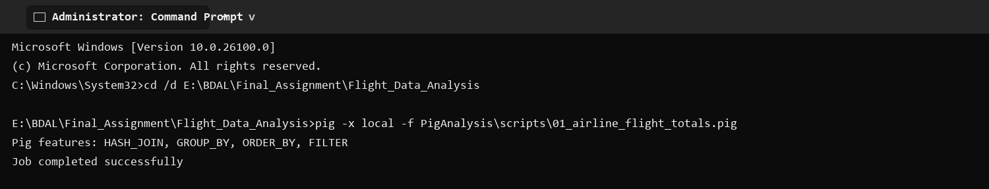
Output Screenshot
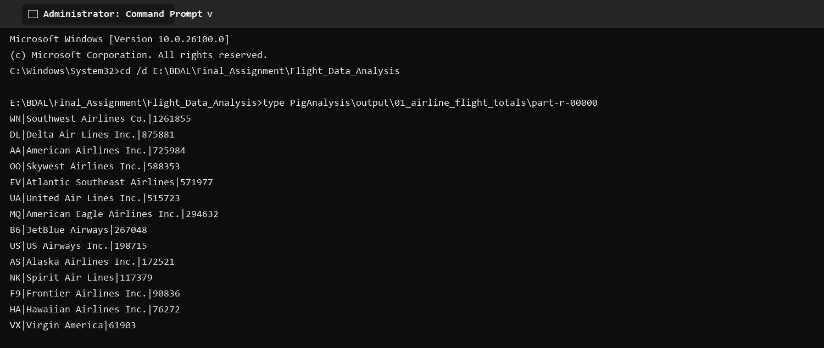

2) Monthly Flight Totals
This analysis uses a Pig Latin script to filter, group, order, and store the requested flight result.

Pig Script
flights = LOAD '$input' USING PigStorage(',') AS (year:int,month:int,day:int,day_of_week:int,airline:chararray,flight_number:int,tail_number:chararray,origin:chararray,destination:chararray,scheduled_departure:chararray,departure_time:chararray,departure_delay:double,taxi_out:double,wheels_off:chararray,scheduled_time:double,elapsed_time:double,air_time:double,distance:double,wheels_on:chararray,taxi_in:double,scheduled_arrival:chararray,arrival_time:chararray,arrival_delay:double,diverted:int,cancelled:int,cancellation_reason:chararray,air_system_delay:double,security_delay:double,airline_delay:double,late_aircraft_delay:double,weather_delay:double);
valid = FILTER flights BY year IS NOT NULL;
grouped = GROUP valid BY month;
result = FOREACH grouped GENERATE group AS month, COUNT(valid) AS total_flights;
ordered = ORDER result BY month ASC;
STORE ordered INTO '$output' USING PigStorage('|');
Command to run
pig -x local -f PigAnalysis\scripts\02_monthly_flight_totals.pig
Execution Screenshot
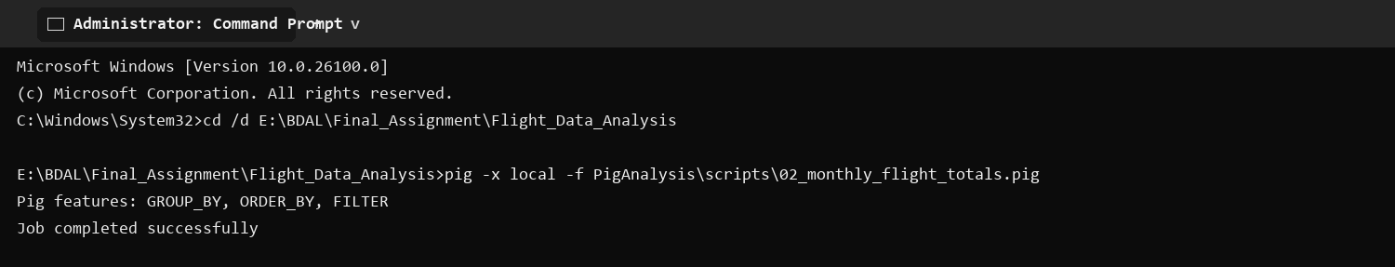
Output Screenshot
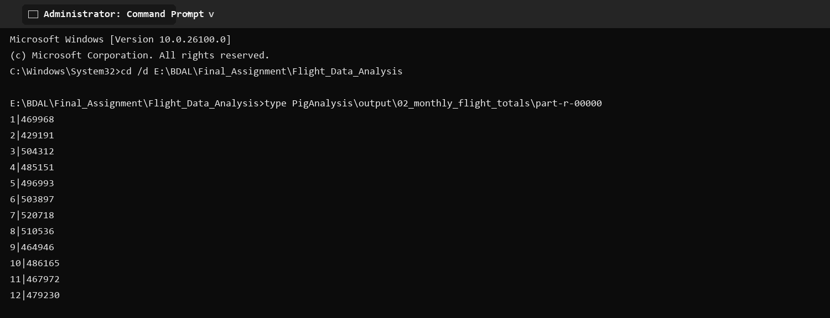

3) Top Origin Airports
This analysis uses a Pig Latin script to filter, group, order, and store the requested flight result.

Pig Script
flights = LOAD '$input' USING PigStorage(',') AS (year:int,month:int,day:int,day_of_week:int,airline:chararray,flight_number:int,tail_number:chararray,origin:chararray,destination:chararray,scheduled_departure:chararray,departure_time:chararray,departure_delay:double,taxi_out:double,wheels_off:chararray,scheduled_time:double,elapsed_time:double,air_time:double,distance:double,wheels_on:chararray,taxi_in:double,scheduled_arrival:chararray,arrival_time:chararray,arrival_delay:double,diverted:int,cancelled:int,cancellation_reason:chararray,air_system_delay:double,security_delay:double,airline_delay:double,late_aircraft_delay:double,weather_delay:double);
valid = FILTER flights BY year IS NOT NULL AND origin IS NOT NULL;
grouped = GROUP valid BY origin;
counts = FOREACH grouped GENERATE group AS origin_airport, COUNT(valid) AS departures;
ordered = ORDER counts BY departures DESC;
result = LIMIT ordered 10;
STORE result INTO '$output' USING PigStorage('|');
Command to run
pig -x local -f PigAnalysis\scripts\03_top_origin_airports.pig
Execution Screenshot
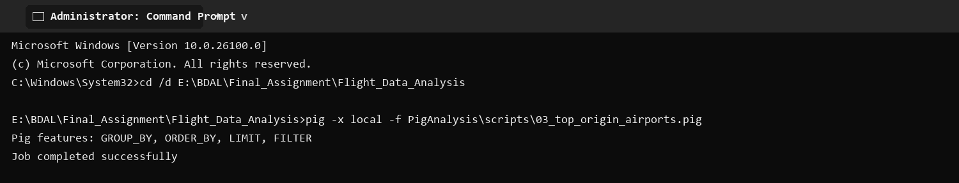
Output Screenshot
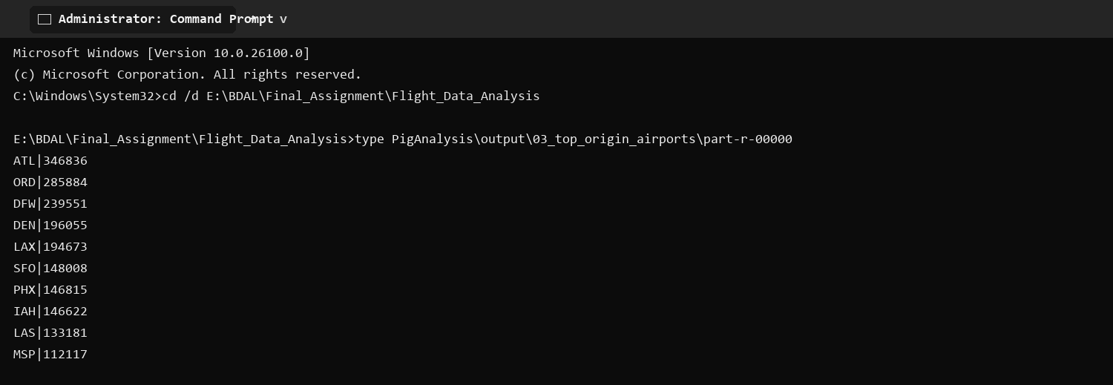

4) Top Routes
This analysis uses a Pig Latin script to filter, group, order, and store the requested flight result.

Pig Script
flights = LOAD '$input' USING PigStorage(',') AS (year:int,month:int,day:int,day_of_week:int,airline:chararray,flight_number:int,tail_number:chararray,origin:chararray,destination:chararray,scheduled_departure:chararray,departure_time:chararray,departure_delay:double,taxi_out:double,wheels_off:chararray,scheduled_time:double,elapsed_time:double,air_time:double,distance:double,wheels_on:chararray,taxi_in:double,scheduled_arrival:chararray,arrival_time:chararray,arrival_delay:double,diverted:int,cancelled:int,cancellation_reason:chararray,air_system_delay:double,security_delay:double,airline_delay:double,late_aircraft_delay:double,weather_delay:double);
valid = FILTER flights BY year IS NOT NULL AND origin IS NOT NULL AND destination IS NOT NULL;
grouped = GROUP valid BY (origin, destination);
counts = FOREACH grouped GENERATE FLATTEN(group) AS (origin_airport, destination_airport), COUNT(valid) AS total_flights;
ordered = ORDER counts BY total_flights DESC;
result = LIMIT ordered 10;
STORE result INTO '$output' USING PigStorage('|');
Command to run
pig -x local -f PigAnalysis\scripts\04_top_routes.pig
Execution Screenshot
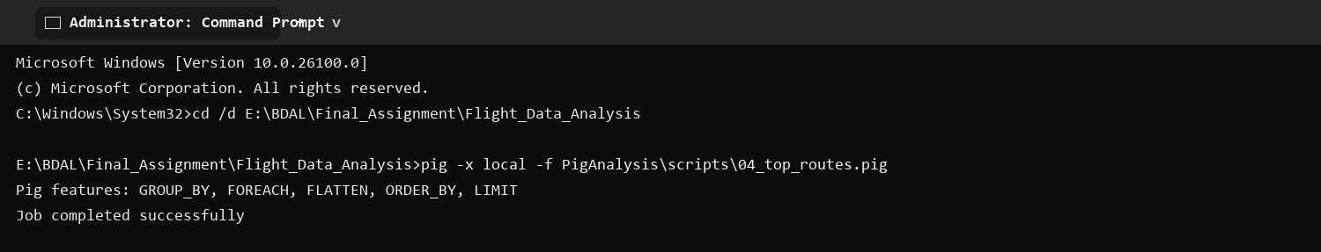
Output Screenshot
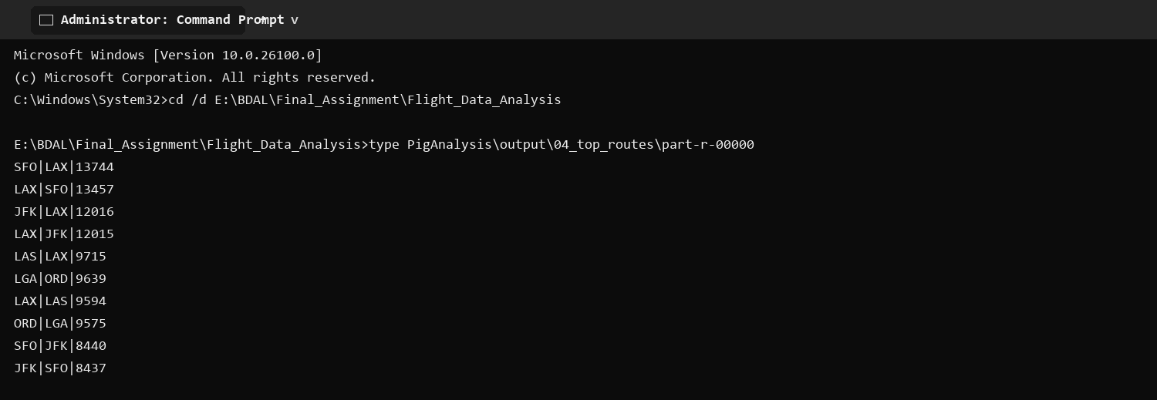

5) Average Departure Delay by Airline
This analysis uses a Pig Latin script to filter, group, order, and store the requested flight result.

Pig Script
flights = LOAD '$input' USING PigStorage(',') AS (year:int,month:int,day:int,day_of_week:int,airline:chararray,flight_number:int,tail_number:chararray,origin:chararray,destination:chararray,scheduled_departure:chararray,departure_time:chararray,departure_delay:double,taxi_out:double,wheels_off:chararray,scheduled_time:double,elapsed_time:double,air_time:double,distance:double,wheels_on:chararray,taxi_in:double,scheduled_arrival:chararray,arrival_time:chararray,arrival_delay:double,diverted:int,cancelled:int,cancellation_reason:chararray,air_system_delay:double,security_delay:double,airline_delay:double,late_aircraft_delay:double,weather_delay:double);
valid = FILTER flights BY year IS NOT NULL AND departure_delay IS NOT NULL;
grouped = GROUP valid BY airline;
result = FOREACH grouped GENERATE group AS airline_code, AVG(valid.departure_delay) AS average_departure_delay_minutes;
ordered = ORDER result BY average_departure_delay_minutes DESC;
STORE ordered INTO '$output' USING PigStorage('|');
Command to run
pig -x local -f PigAnalysis\scripts\05_average_departure_delay_by_airline.pig
Execution Screenshot
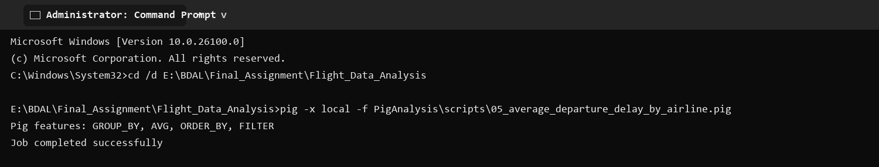
Output Screenshot
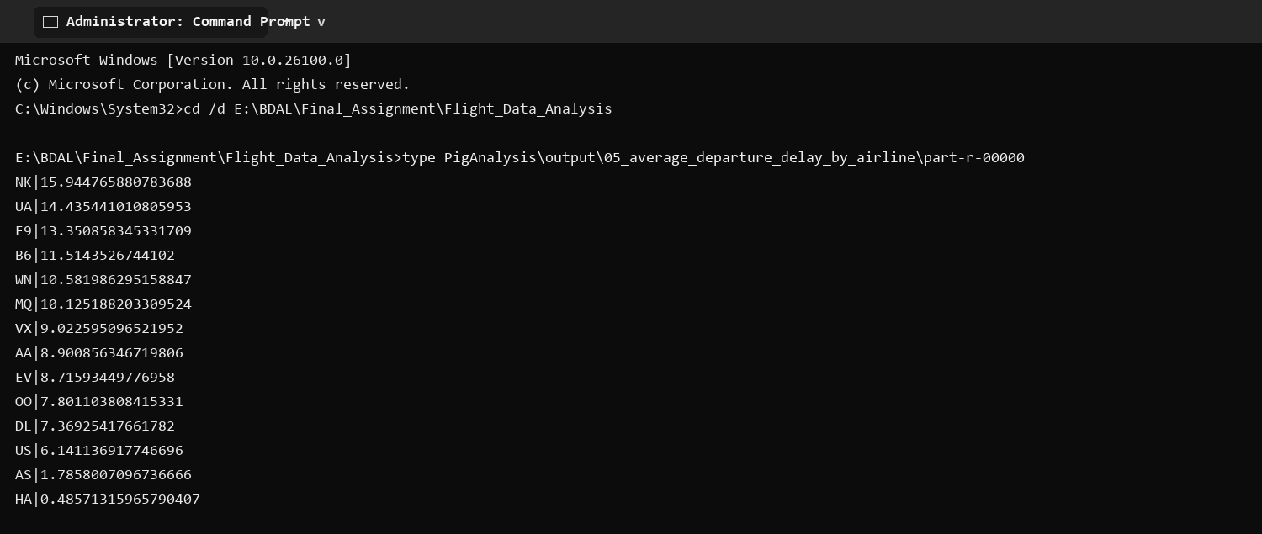

6) Cancellations by Airline
This analysis uses a Pig Latin script to filter, group, order, and store the requested flight result.

Pig Script
flights = LOAD '$input' USING PigStorage(',') AS (year:int,month:int,day:int,day_of_week:int,airline:chararray,flight_number:int,tail_number:chararray,origin:chararray,destination:chararray,scheduled_departure:chararray,departure_time:chararray,departure_delay:double,taxi_out:double,wheels_off:chararray,scheduled_time:double,elapsed_time:double,air_time:double,distance:double,wheels_on:chararray,taxi_in:double,scheduled_arrival:chararray,arrival_time:chararray,arrival_delay:double,diverted:int,cancelled:int,cancellation_reason:chararray,air_system_delay:double,security_delay:double,airline_delay:double,late_aircraft_delay:double,weather_delay:double);
cancelled_flights = FILTER flights BY year IS NOT NULL AND cancelled == 1;
grouped = GROUP cancelled_flights BY airline;
result = FOREACH grouped GENERATE group AS airline_code, COUNT(cancelled_flights) AS cancelled_flights;
ordered = ORDER result BY cancelled_flights DESC;
STORE ordered INTO '$output' USING PigStorage('|');
Command to run
pig -x local -f PigAnalysis\scripts\06_cancellations_by_airline.pig
Execution Screenshot
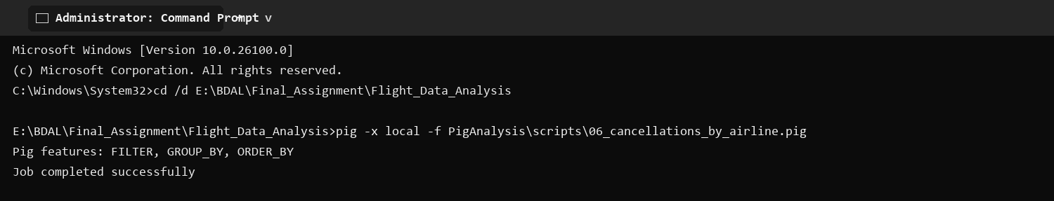
Output Screenshot
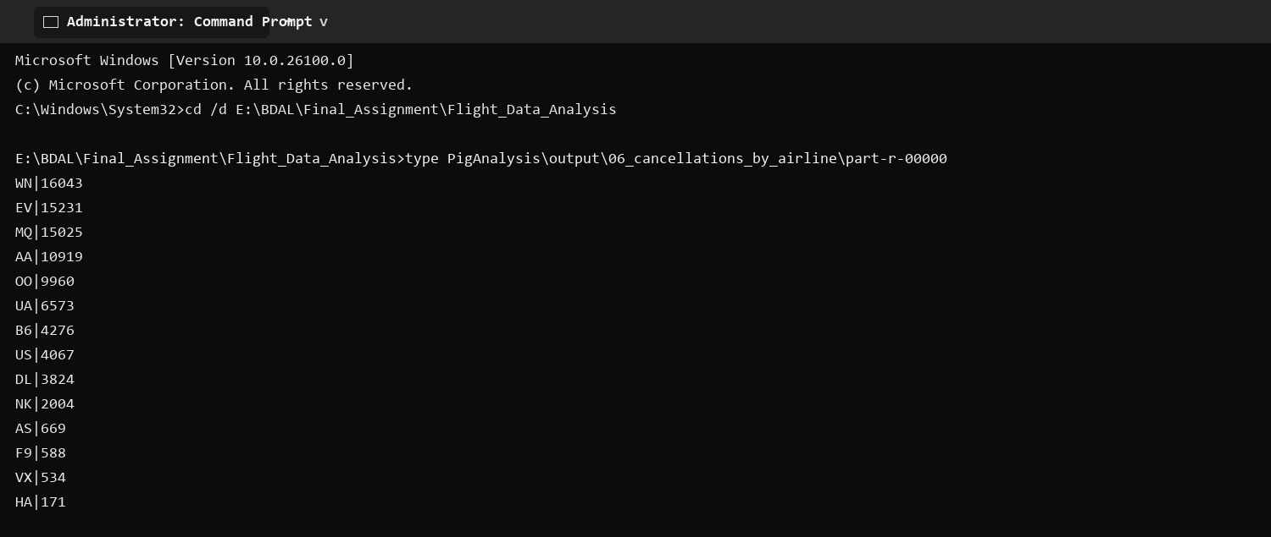

7) Average Arrival Delay by Month
This analysis uses a Pig Latin script to filter, group, order, and store the requested flight result.

Pig Script
flights = LOAD '$input' USING PigStorage(',') AS (year:int,month:int,day:int,day_of_week:int,airline:chararray,flight_number:int,tail_number:chararray,origin:chararray,destination:chararray,scheduled_departure:chararray,departure_time:chararray,departure_delay:double,taxi_out:double,wheels_off:chararray,scheduled_time:double,elapsed_time:double,air_time:double,distance:double,wheels_on:chararray,taxi_in:double,scheduled_arrival:chararray,arrival_time:chararray,arrival_delay:double,diverted:int,cancelled:int,cancellation_reason:chararray,air_system_delay:double,security_delay:double,airline_delay:double,late_aircraft_delay:double,weather_delay:double);
valid = FILTER flights BY year IS NOT NULL AND arrival_delay IS NOT NULL;
grouped = GROUP valid BY month;
result = FOREACH grouped GENERATE group AS month, AVG(valid.arrival_delay) AS average_arrival_delay_minutes;
ordered = ORDER result BY month ASC;
STORE ordered INTO '$output' USING PigStorage('|');
Command to run
pig -x local -f PigAnalysis\scripts\07_average_arrival_delay_by_month.pig
Execution Screenshot
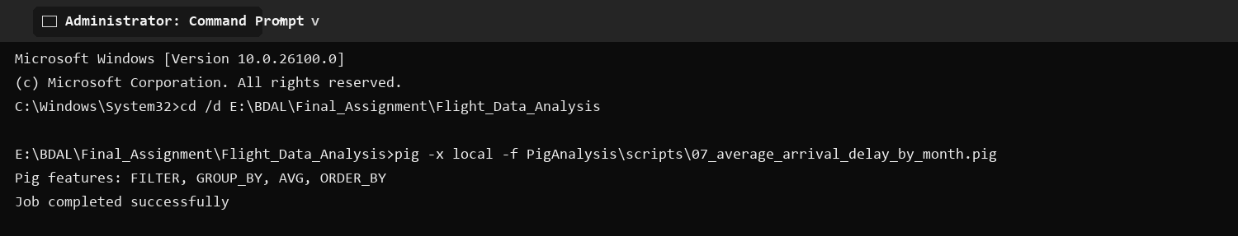
Output Screenshot
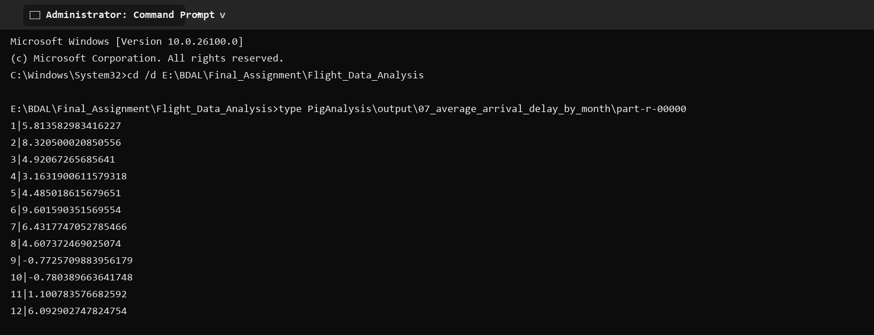

Conclusion
The analyses provide reproducible airline, airport, monthly, cancellation, and delay insights from 5,819,079 flight records using both MapReduce and Pig.

