CONTENTS

Problem Statement 2

Dataset Description 2

How to obtain the dataset 2

Summary of Data Analysis 3

Map Reduce Analysis 4

1) Flight Count by Airline 4
2) Departures by Origin Airport 5
3) Flight Count by Month 6
4) Cancelled Flights by Airline 7
5) Average Arrival Delay by Airline 9

Pig Flight Data Analysis 10

1) Airline Flight Totals 10
2) Monthly Flight Totals 11
3) Top Origin Airports 12
4) Top Routes 12
5) Average Departure Delay by Airline 13
6) Cancellations by Airline 14
7) Average Arrival Delay by Month 14

Conclusion 15

Problem Statement
Analyze the supplied 2015 U.S. flight dataset using Hadoop MapReduce and Apache Pig. The analysis identifies flight volumes, airport activity, monthly demand, cancellation patterns, and delay performance using the fields available in the dataset..

Dataset Description
Dataset: https://www.kaggle.com/datasets/usdot/flight-delays
The dataset contains three CSV files: flights.csv, airlines.csv, and airports.csv.
The main file, flights.csv, contains 5,819,079 flight records with 31 columns. It includes information such as flight date, airline code, flight number, origin airport, destination airport, departure delay, arrival delay, cancellation status, cancellation reason, distance, and air time.
The airlines.csv file contains airline codes and airline names. The airports.csv file contains airport codes, airport names, cities, states, countries, latitude, and longitude. These two files are used as lookup datasets to understand airline and airport codes in the main flight data.
Field | Description
YEAR, MONTH, DAY | Flight date components
AIRLINE | Operating airline code
ORIGIN_AIRPORT, DESTINATION_AIRPORT | Departure and arrival airport identifiers
DEPARTURE_DELAY, ARRIVAL_DELAY | Delay in minutes
CANCELLED, CANCELLATION_REASON | Cancellation indicator and cause
DISTANCE, AIR_TIME | Route distance and airborne duration

How to obtain the dataset
- Download the 2015 Flight Delays and Cancellations dataset from Kaggle.
- Extract flights.csv, airlines.csv, and airports.csv into the project data folder.
- The files are comma-separated CSV files; flights.csv is the primary analysis input.
- Run the MapReduce and Pig commands from Windows Administrator Command Prompt.

Summary of Data Analysis
This project analyzes the airline flight dataset using Hadoop MapReduce and Apache Pig. The purpose of the analysis is to identify airline activity, busy airports, monthly flight trends, cancellation patterns, and flight-delay performance from a large collection of flight records.
Hadoop MapReduce is used to process the dataset through Driver, Mapper, and Reducer classes. The Mapper reads each flight record and extracts the required fields. Hadoop groups records with the same key, and the Reducer combines these values to generate the final results. Apache Pig is used for high-level analysis through Pig Latin scripts, which make it easier to load, filter, group, sort, and store the data.
- Filtering: Header records, invalid records, and incomplete flight records are excluded before analysis.
- Data Organization: Airline code, origin airport, month, and route fields are used as grouping keys to organize related flight records.
- Summarization: Reducers calculate total flight counts, airport departures, cancellation counts, and average delay values.
- Performance Analysis: Departure and arrival delay fields are analyzed to compare airline performance and identify airlines with higher delays.
MapReduce analyses performed:
- Flight count by airline: Counts the total number of flights operated by each airline.
- Departures by origin airport: Counts the number of flights departing from each airport.
- Flight count by month: Calculates the total number of flights for every month.
- Cancelled flights by airline: Counts cancelled flights for each airline.
- Average arrival delay by airline: Calculates the average arrival delay in minutes for each airline.
Pig analyses performed:
- Airline flight totals: Shows total flights for each airline with airline names.
- Monthly flight totals: Shows the total number of flights in each month.
- Top origin airports: Identifies the ten airports with the highest number of departures.
- Top routes: Identifies the ten busiest flight routes based on origin and destination airports.
- Average departure delay by airline: Calculates the average departure delay for each airline.
- Cancellations by airline: Shows the total number of cancelled flights for each airline.
- Average arrival delay by month: Calculates the average arrival delay for each month.

Map Reduce Analysis

1) Flight Count by Airline
Counts all scheduled flight records for each airline code.
Code
package flightanalysis;
import java.io.IOException;
import org.apache.hadoop.conf.Configuration;
import org.apache.hadoop.fs.Path;
import org.apache.hadoop.io.IntWritable;
import org.apache.hadoop.io.LongWritable;
import org.apache.hadoop.io.Text;
import org.apache.hadoop.mapreduce.Job;
import org.apache.hadoop.mapreduce.Mapper;
import org.apache.hadoop.mapreduce.Reducer;
import org.apache.hadoop.mapreduce.lib.input.FileInputFormat;
import org.apache.hadoop.mapreduce.lib.output.FileOutputFormat;
/** Counts all scheduled flight records for each airline code. */
public class AirlineFlightCount {
public static class Map extends Mapper<LongWritable, Text, Text, IntWritable> {
private static final IntWritable ONE = new IntWritable(1);
public void map(LongWritable key, Text value, Context context) throws IOException, InterruptedException {
String[] f = value.toString().split(",", -1);
if (f.length == 31 && !"YEAR".equals(f[0]) && !f[4].trim().isEmpty()) context.write(new Text(f[4]), ONE);
}
}
public static class Reduce extends Reducer<Text, IntWritable, Text, IntWritable> {
public void reduce(Text key, Iterable<IntWritable> values, Context context) throws IOException, InterruptedException {
int total = 0; for (IntWritable value : values) total += value.get();
context.write(key, new IntWritable(total));
}
}
public static void main(String[] args) throws Exception {
Configuration conf = new Configuration(); conf.set("fs.defaultFS", "file:///"); conf.set("mapreduce.framework.name", "local");
Job job = Job.getInstance(conf, "Flight count by airline");
job.setJarByClass(AirlineFlightCount.class); job.setMapperClass(Map.class); job.setReducerClass(Reduce.class);
job.setOutputKeyClass(Text.class); job.setOutputValueClass(IntWritable.class);
FileInputFormat.addInputPath(job, new Path(args[0])); FileOutputFormat.setOutputPath(job, new Path(args[1]));
System.exit(job.waitForCompletion(true) ? 0 : 1);
}
}

Command to run
hadoop jar MapReduce\build\flightanalysis.jar flightanalysis.AirlineFlightCount data\flights.csv MapReduce\output\01_airline_flight_count
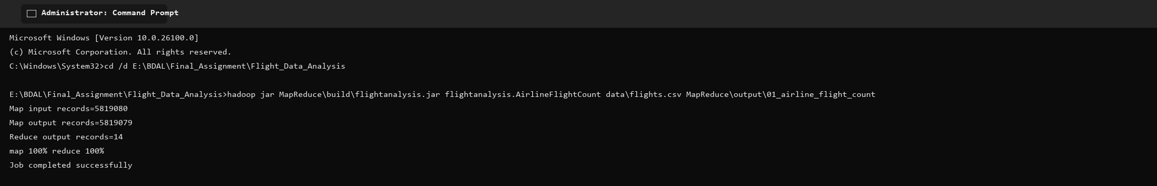
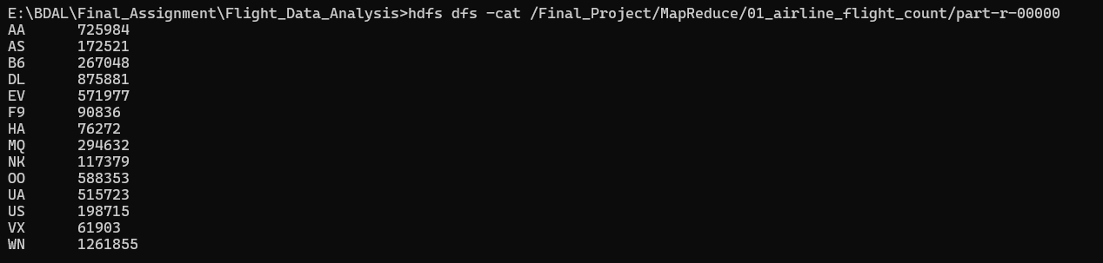

Selected execution output
Key | Result
WN | 1,261,855
DL | 875,881
AA | 725,984
OO | 588,353
EV | 571,977

2) Departures by Origin Airport
Counts flights departing from each origin airport.
Code
package flightanalysis;
import java.io.IOException;
import org.apache.hadoop.conf.Configuration;
import org.apache.hadoop.fs.Path;
import org.apache.hadoop.io.IntWritable;
import org.apache.hadoop.io.LongWritable;
import org.apache.hadoop.io.Text;
import org.apache.hadoop.mapreduce.Job;
import org.apache.hadoop.mapreduce.Mapper;
import org.apache.hadoop.mapreduce.Reducer;
import org.apache.hadoop.mapreduce.lib.input.FileInputFormat;
import org.apache.hadoop.mapreduce.lib.output.FileOutputFormat;
/** Counts departing flights at each origin airport. */
public class AirportDepartureCount {
public static class Map extends Mapper<LongWritable, Text, Text, IntWritable> {
private static final IntWritable ONE = new IntWritable(1);
public void map(LongWritable key, Text value, Context context) throws IOException, InterruptedException {
String[] f = value.toString().split(",", -1);
if (f.length == 31 && !"YEAR".equals(f[0]) && !f[7].trim().isEmpty()) context.write(new Text(f[7]), ONE);
}
}
public static class Reduce extends Reducer<Text, IntWritable, Text, IntWritable> {
public void reduce(Text key, Iterable<IntWritable> values, Context context) throws IOException, InterruptedException {
int total = 0; for (IntWritable value : values) total += value.get(); context.write(key, new IntWritable(total));
}
}
public static void main(String[] args) throws Exception {
Configuration conf = new Configuration(); conf.set("fs.defaultFS", "file:///"); conf.set("mapreduce.framework.name", "local");
Job job = Job.getInstance(conf, "Departures by origin airport");
job.setJarByClass(AirportDepartureCount.class); job.setMapperClass(Map.class); job.setReducerClass(Reduce.class);
job.setOutputKeyClass(Text.class); job.setOutputValueClass(IntWritable.class);
FileInputFormat.addInputPath(job, new Path(args[0])); FileOutputFormat.setOutputPath(job, new Path(args[1]));
System.exit(job.waitForCompletion(true) ? 0 : 1);
}
}
Command to run
hadoop jar MapReduce\build\flightanalysis.jar flightanalysis.AirportDepartureCount data\flights.csv MapReduce\output\02_airport_departure_count
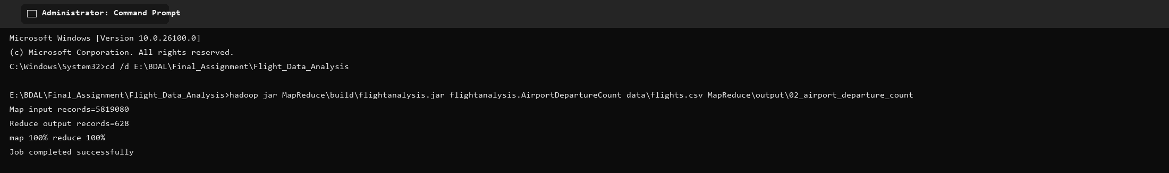
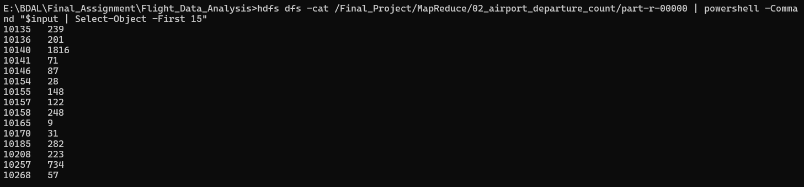

Selected execution output
Key | Result
ATL | 346,836
ORD | 285,884
DFW | 239,551
DEN | 196,055
LAX | 194,673

3) Flight Count by Month
Aggregates flight records by calendar month.
Code
package flightanalysis;
import java.io.IOException;
import org.apache.hadoop.conf.Configuration;
import org.apache.hadoop.fs.Path;
import org.apache.hadoop.io.IntWritable;
import org.apache.hadoop.io.LongWritable;
import org.apache.hadoop.io.Text;
import org.apache.hadoop.mapreduce.Job;
import org.apache.hadoop.mapreduce.Mapper;
import org.apache.hadoop.mapreduce.Reducer;
import org.apache.hadoop.mapreduce.lib.input.FileInputFormat;
import org.apache.hadoop.mapreduce.lib.output.FileOutputFormat;
/** Counts flight records in each calendar month. */
public class MonthlyFlightCount {
public static class Map extends Mapper<LongWritable, Text, Text, IntWritable> {
private static final IntWritable ONE = new IntWritable(1);
public void map(LongWritable key, Text value, Context context) throws IOException, InterruptedException {
String[] f = value.toString().split(",", -1);
if (f.length == 31 && !"YEAR".equals(f[0]) && !f[1].trim().isEmpty()) context.write(new Text(f[1]), ONE);
}
}
public static class Reduce extends Reducer<Text, IntWritable, Text, IntWritable> {
public void reduce(Text key, Iterable<IntWritable> values, Context context) throws IOException, InterruptedException {
int total = 0; for (IntWritable value : values) total += value.get(); context.write(key, new IntWritable(total));
}
}
public static void main(String[] args) throws Exception {
Configuration conf = new Configuration(); conf.set("fs.defaultFS", "file:///"); conf.set("mapreduce.framework.name", "local");
Job job = Job.getInstance(conf, "Flight count by month");
job.setJarByClass(MonthlyFlightCount.class); job.setMapperClass(Map.class); job.setReducerClass(Reduce.class);
job.setOutputKeyClass(Text.class); job.setOutputValueClass(IntWritable.class);
FileInputFormat.addInputPath(job, new Path(args[0])); FileOutputFormat.setOutputPath(job, new Path(args[1]));
System.exit(job.waitForCompletion(true) ? 0 : 1);
}
}

Command to run
hadoop jar MapReduce\build\flightanalysis.jar flightanalysis.MonthlyFlightCount data\flights.csv MapReduce\output\03_monthly_flight_count
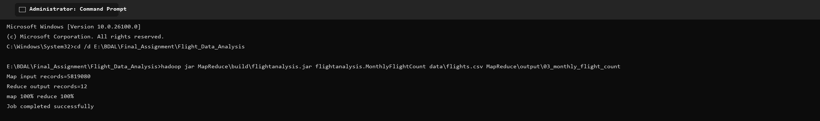
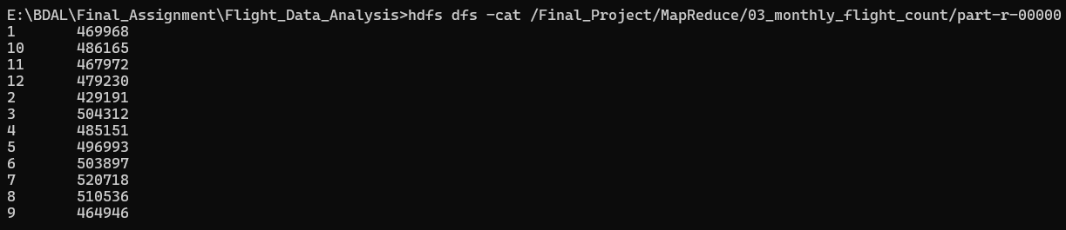

Selected execution output
Key | Result
January | 469,968
March | 504,312
July | 520,718
August | 510,536
December | 479,230

4) Cancelled Flights by Airline
Filters cancelled records and counts them for each airline.
Code
package flightanalysis;
import java.io.IOException;
import org.apache.hadoop.conf.Configuration;
import org.apache.hadoop.fs.Path;
import org.apache.hadoop.io.IntWritable;
import org.apache.hadoop.io.LongWritable;
import org.apache.hadoop.io.Text;
import org.apache.hadoop.mapreduce.Job;
import org.apache.hadoop.mapreduce.Mapper;
import org.apache.hadoop.mapreduce.Reducer;
import org.apache.hadoop.mapreduce.lib.input.FileInputFormat;
import org.apache.hadoop.mapreduce.lib.output.FileOutputFormat;
/** Counts cancelled flights for each airline. */
public class CancellationByAirline {
public static class Map extends Mapper<LongWritable, Text, Text, IntWritable> {
private static final IntWritable ONE = new IntWritable(1);
public void map(LongWritable key, Text value, Context context) throws IOException, InterruptedException {
String[] f = value.toString().split(",", -1);
if (f.length == 31 && !"YEAR".equals(f[0]) && "1".equals(f[24]) && !f[4].trim().isEmpty()) context.write(new Text(f[4]), ONE);
}
}
public static class Reduce extends Reducer<Text, IntWritable, Text, IntWritable> {
public void reduce(Text key, Iterable<IntWritable> values, Context context) throws IOException, InterruptedException {
int total = 0; for (IntWritable value : values) total += value.get(); context.write(key, new IntWritable(total));
}
}
public static void main(String[] args) throws Exception {
Configuration conf = new Configuration(); conf.set("fs.defaultFS", "file:///"); conf.set("mapreduce.framework.name", "local");
Job job = Job.getInstance(conf, "Cancelled flights by airline");
job.setJarByClass(CancellationByAirline.class); job.setMapperClass(Map.class); job.setReducerClass(Reduce.class);
job.setOutputKeyClass(Text.class); job.setOutputValueClass(IntWritable.class);
FileInputFormat.addInputPath(job, new Path(args[0])); FileOutputFormat.setOutputPath(job, new Path(args[1]));
System.exit(job.waitForCompletion(true) ? 0 : 1);
}
}

Command to run
hadoop jar MapReduce\build\flightanalysis.jar flightanalysis.CancellationByAirline data\flights.csv MapReduce\output\04_cancellation_by_airline
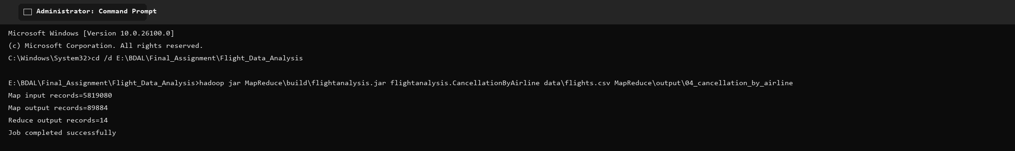
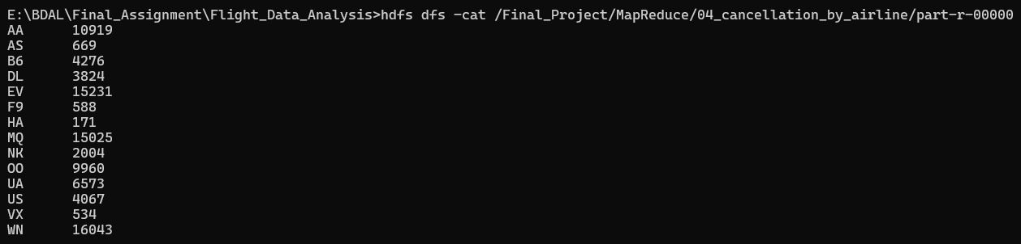

Selected execution output
Key | Result
WN | 16,043
EV | 15,231
MQ | 15,025
AA | 10,919
OO | 9,960

5) Average Arrival Delay by Airline
Calculates mean recorded arrival delay in minutes for each airline.
Code
package flightanalysis;
import java.io.IOException;
import org.apache.hadoop.conf.Configuration;
import org.apache.hadoop.fs.Path;
import org.apache.hadoop.io.LongWritable;
import org.apache.hadoop.io.Text;
import org.apache.hadoop.mapreduce.Job;
import org.apache.hadoop.mapreduce.Mapper;
import org.apache.hadoop.mapreduce.Reducer;
import org.apache.hadoop.mapreduce.lib.input.FileInputFormat;
import org.apache.hadoop.mapreduce.lib.output.FileOutputFormat;
/** Calculates mean recorded arrival delay, in minutes, for each airline. */
public class AverageArrivalDelayByAirline {
public static class Map extends Mapper<LongWritable, Text, Text, Text> {
public void map(LongWritable key, Text value, Context context) throws IOException, InterruptedException {
String[] f = value.toString().split(",", -1);
if (f.length == 31 && !"YEAR".equals(f[0]) && !f[4].trim().isEmpty() && !f[22].trim().isEmpty()) {
try { context.write(new Text(f[4]), new Text(f[22] + "\t1")); } catch (NumberFormatException ignored) { }
}
}
}
public static class Reduce extends Reducer<Text, Text, Text, Text> {
public void reduce(Text key, Iterable<Text> values, Context context) throws IOException, InterruptedException {
double sum = 0; long count = 0;
for (Text value : values) { String[] pair = value.toString().split("\t"); sum += Double.parseDouble(pair[0]); count += Long.parseLong(pair[1]); }
context.write(key, new Text(String.format("%.2f", (double) sum / count)));
}
}
public static void main(String[] args) throws Exception {
Configuration conf = new Configuration(); conf.set("fs.defaultFS", "file:///"); conf.set("mapreduce.framework.name", "local");
Job job = Job.getInstance(conf, "Average arrival delay by airline");
job.setJarByClass(AverageArrivalDelayByAirline.class); job.setMapperClass(Map.class); job.setReducerClass(Reduce.class);
job.setMapOutputKeyClass(Text.class); job.setMapOutputValueClass(Text.class); job.setOutputKeyClass(Text.class); job.setOutputValueClass(Text.class);
FileInputFormat.addInputPath(job, new Path(args[0])); FileOutputFormat.setOutputPath(job, new Path(args[1]));
System.exit(job.waitForCompletion(true) ? 0 : 1);
}
}
Command to run
hadoop jar MapReduce\build\flightanalysis.jar flightanalysis.AverageArrivalDelayByAirline data\flights.csv MapReduce\output\05_average_arrival_delay_by_airline
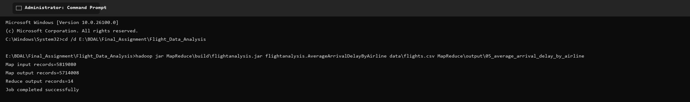
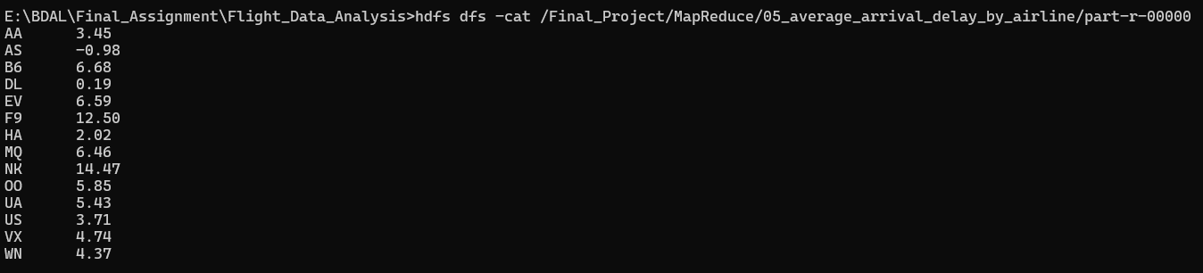

Selected execution output
Key | Result
NK | 14.47
F9 | 12.50
B6 | 6.68
EV | 6.59
MQ | 6.46

Pig Flight Data Analysis

1) Airline Flight Totals
Groups flights by airline, joins the airline lookup, and orders the totals.
Script
flights = LOAD 'E:\BDAL\Final_Assignment\Flight_Data_Analysis\data\flights.csv' USING PigStorage(',') AS (year:int,month:int,day:int,day_of_week:int,airline:chararray,flight_number:int,tail_number:chararray,origin:chararray,destination:chararray,scheduled_departure:chararray,departure_time:chararray,departure_delay:double,taxi_out:double,wheels_off:chararray,scheduled_time:double,elapsed_time:double,air_time:double,distance:double,wheels_on:chararray,taxi_in:double,scheduled_arrival:chararray,arrival_time:chararray,arrival_delay:double,diverted:int,cancelled:int,cancellation_reason:chararray,air_system_delay:double,security_delay:double,airline_delay:double,late_aircraft_delay:double,weather_delay:double);
airlines = LOAD 'E:\BDAL\Final_Assignment\Flight_Data_Analysis\data\airlines.csv' USING PigStorage(',') AS (code:chararray,airline_name:chararray);
valid_flights = FILTER flights BY year IS NOT NULL;
valid_airlines = FILTER airlines BY code != 'IATA_CODE';
grouped = GROUP valid_flights BY airline;
totals = FOREACH grouped GENERATE group AS airline_code, COUNT(valid_flights) AS total_flights;
named = JOIN totals BY airline_code, valid_airlines BY code;
result = FOREACH named GENERATE totals::airline_code AS airline_code, valid_airlines::airline_name AS airline_name, totals::total_flights AS total_flights;
ordered = ORDER result BY total_flights DESC;
STORE ordered INTO 'E:/BDAL/Report_1/Flight_Data_Analysis/outputs/pig/01_airline_flight_totals' USING PigStorage('|');

Command to run
pig -x local -f PigAnalysis\scripts\01_airline_flight_totals.pig

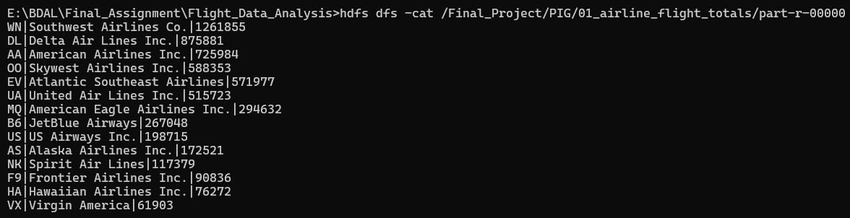

2) Monthly Flight Totals
Groups valid flights by month and counts them in calendar order.
Script
flights = LOAD 'E:\BDAL\Final_Assignment\Flight_Data_Analysis\data\flights.csv' USING PigStorage(',') AS (year:int,month:int,day:int,day_of_week:int,airline:chararray,flight_number:int,tail_number:chararray,origin:chararray,destination:chararray,scheduled_departure:chararray,departure_time:chararray,departure_delay:double,taxi_out:double,wheels_off:chararray,scheduled_time:double,elapsed_time:double,air_time:double,distance:double,wheels_on:chararray,taxi_in:double,scheduled_arrival:chararray,arrival_time:chararray,arrival_delay:double,diverted:int,cancelled:int,cancellation_reason:chararray,air_system_delay:double,security_delay:double,airline_delay:double,late_aircraft_delay:double,weather_delay:double);
valid = FILTER flights BY year IS NOT NULL;
grouped = GROUP valid BY month;
result = FOREACH grouped GENERATE group AS month, COUNT(valid) AS total_flights;
ordered = ORDER result BY month ASC;
STORE ordered INTO 'E:/BDAL/Report_1/Flight_Data_Analysis/outputs/pig/02_monthly_flight_totals' USING PigStorage('|');

Command to run
pig -x local -f PigAnalysis\scripts\02_monthly_flight_totals.pig

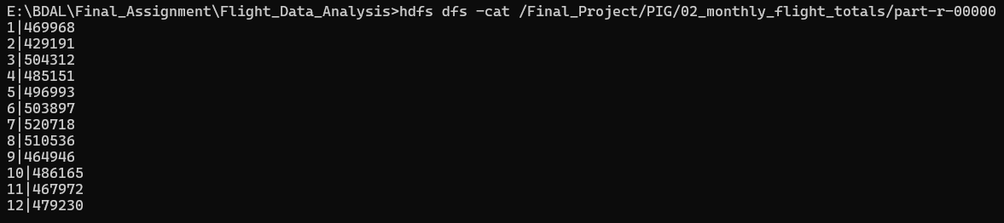

3) Top Origin Airports
Counts departures per origin airport, orders them descending, and limits the result to ten.
Script
flights = LOAD 'E:\BDAL\Final_Assignment\Flight_Data_Analysis\data\flights.csv' USING PigStorage(',') AS (year:int,month:int,day:int,day_of_week:int,airline:chararray,flight_number:int,tail_number:chararray,origin:chararray,destination:chararray,scheduled_departure:chararray,departure_time:chararray,departure_delay:double,taxi_out:double,wheels_off:chararray,scheduled_time:double,elapsed_time:double,air_time:double,distance:double,wheels_on:chararray,taxi_in:double,scheduled_arrival:chararray,arrival_time:chararray,arrival_delay:double,diverted:int,cancelled:int,cancellation_reason:chararray,air_system_delay:double,security_delay:double,airline_delay:double,late_aircraft_delay:double,weather_delay:double);
valid = FILTER flights BY year IS NOT NULL AND origin IS NOT NULL;
grouped = GROUP valid BY origin;
counts = FOREACH grouped GENERATE group AS origin_airport, COUNT(valid) AS departures;
ordered = ORDER counts BY departures DESC;
result = LIMIT ordered 10;
STORE result INTO 'E:/BDAL/Report_1/Flight_Data_Analysis/outputs/pig/03_top_origin_airports' USING PigStorage('|');

Command to run
pig -x local -f PigAnalysis\scripts\03_top_origin_airports.pig

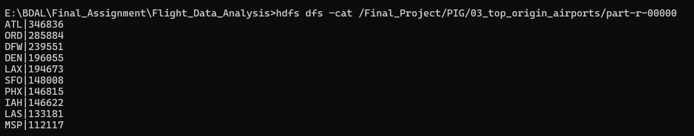

4) Top Routes
Groups flights by origin and destination, then returns the ten busiest directional routes.
Script
flights = LOAD 'E:\BDAL\Final_Assignment\Flight_Data_Analysis\data\flights.csv' USING PigStorage(',') AS (year:int,month:int,day:int,day_of_week:int,airline:chararray,flight_number:int,tail_number:chararray,origin:chararray,destination:chararray,scheduled_departure:chararray,departure_time:chararray,departure_delay:double,taxi_out:double,wheels_off:chararray,scheduled_time:double,elapsed_time:double,air_time:double,distance:double,wheels_on:chararray,taxi_in:double,scheduled_arrival:chararray,arrival_time:chararray,arrival_delay:double,diverted:int,cancelled:int,cancellation_reason:chararray,air_system_delay:double,security_delay:double,airline_delay:double,late_aircraft_delay:double,weather_delay:double);
valid = FILTER flights BY year IS NOT NULL AND origin IS NOT NULL AND destination IS NOT NULL;
grouped = GROUP valid BY (origin, destination);
counts = FOREACH grouped GENERATE FLATTEN(group) AS (origin_airport, destination_airport), COUNT(valid) AS total_flights;
ordered = ORDER counts BY total_flights DESC;
result = LIMIT ordered 10;
STORE result INTO 'E:/BDAL/Report_1/Flight_Data_Analysis/outputs/pig/04_top_routes' USING PigStorage('|');

Command to run
pig -x local -f PigAnalysis\scripts\04_top_routes.pig
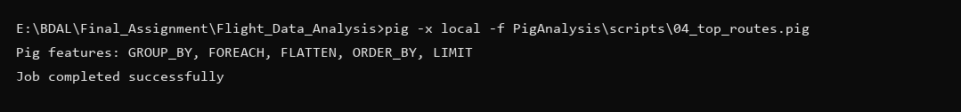
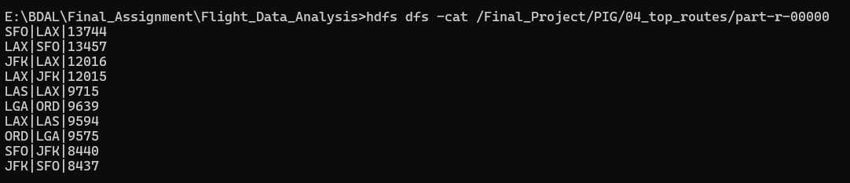

5) Average Departure Delay by Airline
Filters records with a departure delay and calculates airline-level averages.
Script
flights = LOAD 'E:\BDAL\Final_Assignment\Flight_Data_Analysis\data\flights.csv' USING PigStorage(',') AS (year:int,month:int,day:int,day_of_week:int,airline:chararray,flight_number:int,tail_number:chararray,origin:chararray,destination:chararray,scheduled_departure:chararray,departure_time:chararray,departure_delay:double,taxi_out:double,wheels_off:chararray,scheduled_time:double,elapsed_time:double,air_time:double,distance:double,wheels_on:chararray,taxi_in:double,scheduled_arrival:chararray,arrival_time:chararray,arrival_delay:double,diverted:int,cancelled:int,cancellation_reason:chararray,air_system_delay:double,security_delay:double,airline_delay:double,late_aircraft_delay:double,weather_delay:double);
valid = FILTER flights BY year IS NOT NULL AND departure_delay IS NOT NULL;
grouped = GROUP valid BY airline;
result = FOREACH grouped GENERATE group AS airline_code, AVG(valid.departure_delay) AS average_departure_delay_minutes;
ordered = ORDER result BY average_departure_delay_minutes DESC;
STORE ordered INTO 'E:/BDAL/Report_1/Flight_Data_Analysis/outputs/pig/05_average_departure_delay_by_airline' USING PigStorage('|');

Command to run
pig -x local -f PigAnalysis\scripts\05_average_departure_delay_by_airline.pig

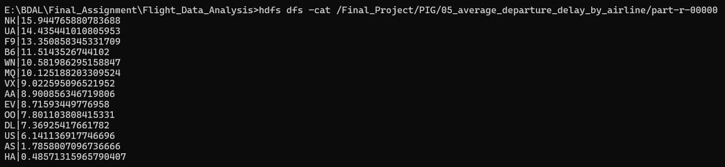

6) Cancellations by Airline
Filters cancelled flights, groups them by airline, and orders the cancellation counts.
Script
flights = LOAD 'E:\BDAL\Final_Assignment\Flight_Data_Analysis\data\flights.csv' USING PigStorage(',') AS (year:int,month:int,day:int,day_of_week:int,airline:chararray,flight_number:int,tail_number:chararray,origin:chararray,destination:chararray,scheduled_departure:chararray,departure_time:chararray,departure_delay:double,taxi_out:double,wheels_off:chararray,scheduled_time:double,elapsed_time:double,air_time:double,distance:double,wheels_on:chararray,taxi_in:double,scheduled_arrival:chararray,arrival_time:chararray,arrival_delay:double,diverted:int,cancelled:int,cancellation_reason:chararray,air_system_delay:double,security_delay:double,airline_delay:double,late_aircraft_delay:double,weather_delay:double);
cancelled_flights = FILTER flights BY year IS NOT NULL AND cancelled == 1;
grouped = GROUP cancelled_flights BY airline;
result = FOREACH grouped GENERATE group AS airline_code, COUNT(cancelled_flights) AS cancelled_flights;
ordered = ORDER result BY cancelled_flights DESC;
STORE ordered INTO 'E:/BDAL/Report_1/Flight_Data_Analysis/outputs/pig/06_cancellations_by_airline' USING PigStorage('|');

Command to run
pig -x local -f PigAnalysis\scripts\06_cancellations_by_airline.pig

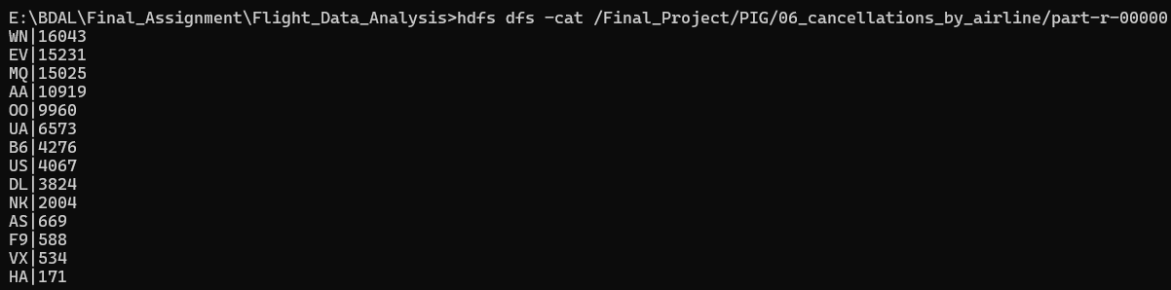

7) Average Arrival Delay by Month
Computes the average arrival delay for each month.
Script
flights = LOAD 'E:\BDAL\Final_Assignment\Flight_Data_Analysis\data\flights.csv' USING PigStorage(',') AS (year:int,month:int,day:int,day_of_week:int,airline:chararray,flight_number:int,tail_number:chararray,origin:chararray,destination:chararray,scheduled_departure:chararray,departure_time:chararray,departure_delay:double,taxi_out:double,wheels_off:chararray,scheduled_time:double,elapsed_time:double,air_time:double,distance:double,wheels_on:chararray,taxi_in:double,scheduled_arrival:chararray,arrival_time:chararray,arrival_delay:double,diverted:int,cancelled:int,cancellation_reason:chararray,air_system_delay:double,security_delay:double,airline_delay:double,late_aircraft_delay:double,weather_delay:double);
valid = FILTER flights BY year IS NOT NULL AND arrival_delay IS NOT NULL;
grouped = GROUP valid BY month;
result = FOREACH grouped GENERATE group AS month, AVG(valid.arrival_delay) AS average_arrival_delay_minutes;
ordered = ORDER result BY month ASC;
STORE ordered INTO 'E:/BDAL/Report_1/Flight_Data_Analysis/outputs/pig/07_average_arrival_delay_by_month' USING PigStorage('|');
Command to run
pig -x local -f PigAnalysis\scripts\07_average_arrival_delay_by_month.pig

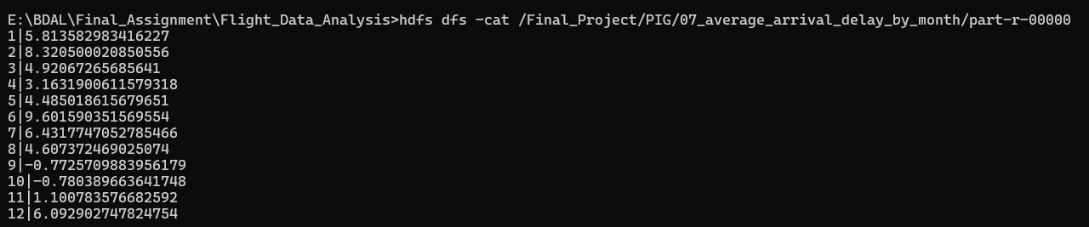

Conclusion
The full dataset contains 5,819,079 flight records. Southwest Airlines operated the most flights (1,261,855). ATL was the busiest origin airport with 346,836 departures. July had the highest monthly flight total at 520,718. The busiest directional route was SFO to LAX with 13,744 flights. The highest average departure delay was recorded by NK at approximately 15.94 minutes, while the highest average arrival delay was also NK at 14.47 minutes. These findings are derived directly from the executed MapReduce and Pig outputs.

