

**Jashore University of Science & Technology**

**Computer Science & Engineering**

**Course Code:** CSE-3202

**A Documentation on**

Design a VLAN with 3 switch and one Router

|  |  |
| --- | --- |
| **Submitted To** | **Submitted By** |
| **Mustain Billah**  **Lecturer**  **Dept.Computer Science & Engineering**  **Jashore University of Science & Technology** | **Md. Monirul Islam**  **3rd year,2nd semester**  **Roll: 180126**  **Session: 2018-19**  **Dept.Computer Science & Engineering**  **Jashore University of Science & Technology** |

**Submission Date:** 17.09.2022

**Experiment no:** 2

**Experiment name:** Design a VLAN with 3 switch and one Route

**Setup process:**

At first open packet tracer and make such diagram.

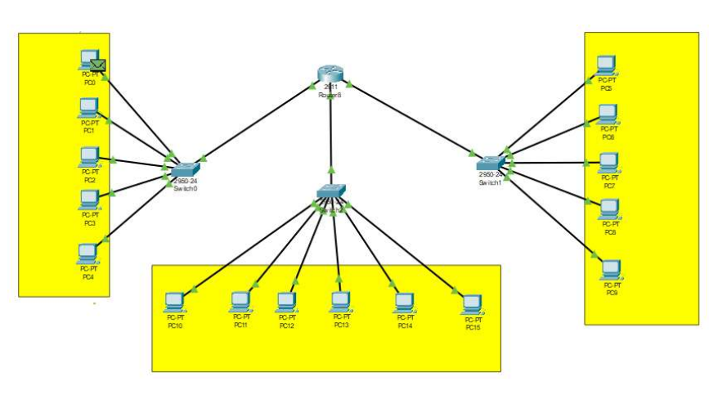

Here we use total **16 PCs (PC0 – PC15)**, **3 switches (2950-24), and one router (2911).**

Now let’s do sub netting of given IP address 160.40.10.1 we have 3 group and they have 5,

6 and 5 user.

Now assign IP for each group of PCs.

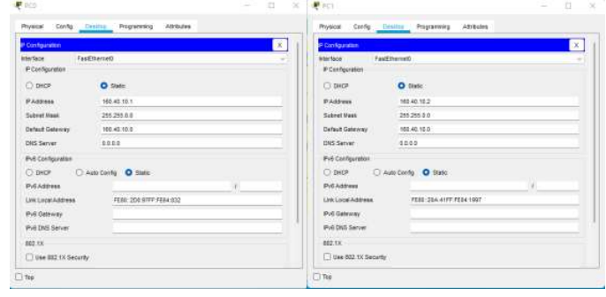

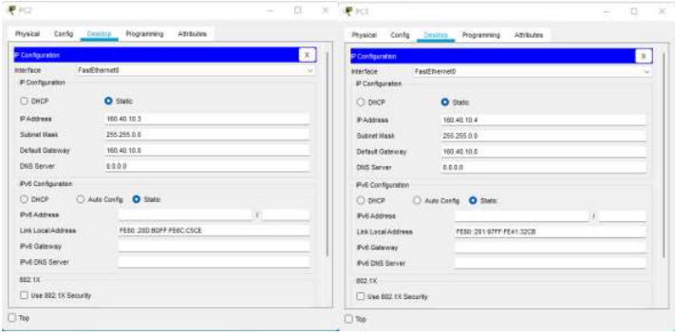

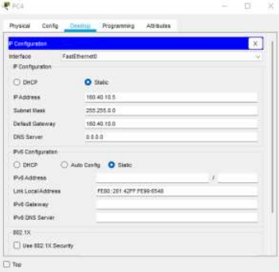

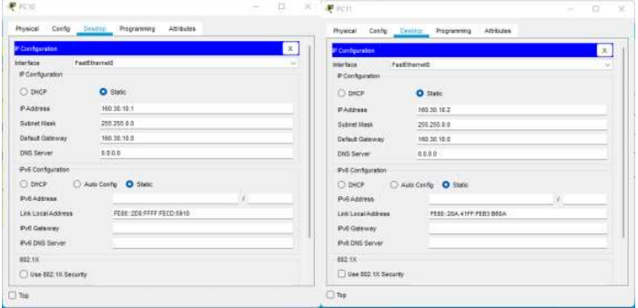

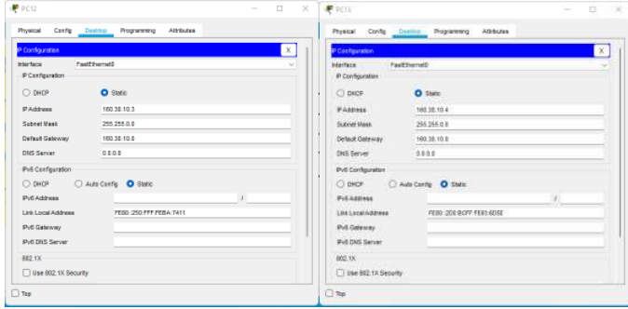

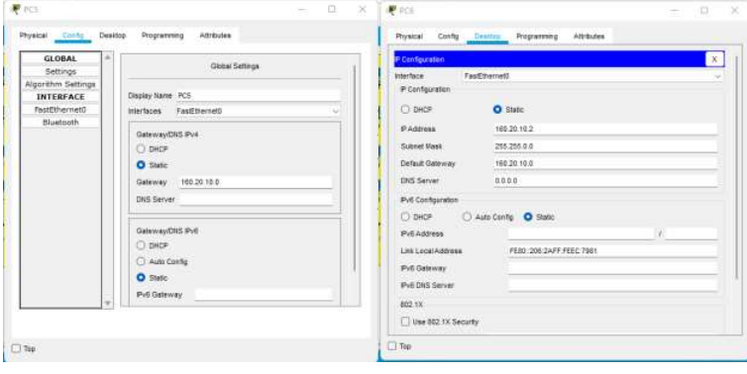

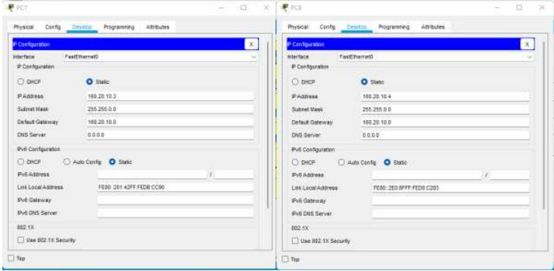

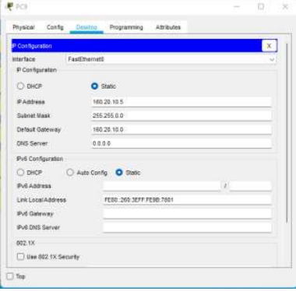

Now configure the router for this 3 groups.

Router>enable

Router#config

Router(config)#interface (port)

Router(config-if)#ip address (ip address)

Router(config-if)#no shutdown

Router(config-if)#

Thus the diagram should establish connection.

Lets ping between each group

**Ping PC1 with PC10**

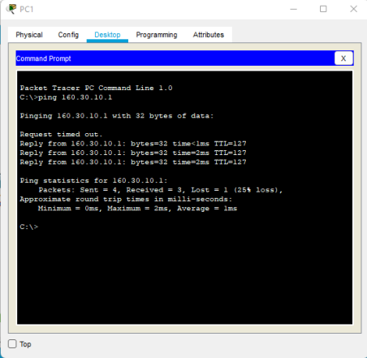

**Ping PC6 with PC14**

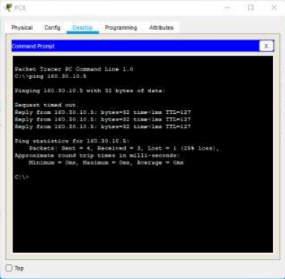

**Ping PC7 with PC3**

