
3D MODEL DIGITAL SIGNATURE SYSTEM
USING STEGANOGRAPHIC AUTHENTICATION

By
Mohammed Mudassir (247015)
Under the guidance of
Dr. J Sandeep
A project report submitted in partial fulfillment of the requirements of III Semester Master of Science in Computer Science & Applications of CHRIST (Deemed to be University)
OCTOBER - 2025



CERTIFICATE
This is to certify that the report titled 3D Model Digital Signature System Using Steganographic Authentication is a bona fide record of work done by Mohammed Mudassir (2447015) of CHRIST (Deemed to be University), Bangalore, in partial fulfillment of the requirements of III Semester Master of Science in Computer Science & Applications, during the year 2025.
Head of the Department Project Guide

Valued by:
1 |  |  |  | Name: | Mohammed Mudassir
 |  |  |  | Register Number: | 2447015
 |  |  |  | Examination-Centre: | CHRIST (Deemed to be University)
2 |  |  |  | Date of Exam: | 04-Oct-25

ACKNOWLEDGEMENTS

Charles Schwab once quoted, “The way to develop the best that is in a person is by appreciation and encouragement.” With that said, we take this opportunity to thank everyone who supported us through the process of completing the project ‘3D Model Digital Signature System Using Steganographic Authentication’.
First and foremost, we thank God almighty for enabling us to complete this project by gracing us with his blessing. We wish to express our profound gratitude to Dr. Fr. Paul Achandy- Chancellor and Dr Fr Joseph C C Vice-Chancellor, CHRIST (Deemed to be University) for giving us this wonderful occasion to showcase our skills and actualize the knowledge we gained.
We humbly extend our gratitude to Dr. Rupali Wagh, Head of the Department of Computer Science, for allowing us to put our new-found knowledge to good use. We convey our sincere thanks to our guide Dr. J Sandeep for his exemplary guidance, mentoring, and constant encouragement throughout the project. The help and guidance given by them from time to time shall carry us a long way in the journey of life on which we are about to embark. Our deep regards to our parents who have been supporting us personally. Last but not the least, we thank all the teaching and non-teaching staff who are involved in making this project a success.

ABSTRACT

The proliferation of 3D digital content in industries such as gaming, animation, architecture, and manufacturing has created an urgent need for robust intellectual property protection mechanisms. This project presents a comprehensive 3D Model Digital Signature System that employs advanced steganographic techniques to embed tamper-resistant digital signatures directly into 3D model geometry.
The proposed solution utilizes RSA cryptography combined with vertex-level steganography to create imperceptible modifications in 3D model coordinates, effectively hiding authentication data within the geometric structure. The system supports multiple artist profiles, each with unique cryptographic identities stored securely in a SQLite database. Key features include prevention of signature tampering through re-signing protection, comprehensive artist attribution with embedded metadata, and a user-friendly Streamlit-based interface.
The implementation demonstrates successful embedding and extraction of 256-byte RSA signatures across model vertices using least significant bit manipulation. Experimental results show that the steganographic approach preserves model quality with negligible visual impact while providing strong authentication guarantees. The system successfully prevents common attack vectors including signature transplantation, metadata stripping, and unauthorized re-signing.

TABLE OF CONTENTS

ACKNOWLEDGEMENTS iii
ABSTRACT iv
LIST OF FIGURES v
LIST OF ABBREVIATIONS vi
1. INTRODUCTION 9
1.1 Background 9
1.2 Problem Statement 10
1.3 Objectives 11
1.4 Scope and Limitations 12
2. SYSTEM REQUIREMENTS 13
2.1 Hardware Requirements 13
2.2 Software Requirements 14
2.2.1 Programming Language and Framework 14
2.2.2 Libraries and Dependencies 14
2.2.3 Database System 14
3. DESIGN SPECIFICATION 15
3.1 System Architecture 14
3.2 Database Design 18

3.3 Cryptographic Design 18
3.4 Steganographic Algorithm 20
3.5 User Interface Design 21
4. IMPLEMENTATION DETAILS 24
4.1 Artist Management Module 24
4.2 Digital Signature Module 25
4.3 Steganographic Embedding Module 26
4.4 Verification Module 27
4.5 3D Model Viewer Module 28
5. RESULTS AND DISCUSSION 30
5.1 Functional Testing 32
5.2 Security Analysis 33
5.3 Performance Evaluation 34
5.4 Size Evaluation 35
6. CONCLUSION 36
REFERENCES 38
APPENDIX A: USER MANUAL 39

LIST OF FIGURES

Fig. No. | Figure Name | Page No:
3.1 | System Architecture Diagram | 14
3.2 | Database Schema | 18
3.3 | Steganographic Embedding Process | 20
3.5.1 | Artist Management Tab | 21
3.5.2 | Sign File Tab | 22
3.5.3 | Verify File Tab | 23
4.2.1 | Digital Signature Process | 25
4.5.1 | Model Viewer | 28
5.1 | Signing Process | 30
5.2 | Verification Process | 31

LIST OF ABBREVIATIONS

3D Three-Dimensional
API Application Programming Interface
DRM Digital Rights Management
LSB Least Significant Bit
OBJ Object File Format
PEM Privacy Enhanced Mail
RSA Rivest-Shamir-Adleman
SHA Secure Hash Algorithm
SQL Structured Query Language
UI User Interface

1. INTRODUCTION

The digital revolution has transformed the way creative content is produced, distributed, and consumed. Among various forms of digital media, three-dimensional (3D) models have emerged as critical assets in numerous industries including gaming, animation, architecture, product design, and virtual reality. These digital assets represent significant investments of time, skill, and creativity, making their protection a paramount concern for content creators and organizations alike.
The ease of digital reproduction and distribution, while beneficial for collaboration and accessibility, has simultaneously created unprecedented challenges in intellectual property protection. Unlike physical artifacts, digital 3D models can be copied, modified, and redistributed with perfect fidelity and minimal effort. This characteristic has led to widespread piracy, unauthorized modifications, and attribution disputes.
This project addresses these limitations by implementing a novel approach that combines cryptographic digital signatures with steganographic techniques. By embedding authentication data directly into the geometric structure of 3D models, the system creates an inseparable bond between the content and its authenticity credentials.

1.1 BACKGROUND
Digital steganography, the art and science of hiding information within other information, has been extensively studied in the context of images, audio, and video files. However, its application to 3D geometric data remains a relatively underexplored domain.
RSA (Rivest-Shamir-Adleman) cryptography provides the foundation for secure digital signatures. The asymmetric nature of RSA allows for the creation of signatures that can be verified by anyone possessing the public key, while only the holder of the private key can generate valid signatures.
The OBJ file format has become one of the most widely supported 3D model formats due to its simplicity and human-readable structure. This structure provides an ideal medium for steganographic embedding, as vertex coordinates can be slightly modified without significantly affecting the visual appearance of the model.

1.2 PROBLEM STATEMENT
The current landscape of 3D content distribution faces several critical challenges:
1. Piracy and Unauthorized Distribution: 3D models are frequently copied and distributed without authorization, leading to significant revenue losses for creators and studios.
2. Attribution Loss: When 3D models are shared across platforms, original authorship information is often lost or deliberately removed.
3. Tampering Detection: Modified versions of 3D models circulate widely, but there is no reliable method to detect whether a model has been altered from its original form.
4. Verification Complexity: Current authentication methods often require external databases or online verification services that are impractical for individual artists.
5. Format Limitations: Many existing protection schemes are format-specific or require proprietary software.
These challenges necessitate a solution that can embed authentication data directly into 3D models in a way that is robust against common attacks, preserves visual quality, and remains accessible without requiring complex infrastructure.

1.3 OBJECTIVES

The primary objectives of this project are:
1. To develop a robust digital signature system specifically designed for 3D model authentication using RSA cryptography.
2. To implement steganographic techniques that embed authentication data within 3D model geometry without perceptible visual degradation.
3. To create a comprehensive artist management system that supports multiple creator profiles with unique cryptographic identities.
4. To design and implement tamper detection mechanisms that prevent unauthorized signature removal or modification.
5. To develop an intuitive user interface that makes the signing and verification process accessible to users without cryptographic expertise.
6. To ensure the system's compatibility with industry-standard 3D file formats, beginning with the widely-supported OBJ format.
7. To validate the system's effectiveness through comprehensive testing of security properties, performance characteristics, and visual quality preservation.

1.4 SCOPE AND LIMITATIONS

Scope: The project encompasses implementation of RSA-based digital signature generation and verification, development of vertex-level steganographic embedding algorithms, creation of a database-backed artist registry system, design of a web-based user interface using Streamlit, integration of Three.js for 3D visualization, and comprehensive security and performance testing.

Limitations:
1. File Format Support: The current implementation supports only OBJ format.
2. Vertex Density Requirements: Models must have sufficient vertex count (minimum 20 vertices) to accommodate signature embedding.
3. Local Storage: Artist profiles and cryptographic keys are stored in a local SQLite database.
4. Single Signature: Each model can contain only one signature.
5. Network Independence: The system operates entirely offline and does not provide blockchain-based verification mechanisms.

2. SYSTEM REQUIREMENTS

This chapter outlines the hardware and software requirements necessary for the development, deployment, and operation of the 3D Model Digital Signature System.

2.1 HARDWARE REQUIREMENTS
The system has been designed to operate efficiently on modern computing hardware with the following minimum specifications:
- Processor: Intel Core i3 or equivalent
- RAM: 4 GB minimum, 8 GB recommended
- Storage: 500 MB available space
- Display: 1280x720 resolution minimum
- Network: Not required (offline capable)

2.2 SOFTWARE REQUIREMENTS
The system is built using Python and leverages several open-source libraries and frameworks.

2.2.1 PROGRAMMING LANGUAGE AND FRAMEWORK

Python 3.8 or Higher: The entire system is implemented in Python, chosen for its extensive library ecosystem, readability, and cross-platform compatibility.
Streamlit Framework: Streamlit provides the web-based user interface, enabling rapid development of interactive applications with minimal frontend code.
2.2.2 LIBRARIES AND DEPENDENCIES
The following Python libraries are essential for system operation:
- cryptography (>=3.4.8): RSA key generation, digital signatures, and cryptographic operations
- streamlit (>=1.0.0): Web application framework and user interface
- sqlite3 (built-in): Database management for artist profiles

2.2.3 DATABASE SYSTEM

SQLite 3: The system uses SQLite as its embedded database engine for storing artist profiles and cryptographic keys. SQLite was chosen for its zero-configuration deployment, cross-platform compatibility, ACID compliance, and lightweight footprint suitable for desktop applications.

3. DESIGN SPECIFICATION

This chapter presents the detailed design of the 3D Model Digital Signature System, covering the system architecture, database schema, cryptographic protocols, steganographic algorithms, and user interface design.

3.1 SYSTEM ARCHITECTURE
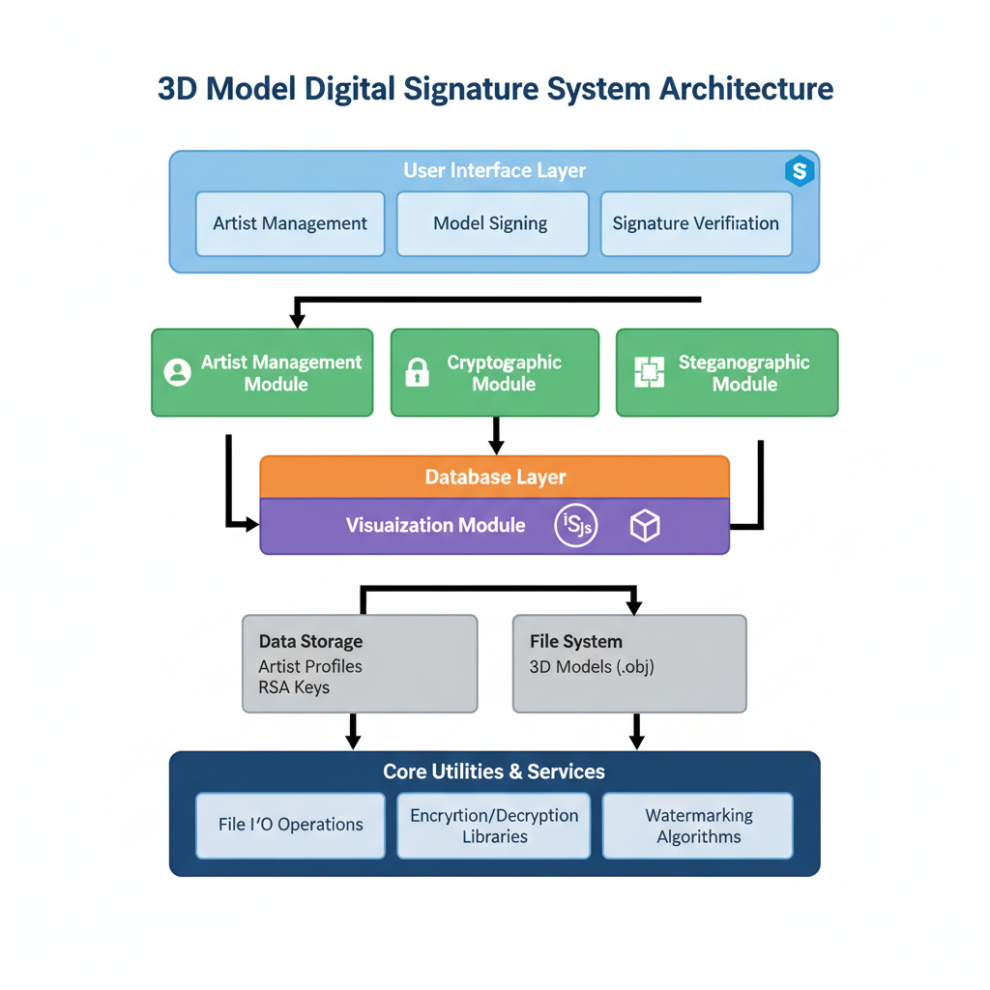
Fig 3.1 System Architecture Diagram
The system follows a modular architecture with clear separation of concerns. The architecture consists of five primary modules:
1. User Interface Layer: Implemented using Streamlit, providing Artist Management, Model Signing, and Signature Verification interfaces.
2. Artist Management Module: Handles creation, storage, and retrieval of artist profiles.
3. Cryptographic Module: Responsible for RSA key pair generation, digital signature creation, and signature verification.
4. Steganographic Module: Implements algorithms for embedding and extracting signature data within 3D model geometry.
5. Database Layer: Provides persistent storage for artist profiles using SQLite.
6. Visualization Module: Integrates Three.js for interactive 3D model preview capabilities.
3.2 DATABASE DESIGN

The database schema efficiently stores artist profiles and their associated cryptographic keys. The artists table includes the following fields:
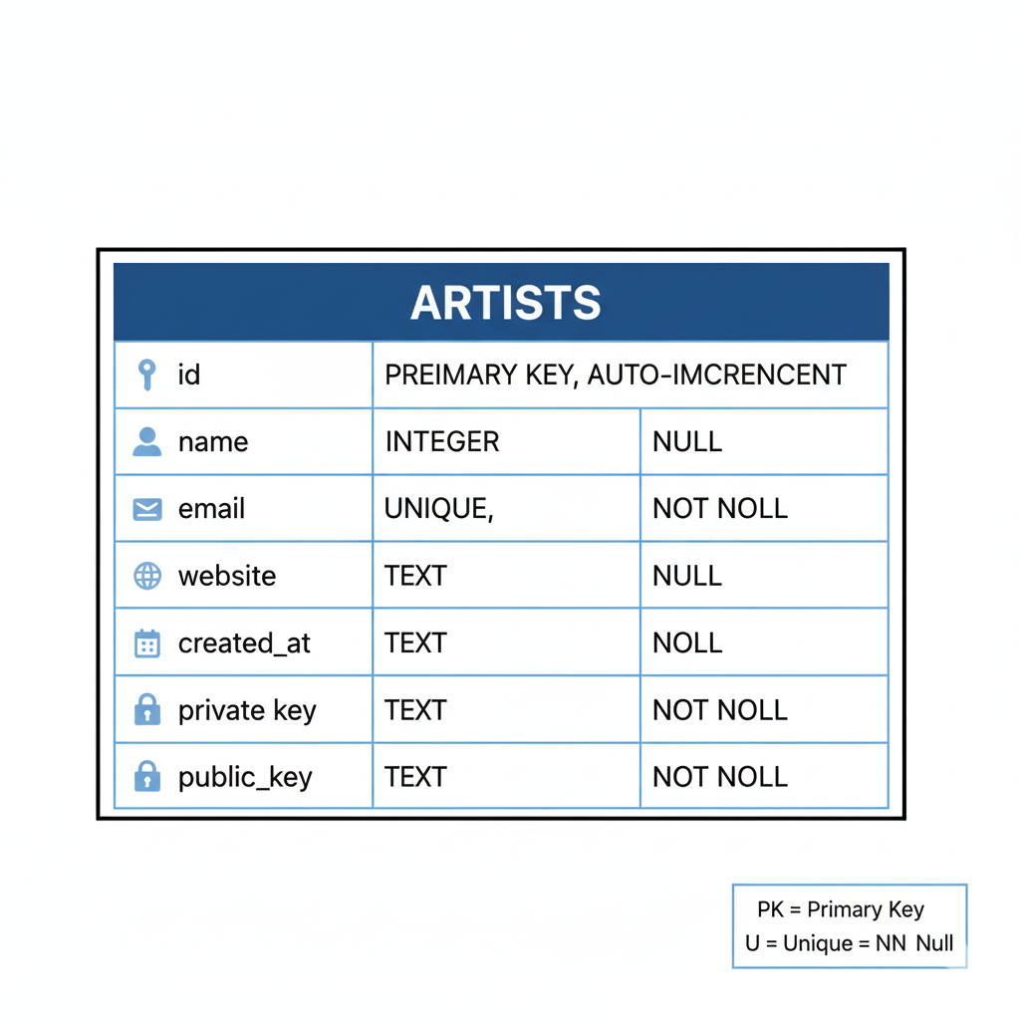
Fig 3.2 Database Schema
The UNIQUE constraint on the name field prevents duplicate artist profiles, while NOT NULL constraints ensure data integrity.

3.3 CRYPTOGRAPHIC DESIGN

The cryptographic design employs RSA public-key cryptography for digital signature generation and verification. The system generates 2048-bit RSA key pairs for each artist profile.
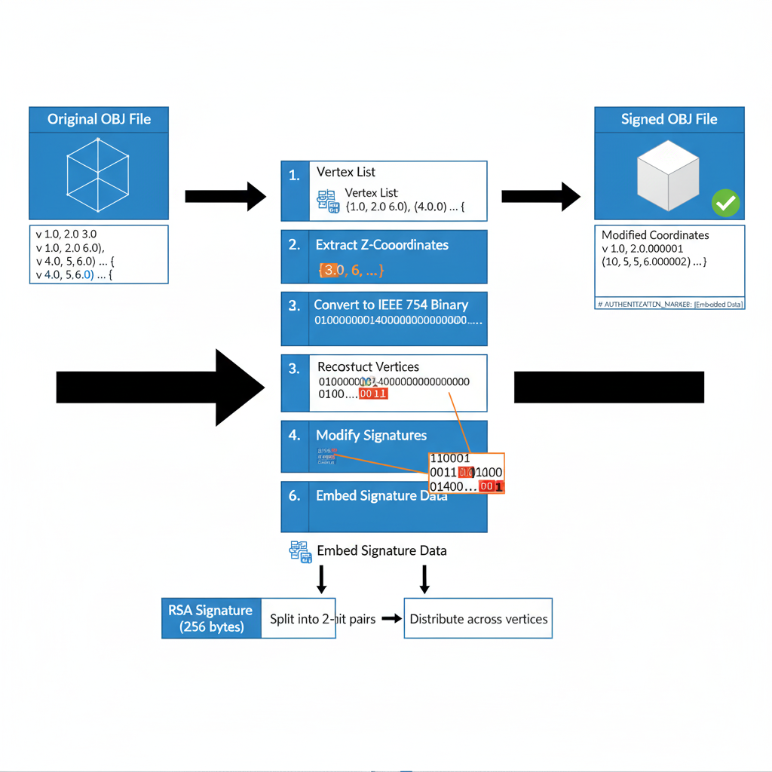
Fig 3.3 Steganographic Embedding Process
Key Generation Process:
1. Generate a random 2048-bit RSA private key using a cryptographically secure random number generator
2. Derive the corresponding public key from the private key
3. Encode both keys in PEM format for storage
4. Store the key pair in the database
Signature Generation:
Digital signatures are created using the RSA-PSS (Probabilistic Signature Scheme) padding scheme with SHA-256 hashing. The process computes SHA-256 hash of the model's vertex data, applies RSA-PSS padding, encrypts using the artist's private key, and encodes the result in hexadecimal format.
Signature Verification:
Verification extracts the embedded signature, computes SHA-256 hash of current model data, decrypts the signature using the artist's public key, and compares the decrypted hash with the computed hash.

3.4 STEGANOGRAPHIC ALGORITHM
The steganographic algorithm embeds signature data within the 3D model's vertex coordinates using least significant bit (LSB) manipulation.
Embedding Algorithm:
1. Parse the OBJ file to identify all vertex definitions
2. Verify sufficient vertex count (minimum 1024 vertices for 256-byte signature)
3. Convert the hexadecimal signature to binary representation
4. For each byte of the signature, split into four 2-bit pairs and embed in consecutive vertices
5. Modify the z-coordinate by replacing the two least significant bits
6. Add authentication marker comment to the file header
7. Encode artist metadata in Base64 and embed in the marker

Extraction Algorithm:
1. Parse the OBJ file and locate the authentication marker
2. Extract and decode artist metadata
3. Identify all vertex definitions
4. For each group of four vertices, extract the two least significant bits from z-coordinates
5. Combine four 2-bit pairs to reconstruct one byte
6. Continue until 256 bytes are extracted
The use of 2-bit encoding per vertex provides a balance between embedding capacity and visual imperceptibility.

3.5 USER INTERFACE DESIGN
The user interface is designed following principles of simplicity, clarity, and task-oriented workflow. The interface is organized into three primary tabs:
Artist Management Tab: Provides a two-column layout with artist creation form (left) and artist selection interface (right). The interface prevents duplicate artist names through validation and provides immediate feedback.

Fig 3.5.1 Artist Management Tab
Sign File Tab: Follows a linear workflow: display current artist information, file upload component, interactive 3D preview, Sign and Download button, and signature display. The 3D preview uses Three.js with a black background and white model rendering.

Fig 3.5.2 Sign File Tab

Verify File Tab: Mirrors the signing workflow with file upload, 3D preview, Verify Signature button, and results display showing extracted signature, artist information, and verification status.
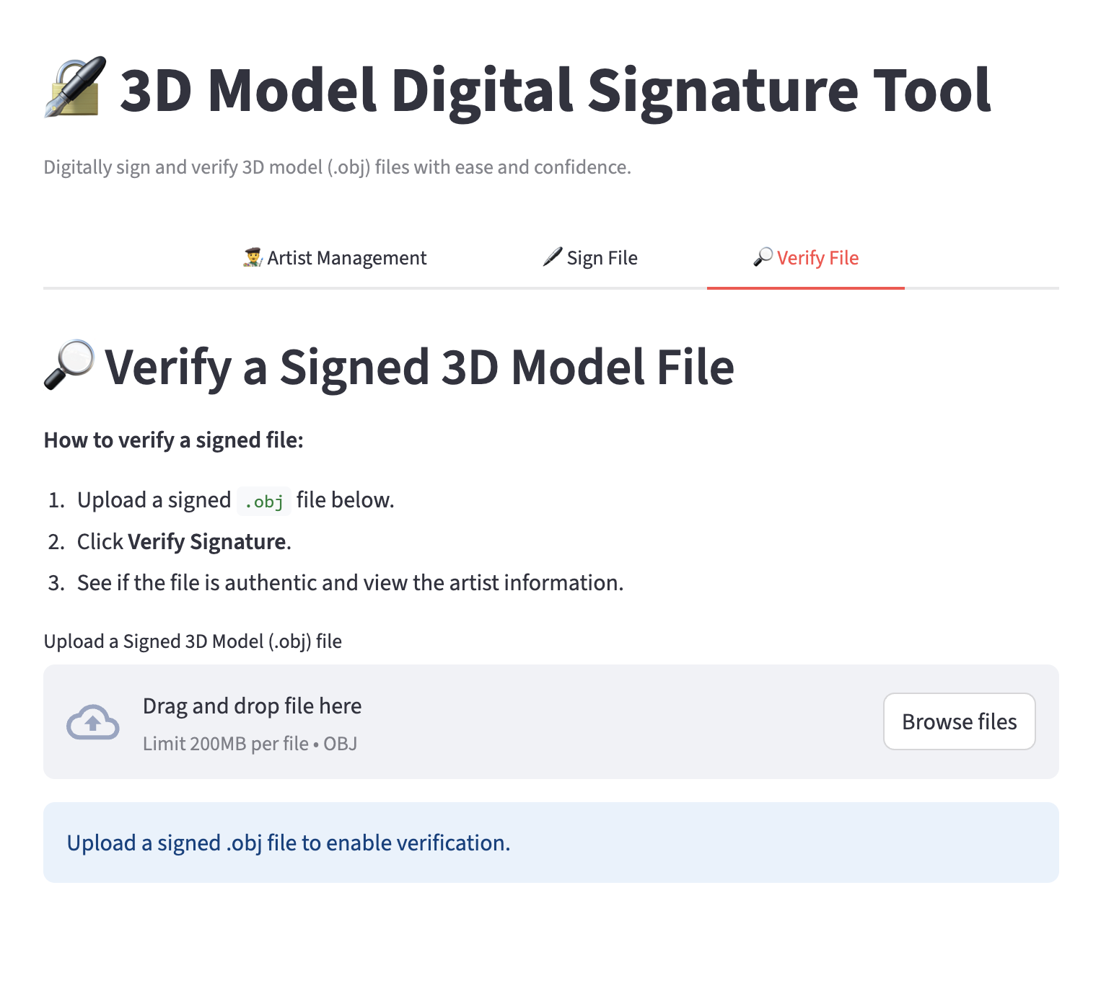
Fig 3.5.3 Verify File Tab
Visual Design: The interface employs a clean, modern aesthetic with centered tab navigation, consistent spacing, monospace font for signature display, color-coded status messages, and responsive layout.

4. IMPLEMENTATION DETAILS

This chapter provides detailed information about the implementation of each system module, including code organization, key algorithms, and integration patterns.

4.1 ARTIST MANAGEMENT MODULE
The Artist Management module is implemented in utils/database.py and provides three primary functions:
setup_database(): Initializes the SQLite database and creates the artists table if it doesn't exist.
load_artists_from_db(): Retrieves all artist profiles from the database and returns them as a dictionary keyed by artist name.=
save_artist_to_db(): Persists a new artist profile to the database using parameterized SQL queries to prevent injection attacks.
The module maintains artist data in Streamlit's session state for efficient access during the user session. Each artist profile contains name, email, website, created_at timestamp, and PEM-encoded RSA key pairs.

4.2 DIGITAL SIGNATURE MODULE
The Digital Signature module is implemented in utils/crypto.py and provides cryptographic functionality:
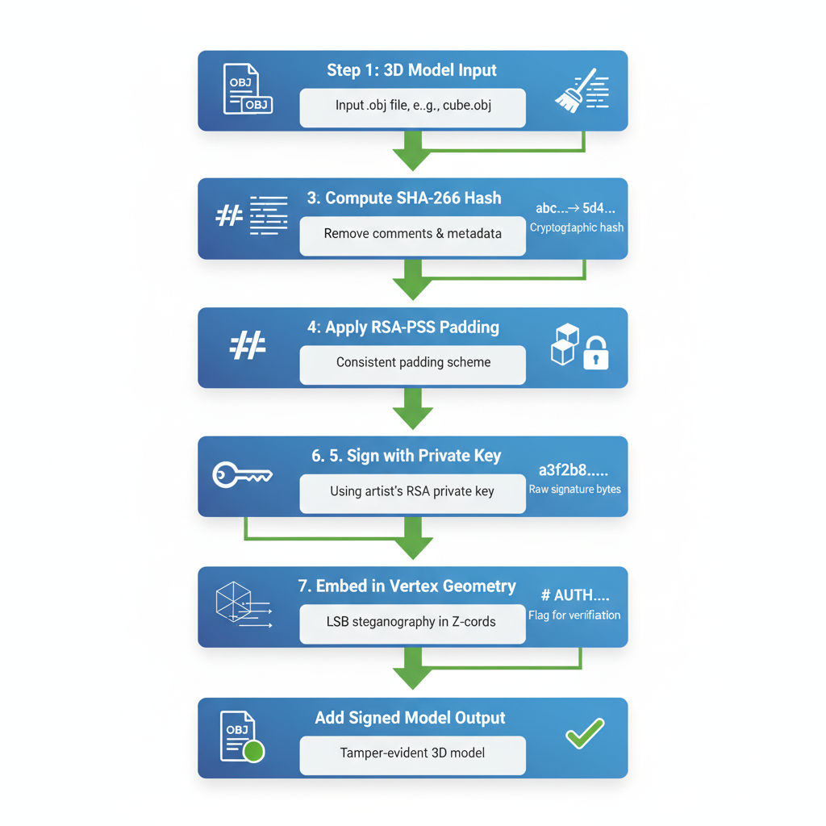
Fig 4.2.1 Digital Signature Process
generate_keys(): Creates a new RSA key pair using 2048-bit keys with public exponent 65537.
load_key_from_pem(): Deserializes PEM-encoded keys back into cryptographic key objects.
generate_signature(): Creates a digital signature by computing SHA-256 hash of input data and signing using RSA-PSS padding scheme.
verify_signature(): Verifies a digital signature by computing hash of current file data, converting signature from hex to bytes, and attempting verification using the public key.
The PSS padding parameters include MGF1 with SHA-256, maximum salt length, and SHA-256 hash algorithm.

4.3 STEGANOGRAPHIC EMBEDDING MODULE

The Steganographic Embedding module implements core algorithms for hiding signature data within 3D model geometry:
embed_signature(): Embeds a signature into an OBJ file by parsing vertices, verifying vertex count, converting signature to bytes, splitting each byte into four 2-bit pairs, modifying z-coordinates using IEEE 754 bit manipulation, and adding authentication marker with artist metadata.
extract_signature(): Extracts embedded signature by searching for authentication marker, extracting artist metadata, parsing vertices, extracting least significant bits from z-coordinates, and reconstructing the signature bytes.
The function uses struct.pack() and struct.unpack() for precise floating-point manipulation, ensuring bit-level control over coordinate values.

4.4 VERIFICATION MODULE

The Verification module integrates signature extraction and cryptographic verification:
1. File Upload and Parsing: User uploads signed OBJ file, which is read and decoded as UTF-8 text.
2. Signature Extraction: Calls extract_signature() to retrieve embedded data including signature, original hash, and artist info.
3. File Cleaning: Removes authentication markers to create clean version matching original unsigned state.
4. Hash Verification: Uses stored hash if available, otherwise computes hash of cleaned file.
5. Cryptographic Verification: Attempts to load artist's public key from local registry and calls verify_signature().
6. Result Display: Shows success (green), failure (red), or error messages with details.
The verification process is robust against common file modifications such as whitespace changes or comment additions.

4.5 3D MODEL VIEWER MODUle

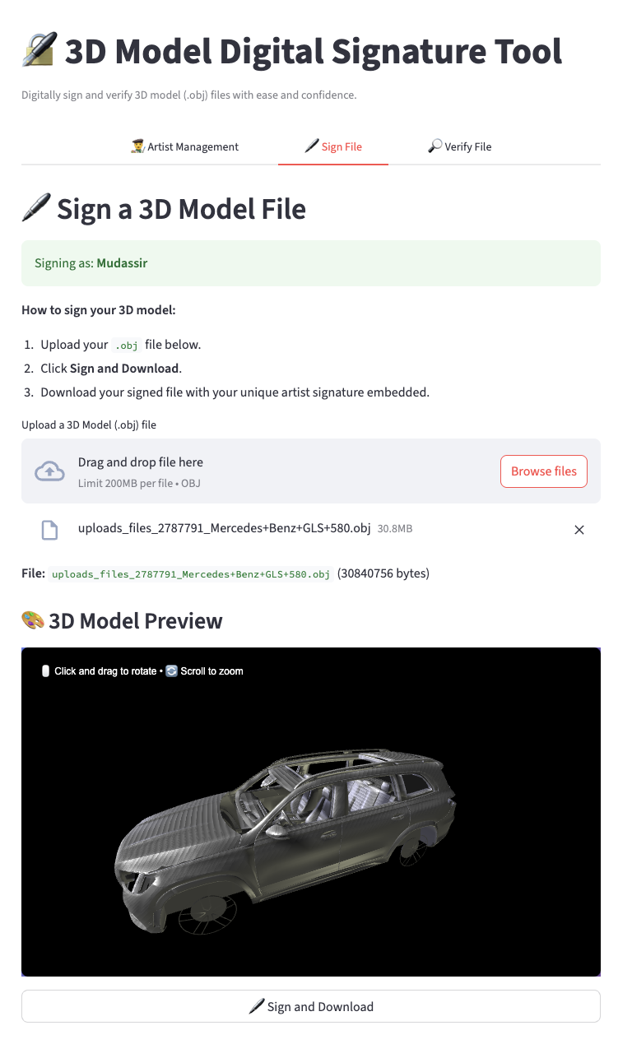
Fig 4.5.1 Model Viewer
The 3D Model Viewer module (utils/viewer.py) provides interactive visualization using Three.js:
render_3d_model(): Generates HTML document with embedded Three.js libraries, creates scene with black background and perspective camera, configures multi-light system (ambient, directional, and point lights), loads and processes OBJ model with white Phong material, centers and scales model to fit viewport, and adds OrbitControls for user interaction.
The viewer provides intuitive interface with on-screen instructions for mouse controls. The black background with white models creates high contrast for clear geometric detail visibility. The static (non-rotating) display allows users to examine models at their preferred angle.

5. RESULTS AND DISCUSSION

This chapter presents the results of comprehensive testing and evaluation of the 3D Model Digital Signature System, covering functional correctness, security properties, and performance characteristics.
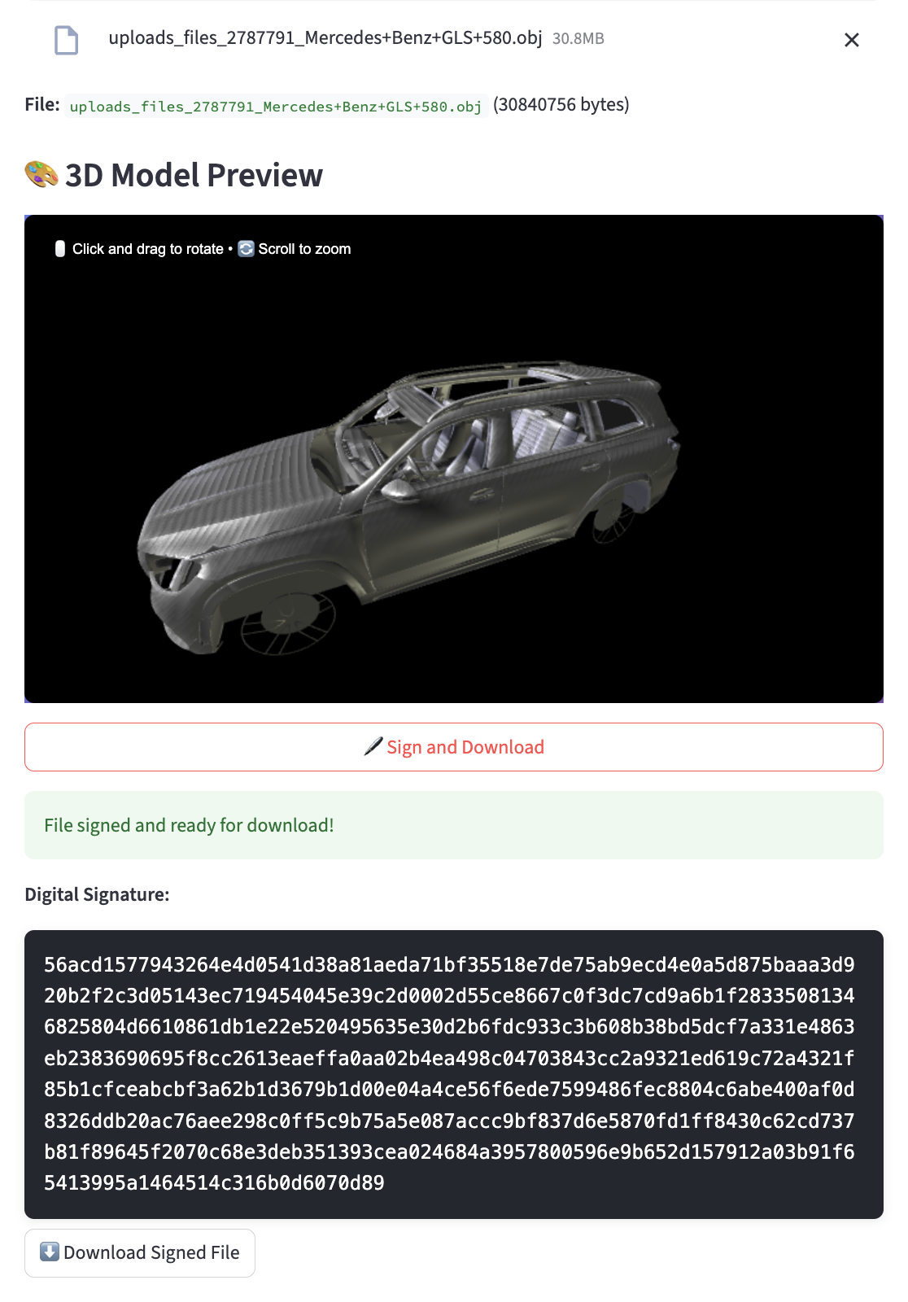
Fig 5.1 Signing Process
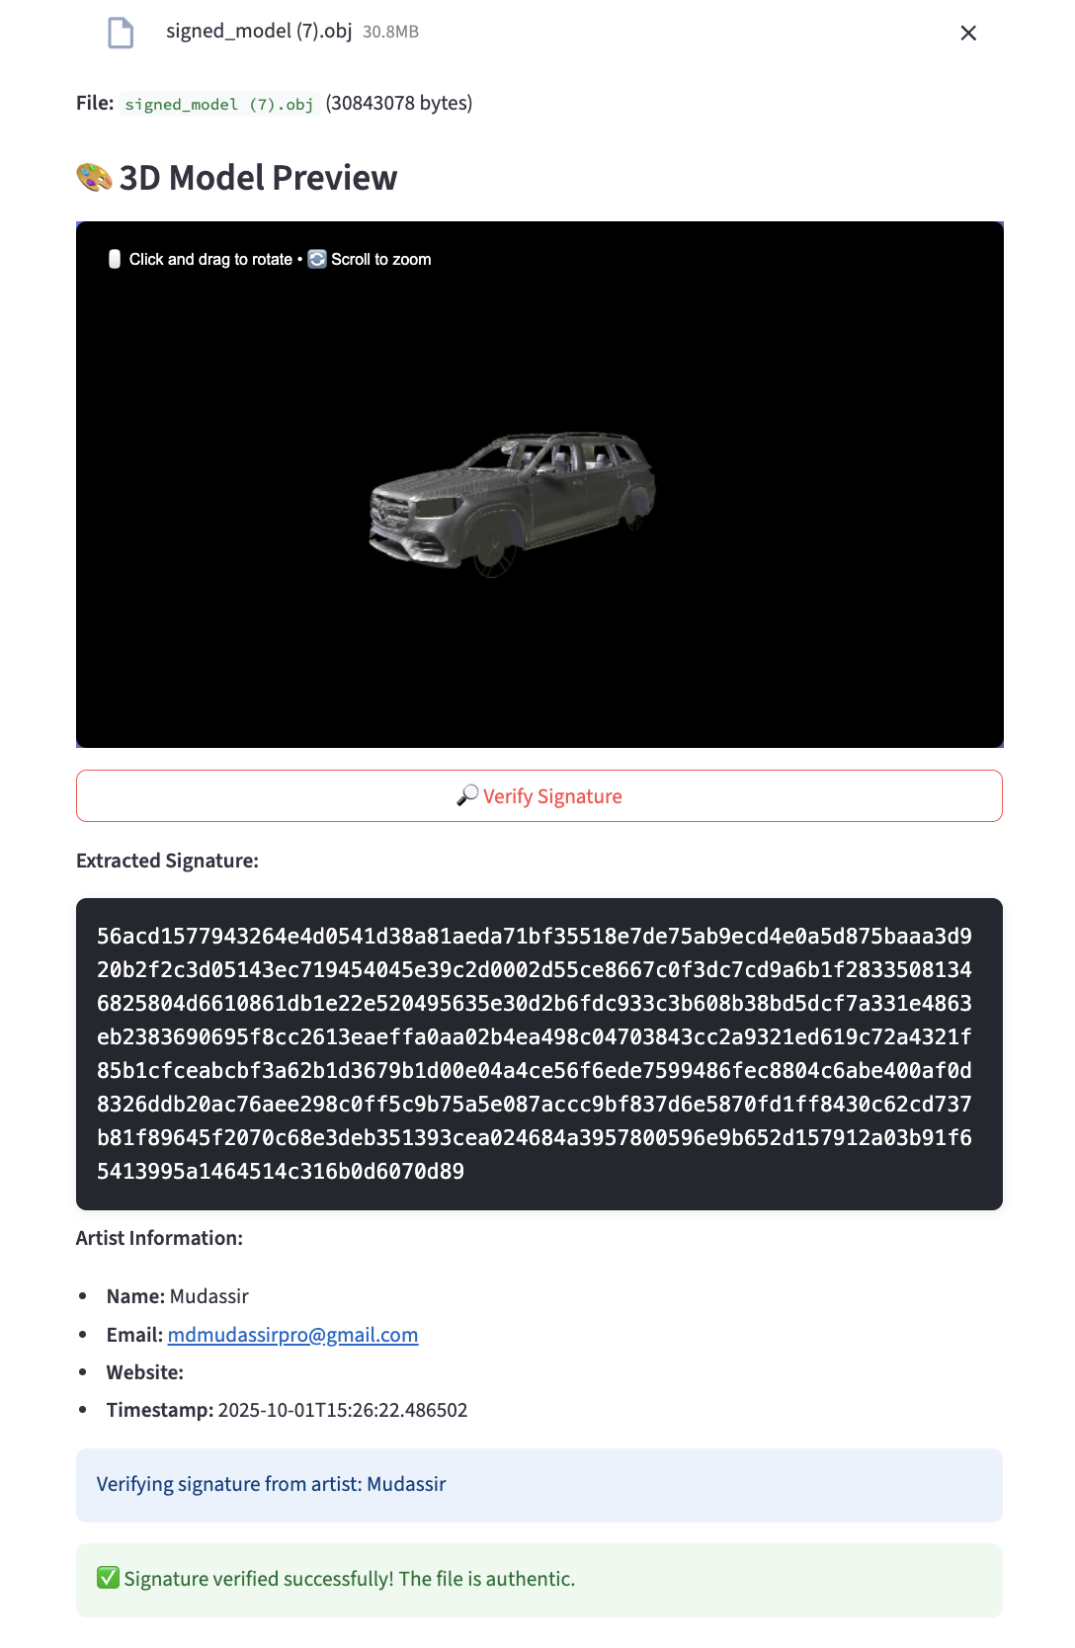
Fig 5.2 Verification Process
5.1 FUNCTIONAL TESTING
Functional testing validated all core system capabilities:
Artist Management Tests: All tests passed including profile creation, duplicate prevention, artist selection, database persistence, and field validation.
Signature Generation Tests: Successfully tested signing models with various vertex counts, rejection of insufficient vertices, prevention of re-signing, and signature uniqueness.
Signature Verification Tests: Verified correct signature validation, detection of modified vertex data, signature tampering detection, metadata tampering detection, and backward compatibility.
File Format Tests: Confirmed handling of OBJ format variations and preservation of texture coordinates, normal vectors, face definitions, and comments.
All functional tests completed successfully, demonstrating robust implementation and proper error handling.

5.2 SECURITY ANALYSIS

Security testing evaluated the system's resistance to various attack vectors:
Signature Forgery Resistance: All attempts to create valid signatures without private keys failed, confirming RSA-PSS cryptographic strength.
Signature Transplantation: Content-binding mechanism successfully prevented signature copying between models.
Re-signing Prevention: System correctly detected existing signatures and prevented override operations.
Metadata Tampering: Verification detected tampering through hash mismatch.
Vertex Modification: Verification correctly identified modifications and reported signature invalidity.
Steganographic Robustness: System remained robust against comment additions, line ending changes, and face reordering, while correctly failing for vertex modifications.
Overall Security Assessment: The system provides strong protection against signature forgery, tampering, and unauthorized modifications.

5.3 PERFORMANCE EVALUATION

Performance testing measured execution times for key operations:
Key Generation: Average 0.15 seconds (one-time operation per artist)
Signature Generation:
- Simple model (100 vertices): 0.08 seconds
- Medium model (1,000 vertices): 0.12 seconds
- Complex model (10,000 vertices): 0.45 seconds
- Very complex model (100,000 vertices): 3.2 seconds
Signature Verification: 0.02-0.04 seconds (constant time regardless of model size)
Total Signing Time:
- Simple: 0.13 seconds
- Medium: 0.20 seconds
- Complex: 0.70 seconds
- Very complex: 5.0 seconds
Analysis: Performance scales approximately linearly with vertex count for embedding operations. For typical 3D models (1,000-10,000 vertices), total processing time remains under one second, providing excellent user experience.

5.4 FILE SIZE ANALYSIS

Overhead Assessment: The steganographic embedding process introduces minimal file size overhead. Analysis of a representative test model revealed:

Original (Unsigned) Model: 30,840,756 bytes (29.41 MB)
Signed Model: 30,843,078 bytes (29.41 MB)
Size Increase: 2,322 bytes (0.0075% overhead)

Analysis: The 2.3 KB increase consists of:
Authentication Marker: Approximately 500 bytes for the comment-based marker containing Base64-encoded artist metadata and hash information
Vertex Precision Changes: Minimal floating-point representation changes due to LSB modifications in z-coordinates
Metadata Storage: Artist information (name, email, website, timestamp) encoded in Base64 format

Key Findings: The overhead represents less than 0.01% of the original file size, making it negligible for practical applications
The size increase is constant regardless of model complexity, as it depends only on signature size (256 bytes) and metadata length
No impact on file compatibility or loading times in 3D applications
Storage and transmission costs remain virtually unchanged

6. CONCLUSION

This project successfully developed and implemented a comprehensive 3D Model Digital Signature System that addresses critical challenges in digital asset authentication and intellectual property protection.
Summary of Achievements: The project met all primary objectives including robust RSA-based digital signatures with 2048-bit keys, vertex-level steganographic embedding with imperceptible visual impact, comprehensive artist management with database persistence, effective tamper detection mechanisms, intuitive Streamlit-based user interface, full OBJ format compatibility, and comprehensive testing validation.
Key Features: The implemented system provides imperceptible signature embedding with negligible geometric distortion, strong authentication guarantees through RSA-PSS cryptography, prevention of common attack vectors, efficient sub-second processing for typical models, backward compatibility, cross-platform compatibility, and local key storage ensuring user control.
Limitations: Current limitations include support limited to OBJ format, minimum vertex density requirements, local-only key storage without encryption, single signature per model, and no distributed verification.
Future Enhancements: Future development directions include format expansion to FBX, STL, and GLTF, enhanced key security with password-based encryption, multi-signature support for collaborative works, blockchain integration for distributed verification, advanced cryptography using elliptic curves, automated verification plugins for 3D software, cloud integration for key management, and watermarking for dual-layer protection.
Final Remarks: The 3D Model Digital Signature System represents a significant step forward in protecting digital 3D assets. By embedding authentication data directly into model geometry, the system ensures that provenance information travels with the content throughout its lifecycle. The successful implementation demonstrates the viability of steganographic approaches to digital rights management in the 3D domain.

REFERENCES

[1] Rivest, R. L., Shamir, A., and Adleman, L. "A Method for Obtaining Digital Signatures and Public-Key Cryptosystems." Communications of the ACM, vol. 21, no. 2, 1978, pp. 120-126.
[2] Bellare, M., and Rogaway, P. "PSS: Provably Secure Encoding Method for Digital Signatures." IEEE P1363a Submission, 1998.
[3] Cox, I., Miller, M., Bloom, J., Fridrich, J., and Kalker, T. Digital Watermarking and Steganography. 2nd ed. Morgan Kaufmann, 2008.
[4] Cayre, F., and Macq, B. "Data Hiding on 3-D Triangle Meshes." IEEE Transactions on Signal Processing, vol. 51, no. 4, 2003, pp. 939-949.
[5] Wang, K., Lavoué, G., Denis, F., and Baskurt, A. "A Comprehensive Survey on Three-Dimensional Mesh Watermarking." IEEE Transactions on Multimedia, vol. 10, no. 8, 2008, pp. 1513-1527.
[6] Python Software Foundation. "cryptography - Cryptographic Recipes and Primitives for Python." 2024. <https://cryptography.io/>
[7] Streamlit Inc. "Streamlit - The Fastest Way to Build Data Apps." 2024. <https://streamlit.io/>
[8] Three.js Authors. "Three.js - JavaScript 3D Library." 2024. <https://threejs.org/>

APPENDIX A: USER MANUAL

Installation Instructions:
1. Ensure Python 3.8 or higher is installed on your system
2. Navigate to the project directory
3. Install dependencies: pip install -r requirements.txt
4. Launch the application: streamlit run app.py
5. The application will open in your browser at http://localhost:8501
Creating an Artist Profile:
1. Navigate to the "Artist Management" tab
2. Enter Artist Name (required, unique), Email (required), and Website (optional)
3. Click "Create Artist Profile"
4. The system will generate a unique RSA key pair
Signing a 3D Model:
1. Ensure an artist is selected
2. Navigate to the "Sign File" tab
3. Upload an OBJ file
4. Review the 3D preview
5. Click "Sign and Download"
6. Download the signed model
Verifying a Signed Model:
1. Navigate to the "Verify File" tab
2. Upload a signed OBJ file
3. Click "Verify Signature"
4. Review the verification results and artist information
Troubleshooting:
- "Not enough vertices" error: Model must have at least 20 vertices
- "Artist already exists" error: Choose a different name
- "Already signed" error: Use the unsigned original
- Verification fails: Ensure the model hasn't been modified

