

University of Dhaka

Department of Computer Science and Engineering

Project Report:
Fundamentals of Programming Lab (CSE-1211)

Project Name:
Helicopter Hurdle Game

Team Members

Md. Abdul Muhit
Suhail Tanvir Nahin
Sourove Hossen

Introduction:
Helicopter Hurdle Game is a simple video game. As the name stated, the main task of the game is to take the control and drive the helicopter through different obstacles without any collision. Player can gain scores by passing certain distance or driving in high speed or both.

Objectives:
This is a classic game and very easy to play. So, people of any ages, specially, the children can play the game in leisure time and have some fun.

Project Features:

a) Two play option; Endless and Timer:
There are two play option, one endless which means there is no time limit and can be play until any crash occurred. Two, timer which means playtime will be fixed (2 minute or 120 s) and game will be over after that time or any crash occurred.

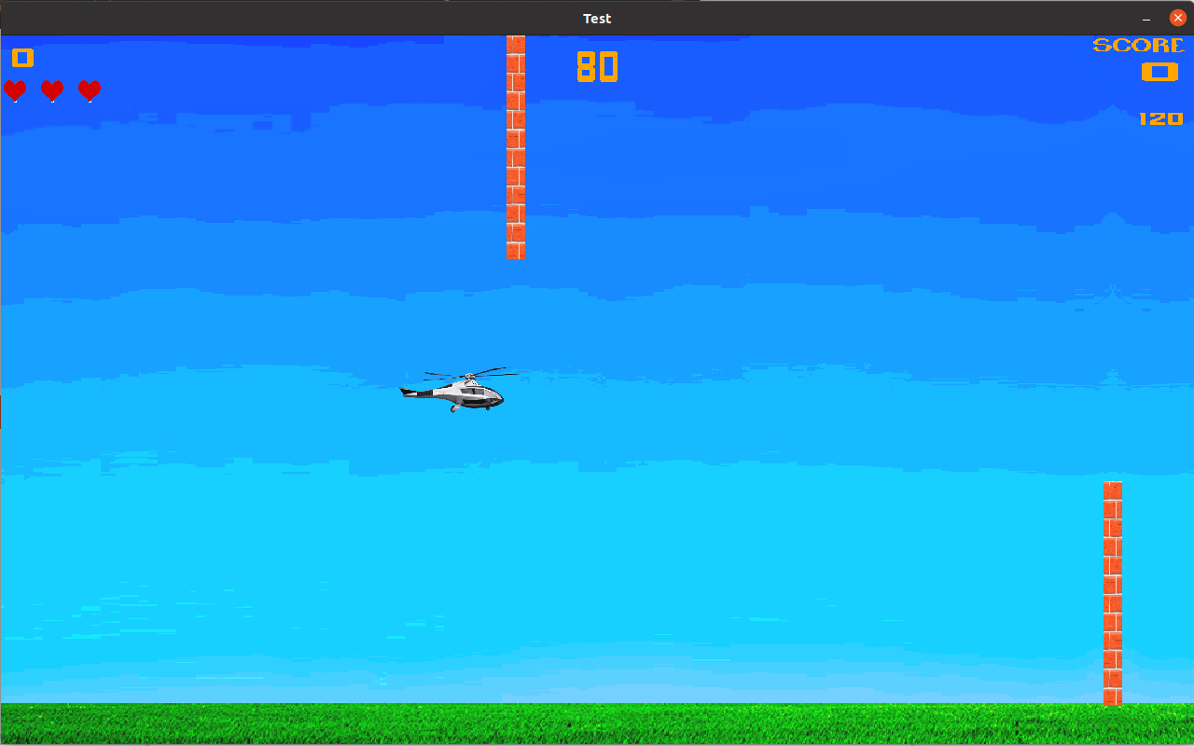

b) Three lives/chances in one playtime:
In one round, one player has three lives. That means, if a player crashed three times the game will be over.

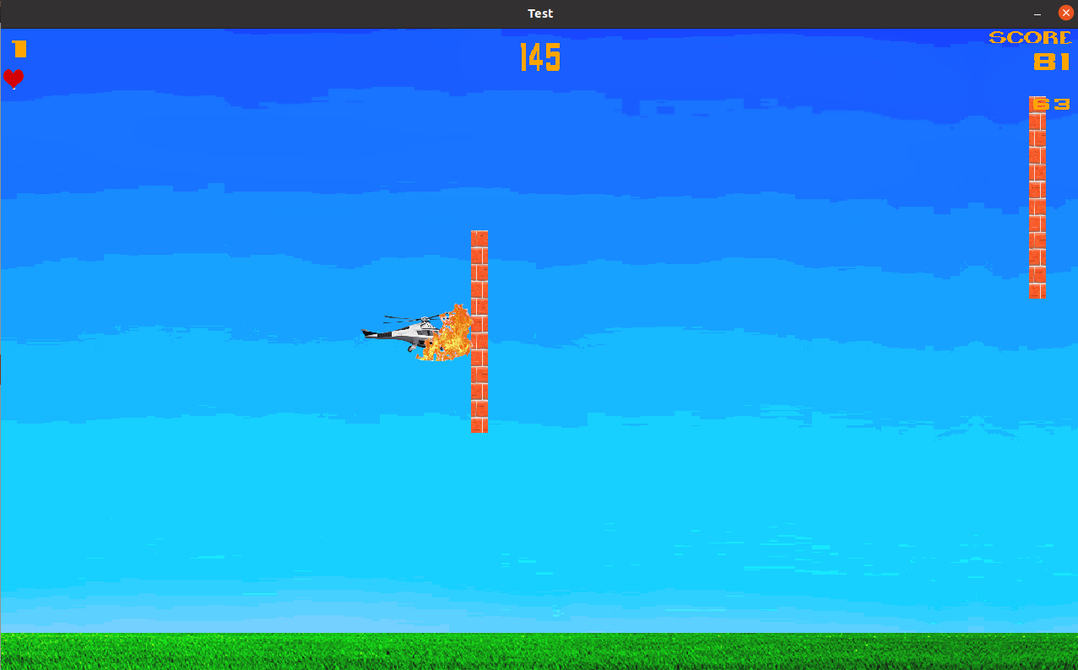

c) Higher speed, better scores:
When a player helicopter speed is more than 140 km/h then in every second points (10% of speed) will be added to total scores.

Project Modules:
The project code consists of several files. They are-
a) main.cpp : It contains main functions and menu of the game.
b) play.h : Contains several vital functions declaration whose definition are in play.cpp
c) play.cpp: It contains several vital functions whose illustrate different core segment of the project. Such as, play() which is the main game function and contain game loop. gameOver() to show game over menu, scores and high scores. open_tutorial() for show tutorial and createOption() for option menu.
d) function.h : It contains randomly used function declaration.
e) function.cpp : It contains definition of function declared in the function.h
f) var.h : It contains global variable declaration, macro and structure declaration.
g) var.cpp : It contains definition of global variable declared in var.h

Team Member Responsibility:
Suhail Tanvir Nahin : GameOver() and open_tutorial() function.
Sourove Hossen : main.cpp
Md. Abdul Muhit : Rest of the project.

Platform, Library and Tools:
The game developed with C and C++. It is compatible with Linux. It uses SDL2 library for audio, video, sound and text.

Limitations:
We have failed to achieve smooth game control and rendering. Besides graphics and sound are not so good. Source code also lengthy.

Conclusions:
We learn mainly how to build program with several files and modularity. We also learn the basics of SDL library. At the beginning our project was very lengthy having unnecessary code and memory leakage.

Future Plan:
In future, we want to add some features and make the game available for other platform.

Repository:
Github repository: https://github.com/Md-Muhit/helicopter_hurdle_game.git

Reference:
1. Book: Head First C.
2. Site: www.lazyfoo.net , www.wiki.libsdl.org

