Lumora
AI-Powered Medical Image Analysis Platform
A clinical decision-support tool that analyzes chest X-rays and CT scans using Vision-Language Models (VLMs). Lumora generates narrative radiology reports, detects 26 pathologies with a multi-label classifier, and translates complex clinical findings into patient-friendly language — all behind an intelligent image modality guardrail.

Table of Contents
- Architecture Overview
- Model Specifications
- Individual Model Details
- Comparison with Published Literature

Architecture Overview
Lumora processes medical images through a sequential four-stage pipeline, where each stage is powered by a purpose-built deep learning model:
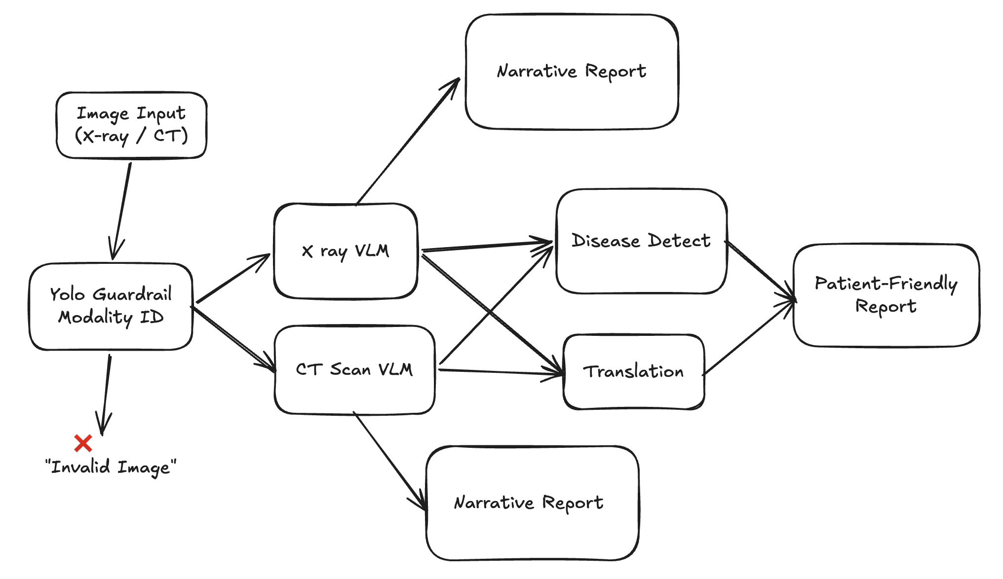

Stage | Model | Purpose
1. Guardrail | YOLOv11s-cls | Validates that the uploaded image is a legitimate chest X-ray or CT scan before consuming compute
2. Report Generation | DenseNet-121 + GPT-2 VLM | Encodes the medical image into visual embeddings and autoregressively generates a narrative radiology report
3. Disease Detection | ClinicalBERT | Performs multi-label classification on the generated report, extracting 26 pathology labels
4. Translation | T5-small + LoRA | Rewrites the clinical jargon into clear, patient-friendly language

Model Specifications
Complete specification matrix for all five models in the Lumora inference pipeline.

Specification | 1. Modality Identification Model (YOLO) | 2. X-Ray VLM | 3. CT VLM | 4. Translation Model (T5) | 5. Disease Detection Model (ClinicalBERT)
Primary Function | Image input validation / guardrail | Frontal chest X-ray narrative report generation | Converted 2D CT slice narrative report generation | Clinical jargon translation to patient friendly layperson terms | Multi-label extraction of 26 pathologies from radiology reports
Transfer Learning Base | yolo11s-cls.pt (Ultralytics) | densenet121 + gpt2 | densenet121 + gpt2 | t5-small + LoRA adapter | emilyalsentzer/Bio_ClinicalBERT
Parameter Count | ~2.8 Million | ~133 Million | ~133 Million | ~60.8 Million (LoRA: 295k) | ~110 Million
Activation Function | SiLU | GELU (Decoder), ReLU (Encoder) | GELU (Decoder), ReLU (Encoder) | ReLU | GELU
Dropout Rate | 0.0 | 0.1 (Decoder), 0.0 (Encoder) | 0.1 (Decoder), 0.0 (Encoder) | 0.1 (LoRA & base T5) | 0.1 (hidden & attention)
Loss Function | CrossEntropyLoss | CrossEntropyLoss (shifted logits) | CrossEntropyLoss (shifted logits) | CrossEntropyLoss (Seq2Seq target) | Binary Cross Entropy with Logits (BCEWithLogitsLoss)
Optimizer | Auto-selected (SGD/AdamW) | AdamW | AdamW | AdamW | AdamW
Learning Rate | 0.01 (initial lr0) | Phase 1: 1e-4, Phase 2: 2e-5 | Phase 1: 1e-4, Phase 2: 2e-5 | 3e-4 | 3e-5 (with 10% warmup, cosine decay)
Weight Decay | 0.0005 | Default (0.01) | Default (0.01) | Default (0.01) | 0.01
Accumulator Steps | 1 | 1 | 1 | 4 (effective batch size: 16) | 1
Batch Size | 128 | 8 (run) / 4 (local script) | 4 | 4 | 8
Epochs | 100 | Phase 1: 3, Phase 2: 3 (Total: 6) | Phase 1: 3, Phase 2: 3 (Total: 6) | 5 | 12
Input Shape / Size | 224 × 224 (image) | 224 × 224 (image), max 128 tokens | 224 × 224 (image), max 128 tokens | max input 512, target 256 tokens | max 512 tokens
Training Dataset Size | 2,640 images (80%) | 64,592 samples | 2,301 samples | 840 samples | 840 samples
Validation/Test Size | 660 images (20%) | 504 samples (Val) | 106 samples (Val) | 105 (Val) / 105 (Test) | 105 (Val) / 105 (Test)
Hugging Face Hub URL | pranto24/xray_ct_scan_identification_model | nur9211/mimic-vlm-model | nur9211/ct-rate-vlm-model | nur9211/lumora_translation | nur9211/lumora_disease_classifier

Individual Model Details

1. Modality Identification Model (YOLO Guardrail)
The first line of defense in the pipeline. A YOLOv11s-cls image classifier trained on 3,300 images across three categories: xray, ct_scan, and other. It prevents non-medical images (selfies, documents, etc.) from reaching the computationally expensive VLM stage.
- Architecture: Ultralytics YOLOv11 small classification backbone with SiLU activations
- Pre-screen: An additional variance-based heuristic rejects blank or near-uniform images before the YOLO forward pass
- Inference output: Class label + confidence score; only xray or ct_scan labels above threshold proceed

2. X-Ray Vision-Language Model
The core report generation model for frontal chest X-rays. Built as a custom multimodal architecture combining a DenseNet-121 visual encoder with a GPT-2 language decoder, bridged by a learned linear projector.
- Encoder: DenseNet-121 (pretrained on ImageNet) extracts 1,024-dim visual features from 224×224 images
- Projector: A linear layer maps the 1,024-dim feature vector to the 768-dim GPT-2 embedding space
- Decoder: GPT-2 autoregressively generates radiology reports conditioned on the projected visual embedding
- Training: Two-phase strategy — Phase 1 freezes the encoder and trains only the projector + decoder; Phase 2 fine-tunes the entire network end-to-end at a lower learning rate
- Dataset: Trained on MIMIC-CXR (64,592 image-report pairs from the Medical Information Mart for Intensive Care)

3. CT Vision-Language Model
An architecturally identical VLM to the X-ray model, separately fine-tuned for CT scan report generation.
- Input adaptation: 3D NIfTI CT volumes are converted to representative 2D slices during preprocessing
- Architecture: Same DenseNet-121 → Projector → GPT-2 pipeline as the X-ray VLM
- Training: Same two-phase regime; trained on CT-RATE dataset (2,301 samples)
- Use case: Generates narrative reports for axial CT slice imagery covering thoracic anatomy

4. Translation Model (T5 + LoRA)
Rewrites clinical radiology reports into language that patients and non-specialists can understand.
- Base model: T5-small (60.8M parameters) — a sequence-to-sequence transformer
- Fine-tuning: Parameter-efficient fine-tuning with LoRA (Low-Rank Adaptation) — only 295K trainable parameters
- Prompt format: Input is prefixed with "translate to patient-friendly: " before the clinical text
- Decoding: Beam search with num_beams=4 for fluent, coherent output
- Dataset: 840 curated clinical → patient-friendly report pairs

5. Disease Detection Model (ClinicalBERT)
A multi-label text classifier that extracts structured pathology labels from the generated narrative report.
- Base model: Bio_ClinicalBERT — a BERT variant pre-trained on clinical notes from MIMIC-III
- Classification head: A linear layer mapping the [CLS] token representation to 26 pathology logits
- Output: Sigmoid activation produces independent probabilities for each of the 26 disease labels
- Threshold: A recall-optimized threshold of 0.15 is applied at inference time
- Post-processing: Mutual-exclusion logic resolves contradictions (e.g., pathologies present ↔ "No acute disease")

26 Supported Pathology Labels — Full Dataset Breakdown
The ClinicalBERT classifier is trained on reports from both the MIMIC-CXR (X-Ray) and CT-RATE (CT) datasets combined. The 26 canonical labels were selected as those appearing ≥ 8 times across the unified training corpus.

X-Ray (MIMIC-CXR) — Primary Disease Coverage
Diseases commonly observed in frontal chest radiograph reports from the MIMIC-CXR dataset:
# | Disease Label | Frequency (approx.)
1 | Atelectasis | Very High
2 | Cardiomegaly | Very High
3 | Pleural Effusion | Very High
4 | Pneumonia | High
5 | Pneumothorax | High
6 | Pulmonary Edema/Vascular Congestion | High
7 | Consolidation | Moderate
8 | No Acute Cardiopulmonary Disease | Very High
9 | Pulmonary Fibrosis/Scarring | Moderate
10 | Pulmonary Nodules | Moderate
11 | Rib/Bone Fracture | Moderate
12 | Possible Aspiration | Low–Moderate

CT Scan (CT-RATE) — Extended Disease Coverage
Diseases additionally observed in thoracic CT reports from the CT-RATE dataset (CT captures deeper anatomical structures beyond chest X-rays):
# | Disease Label | Frequency (approx.)
1 | Atherosclerosis | High
2 | Emphysema/COPD | High
3 | Hepatic Steatosis | Moderate
4 | Hiatal Hernia | Moderate
5 | Pericardial Effusion | Moderate
6 | Mosaic Attenuation Pattern | Moderate
7 | Aortic Dilation | Low–Moderate
8 | Lymphadenopathy | Low–Moderate
9 | Cholelithiasis | Low–Moderate
10 | Osteoporosis | Low–Moderate
11 | Spinal Degenerative Changes | Moderate
12 | Mild Scoliosis | Low–Moderate
13 | Pulmonary Artery Enlargement | Low–Moderate
14 | Possible Malignancy/Mass | Low

🔬 Combined 26-Label Vocabulary (ClinicalBERT Output Classes)
All 26 labels used as multi-label output classes during ClinicalBERT training, with dataset origin noted:
# | Pathology | Primary Dataset Source
1 | Aortic Dilation | CT-RATE
2 | Atelectasis | MIMIC-CXR + CT-RATE
3 | Atherosclerosis | CT-RATE
4 | Cardiomegaly | MIMIC-CXR + CT-RATE
5 | Cholelithiasis | CT-RATE
6 | Consolidation | MIMIC-CXR + CT-RATE
7 | Emphysema/COPD | CT-RATE
8 | Hepatic Steatosis | CT-RATE
9 | Hiatal Hernia | CT-RATE
10 | Lymphadenopathy | CT-RATE
11 | Mild Scoliosis | CT-RATE
12 | Mosaic Attenuation Pattern | CT-RATE
13 | No Acute Cardiopulmonary Disease | MIMIC-CXR + CT-RATE
14 | Osteoporosis | CT-RATE
15 | Pericardial Effusion | CT-RATE
16 | Pleural Effusion | MIMIC-CXR + CT-RATE
17 | Pneumonia | MIMIC-CXR + CT-RATE
18 | Pneumothorax | MIMIC-CXR
19 | Possible Aspiration | MIMIC-CXR + CT-RATE
20 | Possible Malignancy/Mass | CT-RATE
21 | Pulmonary Artery Enlargement | CT-RATE
22 | Pulmonary Edema/Vascular Congestion | MIMIC-CXR + CT-RATE
23 | Pulmonary Fibrosis/Scarring | MIMIC-CXR + CT-RATE
24 | Pulmonary Nodules | MIMIC-CXR + CT-RATE
25 | Rib/Bone Fracture | MIMIC-CXR + CT-RATE
26 | Spinal Degenerative Changes | CT-RATE

Comparison with Published Literature
To evaluate the clinical efficacy and design scope of Lumora, we compare its pipeline and model coverage against both chest X-ray diagnosis papers and recent CT-focused multimodal medical AI papers from strong publication venues. This makes the comparison fairer because Lumora supports both CXR and thoracic CT workflows.

Feature-by-Feature Comparison Matrix
Feature / Dimension | Paper 1: Alshmrani et al. (2023) [1] | Paper 2: Sharma & Guleria (2023) [2] | Paper 3: Hamamci et al. (2026) [3] | Paper 4: Zhang et al. (2025) [4] | Lumora (Ours)
Publication Quality / Venue | Alexandria Engineering Journal; Q1 engineering venue | Procedia Computer Science; indexed conference-proceedings venue | Nature Biomedical Engineering; Q1 biomedical engineering venue | Scientific Data; Q1 Nature Portfolio data journal | Academic research prototype with public model artifacts
Primary Base Model(s) | VGG19 + 3 custom CNN blocks | VGG-16 + Neural Network classifier | CT-CLIP + CT-CHAT foundation models | RadGenome-Chest CT dataset + grounded VLM baselines | 5-Model Pipeline: YOLOv11s-cls + DenseNet121-GPT2 + Bio_ClinicalBERT + T5-small + LoRA
Supported Modalities | Chest X-ray (CXR) only | Chest X-ray (CXR) only | 3D chest CT volumes | 3D chest CT volumes with region-level grounding | Multi-Modal: Chest X-ray (CXR) AND Thoracic CT scans (2D axial slices)
Primary Task Scope | Multi-class Classification | Binary Classification | CT abnormality detection, retrieval, and CT chat | Grounded CT report generation and CT visual question answering dataset | End-to-End Clinical Flow: Guardrail → Report Gen → Label Extraction → Layperson Translation
Narrative Report Gen | No (Outputs class labels only) | No (Outputs "Pneumonia" or "Normal") | CT-CHAT supports CT-focused language interaction | Provides grounded CT report-generation supervision | Yes (Generates full, contextual English reports using visual embeddings)
Pathology Vocabulary | 6 Classes (COVID-19, Normal, Pneumonia, Lung Opacity, TB, Cancer) | 2 Classes (Pneumonia vs. Normal) | 18 CT abnormality labels in CT-RATE plus report text | Region-grounded reports, VQA pairs, and anatomical segmentation labels | 26 canonical pathologies across both X-ray and CT modalities
Patient-Friendly Translation | No | No | No dedicated layperson translation module | No dedicated layperson translation module | Yes (Rewrites complex clinical jargon using sequence-to-sequence T5 with LoRA adapters)
Safety Input Guardrails | No (Assumes correct inputs) | No (Assumes correct inputs) | Not a front-door modality guardrail | Dataset benchmark, not an input-screening pipeline | Yes (YOLOv11 guardrail checks modality and rejects non-medical images)

Key Scientific & Clinical Advancements of Lumora
1. Unified Clinical Workflow Integration: Rather than acting as only a classifier or dataset benchmark, Lumora mirrors a practical radiology-support workflow. It validates the input (YOLO Guardrail), writes a narrative report (DenseNet-GPT2 VLM), identifies multiple clinical findings (ClinicalBERT), and translates these to layperson language (T5+LoRA) for direct patient use.
2. Cross-Modality Versatility: The original CXR comparison papers are limited to chest radiographs, while newer CT papers focus deeply on 3D CT. Lumora sits between these lines of work by supporting both Chest X-rays (via MIMIC-CXR) and Thoracic CT Scans (via CT-RATE) in one application pipeline.
3. High-Granularity Disease Mapping: Several comparator systems collapse diagnosis into a single label, binary output, or CT-specific benchmark task. Lumora classifies 26 multi-label pathologies concurrently, capturing co-occurring conditions (e.g., Pneumonia with Pleural Effusion and Atelectasis) that are common in clinical environments.
4. Patient-Centric Health Literacy: Lumora adds a patient-facing communication layer that the compared works do not include, translating jargon (e.g., "retrocardiac opacity with consolidation") into readable lay terms.

References & Citations
- [1] Alshmrani, G. M. M., Ni, Q., Jiang, R., Pervaiz, H. B., & Elshennawy, N. M. (2023). A deep learning architecture for multi-class lung diseases classification using chest X-ray (CXR) images. Alexandria Engineering Journal, 64, 923-935. https://doi.org/10.1016/j.aej.2022.10.053
- [2] Sharma, S., & Guleria, K. (2023). A Deep Learning based model for the Detection of Pneumonia from Chest X-Ray Images using VGG-16 and Neural Networks. Procedia Computer Science, 218, 337-346. https://doi.org/10.1016/j.procs.2023.01.018
- [3] Hamamci, I. E., Er, S., Wang, C., et al. (2026). Generalist foundation models from a multimodal dataset for 3D computed tomography. Nature Biomedical Engineering. https://doi.org/10.1038/s41551-025-01599-y
- [4] Zhang, X., Wu, C., Zhao, Z., et al. (2025). Development of a large-scale grounded vision language dataset for chest CT analysis. Scientific Data, 12, 1636. https://doi.org/10.1038/s41597-025-05922-9

