Save Inner Item : Param (Sampling > Development > Quantity Definition)

Parameter Preparation:

|  |  |
| --- | --- |
| Step-I | 1. Set operation mode to ‘Entuiry’  2. Set ‘templatePath’ to be used in ‘Template Preparation’ |
|  |
| Step-II |  |
|  |
| Step-III | 1. Prepares ‘Data Save Poilicy’ to be used to prepare IDs by Id_Generator ….added ‘getIdSpec’ in sample_sample_json |
|  |
| Step-IV | 1. populates variables ‘$samplingId, $developmentId’ to be used in ‘data save path’  populates ‘$backeSavePath’ and ‘preparedObject’ to be used in ‘containerLinkPath’, ‘containerLinkData’ in ‘SaveInnerItems’ service call |
|  |

Prepared Parameter

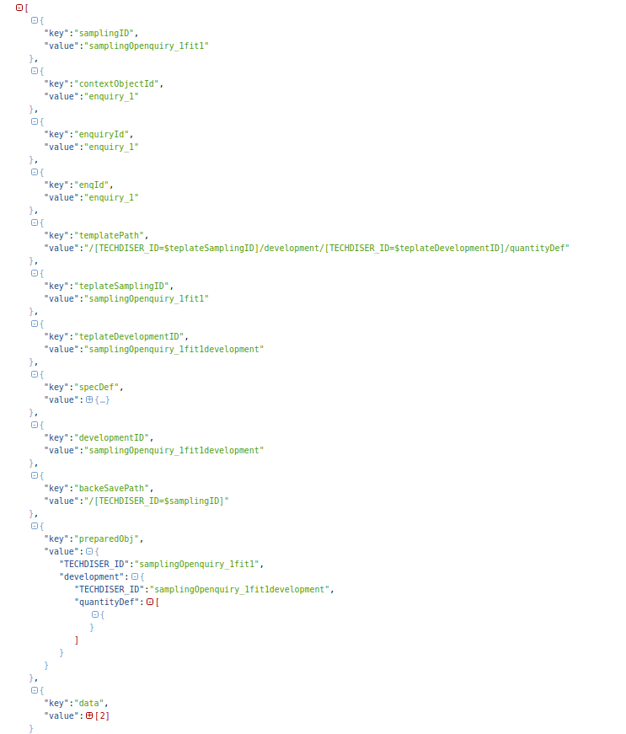

Save Data

|  |  |
| --- | --- |
| Step I | 1. rootID…….TECHDISER_ID of ‘rootObject’  2. data, serviceName, taskName,  3. path…….container path relative to rootObject (excluding root TECHDISER_ID)  4. params, callback  5. first ‘true’ for ‘isArray’ specifies ‘Data’ is an Array  6. second ‘true’ for ‘toRemove’ specifies whether data to be replaced |
|  |

Prepare Data for View

|  |  |
| --- | --- |
| Step I | 1. Read Prerequisite Data …. ‘ComboDefinition’  2. Read Prerequisite Data …. ‘SizeDefinition’ |
|  |
| Step II | 1. Read existing data….quantityDefinition |
|  |
| Step III | Create Prefix…. SpecType : 1...to get Prefix (add ‘getPrefix’ function in sample_sample_jon) |
|  |  |
|  | Prepare Ideal Data |
|  |  |
|  | Update Prepared Data with Existing Saved Data |
|  |  |

Material Definiton

TECHDISER_ID: "99ac384479b23.37bc0bf79"

1. color: "Red"
2. colorId: "Enq_mat_usage_1"
3. comboId: "ordr1combo1"
4. comboTitle: "Black / Turquoise"
5. gMatColorId: "Enq_MaterialCategory1Shell1Enq_mat_usage_1"
6. gMatColorSizeComboId: "Enq_MaterialCategory1Shell1Enq_mat_usage_1ordr1combo1"
7. gMatColorSizeComboPositionId: "Enq_MaterialCategory1Shell1Enq_mat_usage_1ordr1combo1Shell 1"
8. gMatColorSizeId: "Enq_MaterialCategory1Shell1Enq_mat_usage_1"
9. gsm: 40
10. matItemId: "Enq_MaterialCategory1Shell1Enq_mat_usage_1"
11. matSize: "50"
12. matType: "cuttable"
13. materialCatId: "SupplyDefinitionMaterialCategory1"
14. materialDescription: "100 Cotton Shell"
15. materialId: "Enq_MaterialCategory1Shell1"
16. materialTitle: "100 Cotton Shell"
17. materialTypeId: "fabrics"
18. materialWidth: "50"
19. position: "Shell 1"
20. positionId: "Shell 1"
21. sourcingForm: "c"

TECHDISER_ID: "b59f.dbcd0382fb088.ef2ad0b62b836.e18a83ac15cfe.ff373bf4bafe2.57f1e8e0b7024.f0402c808"

1. color: "Red"
2. colorId: "Enq_mat_usage_1"
3. comboId: "ordr1combo1"
4. comboTitle: "Black / Turquoise"
5. gMatColorId: "Enq_MaterialCategory1Shell1Enq_mat_usage_1"
6. gMatColorSizeComboId: "Enq_MaterialCategory1Shell1Enq_mat_usage_1ordr1combo1"
7. gMatColorSizeComboPositionId: "Enq_MaterialCategory1Shell1Enq_mat_usage_1ordr1combo1Shell 2"
8. gMatColorSizeId: "Enq_MaterialCategory1Shell1Enq_mat_usage_1"
9. gsm: 40
10. matItemId: "Enq_MaterialCategory1Shell1Enq_mat_usage_1"
11. matSize: "50"
12. matType: "cuttable"
13. materialCatId: "SupplyDefinitionMaterialCategory1"
14. materialDescription: "100 Cotton Shell"
15. materialId: "Enq_MaterialCategory1Shell1"
16. materialTitle: "100 Cotton Shell"
17. materialTypeId: "fabrics"
18. materialWidth: "50"
19. position: "Shell 2"
20. positionId: "Shell 2"
21. sourcingForm: "c"