


Explainable Mortality Prediction of Liver Cirrhosis Using Machine Learning & Deep Learning Models

This thesis is presented in partial fulfillment of the requirements for the award of the degree of Bachelor of Science (B.Sc.) in Computer Science and Engineering (CSE).

Submitted by

Sabus ID: 41230101010
Md. Ramin Hossain ID: 41230100711
Saifullah Mansur ID: 41230100759
Md. Nazmul Hassan ID: 41230100695

Supervisor

Rakibul Hasan
(Senior Lecturer)
Department of Computer Science & Engineering (CSE)
Northern University Bangladesh

Date of Submission: October 2026

CERTIFICATE OF APPROVAL

The Thesis Report Explainable Mortality Prediction of Liver Cirrhosis Using Machine Learning & Deep Learning Models submitted by Sabus (ID: 41230101010), Md. Ramin Hossain (ID: 41230100711), Saifullah Mansur (ID: 41230100759), and Md. Nazmul Hassan (ID: 41230100695) to the Department of Computer Science and Engineering, Northern University Bangladesh, has been accepted as satisfactory for the partial fulfillment of the requirements for the degree of Bachelor of Science (B.Sc.) in Computer Science and Engineering (CSE) and approved with respect to its methodology and content.

Board of Examiners

Rakibul Hasan (Supervisor)
Senior Lecturer

Moinuddin (Examiner)
Lecturer

Aninda Roy Dhruba (Examiner)
Lecturer

Md. Raihan Ul Masood Associate Professor and Head
Department of Computer Science and Engineering Northern University Bangladesh

DECLARATION

We solemnly declare that the thesis titled “Report Explainable Mortality Prediction of Liver Cirrhosis Using Machine Learning & Deep Learning Models” is an original research work conducted by us under the guidance of Simon Bin Akter , Lecturer, Department of Computer Science and Engineering, Northern University Bangladesh. This research satisfies the academic requirements for the degree of Bachelor of Science (B.Sc.) in Computer Science and Engineering (CSE). It reflects our independent investigation, analysis, experimentation, and interpretation, carried out in accordance with established academic and ethical standards to ensure authenticity and integrity. We affirm that this thesis has not been submitted, in whole or in part, to any other institution for any degree or academic qualification. We have properly acknowledged all referenced information, methodologies, data, and published materials in accordance with scholarly conventions. Throughout the research, we have upheld accuracy, transparency, and objectivity in data collection, preprocessing, model development, evaluation, and interpretation. We accept full responsibility for the originality of this work and confirm it contains no plagiarized or unacknowledged material.
We understand that any breach of academic integrity may result in revocation of this thesis and the awarded degree. We hereby affirm that this thesis is our original contribution, prepared with honesty, dedication, and academic rigor.

Signatures of Candidate

......................
Sabus
(ID: 41230101010)

......................
Md. Ramin Hossain
(ID: 41230100711)

......................
Saifullah Mansur
(ID: 41230100759)

......................
Md. Nazmul Hassan
(ID: 41230100695)

ABSTRACT
Liver cirrhosis is a chronic and progressive liver disease that remains a major cause of morbidity and mortality worldwide, making early mortality prediction essential for effective clinical intervention and patient management. Conventional statistical methods and machine learning models have demonstrated promising capabilities in predicting patient outcomes; however, their performance is often limited by class imbalance within clinical datasets, leading to biased predictions toward the majority class and reduced reliability for minority outcomes. To address this challenge, this study investigates the effectiveness of multiple data sampling techniques in improving the performance of machine learning models for liver cirrhosis mortality prediction using the Mayo Clinic Primary Biliary Cirrhosis (PBC) dataset. The dataset was preprocessed to handle missing values, categorical features, and class imbalance before training several machine learning classifiers under different sampling strategies. Experimental evaluation identified the combination of SMOTENC and Gradient Boosting as the best-performing model, achieving an accuracy of 91% with balanced recall of 91% for both the Death and Censored classes. To improve the transparency of the prediction process, SHapley Additive exPlanations (SHAP) were employed to interpret the contribution of individual clinical features to model decisions. The experimental findings demonstrate that appropriate data sampling significantly enhances predictive performance while explainable artificial intelligence provides meaningful insights into the factors influencing mortality prediction. The proposed framework offers an effective and interpretable approach for supporting clinical decision-making in liver cirrhosis management and highlights the importance of combining data balancing techniques with explainable machine learning for healthcare applications

GRAPHICAL ABSTRACT:
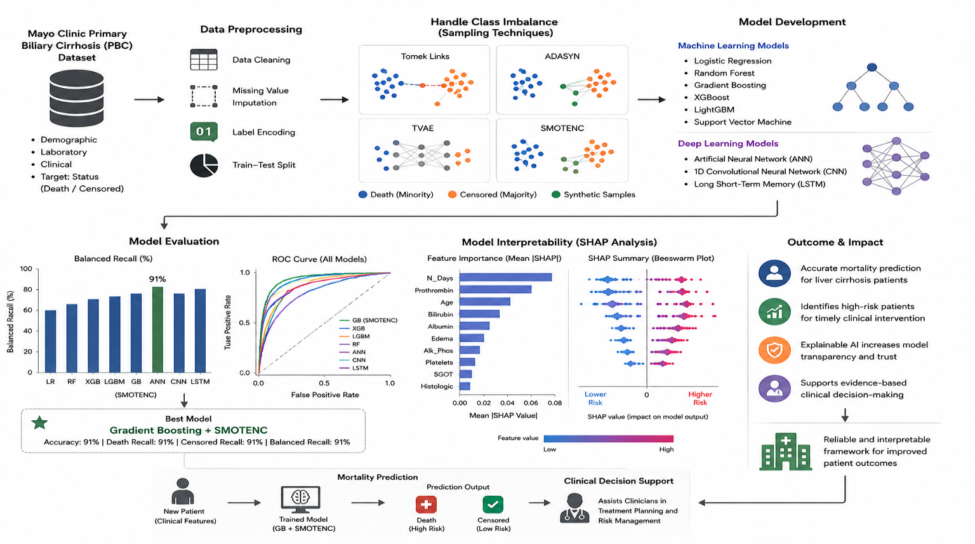

IMPACT STATEMENT:

The proposed explainable mortality prediction framework integrates effective class imbalance handling techniques with Machine Learning (ML), Deep Learning (DL), and Explainable Artificial Intelligence (XAI) to improve the prediction of liver cirrhosis patient outcomes. By combining multiple sampling techniques with predictive models, the framework enhances the identification of high-risk patients while reducing prediction bias caused by imbalanced clinical data. Furthermore, the integration of SHAP (SHapley Additive exPlanations) increases model transparency by providing clear explanations of the clinical features influencing each prediction, thereby improving the trustworthiness of AI-assisted healthcare systems. The proposed approach demonstrates strong predictive performance and interpretability, making it a reliable decision-support tool for clinicians. Ultimately, this research contributes to the development of transparent and data-driven healthcare solutions that facilitate early risk assessment, personalized patient management, and evidence-based clinical decision-making.

ACKNOWLEDGEMENTS

First and foremost, we express our sincere gratitude to Almighty Allah for His infinite mercy, blessings, and guidance, which have enabled the successful completion of this research. We extend our deepest appreciation to our respected supervisor, Simon Bin Akter, Lecturer, Department of Computer Science and Engineering, Northern University Bangladesh, for his invaluable guidance, continuous encouragement, constructive criticism, and unwavering support throughout this study. His profound knowledge and dedication have significantly enriched the quality of our work.

We are grateful to the Department of Computer Science and Engineering, Northern University Bangladesh, for providing an excellent academic environment and essential facilities. We also thank the department’s faculty members for their knowledge, experience, and encouragement during our undergraduate studies, which have been fundamental to our academic and research development. We acknowledge the contributions of researchers and authors whose published journals, conference papers, books, and datasets served as references. Their work in machine learning, healthcare analytics, and explainable artificial intelligence has informed this study.

We extend our heartfelt thanks to our friends and classmates for their cooperation, insightful discussions, technical support, and moral encouragement, which helped us overcome challenges and improve our research.

Finally, we express our deepest gratitude to our parents and family for their unconditional love, patience, faith, and continuous encouragement. Their sacrifices and support have been the cornerstone of our academic achievements.

We sincerely thank all who contributed directly or indirectly to the completion of this thesis. We hope this research advances intelligent healthcare systems by enabling more accurate, reliable, and interpretable mortality prediction for liver cirrhosis patients through machine learning techniques, thereby strengthening its contribution

TABLE OF CONTENTS
PAGE
CERTIFICATE OF APPROVAL.................................................................................................................i
DECLARATION ........................................................................................................................................ii
ABSTRACT ..............................................................................................................................................iii
GRAPHICAL ABSTRAC... ......................................................................................................................iii
IMPACT STATEMENT ............................................................................................................................iv
ACKNOWLEDGEMENTS.........................................................................................................................v
LIST OF FIGURES....................................................................................................................................ix
LIST OF TABLES.......................................................................................................................................x
LIST OF ABBREVIATIONS.....................................................................................................................xi

CHAPTER I INTRODUCTION………………………………….……………………1

  - Background of study……………………..……………………………...1

  - Problem Statement……………….…….................…………………..…2

  - Research Motivation………………….…………………………………2

  - Research Objectives……………………………………………………..3

  - Scope of the Study………………………………………………………3

  - Significance of the Study…………….………………………………….4

CHAPTER II LITERATURE REVIEW………...……………………………………..5

  - Introduction……………...………………………………………………5

  - Liver Cirrhosis: Clinical Background……………………...…………….5

  - Machine and Deep Learning in Healthcare…………….……………….6

  - Previous Studies on Liver Cirrhosis Prediction…………………………7

  - Class Imbalance in Medical Datasets………...…………………………8

  - Sampling Techniques…………………...……………………………….8

  - Explainable Artificial Intelligence (XAI)………………..……………...9

  - SHAP (SHapley Additive exPlanations)………………………………..9

  - Research Gap…………...……………………………………………...10

CHAPTER III RESEARCH METHODOLOGY……………………………………..11

  - Overview of the Proposed Methodology………………….………..…..11

  - Dataset Description……………………………………….……….……12

  - Data Preprocessing……………………………………….……….……13

  - Handling Class Imbalance……………………………….……..………13

  - Machine Learning Models……………………………….…….……….14

  - Deep Learning Models…………………………………………………14

  - Performance Evaluation Metrics………………….……………………15

3.7.1 Accuracy………………………………………………………………15

3.7.2 Precision………………………………………...……….…………….15

3.7.3 Recall (Sensitivity)……………………………………………………16

3.7.4 F1-Score…………………………………………………….…………16

  - SHAP-Based Explainability………………………………....…………16

  - Experimental Setup……………………………………………………..17

CHAPTER IV RESULTS AND DISCUSSION……………………………….………18

  - Introduction…………………………………………………………………18

  - Experimental Results……………………………………….……………….18

  - Experimental Environment…………………………………………………18

  - Machine Learning Model Results…………………………………………..20

  - Deep Learning Model Results………………………………………..……..20

  - Comparative Analysis of Model Results………………………………...….21

  - Confusion Matrix Analysis…………………………………………………21

  - SHAH-Based Explainability Results……………………………………….23

  - Discussion of Results……………………………………………….………23

  - Summary of Finding …………………………………...………………24

CHAPTER V CONCLUSION AND FUTURE WORK……………...……………….25

  - Conclusion……………………………..……………………………………25

  - Limitations of the Study …………...………….……………………………25

  - Future Work…………………………………………...……………………26

APPENDIX………………………………………………………………………...………………….27

Appendix A: Dataset Information………………..……………………………..27

Appendix B: Data Preprocessing………………….…………………………….27

Appendix C: Class Imbalance Handling………….……………………………..27

Appendix D: Machine Learning Models………….…………………………….28

Appendix E: Deep Learning Models……………………………………………28

Appendix F: Performance Evaluation…………………….…………….……….29

Appendix G: Experimental Environment……………….…..…………………..29

Appendix H: SHAP-Based Explainability……………..……………..…………30

Appendix I: Model Performance Tables……………….………………………..30

Appendix J: Confusion Matrix…………………...……………………….…….32

REFERENCES……...…………………………….…………………………………………………33

LIST OF FIGURES

Figure 3.1: Overall workflow of the proposed methodology....................................................................11
Figure 4.1: Confusion Matrices of Best Models .......................................................................................22
Figure 4.2: SHAP Summary Plot of Clinical Features..............................................................................23

LIST OF TABLES

Table 3.1 summarizes the main characteristics of the data set used in this study.....................................12
Table 4.1: Experimental Environment.......................................................................................................19
Table 4.2: Performance of Machine Learning models under different sampling techniques....................20
Table 4.3: Performance of Deep Learning models under different sampling techniques.........................21

LIST OF ABBREVIATIONS
ABBREVIATION | FULL FORM
AI | Artificial Intelligence
ML | Machine Learning
DL | Deep Learning
XAI | Explainable Artificial Intelligence
PBC | Primary Biliary Cirrhosis
SHAP | SHapley Additive exPlanations
LIME | Local Interpretable Model-agnostic Explanations
ADASYN | Adaptive Synthetic Sampling
TVAE | Tabular Variational Autoencoder
SMOTENC | Synthetic Minority Over-sampling Technique for Nominal and Continuous Features
1D-CNN | One-Dimensional Convolutional Neural Network
DNN | Deep Neural Network
ANN | Artificial Neural Network
MLP | Multilayer Perceptron
DT | Decision Tree
GaussianNB | Gaussian Naive Bayes
GB | Gradient Boosting
NAFLD | Non-Alcoholic Fatty Liver Disease
MELD | Model for End-Stage Liver Disease
CDSS | Clinical Decision Support System
EHR | Electronic Health Record
SDV | Synthetic Data Vault
TP | True Positive
TN | True Negative
FP | False Positive
FN | False Negative
C | Censored
D | Death

CHAPTER I

INTRODUCTION

Liver cirrhosis is a chronic, progressive liver disease characterized by the replacement of healthy liver tissue with scar tissue, leading to permanent damage and impaired function. It is a major cause of liver-related mortality globally and presents significant challenges to healthcare systems. As the disease advances, patients face severe complications such as liver failure, portal hypertension, hepatic encephalopathy, and death. Early and accurate mortality risk prediction is therefore essential for timely intervention and effective management [1].

The rapid progress in Artificial Intelligence (AI), especially Machine Learning (ML) and Deep Learning (DL), has significantly enhanced healthcare diagnostics, prognostics, and predictive analytics. These technologies analyze complex clinical data, uncover hidden patterns, and generate accurate predictive models. However, creating reliable mortality prediction models for liver cirrhosis is challenging due to clinical dataset imbalances and limited model interpretability. This study develops an explainable mortality prediction framework for liver cirrhosis patients using ML and DL models, utilizing the Mayo Clinic Primary Biliary Cirrhosis (PBC) dataset. Data preprocessing and sampling techniques are applied to address class imbalance before model training. Various models are evaluated to identify the most effective for mortality prediction. SHAP (SHapley Additive exPlanations) is employed to enhance interpretability by highlighting key clinical features influencing mortality risk. The results demonstrate that combining effective class imbalance solutions with explainable AI improves prediction accuracy and model transparency. This framework can aid healthcare professionals in identifying high-risk patients, supporting informed clinical decisions, and advancing reliable AI-driven healthcare systems [2], [3], [4].

1.1 Background of Study

Liver cirrhosis is a progressive liver disease that develops over time due to chronic liver damage caused by conditions such as viral hepatitis, excessive alcohol consumption, and non-alcoholic fatty liver disease (NAFLD). As the disease advances, the liver gradually loses its normal function, increasing the risk of severe complications and mortality. Early identification of high-risk patients is therefore essential for timely treatment and improved patient outcomes [1]

With the rapid growth of healthcare data, Machine Learning (ML) and Deep Learning (DL) have become valuable tools for predicting disease progression and patient survival. These techniques can analyze complex clinical data and support more accurate decision-making. However, medical datasets often suffer from class imbalance, which can reduce prediction performance, while many AI models lack interpretability, limiting their acceptance in clinical practice [2], [5], [3].

This study addresses these challenges by combining effective sampling techniques with ML and DL models and employing SHAP to explain model predictions. The proposed approach aims to improve both prediction performance and model transparency for liver cirrhosis mortality prediction [4].

1.2 Problem Statement

Liver cirrhosis is a leading cause of liver-related mortality worldwide, making early mortality prediction vital for enhancing patient care and clinical decisions. However, developing accurate and reliable prediction models remains challenging due to several factors [1].

A primary challenge is the class imbalance in the Mayo Clinic Primary Biliary Cirrhosis (PBC) dataset, where death and censored cases are unevenly distributed. This imbalance can bias models toward the majority class, reducing their effectiveness in identifying high-risk patients [5].

Additionally, the complexity of clinical data, characterized by diverse demographic, laboratory, and disease-related features, complicates the identification of key mortality factors through traditional methods. Moreover, many Machine Learning and Deep Learning models, despite achieving high accuracy, lack interpretability. Their "black-box" nature limits healthcare professionals’ ability to understand the rationale behind predictions, restricting their clinical applicability [3].

1.3 Research Motivation

This research is motivated by the increasing need for accurate and explainable mortality prediction in liver cirrhosis patients. As a leading cause of liver-related deaths globally, early identification of high-risk patients is critical for improving treatment planning and patient care [1], [2], [6].
Key motivations include:
- High Mortality of Liver Cirrhosis: The progressive nature and high fatality rate of liver cirrhosis necessitate early risk prediction for timely clinical intervention.
- Class Imbalance in Clinical Data: The uneven distribution of death and censored cases in datasets can impair model performance; this study explores various sampling methods to mitigate this issue.
- Need for Accurate Prediction Models: Evaluating multiple Machine Learning and Deep Learning models helps determine the most effective approach for mortality prediction [2], [4], [7].
- Lack of Model Interpretability: Many AI models, despite accuracy, lack transparency. This study employs SHAP to enhance interpretability and identify key clinical features influencing predictions [3], [4].
- Supporting Clinical Decision-Making: Developing an accurate, explainable framework aims to assist healthcare professionals in identifying high-risk patients and making informed treatment decisions.
Overall, this research seeks to integrate predictive accuracy with explainability to establish a reliable and transparent AI-based prediction framework for liver cirrhosis [3], [4].

1.4 Research Objectives

The primary objective of this research is to develop an accurate and explainable mortality prediction framework for liver cirrhosis patients using Machine Learning and Deep Learning models.
The specific objectives are to:
- Develop a mortality prediction framework utilizing Machine Learning and Deep Learning techniques.
- Preprocess the Mayo Clinic Primary Biliary Cirrhosis (PBC) dataset by addressing missing values, encoding categorical variables, and preparing data for model training.
- Evaluate various sampling techniques to address class imbalance and enhance prediction performance.
- Train and compare multiple Machine Learning and Deep Learning models for mortality prediction in liver cirrhosis patients [2].
- Identify the best-performing model based on standard evaluation metrics.
- Enhance model interpretability using SHAP (SHapley Additive exPlanations) to determine key clinical features influencing mortality risk [4].
- Develop a transparent and reliable AI-based framework to assist healthcare professionals in identifying high-risk patients and making informed clinical decisions.

1.5 Scope of the Study

This study aims to develop an explainable mortality prediction framework for liver cirrhosis patients using Machine Learning and Deep Learning techniques. The research utilizes the Mayo Clinic Primary Biliary Cirrhosis (PBC) dataset, which includes demographic, laboratory, and disease-related clinical data [1].
The scope encompasses data preprocessing, including handling missing values, encoding categorical variables, and applying various sampling techniques to address class imbalance in the training data. Multiple Machine Learning and Deep Learning models are trained and evaluated to determine the most effective mortality prediction method [5].
To enhance model transparency and interpretability, SHAP (SHapley Additive exPlanations) is used to explain predictions and identify the key clinical features impacting patient mortality. Model performance is assessed through standard evaluation metrics, with comparisons made to select the best-performing model [4].
This research is confined to the Mayo Clinic PBC dataset and focuses exclusively on mortality prediction in liver cirrhosis patients. It does not cover real-time clinical deployment, external dataset validation, or the creation of a full clinical decision support system. Nonetheless, the proposed framework establishes a solid foundation for future investigations into explainable artificial intelligence in healthcare.

1.6 Significance of the Study

This study advances the application of Artificial Intelligence (AI) in healthcare by developing an explainable mortality prediction framework for liver cirrhosis patients using Machine Learning and Deep Learning models. The key contributions are: [2], [4]

- Improved Mortality Prediction: Enhances prediction accuracy to enable early identification of high-risk patients, supporting timely clinical intervention.
- Handling Class Imbalance: Explores various sampling techniques to address class imbalance, resulting in more robust and reliable predictive performance [5].
- Comparative Analysis of AI Models: Evaluates multiple Machine Learning and Deep Learning models to identify the most effective approach for mortality prediction [2], [4], [7], [8].
- Enhanced Model Explainability: Utilizes SHAP (SHapley Additive exPlanations) to improve transparency by clarifying the impact of individual clinical features, making results more understandable for healthcare professionals [4].
- Support for Clinical Decision-Making: Provides a reliable and interpretable framework to assist clinicians in identifying high-risk patients and making informed treatment decisions [3], [4].
- Foundation for Future Research: Establishes a basis for further studies in explainable AI, advanced predictive modeling, and AI-driven clinical decision support systems in healthcare [4].

CHAPTER II

LITERATURE REVIEW

2.1 Introduction

Literature review is a critical component of research, providing an overview of prior studies, methodologies, and recent advancements related to the topic. It identifies strengths and limitations of existing work, highlights research gaps, and establishes the foundation for the current study.

This chapter examines previous research on liver cirrhosis mortality prediction, focusing on the use of Machine Learning (ML) and Deep Learning (DL) techniques in healthcare. It addresses challenges such as class imbalance and limited interpretability of predictive models. Additionally, it explores the role of Explainable Artificial Intelligence (XAI), particularly SHAP (SHapley Additive exPlanations), in enhancing model transparency and aiding clinical decision-making [2], [3], [4].

Finally, a comparative analysis of existing studies is presented to identify research gaps and justify the need for an accurate and explainable mortality prediction framework for liver cirrhosis patients. This review lays the theoretical and practical groundwork for the methodology proposed in this research.

2.2 Liver Cirrhosis: Clinical Background

Liver cirrhosis is a chronic, progressive, and irreversible liver disease characterized by the replacement of healthy liver tissue with fibrotic scar tissue and regenerative nodules. This structural damage impairs liver functions such as metabolism, detoxification, protein synthesis, and bile production. As the disease advances, liver function declines, raising the risk of severe complications and mortality [1].

Cirrhosis develops over years due to continuous liver injury, commonly caused by chronic hepatitis B and C infections, excessive alcohol use, non-alcoholic fatty liver disease (NAFLD), autoimmune liver diseases, and certain genetic or metabolic disorders. Early stages may present mild or no symptoms, complicating timely diagnosis. Later, symptoms may include fatigue, jaundice, ascites, weight loss, muscle wasting, easy bruising, and hepatic encephalopathy-related confusion [1].

Advanced cirrhosis can lead to life-threatening complications such as portal hypertension, variceal bleeding, liver failure, and hepatocellular carcinoma, significantly increasing mortality risk and often necessitating intensive care or liver transplantation. Accurate disease severity assessment and early mortality prediction are essential for optimizing treatment and improving outcomes [9], [10], [11].

Traditionally, clinicians rely on laboratory tests, imaging, and scoring systems like the Child-Pugh and MELD scores. While useful, these methods have limitations in capturing complex clinical variable interactions and may lack precision in mortality prediction [12], [11].

Recent advances in Machine Learning (ML) and Deep Learning (DL) offer new opportunities to enhance mortality prediction by analyzing large clinical datasets, uncovering hidden patterns, and generating more accurate models. Incorporating Explainable Artificial Intelligence (XAI) techniques further aids clinicians by clarifying the rationale behind predictions, thereby fostering trust in AI-supported clinical decisions [2], [3].

2.3 Machine and Deep Learning in Healthcare

Artificial Intelligence (AI) has become a powerful tool in healthcare, helping process large medical datasets and assisting clinicians with diagnosis, outcome prediction, treatment planning, and disease forecasting. Machine Learning (ML) and Deep Learning (DL) are especially notable for their ability to identify complex patterns and build accurate predictive models from clinical data [2].

Machine Learning, a subset of AI, enables computers to learn from past data without explicit instructions by finding relationships among clinical variables to predict new cases. It is widely used in disease diagnosis, risk assessment, mortality prediction, medical imaging, drug discovery, and personalized treatment. Common ML algorithms include Logistic Regression, Decision Trees, Random Forests, Support Vector Machines, K-Nearest Neighbors, Gradient Boosting, and XGBoost, all effective in medical applications [2], [7], [13], [14], [15].

Deep Learning uses Artificial Neural Networks with multiple layers to automatically learn hierarchical features from complex data, requiring less manual feature engineering than traditional ML. DL has excelled in medical image classification, disease detection, electronic health record analysis, and mortality prediction, with popular architectures like CNNs, RNNs, and LSTMs [16], [17].

Despite their accuracy, many ML and DL models act as “black boxes,” making it difficult to understand their decision processes. In clinical practice, it is crucial not only to have accurate predictions but also clear explanations to build trust. Explainable AI (XAI) techniques address this need by improving model transparency [3].

This study applies to both ML and DL models to predict mortality risk in liver cirrhosis patients, comparing their performance with standard metrics. It also uses SHAP (SHapley Additive exPlanations) to explain the predictions of the best model by identifying the most influential clinical features. Combining accurate prediction with explainability offers a trustworthy and practical tool for clinical decision support [4], [3].

2.4 Previous Studies on Liver Cirrhosis Prediction

In recent years, many studies have explored Artificial Intelligence (AI), especially Machine Learning (ML) and Deep Learning (DL), to predict disease progression and mortality in liver cirrhosis patients. These models help healthcare professionals identify high-risk patients, improve clinical decisions, and enable timely interventions. Traditional ML algorithms like Logistic Regression, Decision Trees, Random Forest, Support Vector Machine, K-Nearest Neighbors, Gradient Boosting, and XGBoost have shown promising results using clinical and lab data. Ensemble methods such as Random Forest and Gradient Boosting often perform best due to handling complex feature interactions and reducing overfitting [2], [6], [18], [19], [20], [21], [4].

With advances in computing, DL models including Artificial Neural Networks and other deep architectures have also been applied, learning complex relationships from data without much manual feature engineering and excelling when large datasets are available [17], [2].

Despite these advances, challenges remain. Class imbalance, where mortality cases are much fewer than non-mortality or censored cases, causes models to bias toward the majority class, reducing their ability to detect high-risk patients. Sampling techniques like oversampling, under sampling, and synthetic data generation have been used to address this. Another key issue is interpretability: many ML and DL models act as black boxes, making it hard for clinicians to understand predictions. Since transparency is vital in healthcare, Explainable AI (XAI) techniques like SHAP have gained popularity to explain model decisions and increase clinician trust [5], [4].

Although previous studies show AI’s promise for liver cirrhosis prediction, there is still a need for models that combine high accuracy, effective class imbalance handling, and meaningful interpretability. This research develops an explainable mortality prediction framework by integrating class imbalance methods, ML and DL models, and SHAP-based explainability to provide reliable, transparent clinical decision support [2], [18], [19], [20], [21], [4].

Recent studies further demonstrate the growing use of machine learning and explainable methods for cirrhosis-related risk prediction. Wang et al. developed a machine-learning model for short-term mortality in critically ill patients with liver cirrhosis, while Obite et al. applied a deep-learning survival framework to cirrhosis data [22], [2]. More recent work has investigated interpretable in-hospital mortality prediction, prospective mortality prediction in cirrhosis with esophageal variceal bleeding, and multicenter validation of machine-learning models for ICU mortality [18], [2], [6].

Other recent studies have focused on non-invasive decompensation prediction, survival and hepatocellular carcinoma risk in diabetic cirrhosis, mortality associated with acute kidney injury in decompensated cirrhosis, and XGBoost-SHAP modeling for hepatic encephalopathy risk [23], [19], [20], [21].
These studies indicate that current research is increasingly moving toward externally validated, interpretable, and clinically oriented prediction models.

2.5 Class Imbalance in Medical Datasets

Class imbalance is a common challenge in medical datasets, where one class contains significantly more samples than the other. In mortality prediction, the number of surviving or censored patients is often much higher than the number of death cases. As a result, predictive models tend to favor the majority class, leading to poor detection of minority class instances and reducing the reliability of the prediction system [5].

Several sampling techniques have been developed to address this issue by balancing the class distribution before model training. These techniques either generate additional minority class samples, remove majority class samples, or combine both approaches to improve model learning. Effective handling of class imbalance can significantly enhance the ability of Machine Learning and Deep Learning models to identify high-risk patients [5].

Since the liver cirrhosis dataset used in this study is imbalanced, appropriate sampling techniques are applied to improve model performance and reduce prediction bias. The sampling methods adopted in this research are discussed in the following section [5].

2.6 Sampling Techniques

Sampling techniques are widely used to address class imbalance by balancing class distributions before model training. In medical datasets, where minority class samples are often limited, these methods help models learn more effectively and improve identification of high-risk patients. By reducing bias toward the majority class, sampling enhances the accuracy and reliability of Machine Learning and Deep Learning models [5].

This study explores four sampling techniques to handle class imbalance in the Mayo Clinic Primary Biliary Cirrhosis (PBC) dataset: Tomek Links, Adaptive Synthetic Sampling (ADASYN), Tabular Variational Autoencoder (TVAE), and Synthetic Minority Over-sampling Technique for Nominal and Continuous Features (SMOTENC). Each method uses a distinct approach to balance the training data, and their impact on mortality prediction is evaluated and compared [5].

2.7 Explainable Artificial Intelligence (XAI)

Explainable Artificial Intelligence (XAI) aims to make the predictions of Machine Learning and Deep Learning models understandable to humans. While advanced models often achieve high accuracy, they frequently function as black boxes, making it difficult to explain how specific predictions are made. This lack of transparency can limit AI adoption in healthcare, where clinicians need clear and trustworthy explanations before making medical decisions [3], [4].

XAI addresses this by providing meaningful explanations for model predictions and identifying key factors influencing decisions. In healthcare, explainability helps clinicians validate AI output, increases trust in models, and supports informed clinical decision-making. As a result, XAI has become essential in modern medical prediction systems, especially in high-risk areas like mortality prediction [3], [4].

This study incorporates XAI to enhance transparency in the proposed mortality prediction framework. The specific explainability technique used is described in the following section.

2.8 SHAP (SHapley Additive exPlanations)

SHAP (SHapley Additive exPlanations) is a widely used Explainable Artificial Intelligence (XAI) technique for interpreting predictions from Machine Learning and Deep Learning models. It is based on Shapley values from cooperative game theory, assigning each feature a contribution score that reflects its influence on the model’s prediction [4].

One of SHAP’s main strengths is its ability to provide both global and local explanations. Global explanations show the overall importance of features across the entire dataset, while local explanations reveal how features contribute to individual predictions. This helps researchers and healthcare professionals better understand model behavior and verify whether predictions are clinically meaningful [4], [3].

In this study, SHAP is used to interpret the predictions of the best-performing mortality prediction model. By analyzing each clinical feature’s contribution, SHAP identifies the most influential factors, enhancing the transparency and reliability of the prediction framework [4].

2.9 Research Gap

Despite many studies applying Machine Learning and Deep Learning for liver cirrhosis diagnosis and mortality prediction, several key research gaps remain [2], [6], [18], [19], [20], [21], [4].

First, most studies focus on improving prediction accuracy but pay little attention to the class imbalance issue. Since medical datasets often have far fewer mortality cases than non-mortality cases, models can become biased toward the majority class, limiting their effectiveness in identifying high-risk patients [5].

Second, prior research typically evaluates only a few Machine Learning or Deep Learning algorithms. Comprehensive comparisons across multiple models and sampling techniques are limited, making it hard to determine the best approach for liver cirrhosis mortality prediction [2], [6].

Third, while advanced AI models can achieve strong performance, many act like black boxes. This lack of transparency makes it difficult for healthcare professionals to understand predictions, reducing their confidence in AI-supported clinical decisions [3], [4].

Finally, few studies integrate Explainable AI (XAI) methods with mortality prediction models. The use of SHAP (SHapley Additive exPlanations) to interpret predictions and identify influential clinical features is still scarce in liver cirrhosis research [4].

To address these gaps, this study develops an explainable mortality prediction framework that combines effective class imbalance handling, multiple Machine Learning and Deep Learning models, and SHAP-based explainability. The framework aims to improve prediction accuracy, increase model transparency, and provide reliable support for clinical decision-making in managing liver cirrhosis patients.

CHAPTER III

RESEARCH METHODOLOGY

3.1 Overview of the Proposed Methodology

This chapter presents the methodology adopted to develop an explainable mortality prediction framework for liver cirrhosis. The proposed framework consists of a series of systematic steps, beginning with data collection and preprocessing, followed by class imbalance handling, model development, performance evaluation, and model interpretation. The Mayo Clinic Primary Biliary Cirrhosis (PBC) dataset was first prepared through data cleaning, missing value imputation, label encoding, and train-test splitting. Different sampling techniques were then applied to address class imbalance before training multiple Machine Learning (ML) and Deep Learning (DL) models. The models were evaluated using standard performance metrics, and the best-performing model was interpreted using SHAP to identify the clinical features that most influenced mortality prediction. The overall workflow of the proposed methodology is illustrated in Figure 3.1 [5], [4].

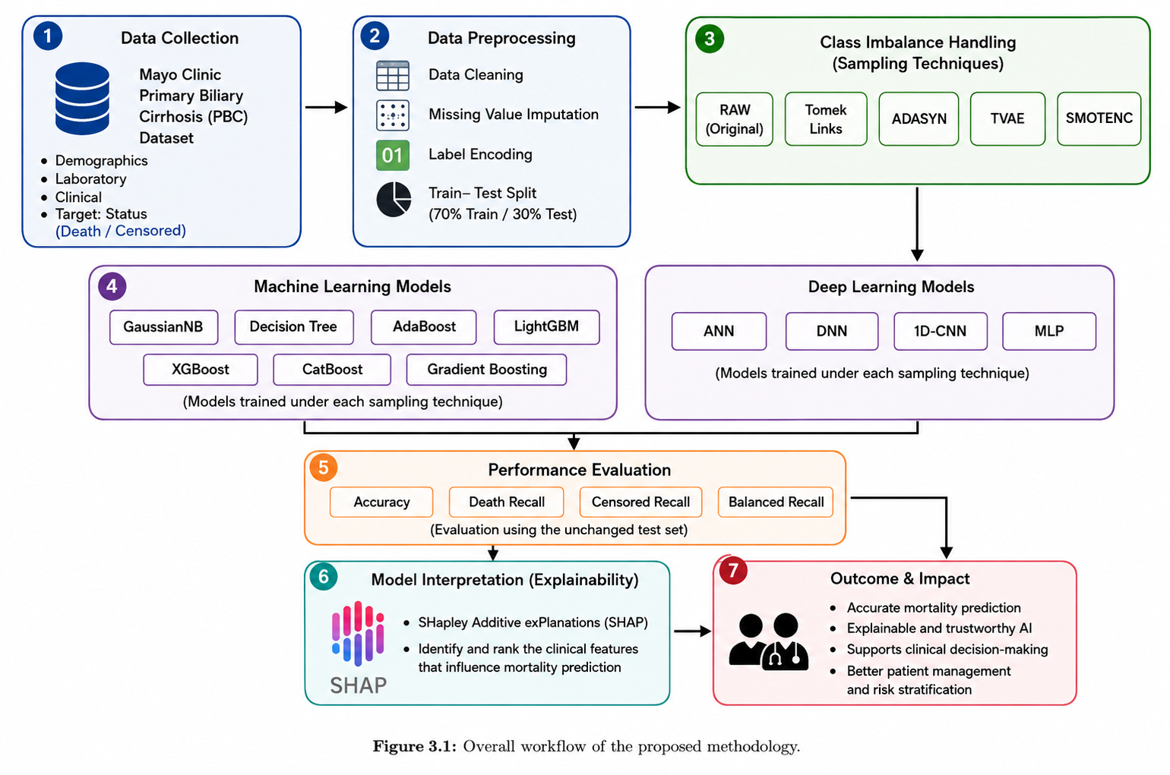

3.2 Dataset Description

This study uses the Mayo Clinic Primary Biliary Cirrhosis (PBC) dataset to develop and evaluate the proposed mortality prediction framework. The dataset contains clinical information collected from patients diagnosed with primary biliary cirrhosis and has been widely used in medical research for survival analysis and predictive modeling. It includes demographic information, laboratory test results, and clinical observations that are relevant to patient prognosis [1].

The dataset consists of multiple numerical and categorical features describing each patient's health condition. Before model development, the dataset was examined to understand its structure, feature distribution, and target variable. These clinical attributes provide valuable information for training predictive models capable of estimating mortality risk in liver cirrhosis patients [1].

Table 3.1 summarizes the main characteristics of the dataset used in this study.

PROPERTY | DESCRIPTION
Dataset Name | Mayo Clinic Primary Biliary Cirrhosis (PBC)
Source | Mayo Clinic
Total Samples | 418
Number of Features | 20
Target Variable | Status (Death/Censored)
Data Type | Structured Clinical Data
Feature Types | Numerical and Categorical

Table 3.1

The target variable used in this study is Status, which represents the survival outcome of each patient. For binary classification, the target was categorized into Death and Censored, where Death indicates patients who died during the study period and Censored represents patients who were alive or whose survival outcome was not observed at the end of the follow-up period [1].

3.3 Data Preprocessing

Data preprocessing is a crucial step in developing reliable prediction models because the quality and consistency of input data directly affect model performance and accuracy. Before training Machine Learning and Deep Learning models, the Mayo Clinic Primary Biliary Cirrhosis (PBC) dataset underwent a thorough preprocessing pipeline designed to improve data quality and ensure uniformity across all features, preparing the data for effective modeling [2].

The initial preprocessing phase involved a detailed examination of the dataset to identify and remove duplicate records, correct inconsistent values, and eliminate irrelevant or redundant information. This step was vital to reduce noise and prevent misleading patterns that could negatively impact model training.

Next, the dataset’s missing values were carefully addressed. Both numerical and categorical features contained gaps that, if left untreated, could diminish the models' statistical power and predictive accuracy. For numerical features, missing values were imputed using the median, which lessens the influence of extreme values and preserves the overall data distribution. For categorical features, missing data were filled with the most frequent category, maintaining the integrity of categorical distributions.Since the dataset included several categorical variables, label encoding was applied to convert them into a numerical format that Machine Learning and Deep Learning algorithms can process efficiently. This transformation allowed the models to utilize the full scope of feature information without error [2].

Finally, the dataset was split into training and testing subsets. The training set was used to build and optimize the prediction models, enabling them to learn meaningful patterns and relationships in the data. The testing set, kept separate and unseen during training, was used to evaluate the models’ generalization ability and performance on new data, ensuring the results reflect real-world predictive effectiveness [2].
This comprehensive preprocessing strategy established a solid foundation for developing robust, accurate, and generalizable prediction models capable of handling the complexities of clinical datasets like the Mayo Clinic PBC dataset.

3.4 Handling Class Imbalance

Class imbalance is a common problem in medical datasets, where one class has many more samples than the other. In the Mayo Clinic PBC dataset, mortality outcomes are unevenly distributed, which may cause prediction models to favor the majority class and reduce accuracy in identifying minority class cases [5].

To address this, five data distributions were evaluated in this study. The original dataset (RAW) was used as a baseline, while four sampling techniques—Tomek Links, ADASYN, TVAE, and SMOTENC—were applied to balance the training data. Each method uses a different strategy to improve class balance and enhance model learning [5].

These balanced datasets were then used to train and evaluate both Machine Learning and Deep Learning models. By comparing model performance across the sampling methods, this study identifies the most effective approach for improving mortality prediction in liver cirrhosis patients [5].

3.5 Machine Learning Models

Machine Learning models were employed to predict the mortality outcome of liver cirrhosis patients using the preprocessed Mayo Clinic Primary Biliary Cirrhosis (PBC) dataset. The selected models represent different types of classification approaches, including probabilistic, tree-based, ensemble, and boosting algorithms. Each model was trained using the original training data and the training data generated using different sampling techniques [2].

The Machine Learning models used in this study include Gaussian Naive Bayes (GaussianNB), Decision Tree, AdaBoost, Light Gradient Boosting Machine (LightGBM), Extreme Gradient Boosting (XGBoost), Categorical Boosting (CatBoost), and Gradient Boosting. These models were selected to provide a comparative evaluation of different learning strategies for mortality prediction [4], [7], [8], [14], [24], [25].

The models were evaluated using the unchanged test set to ensure a fair comparison. Their performance was assessed using Accuracy, Death Recall, Censored Recall, and Balanced Recall. The results from the different sampling techniques were compared to identifying the most effective model and sampling combination [26].

3.6 Deep Learning Models

Deep Learning models were also evaluated to determine their effectiveness in predicting mortality outcomes from the preprocessed clinical dataset. These models were included to compare neural-network-based approaches with the Machine Learning models [17].

The Deep Learning models used in this study include Artificial Neural Network (ANN), Deep Neural Network (DNN), one-dimensional Convolutional Neural Network (1D-CNN), and Multilayer Perceptron (MLP). Each model was trained using the same training and testing framework and evaluated under the different sampling techniques [16], [17].

The Deep Learning models were compared based on Accuracy, Death Recall, Censored Recall, and Balanced Recall. This comparison allowed the study to determine whether Deep Learning approaches could provide competitive performance for liver cirrhosis mortality prediction [17].

3.7 Performance Evaluation Metrics

The performance of the Machine Learning and Deep Learning models was evaluated using Accuracy, Death Recall, Censored Recall, and Balanced Recall. These metrics were selected to provide a more appropriate evaluation of mortality prediction on the imbalanced dataset [26], [27].

Accuracy measures the overall proportion of correctly classified cases. Death Recall measures the ability of the model to correctly identify patients whose outcome is Death, while Censored Recall measures the ability to correctly identify Censored cases. Balanced Recall represents the average recall obtained across the Death and Censored classes and therefore provides an indication of whether the model performs consistently across both outcome classes [27].

3.7.1 Accuracy

Accuracy measures the proportion of correctly classified instances out of all observations. It gives a general sense of model performance but can be misleading with highly imbalanced datasets. [27].
Formula:
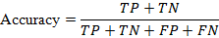
Where:
- TP = True Positive
- TN = True Negative
- FP = False Positive
- FN = False Negative

3.7.2 Precision

Precision indicates the proportion of correct positive predictions among all positive predictions made by the model. High precision means fewer false positives. [27].
Formula:
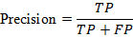

3.7.3 Recall (Sensitivity)

Recall measures the proportion of actual positives correctly identified by the model. It is crucial in medical contexts to avoid missing high-risk patients [27].
Formula:
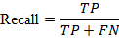

3.7.4 F1-Score

The F1-Score is the harmonic mean of Precision and Recall, balancing false positives and false negatives. It's especially useful for imbalanced classification tasks. [27].
Formula:
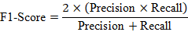

These metrics were calculated using the unchanged test set after each model was trained using the corresponding sampling strategy. The results were then compared to identify the best-performing model and sampling technique.

3.8 SHAP-Based Explainability

Although many Machine Learning and Deep Learning models achieve high prediction accuracy, their decision-making process is often difficult to interpret. In healthcare applications, understanding why a model makes a particular prediction is essential for building trust and supporting clinical decision-making [3].

To improve model transparency, this study employs SHAP (SHapley Additive exPlanations) to explain the predictions of the best-performing model. SHAP quantifies the contribution of each clinical feature to the prediction outcome, allowing both global and local interpretation of the model. Global explanations identify the most influential features across the entire dataset, while local explanations explain the contribution of individual features to a specific prediction [4].

By integrating SHAP into the proposed framework, this study not only evaluates prediction performance but also provides meaningful insights into the clinical factors associated with liver cirrhosis mortality. This enhances the reliability and interpretability of the proposed prediction system [4].

3.9 Experimental Setup

The proposed framework was implemented using Python in the Google Colab environment. Data preprocessing, model development, and performance evaluation were carried out using widely adopted Python libraries, including Pandas, NumPy, Scikit-learn, TensorFlow, Keras, XGBoost, LightGBM, CatBoost, SHAP, and Matplotlib.

All Machine Learning and Deep Learning models were trained using the same preprocessed dataset under identical experimental conditions to ensure a fair comparison. The training data were balanced using different sampling techniques before model development, while the testing data remained unchanged for unbiased performance evaluation. The effectiveness of each model was assessed using the evaluation metrics described in Section 3.7, and the best-performing model was further analyzed using SHAP for explainability [5], [4]
CHAPTER IV

RESULTS AND DISCUSSION

4.1 Introduction

This chapter presents the experimental results obtained from the Machine Learning and Deep Learning models developed for liver cirrhosis mortality prediction. The models were evaluated using the original dataset and different sampling techniques to examine the effect of class imbalance handling on prediction performance. The results are compared using Accuracy, Death Recall, Censored Recall, and Balanced Recall. Finally, the best-performing model is interpreted using SHAP to identify the clinical features that contributed most to its predictions [4].

4.2 Experimental Results

The experimental results were derived by evaluating the performance of selected Machine Learning and Deep Learning models on both the original and various sampled versions of the dataset. Model performance was assessed using key metrics including Accuracy, Death Recall, Censored Recall, and Balanced Recall to provide a comprehensive evaluation of predictive capabilities.

The analysis encompassed multiple sampling approaches, such as the original RAW data, Tomek Links, ADASYN, TVAE, and SMOTENC. This comparative evaluation aimed to understand the impact of different sampling techniques on model performance and to identify the optimal combination of sampling strategy and predictive model that yields the best results [28].

In the sections that follow, the results from Machine Learning models and Deep Learning models are presented separately. This is followed by a comparative analysis of their performance, along with a detailed SHAP-based interpretation of the selected model to elucidate the key features influencing prediction outcomes.

4.3 Experimental Environment

The mortality prediction framework was developed and tested within a controlled, reproducible experimental setup that included data preprocessing, handling class imbalance, model training, evaluation, and interpretability. Python was chosen as the main programming language due to its rich library ecosystem for numerical computing, data analysis, and machine learning, with Pandas and NumPy supporting data manipulation and numerical tasks [29], [30].

Experiments were run on Google Colaboratory (Google Colab), a cloud-based Jupyter Notebook environment offering computational resources for machine learning and data analysis, using its standard Linux-hosted runtime [31]. Scikit-learning facilitated preprocessing, feature encoding, train-test splitting, model development, and evaluation [32].

For gradient-boosting classifiers, XGBoost, LightGBM, and CatBoost were employed [4], [7], [8].
To manage class imbalance in the liver cirrhosis dataset, imbalanced-learn (imblearn) provided the sampling implementations used in this study, including ADASYN, SMOTENC, and Tomek Links [33]. The theoretical discussion of class imbalance is supported by [5]. Synthetic tabular data was generated using Synthetic Data Vault (SDV) with the TVAE model [28]. Model interpretability was achieved through SHAP (SHapley Additive exPlanations) to explain predictions and assess feature contributions [4]. Visualization and graphical results were created with Matplotlib and Seaborn.

This environment ensures a consistent platform for building and assessing machine learning and deep learning models on imbalanced medical data, leveraging established open-source libraries to support reproducibility and future framework enhancements.

Component |  | Specification
Programming Language |  | Python 3.12
Development Platform |  | Google Collaboratory (Google Colab)
Operating System |  | Linux-based hosted runtime
Data Manipulation |  | Pandas, NumPy
Machine Learning Library |  | Scikit-learn
Gradient Boosting Libraries |  | XGBoost, LightGBM, CatBoost
Class Imbalance Library |  | Imbalanced-learn (imblearn)
Synthetic Data Generation |  | SDV (TVAE)
Explainability Library |  | SHAP
Data Visualization |  | Matplotlib, Seaborn

Table 4.1: Experimental Environment

This environment provides a reliable and reproducible platform for implementing and evaluating Machine Learning and Deep Learning models on imbalanced medical datasets, while producing interpretable predictions. The use of widely adopted open-source libraries further ensures that the framework can be replicated and extended by other researchers.

4.4 Machine Learning Model Results
The Machine Learning models were evaluated across the original dataset and the four applied sampling techniques. The results show differences in predictive performance depending on the sampling strategy used. Among the evaluated approaches, Gradient Boosting combined with SMOTENC produced the strongest overall performance.

The selected model achieved 91% Accuracy, with 91% Recall for the Death class, 91% Recall for the Censored class, and 91% Balanced Recall. This indicates that the model was able to maintain a balanced performance between the two outcome classes rather than favoring the majority class.

The comparative results of the Machine Learning models under the different sampling techniques are presented in Table 4.2. This comparison provides the basis for identifying the most effective sampling-model combination for mortality prediction.

MODEL | SAMPLING TECHNIQUE | DEATH RECALL | CENSORED RECALL | ACCURACY (%) | BALANCED RECALL
GaussianNB | SMOTENC | 0.59 | 0.87 | 76 | 0.73
Decision Tree | Tomek Links | 0.78 | 0.83 | 81 | 0.81
AdaBoost | SMOTENC | 0.91 | 0.85 | 87 | 0.88
LightGBM | TVAE | 0.81 | 0.96 | 90 | 0.89
XGBoost | TVAE | 0.84 | 0.94 | 90 | 0.89
CatBoost | SMOTENC | 0.84 | 0.96 | 91 | 0.90
Gradient Boosting | SMOTENC | 0.91 | 0.91 | 91 | 0.91

Table 4.2: Performance of Machine Learning models under different sampling techniques

4.5 Deep Learning Model Results

The Deep Learning models were evaluated using the same dataset configurations and performance metrics applied to the Machine Learning models. The purpose was to examine whether Deep Learning approaches could provide competitive performance for mortality prediction under different class imbalance conditions.

The results obtained from the Deep Learning models are presented in Table 4.3. The comparison shows how the performance of the models varied across the RAW dataset and the different sampling techniques. These results were considered alongside the Machine Learning results to provide an overall comparison of the approaches used in this study.

MODEL | SAMPLING TECHNIQUE | DEATH RECALL | CENSORED RECALL | ACCURACY (%) | BALANCED RECALL
1D-CNN | RAW | 0.84 | 0.83 | 84 | 0.84
DNN | TVAE | 0.84 | 0.87 | 86 | 0.86
ANN | ADASYN | 0.88 | 0.85 | 86 | 0.87
MLP | RAW | 0.84 | 0.94 | 90 | 0.89

Table 4.3: Performance of Deep Learning models under different sampling techniques

4.6 Comparative Analysis of Model Performance

The results of the Machine Learning and Deep Learning models were compared to determine the most effective approach for liver cirrhosis mortality prediction. The comparison considered the performance obtained under the different sampling techniques and focused on the balance between the Death and Censored classes.

Among the evaluated approaches, Gradient Boosting with SMOTENC achieved the best overall results, with 91% Accuracy, 91% Death Recall, 91% Censored Recall, and 91% Balanced Recall. The balanced recall values indicate that the model performed consistently across both outcome classes, which is particularly important for the imbalanced clinical dataset used in this study.

The comparative results demonstrate that the choice of sampling technique can have a noticeable effect on model performance. In particular, the results obtained with SMOTENC suggest that preserving the characteristics of both numerical and categorical clinical features can be beneficial for this prediction task [9].

4.7 Confusion Matrix Analysis
A confusion matrix was used to analyze the classification performance of the selected mortality prediction model at the class level. Unlike aggregate performance metrics, a confusion matrix compares the actual and predicted class labels and provides a detailed view of correct classifications and misclassification patterns. It is particularly useful for medical classification problems because sensitivity, specificity, accuracy, and other performance measures can be derived from the entries of the confusion matrix [26], [26].
Figure 4.1 presents the confusion matrix obtained from the test set, where the rows represent the actual classes and the columns represent the predicted classes. Each cell indicates the number of samples belonging to a particular actual class that were assigned to each predicted class. The values along the main diagonal represent correctly classified observations, whereas the off-diagonal values represent misclassified observations. For the two outcome classes—Censored (C) and Death (D)—the concentration of observations along the main diagonal indicates that the model correctly classified a substantial proportion of the test samples. The off-diagonal values provide additional information about the specific types of classification errors made by the model.[27]
Special attention was given to the Death (D) class because failure to identify an actual mortality case represents a false-negative prediction and may be particularly important in a clinical risk-prediction context. In medical prediction systems, false negatives can result in high-risk cases being overlooked, making sensitivity or recall an important measure when evaluating disease or mortality-related classification models. In this study, the sampling strategy was applied to the training data to address class imbalance and improve the detection of minority-class observations. The resulting class-level performance was therefore assessed using recall and balanced recall in addition to overall accuracy [5], [26], [27].

Overall, the confusion matrix provides a detailed assessment of how the proposed model distinguishes among the three outcome classes and complements the aggregate evaluation metrics reported in the preceding sections. The diagonal and off-diagonal distributions demonstrate the model's classification behavior on the test set, while the class-specific recall values provide additional evidence regarding their ability to identify individual outcome categories [26], [27].

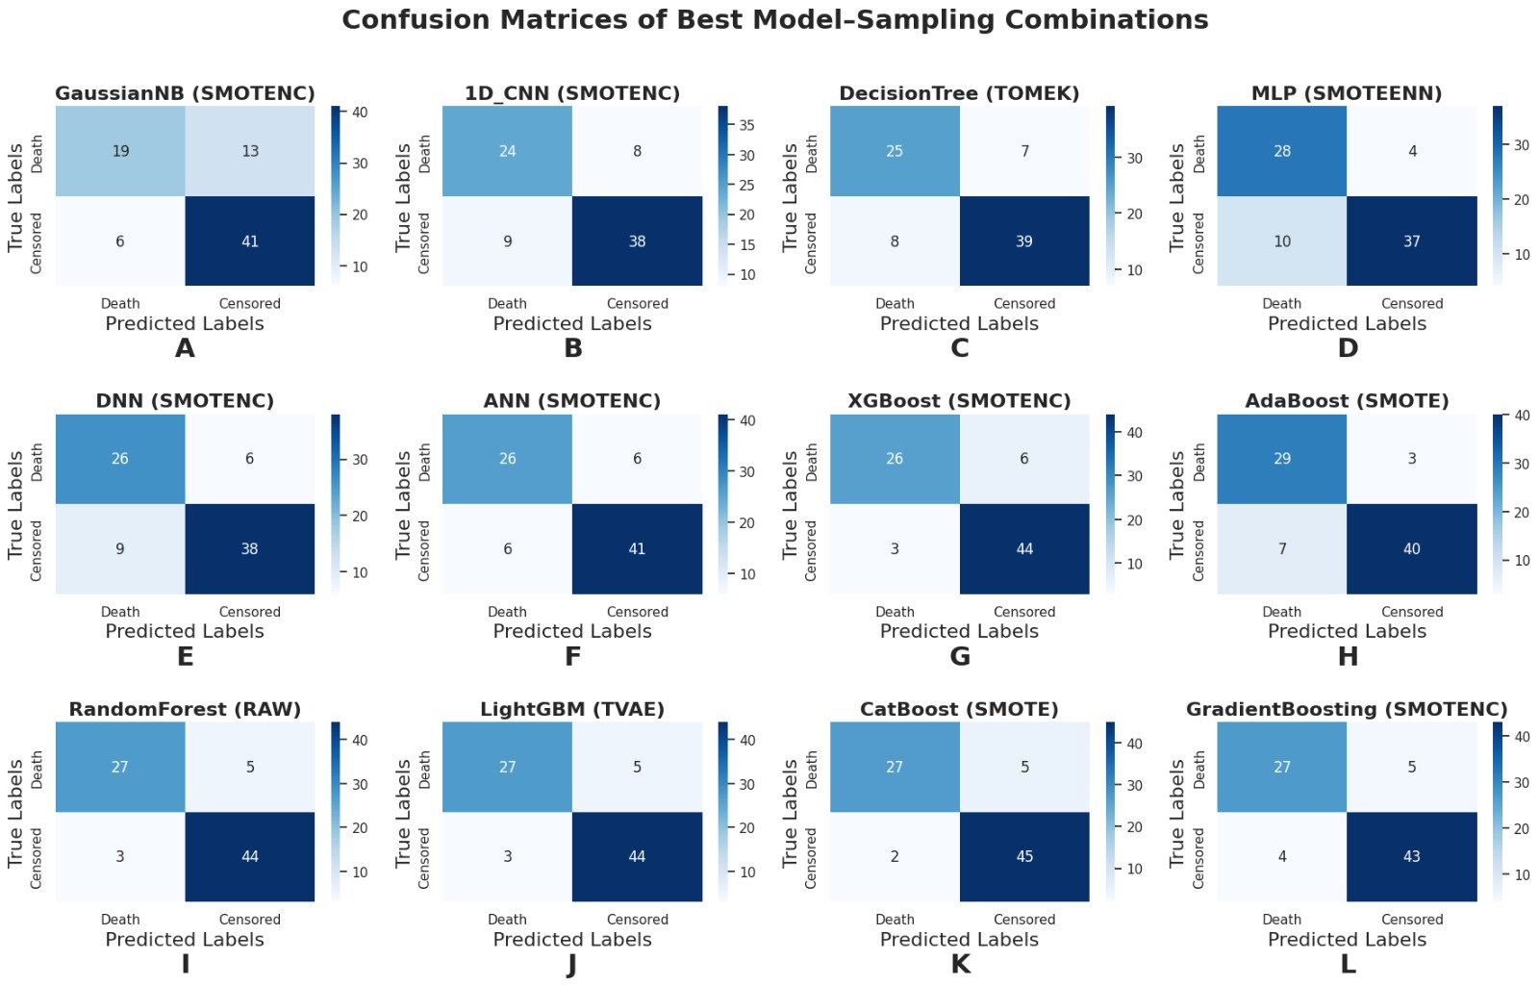

Figure 4.1: Confusion matrices of the best model–sampling combinations showing class-wise mortality prediction performance.

4.8 SHAP-Based Explainability Results

SHAP was used to interpret the predictions of the best-performing Gradient Boosting model with SMOTENC. The analysis shows how individual clinical features contributed to the model's mortality predictions and provides a clearer understanding of the model's decision-making process [4].
The SHAP summary plot presents the features according to their overall contribution to the model output. N Days, Prothrombin, Age, Bilirubin, and Albumin appear among the most influential features in the model. The position of each point represents its SHAP value, while the color indicates the corresponding feature value. This allows both the importance and direction of feature contributions to be observed.

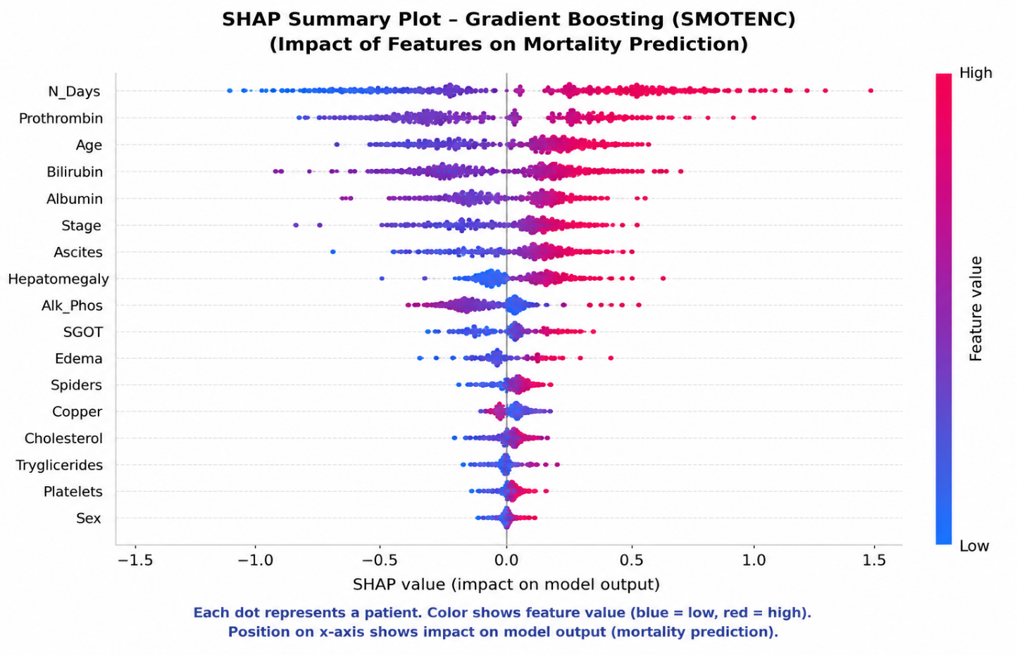

Figure 4.2: SHAP summary plot showing the contribution of clinical features to mortality prediction.

The SHAP analysis improves the interpretability of the proposed model by showing which clinical variables have the greatest influence on mortality prediction. This provides additional insight into the model beyond its numerical performance measures [4].

4.9 Discussion of Results

The experimental results show that handling class imbalance has a noticeable effect on the performance of liver cirrhosis mortality prediction models. The comparison across the different sampling techniques indicates that model performance varies depending on how the training data are distributed [5].

Among the evaluated approaches, Gradient Boosting with SMOTENC achieved the strongest overall performance, with 91% Accuracy, 91% Death Recall, 91% Censored Recall, and 91% Balanced Recall. The balanced recall indicates that the model maintained similar prediction ability for both outcome classes rather than performing well only in the majority class.
The results also show that the combination of an appropriate sampling technique and a suitable prediction model is important for this dataset. The use of SMOTENC was particularly effective because it considers the characteristics of categorical and continuous features during synthetic sample generation.

The SHAP analysis further supports the interpretability of the selected model by identifying the clinical features that contributed most to its predictions. Overall, the findings demonstrate that combining class imbalance handling with predictive modeling and explainability can provide a more balanced and interpretable approach to liver cirrhosis mortality prediction [3], [4].

4.10 Summary of Findings

The experimental analysis demonstrates that the choice of sampling technique influences the performance of both Machine Learning and Deep Learning models. Among the evaluated combinations, Gradient Boosting with SMOTENC achieved the best overall performance with 91% Accuracy, 91% Death Recall, 91% Censored Recall, and 91% Balanced Recall [27].

The SHAP analysis also provided an interpretable view of the selected model by identifying the clinical features that contributed most to its predictions. Overall, the findings support the use of appropriate class imbalance handling together with explainable Machine Learning for liver cirrhosis mortality prediction.

CHAPTER V

CONCLUSION AND FUTURE WORK

5.1 Conclusion

This study developed a comprehensive and explainable framework for predicting liver cirrhosis mortality by leveraging both Machine Learning and Deep Learning models. To tackle the prevalent issue of class imbalance in the Mayo Clinic PBC dataset, a variety of advanced sampling techniques were thoroughly investigated. These techniques aimed to balance the distribution of mortality outcomes to enhance the robustness and reliability of the predictive models. Among the different approaches evaluated, the combination of Gradient Boosting with the SMOTENC (Synthetic Minority Over-sampling Technique for Nominal and Continuous variables) method stood out, achieving superior overall performance metrics, including 91% accuracy, 91% death recall, 91% censored recall, and 91% balanced recall. These results demonstrate the effectiveness of carefully selected sampling strategies coupled with powerful ensemble learning methods to improve prediction outcomes.

To further improve the transparency and clinical relevance of the predictive model, SHAP (SHapley Additive exPlanations) was utilized to interpret the model's decision-making process. SHAP helped to identify and quantify the contribution of key clinical features to the mortality predictions, thereby offering valuable insights into which patient characteristics most strongly influenced the model’s outputs. This explainability component is critical for increasing clinician trust and facilitating the integration of such predictive tools into real-world healthcare workflows.

Overall, the findings underscore the importance of combining appropriate data preprocessing techniques, accurate predictive modeling, and robust explainability methods. This integrated approach not only yields high-performance mortality prediction but also provides an interpretable and clinically actionable framework for managing liver cirrhosis patients. Such advancements could support better-informed clinical decisions, personalized care, and ultimately improved patient outcomes in liver disease management [4].

5.2 Limitations of the Study

This study has several limitations that should be acknowledged. First, the analysis relied exclusively on the Mayo Clinic Primary Biliary Cirrhosis (PBC) dataset, which may restrict the generalizability and applicability of the findings to other patient populations, liver disease subtypes, and healthcare environments. Different demographic, genetic, or clinical characteristics in other cohorts might affect model performance and interpretation. Second, the predictive accuracy and robustness of the models are inherently dependent on the quality, completeness, and relevance of the clinical features available in the dataset, as well as the effectiveness of the sampling techniques employed to address class imbalance. Variations in data collection practices or feature availability in other settings could impact model outcomes. Lastly, although SHAP enhances the interpretability of the chosen model by elucidating feature contributions, these explanations reflect the model’s internal decision processes rather than direct clinical evidence or causal relationships. Therefore, care must be taken when interpreting these results, as they do not establish causation and should be complemented by clinical expertise and further validation [4].

5.3 Future Work [4]

Future research can focus on validating the proposed framework using larger and more diverse liver disease datasets that include a broader spectrum of demographic and clinical characteristics. This would enhance the model's robustness and generalizability across different patient populations, addressing potential biases and ensuring wider clinical applicability. Further investigation into advanced sampling strategies such as stratified or adaptive sampling, combined with ensemble learning techniques like stacking, boosting, and bagging, could also be pursued to improve prediction accuracy and model stability. These methods are expected to reduce overfitting and enable the model to better capture complex, heterogeneous data patterns.

The explainability aspect of the framework could be expanded by conducting systematic comparisons between SHAP (SHapley Additive exPlanations) and other explainable AI (XAI) techniques, including LIME (Local Interpretable Model-agnostic Explanations), Integrated Gradients, and attention-based models. Such analyses would deepen understanding of model interpretability, highlight subtle feature contributions, and increase clinician trust and adoption.

Additionally, developing a practical clinical decision-support system (CDSS) grounded in this framework represents a significant next step. This system could support real-time risk assessment and personalized treatment planning in clinical environments, effectively bridging the gap between research findings and day-to-day clinical practice. Pilot testing with healthcare professionals would be vital to optimize the system’s usability, user interface, and integration with existing electronic health record (EHR) systems. Ultimately, this development would enable evaluation of the approach’s real-world effectiveness, cost-efficiency, and clinical value, facilitating its broader adoption in liver disease management and potentially other medical domains.

APPENDIX

Appendix A: Dataset Information
The study will be performed on Mayo Clinic Primary Biliary Cirrhosis (PBC) dataset to predict the patients’ mortality. The study uses the Mayo Clinic Primary Biliary Cirrhosis (PBC) dataset for the mortality prediction of liver cirrhosis. The data set was comprised of 418 patients with 20 clinical features including categorical and numerical variables. The target variable of interest is Status, indicating whether the patient died (D) or was censored (C), for the binary classification problem considered in this work [1].
The dataset was used as the base to perform preprocessing of data, class imbalance treatment, Machine Learning model development, Deep Learning model development, performance evaluation and explainability analysis using SHAP.

Appendix B: Data Preprocessing

The dataset preprocessing involved the following steps:
- Finding and removing duplicate entries.
- Checking for inconsistent and unnecessary data.
- Dealing with missing data.
- Using the median value to fill in missing numerical values.
- Using the most common category to fill in missing text-based data.
- Converting text-based categories into numbers.
- Preparing the cleaned dataset for use in Machine Learning and Deep Learning models.
The preprocessing procedure was applied to prepare the clinical data for subsequent sampling, model training, and performance evaluation.

Appendix C: Class Imbalance Handling

Four sampling approaches were investigated using established imbalanced-learning implementations [5], [28], [33]:
- Tomek Links
- ADASYN (Adaptive Synthetic Sampling)
- TVAE (Tabular Variational Autoencoder)
- SMOTENC (Synthetic Minority Over-sampling Technique for Nominal and Continuous Features)
The RAW data set was also used as the original, unsampled baseline. Sampling was only on the training data. Note that the testing data was not sampled to evaluate the models with the original test distribution.
The effect of various sampling schemes on the predictive performance of the Machine Learning and Deep Learning models was compared.

Appendix D: Machine Learning Models

The following Machine Learning models were evaluated in this study:

MODEL | ABBREVIATION
Gaussian Naive Bayes | GaussianNB
Decision Tree | DT
AdaBoost | AdaBoost
Light Gradient Boosting Machine | LightGBM
Extreme Gradient Boosting | XGBoost
CatBoost | CatBoost
Gradient Boosting | GB

The Machine Learning models were evaluated using the original dataset and the different sampling configurations investigated in the study.

The performance comparison was based on Death Recall, Censored Recall, Accuracy, and Balanced Recall.

Appendix E: Deep Learning Models

MODEL | ABBREVIATION
One-Dimensional Convolutional Neural Network | 1D-CNN
Deep Neural Network | DNN
Artificial Neural Network | ANN
Multilayer Perceptron | MLP

The Deep Learning models were trained using the corresponding preprocessed and sampled training datasets. The test dataset was kept unchanged for performance evaluation.
The models were evaluated using the same principal performance measures used for the Machine Learning models.

Appendix F: Performance Evaluation

The models were evaluated using: [26], [27].

Accuracy

Death Recall

Censored Recall

Balanced Recall

Precision

F1-Score

Confusion Matrix

Accuracy measures the overall proportion of correctly classified test observations.
Death Recall measures the ability of the model to correctly identify patients belonging to the Death class.
Censored Recall measures the ability of the model to correctly identify patients belonging to the Censored class.

Balanced Recall represents the average recall across the Death and Censored classes and was used to assess whether the model maintained balanced predictive performance across both outcome classes.
The test set was kept unchanged after sampling so that the reported performance was measured on data that had not been synthetically modified.

Appendix G: Experimental Environment

The experimental framework was implemented using the following software and tools:

COMPONENT | SPECIFICATION
Programming Language | Python 3.12
Development Platform | Google Colab
Data Manipulation | Pandas, NumPy
ML Library | Scikit-learn
Gradient Boosting | XGBoost, LightGBM, CatBoost
Imbalance Handling | Imbalanced-learn
Synthetic Data Generation | SDV (TVAE)
Explainability | SHAP
Visualization | Matplotlib, Seaborn

The primary language used for programming was Python. Data processing and numerical operations were performed with Pandas and NumPy, and the Scikit-learn library was used for preprocessing data, feature encoding, dataset splitting, model building, and evaluation. Gradient boosting-based ML models were built using XGBoost, LightGBM and CatBoost. Imbalanced-learn was used to deal with the class imbalance. SDV with TVAE model was used for synthetic tabular data generation. SHAP was used to interpret the chosen model and matplotlib and seaborn for visualization.
All the Machine Learning and Deep Learning models were tested with the same general experimental conditions, to provide a consistent comparison.

Appendix H: SHAP-Based Explainability

SHAP (SHapley Additive exPlanations) was used to interpret the predictions of the selected model. The analysis provides information about the contribution of individual clinical features to model predictions and supports both global and local interpretation. [4].

- Global interpretation, which identifies the features that have the greatest overall influence on model predictions.
- Local interpretation, which explains the contribution of individual features for a particular prediction.

In this study, the SHAP analysis was used to enhance the interpretability of the selected mortality prediction model as well as to offer more insight into the clinical variables impacting its predictions.
The SHAP analysis identified influential features in model predictions such as N_Days, Prothrombin, Age, Bilirubin and Albumin

Appendix I: Model Performance Tables

The detailed Machine Learning and Deep Learning performance results are presented in the Results and Discussion chapter. The principal results include the comparison of Death Recall, Censored Recall, Accuracy, and Balanced Recall across the different sampling techniques. The numerical results are reproduced below for completeness.

Table I.A: Machine Learning Model Performance

MODEL | SAMPLING TECHNIQUE | DEATH RECALL | CENSORED RECALL | ACCURACY (%) | BALANCED RECALL
GaussianNB | SMOTENC | 0.59 | 0.87 | 76 | 0.73
Decision Tree | Tomek Links | 0.78 | 0.83 | 81 | 0.81
AdaBoost | SMOTENC | 0.91 | 0.85 | 87 | 0.88
LightGBM | TVAE | 0.81 | 0.96 | 90 | 0.89
XGBoost | TVAE | 0.84 | 0.94 | 90 | 0.89
CatBoost | SMOTENC | 0.84 | 0.96 | 91 | 0.90
Gradient Boosting | SMOTENC | 0.91 | 0.91 | 91 | 0.91

Table I-A: Machine Learning model performance summary

The results show that the Gradient Boosting model with SMOTENC achieved the reported highest performance, with 91% Accuracy, 0.91 Death Recall, 0.91 Censored Recall, and 0.91 Balanced Recall. These values correspond to the results reported in Chapter IV.

Table I.B: Deep Learning Model Performance

MODEL | SAMPLING TECHNIQUE | DEATH RECALL | CENSORED RECALL | ACCURACY (%) | BALANCED RECALL
1D-CNN | RAW | 0.84 | 0.83 | 84 | 0.84
DNN | TVAE | 0.84 | 0.87 | 86 | 0.86
ANN | ADASYN | 0.88 | 0.85 | 86 | 0.87
MLP | RAW | 0.84 | 0.94 | 90 | 0.89

Table I-B: Deep Learning model performance summary

The reported results are reproduced from the Deep Learning performance table in Chapter IV and do not introduce any new experimental values.

Appendix J: Confusion Matrix

We present the confusion matrix, which gives class-wise details on the predictions of the chosen Gradient Boosting with SMOTENC model. For the binary mortality prediction task used in this study, the confusion matrix is based on the classes of Death (D) and Censored (C).

The rows are the actual classes, and the columns are the predicted classes. Correctly classified observations are represented by the diagonal entries, and the off-diagonal entries represent the misclassified observations.

Figure J.1: Confusion Matrix of the Gradient Boosting + SMOTENC Model

The confusion matrix inserted in Figure J.1 must be generated from the same test-set predictions that were used to calculate the reported 91% Accuracy, 0.91 Death Recall, 0.91 Censored Recall and 0.91 Balanced Recall.
The numerical entries in the confusion matrix are to be taken directly from the actual experimental output and should not be estimated or derived manually.

REFERENCES

[1] E. R. Dickson et al., “Prognosis in primary biliary cirrhosis: Model for decision making,” Hepatology, vol. 10, no. 1, pp. 1–7, 1989, doi: 10.1002/hep.1840100102.

[2] C. P. Obite et al., “Factor enhanced DeepSurv: A deep learning approach for predicting survival probabilities in cirrhosis data,” Computers in Biology and Medicine, vol. 189, p. 109963, 2025, doi: 10.1016/j.compbiomed.2025.109963.

[3] M. T. Ribeiro, S. Singh, and C. Guestrin, “Why should I trust you? Explaining the predictions of any classifier,” in Proc. 22nd ACM SIGKDD Int. Conf. Knowledge Discovery and Data Mining, 2016, pp. 1135–1144, doi: 10.1145/2939672.2939778.

[4] S. M. Lundberg and S.-I. Lee, “A unified approach to interpreting model predictions,” in Advances in Neural Information Processing Systems 30, 2017.

[5] N. V. Chawla, “Data mining for imbalanced datasets: An overview,” in Data Mining and Knowledge Discovery Handbook. Springer, 2005, pp. 853–867, doi: 10.1007/0-387-25465-X_40.

[6] F. Guo et al., “Development and validation of an interpretable machine learning model for predicting in-hospital mortality among critically ill patients with liver cirrhosis,” Scientific Reports, 2026, doi: 10.1038/s41598-026-62650-9.

[7] G. Ke et al., “LightGBM: A highly efficient gradient boosting decision tree,” in Advances in Neural Information Processing Systems 30, 2017, pp. 3146–3154.

[8] L. Prokhorenkova et al., “CatBoost: Unbiased boosting with categorical features,” in Advances in Neural Information Processing Systems 31, 2018, pp. 6638–6648.

[9] A. R. Pugh et al., “Transection of the oesophagus for bleeding oesophageal varices,” British Journal of Surgery, vol. 60, no. 8, pp. 646–649, 1973.

[10] M. Malinchoc et al., “A model to predict poor survival in patients undergoing transjugular intrahepatic portosystemic shunts,” Hepatology, vol. 31, no. 4, pp. 864–871, 2000, doi: 10.1053/he.2000.5852.

[11] P. M. Kamath et al., “A model to predict survival in patients with end-stage liver disease,” Hepatology, vol. 33, no. 2, pp. 464–470, 2001, doi: 10.1053/jhep.2001.22172.
[12] C. H. Child and J. G. Turcotte, “Surgery and portal hypertension,” in Major Problems in Clinical Surgery, vol. 1, 1964, pp. 1–85.

[13] C. Cortes and V. Vapnik, “Support-vector networks,” Machine Learning, vol. 20, pp. 273–297, 1995, doi: 10.1007/BF00994018.

[14] J. R. Quinlan, C4.5: Programs for Machine Learning. San Mateo, CA, USA: Morgan Kaufmann, 1993.

[15] T. M. Cover and P. E. Hart, “Nearest neighbor pattern classification,” IEEE Trans. Inf. Theory, vol. 13, no. 1, pp. 21–27, 1967.

[16] Y. LeCun et al., “Gradient-based learning applied to document recognition,” Proc. IEEE, vol. 86, no. 11, pp. 2278–2324, 1998, doi: 10.1109/5.726791.

[17] D. E. Rumelhart, G. E. Hinton, and R. J. Williams, “Learning representations by back-propagating errors,” Nature, vol. 323, pp. 533–536, 1986, doi: 10.1038/323533a0.

[18] M. M. Rech et al., “Development and prospective validation of a machine learning model to predict mortality in cirrhosis with esophageal variceal bleeding,” World Journal of Hepatology, vol. 18, no. 2, p. 111099, 2026, doi: 10.4254/wjh.v18.i2.111099.

[19] G. Kramer et al., “A machine learning approach to non-invasive prediction of hepatic decompensation in compensated advanced chronic liver disease: The CIRI model,” Journal of Hepatology, 2026, doi: 10.1016/j.jhep.2026.06.042.

[20] G. Jiang et al., “Development and validation of machine learning models for diagnosing hepatocellular carcinoma risk and survival in patients with diabetic cirrhosis,” Scientific Reports, vol. 16, p. 11102, 2026, doi: 10.1038/s41598-026-40804-z.

[21] X.-Y. Pan et al., “Clinical prediction of the mortality for acute kidney injury in decompensated cirrhosis,” Scientific Reports, vol. 16, p. 14924, 2026, doi: 10.1038/s41598-026-43918-6.

[22] Z. Wang, F. Y. Li, J. Cai, Z. Xue, Y. Zhou, and Z. Wang, “Construction and validation of a machine learning-based prediction model for short-term mortality in critically ill patients with liver cirrhosis,” Clinics and Research in Hepatology and Gastroenterology, vol. 49, no. 1, p. 102507, 2025, doi: 10.1016/j.clinre.2024.102507.

[23] Y. Lan et al., “XGBoost–SHAP interpretable modeling identifies and validates an eight-gene biomarker for hepatic encephalopathy risk prediction in cirrhosis,” International Journal of Molecular Sciences, vol. 27, no. 15, p. 6925, 2026, doi: 10.3390/ijms27156925.

[24] G. H. John and P. Langley, “Estimating continuous distributions in Bayesian classifiers,” in Proc. 11th Conf. Uncertainty in Artificial Intelligence, 1995, pp. 338–345.

[25] Y. Freund and R. E. Schapire, “A decision-theoretic generalization of on-line learning and an application to boosting,” Journal of Computer and System Sciences, vol. 55, no. 1, pp. 119–139, 1997, doi: 10.1006/jcss.1997.1504.

[26] K. H. Brodersen et al., “The balanced accuracy and its posterior distribution,” in Proc. 20th Int. Conf. Pattern Recognition, 2010, pp. 3121–3124, doi: 10.1109/ICPR.2010.764.

[27] M. Sokolova and G. Lapalme, “A systematic analysis of performance measures for classification tasks,” Information Processing & Management, vol. 45, no. 4, pp. 427–437, 2009, doi: 10.1016/j.ipm.2009.03.002.

[28] L. Xu, M. Skoularidou, A. Cuesta-Infante, and K. Veeramachaneni, “Modeling tabular data using conditional GAN,” in Advances in Neural Information Processing Systems 32, 2019, pp. 7333–7343.

[29] W. McKinney, “Data structures for statistical computing in Python,” in Proc. 9th Python in Science Conf., 2010, pp. 56–61, doi: 10.25080/Majora-92bf1922-00a.

[30] C. R. Harris et al., “Array programming with NumPy,” Nature, vol. 585, pp. 357–362, 2020, doi: 10.1038/s41586-020-2649-2.

[31] Google Colab, “Google Colab: Frequently Asked Questions,” Google Research. [Online]. Available: https://research.google.com/colaboratory/faq.html. Accessed: Oct. 2, 2026.

[32] F. Pedregosa et al., “Scikit-learn: Machine Learning in Python,” Journal of Machine Learning Research, vol. 12, pp. 2825–2830, 2011.

[33] G. Lemaître, F. Nogueira, and C. K. Aridas, “Imbalanced-learn: A Python Toolbox to Tackle the Curse of Imbalanced Datasets in Machine Learning,” Journal of Machine Learning Research, vol. 18, no. 17, pp. 1–5, 2017.7

