# **Emotion Detection System**

**Software Development and Project Management Report**



**Department of Computer Science and Engineering**

**University of Information Technology and Sciences**

**Submitted To:**

Ferdaus Anam Jibon

Assistant Professor,

University of Information Technology and Sciences (UITS)

**Submitted By:**

Md Rasel Uddin

ID: 1914551116

Batch: 45, Section: B; Course Code: CSE 454

Course Title: Software Development and Project Management

**Submission Date: 17.01.2023**

## **ACKNOWLEDGEMENT**

On the successful completion of our project “Emotion Detection System using NLP”, we would like to express our sincere gratitude to everyone who helped us to complete this project successfully.

We sincerely thank the course teacher and supervisor of this project Mr. Ferdous Anam Jbon for his guidance, suggestions, and help throughout the project. We feel honored and privileged to work under him. He shared his vast knowledge with us, enabling us to solve problems easily.

**Table of Contents**

Problem Statement …………………………………………………………..4

1 Introduction ………………………………………………………………..4

1.1 Purpose

1.2 Scope

1.3 Definitions

1.4 Preview of software

1.5 Overview

1.6 Process model

2 Software Requirements Specification …………………………………….6

2.1 Overall Description

2.1.1 Product Perspective

2.1.2 Product Functions

2.1.3 User Characteristics

2.1.4 General Constraints

2.1.5 Assumptions and Dependencies

2.2 Data Flow Diagram

3 Project Management ……………………………………………………….7

3.1 Risk Table

3.2 Timeline

4. Design Engineering………………………………………………………9

4.1 Architectural Design

4.2 Data Design

4.3 Component Level Design

5 Testing ……………………………………………………………………10

6 References ………………………………………………………………..10

#### Problem Statement

Emotion is natural human behavior. Any person can detect another person's emotion through the face or through conversation. We can understand other people's emotions by analyzing their speech. Nowadays is the era of the modern era with modern technology. Researchers are making machines to mimic humans. Machines are mimicking human objects such as object detection, prediction, and so on. Machines also need to understand human languages also and should also have the capability to understand human emotion.

In this project, we will develop software that can detect emotion from the text in English. The system interacts with users by text. When users provide text to the system, the system predicts the emotion of the text through machine learning and NLP techniques. Besides, the software can demonstrate the probability of all emotions in a graph with the highest accuracy or confidence level. In the history section, the software has records of the usage history of the system.

This software is very important for the modern era. This can be used in many areas, such as detecting the emotion of social media posts and informing guardians accordingly, which can prevent suicide. EDS the system can also be integrated into various companies to detect the emotions of customer reviews. This system is very beneficial for modern business and human lives.

### **1 Introduction**

**1.1 Purpose**

The main purpose of this software is to detect emotion from Twitter posts. This detection will help users to understand the mental condition of any Twitter user through the post. This will contribute to many tasks, such as reducing the suicide rate. EDS software will detect the emotional sentiment of Twitter posts that users post on social media.

This project is equipped with a rich python library and a DBMS design. A friendly UI is also designed by using a streamlit framework where the user of this software will be able to use it easily.

**1.2 Scope**

This software allows users to view the emotions of Twitter users or any particular person. This software user can retrieve tweets from almost 5000 Twitter users. The admin can also see the page view history of this software and can track detection history.

**1.3 Definitions**

* EDS - Emotion Detection System
* UI - User Interface
* DBMS - Database Management System

**1.4 Preview of software**

|  |  |
| --- | --- |
|  |  |
|  | **<---** mobile view |
|  |  |

**1.5 Overview**

The rest of the document demonstrates the main features and functionalities of this software. This shows the relations of each function among the others. How the user can easily use the software. It will provide a glimpse of tests of the used code in this project. A data flow diagram is presented here to show the workflow of this project.

A timeline is also presented to demonstrate the period of each module of this project. The technology used in this project is also presented here with limitations and constraints.

**1.6 Process Model**

Agile development methodology. We will apply the scrum form of agile methodology.

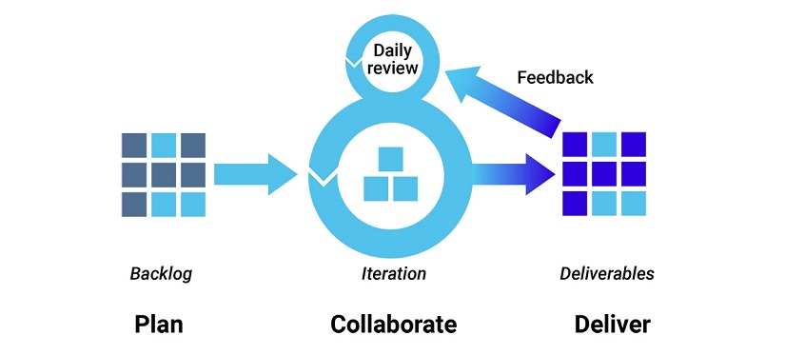

Fig 1: Software development model used in the development of this software

As we have to deliver our project as a module/part of the project in a week, the agile methodology will be perfect for this project development.

This project may have some changes in the future if required or if we find some kind of limitations.

#### **2 Software Requirement Specification**

**2.1 Software Usage Requirement**

This software will require an internet connection to use it. As we will retrieve tweets from Twitter of any Twitter user, so users need to connect to the internet connection. Our software can be used as web-based applications and can also be used as mobile applications. Thus, nothing more is needed and users can easily use this software.

**2.2 Software Development Requirement**

The technological requirements to develop this software are python, streamlit, SQLite, Machine learning, NLP, and python library. The software is developed in the python programming language. We have used streamlit framework and used SQLite database for DBMS. Machine learning and NLP model have been developed for emotion detection. Many python libraries have also been used such as NumPy, pandas, scikit-learn, transformers, snscraper, etc.

**2.3 Constraints and limitations**

This software requires an internet connection. Users of the system should be compatible with English as it is in English and should have basic knowledge of computers. Users have to copy tweets from tweet pages up to 5000 and then detect the emotion as it is not fully automatic yet. In future versions, this will be added.

**2.4 Data Flow Diagram**



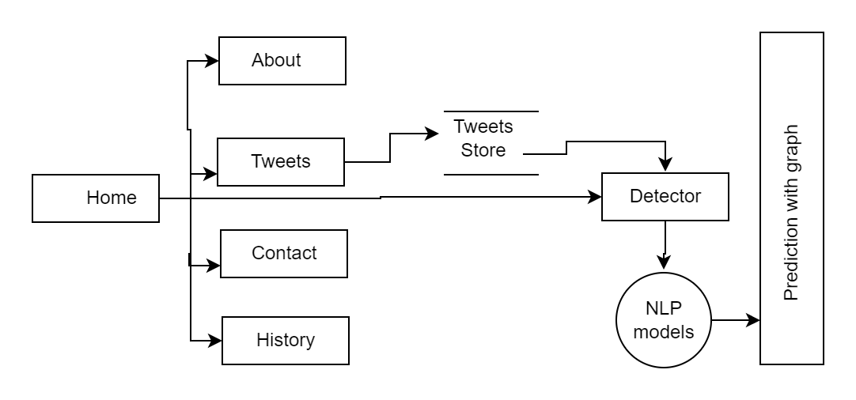

Fig 2: DFD of EDS

#### **3 Project Management**

**3.1 Risk Table**

| Risk | Impact | Mitigation |
| --- | --- | --- |
| Lack of social media skills | Will face using the software properly. | Documentation of usage can help to use appropriately. |
| Internet | The software without the internet won’t work as it collects data from social media | As it is a real-time online-based software, this is required on the internet. Else, default tweets can be used. |

**3.2 Timeline**

| **Task** | **Time Frame** | | | | | | | | | | | | | | |
| --- | --- | --- | --- | --- | --- | --- | --- | --- | --- | --- | --- | --- | --- | --- | --- |
| Week 1 | Week 2 | Week 3 | Week 4 | Week 5 | Week 6 | Week 7 | Week 8 | Week 9 | Week 10 | Week 11 | Week 12 | Week 13 | Week 14 | Week 15 |
| Identify problem |  |  |  |  |  |  |  |  |  |  |  |  |  |  |  |
| Identify requirements and constraints |  |  |  |  |  |  |  |  |  |  |  |  |  |  |  |
| MILESTONE: System function defined |  |  |  |  |  |  |  |  |  |  |  |  |  |  |  |
| Design/Develop Architecture |  |  |  |  |  |  |  |  |  |  |  |  |  |  |  |
| Testing |  |  |  |  |  |  |  |  |  |  |  |  |  |  |  |
| MILESTONE: Testing Complete |  |  |  |  |  |  |  |  |  |  |  |  |  |  |  |

#### 

#### 

#### **4 Design Engineering**

**4.1 Architectural Design**

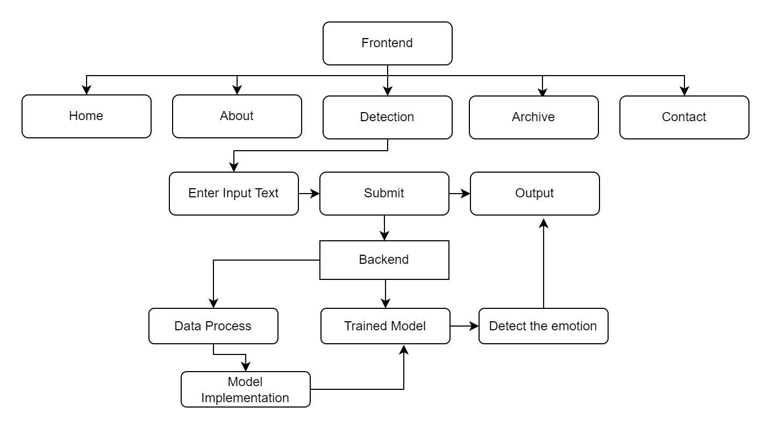

Fig 3: Working methodology of the system

**4.2 Data Design**

| **DATA** | **DESCRIPTION** |
| --- | --- |
| Detection History | Text+Label+Score |
| Page Metrics | Page name+Time_of_Visit |
| Emotion Classifier Metrics | RawText+Predicted+max_score+Predicted+Probability+Time_of_Visit |

#### **5 Testing**

**Test Cases**

| **Test Case** | **Tweet** | **Prediction** | **Accuracy** |
| --- | --- | --- | --- |
| 1 | I hope that the people of Brazil can resolve matters peacefully | POSITIVE | 0.999 |
| 2 | I am sick. I went to the hospital to consult a doctor. | NEGATIVE | 0.9994 |
| 3 | I am fine | POSITIVE | 0.9998 |
| 4 | World is in danger | FEAR | 0.552 |
| 5 | happy | JOY | 0.685 |

#### 

#### 

#### **6** **References**

1. Software Engineering: A Practitioner's Approach, 8th Edition by Roger S. Pressman
2. HuggingFace: The AI community building the future. <https://huggingface.co/>
3. Top 4 software development methodologies, by Synopsys Editorial Team. <https://www.synopsys.com/blogs/software-security/top-4-software-development-methodologies/>