Binary Representation

1 – 1
2 – 1 0
3 – 1 1
4 – 1 0 0
5 – 1 0 1
6 – 1 1 0
7 – 1 1 1
8 – 1 0 0 0
9 – 1 0 0 1
10- 1 0 1 0

last bit of Even Number – 0
Last bit of Odd Number – 1

Binary to Decimal -
Ex: 10 = 1*(2^3)+0*(2^1)+1*(2^1)+ 0*(2^0)
= 10

Odd/Even check
lets n=any number then,
if(n & 1) – Odd number
else –Even number

X-OR
0 ^ 1 || 1 ^ 0 == 1;
0 ^ 0 || 1 ^ 1 == 0;

Left Shift

1<<0 == 1;
1<<1 == 10 == 2
1 <<2 == 100 == 4
1<< 3 ==1000 == 8
1<<4 ==10000 == 16

3<<1 == 110 ==6
3<<2 == 1100 ==12
3<<3 ==11000 ==24
3<<4 ==110000 ==48

Notes:

1. 1<<n means 2^n;
2. x<<n means (x<<(n-1))*2;

Right Shift
8 == 1000
8>>1 == 100 == 4;
8>>2 == 10 == 2
8>>3 == 1 == 1
8>>4 == == 0

Check n’th bit set or Not?
Take a number that’s only n’th bits set, Lets 1001001 then check 3rd bit set or not.

1 0 0 1 0 0 1
1<<3 =0 0 0 1 0 0 0

And operation(&) =0 0 0 1 0 0 0

Print Binary using Right shift:
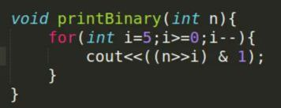

Lets n=9 , 9=1001
i=5 , 1001>>5 == 0 & 1 =0
i=4, 1001>>4 == 0 & 1 =0
i=3, 1001>>3 == 1 & 1 =1
i=2 , 1001>>2 == 10 & 01 =0
i=1, 1001>>1 == 100 & 001 =0
i=0 ,1001>>0 == 1001& 0001 =1

So , 5 bits binary of 9 = 0 0 1 0 0 1

Set n’th bit

Lets set 2nd bit of 9=1001

1 0 0 1
(1<<2) 0 1 0 0

OR operation( | ) 1 1 0 1
bitset<5> bset(9)
cout<<bset<<endl;
Output: 0 1 0 0 1

#Set Bit using bitset
cout<<bset.set(2)<<endl;
output: 0 1 1 0 1
Notes: Also can bset.set(2,1) = 0 1 1 0 1
Or
bset.set(3,0) = 0 0 0 0 1 //set 0 also possible

Reset n’th bit
Reset means change n’th bit if 0 then 1 vice versa;

Lets reset 3rd bit of 9=1001

1 0 0 1
(1<<3) 1 0 0 0

XOR 0 0 0 1

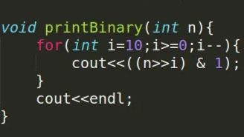

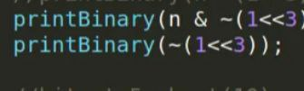

Notes: Rest 3rd bit of 10(1 0 1 0), At First pass (1<<3) = 1 0 0 0 then it will be 00000001000 ,after Tilde(~) it will be 11111110111

Then, printBinary(10 & ~(1<<3));
Lets reset 1st bit of 10=1010

0 0 0 0 0 0 0 1 0 1 0
(n &~(1<<3)) 1 1 1 1 1 1 1 0 1 1 1

& 0 0 0 0 0 0 0 0 0 0 1

# n’th Bit Toggle

Lets toggle 1st bit of 10=1010

1 0 1 0
(1<<3) 0 0 1 0

XOR 1 0 0 0
Notes: 1^1 =0 and 0 ^1 = 1;
#Count,Toggle
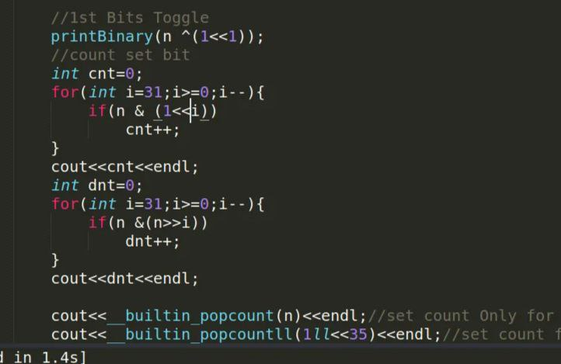
Cout<<bset.count<<endl;
Output: 2 ( Count Set bit)

bitset<32> bset1(string("101"));
cout<<bset1.to_ulong()<<endl;
Output: 5

bset.set();
cout<<bset<<endl;
Output: 1 1 1 1 1

bset.reset();
cout<<bset<<endl;
Output: 0 0 0 0 0

bset.flip();
cout<<bset<<endl;
Output: Change 0 to 1 & 1 to 0

#Tricks from LUV

1.Check Odd or Even

if(n & 1) ----- Odd
else ----- Even

2.Multiply by 2 or Divide by 2
Multiply by 2 ---(n<<1)
Divide by 2------(n>>1)

3.Upper to Lower | Lower to Upper

for(char c='A';c<='E';c++){
printBianry(int(c));
}
Output:
A: 1000001
B: 1000010
C: 1000011
D: 1000100
E: 1000101

for(char c='a';c<='e';c++){
printBianry(int(c));
}
Output:
a: 1100001
b: 1100010
c: 1100011
d: 1100100
e: 1100101

#Here in Upper case letter 5’th bit unset (0), but in Lower case 5’th bit Set(1). If we do (1<<5) OR( | ) operation with Upper then it will be Lower letter. Similarly if do (1<<5) (XOR) with Lower then it will Upper. Lets Example-

#For Upper to Lower

A = 1 0 0 0 0 0 1
(1<<5) = 0 1 0 0 0 0 0
a = 1 1 0 0 0 0 1 (A | (1<<5))

#For Lower to Upper

a =1 1 0 0 0 0 1
(1<<5) =0 1 0 0 0 0 0
XOR A =1 0 0 0 0 0 1 (a ^ (1<<5))
OR, ( a & ~(1<<5))

a =1 1 0 0 0 0 1
~(1<<5) =1 0 1 1 1 1 1
=1 0 0 0 0 0 1 (a & ~ (1<<5))

#Space( ) & Underscore( _ )

(1<<5) = 100000 = (Sapce)
If we apply OR( | ) in any Uppercase and Space( - ) then it will be Lower

A = 1 0 0 0 0 0 1
(Space) = 0 1 0 0 0 0 0
a = 1 1 0 0 0 0 1 (A | ‘ ‘)

Binary of Underscore is = 1 0 1 1 1 1 1 , that is ~(1<<5) . If we apply AND(&) operation in Lowercase and Underscore then it will be Uppercase.

a = 1 1 0 0 0 0 1
(Space) = 1 0 1 1 1 1 1
A = 1 0 0 0 0 0 1 (a &| ‘_‘)

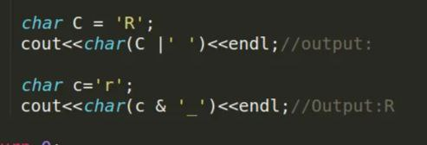

#Unset from i’th bit to 0’th bit (least Significant bit)
Lets take a binary number a = 1 1 0 1 0 0 0 ,now we want to unset 3’th bit 0’th bit. More clearly we want to make number like this
1 1 0 0 0 0 0 . How can we do this.
We need a number like this 1 1 1 0 0 0 0, that’s every bit from 3rd to 0’th bit is 0. Then simply apply (&) this number.

int A=104 ==1 1 0 1 0 0 0;
int i=3;
int B=( A & (~((1<<(i+1))-1)));

(1<<(i+1)) -1 = 1 0 0 0 0 – 1;
= 1 1 1 1;
~(1 1 1 1) = 0 0 0 0

A = 1 1 0 1 0 0 0
~((1<<(i+1))-1) = 1 1 1 0 0 0 0
( & ) = 1 1 0 0 0 0 0

#We know that
1 0 0 0 0 -1 = 1 1 1 1
1 0 0 0 -1 = 1 1 1
1 0 0 – 1 = 1 1
1 0 – 1 = 1
1 – 1 = 0

#We know that

1 1 1 1 1 0 0 0 0 0 (~)
0 0 0 0 0 1 1 1 1 1
0 0 0 0 1 0 0 0 0 0 - 1;

#We know that
0 0 0 0 0 1 1 1 1 1
0 0 0 0 1 0 0 0 0 0 – 1;

#Unset from n’th bit to 3’th bit (Most Significant bit)

A = 1 1 0 1 0 0 0
(1<<(i+1))-1 = 0 0 0 1 1 1 1
( & ) = 0 0 0 1 1 1 1

#Check number is power of 2 – 2^0, 2^1,2^2……….

5 = 1 0 1 12 = 1 1 0 0
6 = 1 1 0 13 = 1 1 0 1

(5 & 6) ====TRUE , (12 & 13) ===TRUE

But ,
15 = 1 1 1 1 31 = 1 1 1 1 1
16 = 1 0 0 0 0 32 = 1 0 0 0 0 0

(15 & 16) ===False ,(31 & 32) ===False

So, if( n & (n-1)
cout<<”Not Power of 2”<<endl;
else
cout<<”Power of 2’<<endl;

#Power of XOR

a ^ a =0
a^0 = a;
Example:
lets a = 1 0 1;
then,
a = 1 0 1
a = 1 0 1
(a^a) = 0 0 0

Similarly,
a = 1 0 1
0 = 0 0 0
(a^0) = 1 1 1

X-OR maintain associative law,like-
x^y^z = x^z^y = y^x^z = z ^x^y ……..

a = 5 = 1 0 1
b = 7 = 1 0 1

a = a^b;
b = a ^ b b = a ^b ^ b)where, b^b = 0 then a^0=a
a = b ^ a a = a ^b ^ a)where, a^a = 0 then b^0=b

Question:Given an array of n integers. All integers are present in array in even count except one. Find that integers that have a odd count. //In O(n) time complexity and O(1) space complexity. N<=10e5 ,a[i]<=10e5;

Description:
a ^ a = 0;
a ^ a ^ a = a;
a ^ a ^ a ^ a = 0;
Even number of similar X-OR output 0; Odd number similar X-OR return the number.

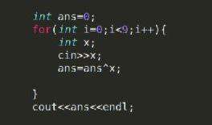

lets arr[9] = {2 ,4, 6, 7 ,7 , 4 , 2, 2 , 2}
int ans = 0;
ans = 0 ^ 2 //ans=2;
ans = 2 ^ 4 //ans = 2^4;
ans =2^4^6; //ans = 2^4^6;
ans = 2^4^6 ^7 //ans= 2^4^6^7
ans = 2^4^6^7^7 //ans = 2^4^6 //Here 7^7=0
ans= 2^4^6^4 //ans =2^6
ans =2^6^2 //ans=6
ans =6^2 //ans=6^2
ans=6^2^2 //ans=6 //

