Print Alphabet:
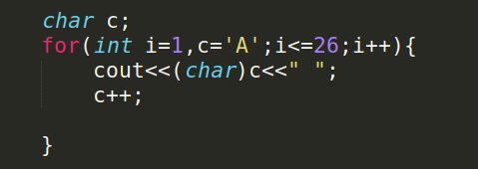

Store Alphabet
1.In array:
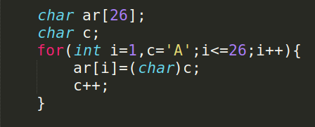

2.In Map
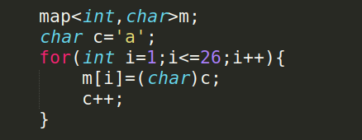

Basic Code:

1. Char to Int:
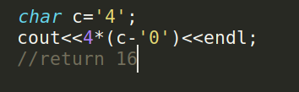

2.Print n’th alphabet:
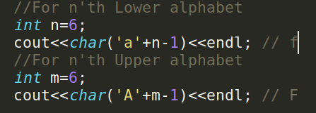

3.Print ASCII value:

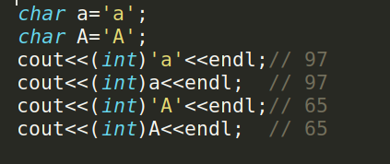

4.Print char from ASCII value

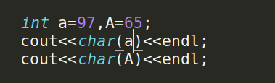

5.Int to String
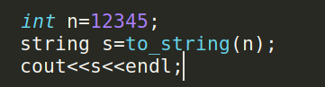

6.String to Int

