Mex String
a b c d e f g h i j k l m n o p q r s t u v w x y z aa ab ac ad ae af ag ah ai aj ak al am an ao ap aq ar as at au av aw ax ay az ba bb bc bd be bf bg bh bi bj bk bl bm bn bo bp bq br bs bt bu bv bw bx by bz ca cb cc cd ce cf cg ch ci cj ck cl cm cn co cp cq cr cs ct cu cv ……….

First Missing string from this sequence is Mex .For example “cleanairactbd” here Mex=b .
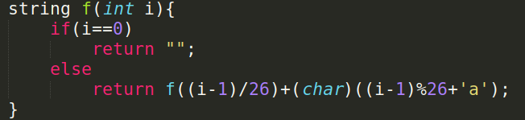
Reference: 1536B Codeforces

Count specific character from string

For example count ‘0’ from this string s=01?????0

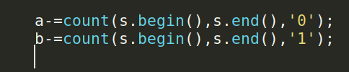

Initialize String like array:
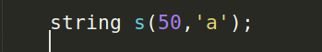

String Array & Sort

string s[n+3]={“Roni”,”BSMRSTU”,”Dhaka”,”Hello”……..};
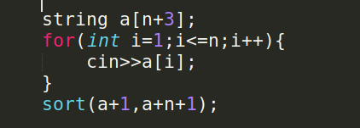

Find index of character from string
find() function return index of given character(if it present).
If character not present then it return npos/-1.
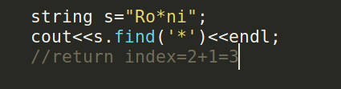

Find Sub_string from string
find() function return index of first occurrence from given sub_string(if it present).
If sub_string not present then it return npos/-1.
static const size_t npos = -1;
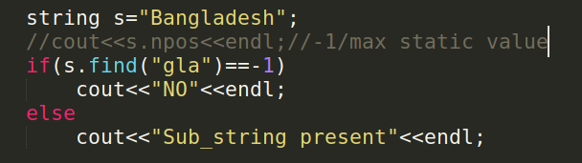

Generate sub_string and find()
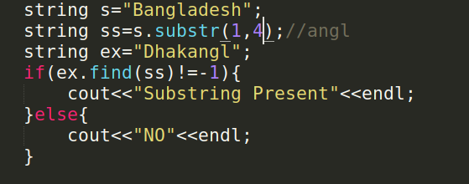

Find sub_string from last position and replace another

Here only changed last found sub_string.
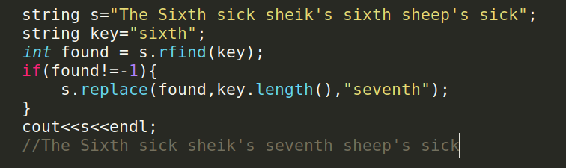

Erase a part from string

1.Erase Full String
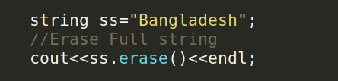

2.Erase all character after given position
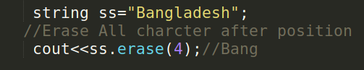

3.Erase n character after position
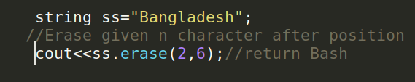

String Front/Back and Substring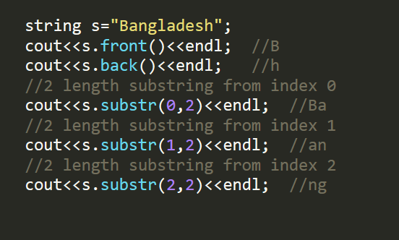

Split String as individual words:
