Sub_array
Sub array is contiguous part of the array. Order of sub array must be same as array. For example-

{1,2,3,4,5,6,7,8,9}

{4,5,6,7} ok
{3} ok
{7,8} ok
{} ok
{1,2,3,4,5,6,7,8,9} ok
{3,5,7} Not a sub array
{5,4} Not a sub array
{13,,4,5} Not a sub array

If length of array is n then there are (n*(n+1))/2 non empty sub array possible. For example
A = {1,2,3,4,5,6} has total 21 subarray possible
{(1,1),(1,2),(1,3),(1,4),(1,5),(1,6)} ,{(2,2),(2,3),(2,4),(2,5),(2,6)},{(3,3),(3,4),(3,5),(3,6)},{(4,4,),(4,5),(4,6)},{(5,5),()5,6},{(6,6)};
Sub_String
A sub string is exactly the same thing as the sub array but in the context in the string. For example sub string of string “ara” is

{a} ok
{r} ok
{ar} ok
{ra} ok
{a,r,a} ok
{} ok
{aa} Not a sub String
{r,a,a} Not a sub String

If length of sting is n then there are (n*(n+1))/2 non empty sub string possible.

Sub Sequence
{May not contiguous but must maintain the relative order. All sub array is subsequence but a subsequence may or may not be subarray. For example-

{1,2,3,4,5,6,7,8,9}

{2,5,7} ok
{3,4,5,6} ok
{5,8,9} ok
{1,2,3,4,5,6,7,8,9} ok
{4,3,5,8,} Not a sub sequence
{7,1,6,8} Not a sub sequence

If length of sequence is n then there are (2^n -1) non empty sub sequence possible. It’s simply we take or not. Every elements have only two chose.

Sub Set
May not be contiguous and may not be in relative order. A subset may be a sub array,or a sub string or be a subsequence;

{1,2,3,4,5,6,7,8,9}

{1,4,7}
{5,4}
{1,4,7,3}
{15,7,9}
{12,5,9,2,3}

If length of sting/array is n then there are (n*(n+1))/2 sub set possible.

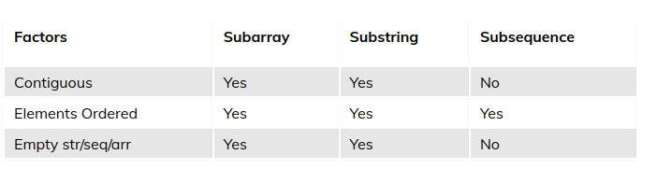

Common Properties of Sub_array,Subset, Substring

