GCD/HCF(Greates Commo Divisor/Highest Common Factor)
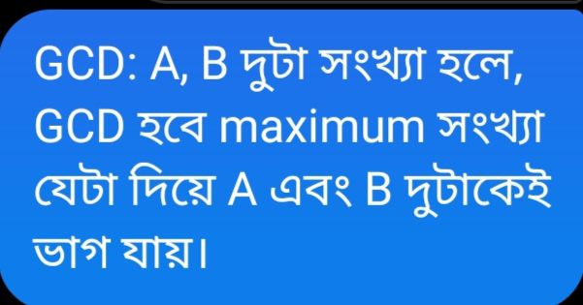

GCD = Greatest number that divides both of number .Multiple of both common factor. For example,
60 = 2 x 3 x 4 x 5 x 6 x 10 x 12 x 15 x 20 x 30
24 = 2 x 3 x 4 x 6 x 8 x 12
Here, 12 is greatest number that divides both number.

lets take two number a=60 , b= 24 then,
60 = 2 x 2 x 3 x 5 (factor/Vange lekha)
24 = 2 x 2 x 2 x 3 (factor/Vange lekha)

So, GCD is-
GCD = 2 x 2 x 3 = 12

another example,

60 = 2 x 2 x 3 x 5
6 = 2 x 3
GCD = 2 x 3 = 6

GCD Algorithm:

lets, n1 = 60, n2 = 24;

n1 = 60 , n2= 24 , rem = n1%n2 = 12;

n1 = 24 , n2 = 12 , rem = n1%n2 = 0;

n1 = 12 , n2 = 0 , rem =

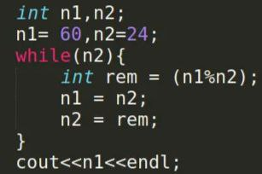

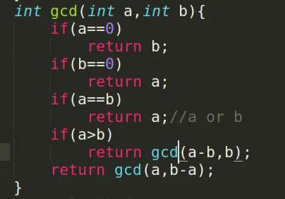

LCM(Least Common Multiple/Lowest Common Multiple)
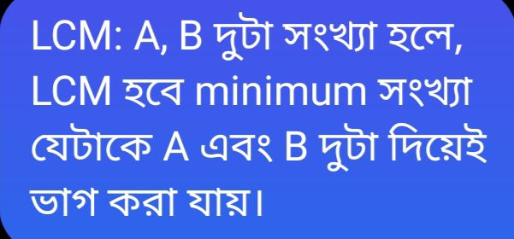

LCM = multiple of both common & uncommon of all divisor.
lets take two number a=60 , b= 24 then,
60 = 2 x 2 x 3 x 5 (factor/Vange lekha)
24 = 2 x 2 x 2 x 3 (factor/Vange lekha)

So, LCM is -
LCM = 2 x 2 x 3 x 2 x 5 = 120

Another example,lets take two number a=60 , b= 24 then,
60 = 2 x 2 x 3 x 5 (factor/Vange lekha)
6 = 2 x 3 (factor/Vange lekha)
So, LCM is -

LCM = 2 x 2 x 3 x 5 = 60

