#Both lower and upper bound work in log(n) complexity if array is sorted , but for unsorted array lower & upper bound work in O(n) complexity that is not efficient.

#Both lower and upper bound return position.

#Lower Bound

First greater or Equal elements. Number is present or not, always return first greater or equal number in the array.

int arr[]={4, 5, 5, 7, 8, 25};

0 | 1 | 2 | 3 | 4 | 5
6 | 5 | 5 | 9 | 8 | 25

int lb=lower_bound(arr, arr+6, 5) – arr;
Here, lb =0;

int lb=lower_bound(arr, arr+6, 7) – arr;
Here, lb =3;

int lb=lower_bound(arr, arr+6, 9) – arr;
Here, lb =3;

#Restricted Range
It,s possible to find lower or Upper bound in restricted range,
lets example: (3 – 7), ( 4- 10) , ( 5- 9) etc;

int lb=lower_bound(arr+2, arr+6, 6) – arr;
int lb=lower_bound(arr+3, arr+5, 5) – arr;
int lb=lower_bound(arr+3, arr+4 ,8) – arr;
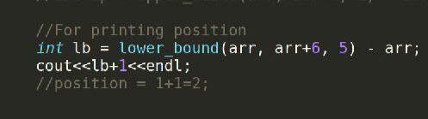
#For printing Position:

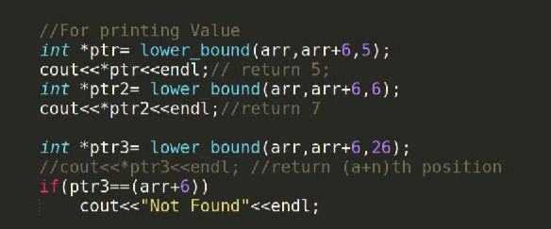
#For printing Value:
Here , (a+n) points to last index of array.

#Upper Bound
First greater elements. Number is present or not, always return first greater number in the array.

int arr[]={4, 5, 5, 7, 8, 25};

0 | 1 | 2 | 3 | 4 | 5
4 | 5 | 6 | 9 | 8 | 25

int up=upper_bound(arr, arr+6, 5) – arr;
Here, up =2;

int up=upper_bound(arr, arr+6, 7) – arr;
Here, up =3;

int up=upper_bound(arr, arr+6, 8) – arr;
Here, up =3;

int up=upper_bound(arr, arr+6, 25) – arr;
Here, up =points to (a+n);

#Set Lower and Upper bound
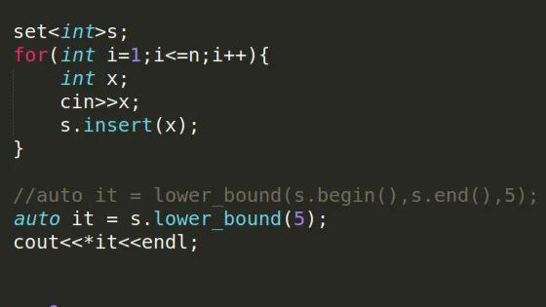
Set used s.lower_bound(value) , it’s show log(n) time complexity in set.

Other hand, lower_bound(s.begin(),s.end(),value); show time limit exceed in set. It’s done O(n) time complexity.

Question:C++ Difference between std::lower_bound and std::set::lower_bound?

Set, Map not used binary search for upper or lower bound . Set used internal tree traversed for upper or lower bound that why it’s show O(n) complexity for lower_bound(s.begin(),s.end(),value); this function.

#Map upper and Lower bound

It’s work only with key value.

* map_name.lower_bound(key) is return just equal or immediate greater key pointers.

* map_name.upper_bound(key) is return just immediate greater key pointers.

