What is Modulation?
Modulation is the process of varying a parameter of a high-frequency carrier signal according to a low-frequency information (message) signal, so that the information can be transmitted over a long distance efficiently.
The carrier signal is usually a high-frequency sinusoidal wave, and the message signal contains the actual information such as voice, music, data, or video.
In modulation, one parameter of the carrier wave is changed based on the message signal:
- Amplitude
- Frequency
- Phase
The result is called a modulated signal.

Why Modulation is Necessary
Direct transmission of low-frequency message signals is not practical. Modulation solves several problems:
- Increases communication range
High-frequency signals can travel longer distances with less loss.
- Reduces antenna size
Antenna height is inversely proportional to frequency.
Higher frequency → smaller antenna.
- Improves signal-to-noise ratio (SNR)
High-frequency transmission reduces the effect of noise.
- Avoids signal mixing (interference)
Different users can transmit at different carrier frequencies.

Carrier Signal and Message Signal
Message Signal
- Low frequency
- Contains information
- Cannot travel long distances efficiently
- Example: human voice (20 Hz – 20 kHz)
Carrier Signal
- High frequency
- Does not contain information by itself
- Used to carry the message signal
- Example: radio frequency signals (MHz range)

Types of Modulation Techniques
Modulation techniques are mainly divided into two categories:
- Analog Modulation
- Digital Modulation

1. Analog Modulation
In Analog Modulation, both the carrier signal and the message signal are analog signals.
An analog signal is continuous in nature and can take infinite values between two limits.

Types of Analog Modulation
- Amplitude Modulation (AM)
  - Amplitude of the carrier is varied
  - Frequency and phase remain constant
- Frequency Modulation (FM)
  - Frequency of the carrier is varied
  - Amplitude remains constant
- Phase Modulation (PM)
  - Phase of the carrier is varied
  - Amplitude and frequency remain constant

2. Digital Modulation
In Digital Modulation:
- Carrier signal is analog
- Message signal is digital (binary)
Digital modulation is widely used in modern communication systems such as mobile communication, Wi-Fi, and satellite communication.

Examples of Digital Modulation
- ASK (Amplitude Shift Keying)
- FSK (Frequency Shift Keying)
- PSK (Phase Shift Keying)
- QAM (Quadrature Amplitude Modulation)

Analog Waves
Analog waves are continuous signals.
- They can take any value within a range
- There are infinite possible amplitude levels
- More sensitive to noise
Example:
Voice signal, temperature signal

Digital Signals
Digital signals are discrete signals.
- They have only two levels:
  - Logic 0 → 0 volts
  - Logic 1 → non-zero voltage
- No intermediate values exist
- Less affected by noise
Example:
Binary data in computers

Feature | Analog Signal | Digital Signal
Nature | Continuous | Discrete
Values | Infinite | Only 0 and 1
Noise immunity | Low | High
Processing | Difficult | Easy
Storage | Difficult | Easy

What are Digital Modulation Techniques?
Digital Modulation is the process of transmitting digital data (bits: 0 and 1) by modifying a high-frequency analog carrier signal.
Unlike Analog Modulation, where the carrier parameter changes continuously, in Digital Modulation the carrier parameter changes discretely between fixed values. This discrete
change is called Shift Keying.

Concept of Shift Keying
Shift Keying means:
- The amplitude, frequency, or phase of the carrier signal is shifted between two or more fixed levels
- Each level represents digital information (bits)
Because digital data is binary:
- Two discrete levels are enough → Binary Shift Keying
- More bits can be grouped together → M-ary Shift Keying

Types of Digital Modulation Techniques
There are three main types of Digital Modulation techniques:
- Amplitude Shift Keying (ASK)
- Frequency Shift Keying (FSK)
- Phase Shift Keying (PSK)

1. Amplitude Shift Keying (ASK)
In ASK, the amplitude of the carrier signal is changed according to the digital data.
- Frequency and phase remain constant
- Amplitude switches between discrete levels
Binary ASK
- Bit 1 → High amplitude
- Bit 0 → Zero or low amplitude
Characteristics
- Simple to implement
- Highly affected by noise
- Used in optical communication and RFID systems

2. Frequency Shift Keying (FSK)
In FSK, the frequency of the carrier signal is changed according to the digital data.
- Amplitude remains constant
- Two different frequencies are used
Binary FSK
- Bit 1 → Frequency f₁
- Bit 0 → Frequency f₂
Characteristics
- Better noise immunity than ASK
- Requires more bandwidth
- Used in modems and low-speed data communication

3. Phase Shift Keying (PSK)
In PSK, the phase of the carrier signal is changed according to the digital data.
- Amplitude and frequency remain constant
- Phase switches between discrete values
Binary PSK (BPSK)
- Bit 1 → Phase 0°
- Bit 0 → Phase 180°
Characteristics
- Very good noise immunity
- More complex receiver
- Widely used in modern communication systems

Comparison of ASK, FSK, and PSK
Feature | ASK | FSK | PSK
Carrier parameter changed | Amplitude | Frequency | Phase
Noise resistance | Low | Medium | High
Bandwidth | Low | High | Medium
Complexity | Low | Medium | High

Amplitude Shift Keying (ASK)
Amplitude Shift Keying (ASK) is a digital modulation technique in which the amplitude of a high-frequency carrier wave is changed (shifted) according to the digital message signal, while the frequency and phase of the carrier remain constant.
Each digital symbol (bit or group of bits) is represented by a distinct amplitude level of the carrier wave.
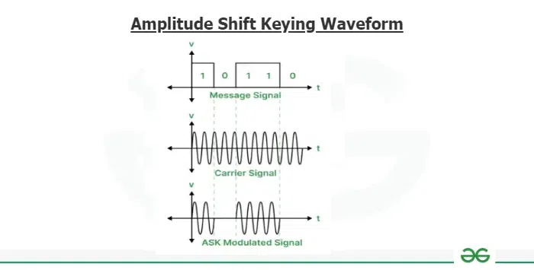
Basic Principle of ASK
- Digital data consists of discrete symbols
- Each symbol is assigned a specific carrier amplitude
- The carrier is transmitted only when required by the data
- Hence, information is carried by amplitude variation only
Mathematically, the ASK signal can be written as:
$$s(t)=m(t) Asin⁡(2πf_{c}t+ϕ)$$
where
- $m(t)$= digital message signal (0 or 1, or M levels)
- $A$= carrier amplitude
- $f_{c}$= carrier frequency
- $ϕ$= phase
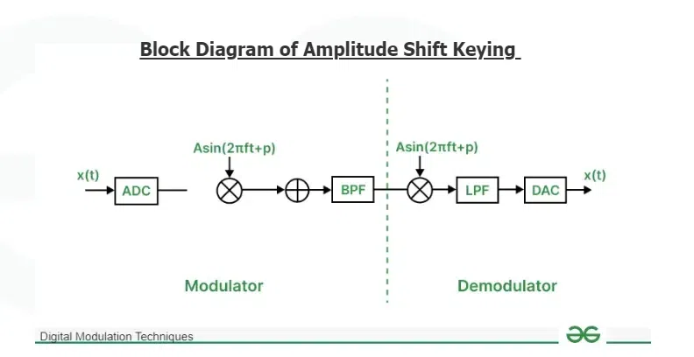
Types of ASK
ASK is mainly divided into two types:
- Binary Amplitude Shift Keying (Binary ASK)
- M-ary Amplitude Shift Keying (M-ary ASK)

1. Binary Amplitude Shift Keying (Binary ASK)
In Binary ASK, one bit is transmitted at a time.
- Logic 1 → carrier with a certain amplitude (for example, 12 V)
- Logic 0 → carrier with zero or lower amplitude (often 0 V)
This special case where carrier is present for 1 and absent for 0 is also called
On–Off Keying (OOK).
Characteristics
- Simple to generate and detect
- Highly sensitive to noise
- Poor power efficiency

2. M-ary Amplitude Shift Keying (M-ary ASK)
In M-ary ASK, a group of bits is transmitted as one symbol.
- Number of bits per symbol = ${log⁡}_{2}M$
- Each symbol is assigned a unique amplitude level
Example: 16-ary ASK
- $M=16$
- Bits per symbol = ${log⁡}_{2}16=4$
- Total possible 4-bit combinations = 16
- Therefore, 16 different amplitude levels are required
This increases data rate, but makes the system more sensitive to noise.

Coherent and Non-Coherent ASK
Coherent ASK
- A single carrier wave is used
- All amplitude levels are generated from the same carrier
- Requires carrier phase synchronization at receiver
- Better performance but higher complexity
Non-Coherent ASK
- Multiple carriers with different amplitudes are used
- No strict carrier phase synchronization needed
- Simpler receiver but poorer performance

ASK Waveform Explanation
- When $m(t)=1$:
Carrier appears with full amplitude
- When $m(t)=0$:
Carrier amplitude becomes zero
- Resulting waveform shows sudden amplitude changes
- These abrupt changes increase bandwidth
Block Diagram of Amplitude Shift Keying (Transmitter)
Working of ASK Modulator
- Analog Message → ADC
The analog message signal is converted into a digital signal using an Analog-to-Digital Converter (ADC).
- Digital Signal m(t)
This digital signal represents logic 0s and 1s.
- Carrier Generator
A high-frequency sine wave is generated:
$$Asin⁡(2πf_{c}t+ϕ)$$
- Multiplier (Modulator)
The digital signal $m(t)$ multiplies the carrier:
  - If $m(t)=1$, carrier passes
  - If $m(t)=0$, output becomes zero
- Band-Pass Filter (BPF)
Removes unwanted frequency components and limits bandwidth
- Output
The resulting signal is the ASK modulated wave

Demodulation of ASK (Receiver)
Working of ASK Demodulator
- Received ASK Signal
The modulated signal is received from the channel.
- Multiplier (Coherent Detection)
The received signal is multiplied by the same carrier frequency:
$$m(t)A{sin⁡}^{2}(2πf_{c}t+ϕ)$$
- Low-Pass Filter (LPF)
Removes high-frequency components and extracts the baseband signal.
- Recovered Digital Signal
The original digital message signal $m(t)$is obtained.
- DAC (Optional)
If required, the digital signal is converted back into analog form using a Digital-to-Analog Converter.

Advantages of ASK
- Simple modulation technique
- Easy implementation
- Low hardware complexity

Disadvantages of ASK
- Highly sensitive to noise
- Poor power efficiency
- Requires higher bandwidth due to abrupt amplitude changes

Applications of ASK
- Optical fiber communication
- RFID systems
- Infrared communication
- Low-cost wireless systems

Frequency Shift Keying (FSK)
Frequency Shift Keying (FSK) is a digital modulation technique in which the frequency of a high-frequency carrier wave is changed (shifted) according to the digital message signal, while the amplitude and phase of the carrier remain constant.
Each digital symbol is represented by a different discrete frequency of the carrier wave.
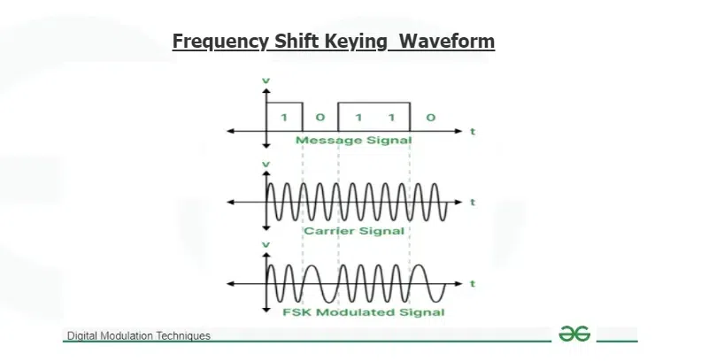
Basic Principle of FSK
- Digital data consists of symbols (bits or groups of bits)
- Each symbol is assigned a unique carrier frequency
- The carrier frequency switches between fixed values
- Information is conveyed through frequency variation only
Mathematically, the FSK signal is written as:
$$s(t)=Asin⁡(2πf_{i}t+ϕ)$$
where
- $A$= constant carrier amplitude
- $f_{i}$= carrier frequency corresponding to the symbol
- $ϕ$= phase

Types of Frequency Shift Keying
FSK is mainly divided into two types:
- Binary Frequency Shift Keying (Binary FSK)
- M-ary Frequency Shift Keying (M-ary FSK)

1. Binary Frequency Shift Keying (Binary FSK)
In Binary FSK, one bit is transmitted at a time using two distinct frequencies.
- Logic 1 → carrier frequency $f_{1}$(e.g., 50 MHz)
- Logic 0 → carrier frequency $f_{2}$(e.g., 25 MHz)
Only the frequency changes; amplitude remains constant.
Characteristics
- Better noise immunity than ASK
- Requires larger bandwidth
- Simple and reliable digital transmission

2. M-ary Frequency Shift Keying (M-ary FSK)
In M-ary FSK, a group of bits is transmitted as one symbol.
- Bits per symbol = ${log⁡}_{2}M$
- Each symbol is assigned a unique carrier frequency
Example: 16-ary FSK
- $M=16$
- Bits per symbol = ${log⁡}_{2}16=4$
- Total possible 4-bit combinations = 16
- Therefore, 16 different carrier frequencies are required
This improves data rate, but increases bandwidth requirement and system complexity.

Coherent and Non-Coherent FSK
Coherent FSK
- Frequencies are generated from a single carrier source
- Receiver requires phase synchronization
- Better performance
- More complex receiver design
Non-Coherent FSK
- Multiple carrier sources with different frequencies are used
- Phase synchronization is not required
- Simpler receiver
- Slightly poorer performance

Block Diagram of Frequency Shift Keying (FSK)
The FSK system consists of two main parts:
- FSK Modulator (Transmitter)
- FSK Demodulator (Receiver)
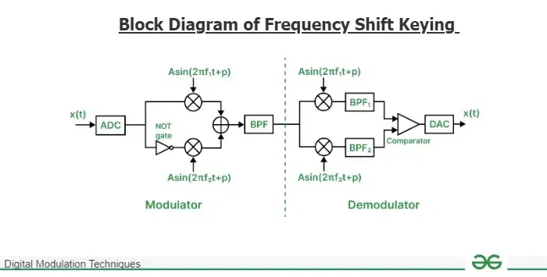

FSK Modulator (Transmitter)
- Analog Message → ADC
The analog message signal is first converted into a digital signal using an Analog-to-Digital Converter (ADC).
- Digital Message Signal
The output of the ADC is a digital signal consisting of logic 1s and logic 0s.
- Carrier Signal Generation
Two carrier signals are generated:
  - $Asin⁡(2πf_{1}t+ϕ)$→ carrier for logic 1
  - $Asin⁡(2πf_{2}t+ϕ)$→ carrier for logic 0
- NOT Gate Operation
The digital signal is split into two paths:
  - One path goes directly to the first multiplier
  - The second path passes through a NOT gate and goes to the second multiplier
- Multipliers (Modulation Process)
  - When the digital input is logic 1:
    - The first multiplier is active
    - Carrier with frequency $f_{1}$appears at the output
    - The second multiplier output is zero
  - When the digital input is logic 0:
    - The NOT gate output becomes logic 1
    - The second multiplier is active
    - Carrier with frequency $f_{2}$appears at the output
    - The first multiplier output is zero
- Adder
The outputs of both multipliers are added together to form the FSK signal:
$$s(t)=Asin⁡(2πf_{1}t+ϕ)+Asin⁡(2πf_{2}t+ϕ)$$
(Only one frequency is present at a time.)
- Band-Pass Filter (BPF)
Due to abrupt frequency switching, the signal contains unwanted frequency components.
The Band-Pass Filter:
  - Limits the bandwidth
  - Removes unwanted spectral components
- Output
The filtered signal is the FSK modulated wave, ready for transmission.

FSK Demodulator (Receiver)
- Received FSK Signal
The FSK modulated signal is received from the communication channel.
- Multipliers (Coherent Detection)
The received signal is fed into two multipliers:
  - One multiplier uses carrier frequency $f_{1}$
  - The other multiplier uses carrier frequency $f_{2}$
- Band-Pass Filters
  - BPF₁ passes only frequency $f_{1}$
  - BPF₂ passes only frequency $f_{2}$
- Comparator
The outputs of the two BPFs are compared:
  - If output of BPF₁ > BPF₂ → logic 1
  - If output of BPF₂ > BPF₁ → logic 0
- Recovered Digital Signal
The comparator output is a digital signal identical to the transmitted data.
- Digital-to-Analog Converter (DAC)
If required, the recovered digital signal is converted back into an analog signal using a DAC.

Phase Shift Keying (PSK)
Phase Shift Keying (PSK) is a digital modulation technique in which the phase of a high-frequency carrier wave is changed (shifted) according to the digital message signal, while the amplitude and frequency of the carrier remain constant.
Each digital symbol is represented by a distinct phase angle of the carrier wave.

Basic Principle of PSK
- Digital data consists of bits or groups of bits
- Each symbol is assigned a fixed phase shift
- Information is transmitted by changing the phase of the carrier
- Amplitude and frequency do not vary
The general PSK signal is:
$$s(t)=Asin⁡(2πf_{c}t+θ_{i})$$
where
- $A$= constant amplitude
- $f_{c}$= carrier frequency
- $θ_{i}$= phase corresponding to the symbol

Types of Phase Shift Keying
PSK is mainly classified into two types:
- Binary Phase Shift Keying (BPSK)
- M-ary Phase Shift Keying (M-ary PSK)
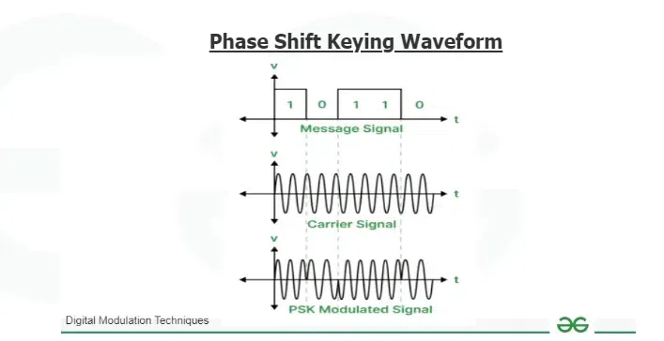
1. Binary Phase Shift Keying (BPSK)
In Binary PSK, one bit is transmitted at a time using two different phase angles.
- Logic 1 → phase shift (for example, 90° or 180°)
- Logic 0 → different phase shift (for example, 0°)
A common practical form is:
- 0° for logic 1
- 180° for logic 0
Characteristics
- Very good noise immunity
- Constant amplitude
- Simple and reliable digital transmission

2. M-ary Phase Shift Keying (M-ary PSK)
In M-ary PSK, multiple bits are grouped together and transmitted as one symbol.
- Bits per symbol = ${log⁡}_{2}M$
- Each symbol is assigned a unique phase shift
Example: 16-ary PSK
- $M=16$
- Bits per symbol = ${log⁡}_{2}16=4$
- Total possible 4-bit combinations = 16
- Therefore, 16 different phase shifts are required
This increases data rate, but reduces noise margin.

Coherent and Non-Coherent PSK
Coherent PSK
- All phase shifts are generated from a single carrier wave
- Receiver requires accurate phase synchronization
- Better performance
- More complex receiver design
Non-Coherent PSK
- Multiple carrier waves with different phase shifts are used
- Phase synchronization is not strictly required
- Simpler receiver
- Lower performance compared to coherent PSK

Advantages of PSK
- Excellent noise performance
- Constant amplitude reduces power variation
- More bandwidth-efficient than FSK
- Widely used in modern digital communication systems

Disadvantages of PSK
- Receiver is more complex
- Requires phase synchronization (coherent PSK)
- Higher-order PSK is sensitive to noise

Applications of PSK
- Satellite communication
- Wireless LANs
- Mobile communication systems
- GPS and digital broadcasting

Block Diagram of Phase Shift Keying (PSK)
A PSK system consists of two main sections:
- PSK Modulator (Transmitter)
- PSK Demodulator (Receiver)
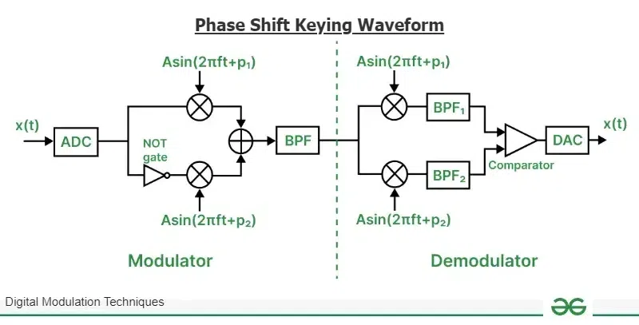
PSK Modulator (Transmitter)
- Analog Message → ADC
The analog message signal is first converted into a digital signal using an Analog-to-Digital Converter (ADC).
- Digital Message Signal
The digital output consists of logic 1s and logic 0s.
- Carrier Signal Generation
Two carrier signals of the same frequency and amplitude but with different phase shifts are generated:
  - $Asin⁡(2πft+ϕ_{1})$→ carrier for logic 1
  - $Asin⁡(2πft+ϕ_{2})$→ carrier for logic 0
- NOT Gate Operation
The digital signal is split into two paths:
  - One path goes directly to the first multiplier
  - The other path passes through a NOT gate and then to the second multiplier
- Multipliers (Phase Modulation Process)
  - When the digital input is logic 1:
    - First multiplier is active
    - Output becomes $Asin⁡(2πft+ϕ_{1})$
    - Second multiplier output is zero
  - When the digital input is logic 0:
    - NOT gate output becomes logic 1
    - Second multiplier is active
    - Output becomes $Asin⁡(2πft+ϕ_{2})$
    - First multiplier output is zero
- Adder
The outputs of both multipliers are added:
$$s(t)=Asin⁡(2πft+ϕ_{1})+Asin⁡(2πft+ϕ_{2})$$
(Only one phase-shifted carrier is present at a time.)
- Band-Pass Filter (BPF)
Abrupt phase transitions introduce unwanted frequency components.
The Band-Pass Filter:
  - Restricts the bandwidth
  - Removes unwanted spectral components
- Output
The filtered signal is the PSK modulated wave, ready for transmission.
PSK Demodulator (Receiver)
- Received PSK Signal
The PSK modulated signal is received from the communication channel.
- Multipliers (Coherent Detection)
The received signal is applied to two multipliers:
  - One uses carrier with phase $ϕ_{1}$
  - The other uses carrier with phase $ϕ_{2}$
- Band-Pass Filters
  - BPF₁ passes the signal with phase $ϕ_{1}$
  - BPF₂ passes the signal with phase $ϕ_{2}$
- Comparator
The outputs of the two BPFs are compared:
  - If output of BPF₁ > BPF₂ → logic 1
  - If output of BPF₂ > BPF₁ → logic 0
- Recovered Digital Signal
The comparator output is the recovered digital message signal.
- Digital-to-Analog Converter (DAC)
If required, the digital signal is converted back into an analog signal using a DAC.

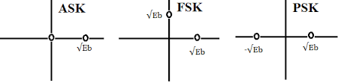

Constellation Diagram of ASK, PSK, FSK

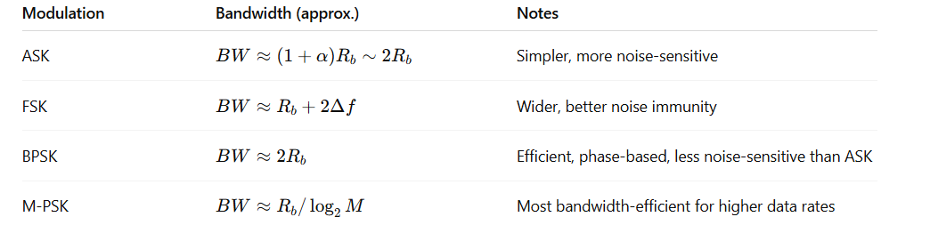

M-ary Encoding
M-ary encoding is a digital modulation technique in which more than two bits are transmitted simultaneously using a single signal symbol.
Here, M represents the number of distinct symbols used for transmission.
- Each symbol carries log₂M bits
- Higher value of M → more bits per symbol
- Main goal: efficient utilization of bandwidth

Need for M-ary Encoding
In binary modulation:
- 1 symbol carries only 1 bit
In M-ary modulation:
- 1 symbol carries multiple bits
This helps to:
- Reduce bandwidth requirement
- Increase data rate
- Improve spectral efficiency

Types of M-ary Digital Modulation
M-ary encoding can be applied to ASK, FSK, and PSK.

1. M-ary Amplitude Shift Keying (M-ASK)
M-ary ASK uses multiple amplitude levels of the carrier wave.
- Each amplitude level represents a unique bit combination
- Number of bits per symbol = log₂M
Example
For 16-ASK:
- M = 16
- Bits per symbol = log₂16 = 4
- 16 different amplitude levels are required
- Each amplitude represents a unique 4-bit pattern
Characteristics
- High data rate
- Poor noise immunity
- Used where channel noise is low

2. M-ary Frequency Shift Keying (M-FSK)
In M-ary FSK, the carrier frequency is shifted among M discrete frequencies.
- Each frequency represents a unique symbol
- Multiple bits are transmitted per symbol
Example
For 8-FSK:
- M = 8
- Bits per symbol = log₂8 = 3
- 8 different carrier frequencies are required
Characteristics
- Better noise performance than M-ASK
- Requires large bandwidth
- Complex transmitter and receiver

3. M-ary Phase Shift Keying (M-PSK)
In M-ary PSK, the phase of the carrier wave is shifted to represent different symbols.
- Carrier amplitude and frequency remain constant
- Each phase shift represents a unique bit pattern
Example
For 16-PSK:
- M = 16
- Bits per symbol = log₂16 = 4
- 16 distinct phase angles are used
Characteristics
- Better bandwidth efficiency than M-FSK
- More sensitive to noise for higher M
- Widely used in modern communication systems

Applications of Digital Modulation Techniques
1. Military Communication Systems
- High security and accuracy required
- Encryption possible with digital signals
- Reliable communication in noisy environments
2. Mobile Communication Systems
- Supports large number of users
- High data rate and low interference
- Efficient long-distance communication
3. Digital Broadcasting
- Used in DAB, DVB, and T-DMB
- Efficient transmission of audio, video, and data
- High quality and reliable broadcasting
4. Radar Systems
- Digital modulation used for pulse shaping
- Accurate object detection and tracking
- Used in weather monitoring, aviation, and defense

Advantages of Digital Modulation Techniques
1. High Immunity to Noise
- Limited number of discrete symbols
- Noise cannot easily convert one symbol into another
- Improves reliability of received data
2. High Security
- Digital data allows encryption
- Ensures confidentiality, integrity, and authenticity
- Not possible in analog modulation
3. Efficient Bandwidth Utilization
- Compression reduces number of bits
- M-ary modulation transmits multiple bits per symbol
- Better use of available spectrum
4. High Accuracy of Data
- Error detection and correction possible
- Errors can be identified and corrected at receiver
5. High Capacity
- Supports TDMA instead of FDMA
- Many users share same frequency at different time slots
- Increases system capacity

Disadvantages of Digital Modulation Techniques
1. Additional Circuitry
- Requires ADC at transmitter
- Requires DAC at receiver
- Increases system cost and complexity
2. Synchronization Requirement
- Carrier and clock synchronization needed
- Requires stable oscillators at both ends
3. High Power Consumption
- More power than pulse modulation techniques
- Complex processing increases energy usage

Conclusion
Digital modulation techniques, especially M-ary encoding, play a crucial role in modern communication systems. They provide high noise immunity, improved security, efficient bandwidth usage, high accuracy, and large system capacity. Although they require additional
circuitry and power, the advantages far outweigh the disadvantages. Hence, digital modulation
is extensively used in military communication, mobile networks, broadcasting, radar systems, and advanced wireless technologies.

Quadrature Amplitude Modulation (QAM)
Definition:
QAM is a modulation technique that combines Amplitude Shift Keying (ASK) and Phase Shift Keying (PSK) to transmit information by varying both the amplitude and phase of a carrier signal simultaneously. It allows multiple bits to be transmitted per symbol, improving data rate and bandwidth efficiency.

Types of QAM:
- Analog QAM:
  - Transmits two analog signals together using two carriers that are 90° out of phase.
  - Similar to standard AM but more efficient.
  - Used in analog TV and radio systems.
- Digital QAM (Quantized QAM):
  - Encodes multiple bits per symbol using discrete amplitude and phase levels.
  - Common in digital communication systems such as Wi-Fi, LTE, and cable modems.
  - Examples: 16-QAM (4 bits/symbol), 64-QAM (6 bits/symbol), 256-QAM (8 bits/symbol), 1024-QAM (10 bits/symbol).

Advantages:
- High data rate transmission (more bits per symbol).
- Efficient use of bandwidth.
- Better noise immunity compared to ASK alone.
- Supports modern communication standards like Wi-Fi 6.
Disadvantages:
- Receiver design is complex (must detect both amplitude and phase).
- Requires coherent demodulation (accurate carrier phase and frequency at the receiver).
- Sensitive to signal distortion; requires linear amplification for amplitude fidelity.

Applications:
- Digital TV and cable modems.
- Wi-Fi (802.11a/b/g/n/ac/ax), LTE and 5G cellular networks.
- Radio communication and satellite links.

QAM Modulation & Demodulation – Step by Step
- QAM (Quadrature Amplitude Modulation): A method to send data by changing both the amplitude and phase of a carrier. It combines ASK (amplitude change) and PSK (phase change).
- Carrier signal: A high-frequency sine wave used to carry data. Denoted as $cos⁡(ω_{c}t)$or $sin⁡(ω_{c}t)$.
- In-phase component (I): The part of the signal multiplied by the cosine carrier. Represents one data stream.
- Quadrature component (Q): The part multiplied by the sine carrier (90° phase-shifted). Represents the second data stream.
- Serial-to-Parallel (S/P) Conversion: Splits the input digital data into two separate streams so each can modulate I and Q components.
- Digital-to-Analog Converter (DAC): Converts the digital data streams into analog signals.
- Low Pass Filter (LPF): Filters out high-frequency components (like 2× carrier frequency) after demodulation to recover the original signal.

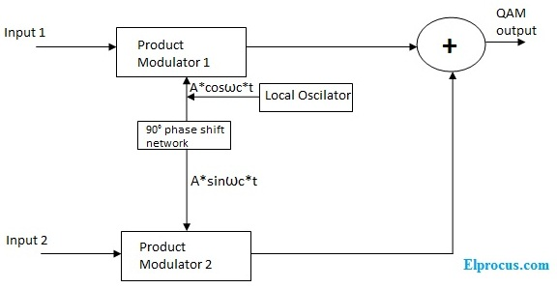
Modulation (Transmitter Side)
- Serial-to-Parallel Conversion:
  - Split input bits into two streams: one for I, one for Q.
  - Example: 1101 → I: 11, Q: 01.
- Digital-to-Analog Conversion (DAC):
  - Convert digital bits into analog voltages:
$$x_{1}(t)\text{ (I)},x_{2}(t)\text{ (Q)}$$
- Product Modulation:
  - Multiply I by cosine carrier: $x_{1}(t)⋅Acos⁡(ω_{c}t)$
  - Multiply Q by sine carrier: $x_{2}(t)⋅Asin⁡(ω_{c}t)$
- Summation:
  - Add the two signals to form the QAM signal:
$$s(t)=x_{1}(t)Acos⁡(ω_{c}t)+x_{2}(t)Asin⁡(ω_{c}t)$$
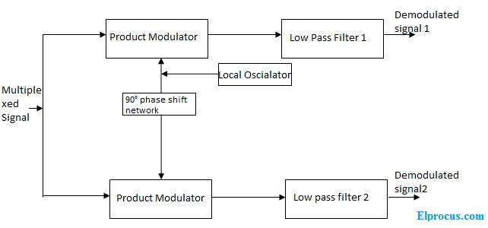
Demodulation (Receiver Side)
- Signal Splitting:
  - Split the received QAM signal into two paths: one for I, one for Q.
- Mixing:
  - Multiply the I path by cosine → $y_{1}^{'}(t)=s(t)⋅cos⁡(ω_{c}t)$
  - Multiply the Q path by sine → $y_{2}^{'}(t)=s(t)⋅sin⁡(ω_{c}t)$
- Low Pass Filtering (LPF):
  - Removes high-frequency terms (2× carrier)
  - Recovers original message signals:
$$y_{1}\left(t\right)=\frac{1}{2}Ax_{1}\left(t\right), y_{2}(t)=\frac{1}{2}Ax_{2}(t)$$
- Digital Conversion:
  - Convert analog signals back to digital bits using threshold detection.

Mathematical Explanation (Simple)
- Transmitted Signal:
$$s(t)=x_{1}(t)Acos⁡(ω_{c}t)+x_{2}(t)Asin⁡(ω_{c}t)$$
- Demodulation (I component):
$$y_{1}^{'}(t)=s(t)⋅cos⁡(ω_{c}t)=x_{1}(t)\frac{A}{2}+\text{high-frequency terms (removed by LPF)}$$
- Demodulation (Q component):
$$y_{2}^{'}(t)=s(t)⋅sin⁡(ω_{c}t)=x_{2}(t)\frac{A}{2}+\text{high-frequency terms (removed by LPF)}$$
Multiplying by the same carrier and filtering out high-frequency terms recovers I and Q signals.

3. Constellation Diagrams & Decision Boundaries
Constellation Diagram:
- A 2D plot with I-axis (horizontal) and Q-axis (vertical).
- Each point represents a symbol (combination of bits).
- The position of the point depends on amplitude (distance from origin) and phase (angle).

4-QAM (Equivalent to QPSK)
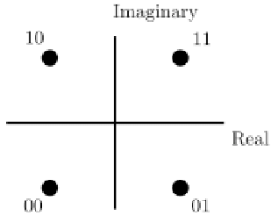
- Bits per symbol: 2 (e.g., 00, 01, 10, 11)
- Points: $\left(±1,±1\right)$in the I-Q plane
- Decision boundaries: I-axis and Q-axis divide the plane into 4 quadrants
16-QAM
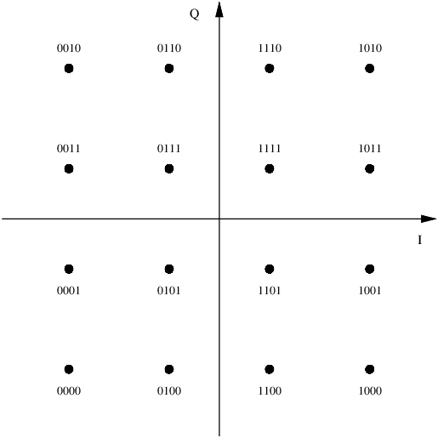
- Bits per symbol: 4
- Points: 16 points arranged in 4×4 grid
- Decision boundaries: Lines halfway between points
- Observation: Points are closer → more sensitive to noise

