What is Muller’s Method?

**Muller's Method** is a numerical method used to **find the roots of a polynomial or a nonlinear equation**, especially when:

* The function is not easily solvable using other methods like bisection or Newton-Raphson.
* The root is complex (imaginary).

It **uses a quadratic interpolation** technique to approximate the function and then find the root of that quadratic equation.

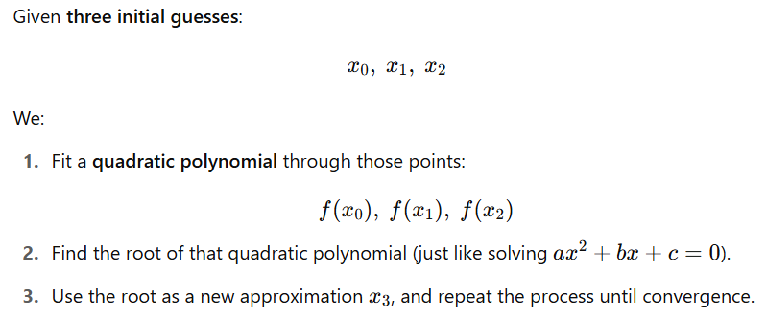

Mathematical Formulas

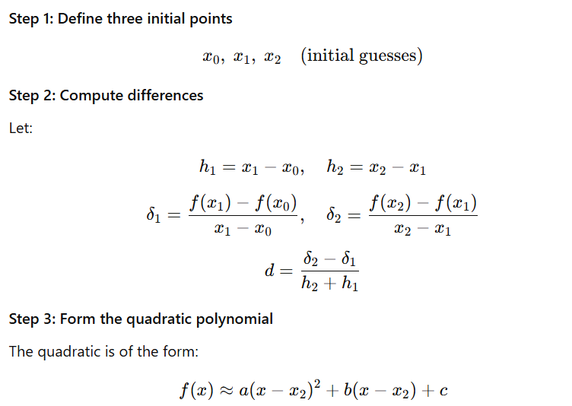

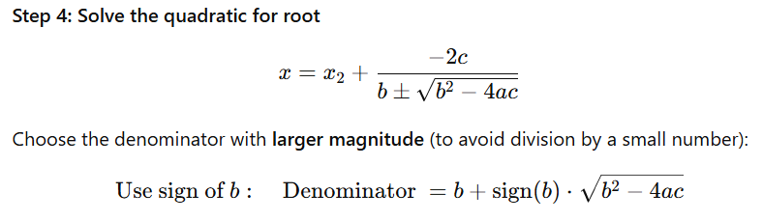

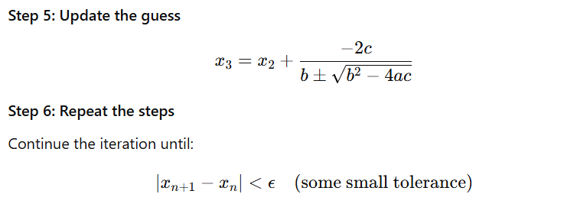

Problem-01:

Find a root of an equation f(x)=2x3-2x-5 using Muller Method

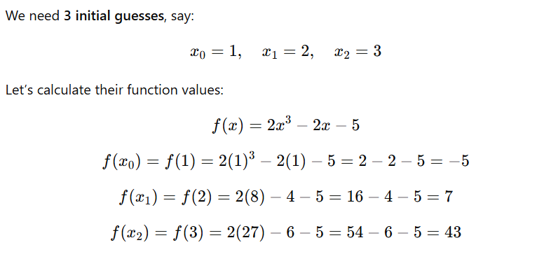

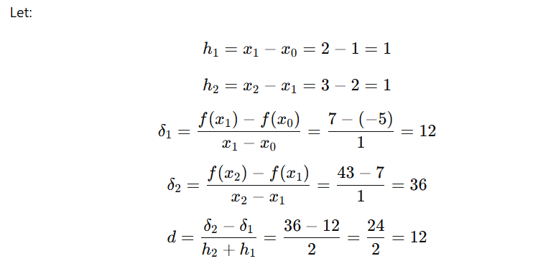

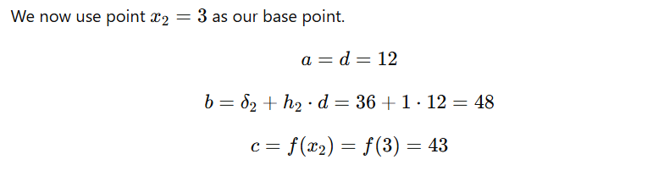

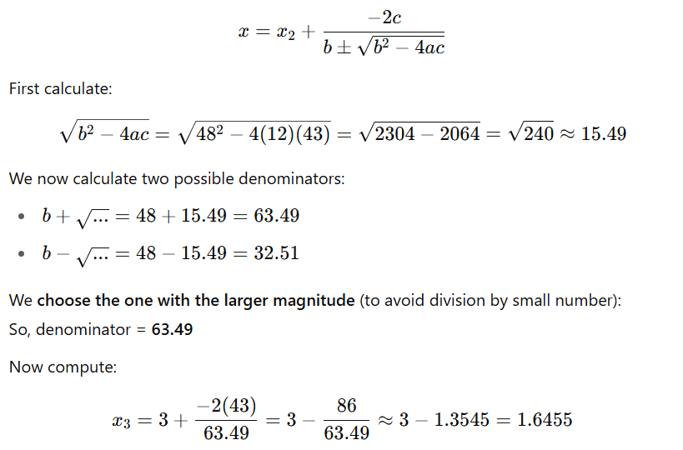

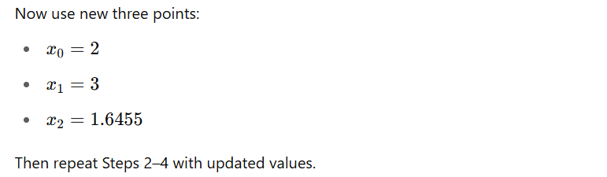

After repeating the steps, the **root converges to** approximately:

x≈1.6006

(Accurate up to 4 decimal places)

**Definition:**

Muller's Method is an **iterative root-finding technique** that uses a **quadratic interpolant** through three points to approximate a root of the equation:

f(x)=0

At each iteration, a quadratic polynomial is constructed using three previous approximations, and the root of this polynomial (closest to the last approximation) is taken as the next estimate.

