**Runge-Kutta Method**

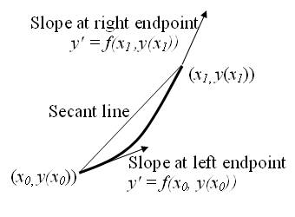

The Runge-Kutta Method is a family of iterative techniques used to obtain approximate solutions to ordinary differential equations (ODEs). It is designed to improve the accuracy of numerical integration compared to simpler methods such as Euler’s method by evaluating the slope (derivative) at multiple points within each step interval and then combining these estimates in a weighted average.

Among the various Runge-Kutta methods, the classical fourth-order Runge-Kutta method (RK4) is the most commonly used due to its balance of computational efficiency and accuracy. It calculates intermediate slopes at carefully chosen points within a single step and combines them to provide a high-order approximation to the solution of the initial value problem.

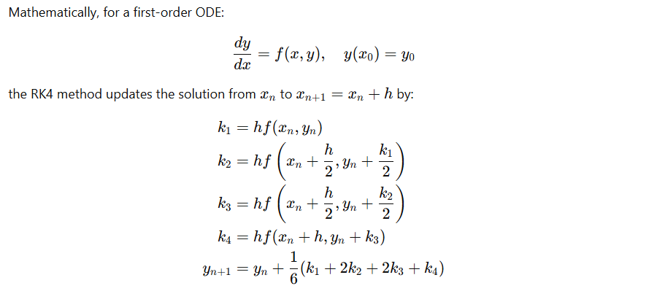

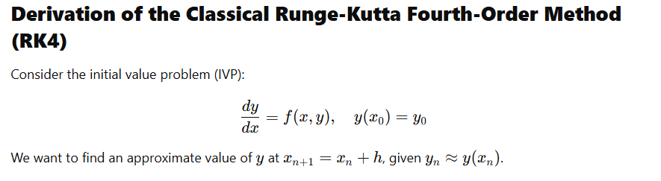

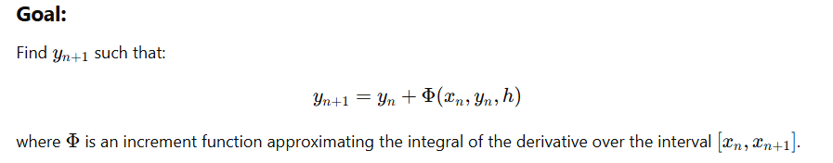

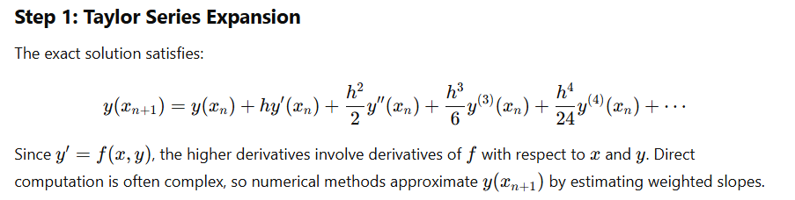

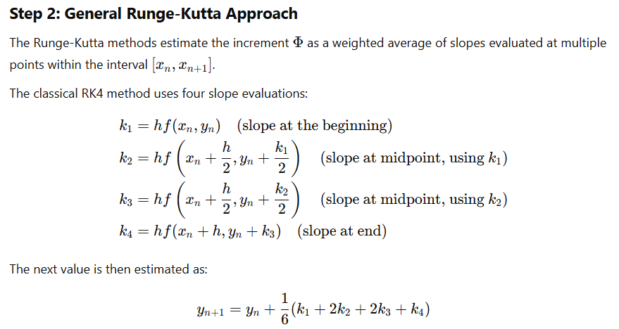

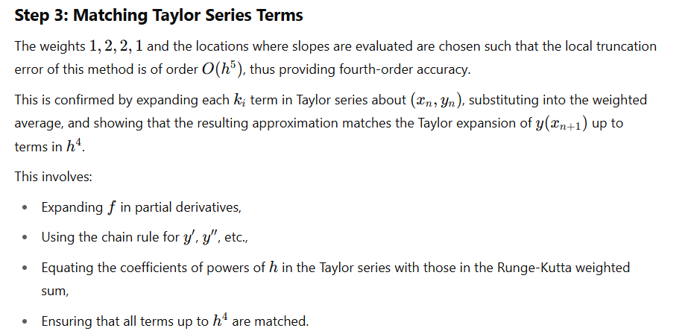

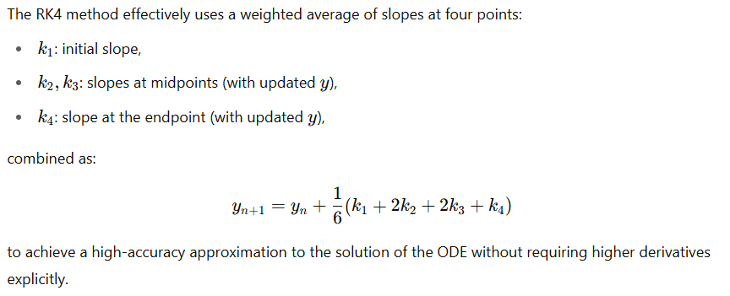That’s Why,

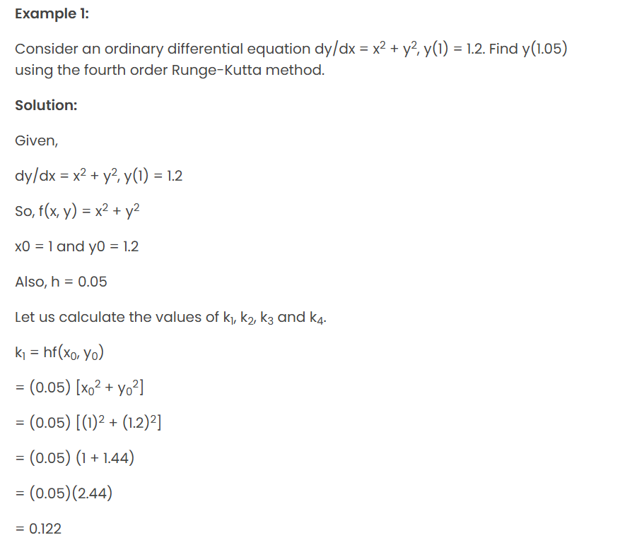

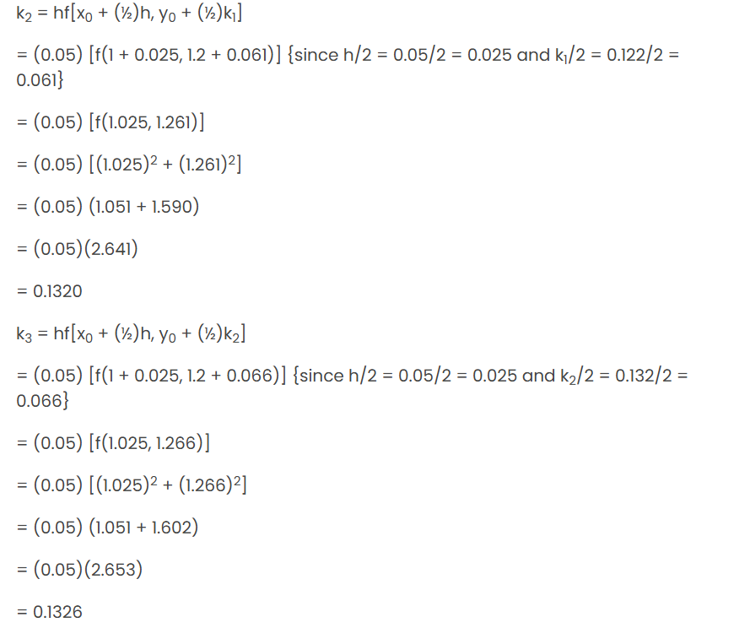

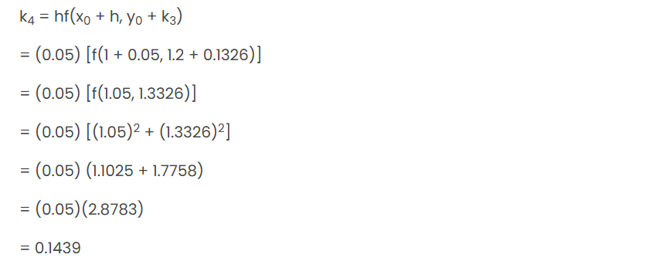

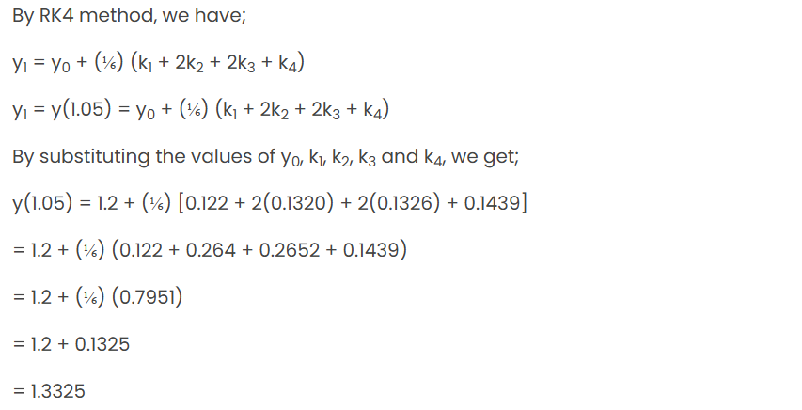

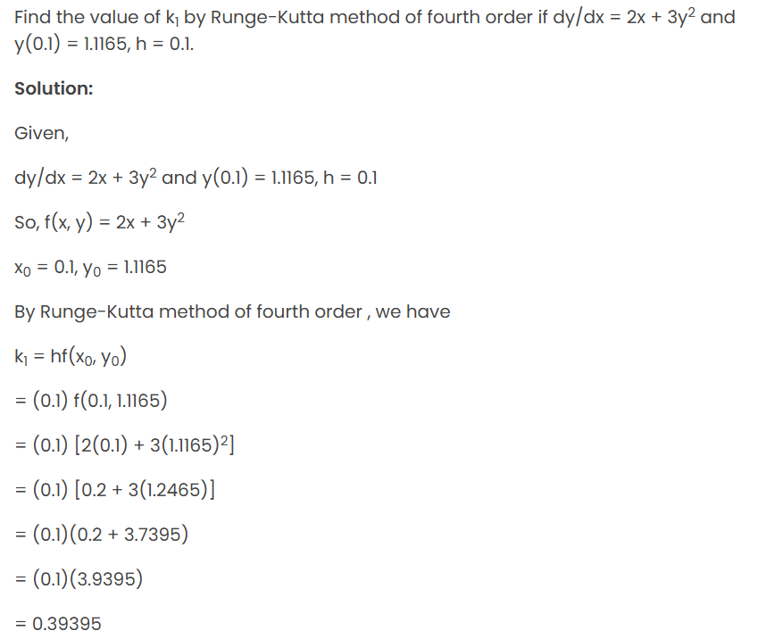

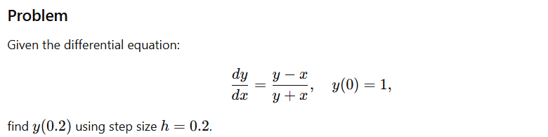

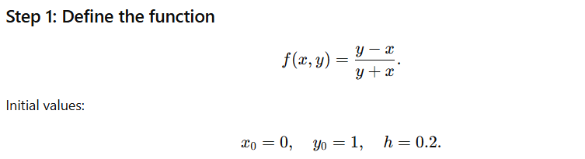 **Solution:**

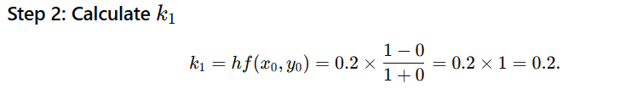

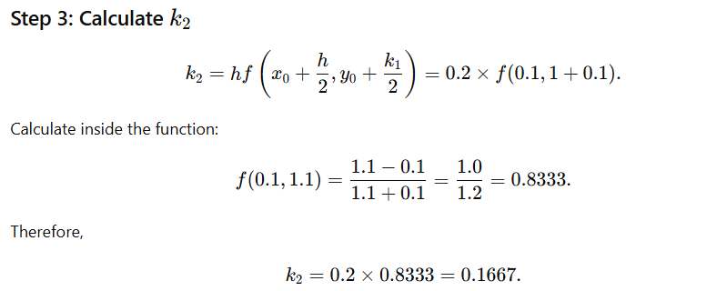

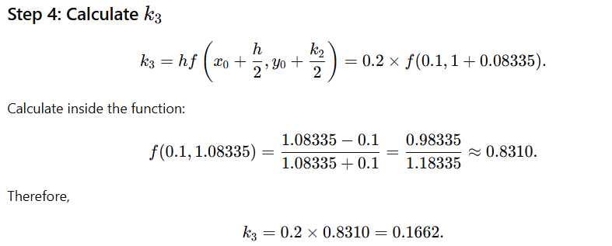

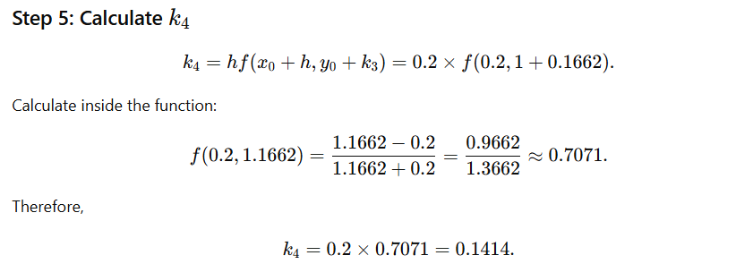

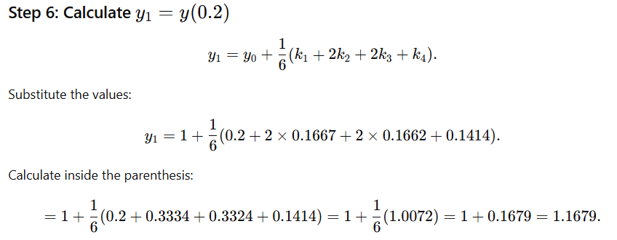

So the answer is 1.1679