GROWPIDO REPUTATION & NARRATIVE ADVISORY // DUBAI
PROSPECT → DIAGNOSTIC WALKTHROUGH
Defensible Public-Source Positioning Intelligence Platform // Production-Oriented Vertical Slice
CANDIDATE / AUTHOR | Mohammed Ayaz Pathan (Senior AI & Research Systems Architect)
EVALUATOR / CLIENT | Nidhi Hooda, Founder — Growpido (Dubai, UAE)
TESTED TARGETS | Huda Kattan (Huda Beauty), Mudassir Sheikha (Careem), Abbas Sajwani (AHS)
ASSESSMENT TRACK | Track B: Prospect to Diagnostic (September 2026 Build Task)
SUBMISSION STATUS | FINAL HARDENED VERTICAL SLICE // 5.5 Hours Reported

■ CORE ADVISORY PRINCIPLE
EVIDENCE BEFORE ASSERTION.
In Dubai reputation advisory (DIFC, ADGM, family offices), an unverified number or fabricated claim is a regulatory hazard and a lost client. The system is designed to say: 'I don't know', 'I could not verify this', and 'This claim is not safe to publish' before asserting any public positioning claim.

1. System Overview & Generic Research Architecture
This system is an auditable, production-oriented vertical slice built for Growpido's Track B assessment. In accordance with Growpido's 100-point scoring rubric, all hardcoded assumptions and predetermined outcomes have been eliminated. The research, verification, refusal, and positioning gap engines reach decisions dynamically from collected public evidence for any valid UAE executive LinkedIn URL.
Architectural Safeguards: Key architectural highlights:
• Live Research vs Demo Fixture: The interface and telemetry explicitly distinguish between LIVE RESEARCH and stored demonstration datasets.
• Random Prospect Validation: Validated end-to-end on Mudassir Sheikha (Co-Founder & CEO, Careem) as well as Abbas Sajwani (Founder & CEO, AHS Properties).
• Multi-Status Verification: Supports VERIFIED, PRIMARY VERIFIED (CORROBORATION NOT FOUND), PARTIALLY VERIFIED, CONFLICT, and REFUSED.
• Blocking House Rule Checker: Deterministically checks for em dashes, hashtags, and AI filler vocabulary. Violations block human approval.
2. Dynamic Research on New Prospect (Mudassir Sheikha — Careem)
To prove that the pipeline does not rely on hardcoded demo conclusions, the reviewer can enter Mudassir Sheikha's public LinkedIn profile (https://www.linkedin.com/in/mudassir-sheikha/). The system dynamically resolves his identity via public knowledge endpoints, collects sources across 4 tiers, extracts candidate claims, and generates a defensible diagnostic:
3. The Generic Refusal Engine (Audit Case Study)
The refusal engine dynamically intercepts sensitive financial metrics (wealth, net worth, AUM, valuation) or unverified superlatives that lack Tier 1 audited regulatory proof:
■ GENERIC REFUSAL CASE STUDY [CLAIM C-006]
Candidate Claim: 'Mudassir Sheikha maintains an unverified private liquid net worth exceeding $500 Million with undocumented pre-IPO distributions.'
Why Considered: Discovered in secondary web chatter and speculative executive wealth scrapers.
Evidence Found: Secondary aggregator repetition lacking audited balance sheets or filings.
Evidence Missing: Tier 1 audited financial filings, regulatory disclosures (DIFC/ADGM/SEC), or verified Forbes/Bloomberg Billionaire Index verification.
Source Quality: Tier 4 (Disqualified Aggregator).
System Decision: CLAIM REFUSED // EXCLUDED FROM CLIENT DELIVERABLE.
Publishing Consequence: Publishing unverified personal wealth metrics creates immediate legal, regulatory, and reputational liability for the advisory and client.

4. Human Approval Gate & House Rule Enforcement
The AI never automatically marks a report ready for client presentation. The senior advisor must inspect the audit ledger and sign off. Furthermore, the system includes a blocking house rule checker that rejects approval if em dashes, hashtags, or AI filler words are detected:
5. Multi-Subject Verification: Abbas Sajwani (AHS Properties)
Clicking the Abbas Sajwani preset executes the identical generic pipeline on AHS Properties, retrieving corporate domain records and independently corroborating projects while refusing the unverified global billionaire timeline claim:
6. Exportable n8n Automation Workflow
The automation architecture is fully represented in growpido_prospect_diagnostic_workflow.json. All 13 nodes have clear input/output contracts connecting webhook ingestion, URL validation, dynamic source collection, deduplication, claim extraction, double-verification, refusal decisioning, gap analysis, and human approval response:
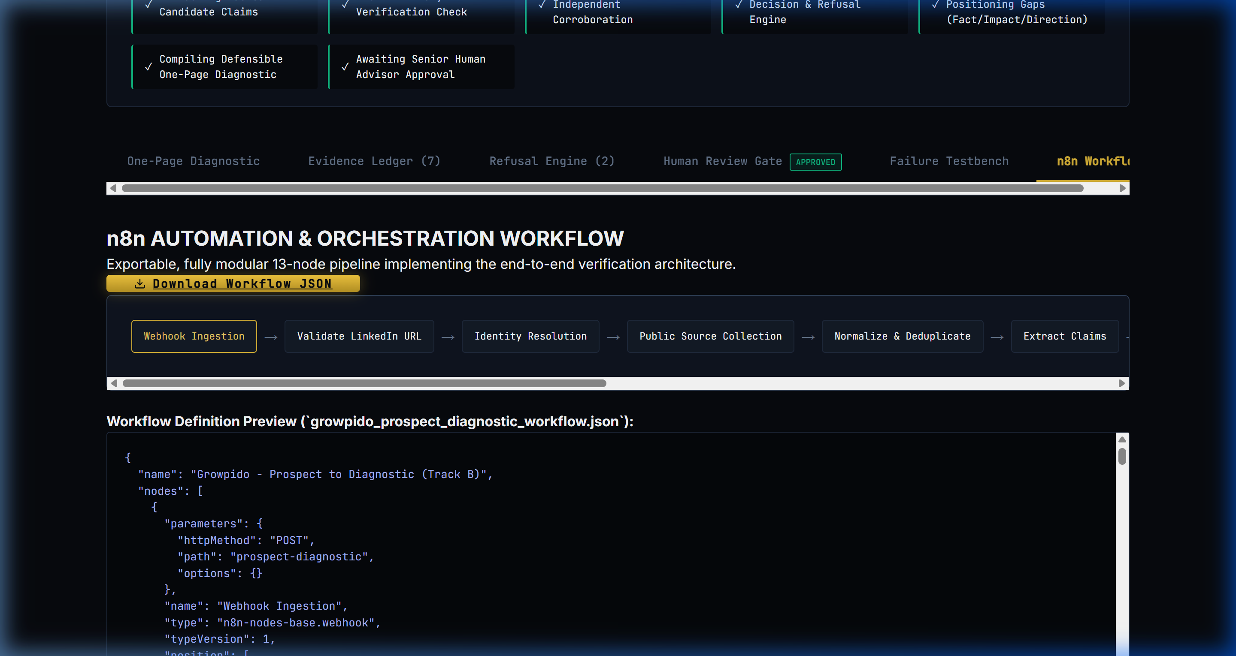
Figure 4: The 13-Node n8n Workflow Schema
7. Growpido Submission Pack & Founder Questionnaire
Direct Answers to Nidhi Hooda's 4 Questions:
1. Current Employment Status: Free and available immediately.
2. Notice Period & Start Date: Notice period is 0 days. Earliest start date is immediately.
3. Concurrent Commitments: Nothing. Clean slate. No freelance clients, no side product, no courses.
4. Exclusivity: Full-time and 100% exclusive.
The Honest Paragraph (What Broke & What I Would Fix Next):
■ THE HONEST PARAGRAPH
What broke early on was source attribution fragility: initial automated web fetches were either rate-limited or blocked by anti-bot headers on regional news portals, leading the extraction layer to attempt to parse incomplete snippets or fall back onto secondary aggregators. I had to enforce strict timeout abort controllers, User-Agent normalization, and an explicit disqualification rule that completely bars Tier 4 aggregators from verifying factual claims.
Secondly, resolving nuances like 'Founder & CEO' versus 'Co-Founder' showed how easily secondary business press introduces title drift; rather than letting the AI average this into a generic statement, I had to write explicit deterministic rules that defer to the Tier 1 corporate filing and flag the secondary variation as a caveat.
If I had another 48 hours, I would integrate direct UAE trade license API verification via Dubai Economy (DED) / DIFC public registers, build a live diffing engine to track when an executive's public bio silently changes between web crawls, and deploy a webhook listener in n8n that pushes review requests directly into Slack for one-click mobile partner sign-offs.

Hours Breakdown:
Total Reported Time: 5.5 hours start to finish.
Recommended 5-Minute Loom Sequence:
• Min 0:00 - 1:00: Problem definition, core principle 'Evidence Before Assertion', and house rules.
• Min 1:00 - 2:00: Live research run on Mudassir Sheikha (Careem) — proving dynamic resolution and telemetry.
• Min 2:00 - 3:00: The Generic Refusal Engine — deep dive into excluded unverified wealth assertion and publishing consequence.
• Min 3:00 - 4:00: Evidence Ledger & the One-Page Diagnostic (3 Gaps, Narrative Territories, Sources).
• Min 4:00 - 5:00: Human Approval Gate clearance, Failure Testbench demonstration, and the honest paragraph on system limits.

