INDEX

|  |  |  |
| --- | --- | --- |
| serial | Experiment Name | Page no |
|  | Section 1 ( HTML ) |  |
|  | Design a simple webpage using only HTML tags for Computer Science & Engineering(CSE) department of your institute or college where <head>,<title>,<body> and Divisional tags like <div>,<span><table> should be used as needed. |  |
|  | Using text links design a simple website to navigate between different pages ( minimum two pages and one page must contain a image link and another page contain 3*4 table). |  |
|  | Section 2 ( CSS ) |  |
|  | Design a simple website using CSS containing formatted text, forms, tables and link styles ( must use three ways of inserting CSS external, internal and inline style). |  |
|  | : Using CSS menu, design a simple website to navigate between different pages ( minimum three pages and each page must contain heading, paragraph , text formatting tag and mouse over links to back home page). |  |
|  | Section 3 ( PHP, My SQL ) |  |
|  | Design a form that contains “text fields”, “text area “ , “check boxes”, “multiple check boxes”, “radio buttons”, ”list”, ”password fields”, submit button and store the value of this into my-sql database and show the stored information into another page using php program. |  |
|  | Design a webpage that collects student information and subject marks and stores the information and marks to my sql database. Show the results in grading GPA system to another page using PHP program. |  |
|  | Section 4 ( Java Scripts ) |  |
|  | Design a page where user can input his/her personal information like name, address, email, gender, mobile number etc. and perform input validation using java scripts like valid email mobile number should be 11digit mandatory field check etc. |  |
|  | Design a webpage containing java scripts function that performs various action like change text, change color, remove tag, insert new tag by different events like mouse click , mouse over etc. |  |

Question 1: Design a simple webpage using only HTML tags for Computer Science & Engineering(CSE) department of your institute or college where <head>,<title>,<body> and

Divisional tags like <div>,<span><table> should be used as needed.

Answer:

Html:

<!DOCTYPE html>

<html lang="en">

<head>

<meta charset="UTF-8">

<title>CSE Department BIST</title>

</head>

<body>

<table align="center" width="768px">

<tr>

<td height="130"><img src="download.jpg" height="100" alt=""></td>

<td>

<table align="right">

<tr>

<td width="60"><a href="#">Home</a></td>

<td width="60"><a href="#">About</a></td>

<td width="60"><a href="#">Gallery</a></td>

<td width="70"><a href="#">Teachers</a></td>

<td width="40"><a href="#">Blog</a></td>

<td width="60"><a href="#">Contact</a></td>

</tr>

</table>

</td>

</tr>

<tr>

<td colspan="2" align='center'>

<h2>About Department</h2>

</td>

</tr>

<tr>

<td colspan="2" height="25px"></td>

</tr>

<tr>

<td colspan="2">

<table width="768px">

<tr>

<td width='55%'>

<img width="100%" src="img.jpg" alt="">

</td>

<td width='3%'>

</td>

<td width="45%">

<p align="justify">Lorem ipsum dolor sit amet, consectetur adipisicing elit. Delectus

recusandae hic nihil ipsum sed quae laudantium, odio doloribus dolorem tenetur at distinctio pariatur cupiditate! Architecto quaerat ducimus repellendus amet mollitia?</p>

<p align="justify">Lorem ipsum dolor sit amet, consectetur adipisicing elit. Delectus

recusandae hic nihil ipsum sed quae laudantium, odio doloribus dolorem tenetur at distinctio pariatur cupiditate! Architecto quaerat ducimus repellendus amet mollitia?</p>

</td>

<td width='2%'>

</tr>

</table>

</td>

</tr>

<tr>

<td colspan="2" height="25px"></td>

</tr>

<tr>

<td colspan="2" align='center'>

<h2>Courses</h2>

</td>

</tr>

<tr>

<td colspan="2">

<table>

<tr>

<td>

<h4>First Semester</h4>

<ul>

<li>C language</li>

<li>Fandament of computer's</li>

<li>Integral Calculas</li>

<li>English</li>

<li>Bsic's physic's</li>

</ul>

</td>

<td>

<h4>Second Semester</h4>

<ul>

<li>Data Structure</li>

<li>Fandament of computer's</li>

<li>Integral Calculas</li>

<li>English</li>

<li>Bsic's physic's</li>

</ul>

</td>

<td>

<h4>Third Semester</h4>

<ul>

<li>C++</li>

<li>Fandament of computer's</li>

<li>Integral Calculas</li>

<li>English</li>

<li>Bsic's physic's</li>

</ul>

</td>

<td>

<h4>Fourth Semester</h4>

<ul>

<li>Algorithm Desing</li>

<li>Fandament of computer's</li>

<li>Integral Calculas</li>

<li>English</li>

<li>Bsic's physic's</li>

</ul>

</td>

</tr>

</table>

</td>

</tr>

<tr>

<td colspan="2" height="25px"></td>

</tr>

<tr>

<td colspan="2" align='center'>

<h2>Contact us</h2>

</td>

</tr>

<tr>

<td colspan="2" height="25px"></td>

</tr>

<tr>

<td colspan="2">

<table width="100%">

<tr>

<td width="100%">

<form action="" width='100%'>

<table width="100%">

<tr>

<td width="10%"><label for="">Name</label></td>

<td width="2%">:</td>

<td width="50%"><input style="width: 100%" type="text" placeholder="give

your name"></td>

</tr>

<tr>

<td colspan="2" height="25px"></td>

</tr>

<tr>

<td width="10%"><label for="">Email</label></td>

<td width="2%">:</td>

<td width="50%"><input style="width: 100%" type="email" placeholder="give

your email"></td>

</tr>

<tr>

<td colspan="2" height="25px"></td>

</tr>

<tr>

<td width="10%"><label for="">subject</label></td>

<td width="2%">:</td>

<td width="50%"><input style="width: 100%" type="text" placeholder="give

your subject"></td>

</tr>

<tr>

<td colspan="2" height="25px"></td>

</tr>

<tr>

<td width="10%"><label for="">Message</label></td>

<td width="2%">:</td>

<td width="50%"><textarea style="width: 100%" rows="4" type="text"

placeholder="write your feedback"></textarea></td>

</tr>

<tr>

<td colspan="2" height="25px"></td>

</tr>

<tr>

<td colspan="3" align="center" width="40%"><button>Send

message</button></td>

</tr>

<tr>

<td colspan="2" height="25px"></td>

</tr>

</table>

</form>

</td>

</tr>

</table>

</td>

</tr>

<tr>

<td colspan="2" bgcolor="#777" height="40px" align="middle">

<p style="color:white; text-align: center; vertical-align: middle;">© COPYRIGHTS 2019 BIST

CSE DEPARTMENT. ALL RIGHTS RESERVED</p>

</td>

</tr>

</table>

</body></html>

Sample output :

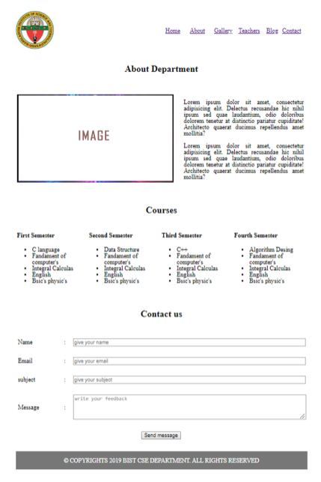

Question 2: Using text links design a simple website to navigate between different pages ( minimum two pages and one page must contain a image link and another page contain 3*4 table).

Answer:

Index page:

<!DOCTYPE html>

<html lang="en">

<head>

<meta charset="UTF-8">

<meta name="viewport" content="width=device-width, initial-scale=1.0">

<meta http-equiv="X-UA-Compatible" content="ie=edge">

<title>Document</title>

</head>

<body>

<table style="width: 500px; margin:0 auto;margin-top: 50px;border: 1px solid balck;text-

align: center;">

<tr>

<td><a href="index2.html">home</a></td>

<td><a href="image.html">gallery</a></td>

<td><a href="table.html">data table</a></td>

</tr>

</table>

</body>

</html>

Sample output:



Inner page image.html:

<!DOCTYPE html>

<html lang="en">

<head>

<meta charset="UTF-8">

<meta name="viewport" content="width=device-width, initial-scale=1.0">

<meta http-equiv="X-UA-Compatible" content="ie=edge">

<title>Document</title>

</head>

<body>

<table style="margin: 0 auto;">

<tr>

<td colspan="3"> <h5 align="center">gallery</h5></td>

</tr>

<tr>

<td style="height: 100px; width:120px; border:1px solid black;"><img src="" alt="image"></td>

<td style="height: 100px; width:120px; border:1px solid black;"><img src="" alt="image"></td>

<td style="height: 100px; width:120px; border:1px solid black;"><img src="" alt="image"></td>

</tr>

<tr>

<td style="height: 100px; width:120px; border:1px solid black;"><img src="" alt="image"></td>

<td style="height: 100px; width:120px; border:1px solid black;"><img src="" alt="image"></td>

<td style="height: 100px; width:120px; border:1px solid black;"><img src="" alt="image"></td>

</tr>

</table>

</body>

</html>

Sample output:

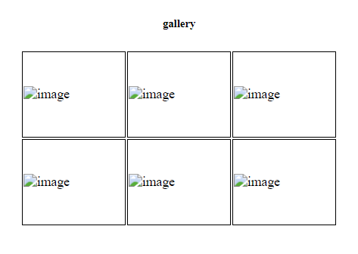

Inner page table.html:

<!DOCTYPE html>

<html lang="en">

<head>

<meta charset="UTF-8">

<meta name="viewport" content="width=device-width, initial-scale=1.0">

<meta http-equiv="X-UA-Compatible" content="ie=edge">

<title>Document</title>

<style>

td{

border: 1px solid gray;

}

</style>

</head>

<body>

<table style="width: 500px; margin:20px auto; border:1px solid black;text-align: center;">

<tr>

<td>Id</td>

<td>Name</td>

<td>Number</td>

</tr>

<tr>

<td>1</td>

<td>John</td>

<td>152</td>

</tr>

<tr>

<td>2</td>

<td>Haris</td>

<td>652</td>

</tr>

<tr>

<td>3</td>

<td>Zain</td>

<td>569</td>

</tr>

</table>

</body>

</html>

Sample output:

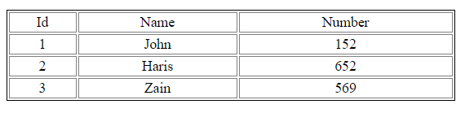

SECTION B

Question 3: Design a simple website using CSS containing formatted text, forms, tables and link styles ( must use three ways of inserting CSS external, internal and inline style).

Answer:

<!DOCTYPE html>

<html lang="en">

<head>

<meta charset="UTF-8">

<meta name="viewport" content="width=device-width, initial-scale=1.0">

<meta http-equiv="X-UA-Compatible" content="ie=edge">

<title>Document</title>

<link rel="stylesheet" href="style.css">

<style>

tr{

border: 1px solid black;

text-align: center;

}

td{

padding: 10px;

}

td table{

width: 100%;

}

td table td{

border:1px solid black;

}

</style>

</head>

<body>

<table style="width: 500px; margin:30px auto;">

<tr>

<td>home</td>

<td>about</td>

<td>contact</td>

</tr>

<tr>

<td colspan="3">

<p>Lorem ipsum dolor sit amet consectetur adipisicing elit. Repudiandae, voluptatum nesciunt dicta

provident eligendi

quaerat ipsum facere animi veniam vitae consectetur! Laboriosam in cum animi tenetur consectetur

ipsa quis aut.</p>

</td>

</tr>

<tr>

<td colspan="3">

<h1>Student information</h1>

</td>

</tr>

<tr>

<td colspan="3">

<table>

<tr>

<td>Id</td>

<td>Name</td>

<td>Number</td>

</tr>

<tr>

<td>1</td>

<td>John</td>

<td>152</td>

</tr>

<tr>

<td>2</td>

<td>Haris</td>

<td>652</td>

</tr>

<tr>

<td>3</td>

<td>Zain</td>

<td>569</td>

</tr>

</table>

</td>

</tr>

</table>

</body>

</html>

Style.css:

body{

background: #f5f5f5;

}

a{

font-size: 18px;

font-weight: 700;

}

a:hover{

text-decoration: none;

color: rgb(93, 6, 47);

}

Sample output:

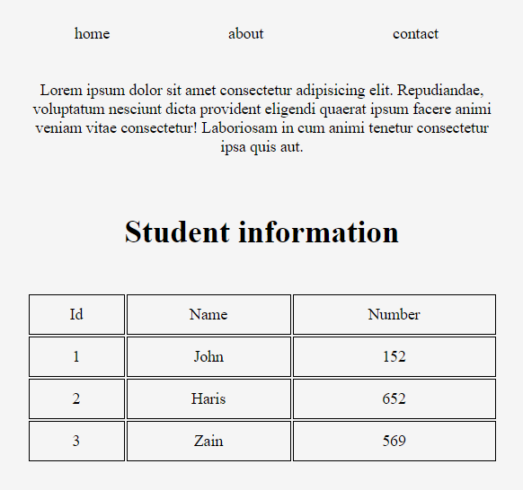

Question 4: Using CSS menu, design a simple website to navigate between different pages ( minimum three pages and each page must contain heading, paragraph , text formatting tag and mouse over links to back home page).

Answer:

Index page:

<!DOCTYPE html>

<html lang="en">

<head>

<meta charset="UTF-8">

<meta name="viewport" content="width=device-width, initial-scale=1.0">

<meta http-equiv="X-UA-Compatible" content="ie=edge">

<title>Document</title>

<link rel="stylesheet" href="style.css">

</head>

<body>

<table style="width: 500px; margin:0 auto;margin-top: 30px;border: 1px solid balck;text-align: center;">

<tr>

<td><a href="index2.html">home</a></td>

<td><a href="page1.html">contact</a></td>

<td><a href="page2.html">gallery</a></td>

<td><a href="page3.html">about us</a></td>

</tr>

</table>

</body>

</html>

Sample output:



Inner page1.html:

<!DOCTYPE html>

<html lang="en">

<head>

<meta charset="UTF-8">

<meta name="viewport" content="width=device-width, initial-scale=1.0">

<meta http-equiv="X-UA-Compatible" content="ie=edge">

<title>Document</title>

<link rel="stylesheet" href="style.css">

<style>

td{

padding: 10px;

}

</style>

</head>

<body>

<table style="width: 500px; margin:0 auto;margin-top: 30px;border: 1px solid balck;text-align: center;">

<tr>

<td><a href="index2.html">home</a></td>

<td><a href="page1.html">contact</a></td>

<td><a href="page2.html">gallery</a></td>

<td><a href="page3.html">about us</a></td>

</tr>

<tr>

<td colspan="4">

<h3>contact us</h3>

</td>

</tr>

<tr>

<td colspan="2"><label for="">name:</label></td>

<td colspan="2"><input type="text" name="" id=""></td>

</tr>

<tr>

<td colspan="2"><label for="">email:</label></td>

<td colspan="2"><input type="text" name="" id=""></td>

</tr>

<tr>

<td colspan="2"><label for="">description:</label></td>

<td colspan="2"><input type="text" name="" id=""></td>

</tr>

<tr>

<td colspan="8"><button>submit</button></td>

</tr>

</table>

</body>

</html>

Sample output:

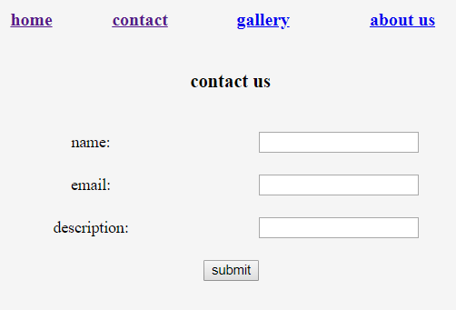

Inner page2.html:

<!DOCTYPE html>

<html lang="en">

<head>

<meta charset="UTF-8">

<meta name="viewport" content="width=device-width, initial-scale=1.0">

<meta http-equiv="X-UA-Compatible" content="ie=edge">

<title>Document</title>

<link rel="stylesheet" href="style.css">

<style>

td{

padding: 10px;

}

</style>

</head>

<body>

<table style="width: 500px; margin:0 auto;margin-top: 30px;border: 1px solid balck;text-align: center;">

<tr>

<td><a href="index2.html">home</a></td>

<td><a href="page1.html">contact</a></td>

<td><a href="page2.html">gallery</a></td>

<td><a href="page3.html">about us</a></td>

</tr>

<tr>

<td colspan="4"><center><h2>gallery</h2></center></td>

</tr>

<tr>

<td><img style="width: 120px; height: 100px;" src="images.png" alt="image"></td>

<td><img style="width: 120px; height: 100px;" src="images.png" alt="image"></td>

<td><img style="width: 120px; height: 100px;" src="images.png" alt="image"></td>

</tr>

<tr>

<td><img style="width: 120px; height: 100px;" src="images.png" alt="image"></td>

<td><img style="width: 120px; height: 100px;" src="images.png" alt="image"></td>

<td><img style="width: 120px; height: 100px;" src="images.png" alt="image"></td>

</tr>

</table>

</body>

</html>

Sample output:

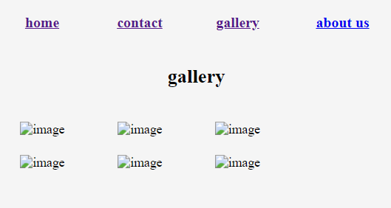

Inner page3.html:

<!DOCTYPE html>

<html lang="en">

<head>

<meta charset="UTF-8">

<meta name="viewport" content="width=device-width, initial-scale=1.0">

<meta http-equiv="X-UA-Compatible" content="ie=edge">

<link rel="stylesheet" href="style.css">

<title>Document</title>

<style>

p{

text-align: justify;

}

</style>

</head>

<body>

<table style="width: 500px; margin:0 auto;margin-top: 30px;border: 1px solid balck;text-align: center;">

<tr>

<td><a href="index2.html">home</a></td>

<td><a href="page1.html">contact</a></td>

<td><a href="page2.html">gallery</a></td>

<td><a href="page3.html">about us</a></td>

</tr>

<tr>

<td colspan="4">

<center>

<h2>About Us</h2>

</center>

</td>

</tr>

<tr>

<td colspan="4">

<p>

Lorem ipsum dolor, sit amet consectetur adipisicing elit. Nemo, mollitia nihil.

Dolorem dolore adipisci corporis atque amet assumenda provident.

Eum maxime quaerat quasi consequatur dolore voluptates hic unde nam voluptate!

</p>

</td>

</tr>

</table>

</body>

</html>

Sample output:

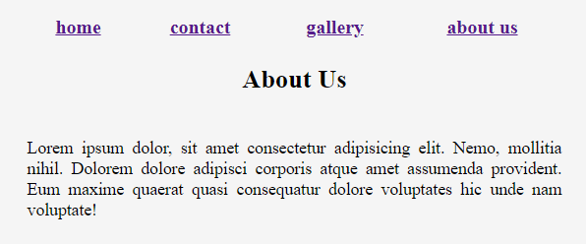

Style.css:

body{

background: #f5f5f5;

}

a{

font-size: 18px;

font-weight: 700;

}

a:hover{

text-decoration: none;

color: rgb(93, 6, 47);

}

SECTION 3

Question 5: Design a form that contains “text fields”, “text area “ , “check boxes”, “multiple check boxes”, “radio buttons”, ”list”, ”password fields”, submit button and store the value of this into my-sql database and show the stored information into another page using php program.

Answer:

Index.php:

<?php

$con=mysqli_connect('localhost','root','','student_infor');

if(!$con){

echo "<script> alert('db not success'); </script>";

}

if(!empty($_POST)){

$name = $_POST['name'];

$email = $_POST['email'];

$password = $_POST['password'];

$department = $_POST['department'];

$gender = $_POST['gender'];

$role1 = $_POST['student'];

$role2 = $_POST['captains'];

$role3 = $_POST['trainer'];

if( empty($role1))$role1= "";

if( empty($role2))$role2= "";

if( empty($role3))$role3= "";

$insert = "INSERT INTO student_information(name,email,password,department,gender,role1,role2,role3)

values('$name','$email','$password','$department','$gender','$role1','$role2','$role3')";

if(mysqli_query($con,$insert)){

echo "<script> alert('success'); </script>";

}

else{

echo "<script> alert('not success'); </script>";

}

}

?>

<!DOCTYPE html>

<html lang="en">

<head>

<meta charset="UTF-8">

<meta name="viewport" content="width=device-width, initial-scale=1.0">

<meta http-equiv="X-UA-Compatible" content="ie=edge">

<title>Document</title>

<link rel="stylesheet" href="style2.css">

</head>

<body>

<div class="body">

<div class="nav">

<a href="index2.php">add new record</a>

<a href="view.php">view record</a>

</div>

<form action="index2.php" method="POST">

<label for="">your name</label>

<input name="name" type="text">

<label for="">your email</label>

<input name="email" type="text">

<label for="">your password</label>

<input name="password" type="password">

<label for="">department</label>

<select name="department" id="">

<option value="cse">cse</option>

<option value="ece">ece</option>

<option value="bba">bba</option>

</select>

<label for="">gender</label>

<input type="checkbox" name="gender" value="male"><span>male</span>

<input type="checkbox" name="gender" value="female"><span>female</span>

<label for="">your role</label>

<input type="radio" name="student" hidden checked value="">

<input type="radio" name="student" value="student"><span>student</span>

<input type="radio" name="captains" hidden checked value="">

<input type="radio" name="captains" value="captain"><span>class captain</span>

<input type="radio" name="trainer" hidden checked value="">

<input type="radio" name="trainer" value="trainer"><span>trainer</span><br>

<button type="submit">submit</button>

<button type="reset">reset</button>

</form>

</div>

</body>

</html>

Sample output:

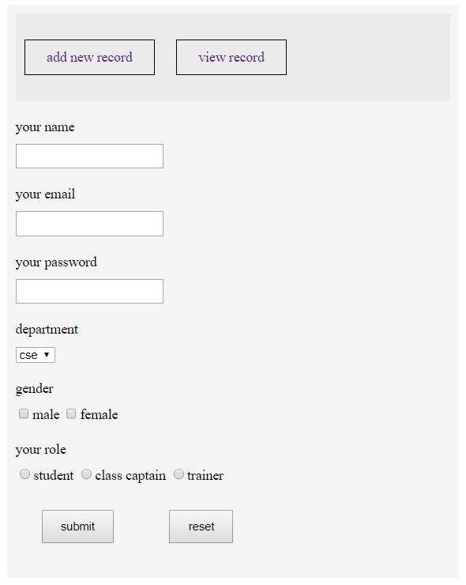

View.php:

<!DOCTYPE html>

<html lang="en">

<?php

$con=mysqli_connect('localhost','root','','student_infor');

?>

<head>

<meta charset="UTF-8">

<meta name="viewport" content="width=device-width, initial-scale=1.0">

<meta http-equiv="X-UA-Compatible" content="ie=edge">

<title>Document</title>

<link rel="stylesheet" href="style2.css">

<style>

table{

padding: 5px;

width: 100%;

text-align: center;

}

td,th{

border-bottom: 1px solid gray;

padding: 20px 5px;

}

</style>

</head>

<body>

<div class="body body2">

<div class="nav">

<a href="index2.php">add new record</a>

<a href="view.php">view record</a>

</div>

<table class="table product-overview" cellspacing="0" cellpadding="0">

<thead>

<tr>

<th>Id</th>

<th>Name</th>

<th>email</th>

<th>department</th>

<th>gender</th>

<th>role</th>

</tr>

</thead>

<tbody>

<?php

$select = "SELECT * FROM student_information";

$all = mysqli_query($con,$select);

while( $data = mysqli_fetch_assoc($all)){

?>

<tr>

<td><?= $data['id'];?></td>

<td><?= $data['name'];?></td>

<td><?= $data['email'];?></td>

<td><?= $data['department'];?></td>

<td><?= $data['gender'];?></td>

<td><?= $data['role1'];?> &nbsp;&nbsp; <?= $data['role2'];?> &nbsp;&nbsp; <?= $data['role3']; ""?></td>

</tr>

<?php } ?>

</tbody>

</table>

</div>

</body>

</html>

Sample output:

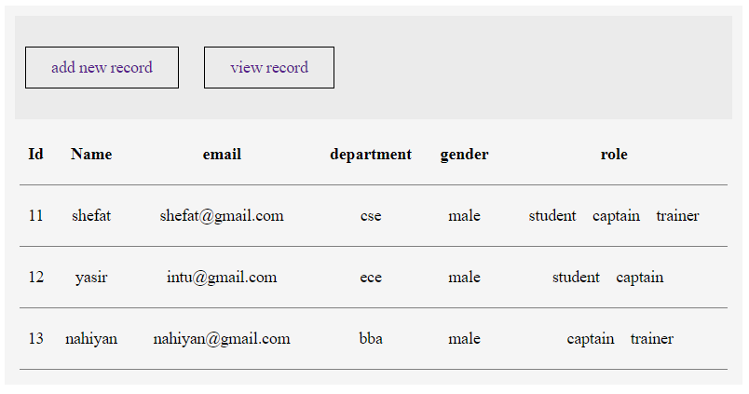

Question 6: Design a webpage that collects student information and subject marks and stores the information and marks to my sql database. Show the results in grading GPA system to another page using PHP program.

Answer:

Index.php:

<?php

$con=mysqli_connect('localhost','root','','student_infor');

?>

<!DOCTYPE html>

<html lang="en">

<head>

<meta charset="UTF-8">

<meta name="viewport" content="width=device-width, initial-scale=1.0">

<meta http-equiv="X-UA-Compatible" content="ie=edge">

<!-- <link rel="stylesheet" href="css/style.css"> -->

<title>Student's CGPA</title>

<style>

.body a{

text-decoration: none;

padding: 10px 20px;

margin: 0px 20px;

border: 1px solid gray;

border-radius: 5px;

}

section{

width: 500px;

margin: 0 auto;

}

section table{

width: 100%;

text-align: center;

}

section table td,section table th{

border-bottom: 1px solid gray;

padding: 10px;

}

</style>

</head>

<body>

<div class="body" style="width:500px; margin:30px auto;">

<table>

<tr>

<td><a href="index.php">home</a></td>

<td><a href="add.php">add new record</a></td>

</tr>

</table>

</div>

<section>

<div class="container">

<table class="table product-overview" cellpadding='0' cellspacing="0">

<thead>

<tr>

<th>Id</th>

<th>Name</th>

<th>Roll</th>

<th>Department</th>

<th>GPA</th>

<th>Action</th>

</tr>

</thead>

<tbody>

<?php

$select = "SELECT * FROM gpa";

$all = mysqli_query($con,$select);

while( $data = mysqli_fetch_assoc($all)){

?>

<tr>

<td><?= $data['id'];?></td>

<td><?= $data['name'];?></td>

<td><?= $data['roll'];?></td>

<td><?= $data['department'];?></td>

<td>

<?php printf("%.2f", ($data['first'] + $data['second'] + $data['third'] + $data['fourth'] + $data['fifth'] + $data['sixth'] + $data['seventh'] + $data['eighth'] )/8)?>

</td>

<td>

<a href="delete.php?d=<?= $data['id'];?>">Delete</a>

</td>

</tr>

<?php } ?>

</tbody>

</table>

</div>

</section>

</body>

</html>

Sample output:

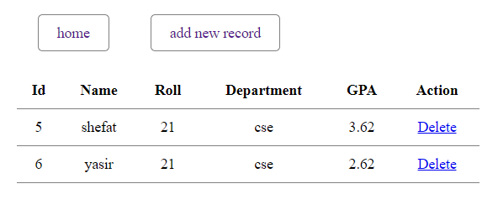

Add.php:

<?php

$con=mysqli_connect('localhost','root','','student_infor');

if(!$con){

echo "<script> alert('db not success'); </script>";

}

if(!empty($_POST)){

$name = $_POST['name'];

$roll = $_POST['roll'];

$department = $_POST['department'];

$first = $_POST['first'];

$second = $_POST['second'];

$third = $_POST['third'];

$fourth = $_POST['fourth'];

$fifth = $_POST['fifth'];

$sixth = $_POST['sixth'];

$seventh = $_POST['seventh'];

$eighth = $_POST['eighth'];

$insert = "INSERT INTO gpa(name,roll,department,first,second,third,fourth,fifth,sixth,seventh,eighth)

VALUES('$name','$roll','$department','$first','$second','$third','$fourth','$fifth','$sixth','$seventh','$eighth')";

if(mysqli_query($con,$insert)){

echo "<script> alert('success'); </script>";

}

else{

echo "<script> alert('not success'); </script>";

}

}

?>

<!DOCTYPE html>

<html lang="en">

<head>

<meta charset="UTF-8">

<meta name="viewport" content="width=device-width, initial-scale=1.0">

<meta http-equiv="X-UA-Compatible" content="ie=edge">

<title>Student's CGPA</title>

<style>

.body a{

text-decoration: none;

padding: 10px 20px;

margin: 0px 20px;

border: 1px solid gray;

border-radius: 5px;

}

input{

width: 100%;

margin: 10px 0px;

box-sizing: border-box;

padding: 10px;

}

button{

padding: 10px 20px;

border-radius: 5px;

}

</style>

</head>

<body>

<div class="body" style="width:500px; margin:30px auto;">

<table>

<tr>

<td><a href="index.php">home</a></td>

<td><a href="add.php">add new record</a></td>

</tr>

</table>

</div>

<section id="login" style="width: 500px;margin: 0 auto;">

<div class="container">

<div class="login">

<form action="" method="post" style="" class="">

<h2>Student Result Information</h2>

<input name="name" type="text" placeholder="name">

<input name="roll" type="text" placeholder="Roll">

<input name="department" type="text" placeholder="Department">

<h3>CGPA</h3>

<div style="width:45%; float:left;margin: 0px 5px; overflow:hidden;">

<input name="first" placeholder="1st Semester" type="number">

<input name="second" placeholder="2nd Semester" type="number">

<input name="third" placeholder="3rd Semester" type="number">

<input name="fourth" placeholder="4th Semester" type="number">

</div>

<div style="width:50%; float:left;margin: 0px 5px;overflow:hidden;">

<input name="fifth" placeholder="5th Semester" type="number">

<input name="sixth" placeholder="6th Semester" type="number">

<input name="seventh" placeholder="7th Semester" type="number">

<input name="eighth" placeholder="8th Semester" type="number">

</div>

<button type="submit" style="width: 200px;">Add Information</button>

</form>

</div>

</div>

</section>

</body>

</html>

Sample output:

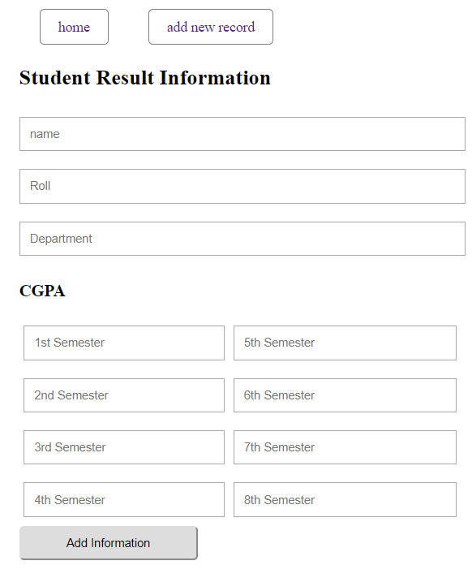

SECTION 4

Question 7: Design a page where user can input his/her personal information like name, address, email, gender, mobile number etc. and perform input validation using java scripts like valid email mobile number should be 11digit mandatory field check etc.

Answer:

<!DOCTYPE html>

<html lang="en">

<head>

<meta charset="UTF-8">

<meta name="viewport" content="width=device-width, initial-scale=1.0">

<meta http-equiv="X-UA-Compatible" content="ie=edge">

<title>js Validation</title>

<style>

input{

width: 100%; margin: 10px 0px; padding: 10px; border-radius: 3px;

}

span{

color: red;

}

</style>

</head>

<body>

<section id="login" style="width: 500px; margin: 0 auto;">

<div class="container">

<div class="login">

<form action="" style="height: 500px" class="form2">

<h2>Registration FORM</h2>

<input id="name" type="text" placeholder="name">

<span id="name-error" class=""></span>

<input id="email" placeholder="email" type="email">

<span id="email-error" class=""></span>

<input id="password" placeholder="password" type="password">

<span id="password-error" class=""></span>

<input id="repass" type="password" placeholder="repeat password" type="text">

<span id="repass-error" class=""></span>

<button type="submit" onsubmit="submit()" onclick="return Validation()">Submit</button>

</form>

</div>

</div>

</section>

</body>

</html>

<script>

function Validation(){

var name = document.getElementById('name');

var email = document.getElementById('email');

var password = document.getElementById('password');

var repass = document.getElementById('repass');

if( name.value == ''){

document.getElementById('name-error').innerHTML="Name is required";

name.focus();

return false;

}

if( email.value == ''){

document.getElementById('email-error').innerHTML="email is required";

email.focus();

return false;

}

if( password.value == ''){

document.getElementById('password-error').innerHTML="password is required";

password.focus();

return false;

}

if(password.value.length < 5){

document.getElementById('password-error').innerHTML="password minimum length should be 11 character";

password.focus();

return false;

}

if( repass.value == ''){

document.getElementById('repass-error').innerHTML="repeat password is required";

repass.focus();

return false;

}

if(password.value.length != repass.value.length){

document.getElementById('repass-error').innerHTML="password didn't matched";

repass.focus();

return false;

}

alert('Click ok to Submit');

}

</script>

Sample output:

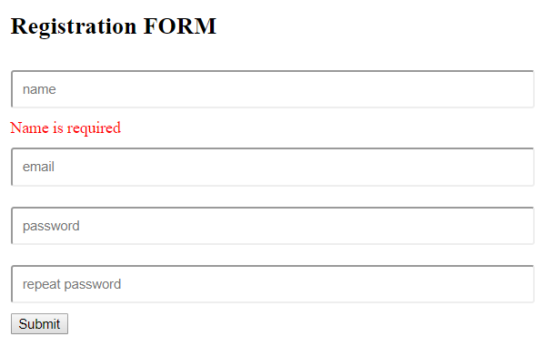

Question 8: Design a webpage containing java scripts function that performs various action like change text, change color, remove tag, insert new tag by different events like mouse click , mouse over etc.

Answer:

<!DOCTYPE html>

<html lang="en">

<head>

<meta charset="UTF-8">

<meta name="viewport" content="width=device-width, initial-scale=1.0">

<meta http-equiv="X-UA-Compatible" content="ie=edge">

<title>Document</title>

<link rel="stylesheet" href="style2.css">

<script>

function hover(){

document.getElementById('hover').style.color="red";

}

function out(){

document.getElementById('hover').style.color="black";

}

function remove(){

document.getElementById('remove').remove();

}

function add(){

var parent = document.getElementById('body');

var div = document.createElement('div');

var value = document.getElementById('value').value;

div.innerHTML = value ;

parent.appendChild(div);

}

function replace(){

var replace = document.getElementById('text');

var Text = document.getElementById('replace').value;

replace.innerHTML = Text;

}

</script>

</head>

<body>

<div class="body" id="body">

<div class="section" id="hover" onmouseover="hover()" onmouseout="out()">

<h4>keep mouse over to change color</h4>

</div>

<div class="section" id="remove" onclick="remove()">

<h4>click to remove this section</h4>

</div>

<div class="section">

<input type="text" id="value" placeholder="write tag and information and add to body">

<button onclick="add()">add new section</button>

</div>

<div class="section">

<p id="text">Lorem ipsum dolor sit amet, consectetur adipisicing elit. Nesciunt possimus architecto,

saepe incidunt quia eos,

distinctio alias provident quas inventore maxime sint blanditiis eveniet placeat omnis minus

iure soluta dolor.</p>

<input type="text" id="replace" placeholder="write something">

<button onclick="replace()">replace the paragraph</button>

</div>

</div>

</body>

</html>

Sample output:

