Electricity Bill Forecaster Using Multiple Linear Regression

Introduction

Electricity plays a vital role in our daily lives, and managing electricity consumption has become increasingly important for reducing household expenses. Many users are unaware of their expected electricity bill until it is generated, making it difficult to plan monthly expenses or monitor excessive power usage.
The Electricity Bill Forecaster is a machine learning application that predicts monthly electricity consumption and estimates the corresponding electricity bill using the Multiple Linear Regression algorithm. The prediction is based on household characteristics such as family size, number of electrical appliances, previous month's electricity usage, average daily usage hours, and temperature.
This project demonstrates the practical application of machine learning in solving a real-world forecasting problem while helping users better understand their electricity consumption patterns.

Problem Statement

The objective of this project is to develop a machine learning model capable of predicting monthly electricity consumption and estimating the electricity bill based on household usage patterns.
The application accepts several household-related inputs including family members, number of air conditioners, fans, refrigerators, televisions, washing machine usage, daily electricity usage hours, previous month's electricity units, and average temperature. Using these features, a Multiple Linear Regression model predicts monthly electricity units, after which the estimated electricity bill is calculated using a predefined tariff formula.
The system helps users estimate their future electricity expenses and promotes efficient energy management.

Results and Discussion

The project was successfully implemented using Python, Scikit-learn, Pandas, and Flask. A realistic synthetic dataset was generated and analyzed through Exploratory Data Analysis (EDA) using visualizations such as correlation heatmaps, histograms, scatter plots, and box plots.
The Multiple Linear Regression model was trained using 80% of the dataset and tested using the remaining 20%. The model performance was evaluated using Mean Absolute Error (MAE), Root Mean Squared Error (RMSE), and R² Score.
A Flask-based web application was developed where users can enter household details and instantly receive predicted electricity units along with the estimated monthly electricity bill. The prediction results were consistent with the generated dataset and demonstrated the effectiveness of the regression model.
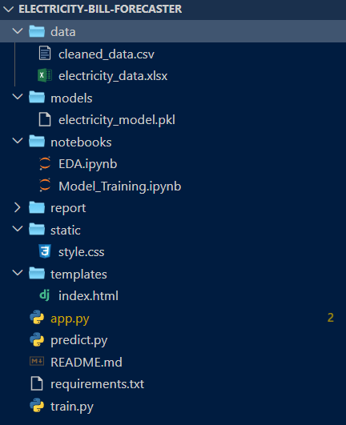

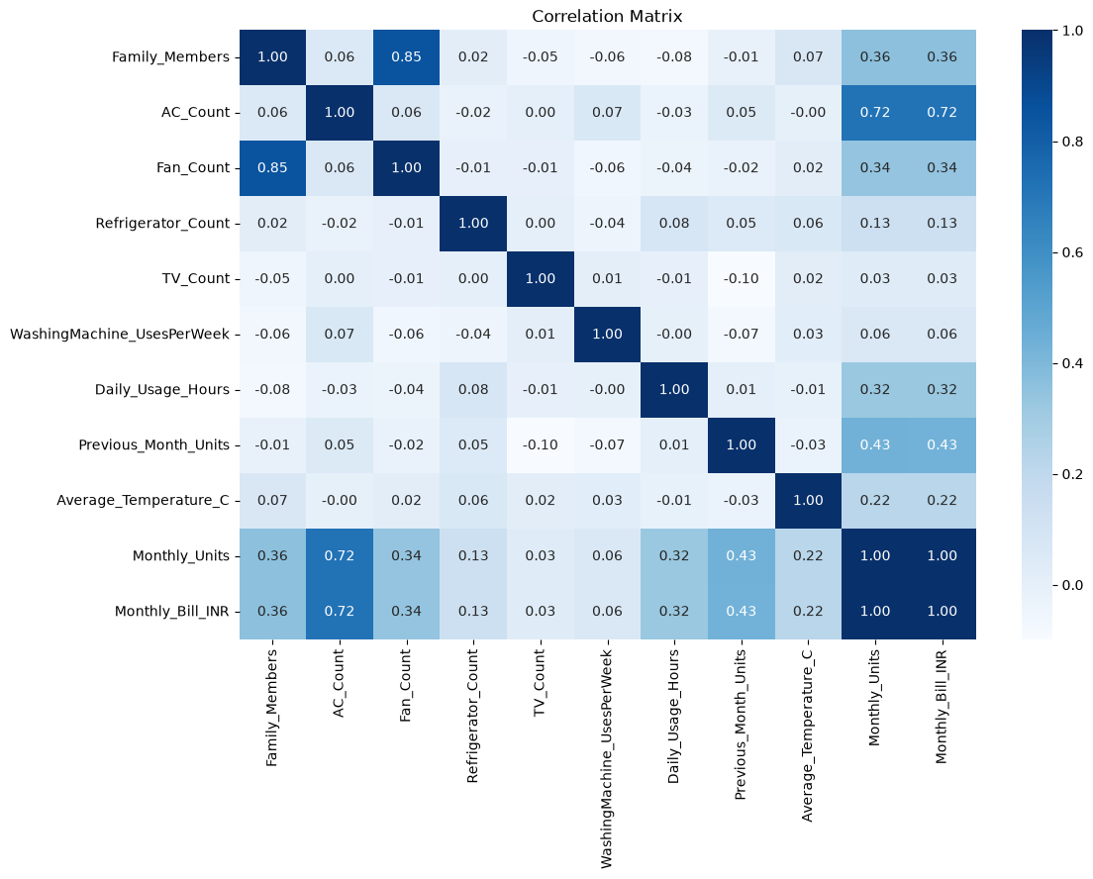
Figure 1 : Project Folder Structure

Figure 2 : Correlation Heatmap
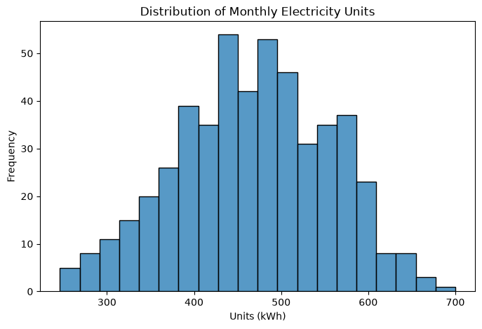
Figure 3 : Histogram (Monthly Units Distribution)

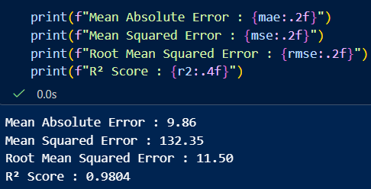

Figure 4: Model Evaluation Metrics of the Multiple Linear Regression Model

Figure 5: Electricity Bill Forecaster Home Page
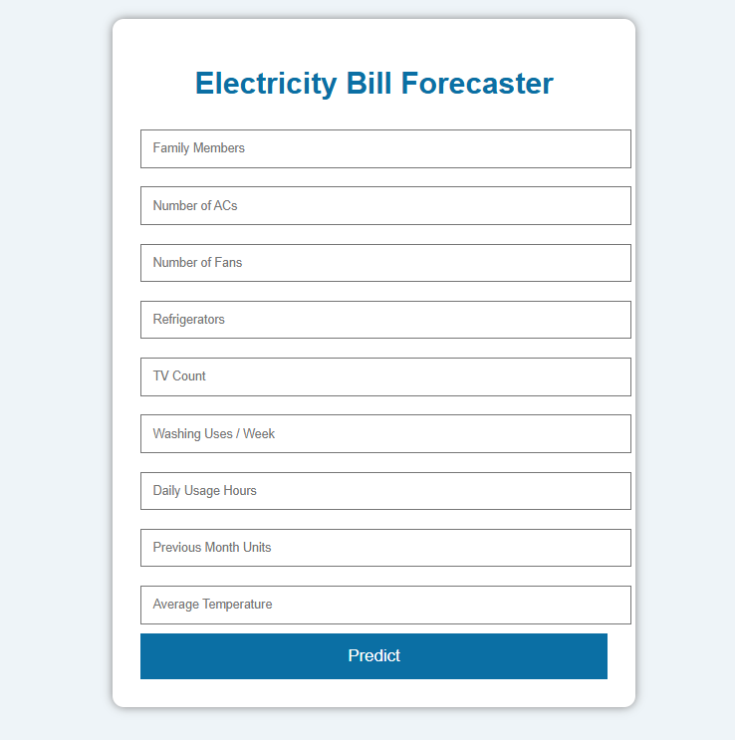
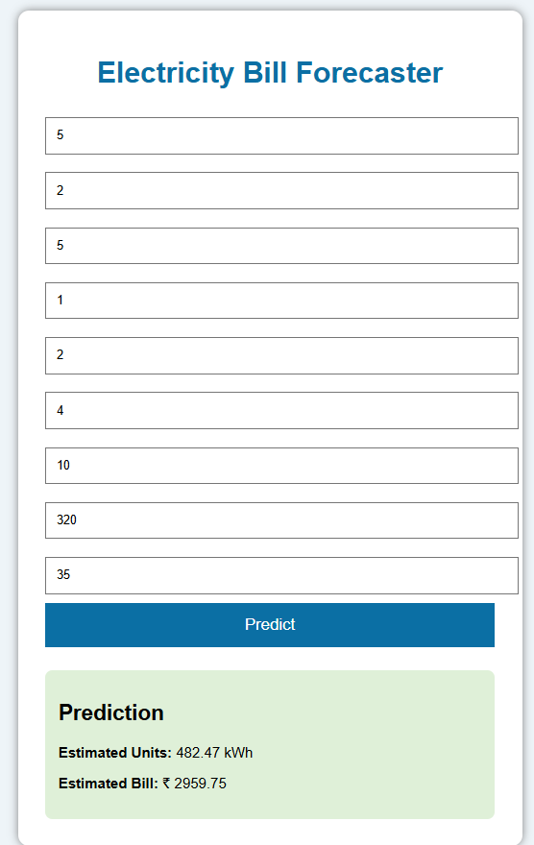

Figure 6: Electricity Bill Prediction Result

