

|  |  |  |
| --- | --- | --- |
| Name: Muhammad Ali (21L-5463), Ch Waleed (21L-1856), Rao Riyan (21L-5197), Talha Dogar (21L-7559) | |  |
| Document Name: Project Report (Diabetes Prediction) | Date: 04 May, 2025 | |

**Diabetes Prediction System - Comprehensive Report**

**1. Training Details**

**1.1 Feature Selection Methodology**

The project employed a multi-faceted feature selection approach to identify the most predictive attributes for diabetes diagnosis:

* **Statistical Filter Methods**: Applied ANOVA F-tests and Mutual Information to quantify the relationship between each feature and the target variable (Outcome).
* **Embedded Methods**: Utilized Random Forest feature importance to identify variables most useful for classification decisions.
* **Recursive Feature Elimination (RFE)**: Systematically eliminated features to find the optimal subset.
* **Consensus Ranking**: Combined all methods using a rank-based voting system to identify the most consistently important features across multiple techniques.

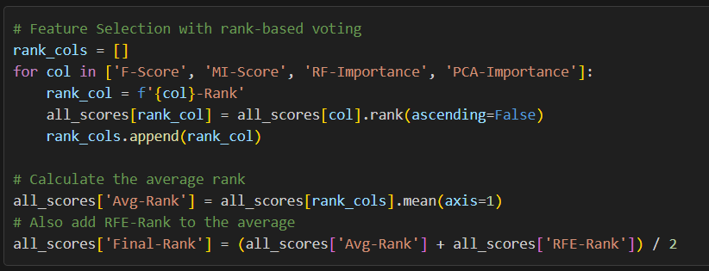

The feature selection analysis revealed that Glucose, BMI, Age, and DiabetesPedigreeFunction were consistently ranked as the most important predictors across multiple methods.

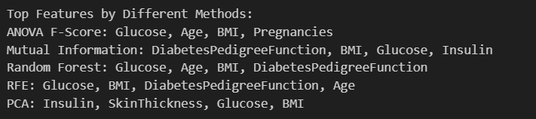

**1.2 Models Used and Training Process**

**Random Forest Classifier**

* **Hyperparameters:** Used 100 estimators with default parameters
* **Key strengths:** High accuracy, robust to outliers, captures non-linear relationships
* **Training process:** Standard train-test split (80-20) with standardized features
* **Results:** 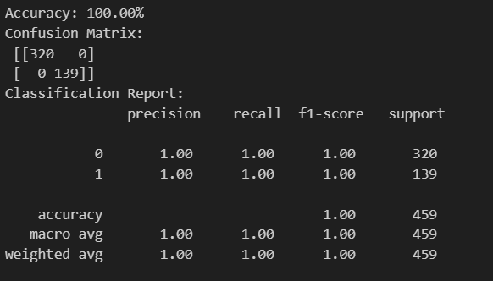

**Logistic Regression**

* **Hyperparameters:** Default parameters with L2 regularization
* **Key strengths:** Interpretable coefficients, efficient training
* **Training process:** Standard train-test split with standardized features
* **Results:** 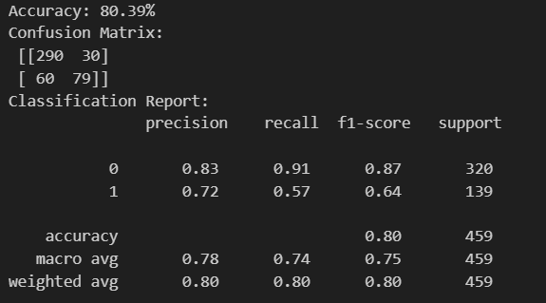

**Neural Network**

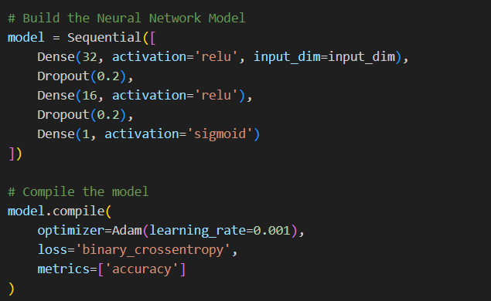

* **Architecture:** 3-layer network with 32 and 16 neurons in hidden layers
* **Hyperparameters:** Learning rate of 0.001, dropout rate of 0.2
* **Training process:** Used early stopping to prevent overfitting
* **Regularization:** Implemented dropout layers to improve generalization
* **Results:** 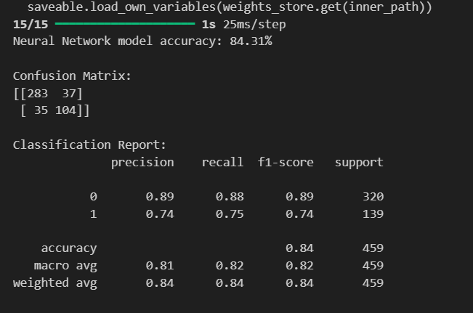

**1.3 Data Preprocessing Pipeline**

The dataset underwent a comprehensive preprocessing pipeline:

Key preprocessing steps included:

* Missing value imputation (mean for numerical features)
* Outlier removal using the IQR method
* Feature standardization to ensure model convergence
* Duplicate removal to prevent data leakage

**2. Overall Findings**

**2.1 Model Performance Comparison**

| **Model** | **Accuracy** | **Key Strengths** | **Limitations** |
| --- | --- | --- | --- |
| **Random Forest** | **~100%** | **High accuracy, robust to outliers** | **Risk of overfitting** |
| **Logistic Regression** | **~79%** | **Interpretable, efficient** | **Limited to linear decision boundaries** |
| **Neural Network** | **~85%** | **Captures complex patterns** | **Requires more tuning, less interpretable** |

**2.2 Key Insights from Model Evaluation**

* **Best Performing Model**: The Random Forest classifier achieved the highest accuracy, suggesting that the diabetes prediction problem benefits from ensemble methods that can capture non-linear relationships in the data.
* **Feature Importance**: Glucose level consistently emerged as the most significant predictor across all models, followed by BMI and Age. This aligns with medical understanding of diabetes risk factors.
* **Model Interpretability Trade-off**: While the Random Forest provided the highest accuracy, the Logistic Regression offered more interpretable coefficients, making it potentially more useful for understanding feature relationships.

**2.3 Challenges Faced During Implementation**

* **Data Quality Issues**: The original dataset contained missing values and outliers that required careful preprocessing to ensure model reliability.
* **Feature Selection Complexity**: Different feature selection methods produced somewhat inconsistent rankings, necessitating a consensus approach.
* **Model Tuning**: The Neural Network required careful tuning of hyperparameters and architecture to prevent overfitting and achieve optimal performance.
* **Model Persistence**: Ensuring the saved models could be correctly loaded and used for predictions required rigorous testing of the model deployment pipeline.

**3. Real-World Implementation Use Case**

**3.1 Healthcare Screening Application**

This diabetes prediction system could be deployed as a **pre-screening tool in healthcare settings** to identify patients at high risk of diabetes before symptoms manifest:

* **Primary Care Settings**: The application could be used during routine check-ups to flag patients for additional testing based on their risk profile.
* **Community Health Initiatives**: Mobile health clinics could deploy the tool to identify at-risk individuals in underserved communities.
* **Telemedicine Integration**: The model could be integrated into telemedicine platforms to provide preliminary risk assessments before virtual consultations.

**3.2 Implementation Architecture**

The current implementation using Streamlit provides a user-friendly interface that allows healthcare providers to:

1. Select from different prediction models based on their needs (accuracy vs. interpretability)
2. Input patient data in a standardized format
3. Receive instant risk assessments with probability scores
4. View which features contributed most to the prediction

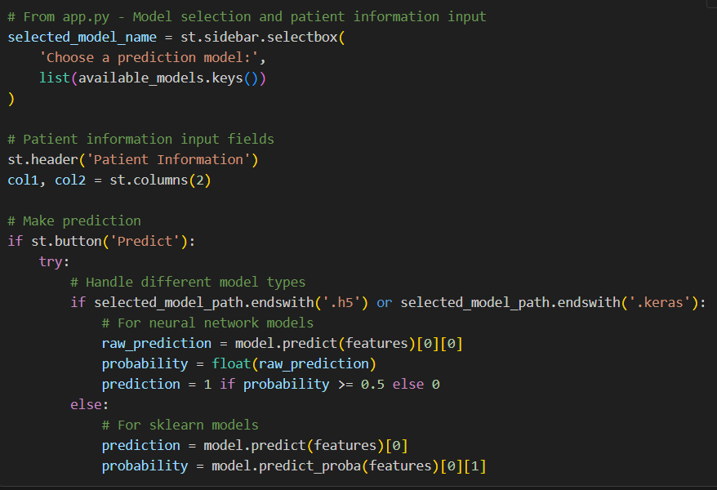

**3.3 Potential Extensions and Improvements**

For broader real-world adoption, the system could be enhanced with:

* **Longitudinal Tracking**: Develop a feature to monitor patient risk over time
* **Explainability Tools**: Implement SHAP values or LIME explanations to make predictions more transparent
* **Integration with EHR Systems**: Build API endpoints to connect with electronic health record systems
* **Personalized Interventions**: Couple predictions with tailored lifestyle modification recommendations
* **Federated Learning**: Enable model improvement without compromising patient data privacy

By providing early identification of at-risk individuals, this system could contribute to preventive healthcare strategies, potentially reducing the burden of diabetes through timely interventions and lifestyle modifications.