**ORAL CANCER CLASSIFICATION USING OPTIMIZED DEEP CONVOLUTION NEURAL NETWORK**

**Course: CPSC5616**

**(Research topics in data management)**

Submitted By

**Mohammed Amaan Mohiuddin (0454523)**

**Mazher Ahmed Khan (0454520)**

**ABSTRACT**

Cancer is a broad term for a range of diseases that are caused by the uncontrolled proliferation of a body’s cells. These cells eventually form a tumour in the body and are likely to invade surrounding tissue or spread throughout the body. In order to make cancer-related healthcare optimized and accessible to all, it is important that early detection and non-invasive testing for various types of cancer are widespread and accurate. Since accuracy and efficiency are incredibly important features for any cancer detection process, there is a need for a highly accurate optimization function for parameters and features.

Convolutional neural networks (CNNs) have gained remarkable success on many image classification tasks in recent years. However, the performance of CNNs highly relies upon their architectures. CNN architecture designs can also be classified into the evolutionary algorithm-based ones and the reinforcement learning-based ones. Evolutionary algorithms can find the optimal or near-optimal solutions in large datasets and are widely used for optimization. This also makes them ideal for detecting cancer by creating models to interpret the results of tests.

In our project we aim to classify the suspicious and non-suspicious oral lesions from photographic images of mouth and lip cancer. We will be focussing on utilising a Genetic Algorithm to automatically search for optimised results in the proposed CNN architecture without any manual work involved. For the CNN architecture we will be using transfer learning approach based on default architectures available. The default architecture that gives the best results will be chosen as the base model for our proposed architecture. Finally, the results will be evaluated using accuracy, precision and recall parameters.

**INDEX**

**CONTENTS**

1. **INTRODUCTION** 
   1. Introduction to Lung Cancer
   2. Problem Statement
   3. 1.3 Objective
2. **LITERATURE SURVEY**
3. **3. SYSTEM ANALYSIS**

3.1 Existing System

3.2 Problems with Existing System

3.3 Proposed System

3.4 Feasibility Study

3.5 Effort, Duration and Cost Estimation using COCOMO

3.6 Software Requirement Specification

3.6.1 Purpose

3.6.2 Scope

3.6.3 Hardware Requirements

4. SYSTEM DESIGN

* 1. Block Diagram
  2. Use Case Diagram
  3. Activity Diagram
  4. Class Diagram
  5. Sequence Diagram

1. **IMPLEMENTATION** 
   1. Deep Learning
   2. CNN Model
   3. Image Pre-Processing
   4. Genetic Algorithm
   5. Confusion Matrix
2. **TESTING** 
   1. Test Case – 1
   2. Test Case – 2
   3. Test Case – 3
   4. Test Case – 4
3. **RESULT SCREENSHOTS**
4. **CONCLUSION**
5. **FUTURE ENHANCEMENTS**
6. **REFERENCES**
7. **APPENDIX**

**LIST OF FIGURES**

|  |  |  |
| --- | --- | --- |
| **Figure No.** | **Figure Name** | **Page No.** |
| 1.1 | Oral Cancer | 01 |
| 1.2 | Main Causes of Oral Cancer | 03 |
| 1.3 | Sample Images of Oral cancer | 06 |
| 4.1 | Block Diagram | 30 |
| 4.2 | Use Case Diagram | 31 |
| 4.3 | Activity Diagram | 32 |
| 4.4 | Class Diagram | 33 |
| 4.5 | Sequence Diagram | 34 |
| 5.1 | Deep Learning Model | 35 |
| 5.2 | CNN Model | 36 |
| 5.3 | Image Pre-Processing | 37 |
| 5.4 | Layers Used in the Model | 39 |
| 5.5 | Confusion Matrix Logic | 40 |
| 6.1 | Cancerous Case Example | 41 |
| 6.2 | Non-Cancerous Case Example | 41 |
| 6.3 | Cancerous Case Prediction | 42 |
| 6.4 | Non-Cancerous Case Prediction | 43 |
| 6.5 | Cancerous Case Prediction | 44 |
| 6.6 | Non-Cancerous Case Prediction | 45 |
| 7.1 | Classification Report Before Optimization | 46 |
| 7.2 | Classification Report After Optimization | 46 |
| 7.3 | Classification Result | 47 |
| 7.4 | Confusion Matrix | 48 |
| 7.5 | Model Accuracy and Loss | 48 |

**LIST OF TABLES**

|  |  |  |
| --- | --- | --- |
| **Table No.** | **Table Name** | **Page No.** |
| 3.5 | COCOMO Table | 23 |
| 6.1 | Test case – 1 | 42 |
| 6.2 | Test case – 2 | 43 |
| 6.3 | Test case – 3 | 44 |
| 6.4 | Test case – 4 | 45 |

**1. INTRODUCTION**

**1.1 Introduction to Oral Cancer**

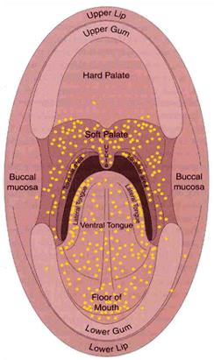

Fig 1.1 – Oral Cancer

[Oral cancer](https://www.webmd.com/oral-health/guide/oral-cancer) appears as a growth or sore in the mouth that does not go away. About 50,000 people in the U.S. get oral cancer each year, 70% of them men. Oral cancer includes cancers of the lips, [tongue,](https://www.webmd.com/oral-health/picture-of-the-tongue) cheeks, floor of the [mouth,](https://www.webmd.com/oral-health/ss/slideshow-mouth-problems) hard and soft palate, [sinuses,](https://www.webmd.com/allergies/picture-of-the-sinuses) and pharynx throat. Oral cancer is a type of cancer that develops in the tissues of the mouth or throat. It typically starts as a small, painless bump or ulcer in the mouth or on the tongue, but can spread to other parts of the body if not detected and treated early. When it is caught early, oral cancer is much easier for doctors to treat. Yet most people get a diagnosis when their condition is too advanced to treat effectively.

The exact cause of oral cancer is not fully understood, but it is thought to be related to a combination of genetic and environmental factors. Certain lifestyle behaviours, such as tobacco use (smoking or chewing) and excessive alcohol consumption, are known to increase the risk of developing oral cancer. Other risk factors may include exposure to certain viruses, such as human papillomavirus (HPV), a weakened immune system, and a family history of cancer.

The development of oral cancer begins with the accumulation of genetic mutations in the cells that line the tissues of the mouth. These mutations can be caused by a variety of factors, such as exposure to harmful chemicals or radiation, as well as lifestyle factors such as smoking and heavy alcohol use. The mutations can cause the cells to grow and divide uncontrollably, leading to the formation of a mass or tumour.

As the tumour grows, it can invade and destroy nearby tissues and structures, including bones and teeth. It can also spread to other parts of the body through the lymphatic system or bloodstream, which is known as metastasis. This can lead to the formation of secondary tumours in other parts of the body, such as the lungs, liver, or bones.

The symptoms of oral cancer may not be noticeable in the early stages, which is why routine dental exams and screenings are important for early detection. Common signs and symptoms of oral cancer may include persistent mouth sores, swelling or lumps in the mouth or neck, difficulty swallowing, chronic sore throat, hoarseness or changes in voice, and unexplained weight loss. If you notice any of these symptoms, it is important to see a healthcare professional for further evaluation and testing.

Overall, the development of oral cancer is a complex process that can be influenced by a variety of factors. It is important to take steps to reduce your risk of developing oral cancer, such as avoiding tobacco use and excessive alcohol consumption, maintaining good oral hygiene, and seeing a dentist regularly for check-ups and screenings. Early detection and treatment can improve outcomes and increase the chances of a full recovery. Some of the common causes of oral cancer are:

**Tobacco and alcohol use.** Tobacco use of any kind, including cigarette smoking, puts you at risk for developing oral cancers. Heavy alcohol use also increases the risk. Using both tobacco and alcohol increases the risk even further.

**HPV.** Infection with the sexually transmitted human papillomavirus (specifically the HPV 16 type) has been linked to oral cancers.

**Age.** Risk increases with age. Oral cancers most often occur in people over the age of 40.

**Sun Exposure.** Cancer of the lip can be caused by sun exposure.

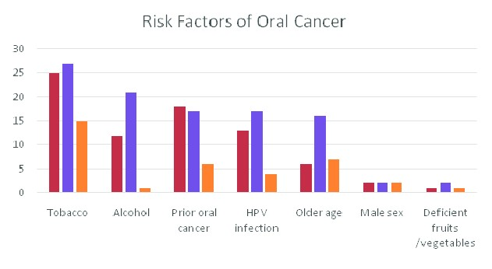

Fig 1.2 – Main Causes of Oral Cancer

The symptoms of oral cancer can vary depending on the location and stage of the cancer. In the early stages, oral cancer may not cause any noticeable symptoms, which is why routine dental exams and screenings are important for early detection. As the cancer progresses, the following symptoms may occur:

**Persistent mouth sores:** Sores or ulcers in the mouth that do not heal within a few weeks can be a sign of oral cancer.

**Red or white patches:** Abnormal red or white patches on the gums, tongue, or other parts of the mouth can be a sign of oral cancer.

**Swelling or lumps:** Swelling or lumps in the mouth or on the neck can be a sign of oral cancer. These lumps may be painless or painful.

**Difficulty swallowing:** Difficulty or pain when swallowing can be a sign of oral cancer, especially if it persists over time.

**Chronic sore throat**: A sore throat that does not go away can be a sign of oral cancer. **Hoarseness or changes in voice:** Changes in the voice, such as hoarseness or a raspy quality, can be a sign of oral cancer.

**Numbness or pain:** Numbness, pain, or a burning sensation in the mouth, lips, or tongue can be a sign of oral cancer.

**Loose teeth:** Oral cancer can cause teeth to become loose or fall out.

**Unexplained weight loss:** Rapid and unexplained weight loss can be a sign of advanced oral cancer.

There are several ways that images of oral cancer can be taken, depending on the location and extent of the cancer, such as, visual examination, X-rays, CT scan (Computed Tomography scan), MRI (Magnetic Resonance Imaging) and Biopsy. In some cases, a combination of imaging techniques may be used to get a more accurate picture of the extent and location of the cancer. The type of imaging used will depend on factors such as the size and location of the tumour, as well as the patient's overall health and medical history. To identify oral cancer, image processing, and deep learning methods will be used. The use of optimization in 3D convolutional neural networks (3DCNN) can be a powerful tool in classifying oral cancer. The 3DCNN is a type of machine learning algorithm that can process volumetric data, such as CT or MRI scans, and extract features that can help distinguish between different types of tissue, including cancerous and non-cancerous tissue. This methodology can help improve patient outcomes by enabling more accurate and timely diagnosis and treatment.

**1.2 Problem Statement**

The early detection and accurate diagnosis of oral cancer is crucial for successful treatment outcomes, but current methods for oral cancer detection often require invasive biopsy procedures and can be subject to variations in accuracy depending on the skill and experience of the clinician. In this context, there is a need for non-invasive and highly accurate methods for the early detection of oral cancer. Machine learning techniques such as convolutional neural networks (CNNs) have shown promise in the early detection of various types of cancer, but the detection of oral cancer using photographic images of the mouth and lips remains a challenging problem. The aim of this project is to develop a CNN-based algorithm for the early detection of oral cancer using photographic images of the mouth and lips, with a focus on using a genetic algorithm to automatically optimize the CNN architecture for maximum accuracy and efficiency.

**1.3 Objective**

Oral cancer has traditionally been detected through visual inspection and biopsy. During a visual inspection, a clinician examines the patient's mouth and throat for any signs of abnormal growths, sores, or lesions. If any suspicious areas are found, a biopsy may be performed, which involves removing a small tissue sample from the affected area and examining it under a microscope to determine whether cancerous cells are present. However, these methods can be time-consuming, invasive, and may not always be accurate.

Other non-invasive methods for the early detection of oral cancer have been developed in recent years, such as using autofluorescence imaging, brush biopsy, and salivary diagnostics. Autofluorescence imaging uses a special light to highlight abnormal cells in the mouth, while brush biopsy involves collecting cells from the affected area using a small brush. Salivary diagnostics involves analysing the chemical composition of a patient's saliva to detect biomarkers associated with oral cancer. However, these methods also have limitations and may not be as accurate or widely available as desired.

For oral cancer, the standard medical procedures for early detection include physical examination and biopsy. However, these methods rely on the expertise of the clinician and may not always detect early-stage cancers. In recent years, computer-aided diagnosis (CAD) systems using deep learning technology have been proposed to improve the accuracy of oral cancer detection.

Previous intelligent methods for oral cancer detection used hand-crafted feature extraction methods such as Sequential Flood Feature Selection Algorithms (SFFSA) or Genetic Algorithm (GA) to generate optimal features. However, these methods have limitations in detecting subtle changes in images and may not be able to capture complex features.

Deep learning technology offers a promising solution for oral cancer detection as it can automatically extract features from images, including those that are difficult to identify using traditional methods. Convolutional neural networks (CNNs) are commonly used in deep learning-based CAD systems for oral cancer detection.

Our project aims to develop a CNN-based CAD system for early detection of oral cancer using magnetic resonance imaging (MRI) and computed tomography (CT) scans. We collected a dataset of MRI and CT images of patients with oral cancer, as well as healthy subjects, from several hospitals. The dataset includes a total of 2000 images representing MRI and CT scan slices of numerous cases. These cases are grouped into three classes: normal, benign, and malignant.

We pre-processed the images by converting them from the DICOM format to a digital image and applying various image enhancement techniques. We then used these pre-processed images to train and test our CNN model. Our model consists of several layers for detecting cancerous lesions from MRI and CT images more accurately. The proposed CAD system has the potential to improve the accuracy and efficiency of oral cancer detection, allowing for earlier diagnosis and better patient outcomes.

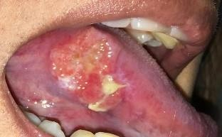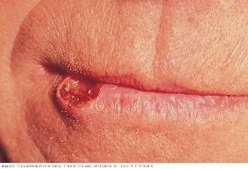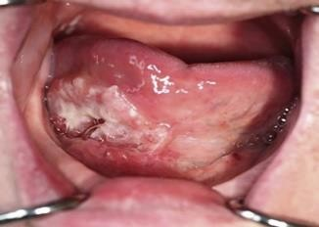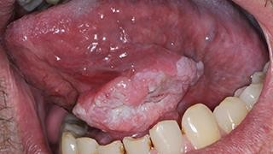

Fig 1.3 – Sample images of oral cancer

* **To develop a convolutional neural network (CNN) model for the early detection of oral cancer using photographic images of the mouth and lips:** This objective involves developing a CNN-based algorithm that can accurately detect oral cancer using photographic images of the mouth and lips as input. This will require choosing an appropriate CNN architecture, designing an appropriate training dataset, and optimizing the parameters of the CNN model to achieve the best possible performance.
* **To apply a genetic algorithm to automatically optimize the CNN architecture for maximum accuracy and efficiency:** This objective involves using a genetic algorithm to search for the optimal or near-optimal architecture for the CNN model. The genetic algorithm will evaluate different combinations of CNN architecture parameters and choose the ones that result in the highest accuracy and efficiency. This can significantly reduce the amount of manual work required for designing the CNN architecture and optimizing its parameters.
* **To evaluate the performance of the proposed CNN-based algorithm using accuracy, precision, recall, f1-score, and support parameters:** This objective involves evaluating the performance of the CNN-based algorithm in terms of its accuracy, precision, and recall. Accuracy measures how well the model predicts the correct label for each input, while precision measures the proportion of true positives (correctly identified cancer cases) out of all the samples that the model classified as positive. Recall measures the proportion of true positives out of all the actual positive samples in the dataset. F1-score measures a model’s accuracy by calculating harmonic mean of precision and recall. Support is the number of actual occurrences of the class in the specified dataset.
* **To compare the performance of the proposed CNN-based algorithm with existing methods for the early detection of oral cancer:** This objective involves comparing the performance of the CNN-based algorithm with existing methods for the early detection of oral cancer, such as biopsy and visual inspection by a clinician. This will require designing appropriate experiments and datasets to compare the accuracy and efficiency of the CNN-based algorithm with these existing methods.
* **To investigate the potential of CNN-based algorithms for the early detection of other types of cancer using photographic images:** This objective involves investigating whether the CNN-based algorithm developed for oral cancer detection can be adapted to detect other types of cancer using photographic images. This will require identifying appropriate datasets and modifying the CNN architecture and training procedures to suit the characteristics of the new datasets.
* **To explore the potential of machine learning techniques for improving the accessibility and affordability of cancer-related healthcare:** This objective involves exploring the broader implications of using machine learning techniques for cancer detection and treatment. This may include investigating the potential for machine learning techniques to reduce the cost and time required for cancer diagnosis and treatment, and to increase access to cancer-related healthcare for underprivileged populations.
* **To contribute to the growing body of research on machine learning applications in healthcare, particularly in the field of cancer diagnosis and treatment:** This objective involves contributing to the field of machine learning applications in healthcare, particularly in the area of cancer diagnosis and treatment. This may involve publishing research papers, presenting findings at conferences, and collaborating with other researchers in the field to further advance the state of the art.

**2. LITERATURE SURVEY**

Three-dimensional convolutional neural networks (3DCNNs), a rapidly evolving modality of deep learning, has gained popularity in many fields. For oral cancers, CT images are traditionally processed using two-dimensional input, without considering information between lesion slices. Shipu Xu, Chang Liu M, Yongshuo Zong, Sirui Chen, Yiwen Lu, Longzhi Yang, Eddie Y. K. Ng, Yongtong Wang, Yunsheng Wang, Yong Liu, Wenwen Hu, and Chenxi Zhang [1] established a 3DCNNs-based image processing algorithm for the early diagnosis of oral cancers, which was compared with a 2DCNNs-based algorithm. The 3D and 2D CNNs were constructed using the same hierarchical structure to profile oral tumours as benign or malignant. Their results showed that 3DCNNs with dynamic characteristics of the enhancement rate image performed better than 2DCNNS with single enhancement sequence for the discrimination of oral cancer lesions. Their data indicate that spatial features and spatial dynamics extracted from 3DCNNs may inform future design of CT-assisted diagnosis system.

There are various diagnostic methods for oral cancer, such as a biopsy, in which a small tissue sample is taken from a part of the body and tested under a microscope also some screening methods. But the downside is that cannot clearly identify cancer cells and cannot classify the number of cells affected by cancer, so R.dharani, and S.Revathy [2] proposed that in their work cancer cells will find and classify that affected in the oral area through digital processing technology. The use of advanced technologies and an in-depth learning algorithm are possible for early detection and classification. This work uses three characteristics-extracting techniques such as the bag histogram of oriented gradients, wavelet features and the Zernike Moment. Once retrieving the texture characteristics, the fuzzy particle swarm optimization algorithm (FPSO) is applied to choose the best characteristic. Finally, these characteristics were classified using the Convolution Neural Network (CNN) classifier. For comparison of the efficiency of the proposed method, Recall Rate, Classification Accuracy, Precision Rate, and Error Rate. Evaluation outcomes demonstrated that the combination of ABC, FPSO and CNN performs better in the detection of oral cancer. This work utilized six supervised machine learning methods, namely, SVM, Bagging, Navie Bayes, KNN Adaboost, CNN and IELM for comparison process. CNN classifiers can obtain an overall accuracy 97.21%. So the results indicate that CNN approach performs well for oral cancer detection of CT images. The sensitivity, specificity and error rate are commonly used to measure how well the method can identify the oral cancer. From these results, it is well known that CNN performs best than the other approach. As well as the similar experiments are also conducted for segmentation approaches.

Oral cancer is a dangerous and extensive cancer with a high death ratio. Oral cancer is the most usual cancer in the world, with more than 300,335 deaths every year. The cancerous tumour appears in the neck, oral glands, face, and mouth. To overcome this dangerous cancer, Atta-ur Rahman, Abdullah Alqahtani, Nahier Aldhafferi, Muhammad Umar Nasir, Muhammad Farhan Khan, Muhammad Adnan Khan, and Amir Mosavi [3] proposed that there are many ways to detect like a biopsy, in which small chunks of tissues are taken from the mouth and tested under a secure and hygienic microscope. However, microscope results of tissues to detect oral cancer are not up to the mark, a microscope cannot easily identify the cancerous cells and normal cells. Detection of cancerous cells using microscopic biopsy images helps in allaying and predicting the issues and gives better results if biologically approaches apply accurately for the prediction of cancerous cells, but during the physical examinations microscopic biopsy images for cancer detection there are major chances for human error and mistake. So, with the development of technology deep learning algorithms plays a major role in medical image diagnosing. Deep learning algorithms are efficiently developed to predict breast cancer, oral cancer, lung cancer, or any other type of medical image. In this study, the proposed model of transfer learning model using AlexNet in the convolutional neural network to extract rank features from oral squamous cell carcinoma (OSCC) biopsy images to train the model.

Cancer is a wide category of diseases that is caused by the abnormal, uncontrollable growth of cells, and it is the second leading cause of death globally. Screening, early diagnosis, and prediction of recurrence give patients the best possible chance for successful treatment. However, these tests can be expensive and invasive and the results have to be interpreted by experts. To solve this problem, Aradhita Bhandari, B.K. Tripathy, Khurram Jawad, Surbhi Bhatia, Mohammad Khalid Imam Rahmani, and Arwa Mashat [4] used Genetic algorithms (GAs). GAs are metaheuristics that belong to the class of evolutionary algorithms. GAs can find the optimal or near-optimal solutions in huge, difficult search spaces and are widely used for search and optimization. is makes them ideal for detecting cancer by creating models to interpret the results of tests, especially non-invasive. In this article, we have comprehensively reviewed the existing literature, analysed them critically, provided a comparative analysis of the state-of-the-art techniques, and identified the future challenges in the development of such techniques by medical professionals.

The main question: Is it possible to define an approach that allows automatic deep architecture adjustment, increasing accuracy, reducing the number of tests and starting from a known architecture was answered in the paper by Rafael Marconi Ramos, Celia Ghedini Ralha, Tahsin M. Kurc, Joel H. Saltz, and George Teodoro [5]. They proposed an approach to increase the medical CNN accuracy. The specific problems of this subset of CNN need special attention when we it is necessary to create a new architecture with better accuracy. The generation of improved architectures in medical CNN cases is hard. It is necessary much time, resources and knowledge. Their approach presents a strategy to apply optimization algorithms to change blocks of convolutional layers and its parameters. The approach reduces the search space presenting better architectures. Consequently, the process is faster than generating from scratch. The changes in architecture produce a more sensible network with better accuracy. The experiments show that all optimization algorithms can reach better architectures with little tests. The max difference between algorithms was 11% of the accuracy. The NM generate the best accuracy of 57% but take more time to finish. It was necessary 100 tests. However, BOA and GA reached an accuracy of 55% and executed just 30 tests. The parallel algorithms reached the same results but with less time. Their approach shows good results without consuming much time. Their strategy to change the convolutional blocks works with all algorithms generating new CNN architectures with better accuracy. Although their approach attains good results, the possibilities of generating new architectures are limited by our operations/transformations. In cases where the initial architecture is simple and the block changes do not reach satisfactory results, it would be recommended to use an approach that generates architectures from scratch.

Bin Wang, Yanan Sun, Bing Xue, and Mengjie Zhang [6] developed a new PSO approach with variable length to automatically evolve the architectures of CNNs for image classification problems. This has been successfully achieved by proposing a new encoding scheme of using a network interface containing an IP address and its corresponding subnet to carry the configurations of a CNN layers, the design of four subnets including a disabled subnet in order to simulate a variable-length PSO, and an efficient fitness evaluation method by using partial dataset. This approach was examined and compared with 12 peer competitors including the most state-of-theart algorithms on three benchmark datasets commonly used in deep learning and the experimental results show that the proposed IPPSO method can achieve a very competitive accuracy by outperforming all others on the MDRBI benchmark dataset, being the second-best on the MNIST benchmark dataset and ranking above the middle line on the CS benchmark dataset. The most important improvement from the traditional PSO to the novel IPPSO proposed in the paper is to invent the new encoding strategy of using network interface. Since the subnet in the interface can distinguish any type of layers, any layer configurations can be encoded into the IP address and the length of the IP address can be easily extended to 4 bytes (the length of real IP addresses) or even more, the IPPSO method has the ability of encoding any type of Deep Neural Network layers. In addition, the particle length of the IPPSO method can be easily made variable by simply introducing a disabled layer which could be deemed as another major improvement as it breaks the obstacle of traditional PSO being fix-length.

Adwan A. Alanazi, Manal M. Khayyat, Mashael M. Khayyat, Bushra M. Elamin Elnaim, and Sayed Abdel-Khalek [7] established a novel IDL-OSCDC model for the identification and classification of oral lesions using biomedical images. At the initial stage, the IDL-OSCDC model utilized the GF technique to get rid of noise content. Following this, the NasNet model is exploited for the generation of higher-level deep features from the input images. Finally, the EGOA-DBN model is utilized to detect and categorize oral cancer. e hyperparameter tuning of the DBN model is performed using the EGOA algorithm which in turn boosts the classification outcomes. The experimentation outcomes of the IDL-OSCDC model are performed using a benchmark biomedical imaging dataset. An extensive comparison study highlighted its promising performance over the other methods. In the future, advanced DL models can be utilized as a classier to optimize the detection performance.

Yanan Sun, Bing Xue, Mengjie Zhang, Gary G. Yen, and Jiancheng Lv [8] proposed an automatic architecture design algorithm for CNNs by using the GA (in short called CNN-GA), which is capable of discovering the best CNN architecture in addressing image classification problems for the users who have no expertise in tuning CNN architectures. This goal has been successfully achieved by designing a new encoding strategy for the GA to encode arbitrary depths of CNNs, incorporating the skip connections to promote deeper CNNs to be produced during the evolution, and developing a parallel as well as a cache component to significantly accelerate the fitness evaluation given a limited computational resource. The proposed algorithm was examined on two challenging benchmark datasets, and compared with 18 state-of-the-art peer competitors, including eight manually designed CNNs, six automatic + manually tuning, and four automatic algorithms discovering the architectures of CNNs. The experimental results show that CNN-GA outperforms almost all of the manually designed CNNs as well as the automatic peer competitors, and shows competitive performance with respect to automatic + manually tuning peer competitors in terms of the best classification accuracy. The CNN discovered by CNN-GA has a much smaller number of parameters than those of most peer competitors. Furthermore, CNN-GA also employs significantly less computational resources than most automatic and automatic + manually tuning peer competitors. CNN-GA is also completely automatic, and users can directly use it to address their own image classification problems whether or not they have domain expertise in CNNs or GAs. Moreover, the CNN architecture designed by CNN-GA on CIFAR10 also shows the promising performance when it is transferred to the ImageNet dataset.

Xiaoying Pan, Ting Zhang, Qingping Yang, Di Yang, Jean-Claude Rwigema, and X. Sharon Qi [9] demonstrated the application of neural network models to access clinical treatment outcome data using pre-treatment Radiomics features. The proposed Probabilistic Adaptive Genetic-Back Propagation neural network, combined with the novel t-SNE feature dimension reduction algorithm, shows improved prediction accuracy of patient survival. The accurate prediction of survival may facilitate personalized treatment in radiation therapy. High throughput pre-treatment imaging features may predict radiation treatment outcome and guide individualized treatment in radiotherapy (RT). Given relatively small patient sample (as compared with high dimensional imaging features), identifying potential prognostic imaging biomarkers is typically challenging. We aimed to develop robust machine learning methods for patient survival prediction using pre-treatment quantitative CT image features for a subgroup of head-and-neck cancer patients.

The traditional classification layer in CNN cannot fully understand the feature information.

In order to further improve the model’s ability to understand image features and then improve the accuracy of image classification, Wenjiang Jiao, Xingwei Hao, and Chao Qin [10] proposed a novel CNN-XGBoost based on APSO image classification model is proposed. The model is mainly composed of feature extractor CNN and feature classifier XGBoost. The two-stage model not only ensures that CNN can fully extract image features but also uses XGBoost to overcome the shortcomings of a single classifier and effectively distinguish features, and APSO optimizes the hyperparameters of the overall architecture. APSO uses two different learning strategies to update information of particles, enhance the diversity of particle populations and avoid the algorithm from falling into local optimality. Thereby, the adaptive processing capability of the model to image features was improved, and the classification accuracy got better. APSO optimizes both CNN and XGBoost. On the one hand, CNN is optimized to extract deep features so that the extracted features are more suitable for decision tree XGBoost. In addition, XG-Boost is optimized to make the structure of the model better match the extracted features, so as to better understand the image features. Bidirection optimization structure to fully extract the features of the image and fully used for classification. Our model has the best results on the image data set compared to other models, which shows the effectiveness of the model. In addition, the experimental results on the additional data set show that the proposed APSO-XGBoost credit scoring model also achieved good results on credit data, indicating the model has strong generalization ability.

Roshan Alex Welikala, Paolo Remagnino, Jian Ham Lim, Chee Seng Chan, Senthilmani Rajendran, Thomas George Kallarakkal, Rosnah Binti Zain, Ruwan Duminda Jayasinghe, Jyotsna Rimal, Alexander Ross Kerr, Rahmi Amtha, Karthikeya Patil, Wanninayake Mudiyansilage Tilakaratne, John Gibson, Sok Ching Cheong, and Sarah Ann Barman [11] has discussed the collection and annotation of images from the oral cavity and demonstrated results for automating the early detection of oral cancer. The contribution of this paper is a novel strategy to combine bounding box annotations from multiple clinicians; followed by the assessment of two different deep learning-based approaches to provide a solution to automation. Their promising initial results demonstrate the effectiveness of deep learning and suggest it has the potential to tackle this challenging task. Performances are set to increase as the dataset grows and this will have a significant impact in low- and middle-income countries where health resources are limited.

Detecting and preventing Oral cancer at the earliest, can be beneficial in minimizing the death rate and increasing the life span. The research by S. Hemalatha, N. Chidambararaj, and Ravikanth Motupalli [12] proposes a technique concerning Oral cancer detection and prevention by adopting DL (Deep Learning) approaches. Data analysis relies upon history of addiction, clinical symptoms, co-morbid condition and survivability factor related to the cancer patients. This research work aims to segment and classify the oral cancer and measure the performance metrics using these intelligent computing techniques. The oral cancer detection and Classification Using Deep Learning Approach contribution was based on Fragment Jaya Whale Optimizer with Deep Convolutional Neural Network (FJWO-DCNN) for achieving a good recognition rate using the optimal theoretical features of oral cancer images. Then the extracted theoretical features and the original image were given as the input to different level classification strategy which were performed using Deep Convolution Neural Network (DCNN) classifier, which was trained by the proposed Fragment Jaya Whale Optimization (FJWO) algorithm. Finally, employing this approach, the results were obtained with a higher performance value. This proposed work achieves a higher performance percentage in terms of accuracy.

Oral Cancer is one of the most common cancers caused in the oral cavity region that damages oral epithelial cells due to uncontrolled growth of the cells. Chewing tobacco, smoking and betel quid are potential reasons for oral cancer. Sayyada Hajera Begum, and P. Vidyullatha [13] proposed that with the advancement of Deep learning (DL) in biomedical image classification, automated image classification can aid in effective and early treatment of oral cancer. Their paper discusses the technical aspects and applications of DL techniques in oral cancer detection, presenting a comprehensive comparison of various studies related to oral cancer detection and prediction in the paper.

Sunil Kumar Prabhakar, and Harikumar Rajaguru [14] stated that a plethora of disorders are found in human oral mucosa. A variety and huge number of lesions and diseases in human oral mucosa have been clinically identified and classified. Most lesions have the possibility to develop into oral cancer. The initial diagnosis of oral cancer is to inspect the ocular regions carefully and register the oral cavity of the patient as true-color digital images. The decision about the further treatment of the oral cancer patient is predominantly depending on the appearance of the lesion. The primary intention of this work is to analyse the clinical features, its respective diagnostic procedures and the required treatment suitable for the oral cancer patients. The oral cancer staging is classified into two types namely pathological and clinical. A lot of prognostic and most efficient tools have been developed in Tumour-Node-Metasis (TNM) stages. The classification accuracy of the TNM staging system is compared to the Linear Layer Neural Network. The study is analysed for 75 oral cancer patients and the input variables are considered here as the TNM variables. Results show that an average classification accuracy of 100% is obtained in T1 stage, 85.19% is obtained in T2 stage, 84.21% is obtained in T3 stage and 94.12% is obtained in T4 stage.

In latest years, convolutional neural networks (CNNs) have accomplished state-of-the-art performance in many computer vision tasks such as classification of images, object detection, instance segmentation etc. CNN has a robust learning capacity and can enhance the use of datasets for feature extraction. Identifying the key visual features from the oral squamous cells are the significant and compulsory task for the clinicians to detect the different stages of oral cancer. The computer-aided instrument performing the same identifying job would provide clinicians with a vital guidance during diagnosis for evaluating histological images. Santisudha Panigrahi, and Tripti Swarnkar [15] suggested the use of 4-layered (5X5X3) patches of convolutional neural networks (CNNs) for feature extraction and classification from oral cancer images. To prevent overfitting the images were augmented by rotating, inverting and flipping. The proposed model has achieved 96.77 % accuracy, with 10-fold cross validation, which is at par with the accuracy of cytotechnologists and pathologists. Therefore, this model is helpful in classifying oral cancer microscopic images.

The biology is disrupted for many reasons which are sometimes fathomable and sometimes not. The paramount factors can be genetic and variations acquired but both subsequently gives the catastrophic outcome in case of menacing disease such as cancer. The detection of it has been done and goes way back but newer technology is taking over every decade in order to make it more and more precise. As human intervention can lead to errors, automated detection can improve the accuracy. Therefore, Bibek Goswami, Jyotirmoy Chatterjee, Ranjan Rashmi Paul, Mousumi Pal, and Rusha Patra [16] has proposed a study where convolutional neural network (CNN) has been explored for detection of normal and different stages of oral submucous fibrosis from microscopic images of stained biopsy samples. Data pre-processing has been implemented before feeding the images into neural network and an overall accuracy of 99.4% has been achieved which shows the effectiveness of CNN for the same.

S. Premalatha, and K. Lakshmi Joshitha [17] has stated that Oral cancer is the widely witnessed and devastating disease formulating in a transient anticipation in their superior grade. There is a sudden progression in the vicinity of oral cancer imaging technologies that play a significant role in assessing and centralizing the novel perception of buccal cavity inspection and functioning. The image processing techniques have enhanced premature diagnosis and treatment phases of the threatening disease. The main objective is to evolve a systematic oral cancer prediction model utilizing the wholesome concept of classification by applying (FVI) Optical images, MRI and CT images. A hybrid classifier is used for classification purposes. The outcome from the classifier is used to label the input image as a benign and malignant cell. The execution of the suggested model can be calculated using measuring performance like accuracy, sensitivity and specificity.

Oral diseases such as periodontal, oral cancer and tooth trauma are common noncommunicable diseases that affect during the lifetime causing pain, uneasiness and even death. Periodontal is normally caused by poor brushing, hormonal changes and flossing habits that allow plaque, a sticky film of bacteria. The mouth is regarded as a mirror of the complete wellness of the body and till now there is no personal device existing currently to monitor the oral health. An accurate prediction is essential for correct diagnosis and treatment of oral diseases. Dental diseases are mostly diagnosed at the later stage after severe pain occurs in the mouth. By predicting it at early stage, oral diseases which slowly make the roots of the teeth to get weaker can be prevented. S. Swetha, P. Kamali, B. Swathi, R. Vanithamani, E. Karolinekersin [18] has aimed at creating an economical, multimodal, personal oral sensing device that automatically senses and categorizes the data which will assist the clinician in early diagnosis and effective treatment. Their proposed smart electronic device automatically captures valuable parameters like pH, temperature, CO2 and other gases to overcome the challenges in the diagnosis of the oral problem. The captured data is fed to Convolutional Neural Network for classification of oral diseases.

**3. SYSTEM ANALYSIS**

## 3.1 Existing System

Tests include imaging tests, biomarkers, and biopsies; one or more of which may be indicated in patients with a suggestive history or physical or laboratory findings.

**Visual examination**: This is the most common method used for early detection of oral cancer. A dentist or doctor examines the inside of the mouth, lips, tongue, and throat to look for any abnormalities or signs of cancer.

**Brush biopsy**: This is a less invasive alternative to traditional biopsy. A small brush is used to collect cells from the suspicious area, which are then analysed in a laboratory.

**Fluorescence visualization**: This is a new technology that uses a special light to detect cancerous and precancerous lesions in the mouth. The light causes abnormal cells to appear as a different colour than healthy cells, making it easier to identify and remove them.

**Imaging techniques**: Imaging techniques such as computed tomography (CT), magnetic resonance imaging (MRI), and positron emission tomography (PET) are also being used for early detection of oral cancer. These techniques can provide detailed images of the inside of the mouth, allowing doctors to identify and locate any abnormalities.

**Imaging tests:** Include plain x-rays, ultrasonography, CT, positron emission tomography (PET), and MRI studies. These tests assist in identifying abnormalities, determining qualities of a mass (solid or cystic), providing dimensions, and establishing relationship to surrounding structures, which may be important if surgery or biopsy is being considered.

**Biopsy:** To confirm the diagnosis and tissue of origin is almost always required when cancer is suspected. The choice of biopsy site is usually determined by ease of access and degree of invasiveness. If lymphadenopathy is present, fine-needle or core biopsy may reveal the cancer type. Core biopsies or lymph node excision are recommended for diagnosis of lymphomas because preservation of nodal architecture is important for accurate histologic diagnosis. Sometimes an open biopsy is needed. Other biopsy routes include bronchoscopy or mediastinoscopy for easily accessible mediastinal or central pulmonary tumours, percutaneous liver biopsy if liver lesions are present, and CT- or ultrasound-guided biopsy of lung or soft tissue masses.

**Grading:** This is a histologic measure of cancer aggressiveness and provides important prognostic information. It is determined by examining the tissue specimen. Grade is based on the morphologic appearance of cancer cells, including the appearance of the nuclei, cytoplasm, and nucleoli; frequency of mitoses; and amount of necrosis. For many cancers, grading scales have been developed.

**Molecular tests:** such as chromosomal analysis, fluorescent *in situ* hybridization (FISH), polymerase chain reaction (PCR), and cell surface antigen testing (eg, in lymphomas, leukemias, lung, and gastrointestinal cancers) help delineate the origin of metastatic cancers, particularly for cancers of unknown primary origin, and may be helpful in selecting therapy.

## 3.2 Problem with Existing System

The existing system for oral cancer detection relies heavily on visual inspection and manual palpation by trained healthcare professionals such as dentists, oral surgeons, and pathologists. This process can be time-consuming, subjective, and prone to errors, especially in detecting early-stage cancer or pre-cancerous lesions. Moreover, it requires a high level of expertise and experience, which may not be available in all healthcare settings, particularly in under-resourced areas or developing countries.

Furthermore, the existing diagnostic tools for oral cancer, such as biopsy, histopathology, and cytology, have limitations in terms of invasiveness, accuracy, and costeffectiveness. Biopsy, for example, requires the removal of tissue samples from the lesion, which can cause pain, bleeding, infection, and scarring, and may not always yield enough or representative samples for diagnosis. Histopathology and cytology, on the other hand, rely on the examination of tissue or cell samples under a microscope, which can be time-consuming, labour-intensive, and subject to interpretation.

The various techniques that have been employed till date in order to recognize the image as cancerous or non-cancerous cannot be précised or accurate. there might be an error made by doctors which may result to different medications and procedures,

Disadvantages Of Existing System:

* Manually, Cancer is suspected based on a person's symptoms, the results of a physical examination, and sometimes the results of screening tests. This may pose some technical error or false symptom alarms.
* Screening tests, MRIs and other tests might be expensive for a section of people.
* There are very limited oral cancer screening programs in India.
* Primary care doctors might be vulnerable to human errors.

The previous modes of oral cancer detection, which relied mainly on visual examination by healthcare professionals, had several disadvantages. These include:

**Inaccuracy**: Visual examination alone may not be able to detect early-stage oral cancer or precancerous lesions accurately. This can lead to delayed diagnosis and treatment, which can affect the overall prognosis.

**Subjectivity**: The interpretation of visual examination results can vary depending on the experience and skill of the healthcare professional. This can lead to inconsistencies in the detection and diagnosis of oral cancer.

**Time-consuming**: Visual examination of the entire oral cavity requires significant time and effort from healthcare professionals, which can result in longer wait times for patients. **Costly**: Traditional oral cancer detection methods, such as biopsy, can be expensive and may require multiple visits to the healthcare professional.

**Invasive**: Biopsy, which is often used to confirm the presence of oral cancer, involves the removal of a tissue sample from the affected area. This can be painful and may require anaesthesia, which can cause discomfort for the patient.

## 3.3 Proposed System

* **Load the medical data set.** The first step is to obtain the medical dataset that contains information about patients with oral cancer. This dataset typically includes images or scans of the affected areas, patient history, and any other relevant data.
* **Apply pre-processing methods on the data set.** Before using the data for analysis, pre-processing methods need to be applied. These methods may include image enhancement, filtering, segmentation, and normalization. The goal of pre-processing is to improve the quality and accuracy of the data, making it easier to analyse.
* **Apply Genetic algorithm on the data set.** The next step is to apply a genetic algorithm (GA) to the pre-processed data. GA is a search and optimization technique that mimics the process of natural selection. It can be used to identify the most relevant features in the dataset that are associated with oral cancer.
* **Build and train a CNN model from the resultant data.** After using the GA algorithm to extract the most relevant features, a convolutional neural network (CNN) is built and trained on the resultant data. CNNs are powerful deep learning algorithms that can learn to recognize patterns and features in images.
* **Classify cancer data set as suspicious and non-suspicious**. Finally, the trained CNN model is used to classify the cancer dataset as either suspicious or non-suspicious. The model is tested on a separate dataset to evaluate its accuracy and performance. If a patient's data is classified as suspicious, further testing and diagnosis can be done to confirm the presence of oral cancer.

## 3.4 Feasibility Study

Oral cancer is a serious health concern and is one of the most common cancers globally. Early detection of oral cancer is crucial for the successful treatment of the disease. In recent years, deep learning techniques have shown promising results in the field of medical image analysis. Deep Convolutional Neural Networks (DCNNs) are a type of deep learning technique that has shown excellent performance in various image classification tasks.

The proposed study aims to develop an optimized deep convolutional neural network for oral cancer classification. The study will use a publicly available dataset of oral cancer images for training and testing the model. The dataset consists of oral cancer images of various types and stages.

It is important to find a new robust method to make a diagnosis of cancer at a former stage. The availability of large imaging datasets provides a great opportunity for investigators to segment and classify the cancer cells using deep learning-based convolution neural network methods. Our focus will be on the development of a convolution neural network-based approach for the classification of oral cancer cells.

The proposed project is technically feasible as deep learning algorithms, especially convolutional neural networks (CNNs), have shown excellent performance in image classification tasks. Availability of a sufficient amount of labelled data is a critical factor in the success of any deep learning project. In this case, the feasibility of the project will depend on the availability of a large and diverse dataset of oral cancer images. Depending on the specific goals of the project, the data may need to be pre-processed and annotated before training the model. Deep learning models require high-performance computing resources, such as GPUs and high memory systems, to achieve optimal performance. Therefore, it is essential to assess the availability and feasibility of these resources to train the proposed deep convolutional neural network.

In paper [2] the oral cancer detection techniques of CT images are taken for the comparison. The comparison is done on three steps of the proposed work such as segmentation, feature extraction and classification. This work utilized six supervised machine learning methods, namely, SVM, Bagging, Navie Bayes, KNN Adaboost, CNN and IELM for comparison process. CNN classifiers can obtain an overall accuracy 97.21%. So, the results indicate that CNN approach performs well for oral cancer detection of CT images.

In paper [7] a novel IDL-OSCDC model has been established for the identification and classification of oral lesions using biomedical images. At the initial stage, the IDL-OSCDC model utilized the GF technique to get rid of noise content. Following this, the NasNet model is exploited for the generation of higher-level deep features from the input images.

In paper [8] In CNN-GA, two components have been designed to speed up the fitness evaluation, and much computational resource has been saved. However, the computational resource employed is still fairly large compared to that used in GAs when solving traditional problems. In the field of solving expensive optimization problems, several algorithms based on evolutionary computation techniques have been developed.

**Types of Feasibility Study**

The feasibility study mainly concentrates on below five mentioned areas. Among this, Economic Feasibility Study is most important part of the feasibility analysis and Legal Feasibility Study is less considered feasibility analysis.

**Technical Feasibility**

In Technical Feasibility current resources both hardware & software along with required technology are analysed/assessed to develop the project. This technical feasibility study gives report whether there exists correct required resources and technologies which will be used for project development. Along with this, feasibility study also analyses technical skills and capabilities of technical team, existing technology can be used or not, maintenance and upgradation is easy or not for chosen technology etc.

**Operational Feasibility**

In Operational Feasibility degree of providing service to requirements is analysed along with how much easy product will be to operate and maintenance after deployment. Along with these other operational scopes are determining usability of product, determining suggested solution by software development team is acceptable or not etc.

**Economic Feasibility**

In Economic Feasibility study cost and benefit of the project is analysed. Means under this feasibility, study a detail analysis is carried out; what will be cost of the project for development which includes all required cost for final development like hardware and software resource required, design and development cost and operational cost and so on. After that, it is analysed whether the project will be beneficial in terms of finance for organization or not.

**Legal Feasibility**

In Legal Feasibility study, the project is analysed in legality point of view. This includes analysing barriers of legal implementation of project, data protection acts or social media laws, project certificate, license, copyright etc. Overall, it can be said that Legal Feasibility Study is study to know if proposed project conforms legal and ethical requirements.

**Schedule Feasibility**

In Schedule Feasibility Study mainly timelines/deadlines are analysed for proposed project which includes how many times teams will take to complete final project which has a great impact on the organization as purpose of project may fail if it can’t be completed on time.

**System Analysis**

At this step the developers decide a roadmap of their plan and try to bring up the best software model suitable for the project. System analysis includes Understanding of software product limitations, learning system related problems or changes to be done in existing systems beforehand, identifying and addressing the impact of project on organization and personnel etc. The project team analyses the scope of the project and plans the schedule and resources accordingly.

**Requirements analysis**

It is very critical process that enables the success of a system or software project to be assessed. Requirements are generally split into two types: Functional and Non-functional requirements.

**Functional Requirements**

These are the requirements that the end user specifically demands as basic facilities that the system should offer. All these functionalities need to be necessarily incorporated into the system as a part of the contract. These are represented or stated in the form of input to be given to the system, the operation performed and the output expected. They are basically the requirements stated by the user which one can see directly in the final product, unlike the nonfunctional requirements.

**Non-Functional requirements**

These are basically the quality constraints that the system must satisfy according to the project contract. The priority or extent to which these factors are implemented varies from one project to other. They are also called non-behavioural requirements.

They basically deal with issues like:

* Portability
* Security
* Maintainability
* Reliability
* Scalability
* Performance
* Reusability
* Flexibility

## 3.5 Effort, Duration and Cost Estimation using COCOMO

Boehm proposed COCOMO (Constructive Cost Estimation Model) in 1981. COCOMO is one of the most generally used software estimation models in the world. COCOMO predicts the efforts and schedule of a software product based on the size of the software.

The key parameters which are also outcome of COCOMO are ‘Effort’ and ‘Time’. In COCOMO, projects are categorized into three types:

1. Organic
2. Semidetached
3. Embedded

We are using the Organic type (Relatively small, simple software projects in which small teams with good application experience work to a set of less than rigid requirement).

According to Boehm, software cost estimation should be done through three stages:

i. Basic Model ii. Intermediate Model iii. Detailed Model

**Basic COCOMO Model:** The basic COCOMO model provide an accurate size of the project parameters. The following expressions give the basic COCOMO estimation model: **Effort = a*KLOCb**

**Duration = c*Effortd PersonRequired = Effort / Duration** Here, KLOC is the delivered lines of code. a, c are predefined co-efficient (organic) b, d are predefined exponents (organic)

|  |  |  |  |  |
| --- | --- | --- | --- | --- |
| **Software Projects** | **a** | **b** | **c** | **d** |
| Organic | 2.4 | 1.05 | 2.5 | 0.38 |
| Semi Detached | 3.0 | 1.12 | 2.5 | 0.35 |
| Embedded | 3.6 | 1.20 | 2.5 | 0.32 |

Table 3.5 – COCOMO Table

**Project Effort Estimation:**

**KLOC =** 4

**Effort = a*KLOCb**

Effort = 2.4*(4)1.05

**Effort = 10.28 Person-Month Project Duration Estimation:**

**Duration = c*Effort d** Duration = 2.5*(10.28)0.38

**Duration = 6.06 Months**

**Required Persons for project:**

**RequiredPersons = effort/duration**

RequiredPersons = 10.28/6.06

**RequiredPersons = 1.69 people**

## 3.6 Software Requirement Specification (SRS)

### 3.6.1 Purpose

The purpose of the project "Oral cancer classification using optimized deep convolution neural network" is to develop an accurate and efficient automated system for the classification of oral cancer using deep learning techniques. The project aims to address the limitations of traditional methods of oral cancer diagnosis, which often rely on subjective interpretations of visual data by human experts.

By using a deep convolutional neural network, the project aims to improve the accuracy and speed of diagnosis, allowing for earlier detection and better treatment outcomes for patients with oral cancer. The optimization of the network is also aimed at improving the performance of the system and reducing the risk of misdiagnosis.

Overall, the project has the potential to significantly improve the diagnosis and treatment of oral cancer, which is a significant health issue worldwide.

### 3.6.2 Scope

This is a deep learning program developed for classification of oral cancer. This system is designed to automate the classification of oral cancer using images, which would otherwise have to be performed manually. By automating the cancer classification process, efficiency and production of the system will meet the user needs.

More specifically, this system is designed to allow a user to give images of mouth region as input to detect the patient has oral cancer or not. Pre-processing of oral images is done initially to extract the features of image and classify the images as Cancerous or NonCancerous.

### 3.6.3 Hardware Requirements

* Processor : Intel® Core ™ i5; Recommended i7 or more
* Speed : Minimum 1 GHz; Recommended 2GHz or more
* Hard Disk : Minimum 32 GB; Recommended 64 GB or more
* Memory (RAM) : Minimum 1 GB; Recommended 8 GB or above

### 3.6.4 Software Requirements

* Operating System : Windows XP/2000/vista/7/8/10/11
* Coding Language : Python
* IDE : VS Code/Google Colab
* Development Kit : Python 3.10.4
* Version Control : GitHub
* Documentation : MS Office

## 3.7 Technologies Used

1. **Python**



Python is an interpreted, object-oriented, high-level programming language with dynamic semantics. Its high-level built-in data structures, combined with dynamic typing and dynamic binding, make it very attractive for Rapid Application Development, as well as for use as a scripting or glue language to connect existing components together. Python's simple, easy to learn syntax emphasizes readability and therefore reduces the cost of program maintenance. Python supports modules and packages, which encourages program modularity and code reuse. The Python interpreter and the extensive standard library are available in source or binary form without charge for all major platforms, and can be freely distributed. Often, programmers fall in love with Python because of the increased productivity it provides. Since there is no compilation step, the edit-test-debug cycle is incredibly fast. Debugging Python programs is easy. When the program doesn't catch the exception, the interpreter prints a stack trace. A source level debugger allows inspection of local and global variables, evaluation of arbitrary expressions, setting breakpoints, stepping through the code a line at a time, and so on. The debugger is written in Python itself, testifying to Python's introspective power. On the other hand, often the quickest way to debug a program is to add a few print statements to the source: the fast edit-test-debug cycle makes this simple approach very effective.

1. **Visual Studio Code**



Visual Studio Code combines the simplicity of a source code editor with powerful developer tooling, like IntelliSense code completion and debugging. First and foremost, it is an editor that gets out of your way. The delightfully frictionless edit-build-debug cycle means less time fiddling with your environment, and more time executing on your ideas. Visual Studio Code features a lightning-fast source code editor, perfect for day-to-day use. With support for hundreds of languages, VS Code helps you be instantly productive with syntax highlighting, bracket-matching, auto-indentation, box-selection, snippets, and more. Intuitive keyboard shortcuts, easy customization and community contributed keyboard shortcut mappings let you navigate your code with ease. For serious coding, you'll often benefit from tools with more code understanding than just blocks of text. Visual Studio Code includes built-in support for IntelliSense code completion, rich semantic code understanding and navigation, and code refactoring. And when the coding gets tough, the tough gets debugging. Debugging is often the one feature that developers miss most in a leaner coding experience, so we made it happen. Visual Studio Code includes an interactive debugger, so you can step through source code, inspect variables, view call stacks, and execute commands in the console.

1. **NumPy**



NumPy is a library in Python that allows for efficient numerical computing in Python. This library is highly optimized to do mathematical tasks. In the project workflow NumPy is heavily used in data pre-processing and preparation One of the main features about NumPy is, it’s highly efficient n-dimensional array (ndarray). Compared to a list in Python a NumPy array can be n-dimensions and has more features associated with the ndarray. NumPy can also perform more efficient mathematical operations compared to the math library in Python. **d. Matplotlib**



Matplotlib is a Python plotting library that allows programmers to create a wide variety of graphs and visualizations with ease of use. The great feature about Matplotlib is that it integrates very well with Jupyter Notebook and creating visualizations is simplified. Matplotlib also works very well with pandas and numpy.

* 1. **OpenCV**



OpenCV (Open-Source Computer Vision) is a well-established computer vision library which is written in C/C++ and has been abstracted to interface with C++, Python and Java. This is a powerful tool when working with images and has a myriad of tools regarding image data manipulation, feature extraction and etc.

* 1. **TensorFlow**



Tensorflow is an open-source deep learning library by Google. It was originally developed by Google’s engineers who were working on Google Brain and has been used for research on machine learning and deep learning. Tensorflow at its core is about computations of multidimensional arrays called tensors but what makes Tensorflow great is its ability to be flexible to deploy computations on different devices such as CPU’s and GPU’s. **g. Keras**



Keras is a deep learning API written in Python, running on top of the machine learning platform [TensorFlow.](https://github.com/tensorflow/tensorflow) It was developed with a focus on enabling fast experimentation. Being able to go from idea to result as fast as possible is key to doing good research. Keras is simple, flexible, powerful. Keras is the high-level API of TensorFlow 2: an approachable, highlyproductive interface for solving machine learning problems, with a focus on modern deep learning. It provides essential abstractions and building blocks for developing and shipping machine learning solutions with high iteration velocity.

# SYSTEM DESIGN

**4.1 Block Diagram**

A block diagram is a visual representation of a system that uses simple, labelled blocks that represent single or multiple items, entities or concepts, connected by lines to show relationships between them. Block diagrams are used heavily in engineering and design of diagrams for electronics, hardware, software and processes. Most commonly, they represent concepts and systems in a higher level, less detailed overview. The diagrams are useful for [troubleshooting](https://www.techtarget.com/whatis/definition/troubleshooting) technical issues.

Block diagrams are a generalized representation of a concept and are not intended to display complete information in regards to design or manufacture. Unlike schematics, blueprints and layout diagrams, block diagrams do not portray the necessary detail for physical construction. Block diagrams are made simple so as not to cloud concepts.

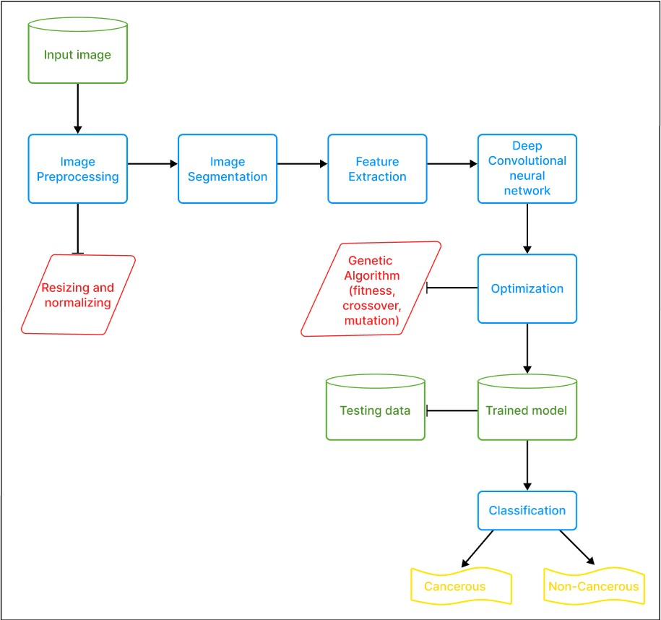

Fig 4.1 – Block Diagram

**4.2 Use Case Diagram**

A use case diagram is used to represent the dynamic behavior of a system. It encapsulates the system's functionality by incorporating use cases, actors, and their relationships. It models the tasks, services, and functions required by a system/subsystem of an application. It depicts the high-level functionality of a system and also tells how the user handles a system.

The main purpose of a use case diagram is to portray the dynamic aspect of a system. It accumulates the system's requirement, which includes both internal as well as external influences. It invokes persons, use cases, and several things that invoke the actors and elements accountable for the implementation of use case diagrams. It represents how an entity from the external environment can interact with a part of the system.

Following are the purposes of a use case diagram given below:

* + It gathers the system's needs.
  + It depicts the external view of the system.
  + It recognizes the internal as well as external factors that influence the system.
  + It represents the interaction between the actors.

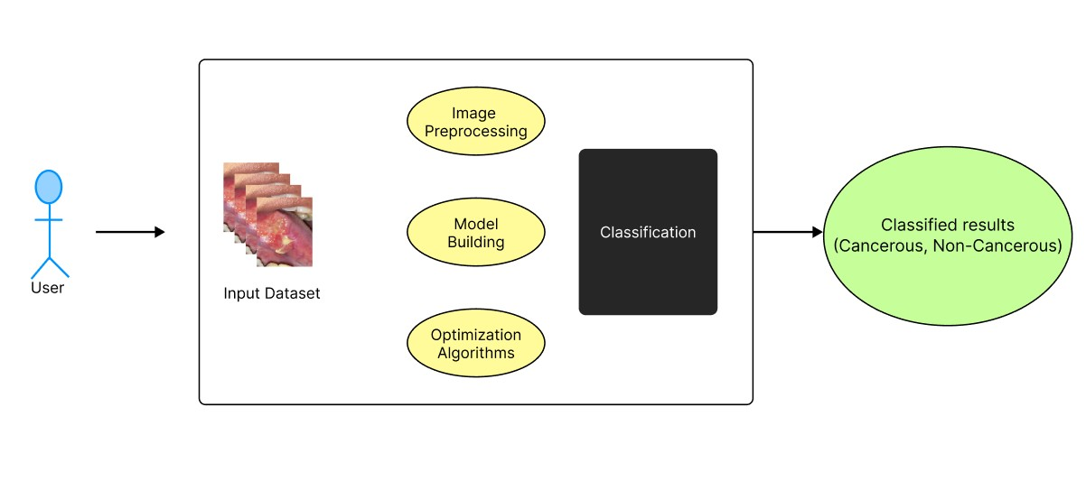

Fig 4.2 – Use Case Diagram

**4.3 Activity Diagram**

Activity Diagrams describe how activities are coordinated to provide a service which can be at different levels of abstraction. Typically, an event needs to be achieved by some operations, particularly where the operation is intended to achieve a number of different things that require coordination, or how the events in a single use case relate to one another, in particular, use cases where activities may overlap and require coordination. It is also suitable for modelling how a collection of use cases coordinates to represent business workflows.

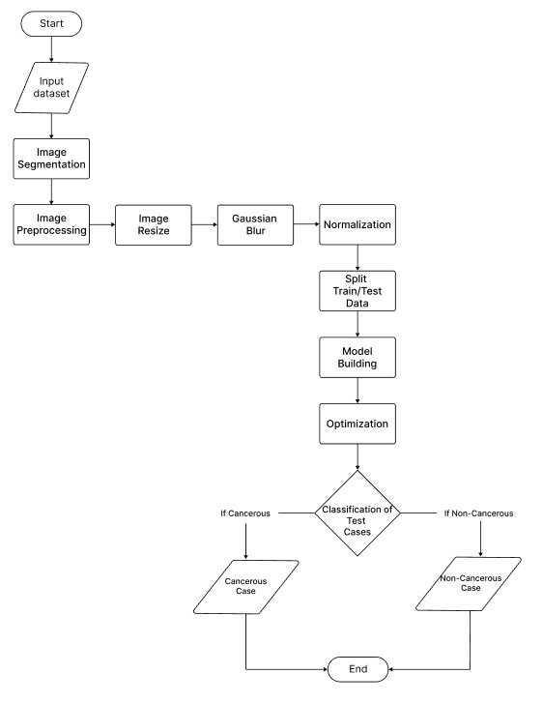

Fig 4.3 – Activity Diagram

**4.4 Class Diagram**

Class diagram is a static diagram. It represents the static view of an application. Class diagram is not only used for visualizing, describing, and documenting different aspects of a system but also for constructing executable code of the software application.

The purpose of the class diagram can be summarized as – • Analysis and design of the static view of an application.

* + - * Describe responsibilities of a system.
      * Base for component and deployment diagrams.
      * Forward and reverse engineering.

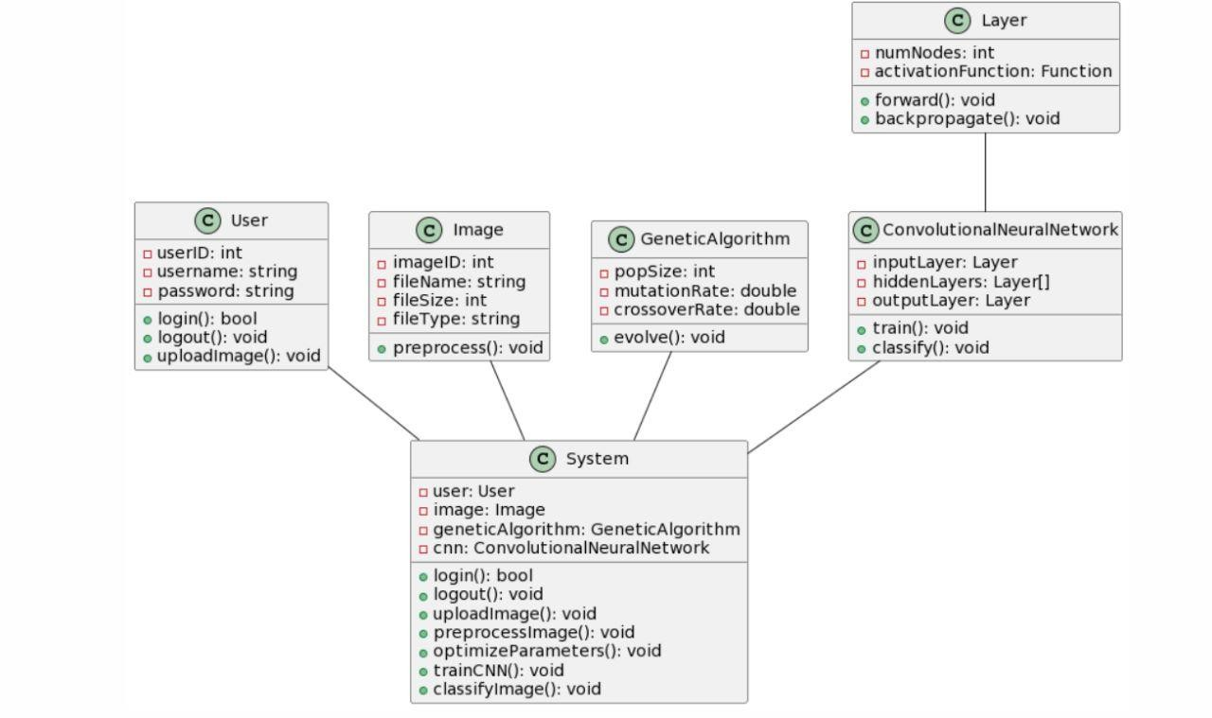

Fig 4.4 – Class Diagram

**4.5 Sequence Diagram**

The sequence diagram represents the flow of messages in the system and is also termed as an event diagram. It helps in envisioning several dynamic scenarios. It portrays the communication between any two lifelines as a time-ordered sequence of events, such that these lifelines took part at the run time. In UML, the lifeline is represented by a vertical bar, whereas the message flow is represented by a vertical dotted line that extends across the bottom of the page. It incorporates the iterations as well as branching.

The purpose of the class diagram can be summarized as –

* + - * To model high-level interaction among active objects within a system.
      * To model interaction among objects inside a collaboration realizing a use case.
      * It either models generic interactions or some certain instances of interaction.

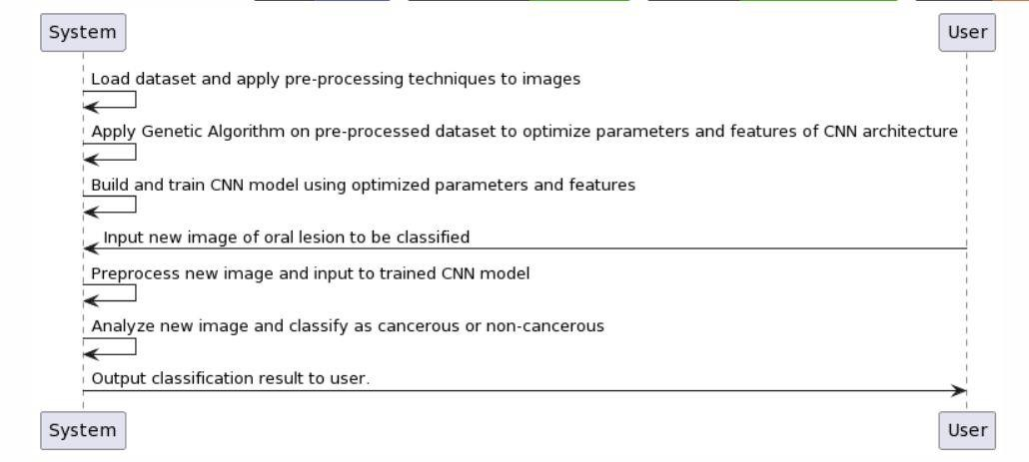

Fig 4.5 – Sequence Diagram

**5. IMPLEMENTATION**

**5.1 Deep Learning**

Deep learning is a subset of [machine learning,](https://www.ibm.com/cloud/learn/machine-learning) which is essentially a neural network with three or more layers. These neural networks attempt to simulate the behaviour of the human brain—albeit far from matching its ability—allowing it to “learn” from large amounts of data. While a neural network with a single layer can still make approximate predictions, additional hidden layers can help to optimize and refine for accuracy.

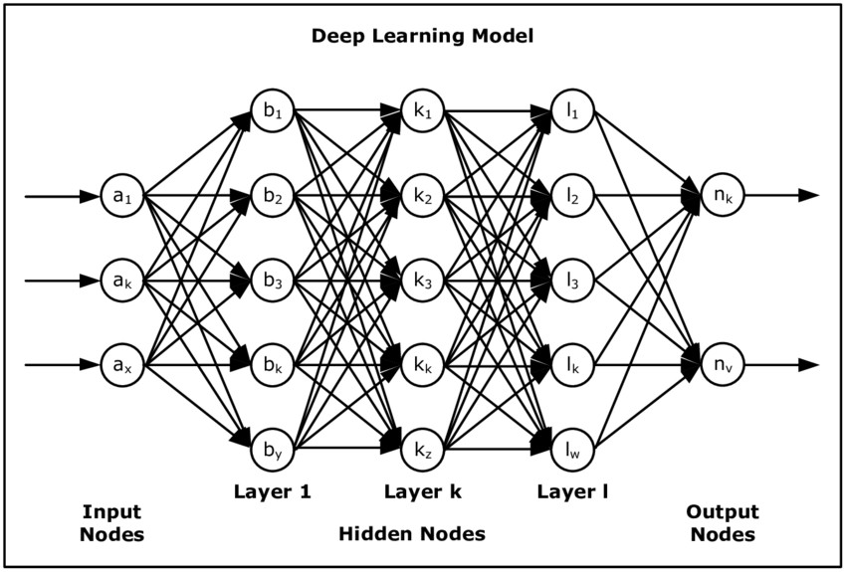

#### Fig 5.1– Deep Learning Model

Deep learning drives many [artificial intelligence (AI)](https://www.ibm.com/cloud/learn/what-is-artificial-intelligence) applications and services that improve automation, performing analytical and physical tasks without human intervention. Deep learning technology lies behind everyday products and services (such as digital assistants, voice-enabled TV remotes, and credit card fraud detection) as well as emerging technologies (such as self-driving cars).

Deep neural networks consist of multiple layers of interconnected nodes, each building upon the previous layer to refine and optimize the prediction or categorization. This progression of computations through the network is called forward propagation. The input and output layers of a deep neural network are called *visible* layers. The input layer is where the deep learning model ingests the data for processing, and the output layer is where the final prediction or classification is made.

Deep learning achieves recognition accuracy at higher levels than ever before. This helps consumer electronics meet user expectations, and it is crucial for safety-critical applications like driverless cars. Recent advances in deep learning have improved to the point where deep learning outperforms humans in some tasks like classifying objects in images.

**5.2 Convolutional Neural Network Model (CNN)**

A convolutional [neural network,](https://deepai.org/machine-learning-glossary-and-terms/neural-network) or CNN, is a [deep learning](https://deepai.org/machine-learning-glossary-and-terms/deep-learning) neural network designed for processing structured arrays of data such as images. Convolutional neural networks are widely used in [computer vision](https://deepai.org/machine-learning-glossary-and-terms/computer-vision) and have become the state of the art for many visual applications such as image classification, and have also found success in [natural language processing](https://deepai.org/machine-learning-glossary-and-terms/natural-language-processing) for text classification.

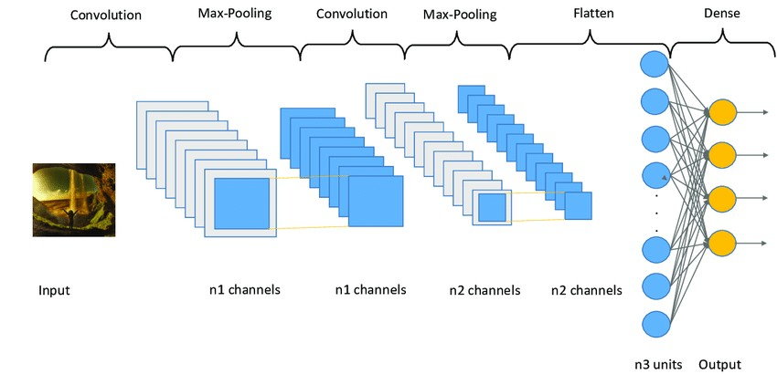

#### Fig 5.2 – CNN Model

Convolutional neural networks are very good at picking up on patterns in the input image, such as lines, gradients, circles, or even eyes and faces. It is this property that makes convolutional neural networks so powerful for computer vision. Unlike earlier computer vision algorithms, convolutional neural networks can operate directly on a raw image and do not need any pre-processing.

A convolutional neural network is a [feed-forward neural network,](https://deepai.org/machine-learning-glossary-and-terms/feed-forward-neural-network) often with up to 20 or 30 layers. The power of a convolutional neural network comes from a special kind of layer called the convolutional layer.

Convolutional neural networks contain many convolutional layers stacked on top of each other, each one capable of recognizing more sophisticated shapes. With three or four convolutional layers it is possible to recognize handwritten digits and with 25 layers it is possible to distinguish human faces.

**5.3 Image Pre-Processing**

The aim of pre-processing is to improve the quality of the image so that we can analyse it in a better way. By pre-processing we can suppress undesired distortions and enhance some features which are necessary for the particular application we are working for. Those features might vary for different applications.

An important part of pre-processing is resizing the image such that all the images of the dataset are of the same size. This ensures that the algorithm is considering the same scale of images and that there is no reduction in the accuracy of the classification/prediction.

Another step involved in image pre-processing is the use of Filters. The most used filter is called the Gaussian filter. In [image processing,](https://en.wikipedia.org/wiki/Image_processing) a Gaussian blur (also known as Gaussian smoothing) is the result of blurring an [image](https://en.wikipedia.org/wiki/Image) by a [Gaussian function](https://en.wikipedia.org/wiki/Gaussian_function) (named after mathematician and scientist [Carl Friedrich Gauss)](https://en.wikipedia.org/wiki/Carl_Friedrich_Gauss). It is a widely used effect in graphics software, typically to reduce [image noise](https://en.wikipedia.org/wiki/Image_noise) and reduce detail. The visual effect of this blurring technique is a smooth blur resembling that of viewing the image through a translucent screen, distinctly different from the [bokeh](https://en.wikipedia.org/wiki/Bokeh) effect produced by an out-of-focus lens or the shadow of an object under usual illumination.

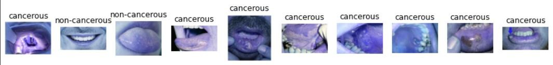

Fig 5.3– Image Pre-Processing

**5.4 Genetic Algorithm**

A genetic algorithm (GA) is a type of optimization algorithm that is inspired by the process of natural selection. It is used to find optimal solutions to complex problems that involve a large search space, where other optimization methods may struggle to find the best solution.

The basic idea behind a genetic algorithm is to simulate the process of natural selection by creating a population of individuals (often called "chromosomes") and iteratively improving it over multiple generations by applying genetic operators such as mutation and crossover. These genetic operators mimic the natural processes of mutation and recombination that occur during reproduction, and they can help to introduce diversity into the population and explore different regions of the search space.

**The** **fitness function** is a crucial component of a genetic algorithm, as it determines how well each individual in the population performs on the problem being solved. The fitness function assigns a fitness score to each individual based on how well it solves the problem, with higher scores indicating better solutions. The algorithm then uses these fitness scores to determine which individuals should be selected for reproduction and which should be discarded.

**Mutation** is a genetic operator that introduces random changes to the chromosomes in the population. It is used to prevent the algorithm from converging on a local optimum and to explore different regions of the search space. Mutation can be applied to a random subset of the population, and it can involve a variety of different types of changes to the chromosomes, such as flipping bits, changing values, or adding or deleting genes.

**Crossover** is another genetic operator that involves combining two parent chromosomes to create a new offspring chromosome. This process mimics the process of sexual reproduction in nature, where the genetic material of two parents is combined to create a new offspring. Crossover can be applied to a random subset of the population, and it can involve a variety of different methods for combining the genetic material of the parents, such as single-point crossover, two-point crossover, and uniform crossover.

Therefore, a genetic algorithm is an optimization algorithm that uses a combination of selection, mutation, and crossover to iteratively improve a population of individuals over multiple generations. The fitness function is used to evaluate the performance of each individual, while mutation and crossover are used to introduce diversity into the population and explore different regions of the search space.

There are several layers that are used to train the model. They are –

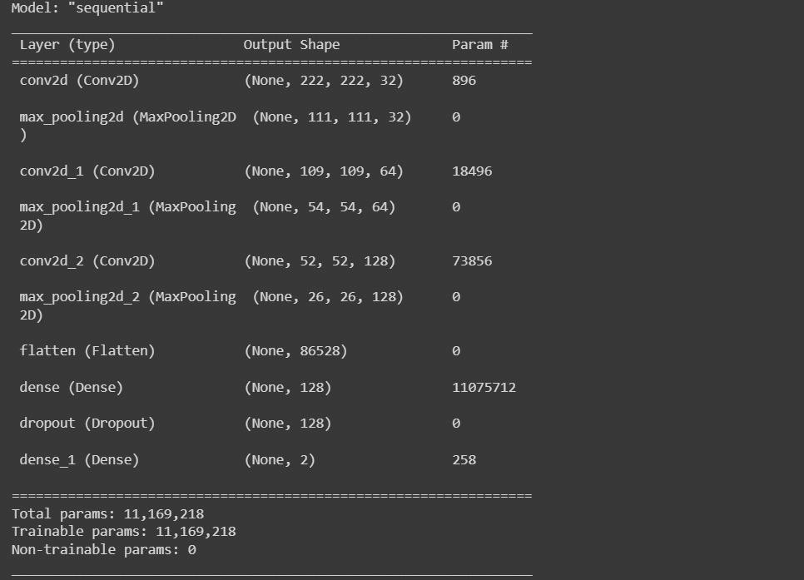

Fig 5.4 – Layers used in the model

**5.5 Confusion Matrix**

In the field of [machine learning](https://en.wikipedia.org/wiki/Machine_learning) and specifically the problem of [statistical classification,](https://en.wikipedia.org/wiki/Statistical_classification) a confusion matrix, also known as an error matrix, is a specific table layout that allows visualization of the performance of an algorithm, typically a [supervised learning](https://en.wikipedia.org/wiki/Supervised_learning) one (in [unsupervised learning](https://en.wikipedia.org/wiki/Unsupervised_learning) it is usually called a matching matrix). Each row of the [matrix](https://en.wikipedia.org/wiki/Matrix_(mathematics)) represents the instances in an actual class while each column represents the instances in a predicted class, or vice versa – both variants are found in the literature. The name stems from the fact that it makes it easy to see whether the system is confusing two classes (i.e. commonly mislabelling one as another).

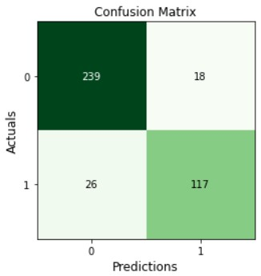

#### Fig 5.5– Confusion Matrix Logic

It is a special kind of [contingency table,](https://en.wikipedia.org/wiki/Contingency_table) with two dimensions ("actual" and "predicted"), and identical sets of "classes" in both dimensions (each combination of dimension and class is a variable in the contingency table).

**CODE:**

**Defining CNN Model**

# define the population of CNN models model = keras.Sequential([ keras.layers.Conv2D(32, kernel_size=(3, 3), activation='relu', input_shape=(224, 224, 3)), keras.layers.MaxPooling2D(pool_size=(2, 2)),

keras.layers.Conv2D(64, kernel_size=(3, 3), activation='relu',input_shape=(224, 224, 3)), keras.layers.MaxPooling2D(pool_size=(2, 2)),

keras.layers.Conv2D(128, kernel_size=(3, 3), activation='relu',input_shape=(224, 224, 3)), keras.layers.MaxPooling2D(pool_size=(2, 2)), keras.layers.Flatten(), keras.layers.Dense(128, activation='relu'), keras.layers.Dropout(0.5), keras.layers.Dense(2, activation='softmax')

])

1. **TESTING**

For testing, a convolutional neural network (CNN) model is used to classify oral histopathology images as cancerous or non-cancerous. Images are in PNG format gray scale image. It begins by loading the dataset, and pre-processing the images. Then, the data is split into training and testing sets, and data augmentation is applied to the training set to increase the amount of available training data. A CNN model is defined, compiled, and trained on the training set, followed by making predictions on the test set using the trained model. A classification report is generated to evaluate the model's performance. Finally, a genetic algorithm is implemented to optimize the CNN model's hyperparameters and improve its performance. Overall, the provided code provides a comprehensive example of building, testing, and optimizing a CNN model for image classification tasks.

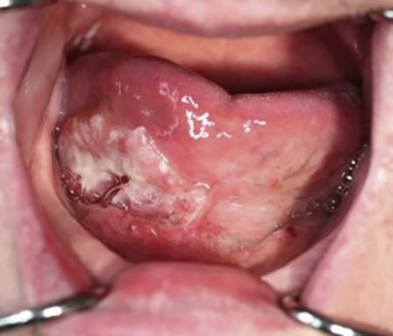

Fig 6.1 – Cancerous Case Example

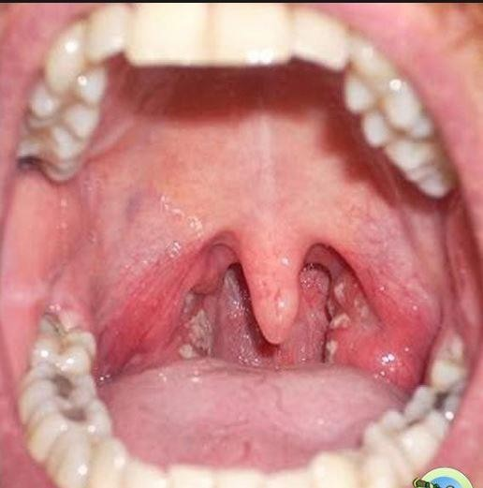

Fig 6.2 – Non-Cancerous Case Example

**6.1 Test Case 1**

|  |  |  |  |  |  |  |  |
| --- | --- | --- | --- | --- | --- | --- | --- |
| **Test case**  **Id** | **Test Case** | **Preconditions** | **Input test data** | **Steps to be executed** | **Expected result** | **Actual result** | **Pass/**  **Fail** |
| **1.** | Detection of  Cancerous Cases | Train Model using sample Cancerous  Cases and apply  Genetic  Algorithm to detect  Cancerous Cases | 2000 cases dataset | Run The Code in Google  Colab or VS Code | Based on  Training  Data, system predicts the  test case as  Case of  Cancer | Predicted  The Cancer  Case  Successfully | Pass |

#### Table 6.1 – Test Case 1

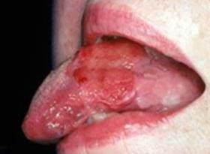

Fig 6.3 – Prediction = Cancerous

**6.2 Test Case 2**

|  |  |  |  |  |  |  |  |
| --- | --- | --- | --- | --- | --- | --- | --- |
| **Test case**  **Id** | **Test Case** | **Preconditions** | **Input test data** | **Steps to be executed** | **Expected result** | **Actual result** | **Pass/**  **Fail** |
| **2.** | Detection of  Non-  Cancerous Cases | Train Model using sample  Non-Cancerous  Cases and apply  Genetic  Algorithm to detect Non-  Cancerous Cases | 2000 cases dataset | Run The Code in Google  Colab or VS Code | Based on  Training  Data, system predicts the  test case as  Case of  Non-Cancer | Predicted  The Normal Case  Successfully | Pass |

#### Table 6.2 – Test Case 2



Fig 6.4 – Prediction = Non-Cancerous

**6.3 Test Case 3**

|  |  |  |  |  |  |  |  |
| --- | --- | --- | --- | --- | --- | --- | --- |
| **Test case**  **Id** | **Test Case** | **Preconditions** | **Input test data** | **Steps to be executed** | **Expected result** | **Actual result** | **Pass/**  **Fail** |
| **3.** | Detection of  Cancerous Cases | Train Model using sample Cancerous  Cases and apply  Genetic  Algorithm to detect  Cancerous Cases | 2000 cases dataset | Run The Code in Google  Colab or VS Code | Based on  Training  Data, system predicts the  test case as  Case of  Cancer | Predicted  The Cancer  Case  Successfully | Pass |

#### Table 6.3 – Test Case 3

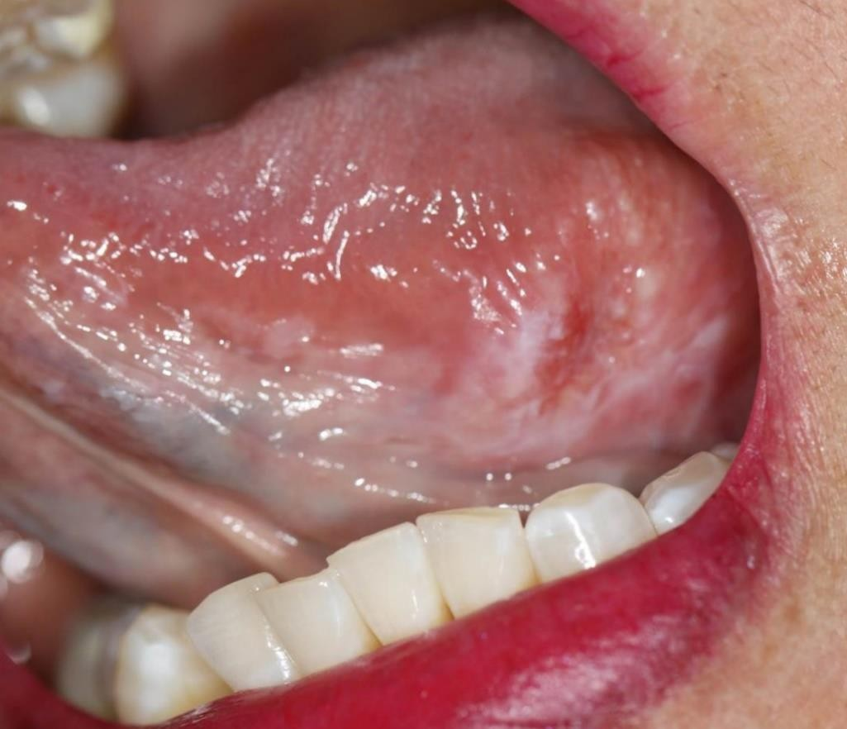

Fig 6.5 – Prediction = Cancerous

**6.4 Test Case 4**

|  |  |  |  |  |  |  |  |
| --- | --- | --- | --- | --- | --- | --- | --- |
| **Test case**  **Id** | **Test Case** | **Preconditions** | **Input test data** | **Steps to be executed** | **Expected result** | **Actual result** | **Pass/**  **Fail** |
| **4.** | Detection of  Non-  Cancerous Cases | Train Model using sample  Non-Cancerous  Cases and apply  Genetic  Algorithm to detect Non-  Cancerous Cases | 2000 cases dataset | Run The Code in Google  Colab or VS Code | Based on  Training  Data, system predicts the  test case as  Case of  Non-Cancer | Predicted  The Normal Case  Successfully | Pass |

#### Table 6.4 – Test Case 4

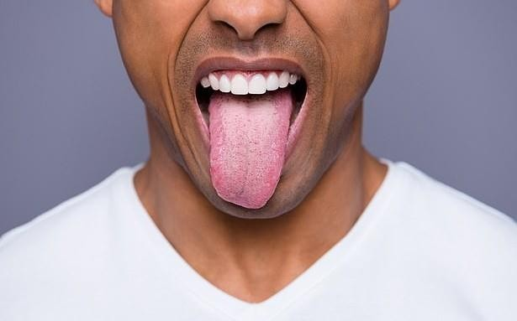

Fig 6.6 – Prediction = Non-Cancerous

**7. RESULT SCREENSHOTS**

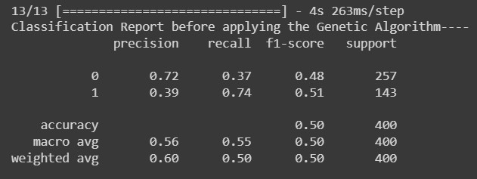

Fig 7.1 – Classification Report before Optimization

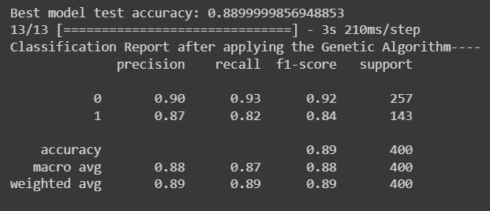

Fig 7.2 – Classification Report after Optimization

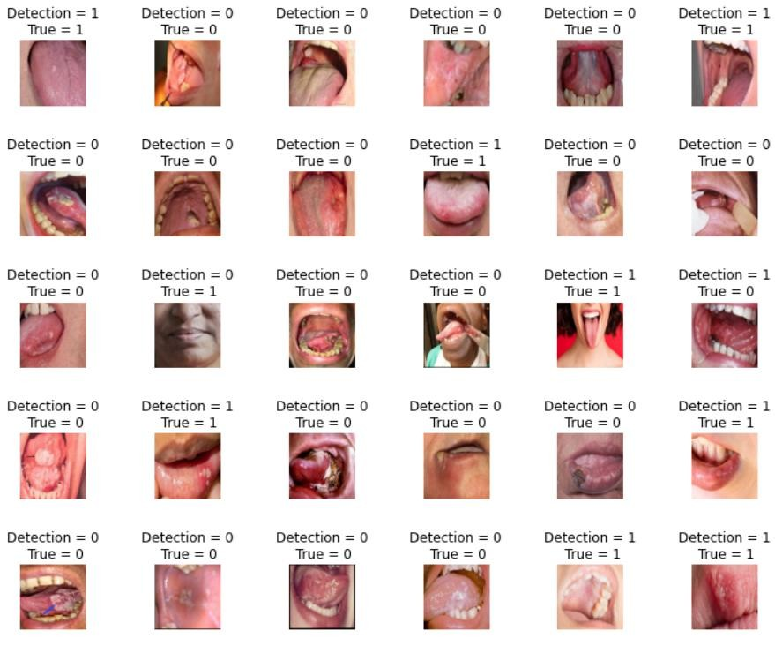

Fig 7.3 – Classification Result



Fig 7.4 – Confusion Matrix

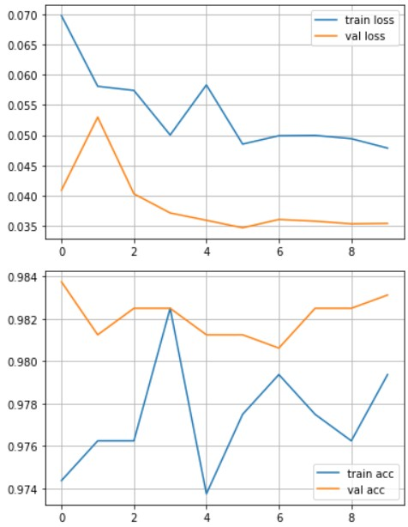

Fig 7.5 – Model and Accuracy Loss

**8. CONCLUSION**

The project showcases the effectiveness of using a genetic algorithm to optimize a deep convolutional neural network for the task of oral cancer classification. The use of genetic algorithm for hyperparameter tuning resulted in a significant improvement in the classification accuracy compared to the model without optimization. This highlights the importance of selecting optimal hyperparameters for deep learning models, which can significantly impact their performance. Overall, this project demonstrates the potential of combining machine learning and optimization techniques for improving the accuracy of cancer classification models, which could have significant implications for early detection and diagnosis of oral cancer.

**9.FUTURE ENHANCEMENTS**

The proposed algorithm uses deep learning model CNN (Convolutional Neural Network) for detecting the oral cancer, although the algorithm accuracy is good but the execution time of the proposed algorithm can be reduced further by making some more improvements in the algorithm.

Anyhow our proposed algorithm’s result and accuracy is satisfactory and can classify the cases successfully. Also, in future we can add user interface for user interaction and for easy understanding of result.

**10.REFERENCES**

1. Shipu Xu, Chang Liu, yongshou Zong, Sirui Chen, Yiwen Lu, Longzhi Yang, Eddie Y. K. NG,

Yongtong Wang, Yunsheng Wang, Yong Liu, Wenwen Hu and Chenxi: “An Early Diagnosis of Oral Cancer based on Three-dimensional Convolutional Neural Networks”, IEEE Acess (Volume: 7), 2019

1. R. Dharani and S. Revathy: “DEEPORCD: Detection of Oral Cancer using Deep Learning”, Journal of Physics: Conference Series 1911 (2021) 012006, 2021
2. Atta-ur Rahman, Abdullah Alqahtani, Nahier Aldhafferi, Muhammad Umar Nasir, Muhammad

Farhan Khan, Muhammad Adnan Khan, Amir Mosavi: “Histopathologic Oral Cancer Prediction Using Oral Squamous Cell Carcinoma Biopsy Empowered with Transfer Learning”, Sensors, 2022

1. Aradhita Bhandari, B. K. Tripathy, Khurram Jawad, Surbhi Bhatia, Mohammad Khalid Imam

Rahmani, Arwa Mashat: “Cancer Detection and Prediction Using Genetic Algorithms”, Hindawi Computational Intelligence and Neuroscience Volume 2022

1. Rafael Marconi Ramos, Celia Ghedini Ralha, Tahsin M. Kurc, Joel H. Saltz, George Teodoro: “Increasing Accuracy of Medical CNN Applying Optimization Algorithms: an Image Classification Case”, 8th Brazilian Conference on Intelligent Systems (BRACIS), 2019
2. Bin Wang, Yanan Sun, Bing Xue, Mengjie Zhang: “Evolving Deep Convolutional Neural Networks by Variable-length Particle Swarm Optimization for Image Classification”, 2018
3. Adwan A. Alanazi, Manal M. Khayyat, Mashael M. Khayyat, Bushra M. Elamin Elnaim, Sayed Abdel- Khalek: “Intelligent Deep Learning Enabled Oral Squamous Cell Carcinoma

Detection and Classification Using Biomedical Images”, Hindawi Computational Intelligence and Neuroscience Volume 2022

1. Yanan Sun, Member, IEEE, Bing Xue, Member, IEEE, Mengjie Zhang, Fellow, IEEE, Gary

G. Yen, Fellow, IEEE, and Jiancheng Lv, Member, IEEE: “Automatically Designing CNN

Architectures Using the Genetic Algorithm for Image Classification”, IEEE Transactions on Cybernetics, Vol. 50, No. 9, 2020

1. Xiaoying Pan, Ting Zhang, QingPing Yang, Di Yang, Jean-Claude Rwigema, and X. Sharon Qi: “Survival prediction for oral tongue cancer patients via probabilistic genetic algorithm optimized neural network models”, The Authors. Published by the British Institute of

Radiology, 2020

1. Wenjiang Jiao, Xingwei Hao, Chao Qin: “The Image Classification Method with CNNXGBoost Model Based on Adaptive Particle Swarm Optimization”, 2021
2. Roshan Alex Welikala, Paolo Remagnino, Jian Ham Lim, Chee Seng Chan, Senthilmani

Rajendran, Thomas George Kallarakkal, Rosnah Binti Zain, Ruwan Duminda Jayasinghe,

Jyotsna Rimal, Alexander Ross Kerr, Rahmi Amtha, Karthikeya Patil, Wanninayake

Mudiyansilage Tilakaratne, John Gibson, Sok Ching Cheong, Sarah Ann Barman: “Automated

Detection and Classification of Oral Lesions Using Deep Learning for Early Detection of Oral Canecr”, 2020

1. S. Hemalatha, N. Chidambararaj, Ravikanth Motupalli: “Performance Evaluation of Oral Cancer Detection and Classification using Deep Learning Approach”, 2022
2. Sayyada Hajera Begum, P. Vidyullatha: “A Review of Deep Learning Application in Oral Cancer Prognosis”, 2023
3. Sunil Kumar Prabhakar, Harikumar Rajaguru: “Performance analysis of Linear Layer Neural Networks for Oral Cancer Classification”, 2017
4. Santisudha Panigrahi, Tripti Swarnkar: “Automated Classification of Oral Cancer Histopathology Images Using Convolutional Neural Network”, 2020
5. Bibek Goswami, Jyotirmoy Chatterjee, Ranjan Rashmi Paul, Mousumi Pal, Rusha Patra: “Classification of Oral Submucous Fibrosis Using Convolutional Neural Network”, 2020
6. S. Premalatha, K. Lakshmi Joshitha: “A Comprehensive Review of Early Detection of Oral Cancer Using Deep Learning”, 2022
7. S. Swetha, P. Kamali, B. Swathi, R. Vanithamani, E. Karolinekersin: “Oral Disease Detection Using Neural Network”, 2021

**APPENDIX**

**GANTT CHART**

