ORAL CANCER CLASSIFICATION USING OPTIMIZED DEEP CONVOLUTION NEURAL NETWORK

Anam Suroor
Information Technology
Muffakham Jah College of Engineering & Technology
Hyderabad,indi
160419737003@mjcollege.ac.in
Shariqa Moin
Information Technology
Muffakham Jah College of Engineering & Technology
Hyderabad,indi
160419737017@mjcollege.ac.in

Mohammed Amaan Mohiuddin
Information Technology
Muffakham Jah College of Engineering & Technology
Hyderabad,indi
160419737057@mjcollege.ac.in

Abstract— To improve cancer-related healthcare, accurate and efficient early detection and non-invasive testing are necessary. Therefore, an optimization function for parameters and features is needed to ensure accuracy.
Convolutional neural networks (CNNs) have gained remarkable success on many image classification tasks in recent years. CNN architecture designs can also be classified into the evolutionary algorithm-based ones and the reinforcement learning-based ones. Evolutionary algorithms can find the optimal or near-optimal solutions in large datasets and are widely used for optimization. This also makes them ideal for detecting cancer by creating models to interpret the results of tests.
In our project we aim to classify the suspicious and non-suspicious oral lesions from photographic images of mouth and lip cancer. We will be focusing on utilizing a Genetic Algorithm to automatically search for optimized results in the proposed CNN architecture without any manual work involved. For the CNN architecture we will be using transfer learning approach based on default architectures available. The default architecture that gives the best results will be chosen as the base model for our proposed architecture. Finally, the results will be evaluated using accuracy, precision and recall parameters.
Keywords: cancer detection, oral lesions, convolutional neural network, genetic algorithm, transfer learning, accuracy, precision, recall.

INTRODUCTION
Oral cancer is a significant public health problem, and early detection is vital for improving patient outcomes and survival rates. However, traditional methods of diagnosing oral cancer can be challenging, as they rely on the expertise of trained medical professionals and can be time-consuming and costly. Advances in machine learning and computer vision have shown great promise in improving the accuracy and efficiency of oral cancer detection, making it a promising area of research.
In this project, we aim to develop an automated system for detecting oral cancer using machine learning and computer vision techniques. The system will use a convolutional neural network (CNN) to classify medical images of oral lesions as either cancerous or non-cancerous. The CNN architecture will be optimized using a genetic algorithm to find the optimal or near-optimal solutions in large datasets. The genetic algorithm will be used to explore the parameter and feature space of the CNN architecture, including crossover and mutation, to obtain a highly efficient and accurate classification model.

The system takes in a medical dataset containing images of oral lesions and uses pre-processing techniques, including the Gaussian blur filter, to prepare the data for analysis. The pre-processing step is essential to enhance the quality of the images and improve the accuracy of the system's classification. The system then applies a genetic algorithm to optimize the parameters and features of the convolutional neural network (CNN) architecture, including using crossover and mutation. To optimize the performance of the CNN, a genetic algorithm will be used to optimize the parameters and features of the network architecture.

The proposed system will be designed to be user-friendly and easily accessible to healthcare professionals. It is expected that this system will provide a valuable tool for early oral cancer detection. The results of this project will be evaluated using various performance metrics, including accuracy, precision, and recall, to demonstrate the effectiveness of the proposed approach.
.

Literature Survey
In literature [1],Shipu Xu, Chang Liu M, Yongshuo Zong, Sirui Chen, Yiwen Lu, Longzhi Yang, Eddie Y. K. Ng, Yongtong Wang, Yunsheng Wang, Yong Liu, Wenwen Hu, and Chenxi Zhang [1] established a 3DCNNs-based image processing algorithm for the early diagnosis of oral cancers, which was compared with a 2DCNNs-based algorithm. The 3D and 2D CNNs were constructed using the same hierarchical structure to profile oral tumours as benign or malignant. Their results showed that 3DCNNs with dynamic characteristics of the enhancement rate image performed better than 2DCNNS with single enhancement sequence for the discrimination of oral cancer lesions. Their data indicate that spatial features and spatial dynamics extracted from 3DCNNs may inform future design of CT-assisted diagnosis system.
In literature [2], R.dharani, and S.Revathy [2] proposed that in their work cancer cells will find and classify that affected in the oral area through digital processing technology. The use of advanced technologies and an in-depth learning algorithm are possible for early detection and classification. This work uses three characteristics-extracting techniques such as the bag histogram of oriented gradients, wavelet features and the Zernike Moment. Once retrieving the texture characteristics, the fuzzy particle swarm optimization algorithm (FPSO) is applied to choose the best characteristic. Finally, these characteristics were classified using the Convolution Neural Network (CNN) classifier. For comparison of the efficiency of the proposed method, Recall Rate, Classification Accuracy, Precision Rate, and Error Rate. Evaluation outcomes demonstrated that the combination of ABC, FPSO and CNN performs better in the detection of oral cancer. This work utilized six supervised machine learning methods, namely, SVM, Bagging, Navie Bayes, KNN Adaboost, CNN and IELM for comparison process. CNN classifiers can obtain an overall accuracy 97.21%. So the results indicate that CNN approach performs well for oral cancer detection of CT images.
In literature [3], Atta-ur Rahman, Abdullah Alqahtani, Nahier Aldhafferi, Muhammad Umar Nasir, Muhammad Farhan Khan, Muhammad Adnan Khan, and Amir Mosavi [3] proposed that there are many ways to detect like a biopsy, in which small chunks of tissues are taken from the mouth and tested under a secure and hygienic microscope. However, microscope results of tissues to detect oral cancer are not up to the mark, a microscope cannot easily identify the cancerous cells and normal cells. Detection of cancerous cells using microscopic biopsy images helps in allaying and predicting the issues and gives better results if biologically approaches apply accurately for the prediction of cancerous cells, but during the physical examinations microscopic biopsy images for cancer detection there are major chances for human error and mistake. So, with the development of technology deep learning algorithms plays a major role in medical image diagnosing.
In literature [4],Aradhita Bhandari, B.K. Tripathy, Khurram Jawad, Surbhi Bhatia, Mohammad Khalid Imam Rahmani, and Arwa Mashat [4] used Genetic algorithms (GAs). GAs are metaheuristics that belong to the class of evolutionary algorithms. GAs can find the optimal or near-optimal solutions in huge, difficult search spaces and are widely used for search and optimization. is makes them ideal for detecting cancer by creating models to interpret the results of tests, especially non-invasive. In this article, we have comprehensively reviewed the existing literature, analysed them critically, provided a comparative analysis of the state-of-the-art techniques, and identified the future challenges in the development of such techniques by medical professionals

In literature [5],Is it possible to define an approach that allows automatic deep architecture adjustment, increasing accuracy, reducing the number of tests and starting from a known architecture was answered in the paper by Rafael Marconi Ramos, Celia Ghedini Ralha, Tahsin M. Kurc, Joel H. Saltz, and George Teodoro [5]. They proposed an approach to increase the medical CNN accuracy. The specific problems of this subset of CNN need special attention when we it is necessary to create a new architecture with better accuracy. The generation of improved architectures in medical CNN cases is hard. It is necessary much time, resources and knowledge. Their approach presents a strategy to apply optimization algorithms to change blocks of convolutional layers and its parameters. The approach reduces the search space presenting better architectures. Consequently, the process is faster than generating from scratch. The changes in architecture produce a more sensible network with better accuracy. The experiments show that all optimization algorithms can reach better architectures with little tests. The max difference between algorithms was 11% of the accuracy
In literature [6],Bin Wang, Yanan Sun, Bing Xue, and Mengjie Zhang [6] developed a new PSO approach with variable length to automatically evolve the architectures of CNNs for image classification problems. This has been successfully achieved by proposing a new encoding scheme of using a network interface containing an IP address and its corresponding subnet to carry the configurations of a CNN layers, the design of four subnets including a disabled subnet in order to simulate a variable-length PSO, and an efficient fitness evaluation method by using partial dataset. This approach was examined and compared with 12 peer competitors including the most state-of-the-art algorithms on three benchmark datasets commonly used in deep learning and the experimental results show that the proposed IPPSO method can achieve a very competitive accuracy by outperforming all others on the MDRBI benchmark dataset, being the second-best on the MNIST benchmark dataset and ranking above the middle line on the CS benchmark dataset. The most important improvement from the traditional PSO to the novel IPPSO proposed in the paper is to invent the new encoding strategy of using network interface

ACT METHODOLIGY

Deep learning
Deep learning is a subset of machine learning, which is essentially a neural network with three or more layers. These neural networks attempt to simulate the behavior of the human brain—albeit far from matching its ability—allowing it to “learn” from large amounts of data. While a neural network with a single layer can still make approximate predictions, additional hidden layers can help to optimize and refine for accuracy.

Deep neural networks consist of multiple layers of interconnected nodes, each building upon the previous layer to refine and optimize the prediction or categorization. This progression of computations through the network is called forward propagation. The input and output layers of a deep neural network are called visible layers. The input layer is where the deep learning model ingests the data for processing, and the output layer is where the final prediction or classification is made.
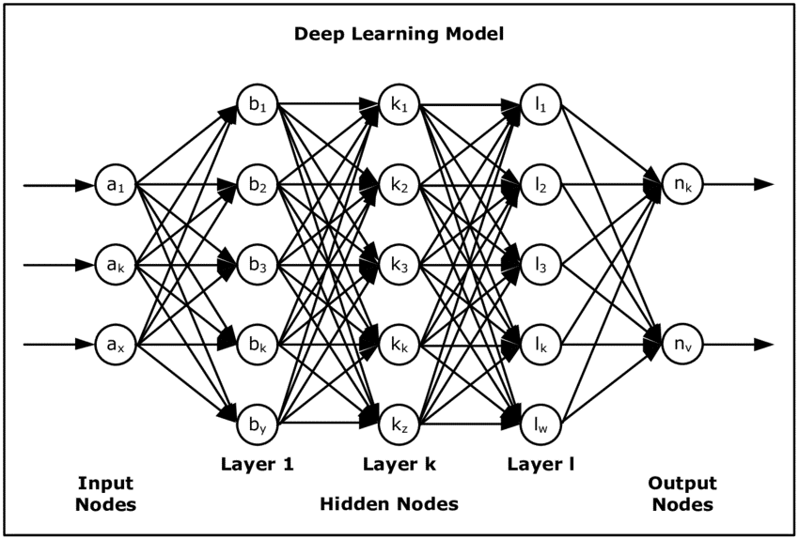
Fig 1

Deep learning achieves recognition accuracy at higher levels than ever before. This helps consumer electronics meet user expectations, and it is crucial for safety-critical applications like driverless cars. Recent advances in deep learning have improved to the point where deep learning outperforms humans in some tasks like classifying objects in images

Convolution Neural Network Model(CNN)
A convolutional neural network, or CNN, is a deep learning neural network designed for processing structured arrays of data such as images. Convolutional neural networks are widely used in computer vision and have become the state of the art for many visual applications such as image classification, and have also found success in natural language processing for text classification.

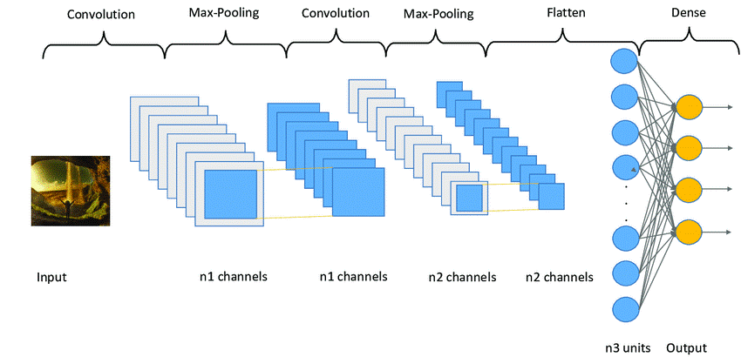
Fig 2

Convolutional neural networks contain many convolutional layers stacked on top of each other, each one capable of recognizing more sophisticated shapes. With three or four convolutional layers it is possible to recognize handwritten digits and with 25 layers it is possible to distinguish human faces

Image pre-processing
The aim of pre-processing is to improve the quality of the image so that we can analyze it in a better way. By pre-processing we can suppress undesired distortions and enhance some features which are necessary for the particular application we are working for. Those features might vary for different applications

Another step involved in image pre-processing is the use of Filters. The most used filter is called the Gaussian filter. In image processing, a Gaussian blur (also known as Gaussian smoothing) is the result of blurring an image by a Gaussian function (named after mathematician and scientist Carl Friedrich Gauss). It is a widely used effect in graphics software, typically to reduce image noise and reduce detail. The visual effect of this blurring technique is a smooth blur resembling that of viewing the image through a translucent screen, distinctly different from the bokeh effect produced by an out-of-focus lens or the shadow of an object under usual illumination.

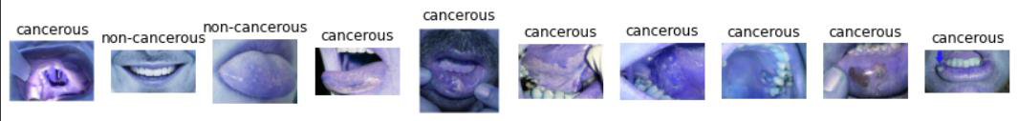
Fig 3

Genetic algorithm
The basic idea behind a genetic algorithm is to simulate the process of natural selection by creating a population of individuals (often called "chromosomes") and iteratively improving it over multiple generations by applying genetic operators such as mutation and crossover. These genetic operators mimic the natural processes of mutation and recombination that occur during reproduction, and they can help to introduce diversity into the population and explore different regions of the search space.

The fitness function is a crucial component of a genetic algorithm, as it determines how well each individual in the population performs on the problem being solved. The fitness function assigns a fitness score to each individual based on how well it solves the problem, with higher scores indicating better solutions. The algorithm then uses these fitness scores to determine which individuals should be selected for reproduction and which should be discarded.

Mutation is a genetic operator that introduces random changes to the chromosomes in the population. It is used to prevent the algorithm from converging on a local optimum and to explore different regions of the search space. Mutation can be applied to a random subset of the population, and it can involve a variety of different types of changes to the chromosomes, such as flipping bits, changing values, or adding or deleting genes.

Crossover is another genetic operator that involves combining two parent chromosomes to create a new offspring chromosome. This process mimics the process of sexual reproduction in nature, where the genetic material of two parents is combined to create a new offspring. Crossover can be applied to a random subset of the population, and it can involve a variety of different methods for combining the genetic material of the parents, such as single-point crossover, two-point crossover, and uniform crossover.

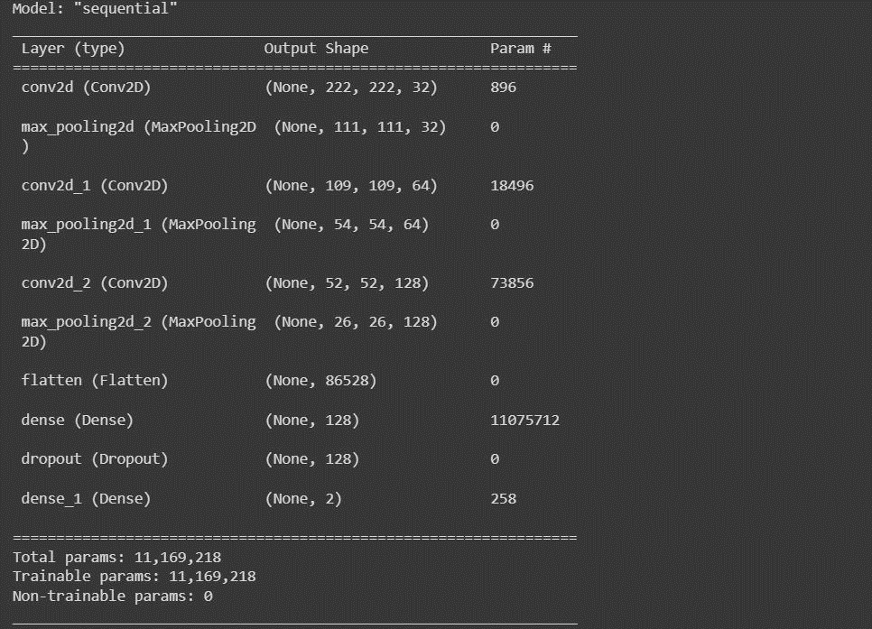

Fig 4

A genetic algorithm is an optimization algorithm that uses a combination of selection, mutation, and crossover to iteratively improve a population of individuals over multiple generations. The fitness function is used to evaluate the performance of each individual, while mutation and crossover are used to introduce diversity into the population and explore different regions of the search space.

Problem statement
The early detection and accurate diagnosis of oral cancer is crucial for successful treatment outcomes, but current methods for oral cancer detection often require invasive biopsy procedures and can be subject to variations in accuracy depending on the skill and experience of the clinician. In this context, there is a need for non-invasive and highly accurate methods for the early detection of oral cancer. Machine learning techniques such as convolutional neural networks (CNNs) have shown promise in the early detection of various types of cancer, but the detection of oral cancer using photographic images of the mouth and lips remains a challenging problem. The aim of this project is to develop a CNN-based algorithm for the early detection of oral cancer using photographic images of the mouth and lips, with a focus on using a genetic algorithm to automatically optimize the CNN architecture for maximum accuracy and efficiency

proposed system

• Load the medical data set. The first step is to obtain the medical dataset that contains information about patients with oral cancer. This dataset typically includes images or scans of the affected areas, patient history, and any other relevant data.

• Apply pre-processing methods on the data set. Before using the data for analysis, pre-processing methods need to be applied. These methods may include image enhancement, filtering, segmentation, and normalization. The goal of pre-processing is to improve the quality and accuracy of the data, making it easier to analyze.

• Apply Genetic algorithm on the data set. The next step is to apply a genetic algorithm (GA) to the pre-processed data. GA is a search and optimization technique that mimics the process of natural selection. It can be used to identify the most relevant features in the dataset that are associated with oral cancer.

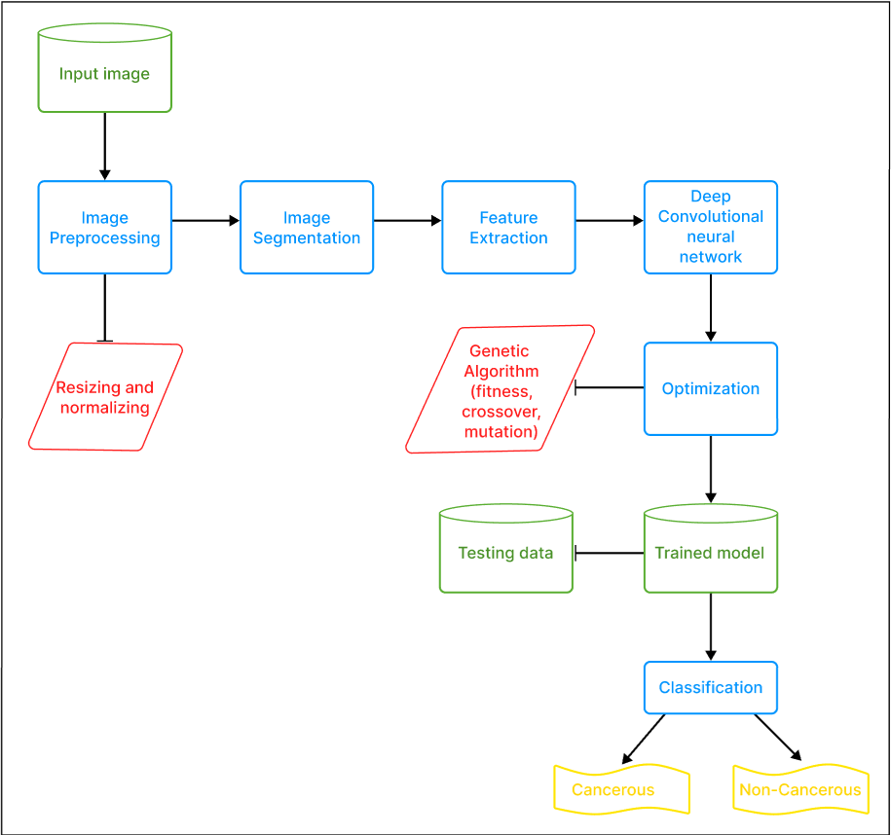

Fig 5 – Block Diagram

• Build and train a CNN model from the resultant data. After using the GA algorithm to extract the most relevant features, a convolutional neural network (CNN) is built and trained on the resultant data. CNNs are powerful deep learning algorithms that can learn to recognize patterns and features in images.

• Classify cancer data set as suspicious and non-suspicious. Finally, the trained CNN model is used to classify the cancer dataset as either suspicious or non-suspicious. The model is tested on a separate dataset to evaluate its accuracy and performance. If a patient's data is classified as suspicious, further testing and diagnosis can be done to confirm the presence of oral cancer.
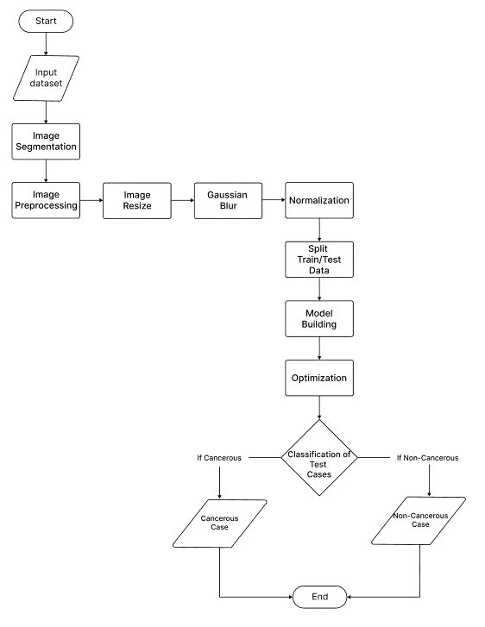
Fig 6 – Activity Diagram

CONCLUSION

The project showcases the effectiveness of using a genetic algorithm to optimize a deep convolutional neural network for the task of oral cancer classification. The use of genetic algorithm for hyperparameter tuning resulted in a significant improvement in the classification accuracy compared to the model without optimization. This highlights the importance of selecting optimal hyperparameters for deep learning models, which can significantly impact their performance. Overall, this project demonstrates the potential of combining machine learning and optimization techniques for improving the accuracy of cancer classification models, which could have significant implications for early detection and diagnosis of oral cancer.

REFERENCES

[1] Shipu Xu, Chang Liu, yongshou Zong, Sirui Chen, Yiwen Lu, Longzhi Yang, Eddie Y. K. NG, Yongtong Wang, Yunsheng Wang, Yong Liu, Wenwen Hu and Chenxi: “An Early Diagnosis of Oral Cancer based on Three-dimensional Convolutional Neural Networks”, IEEE Acess (Volume: 7), 2019
[2] R. Dharani and S. Revathy: “DEEPORCD: Detection of Oral Cancer using Deep Learning”, Journal of Physics: Conference Series 1911 (2021) 012006, 2021
[3] Atta-ur Rahman, Abdullah Alqahtani, Nahier Aldhafferi, Muhammad Umar Nasir, Muhammad Farhan Khan, Muhammad Adnan Khan, Amir Mosavi: “Histopathologic Oral Cancer Prediction Using Oral Squamous Cell Carcinoma Biopsy Empowered with Transfer Learning”, Sensors, 2022
[4] Aradhita Bhandari, B. K. Tripathy, Khurram Jawad, Surbhi Bhatia, Mohammad Khalid Imam Rahmani, Arwa Mashat: “Cancer Detection and Prediction Using Genetic Algorithms”, Hindawi Computational Intelligence and Neuroscience Volume 2022
[5] Rafael Marconi Ramos, Celia Ghedini Ralha, Tahsin M. Kurc, Joel H. Saltz, George Teodoro: “Increasing Accuracy of Medical CNN Applying Optimization Algorithms: an Image Classification Case”, 8th Brazilian Conference on Intelligent Systems (BRACIS), 2019
[6] Bin Wang, Yanan Sun, Bing Xue, Mengjie Zhang: “Evolving Deep Convolutional Neural Networks by Variable-length Particle Swarm Optimization for Image Classification”, 2018
[7] Adwan A. Alanazi, Manal M. Khayyat, Mashael M. Khayyat, Bushra M. Elamin Elnaim, Sayed Abdel- Khalek: “Intelligent Deep Learning Enabled Oral Squamous Cell Carcinoma Detection and Classification Using Biomedical Images”, Hindawi Computational Intelligence and Neuroscience Volume 2022
[8] Yanan Sun, Member, IEEE, Bing Xue, Member, IEEE, Mengjie Zhang, Fellow, IEEE, Gary G. Yen, Fellow, IEEE, and Jiancheng Lv, Member, IEEE: “Automatically Designing CNN Architectures Using the Genetic Algorithm for Image Classification”, IEEE Transactions on Cybernetics, Vol. 50, No. 9, 2020
[9] Xiaoying Pan, Ting Zhang, QingPing Yang, Di Yang, Jean-Claude Rwigema, and X. Sharon Qi: “Survival prediction for oral tongue cancer patients via probabilistic genetic algorithm optimized neural network models”, The Authors. Published by the British Institute of Radiology, 2020they are unavoidable.
[10] Wenjiang Jiao, Xingwei Hao, Chao Qin: “The Image Classification Method with CNN-XGBoost Model Based on Adaptive Particle Swarm Optimization”, 2021
[11] Roshan Alex Welikala, Paolo Remagnino, Jian Ham Lim, Chee Seng Chan, Senthilmani Rajendran, Thomas George Kallarakkal, Rosnah Binti Zain, Ruwan Duminda Jayasinghe, Jyotsna Rimal, Alexander Ross Kerr, Rahmi Amtha, Karthikeya Patil, Wanninayake Mudiyansilage Tilakaratne, John Gibson, Sok Ching Cheong, Sarah Ann Barman: “Automated Detection and Classification of Oral Lesions Using Deep Learning for Early Detection of Oral Canecr”, 2020
[12] S. Hemalatha, N. Chidambararaj, Ravikanth Motupalli: “Performance Evaluation of Oral Cancer Detection and Classification using Deep Learning Approach”, 2022
[13] Sayyada Hajera Begum, P. Vidyullatha: “A Review of Deep Learning Application in Oral Cancer Prognosis”, 2023
[14] Sunil Kumar Prabhakar, Harikumar Rajaguru: “Performance analysis of Linear Layer Neural Networks for Oral Cancer Classification”, 2017
[15] Santisudha Panigrahi, Tripti Swarnkar: “Automated Classification of Oral Cancer Histopathology Images Using Convolutional Neural Network”, 2020
[16] Bibek Goswami, Jyotirmoy Chatterjee, Ranjan Rashmi Paul, Mousumi Pal, Rusha Patra: “Classification of Oral Submucous Fibrosis Using Convolutional Neural Network”, 2020
[17] S. Premalatha, K. Lakshmi Joshitha: “A Comprehensive Review of Early Detection of Oral Cancer Using Deep Learning”, 2022
[18] S. Swetha, P. Kamali, B. Swathi, R. Vanithamani, E. Karolinekersin: “Oral Disease Detection Using Neural Network”, 2021.

