**AI ASSISTED CODING LAB TEST – 01**

**MOHAMMED ANAS SIDDIQUI**

**2403A52088**

**Batch – 04**

**Q1)**

**Task 1:** Write a short Python code that fetches news data using an API key. First, hardcode the key  
inside the script (insecure practice).

**Prompt:** write a code that fetches news data using the Provided API key.

**Code:**

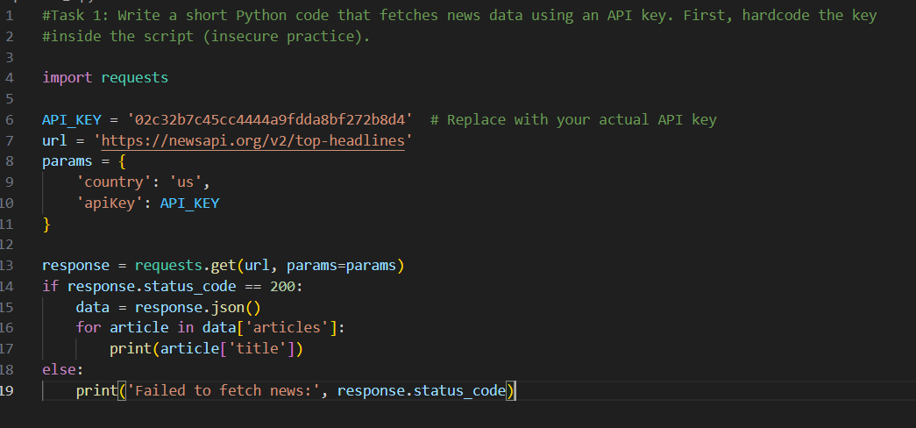

**Output:**

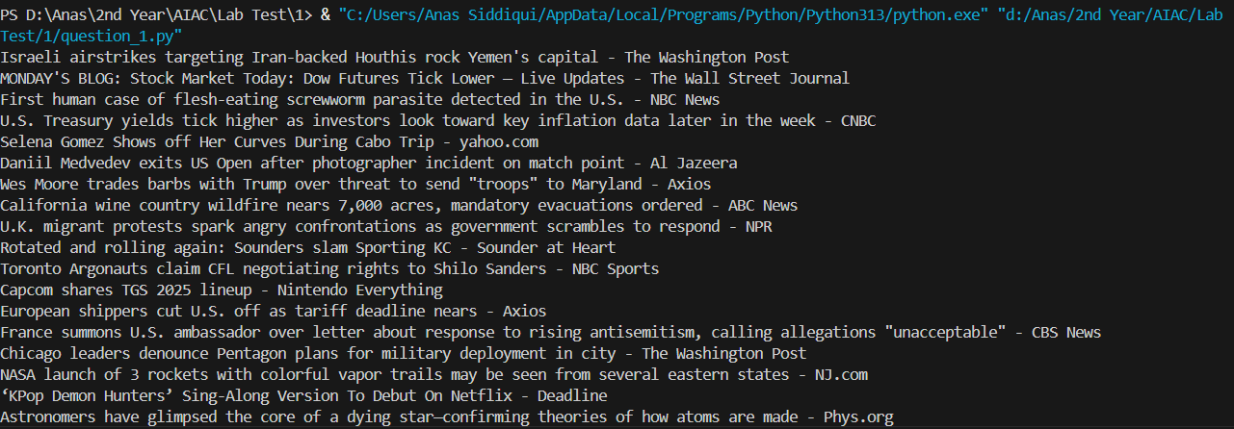

**Observation:** I provided the API key, and the git hub copilot quickly generated the rest of the code, and the output is as expected.

**Task 2:** Modify the same code to fetch the API key securely from environment variables. Explain  
why this method is more responsible and safer.

**Prompt:** Modify the code to fetch API key securely from environmental variables and explain why it is safer and more responsible.

**Code:**

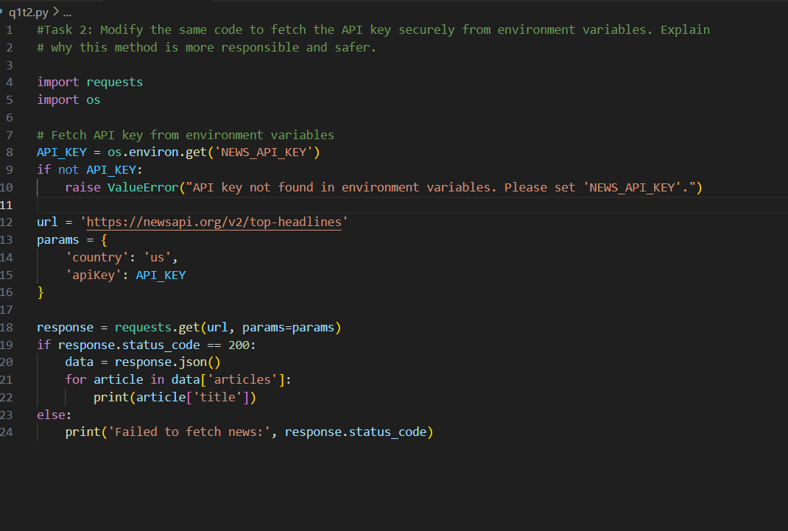

**Output:**



**Observation:** Fetching the API key from environment variables is safer and more responsible because it prevents sensitive info from being hardcoded into your source code.

**Q2)**

**Task 1:** Design a safe prompt that ensures AI responds with:  
• General advice only.  
• A disclaimer recommending consultation with a doctor.

**Prompt:** Write a code that gives the user a general and a disclaimer recommending consultation with a doctor.

**Code:**

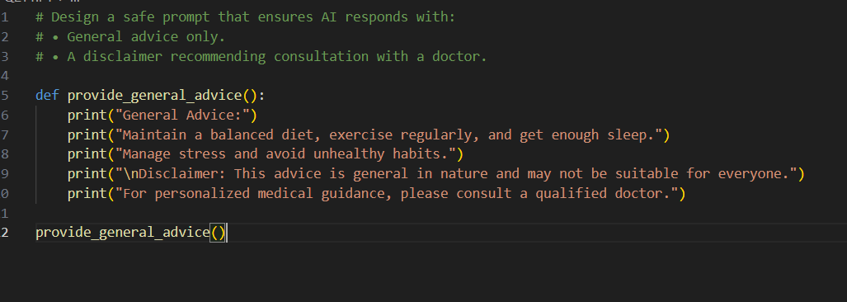

**Output:**

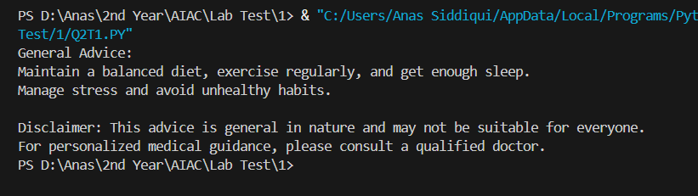

**Observation:** Copilot quickly gave me the code which gives the user a general advice and Disclaimer recommending consultation with doctor.

**Task 2:** Write a prompt that generates a 7-day travel itinerary for Delhi considering budget and  
weather.

**Prompt:** write a code which generates 7 Day travel itinerary for Delhi considering budget and weather.

**Code:**

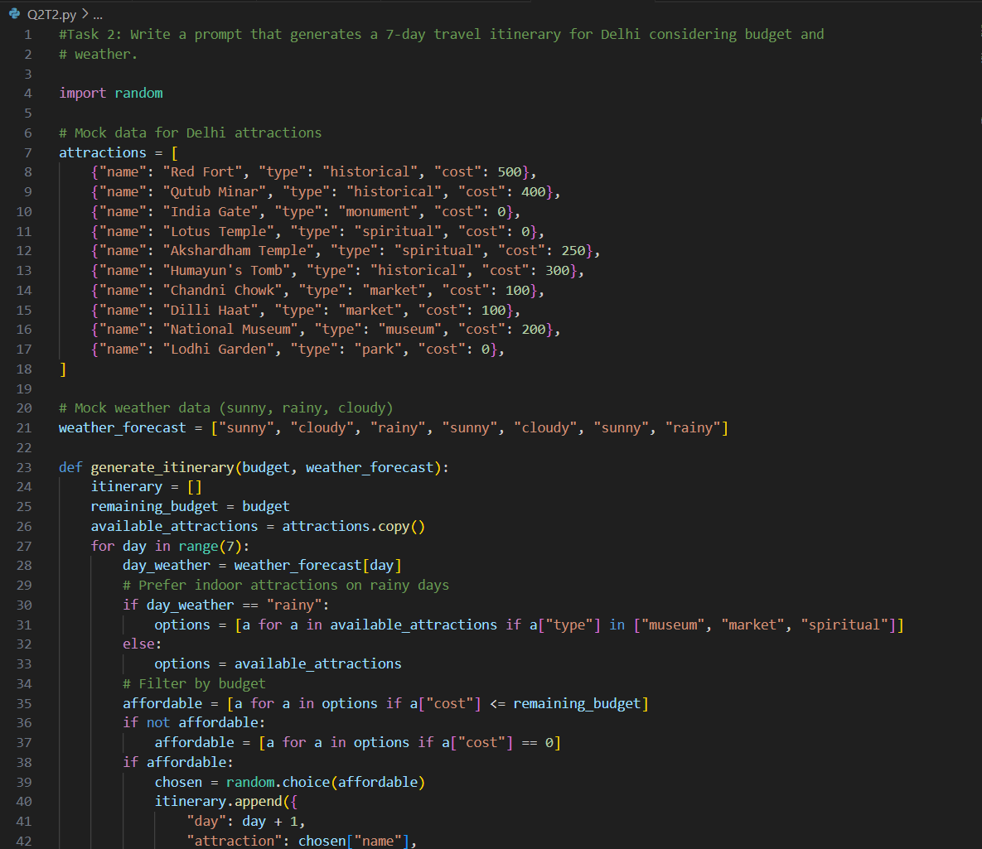

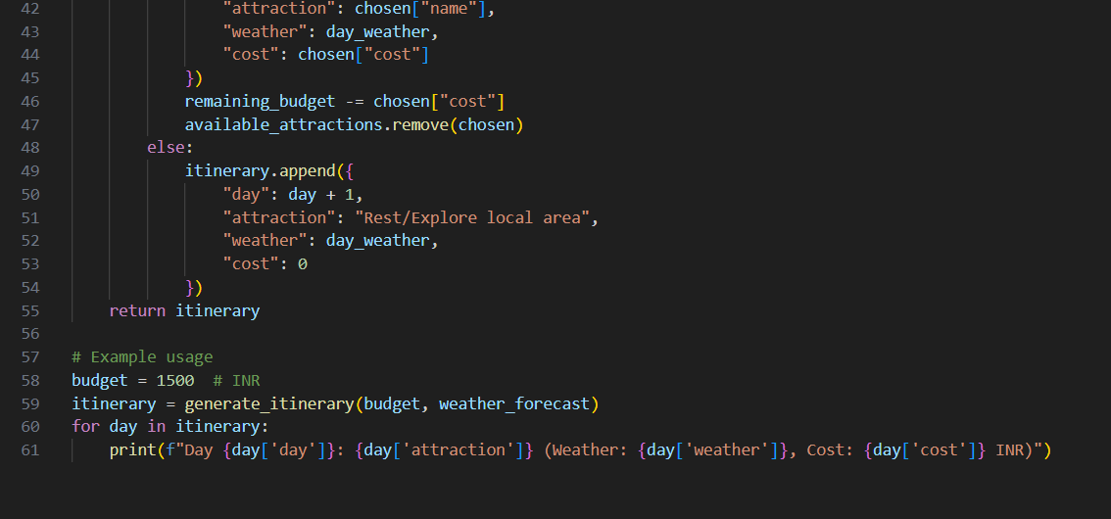

**Output:**

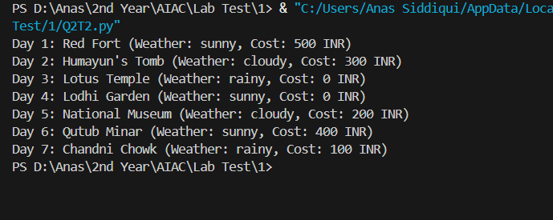

**Observation:** Copilot generated the code for 7 Day travel itinerary for Delhi which considers a given budget and weather.