**ASK**

|  |  |
| --- | --- |
| Using Matlab  clear all;  clc;  close all;  fc = 100;  fm = 10;  amp = 3;  t = 0: 0.001: 1;  %Carrier Sine wave  c = amp .* sin(2*pi*fc*t);  %message  m = amp/2 .* square(2*pi*fm*t) + (amp/2);  y = c .* m;  subplot(3,1,1);  plot(t, c);  xlabel('Time');  ylabel('Amplitude');  title('Carrier');  grid on;  subplot(3,1,2);  plot(t, m);  xlabel('Time');  ylabel('Amplitude');  title('Message');  grid on;  subplot(3,1,3);  plot(t, y);  xlabel('Time');  ylabel('Amplitude');  title('ASK Signal');  grid on; | Using python  import matplotlib.pylab as plt  import numpy as num  F1 = 20; F2 = 5;A = 3  t = num.arange(0, 1, 0.001)  x = A*num.sin(2*num.pi*F1*t)  u = []  b = [0.2, 0.4, 0.6, 0.8, 1.0]  s = 1  for i in t:  if(i == b[0]):  b.pop(0)  if(s == 0):  s = 1  else:  s = 0  u.append(s)  v = []  for i in range(len(t)):  v.append(A*num.sin(2*num.pi*F1*t[i])*u[i])  plt.plot(t, x)  plt.xlabel('Time')  plt.ylabel('Amplitude')  plt.title('Carrier')  plt.grid(True)  plt.show()  plt.plot(t, u)  plt.xlabel('Time')  plt.ylabel('Amplitude')  plt.title('Square wave Pulses')  plt.grid(True)  plt.show()  plt.plot(t, v)  plt.xlabel('Time')  plt.ylabel('Amplitude')  plt.title('ASK Signal')  plt.grid(True)  plt.show() |

Output:

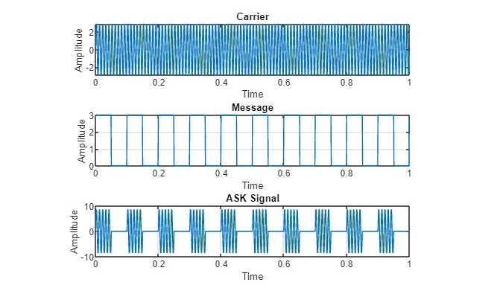

**FSK**

|  |  |
| --- | --- |
| 1. Using Matlab 2. clear all; clc; close all;   fc = 20;  fm = 2;  amp = 1; %Amplitude  t = 0: 0.001: 1;  %Carrier Sine wave  c = amp.* sin(2*pi*fc*t);  %message  m = amp/2.* square(2*pi*fm*t) + (amp/2);  %FSK signal  y = amp.* sin(2*pi*fc*(m+1).*t);  subplot(3,1,1);  plot(t, c);  xlabel('Time');  ylabel('Amplitude');  title('Carrier');  grid on;  subplot(3,1,2);  plot(t, m);  xlabel('Time');  ylabel('Amplitude');  title('Message');  grid on;  subplot(3,1,3);  plot(t, y);  xlabel('Time');  ylabel('Amplitude');  title('FSK Signal');  grid on; | Using Python  import matplotlib.pylab as plt  import numpy as num  fm = 1  fc = 25  mi = 10  t = num.arange(0, 1, 0.001)  m = num.sin(2*num.pi*fm*t)  plt.plot(t, m)  plt.xlabel('Time')  plt.ylabel('Amplitude')  plt.title('Message Signal')  plt.grid(True)  plt.show()  c = num.sin(2*num.pi*fc*t)  plt.plot(t, c)  plt.xlabel('Time')  plt.ylabel('Amplitude')  plt.title('Carrier Signal')  plt.grid(True)  plt.show()  y=num.sin(2*num.pi*fc*t+(mi*num.sin(2*num.pi*fm*t)))  plt.plot(t, y)  plt.xlabel('Time')  plt.ylabel('Amplitude')  plt.title('FSK Signal')  plt.grid(True)  plt.show() |

Output:

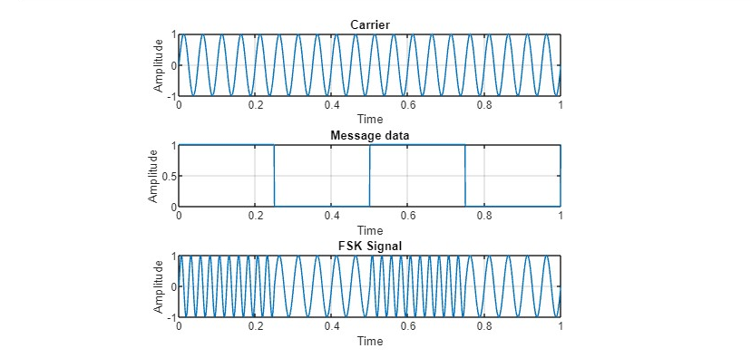

**PSK**

|  |  |
| --- | --- |
| Using Matlab  clear all;  clc;  close all;  fc = 20;  fm = 2;  amp = 1; t = 0: 0.001: 1;  c = amp .* sin(2*pi*fc*t);  m = amp/2 .* square(2*pi*fm*t) + (amp/2);  y = amp .* sin(2*pi*fc*t + pi*m);  subplot(3,1,1);  plot(t, c);  xlabel('Time');  ylabel('Amplitude');  title('Carrier');  grid on;  subplot(3,1,2);  plot(t, m);  xlabel('Time');  ylabel('Amplitude');  title('Message data');  grid on;  subplot(3,1,3);  plot(t, y);  xlabel('Time');  ylabel('Amplitude');  title('PSK Signal');  grid on; | Using Python  import matplotlib.pyplot as plt  import numpy as num  A = 5  t = num.arange(0, 1, 0.001)  f1 = 20  f2 = 2  x = A*num.sin(2*num.pi*f1*t)  plt.plot(t, x)  plt.xlabel("time")  plt.ylabel("Amplitude")  plt.title("Carrier")  plt.grid(True)  plt.show()  u = []  b = [0.2, 0.4, 0.6, 0.8, 1.0]  s = 1  for i in t:  if(i == b[0]):  b.pop(0)  if(s == 0):  s = 1  else:  s = 0  u.append(s)  plt.plot(t, u)  plt.xlabel('time')  plt.ylabel('Amplitude')  plt.title('Message Signal')  plt.grid(True)  plt.show()  v = []  for i in range(len(t)):  if(u[i] == 1):  v.append(A*num.sin(2*num.pi*f1*t[i]))  else:  v.append(A*num.sin(2*num.pi*f1*t[i])*-1)  plt.plot(t, v)  plt.xlabel("t")  plt.ylabel("y")  plt.title("PSK")  plt.grid(True)  plt.show() |

Output:

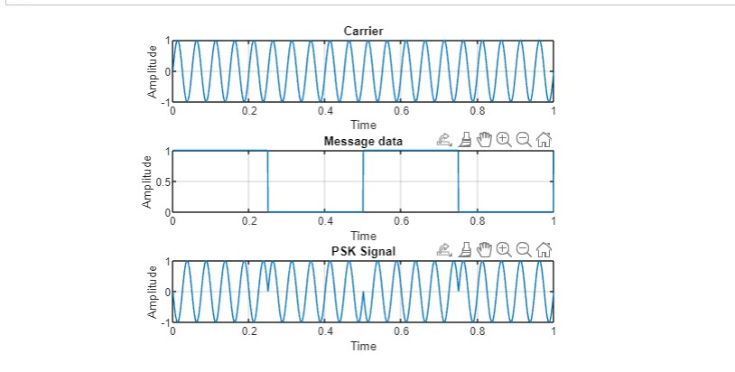

1. QAM

Using Martlab

clear all;

clc;

close all;

fc = 2;

x = [0 1 2 3 4 5 6 7 2 4 3 1 0];

nx = size(x, 2);

amp1 = 1;

amp2 = 2;

i = 1;

while i < nx+1

t = i: 0.0001: i+1;

if mod (x(i), 2) == 0

qam = amp1 .* sin(2*pi*fc*t + (pi/4)*x(i));

else

qam = amp2 .* sin(2*pi*fc*t + (pi/4)*(x(i)-1));

end

plot (t, qam);

hold on;

grid on;

% axis([1 10 -1 1]);

title('8-QAM');

xlabel('time');

ylabel('amplitude');

i = i+1;

end;