
PRT563 Advanced Data Management
Assessment 4: Group Project Report
Group: Syd_Group_09
Student Name | Student ID
Mohammed Nahid Hossain | s401546
Md Ashraful Islam | s397296
Udoy Saha Joy | s401428
Md Mehedi Hasan | s400862
GitHub Repository
https://github.com/MdAshrafulIslam1998/Syd_Group_09_PRT563_Assignment_4
Semester 2, 2026
Submission date: 16 October 2026

Table of Contents
Executive Summary 4
1. Introduction 5
2. Graph Database Modelling 5
2.1 Basic translation 5
2.2 Optimised model 6
3. Graph Database Implementation 8
3.1 Migration from SQLite 8
3.2 Checking the migration 9
4. Graph Database Queries 10
4.1 Query 1 (simple): Deliveries still on the way 10
4.2 Query 2 (moderate): Low-stock reorder list 11
4.3 Query 3 (complex): Weekly sales by aisle 12
4.4 Query 4 (complex): Why did the shelf run low? 13
5. Centrality Algorithms 14
5.1 Use case 14
5.2 Graph and algorithms 14
5.3 Results and comparison 15
5.4 Recommendation 16
6. Similarity Algorithms 16
6.1 Use case 16
6.2 Graph and algorithms 17
6.3 Results and comparison 17
6.4 Recommendation 19
7. Teamwork 20
8. Discussion and Limitations 21
9. Conclusion 21
References 22
Individual Contributions 23

List of Figures
Figure 1: Basic graph model translated directly from the EER model (Model A) 6
Figure 2: Optimised graph model built in Neo4j (Model B) 8
Figure 3: Neo4j Desktop after running import.txt 9
Figure 4: Schema of the database in Neo4j 10
Figure 5: Constraints and indexes created by import.txt 10
Figure 6: Query 1 and its result 11
Figure 7: Query 2 and its result 12
Figure 8: Query 3 and its result 12
Figure 9: Query 4 and the first part of its result 13
Figure 10: Query 4, second part of the result 14
Figure 11: The six centrality algorithms run in Neo4j 15
Figure 12: Centrality scores of the top 15 products 15
Figure 13: Comparison of the centrality algorithms in Neo4j 16
Figure 14: Agreement of each algorithm with basket value at risk 16
Figure 15: The four similarity algorithms run in Neo4j 17
Figure 16: Look-alikes of member M0002 from each algorithm 18
Figure 17: Accuracy of the similarity algorithms in Neo4j 18
Figure 18: Precision at 5 of each similarity algorithm 19
Figure 19: Suggested offers for member M0002 19
Figure 20: Our WhatsApp group with all four members 20
Figure 21: Group Colaboration 20

Executive Summary
In Assessment 2 our group designed a relational database for store operations at Woolworths. In this assessment we moved that database to Neo4j. We first translated the EER model into a basic graph model and then improved it, for example by storing sale lines and stock levels as relationships with properties instead of separate nodes. All 23 tables were loaded from CSV files with Cypher scripts, and the counts in Neo4j matched the original database. We wrote four queries for real store situations, from a simple delivery check to a query that explains why a shelf ran low. We also tested six centrality algorithms to find the products that matter most in customer baskets, and four similarity algorithms to find loyalty members who shop alike. Weighted degree and Jaccard similarity gave the best results for our use cases.

1. Introduction
Woolworths is one of the largest supermarket chains in Australia. In Assessments 1 and 2 our group looked at store operations: the stock on the shelf, orders and deliveries, staff shifts, sales and wastage. The main problem we found is that this information is kept in separate systems. Because of this, the stock on hand in the system often does not match the shelf, and when a product runs out the store cannot easily tell whether it was caused by a late delivery or by higher demand. In Assessment 2 we built a relational database in SQLite to bring these records together.
As the company grows, it wants to move this database to Neo4j. A graph database suits this data well because most questions follow links between records, for example from a shelf to its orders, deliveries and sales. In a relational database each of these links needs a join, while in a graph database the links are stored directly and can be followed quickly (Robinson et al., 2015). Neo4j also includes the Graph Data Science (GDS) library, which we used for the analytics tasks (Needham & Hodler, 2019).
We used Neo4j Desktop 2.2.1 with Neo4j 2026.09 and GDS 2026.09. All our scripts, CSV files and queries are in our GitHub repository: https://github.com/MdAshrafulIslam1998/Syd_Group_09_PRT563_Assignment_4. The rest of the report follows the five tasks: graph modelling, implementation, queries, centrality algorithms and similarity algorithms.
Changes to the Assessment 2 database. The brief allows changes as long as they are explained. We made two:
- More sample data. The Assessment 2 database had only 12 sales and 6 loyalty members, which is too small for the graph algorithms to show anything useful. We kept every Assessment 2 row and used a small Python script to add made-up records for 7 to 20 September 2026. For example, sales went from 12 to 384, loyalty members from 6 to 50 and products from 15 to 36. The new rows follow the same rules and constraints as Assessment 2. All of this data is fictional.
- Trading hours. Assessment 2 only had trading hours for Monday, Saturday and Sunday, so we added Tuesday to Friday.

2. Graph Database Modelling

2.1 Basic translation
We started with a direct translation of our EER model using the usual conversion rules (Elmasri & Navathe, 2016; Robinson et al., 2015). Each table became a node label, each column became a property, each primary key became a unique property, and each foreign key became a relationship. Figure 1 shows this basic model (Model A).
The basic model works, but it has many in-between nodes such as SaleLine, DeliveryLine, StockHolding and Consignor. These nodes only exist to connect other nodes, so most queries need extra steps. For example, to get from a sale to its products a query has to go through the sale line node first.
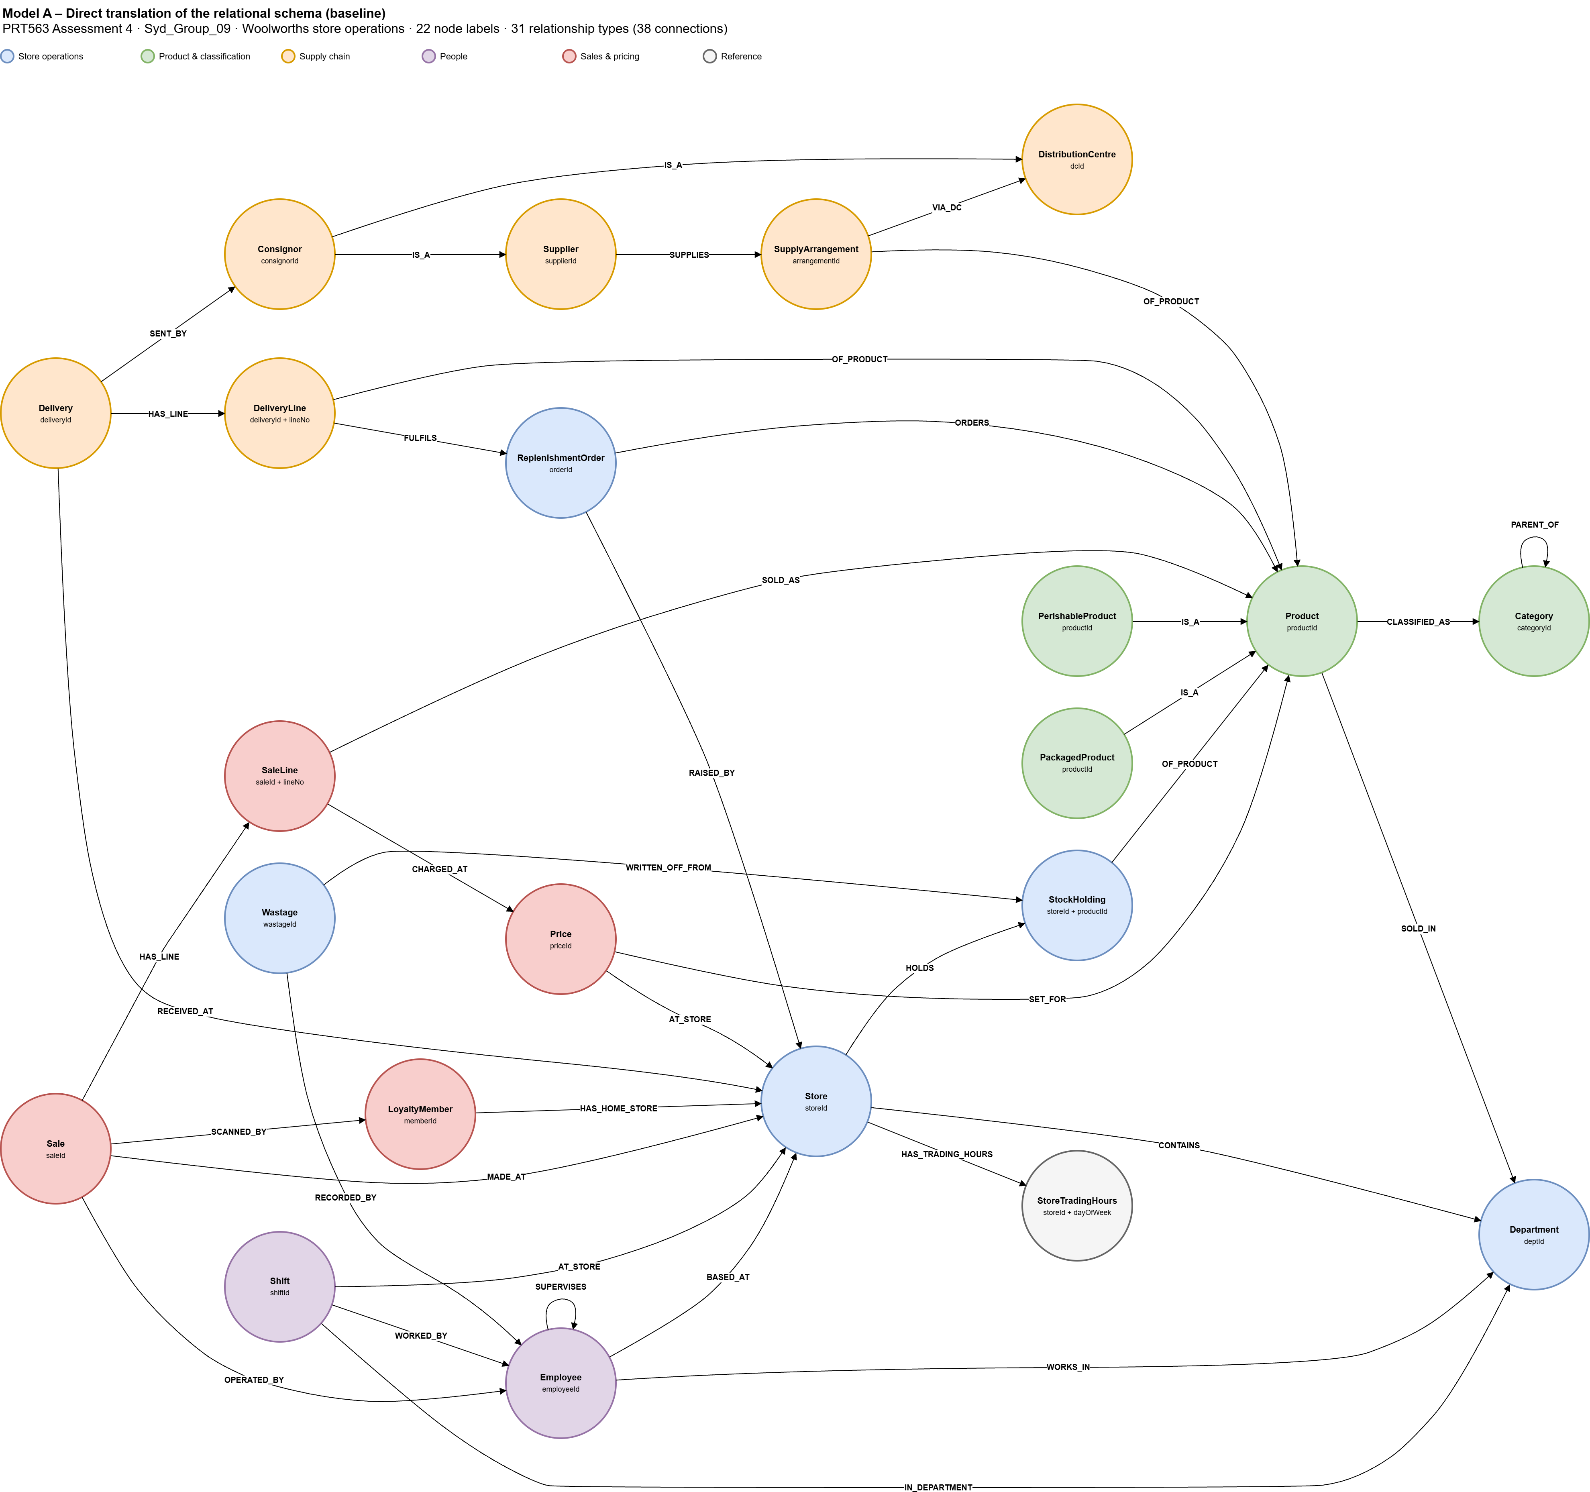
Figure 1: Basic graph model translated directly from the EER model (Model A)

2.2 Optimised model
We then improved the model so that it fits the questions the store actually asks. Table 1 lists the main changes, and Figure 2 shows the final model that we built in Neo4j (Model B).
Table 1: Changes from the basic model to the optimised model
EER element (Assessment 2) | Basic model (A) | Optimised model (B) | Reason
PERISHABLE_PRODUCT and PACKAGED_PRODUCT (specialisation) | Separate nodes linked by IS_A | Extra labels :Perishable and :Packaged on Product | A product is only ever one type, so a label is enough
CONSIGNOR (category of supplier or DC) | Consignor node linked to Supplier or DC | :Consignor label on Supplier and DistributionCentre | Deliveries can link straight to the sender
SALE_LINE and DELIVERY_LINE (weak entities) | Line nodes | SOLD and DELIVERED relationships with line number and quantity | A line only links a sale or delivery to a product
STOCK_HOLDING (aggregation) | StockHolding node | HOLDS relationship from Store to Product with the stock properties | Stock belongs to one store and one product
STORE_TRADING_HOURS (multivalued attribute) | StoreTradingHours nodes | OPEN_ON relationship to seven Day nodes | Opening and closing times sit on the relationship
SUPPLY_ARRANGEMENT (ternary relationship) | Node | Kept as a node | It links three nodes, and a relationship can only link two

Other parts stayed the same, such as the recursive relationships PARENT_OF (category hierarchy) and SUPERVISES (manager to employee). Relationship names are written as verbs, for example MADE_AT and RECEIVED_AT, and they point from the detail record to the main record. With these changes the optimised model holds the same data in 1,146 nodes instead of 2,690, which is 57% fewer, and a sale is now one step away from its products instead of two.
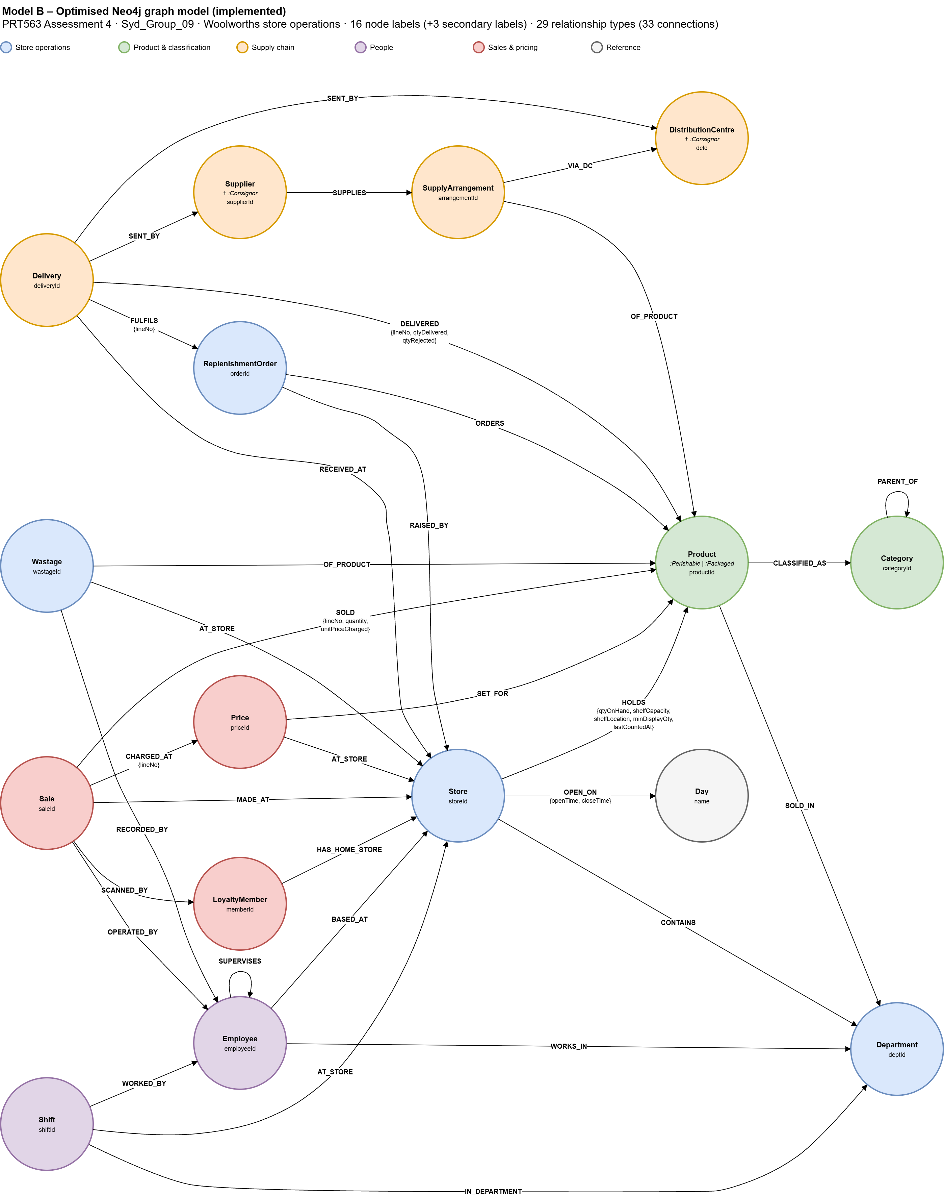
Figure 2: Optimised graph model built in Neo4j (Model B)

3. Graph Database Implementation

3.1 Migration from SQLite
We rebuilt the SQLite database from our Assessment 2 script and the extra data, and exported each of the 23 tables to its own CSV file. The CSV files were copied into the import folder of the Neo4j instance. The script import.txt then loads everything in four parts, using LOAD CSV and MERGE (Neo4j, n.d.-a):
- Constraints. One uniqueness constraint for each primary key (18 in total). These stop duplicate records and also create an index on each key, which makes the later steps faster.
- Indexes. Twelve extra indexes on properties that the queries filter on, such as the sale date, order status, delivery status and product description (Figure 5).
- Nodes. One LOAD CSV step for each table creates the nodes. Values are converted to the right type, for example dates with date() and numbers with toInteger(). The two product subtypes are added as extra labels.
- Relationships. One LOAD CSV step for each foreign key matches the two nodes and creates the relationship. For the optimised parts, the values are stored on the relationship, as in the example below.
LOAD CSV WITH HEADERS FROM 'file:///sale_line.csv' AS row
MATCH (sa:Sale {saleId: row.SaleID})
MATCH (p:Product {productId: row.ProductID})
MERGE (sa)-[r:SOLD {lineNo: toInteger(row.LineNo)}]->(p)
SET r.quantity = toInteger(row.Quantity),
r.unitPriceCharged = toFloat(row.UnitPriceCharged);
Because the script uses MERGE, running it a second time does not create any duplicates. We tested this and the counts stayed the same.

3.2 Checking the migration
After running the script, Neo4j showed 1,146 nodes and 5,285 relationships (Figure 3), and the schema in Figure 4 matches our optimised model. We also compared Neo4j with SQLite for every label and relationship type, and checked totals such as total sales revenue ($9,375.90) and total stock on hand (4,038 units). All of the checks matched, so all the data was moved across correctly.
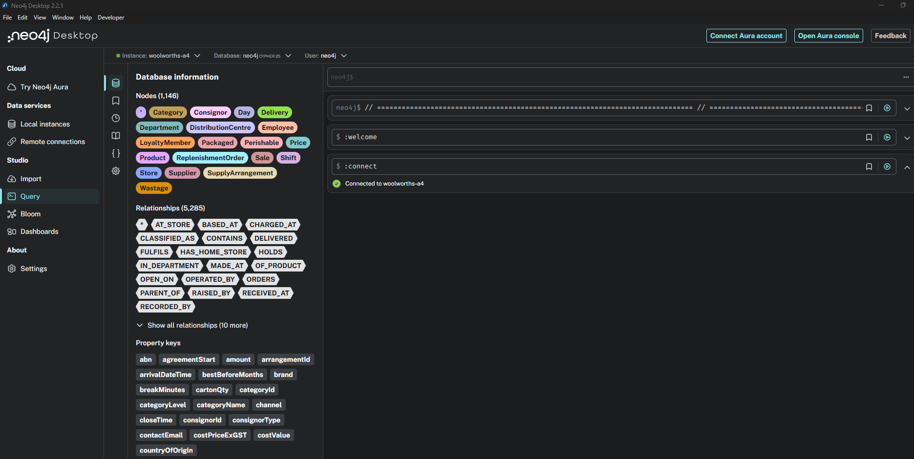
Figure 3: Neo4j Desktop after running import.txt
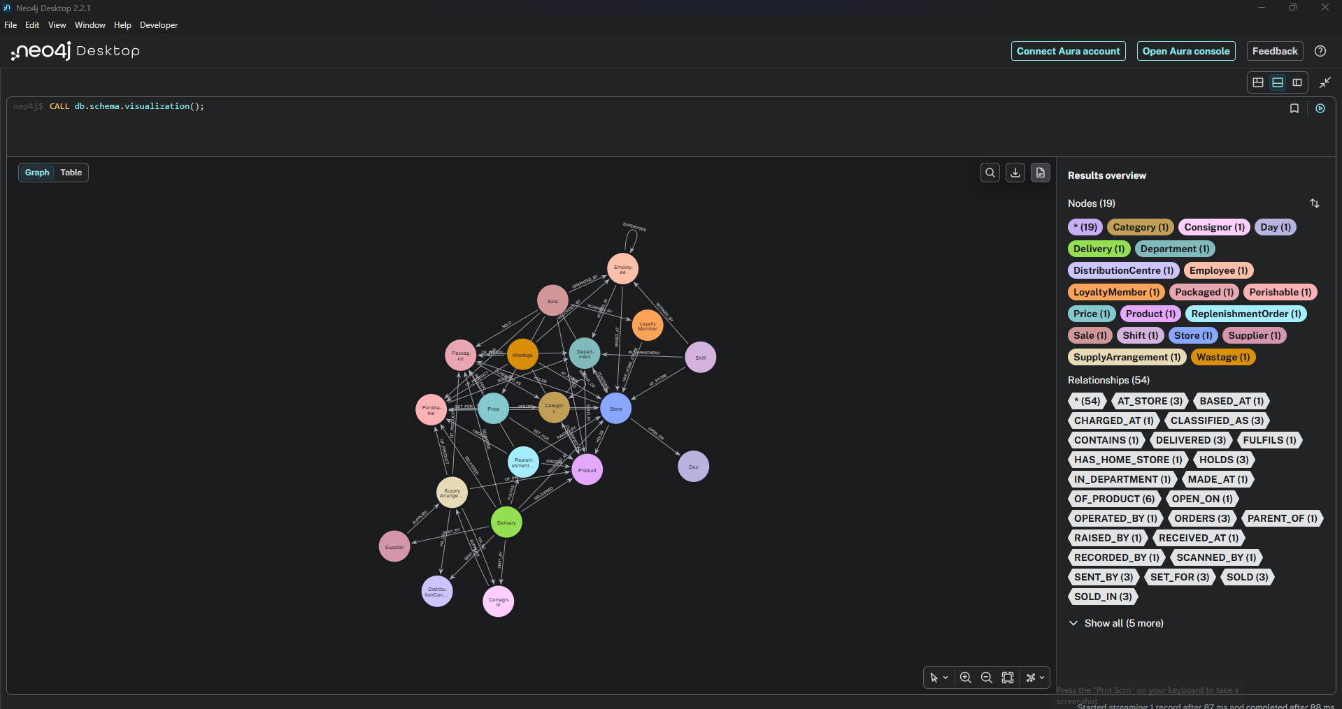
Figure 4: Schema of the database in Neo4j
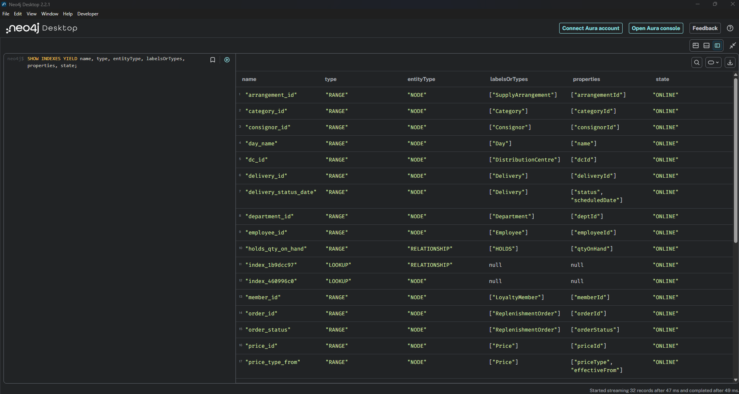
Figure 5: Constraints and indexes created by import.txt

4. Graph Database Queries
We wrote four queries based on real situations in a store, starting simple and getting more complex. The full queries are in queries.txt in our repository. We used 20 September 2026 as "today" because it is the last day in our data.

4.1 Query 1 (simple): Deliveries still on the way
Scenario. At the start of a shift the duty manager wants to know which deliveries are still on the way, for which store, how many cartons they carry, and whether they come from a distribution centre or straight from a supplier. This helps plan staff for the receiving dock.
Query. This is a single MATCH pattern with a property filter. Because suppliers and distribution centres both have the :Consignor label, one pattern finds both, and a CASE with a label check shows which one sent the delivery.
Result. Twelve deliveries are still on the way (Figure 6). Two of them, DLV004 and DLV007 for St Ives, were due on 6 September, so they are very late.
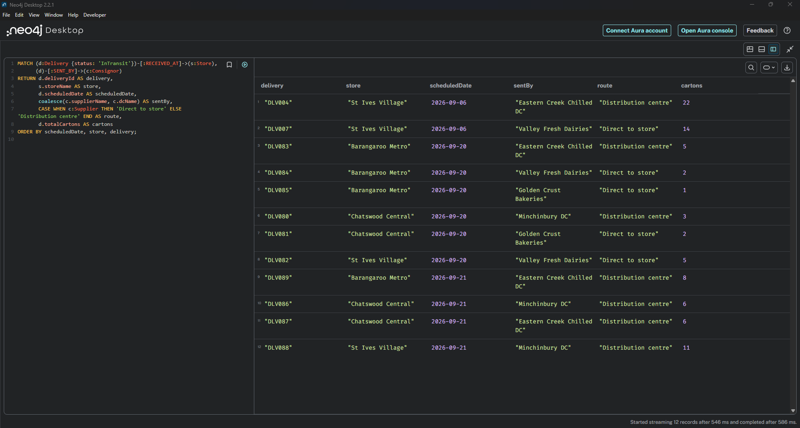
Figure 6: Query 1 and its result

4.2 Query 2 (moderate): Low-stock reorder list
Scenario. The store wants a reorder list for every product that is below its minimum display quantity. The list shows how many cartons to order to fill the shelf, the cost, the supplier and the expected arrival date. It also shows if an order is already open, so the store does not order twice.
Query. The query follows the path from the store to the product, the supply arrangement, the supplier and the distribution centre. It uses ceil() to round up the number of cartons, duration() to work out the arrival date, and an EXISTS subquery to look for open orders.
Result. Fifteen products are below their minimum (Figure 7). Four of them already have an open order, so the store only needs to place 11 new orders.
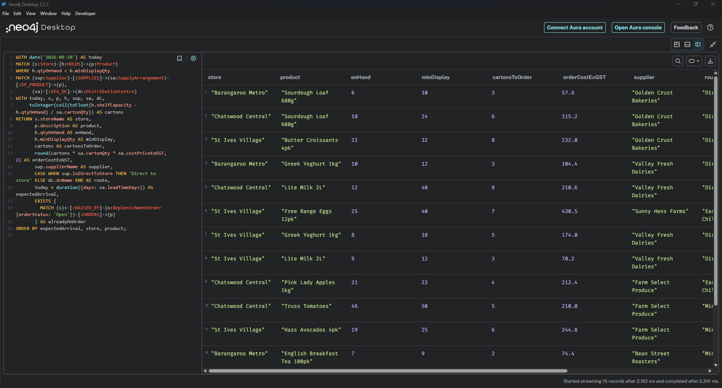
Figure 7: Query 2 and its result

4.3 Query 3 (complex): Weekly sales by aisle
Scenario. The category manager wants to see weekly sales for each aisle, how much of those sales came from promotions and markdowns, and the change from the week before.
Query. Products are linked to categories at different levels, so the query uses a variable-length path (-[:PARENT_OF]->{0,2}) to reach the aisle from any level. Sales are grouped by week with date.truncate(), and CASE is used inside sum() to separate promotion and markdown sales. Cypher does not have window functions, so the weeks are collected into a list and each week is compared with the one before it.
Result. Dairy is the biggest aisle but dropped by 15.4% in the second week. Pantry relies the most on promotions, with about 22% to 24% of its sales on promotion, and it fell by 27.5%. Frozen and Fresh Produce both grew (Figure 8).
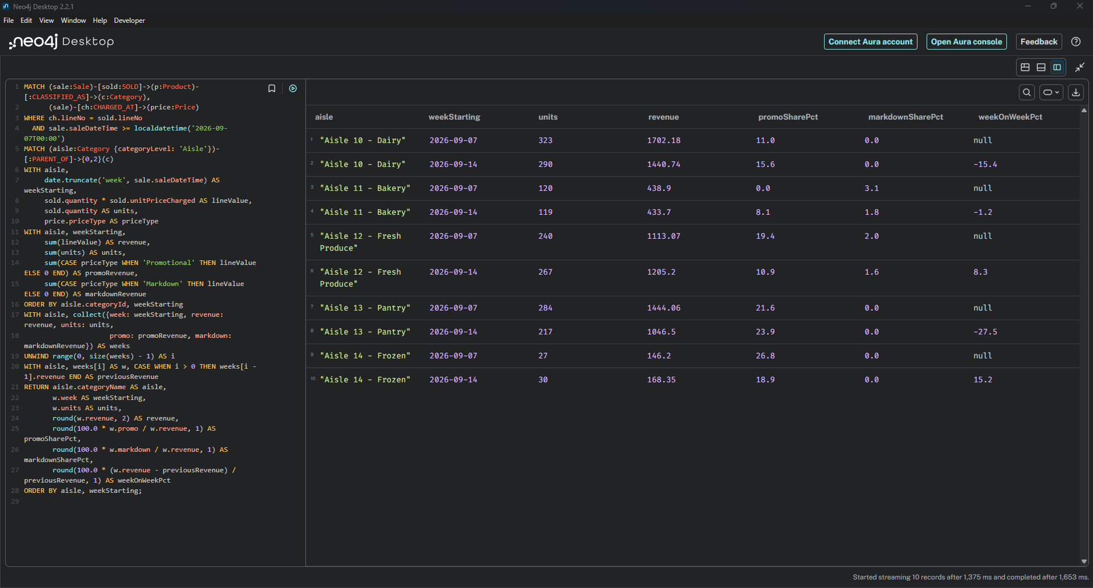
Figure 8: Query 3 and its result

4.4 Query 4 (complex): Why did the shelf run low?
Scenario. This is the main business problem from Assessment 1. For each product below its minimum display quantity, the store wants to know the most likely reason: a late delivery, a short or rejected delivery, no order being placed, high wastage, demand higher than supply, an old stock count, or stock that is missing for no clear reason.
Query. Four CALL subqueries add up the units sold, the units received, the units wasted and the orders for each store and product. Running them separately stops the totals from being multiplied by each other. A CASE then picks the most likely reason using simple rules, checked in order.
Result. The query found all of these reasons among the 15 products (Figures 9 and 10). For example, Greek yoghurt at St Ives is low because of the late delivery seen in Query 1, truss tomatoes at Chatswood lost 17 units to wastage, and English breakfast tea at Barangaroo sold 24 units but was never ordered. This is the kind of question the store could not answer while the data was spread across separate systems.
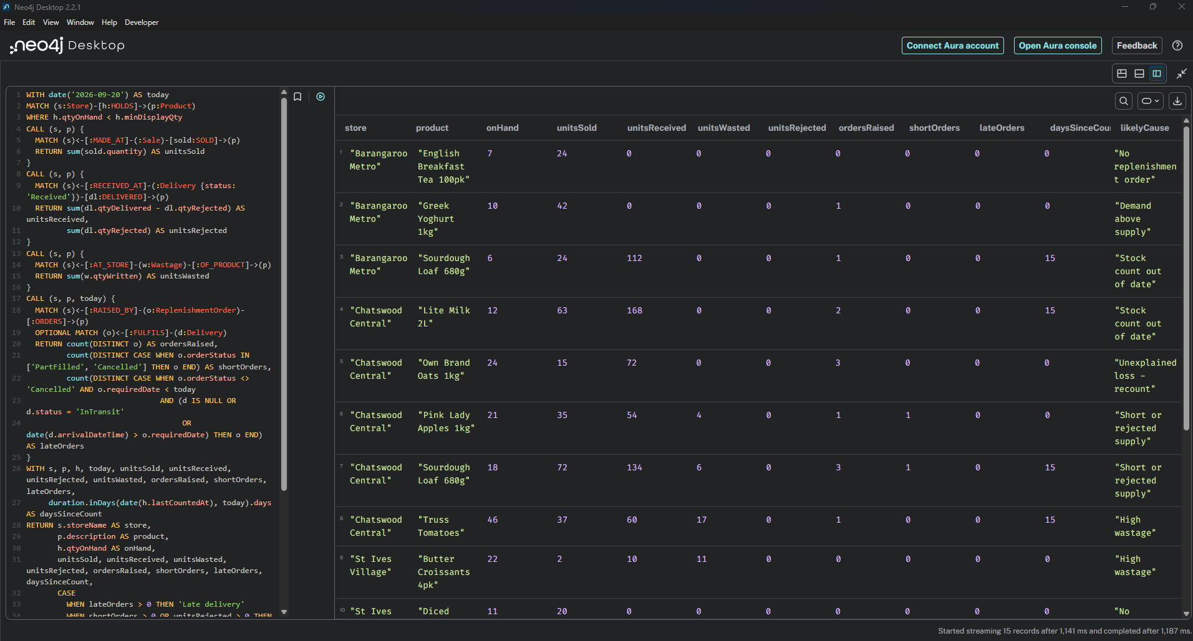
Figure 9: Query 4 and the first part of its result
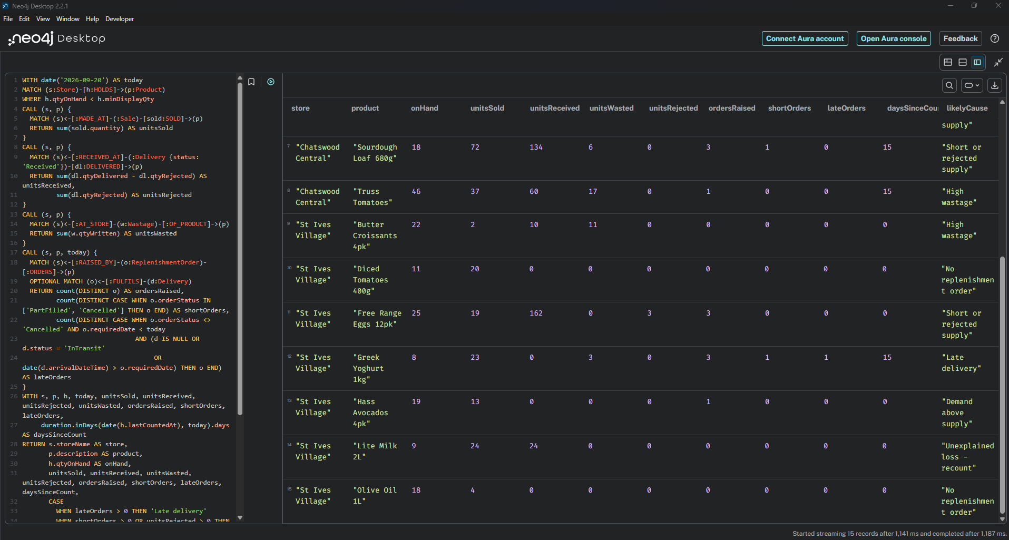
Figure 10: Query 4, second part of the result

5. Centrality Algorithms

5.1 Use case
Some products appear in most customer baskets. If one of them runs out, the whole shopping trip can be affected and the customer may go elsewhere. Our use case is to find these key products, so the store can give them priority when ordering and keep more of them on the shelf.

5.2 Graph and algorithms
We built a co-purchase graph in GDS. Each product is a node, and two products are linked if they were bought in the same sale. The weight of a link (together) is the number of sales that contained both products. This gave 36 products and 368 links. For the path-based algorithms we also made a smaller graph that only keeps the strong links (pairs bought together at least three times and more often than expected by chance), because in the full graph almost every product is directly linked to every other product.
We tried six centrality algorithms (Needham & Hodler, 2019; Neo4j, n.d.-b):
- Degree: how often a product was bought together with other products. It is simple and fast.
- PageRank: a product is important if it is linked to other important products.
- ArticleRank: a version of PageRank that reduces the influence of very popular neighbours.
- Eigenvector: a similar idea to PageRank, based on how well connected the neighbours are.
- Betweenness: how often a product lies on the shortest path between other products, which shows bridge products.
- Harmonic closeness: how close a product is to all the other products.
The first four used the full graph with the together weight, and the last two used the strong-link graph. All six were run in one statement and their scores were written to the Product nodes (Figure 11).
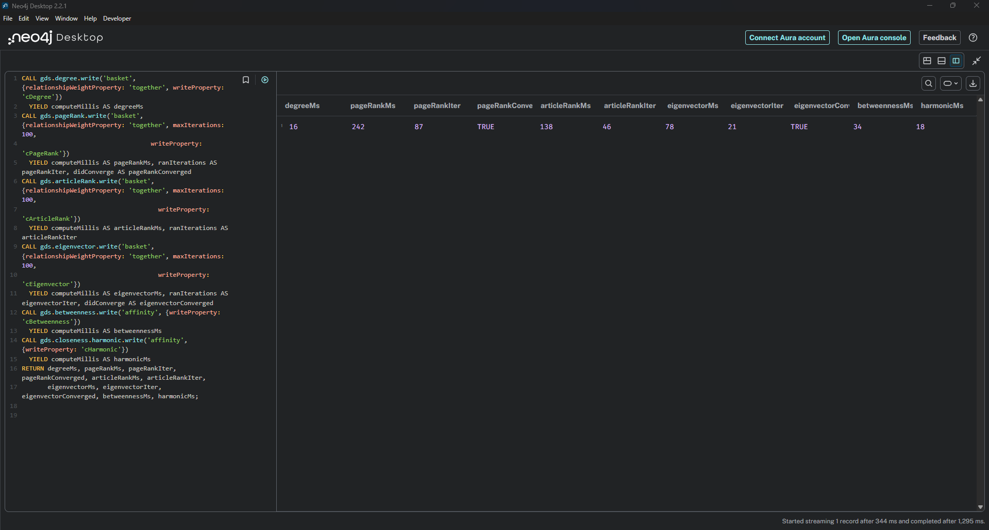
Figure 11: The six centrality algorithms run in Neo4j

5.3 Results and comparison
Figure 12 shows the scores. Degree, PageRank, ArticleRank and Eigenvector all put the same five products at the top: bananas, full cream milk, lite milk, sourdough and Greek yoghurt. Betweenness and harmonic closeness picked different products, such as own brand white bread, potatoes and carrots, which connect different kinds of shopping trips.
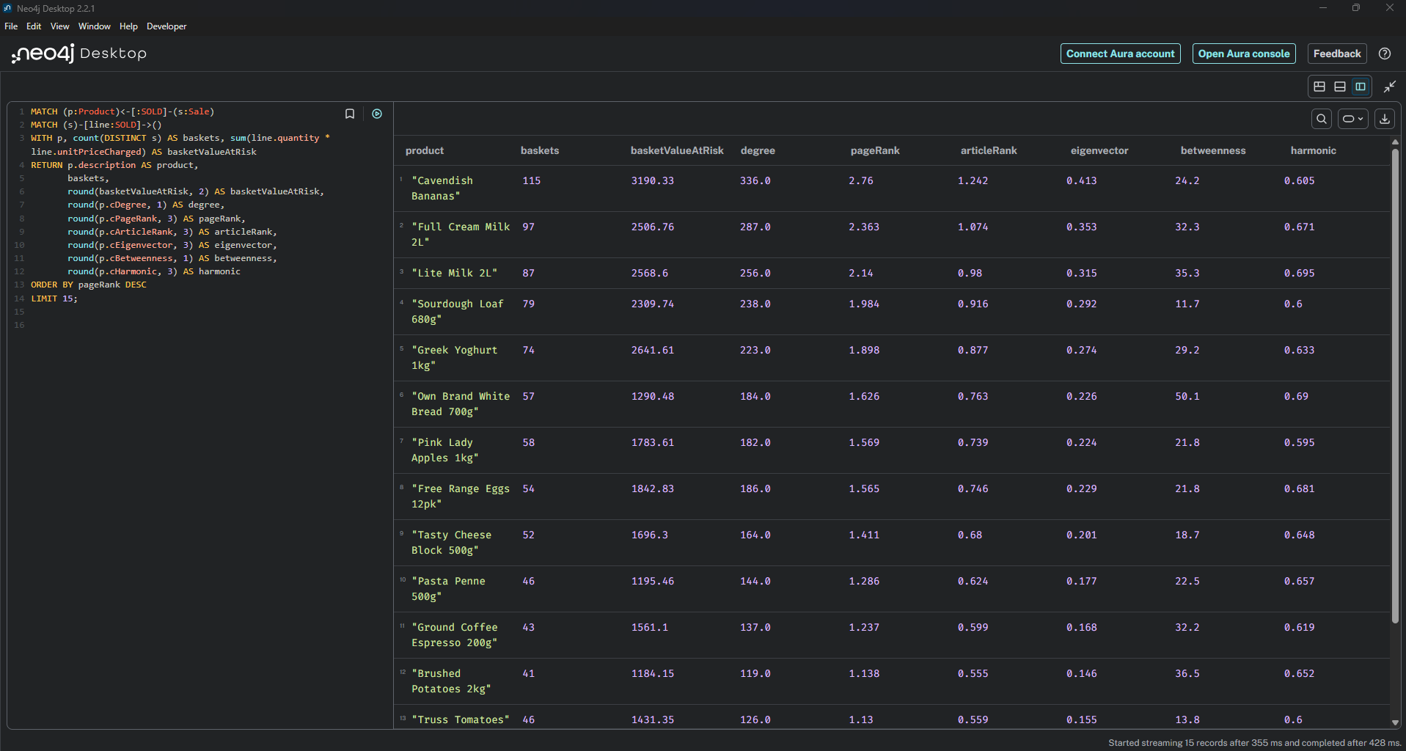
Figure 12: Centrality scores of the top 15 products
To compare the algorithms we used basket value at risk, which is the total value of all baskets that contain the product. This is the money at risk if the product is out of stock. We compared each ranking with it using Spearman rank correlation and counted how many of the top 10 products matched (Figures 13 and 14). The four weighted algorithms scored about 0.97 and matched 8 of the top 10. Betweenness (0.755) and harmonic closeness (0.738) scored lower because they measure something different.
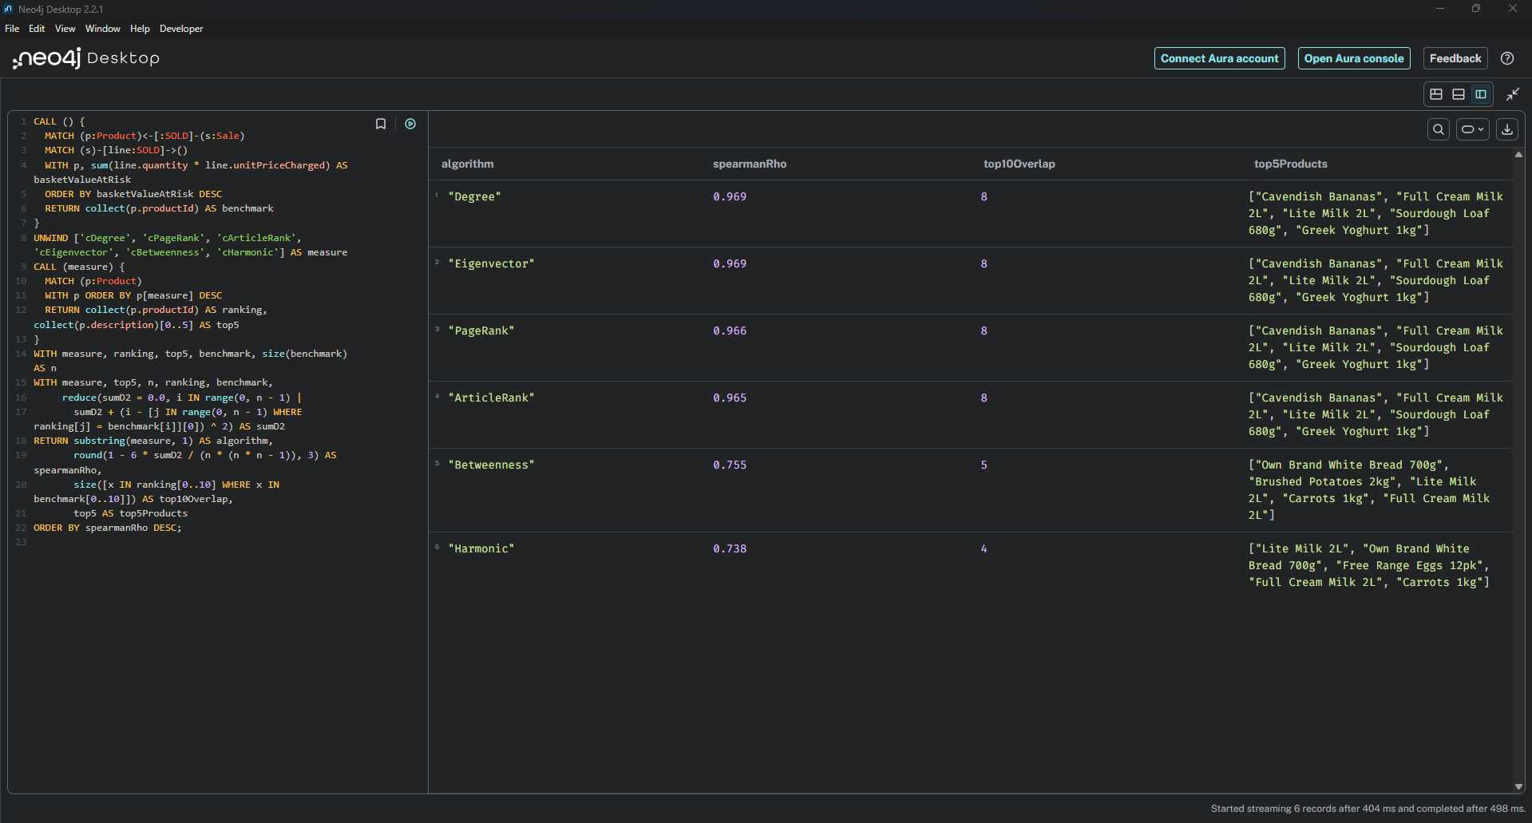
Figure 13: Comparison of the centrality algorithms in Neo4j
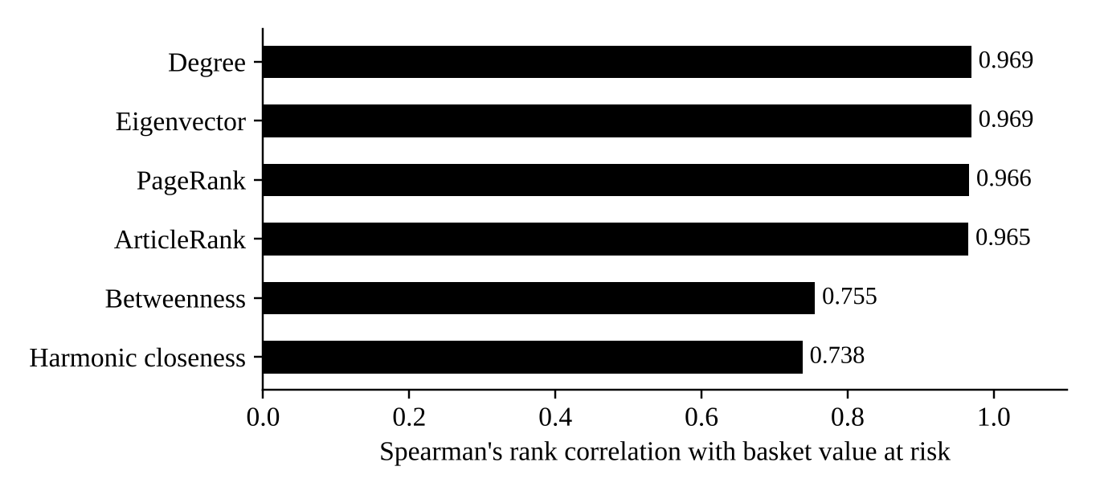
Figure 14: Agreement of each algorithm with basket value at risk

5.4 Recommendation
We recommend weighted degree for this use case. It was as accurate as PageRank, Eigenvector and ArticleRank, but it is the simplest and fastest, and store managers can easily understand it. PageRank did not add anything here because most products are bought together with most other products. Betweenness is still useful for a different purpose, for example deciding which products to place near each other in the store.

6. Similarity Algorithms

6.1 Use case
Loyalty programs such as Everyday Rewards send personalised offers to members. Members who buy similar things usually respond to similar offers. Our use case is to find, for each member, the five members who shop most like them, and then offer the products that these look-alike members buy but the member has not bought yet.

6.2 Graph and algorithms
We built a graph of 50 members and 36 products, with a BOUGHT link from each member to each product they bought, weighted by quantity. This gave 500 links. We compared four approaches (Neo4j, n.d.-b):
- Node Similarity with Jaccard: products in common divided by all the products bought by either member.
- Node Similarity with Overlap: products in common divided by the products of the member who bought fewer products.
- Node Similarity with Cosine: also takes into account how much of each product was bought.
- FastRP and KNN: FastRP turns each member into a vector (an embedding), and K-Nearest Neighbours then finds the closest members. It is approximate but works well on large data.
Each approach found the top five look-alikes for every member (Figure 15).
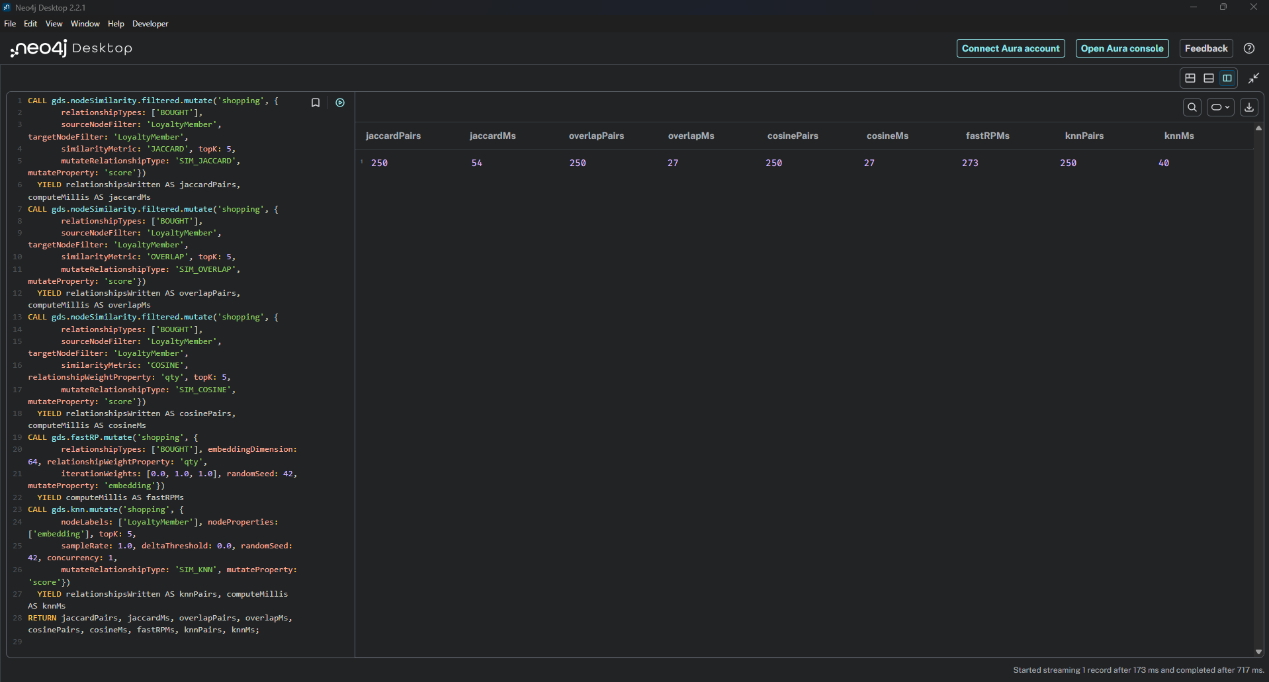
Figure 15: The four similarity algorithms run in Neo4j

6.3 Results and comparison
Figure 16 shows the look-alikes of member M0002 found by each algorithm. All four found members with the same breakfast-type shopping, but the lists and the scores were different. Overlap gave a score of 1.0 to some pairs only because one member’s products were a subset of the other’s, and the KNN scores were all close to 1, which makes them harder to use.
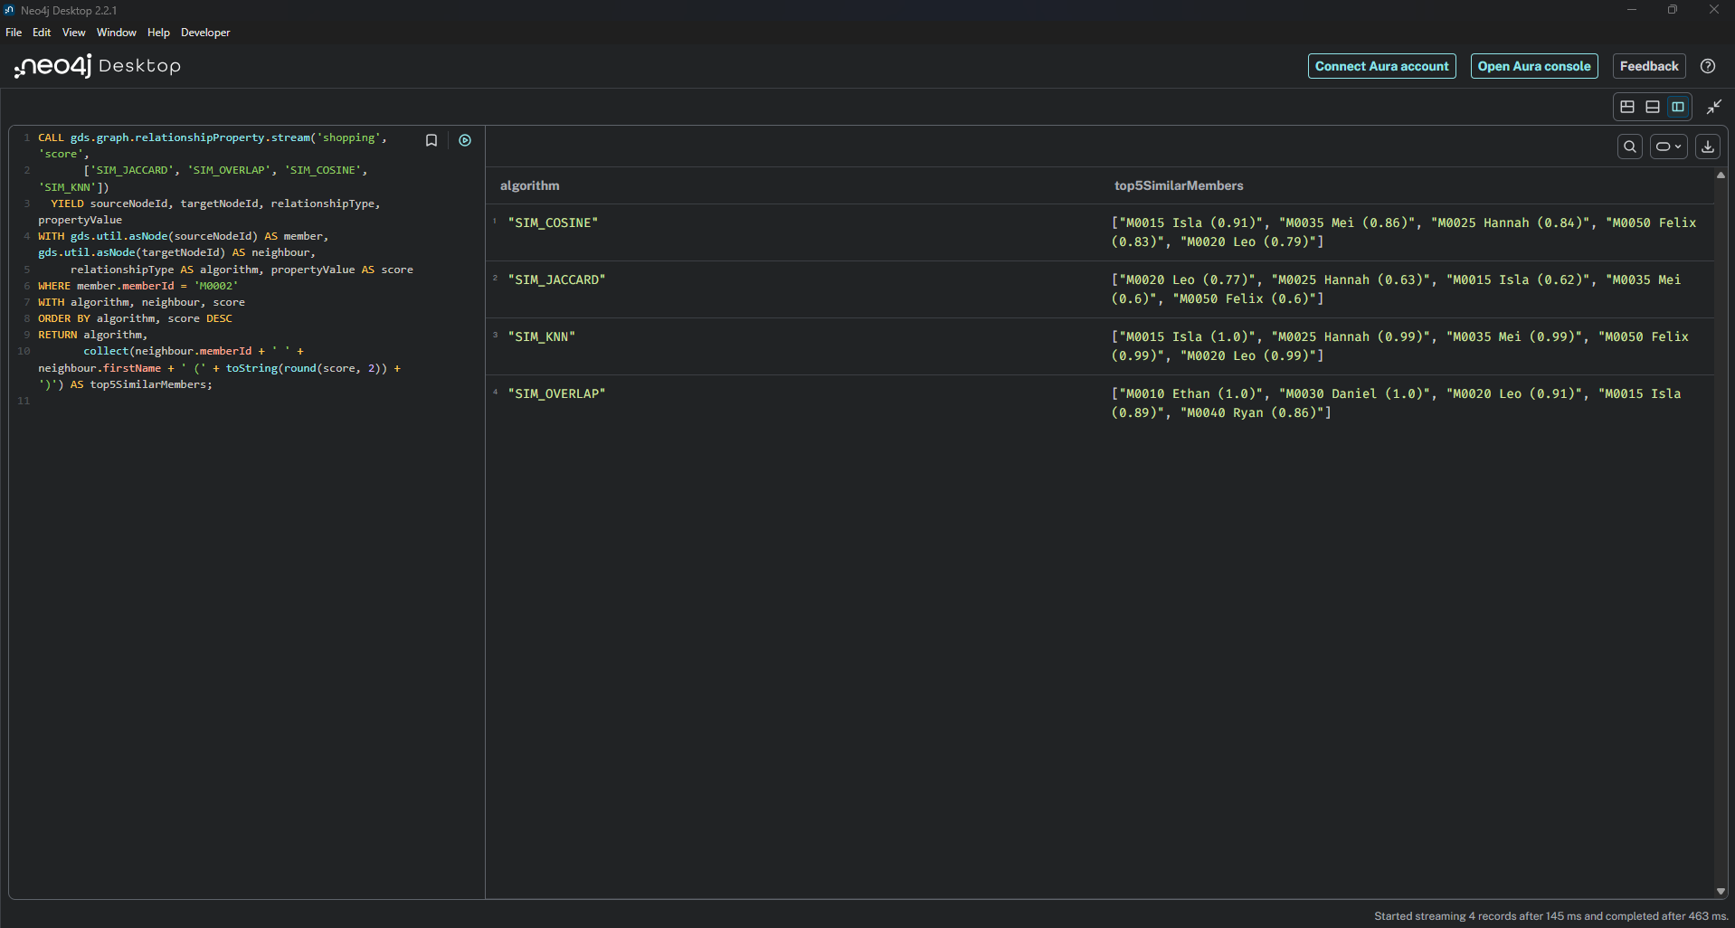
Figure 16: Look-alikes of member M0002 from each algorithm
To check accuracy we used the shopping style that the data script gave each member when it was created (for example breakfast, budget or family). This style is not stored in the database, so it gives a fair test. We measured precision at 5, which is the share of a member’s five look-alikes that have the same style as the member. A random guess would score 0.186. Jaccard scored 0.968, Overlap 0.952, FastRP and KNN 0.936, and Cosine 0.912 (Figures 17 and 18).
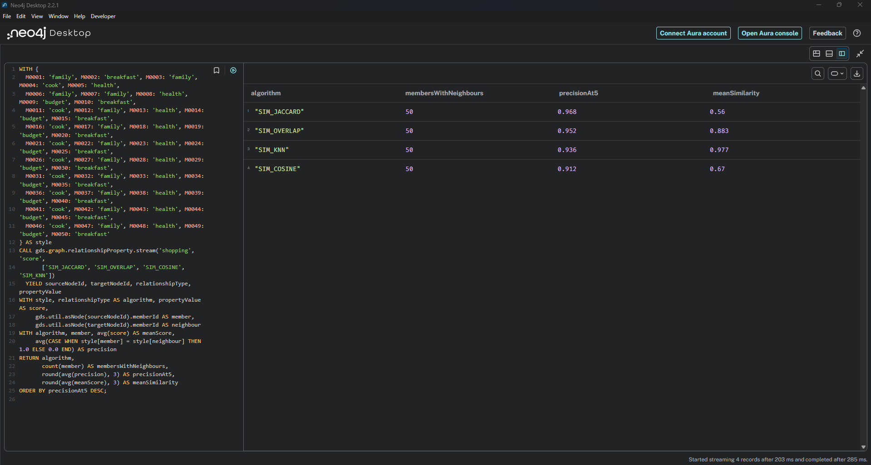
Figure 17: Accuracy of the similarity algorithms in Neo4j
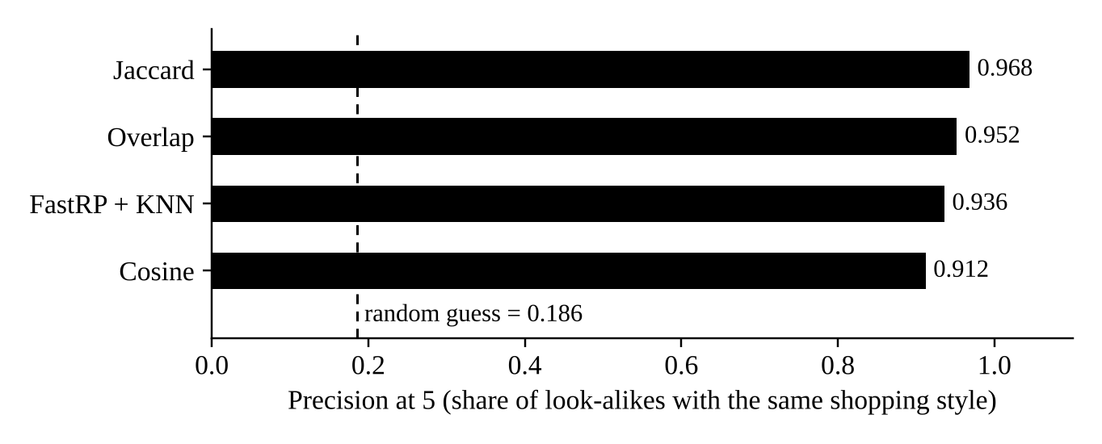
Figure 18: Precision at 5 of each similarity algorithm
Figure 19 shows how the results can be used. The suggested offers for member M0002 are truss tomatoes, tasty cheese and Pink Lady apples, because most of its look-alikes buy them and M0002 has not bought them yet.
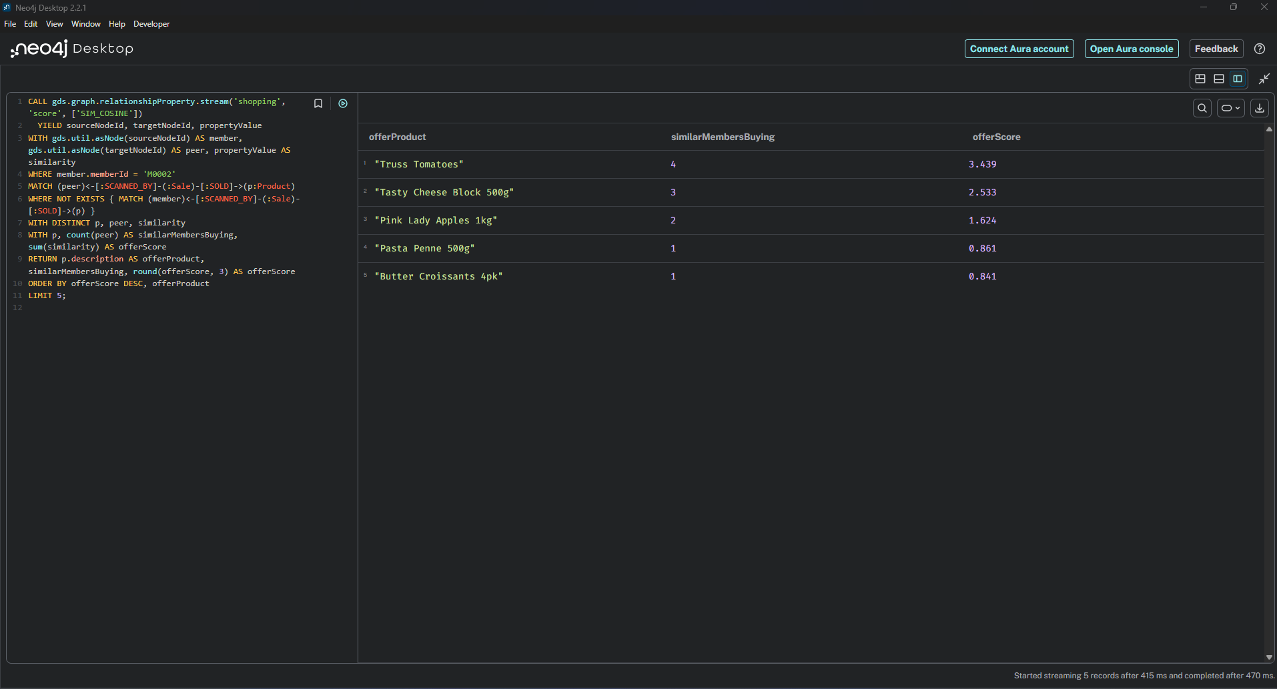
Figure 19: Suggested offers for member M0002

6.4 Recommendation
We recommend Node Similarity with Jaccard for our data. It was the most accurate, its scores are easy to explain (for example, "60% of products in common"), and it does not need any extra settings. For a very large member base, FastRP with KNN would be a better choice because it scales much better and was only slightly less accurate.

7. Teamwork
We used a WhatsApp group to discuss the tasks and share our files, including the task details, Neo4j screenshots and drafts of this report (Figures 20 and 21).
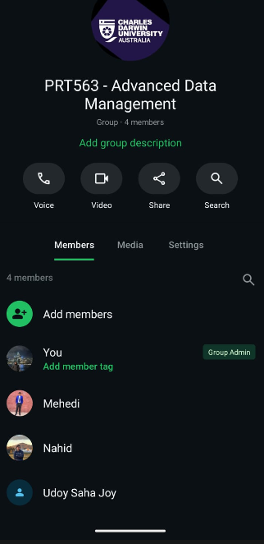
Figure 20: Our WhatsApp group with all four members

Figure 21: Group Colaboration

8. Discussion and Limitations
Moving the database to Neo4j made it much easier to answer questions that cross stock, orders, deliveries, sales and wastage. Query 4 is a good example, because it answers our main business problem in one query that would need many joins and subqueries in SQL. The GDS library also let us run analytics directly on the data without exporting it.
There are some limitations to our work:
- Most of the data is made up, so the results show how the methods work but are not real Woolworths results. The similarity results are probably better than they would be with real customers, because the shopping styles were built into the data.
- The data set is small, so we could not test speed in a meaningful way. A real store network would have millions of sales.
- Stock is stored as a single number for each store and product, as in Assessment 2. Without a history of stock movements we cannot fully explain where missing stock went.
- Neo4j Desktop runs one active database at a time, and GDS needs the graph to fit in memory. A real system would need the Enterprise edition or Neo4j Aura.
- Loyalty data is personal information, so a real system would need to protect member details.

9. Conclusion
In this assessment we moved our store operations database from SQLite to Neo4j. We translated the EER model into a graph model, improved it by using labels and relationships with properties, and loaded all 23 tables with Cypher scripts. The counts in Neo4j matched the original database. Our four queries show how the graph can answer real store questions, including why a shelf ran low. For the analytics, weighted degree centrality was the best way to find the key products, and Jaccard similarity was the most accurate way to find members who shop alike. The next steps would be to test the database with real and larger data and to record stock movements over time.

References
Elmasri, R., & Navathe, S. B. (2016). Fundamentals of database systems (7th ed.). Pearson.
Needham, M., & Hodler, A. E. (2019). Graph algorithms: Practical examples in Apache Spark and Neo4j. O’Reilly Media.
Neo4j, Inc. (n.d.-a). Cypher manual. Retrieved October 15, 2026, from https://neo4j.com/docs/cypher-manual/current/
Neo4j, Inc. (n.d.-b). The Neo4j Graph Data Science library manual. Retrieved October 15, 2026, from https://neo4j.com/docs/graph-data-science/current/
Robinson, I., Webber, J., & Eifrem, E. (2015). Graph databases: New opportunities for connected data (2nd ed.). O’Reilly Media.

Individual Contributions
Member | Student ID | Contribution
Mohammed Nahid Hossain | s401546 | Task 1: translated the EER model into the basic and optimised graph models, drew both diagrams in draw.io and wrote Section 2. Reviewed the final report.
Md Ashraful Islam | s397296 | Task 2: prepared the CSV files and the extra sample data, wrote import.txt (constraints, indexes, nodes and relationships), ran and checked the migration in Neo4j and wrote Section 3. Put the report together.
Udoy Saha Joy | s401428 | Task 3: designed, tested and explained the four Cypher queries and wrote Section 4. Wrote the discussion and limitations.
Md Mehedi Hasan | s400862 | Tasks 4 and 5: ran and compared the centrality and similarity algorithms in GDS and wrote Sections 5 and 6. Wrote the introduction and conclusion.

