

Dhaka International University (DIU)

Project

**Department of CSE**

**B. Sc. In CSE**

**Project Name**

**“Automated Home energy control System”**

**Course Code: CSE-**

**Submitted To**

**Mr.Musarof Hossain**

**Assistant Professor**

**DIU**

**Submitted By**

**Name:Najim Hossain,Rashed sami ,Atiqul islam atiq**

**Roll:10,28,26**

**Batch: D-34th 9th Semester**

**­­**

**Date of Submission: 23/07/2017**

**Automated indoor energy control system**

**Introduction**

Home automation allows us to control household appliances like light, door, fan, AC etc. It also provides home energy consumption system to be activated. Home automation not only refers to reduce human efforts but also energy efficiency.

**Purpose**

The main objective of home automation is to help handicapped and senior citizens which will help them to use home appliances and use that energy efficiently.

**Literature Review**

Bangladesh is a developing country [[1]](https://en.wikipedia.org/wiki/Developing_country).It is a country of 163 million people [[2]](https://www.google.com/search?q=bangladesh+population&oq=bangladesh+population+&aqs=chrome..69i57.5046j0j7&sourceid=chrome&ie=UTF-8).If we talk about the power/ energy, we have more than 15000 megawatt energy. Though 15000 MW is not quite sufficient for 163 million people. There are more than 40% rural people who are deprived of electricity [[3]](https://www.slideshare.net/amigalib/power-generation-and-demand-in-bangladesh).Moreover there are a lot of offices and school colleges, universities in urban area. Every day they are using a lot of high voltage products like: air condition (AC), generators and so on. This product consumes too much electricity which is not good for us. So we have to find out how to save energy from this high voltage products and as well as home appliance. Now if we think about 1 ton 1 ac then, we can see 1 ton 1 ac(5 star)consumes 1 unit in 1 hour [[4]](https://www.quora.com/How-much-electricity-units-is-used-by-1-5-ton-split-AC) . Now if we think about a district like Dhaka , suppose 500 1 ton ac are using in Dhaka and if these ac are using8 hours every day then we can see that 1 ton 1 ac consumes 8 units. So we can see that 500 ton ac consumes 4000 unit. Now if we don’t use these ac through 1 hour then we can save 500 unit energy(per day). In 1 month we can save 500*30=15000 unit(15 Megawatt). So these is the statistics of 1 month.  
Bangladesh has 64 districts. So we can save 960 megawatt energy from 64 districts. By this 960 Megawatt energy ,a villages every family will get energy without any lacking.

**Implementation**

At first we generate the idea about how to save energy for our country. Then we gather the components by which we can make our project. We used some formula to make our codes useful.

Then we took all components and made a real life project and then we will implement the codes to that project. Then we checked our system that it actually saves energy or not. And finally we are successful on our project.

**Output and result:**

At first we will check that if anybody is in the house or not .if yes then the system will go on active mode otherwise the system will go on inactive mode. Then the systems sensor will check if its day or night. If its day then the light will be turned off and if its night then the light will turn on. Then the system will check the temperature of the home. If the temperature is above 20°C ,then homes fan ,ac both will be turned on. and if the temperature below 20° c, then only ac will turned on. If the temperature goes below 15 c then both fan and ac will turned off.

In this system we can see, there are 3 modes:

1.High mode: In this mode both ac and fan will be turned on.

2.Medium mode: In this mode only fan will be turned on.

3.Low mode: In this mode both fan and ac will turned on.

**References:**

<https://en.wikipedia.org/wiki/Developing_country>

<https://www.google.com/search?q=bangladesh+population&oq=bangladesh+population+&aqs=chrome..69i57.5046j0j7&sourceid=chrome&ie=UTF-8>

<https://www.slideshare.net/amigalib/power-generation-and-demand-in-bangladesh>

<https://www.quora.com/How-much-electricity-units-is-used-by-1-5-ton-split-AC>

***Tutorial:***

**Components:**

Here is the list of all components we have need to this project. We have to collect all these things to accomplish this project.

* Breadboard: 1 piece
* Atmega328 microcontroller: 1 piece
* 16*2 LCD: 1pice
* LDR: 1 piece
* 10k thermistor : 1 piece
* Proximity sensor: 1 piece
* 10k resistor: 2 pieces
* 16Mz crystal: 1 piece
* 10k potentiometer: 1 piece
* 7805 voltage regulator: 1 piece
* DC 9V battery: 1 piece
* DC fan: 2 pieces
* LED: 1 piece
* Male to male wire: 30 to 40 pieces
* Some hot glue
* Arduino UNO kit

After collecting all this parts we have to assemble them. The circuit diagram is as follow:

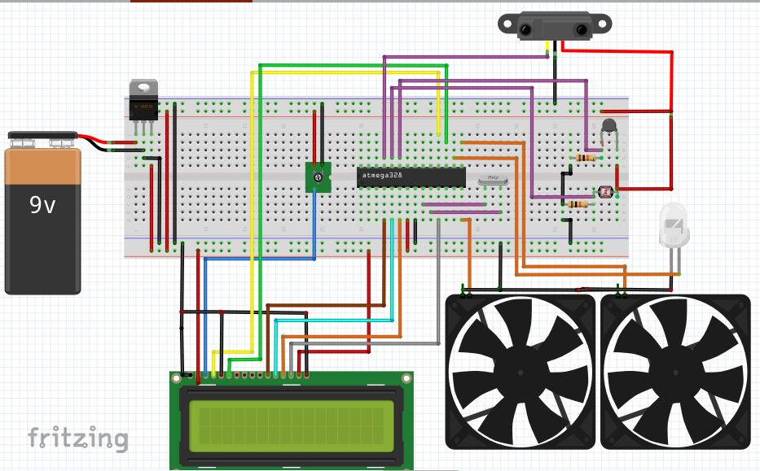

Here we have used three type of sensors (Light, Temperature, Proximity). Before using these sensors at first we have to make them compatible for our microcontroller. The circuit diagram for these sensors is shown in the picture:

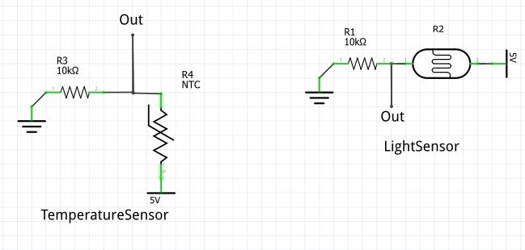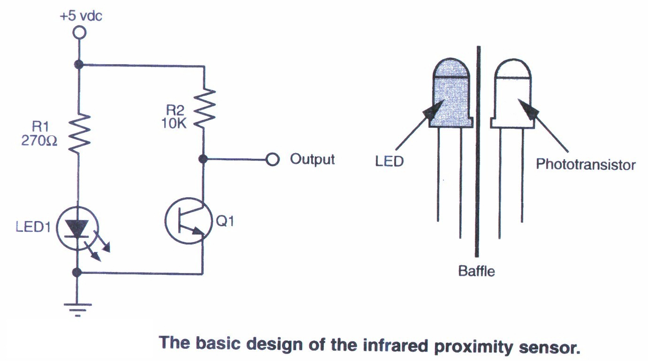

**Programming microcontroller**

Now we have to program our microcontroller (Atmega328 ). We can load program in several ways on it. Here we are going to use Arduino UNO kit as our programmer. To use Arduino UNO as a programmer we have to follow the steps given here:

Burning the Bootloader

If you have a new ATmega328 (or ATmega168), you'll need to burn the bootloader onto it. You can do this using an Arduino board as an in-system program (ISP). If the microcontroller already has the bootloader on it (e.g. because you took it out of an Arduino board or ordered an already-bootloaded ATmega), you can skip this section.

To burn the bootloader, follow these steps:

* as ISP" from Tools > Programmer
* Run Tools > Burn Bootloader
* You should only need to burn the bootloader once. After you've done so, you can remove the jumper wires connected Upload the ArduinoISP sketch onto your Arduino board. (You'll need to select the board and serial port from the Tools menu that correspond to your board.)
* Wire up the Arduino board and microcontroller as shown in the diagram to the right.
* Select "Arduino Duemilanove or Nano w/ ATmega328" from the Tools > Board menu. (Or "ATmega328 on a breadboard (8 MHz internal clock)" if using the minimal configuration described below.)
* Select "Arduino to pins 10, 11, 12, and 13 of the Arduino board.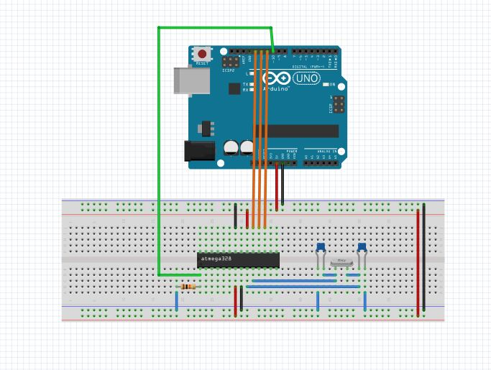

### Uploading Using an Arduino Board

Once your ATmega328p has the Arduino boot loader on it, you can upload programs to it using the USB-to-serial convertor (FTDI chip) on an Arduino board. To do, you remove the microcontroller from the Arduino board so the FTDI chip can talk to the microcontroller on the breadboard instead. The diagram at right shows how to connect the RX and TX lines from the Arduino board to the ATmega on the breadboard. To program the microcontroller, select "Arduino Duemilanove or Nano w/ ATmega328" from the the Tools > Board menu (or "ATmega328 on a breadboard (8 MHzinternal clock)" if you're using the minimal configuration described below). Then upload as usual.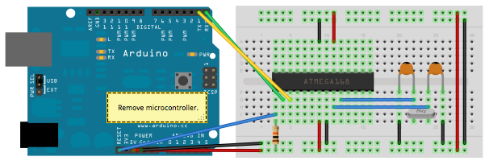

For uploading program on our microcontroller (Atmega328) the code we have used is:

*// include the library code:*

*#include <LiquidCrystal.h>*

*// initialize the library with the numbers of the interface pins*

*LiquidCrystal lcd(12, 11, 5, 4, 3, 2);*

*int ThermistorPin = A0;*

*int ledPin = 10; //the number of the LED pin*

*int ldrPin = A1; //the number of the LDR pin*

*float R1 = 10000;*

*int Vo;*

*float logR2, R2, T, Tc, Tf;*

*float c1 = 1.009249522e-03, c2 = 2.378405444e-04, c3 = 2.019202697e-07;*

*int dtime=1000;*

*void setup() {*

*lcd.begin(16, 2);*

*lcd.print("Inactive Mode");*

*pinMode(A2,INPUT);*

*pinMode(9,OUTPUT);//AC out*

*pinMode(8,OUTPUT);//Fan out*

*pinMode(ledPin, OUTPUT); //initialize the LED pin as an output*

*pinMode(ldrPin, INPUT); //initialize the LDR pin as an input*

*}*

*void loop() {*

*if(analogRead(A2)<700)*

*{*

*lcd.clear();*

*lcd.setCursor(0, 0);*

*// print LCD Heder*

*lcd.print("Tem. AC Fan Lig.");*

*int ldrStatus = analogRead(ldrPin); //read the status of the LDR value*

*//check if the LDR status is <= 300*

*//if it is, the LED is HIGH*

*if (ldrStatus <=300) {*

*digitalWrite(ledPin, HIGH); //turn LED on*

*lcd.setCursor(13, 1);*

*// print the light is on*

*lcd.print("ON");*

*}*

*else {*

*digitalWrite(ledPin, LOW); //turn LED off*

*lcd.setCursor(13, 1);*

*// print the light is off*

*lcd.print("OFF");*

*}*

*Vo = analogRead(ThermistorPin);*

*R2 = R1 * (1023.0 / (float)Vo - 1.0);*

*logR2 = log(R2);*

*T = (1.0 / (c1 + c2*logR2 + c3*logR2*logR2*logR2));*

*Tc = T - 273.15;*

*//Tf = (Tc * 9.0)/ 5.0 + 32.0;*

*lcd.setCursor(0, 1);*

*// print Temperature*

*lcd.print(Tc);*

*if ((Tc>=0)&&(Tc<15) )*

*{*

*digitalWrite(9,LOW);*

*digitalWrite(8,LOW);*

*lcd.setCursor(6, 1);*

*// print the AC is off*

*lcd.print("OFF");*

*lcd.setCursor(9, 1);*

*// print the Fan is off*

*lcd.print("OFF");*

*delay(dtime);*

*}*

*else if((Tc>=15)&&(Tc<20))*

*{*

*digitalWrite(9,HIGH);//AC on*

*digitalWrite(8,LOW);//Fan off*

*lcd.setCursor(6, 1);*

*// print the AC is on*

*lcd.print("ON");*

*lcd.setCursor(9, 1);*

*// print the Fan is off*

*lcd.print("OFF");*

*delay(dtime);*

*}*

*else*

*{*

*digitalWrite(9,HIGH);//AC on*

*digitalWrite(8,HIGH);//Fan on*

*lcd.setCursor(6, 1);*

*// print the AC is on*

*lcd.print("ON");*

*lcd.setCursor(9, 1);*

*// print the Fan is on*

*lcd.print("ON");*

*delay(dtime);*

*}*

*}*

*else*

*{*

*lcd.clear();*

*lcd.setCursor(0,0);*

*lcd.print(" Inactive Mode ");*

*digitalWrite(9,LOW);//AC off*

*digitalWrite(8,LOW);//Fan off*

*digitalWrite(ledPin, LOW);//LIGHT OFF*

*delay(1000);*

*}*

*}*

Now we are ready to go.