HOTEL MEJBAN MANAGEMENT SYSTEM

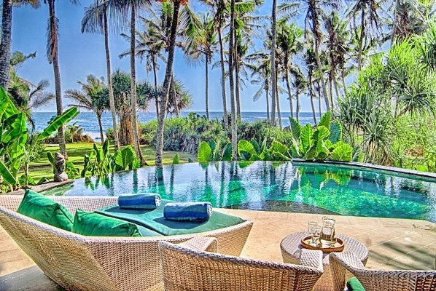

TAHMINA AHMMED – 300937437

ROJINA AKTER – 300756946

NUSRAT JAHAN – 300967157

DR. MD. FARDOUSH RAHMAN – 300958291

MASUDUR RAHMAN – 300578293

SALIM SAYEED – 300933148

MD HUMAYUN KABIR – 300527330

Table of Contents

**PROBLEM ANALYSIS** 4

**FACTS IN THE PROJECT** 4

**SYSTEM MODULES** 4

**Rental** 4

**Car Pick-ups and returns:** 5

**Invoicing and Payment:** 5

**General Administration:** 5

**DATA OF HOTEL MEJBAN MANAGEMENT SYSTEM** 6

**Entity Relationship Diagram** 6

**BUSINESS RULES** 9

**TABLE DESCRIPTION** 10

**TABLES CREATION SCRIPT** 12

**DATA INSERT SCRIPT** 17

**CONSTRAINTS** 26

**SHOW THE TABLES** 28

**TESTING THE DATABASE-SQL QUERY** 31

**1.** **Listing data from tables using alias for table name:** 31

**2.** **List of customer using alias, join, between and LIKE keyword** 31

**3.** **Retrieve customer data using between and keyword:** 32

**4.** **Listing customers’ first name, last name, Booking_ID, Room_Type, Booking date from table** 33

**5.** **Listing hotel’s name, address, rooms’ description, booking date, and customers’ name if a customer’s first name is “Yunus” or “Donald” :** 33

**TESTING THE DATABASE-PL/SQL QUERY** 34

**1.** **Creating a Sequence where hotel id will increment by 1** 34

**2.** **Inserting value using sequence- where we inserted a new hotel using the hotel id sequence** 35

**3.** **Use of %RowType attribute to retrieve the employee information with hotel id 6** 36

**4.** **Data Insert Using Record – where we inserted a new employee data in the comm_employees table** 37

**5.** **Create Function** 39

**6.** **Display the customer details using the function created** 40

**7.** **User define exception for room price with hotel id 1** 41

**8.** **Creating Procedure with room type** 43

**9.** **Creating Cursor and displaying details of rooms available in the hotel Holiday Inn** 44

**10.** **Creating Package and displaying customers last name according to customer id** 45

**CONCLUSION** 46

# **PROBLEM ANALYSIS**

Online international hotel system is very convenient for the people who likes to travel whole world to enjoy their life. The management of Hotel Mejban opted for an online booking system due to their massive losses experienced by current manual system as:

1. Would be more convenient for customer and employee

2. Improve customer service by providing prompt customer support

3. Reduce operational cost for the company

# **FACTS IN THE PROJECT**

The elements of the database preparation for the hotel management-

* **Computerization** - All the details regarding hotels, whether it is small or big, will be computerized.
* **Inventory** – If the rooms are provided to the customers, the availability will be reduced in the inventory, and will help in to know the status of the available rooms.
* **Avoid duplication** - For every reservation that is conducted for the customers, an automated report will be generated and will be available to the customers and his / her concerned manager uniformly.
* **Record keeping**– It will be easier task for the management to keep the record of the customers for historical purpose.
* **Booking**– It will be easier for both the customers and the receptionist to have the bookings. It is just two clicks away.

# **SYSTEM MODULES**

## **Rental**

The following primary marketing strategies that we use to grow rental revenue and enhance each of our hotel brand.

Internet Marketing: We will make sure your website booking directly to us. We use social media such as Twitter, Facebook, and Trip Advisor to manage and enhance our brands. We also use mobile, email, and pay per click for marketing campaigns.

Sales Calls: We contact to our customers and response them for any information.

Trade Shows: We participate in different trade shows in different fair in whole world.

Incentive Programs: We have good offer for them, who are our regular customers.

## **Car Pick-ups and returns:**

Our pick-up and return always free for the customers who booked us and confirmed their payment.

## **Invoicing and Payment:**

Customers always get instant invoice and payment confirmation documents after they confirm their bookings. Moreover, we provide hard copy of invoice according to customers’ request.

## **General Administration:**

The respective departmental heads are very loyal to provide services to our valuable customers. We always prompt our valuable customers to provide their valuable opinion in any aspect.

# **DATA OF HOTEL MEJBAN MANAGEMENT SYSTEM**

## **Entity Relationship Diagram**









# **BUSINESS RULES**

|  |  |  |  |
| --- | --- | --- | --- |
| **RELATIONSHIP** | **TABLE1** | **TABLE2** | **CARDINALITY** |
| A hotel has many employees and  Each employee belongs to one hotel | COMM_HOTELS | COMM_EMPLOYEE | 1:M |
| A hotel has one or many rooms and  Each room belongs to one hotel | COMM_HOTELS | COMM_ROOMS | 1:M |
| A customer can have zero or many payment profile and each payment may be made by one customer | COMM_CUS_DETAILS | COMM_PAYMENT | 1:M |
| A room can be booked zero or many times and in each booking one room must be booked | COMM_ROOMS | COMM_BOOKING | 1:M |
| One payment must be made in one booking and for each booking one payment must be made | COMM_BOOKING | COMM_PAYMENT | 1:1 |

# **TABLE DESCRIPTION**

1. **COMM_EMPLOYEE Table**

|  |  |  |  |  |
| --- | --- | --- | --- | --- |
| **Attribute** | **Description** | **Key Type/ Constraint** | **Data Type** | **Length** |
| EMP_ID | ID of employees who work for hotels | Primary Key | VARCHAR2 | 10 |
| FNAME | A first name of an employee |  | VARCHAR2 | 15 |
| LNAME | A last name of an employee |  | VARCHAR2 | 15 |
| ADDRESS | Address of employees |  | VARCHAR2 | 15 |
| POSTALCODE | Postal Code |  | VARCHAR2 | 15 |
| PHONE | Phone Number of employees |  | NUMBER | 15 |
| EMAIL | Email Address | Unique | VARCHAR2 | 15 |
| HOTEL_ID | ID of hotels which employees work for | Foreign Key | NUMBER | 10 |

1. **COMM_HOTELS Table**

|  |  |  |  |  |
| --- | --- | --- | --- | --- |
| **Attribute** | **Description** | **Key Type/ Constraint** | **Data Type** | **Length** |
| HOTEL_ID | ID of hotels | Primary Key | NUMBER | 10 |
| NAME | Names of hotels |  | VARCHAR2 | 15 |
| ADDRESS | Address of hotels |  | VARCHAR2 | 15 |
| POSTALCODE | Postal Code |  | VARCHAR2 | 15 |
| PROVINCE | Province |  | VARCHAR2 | 15 |
| TELEPHONE | Telephone Number |  | VARCHAR2 | 15 |
| MANAGER_ID | ID of managers who are in charge of hotels | Unique | VARCHAR2 | 10 |

1. **COMM_ROOMS Table**

|  |  |  |  |  |
| --- | --- | --- | --- | --- |
| **Attribute** | **Description** | **Key Type/ Constraint** | **Data Type** | **Length** |
| ROOM_NO | No of rooms | Primary Key | NUMBER | 10 |
| ROOM_TYPE | Types of rooms |  | VARCHAR2 | 15 |
| ROOMDETAILS | Description of rooms |  | VARCHAR2 | 20 |
| ROOMPRICE | Price of rooms |  | NUMBER | 15 |
| HOTEL_ID | ID of hotels | Foreign Key | NUMBER | 10 |

1. **COMM_BOOKING Table**

|  |  |  |  |  |
| --- | --- | --- | --- | --- |
| **Attribute** | **Description** | **Key Type/ Constraint** | **Data Type** | **Length** |
| BOOKING_ID | ID of booking | Primary Key | NUMBER | 10 |
| CUSTOMER_ID | ID of customers | Foreign Key | NUMBER | 10 |
| ROOM_NO | ID of rooms | Foreign Key | NUMBER | 10 |
| BOOKINGDATE | Date when customers book rooms |  | DATE |  |
| CHECKIN | Date of check in |  | DATE |  |
| CHECKOUT | Date of check out |  | DATE |  |
| NOOFNIGHT | Number of night that customers stay in hotels |  | NUMBER | 15 |

1. **COMM_CUS_DETAILS Table**

|  |  |  |  |  |
| --- | --- | --- | --- | --- |
| **Attribute** | **Description** | **Key Type/ Constraint** | **Data Type** | **Length** |
| CUSTOMER_ID | ID of customers | Primary Key | NUMBER | 10 |
| FIRST NAME | First name of customers |  | VARCHAR2 | 15 |
| LAST NAME | Last name of customers |  | VARCHAR2 | 15 |
| DATE OF BIRTH | Date of Birth |  | DATE |  |
| ADDRESS | Address |  | VARCHAR2 | 15 |
| POSTALCODE | Postal Code |  | VARCHAR2 | 15 |
| COUNTRY | Countries where customers come from |  | VARCHAR2 | 15 |
| PHONE NO | Phone Number |  | VARCHAR2 | 15 |
| EMAIL | Email Address | Unique | VARCHAR2 | 15 |

1. **COMM_PAYMENT Table**

|  |  |  |  |  |
| --- | --- | --- | --- | --- |
| **Attribute** | **Description** | **Key Type/ Constraint** | **Data Type** | **Length** |
| PAYMENT_ID | ID of payment | Primary Key | NUMBER | 10 |
| CUSTOMER_ID | ID of customers | Foreign Key | NUMBER | 10 |
| BOOKING_ID | ID of booking | Foreign Key | NUMBER | 10 |
| CARD# | Credit Card Number | Unique | VARCHAR2 | 15 |
| EXPIREDATE | Expire Date of the credit card |  | DATE |  |

# **TABLES CREATION SCRIPT**

**======= COMM_EMPLOYEES =======**

CREATE TABLE COMM_EMPLOYEES

( EMP_ID VARCHAR2(10),

FNAME VARCHAR2(15) NOT NULL,

LNAME VARCHAR2(15) NOT NULL,

ADDRESS VARCHAR2(15),

POSTALCODE VARCHAR2(15),

PHONE VARCHAR(15),

EMAIL VARCHAR2(15),

HOTEL_ID NUMBER(10),

CONSTRAINT EMP_EMPID_PK PRIMARY KEY(EMP_ID),

CONSTRAINT EMP_EMAIL_UK UNIQUE(EMAIL));

**======= COMM_HOTELS=======**

CREATE TABLE COMM_HOTELS

( HOTEL_ID NUMBER(10),

NAME VARCHAR2(15),

ADDRESS VARCHAR2(15),

POSTALCODE VARCHAR2(15),

PROVINCE VARCHAR2(15),

TELEPHONE VARCHAR2(15),

MANAGER_ID VARCHAR2(10),

CONSTRAINT HOTELS_HOTELID_PK PRIMARY KEY(HOTEL_ID));

**========= COMM_ROOMS========**

CREATE TABLE COMM_ROOMS

( ROOM_NO NUMBER(10),

ROOM_TYPE VARCHAR2(15),

ROOMDETAILS VARCHAR2(20),

ROOMPRICE NUMBER(15,2),

HOTEL_ID NUMBER(10),

CONSTRAINT ROOMS_ROOMNO_PK PRIMARY KEY(ROOM_NO));

**========= COMM_BOOKING =========**

CREATE TABLE COMM_BOOKING

( BOOKING_ID NUMBER(10),

CUSTOMER_ID NUMBER (10),

ROOM_NO NUMBER(10),

BOOKINGDATE DATE NOT NULL,

CHECKIN DATE NOT NULL,

CHECKOUT DATE NOT NULL,

NOOFNIGHT NUMBER(15) NOT NULL,

CONSTRAINT BOOKING_BOOKINGID_PK PRIMARY KEY(BOOKING_ID));

**======COMM_CUS_DETAILS ======**

CREATE TABLE COMM_CUS_DETAILS

( CUSTOMER_ID NUMBER (10),

FNAME VARCHAR2(15) NOT NULL,

LNAME VARCHAR2(15) NOT NULL,

DOB DATE,

ADDRESS VARCHAR2(15),

POSTALCODE VARCHAR2(15),

COUNTRY VARCHAR2(15),

PHONE VARCHAR2(15),

EMAIL VARCHAR2(15),

CONSTRAINT CUSDETAILS_CUSTOMERID_PK PRIMARY KEY(CUSTOMER_ID));

**====== COMM_PAYMENT======**

CREATE TABLE COMM_PAYMENT

( PAYMENT_ID NUMBER(10),

CUSTOMER_ID NUMBER (10),

BOOKING_ID NUMBER(10),

CARD# VARCHAR2(15),

EXPIREDATE DATE,

CONSTRAINT PAYMENT_PAYMENTID_PK PRIMARY KEY(PAYMENT_ID));

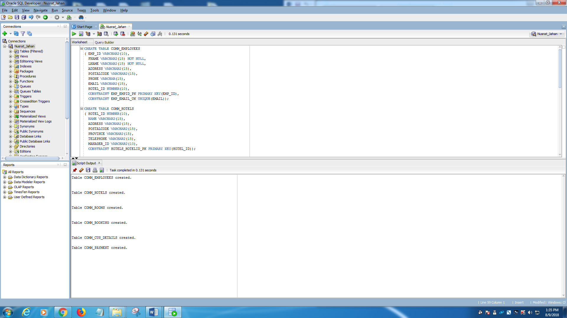

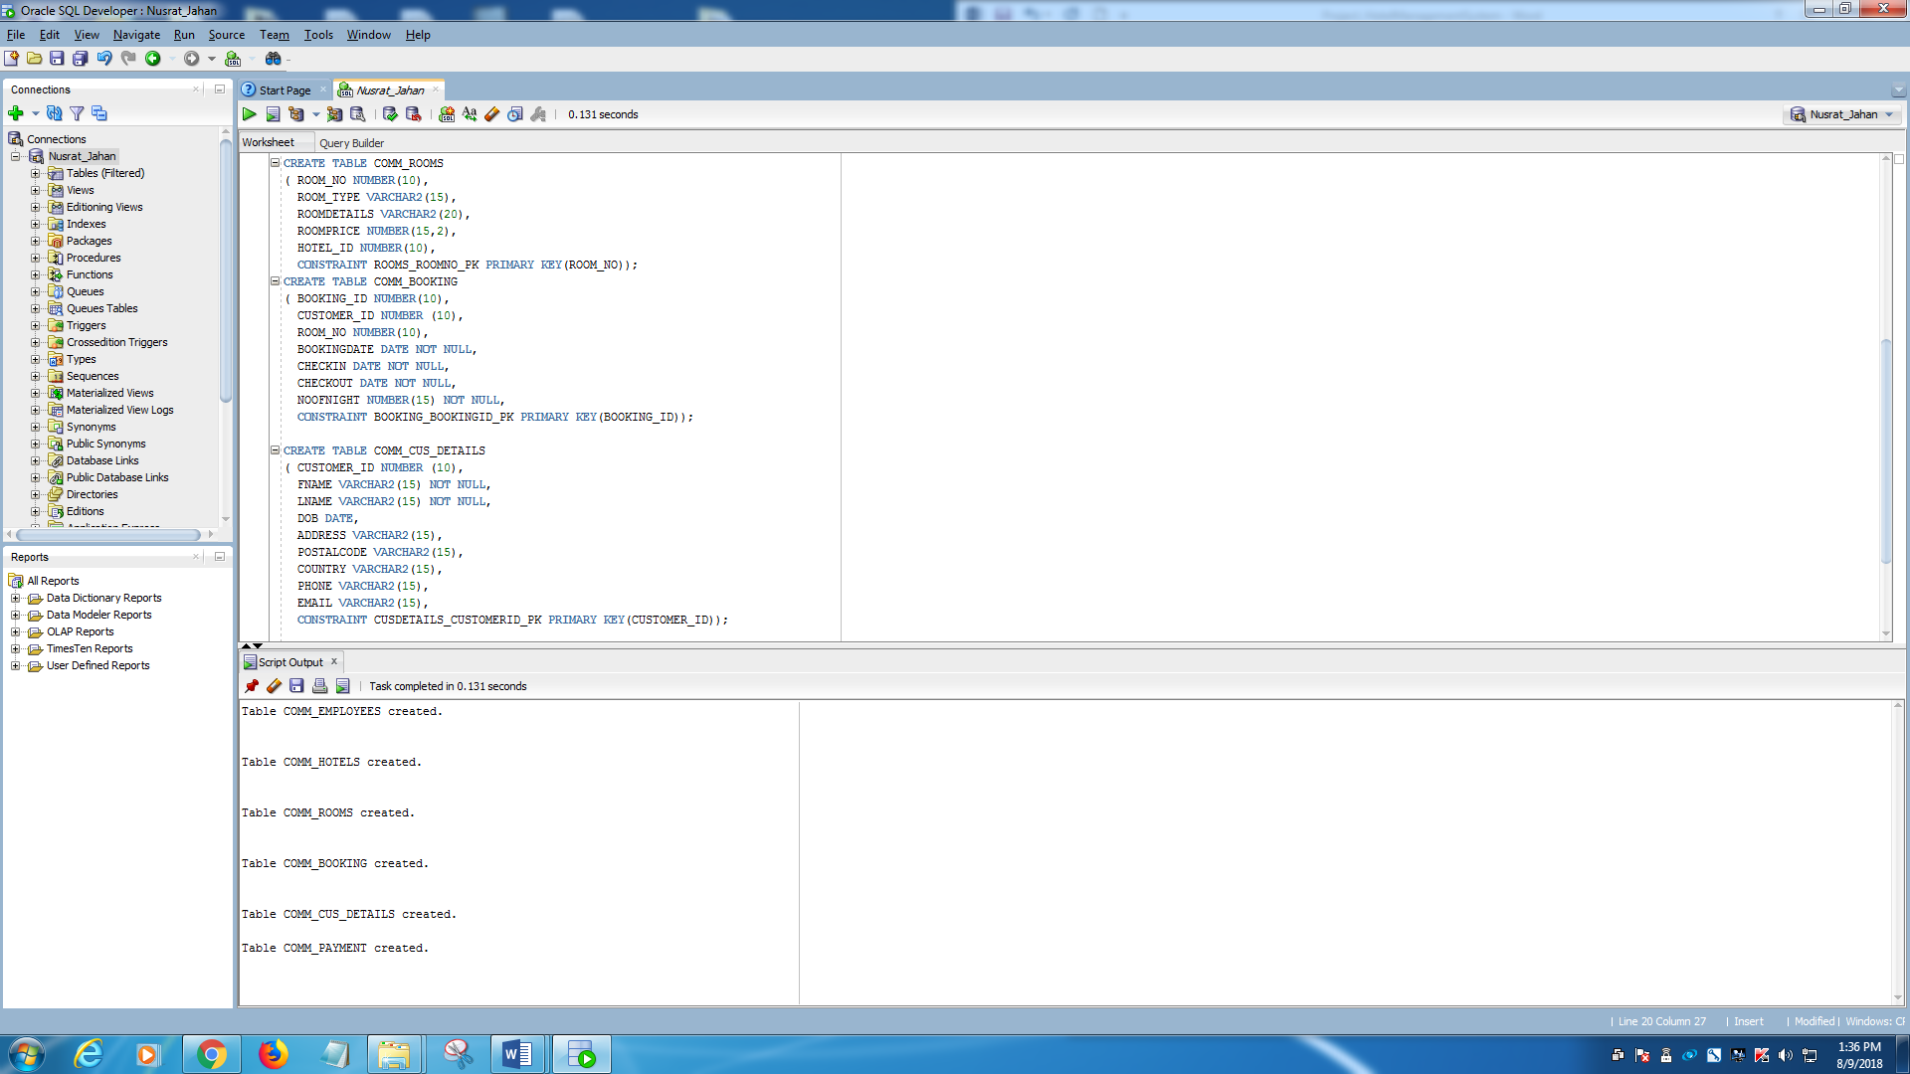

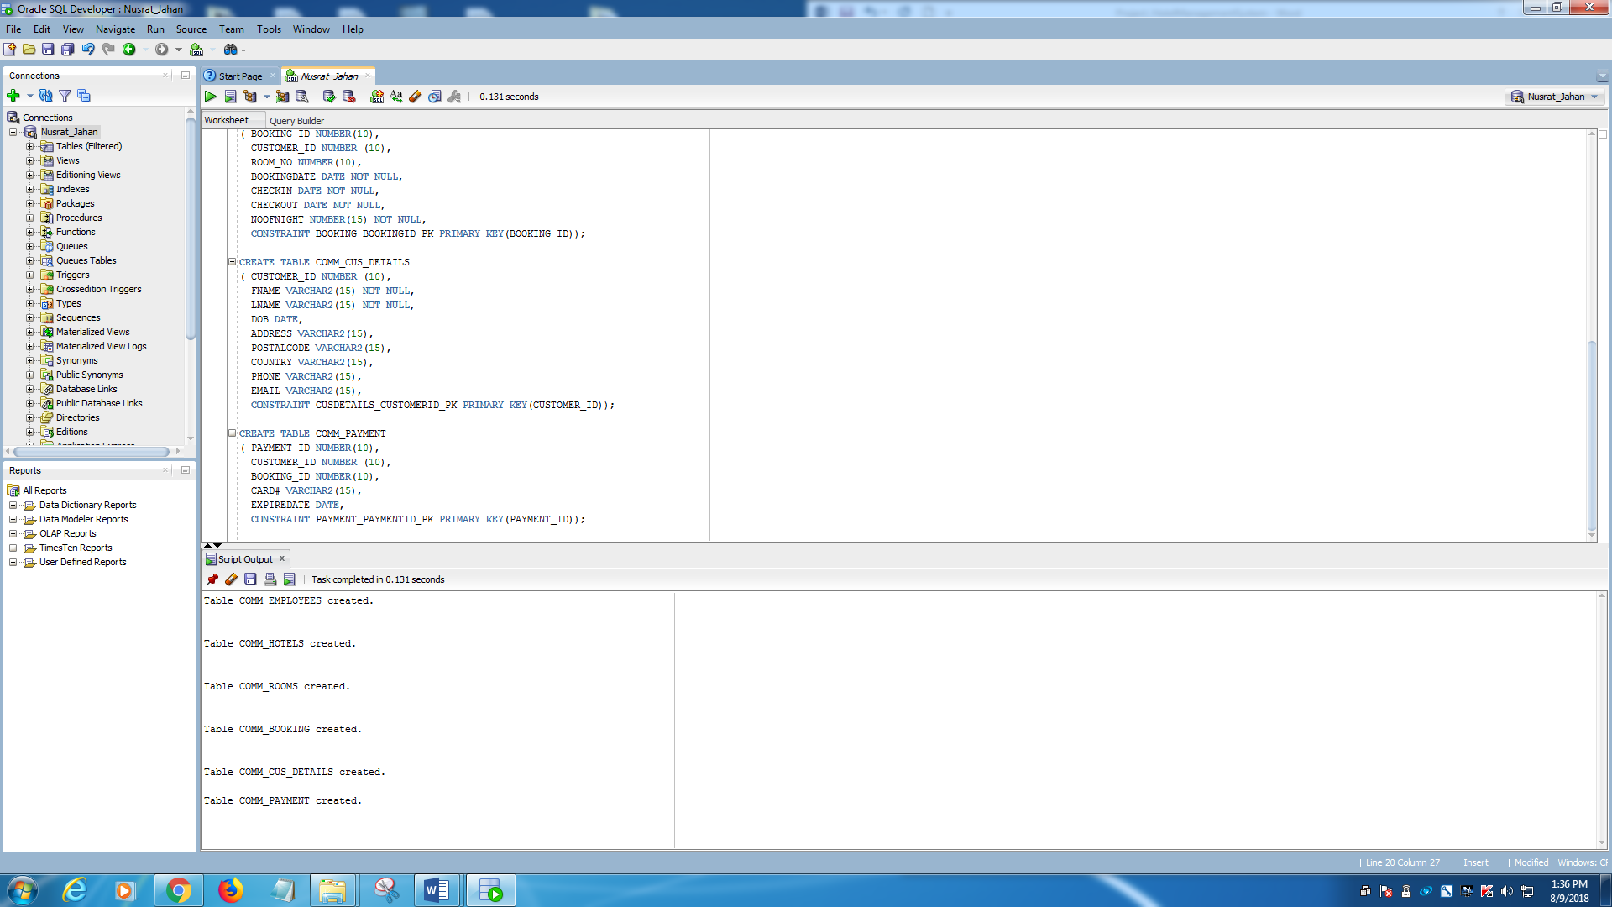

# **DATA INSERT SCRIPT**

**==== COMM_EMPLOYEES Table=====**

INSERT INTO COMM_EMPLOYEES VALUES ('M-101', 'NUSRAT', 'JAHAN', 'P.O. BOX 651', 'M1M1M1', '647-111-1111', 'a@yahoo.com', 0001);

INSERT INTO COMM_EMPLOYEES VALUES ('T-102', 'ROJINA', 'AKTER', 'P.O. BOX 581', 'M2M2M2', '647-222-2222', 'b@yahoo.com', 0006);

INSERT INTO COMM_EMPLOYEES VALUES ('S-103', 'SMITH', 'LEILA', 'P.O. BOX 234', 'M3M3M3', '647-333-3333', 'c@yahoo.com', 0004);

INSERT INTO COMM_EMPLOYEES VALUES ('P-104', 'PIERSON', 'THOMAS', 'P.O. BOX 925', 'M4M4M4', '647-444-4444', 'd@yahoo.com', 0001);

INSERT INTO COMM_EMPLOYEES VALUES ('G-105', 'GIRARD', 'CINDY', 'P.O. BOX 652', 'M5M5M5', '647-555-5555', 'e@yahoo.com', 0001);

INSERT INTO COMM_EMPLOYEES VALUES ('C-106', 'CRUZ', 'MESHIA', 'P.O. BOX 787', 'M6M6M6', '647-666-6666', 'f@yahoo.com', 0007);

INSERT INTO COMM_EMPLOYEES VALUES ('S-107', 'SHILA', 'DESHAI', 'P.O. BOX 678', 'M6M3M4', '647-777-7777', 'g@yahoo.com', 0002);

INSERT INTO COMM_EMPLOYEES VALUES ('P-108', 'KIM', 'THOMPSON', 'P.O. BOX 454', 'M4M4M1', '647-888-8888', 'h@yahoo.com', 0002);

INSERT INTO COMM_EMPLOYEES VALUES ('G-109', 'LILY', 'MISTRA', 'P.O. BOX 786', 'M5M7M5', '647-999-9999', 'i@yahoo.com', 0001);

INSERT INTO COMM_EMPLOYEES VALUES ('C-110', 'SULTANA', 'AMIR', 'P.O. BOX 255', 'M4M6M6', '647-101-1010', 'j@yahoo.com', 0003);

INSERT INTO COMM_EMPLOYEES VALUES ('P-111', 'ROJ', 'THOMAS', 'P.O. BOX 454', 'M4M4M1', '647-888-8888', 'k@yahoo.com', 0002);

INSERT INTO COMM_EMPLOYEES VALUES ('G-112', 'LAILA', 'AHMED', 'P.O. BOX 786', 'M5M7M5', '647-999-9999', 'l@yahoo.com', 0001);

INSERT INTO COMM_EMPLOYEES VALUES ('C-113', 'SULTAN', 'KHAN', 'P.O. BOX 255', 'M4M6M6', '647-101-1010', 'm@yahoo.com', 0003);

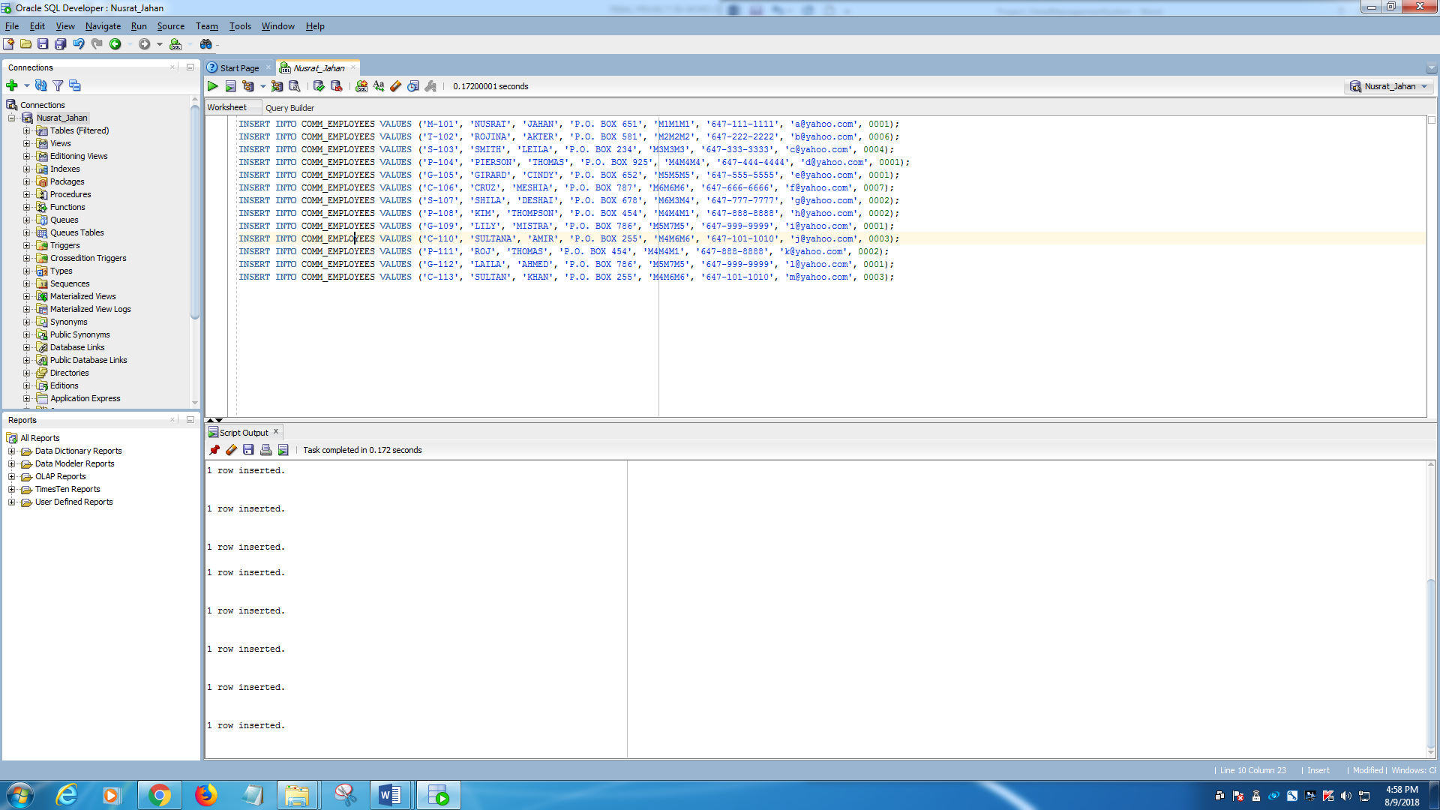

**===== COMM_HOTELS Table=====**

INSERT INTO COMM_HOTELS VALUES (0001, 'SWEET DREAMS', '565 SHER ST', 'M4X1W7', 'ONTARIO', '000-123-5478', 'M-9000');

INSERT INTO COMM_HOTELS VALUES (0002, 'Holiday Inn', '575 VIC ST', 'M4X1W7', 'ONTARIO', '000-123-7896', 'M-8000');

INSERT INTO COMM_HOTELS VALUES (0003, 'Quality Inn', '555 FINCH ST', 'M4X1W7', 'ONTARIO', '000-123-1234', 'M-7000');

INSERT INTO COMM_HOTELS VALUES (0004, 'Sheraton', '595 KENEDY ST', 'M4X1W7', 'ONTARIO', '000-123-5932', 'M-6000');

INSERT INTO COMM_HOTELS VALUES (0005, 'Toronto Inn', '466 WARDEN ST', 'M4X1W7', 'ONTARIO', '000-123-5467', 'M-1000');

INSERT INTO COMM_HOTELS VALUES (0006, 'Holiday Inn', '567 VILL ST', 'M4X1W7', 'ONTARIO', '000-123-7864', 'M-3000');

INSERT INTO COMM_HOTELS VALUES (0007, 'Sea Gull', '546 UNION ST', 'M4Y1W7', 'ONTARIO', '000-123-7567', 'M-2000');

INSERT INTO COMM_HOTELS VALUES (0008, 'Shonargao', '675 BLOOR ST', 'M3X1W7', 'ONTARIO', '000-123-4645', 'M-4000');

INSERT INTO COMM_HOTELS VALUES (0009, 'Hotel Paradise', '456 FINCH ST', 'M4X9W7', 'ONTARIO', '000-123-5475', 'M-5000');

INSERT INTO COMM_HOTELS VALUES (0010, 'Danforth Inn', '786 UNION ST', 'M4X1W8', 'ONTARIO', '000-123-2434', 'M-1100');

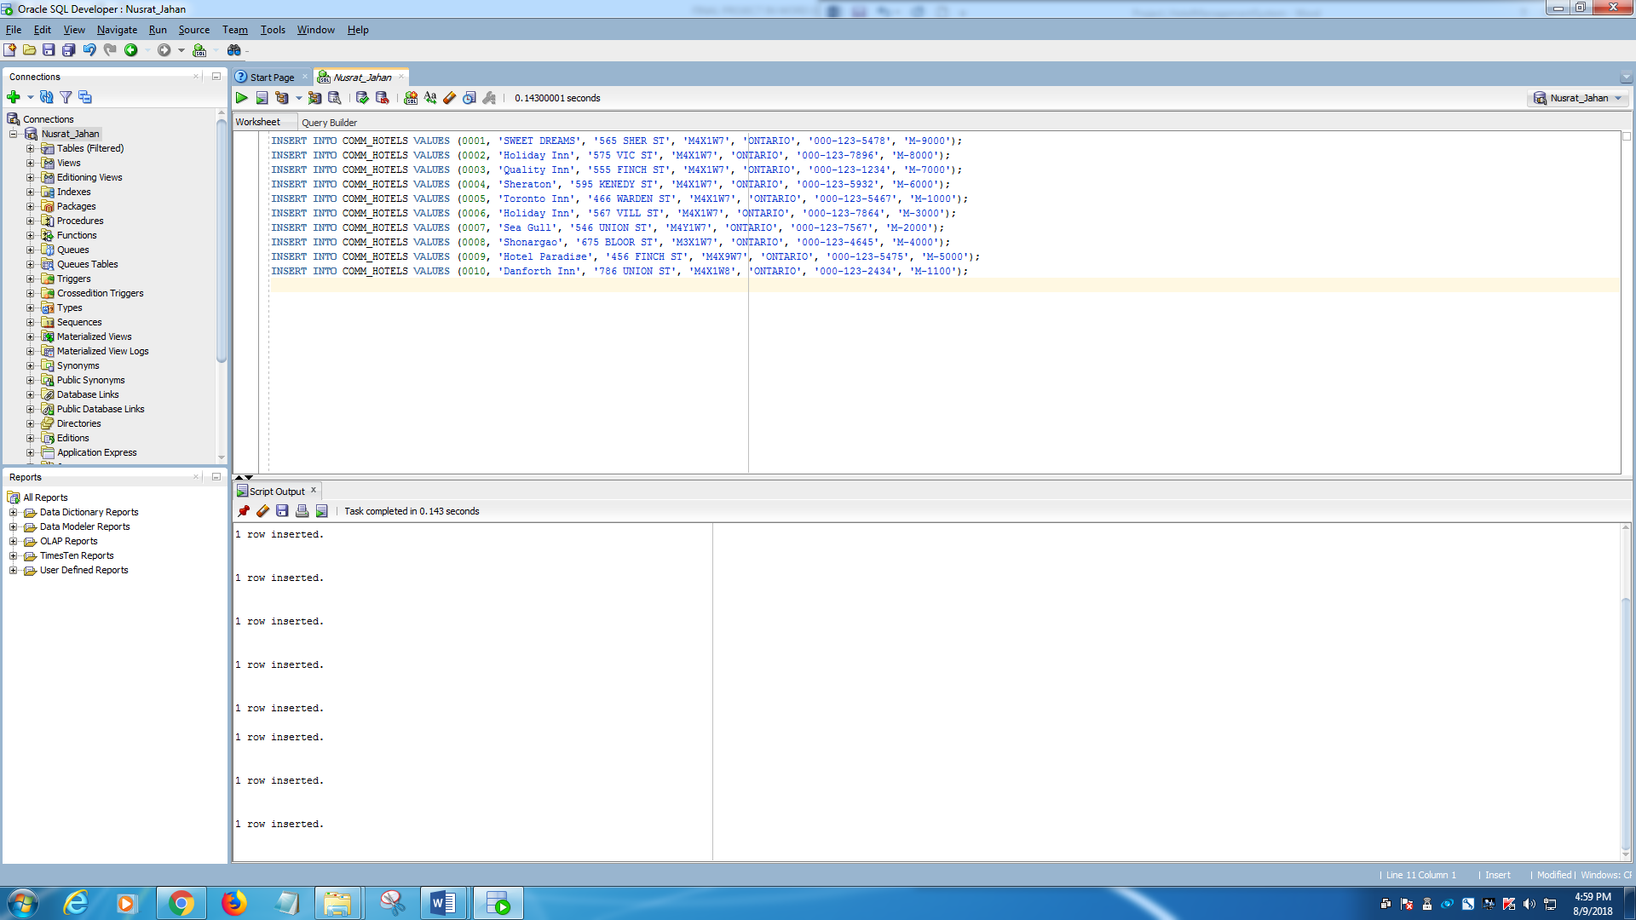

**======== COMM_ROOMS Table========**

INSERT INTO COMM_ROOMS VALUES (101, 'SINGLE', 'MAX 2 ALLOWED', 200, 0002);

INSERT INTO COMM_ROOMS VALUES (302, 'SINGLE', 'MAX 2 ALLOWED', 250, 0008);

INSERT INTO COMM_ROOMS VALUES (701, 'SINGLE', 'MAX 2 ALLOWED', 200, 0001);

INSERT INTO COMM_ROOMS VALUES (408, 'DOUBLE', 'MAX 4 ALLOWED', 400, 0003);

INSERT INTO COMM_ROOMS VALUES (905, 'DOUBLE', 'MAX 4 ALLOWED', 300, 0002);

INSERT INTO COMM_ROOMS VALUES (710, 'FAMILY', 'MAX 6 ALLOWED', 550, 0006);

INSERT INTO COMM_ROOMS VALUES (609, 'DELUX', 'MAX 6 ALLOWED', 650, 0008);

INSERT INTO COMM_ROOMS VALUES (403, 'FAMILY', 'MAX 6 ALLOWED', 550, 0003);

INSERT INTO COMM_ROOMS VALUES (1005, 'BUSINESS', 'MAX 10 ALLOWED', 700,0010);

INSERT INTO COMM_ROOMS VALUES (456, 'BUSINESS', 'MAX 10 ALLOWED', 800,0002);

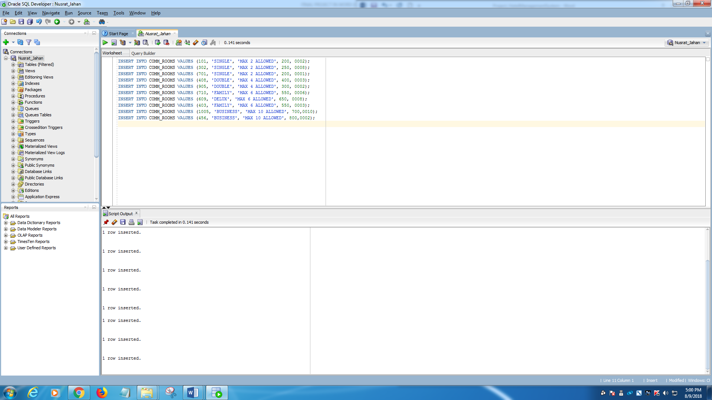

**========COMM_BOOKING========**

INSERT INTO COMM_BOOKING VALUES (1602001, 161007, 1005, To_Date('07-JAN-2018','dd-mm-yy'), '10-FEB-2018', '15-FEB-18', 5);

INSERT INTO COMM_BOOKING VALUES (1602002, 161002, 302, To_Date('10-FEB-2018','dd-mm-yy'), '10-MAR-18', '20-MAR-18', 10);

INSERT INTO COMM_BOOKING VALUES (1602003, 161006, 710, To_Date('12-MAR-2018','dd-mm-yy'), '05-APR-18', '08-APR-18',3);

INSERT INTO COMM_BOOKING VALUES (1602004, 161010, 701, To_Date('15- MAR -2018','dd-mm-yy'), '10-APR-18', '16- APR -18', 6);

INSERT INTO COMM_BOOKING VALUES (1602005, 161004, 609, To_Date('10- APR -2018','dd-mm-yy'), '20- APR -18', '30- APR -18', 10);

INSERT INTO COMM_BOOKING VALUES (1602006, 161003, 905, To_Date('21- APR -2018','dd-mm-yy'), '10-MAY-2018', '13-FEB-18',3);

INSERT INTO COMM_BOOKING VALUES (1602007, 161005, 403, To_Date('10-MAY-2018','dd-mm-yy'), '22-MAY-18', '27-MAY-18', 5);

INSERT INTO COMM_BOOKING VALUES (1602008, 161008, 403, To_Date('10-MAY-2018','dd-mm-yy'), '10-JUN-18', '14-JUN-18',4);

INSERT INTO COMM_BOOKING VALUES (1602009, 161001, 701, To_Date('01-JUN-2018','dd-mm-yy'), '10-JUN-18', '18-JUNE-17', 8);

INSERT INTO COMM_BOOKING VALUES (1602010, 161009, 456, To_Date('10-JUN-2018','dd-mm-yy'), '28-JUN-18', '04-JUL-18', 7);

INSERT INTO COMM_BOOKING VALUES (1602011, 161005, 403, To_Date('10-MAY-2018','dd-mm-yy'), '02-JUL-18', '07-JUL-18', 5);

INSERT INTO COMM_BOOKING VALUES (1602012, 161003, 905, To_Date('25-JUN-2018','dd-mm-yy'), '10-JUL-18', '14-JUL-18',4);

INSERT INTO COMM_BOOKING VALUES (1602013, 161002, 701, To_Date('01-JUN-2018','dd-mm-yy'), '10-JUL-18', '18-JUL-18', 8);

INSERT INTO COMM_BOOKING VALUES (1602014, 161006, 456, To_Date('24-JUN-2018','dd-mm-yy'), '28-JUL-18', '05-AUG-18', 9);

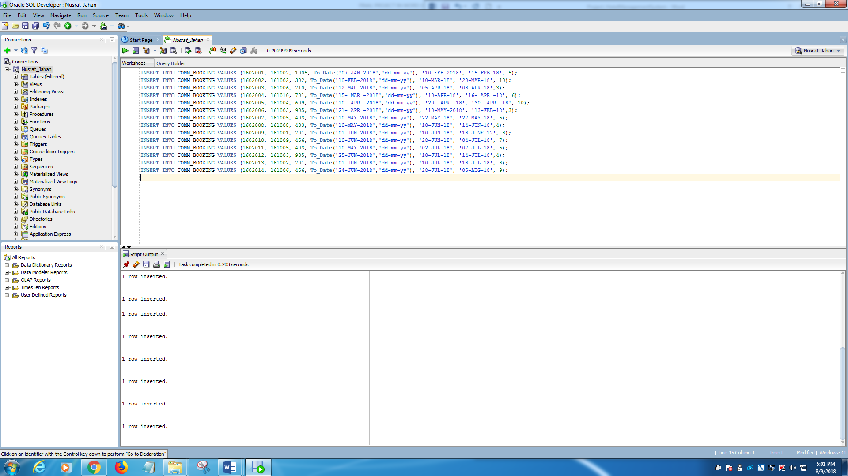

**========COMM_CUS_DETAILS Table========**

INSERT INTO COMM_CUS_DETAILS VALUES (161001, 'ADAM', 'HECK', TO_DATE('26-MARCH-1992', 'DD-MM-YY'), '10 VICTORIA', 'M3J1W7', 'CANADA', '647-111-1111', 'ad@yahoo.com');

INSERT INTO COMM_CUS_DETAILS VALUES (161002, 'DAVID', 'DSUZA', TO_DATE('6-MAY-1990', 'DD-MM-YY'), '20 VICTORIA', 'M3J1W7', 'CANADA', '416-222-2222', 'da@gmail.com');

INSERT INTO COMM_CUS_DETAILS VALUES (161003, 'BARAK', 'OBAMA', TO_DATE('2-JUNE-1972','DD-MM-YY'), '10 DC', 'M-2500', 'USA', '816-333-3333', 'ba@gmail.com');

INSERT INTO COMM_CUS_DETAILS VALUES (161004, 'HILARY', 'CLINTON', TO_DATE('21-JAN-1962','DD-MM-YY'), '103 LOS ANGELS', 'L-2010', 'USA', '816-444-4444', 'hi@yahoo.com');

INSERT INTO COMM_CUS_DETAILS VALUES (161005, 'BOB', 'PATRICK', TO_DATE('10-MARCH-1976','DD-MM-YY'), '10 BAY ', 'M3J5Y6', 'CANADA', '647-555-5555', 'bo@yahoo.com');

INSERT INTO COMM_CUS_DETAILS VALUES (161006, 'YUNUS', 'MIAH', TO_DATE('3-FEB-1979','DD-MM-YY'), '15 VICTORIA', 'M3J1W7', 'CANADA', '416-666-6666', 'yu@gmail.com');

INSERT INTO COMM_CUS_DETAILS VALUES (161007, 'DONALD', 'TRUMP', TO_DATE('12-DEC-1962','DD-MM-YY'), '10 MANHATAN', 'N-2500', 'USA', '816-777-8888', 'do@gmail.com');

INSERT INTO COMM_CUS_DETAILS VALUES (161008, 'ROJINA', 'AKTER', TO_DATE('10-MARCH-1976','DD-MM-YY'), '10 BAY ', 'M3J5Y6', 'CANADA', '647-555-4555', 'ro@yahoo.com');

INSERT INTO COMM_CUS_DETAILS VALUES (161009, 'IBRAHIM', 'KHAN', TO_DATE('3-FEB-1979','DD-MM-YY'), '15 VICTORIA', 'M3J1W7', 'CANADA', '416-666-6356', 'ib@gmail.com');

INSERT INTO COMM_CUS_DETAILS VALUES (161010, 'NUSRAT', 'JAHAN', TO_DATE('12-DEC-1962','DD-MM-YY'), '10 MANHATAN', 'N-2500', 'USA', '816-777-8458', 'nu@yahoo.com');

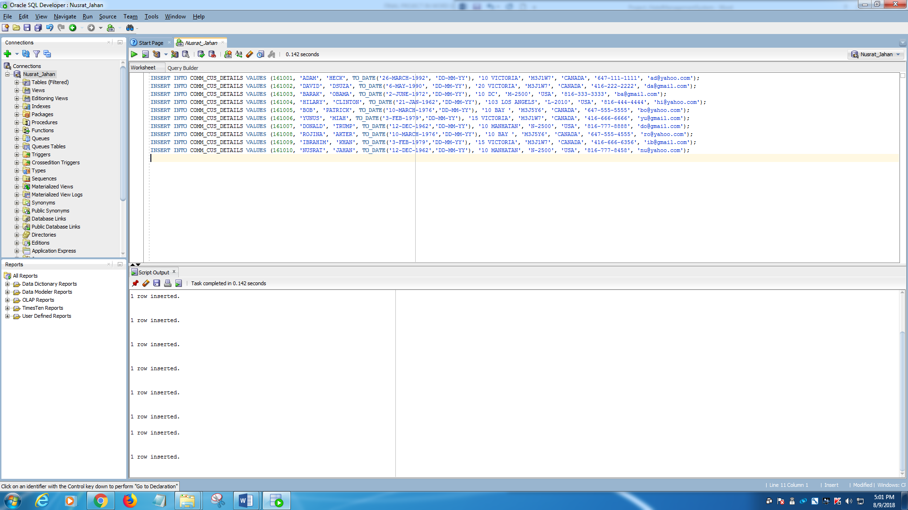

**=========COMM_PAYMENT=========**

INSERT INTO COMM_PAYMENT VALUES (98745621, 161004, 1602005, '547-895-6541', To_Date('10-MAY-2019','dd-mm-yy'));

INSERT INTO COMM_PAYMENT VALUES (92136547, 161006, 1602003, '547-523-3215', To_Date('10-JUN-2021','dd-mm-yy'));

INSERT INTO COMM_PAYMENT VALUES (93547865, 161007, 1602001, '215-965-4156', To_Date('10-JUL-2021','dd-mm-yy'));

INSERT INTO COMM_PAYMENT VALUES (96587413, 161002, 1602004, '798-825-1251', To_Date('10-AUG-2019','dd-mm-yy'));

INSERT INTO COMM_PAYMENT VALUES (98745622, 161008, 1602002, '547-895-6540', To_Date('15-APR-2020','dd-mm-yy'));

INSERT INTO COMM_PAYMENT VALUES (92136548, 161005, 1602006, '547-523-3267', To_Date('11-OCT-2018','dd-mm-yy'));

INSERT INTO COMM_PAYMENT VALUES (93547823, 161003, 1602010, '215-965-4134', To_Date('10-DEC-2018','dd-mm-yy'));

INSERT INTO COMM_PAYMENT VALUES (96587424, 161001, 1602007, '798-825-1250', To_Date('04-AUG-2019','dd-mm-yy'));

INSERT INTO COMM_PAYMENT VALUES (98745625, 161009, 1602009, '547-895-6571', To_Date('20-MAY-2021','dd-mm-yy'));

INSERT INTO COMM_PAYMENT VALUES (92136526, 161010, 1602008, '547-523-5657', To_Date('10-DEC-2018','dd-mm-yy'));

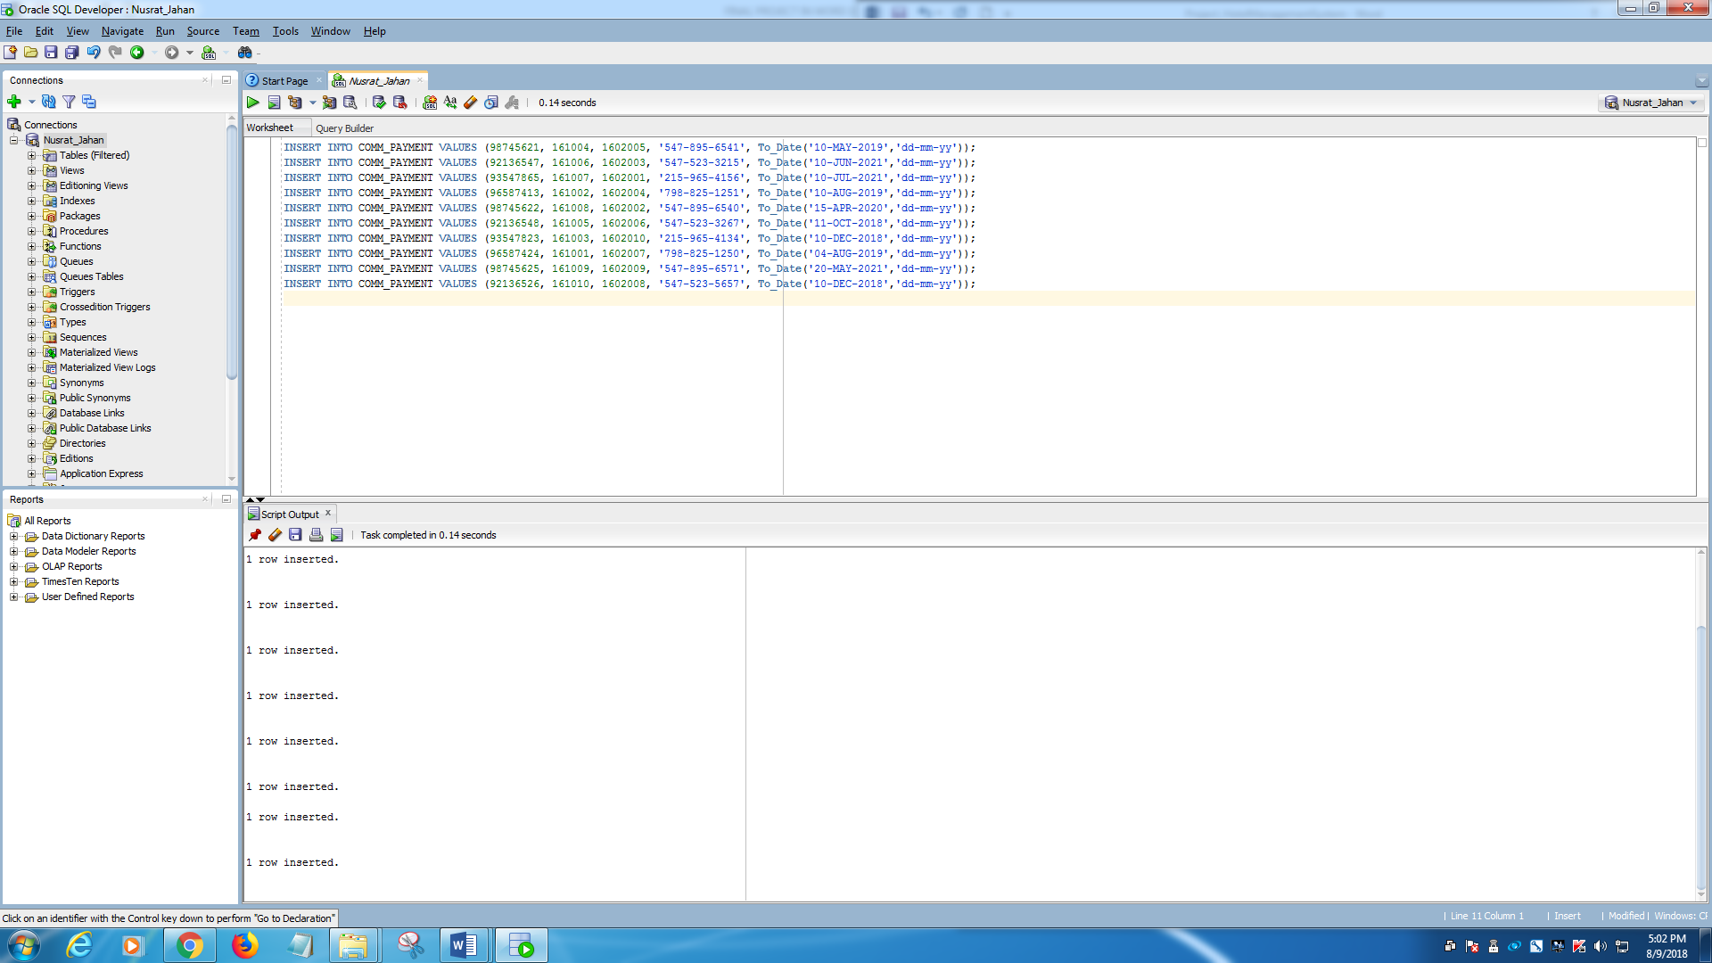

# **CONSTRAINTS**

**======Adding constraint on COMM_EMPLOYEES Table=======**

ALTER TABLE COMM_EMPLOYEES ADD CONSTRAINT HOTELS_HOTELID_FK FOREIGN KEY(HOTEL_ID) REFERENCES COMM_HOTELS(HOTEL_ID);

**======Adding constraint on COMM_ROOMS Table=======**

ALTER TABLE COMM_ROOMS ADD CONSTRAINT ROOMS_HOTELID_FK FOREIGN KEY(HOTEL_ID) REFERENCES COMM_HOTELS(HOTEL_ID);

**======Adding constraint on COMM_BOOKING Table=======**

ALTER TABLE COMM_BOOKING ADD CONSTRAINT BOOKING_CUSTOMERID_FK FOREIGN KEY(CUSTOMER_ID) REFERENCES COMM_CUS_DETAILS(CUSTOMER_ID);

ALTER TABLE COMM_BOOKING ADD CONSTRAINT BOOKING_ROOMNO_FK FOREIGN KEY(ROOM_NO) REFERENCES COMM_ROOMS(ROOM_NO);

**======Adding constraint on COMM_CUS_DETAILS Table=======**

ALTER TABLE COMM_CUS_DETAILS ADD CONSTRAINT CUSDETAILS_EMAIL_UK UNIQUE(EMAIL);

**======Adding constraint on COMM_PAYMENT Table=======**

ALTER TABLE COMM_PAYMENT ADD CONSTRAINT PAYMENT_CUSID_FK FOREIGN KEY(CUSTOMER_ID) REFERENCES COMM_CUS_DETAILS(CUSTOMER_ID);

ALTER TABLE COMM_PAYMENT ADD CONSTRAINT PAYMENT_BOOKINGID_FK FOREIGN KEY(BOOKING_ID) REFERENCES COMM_BOOKING(BOOKING_ID);

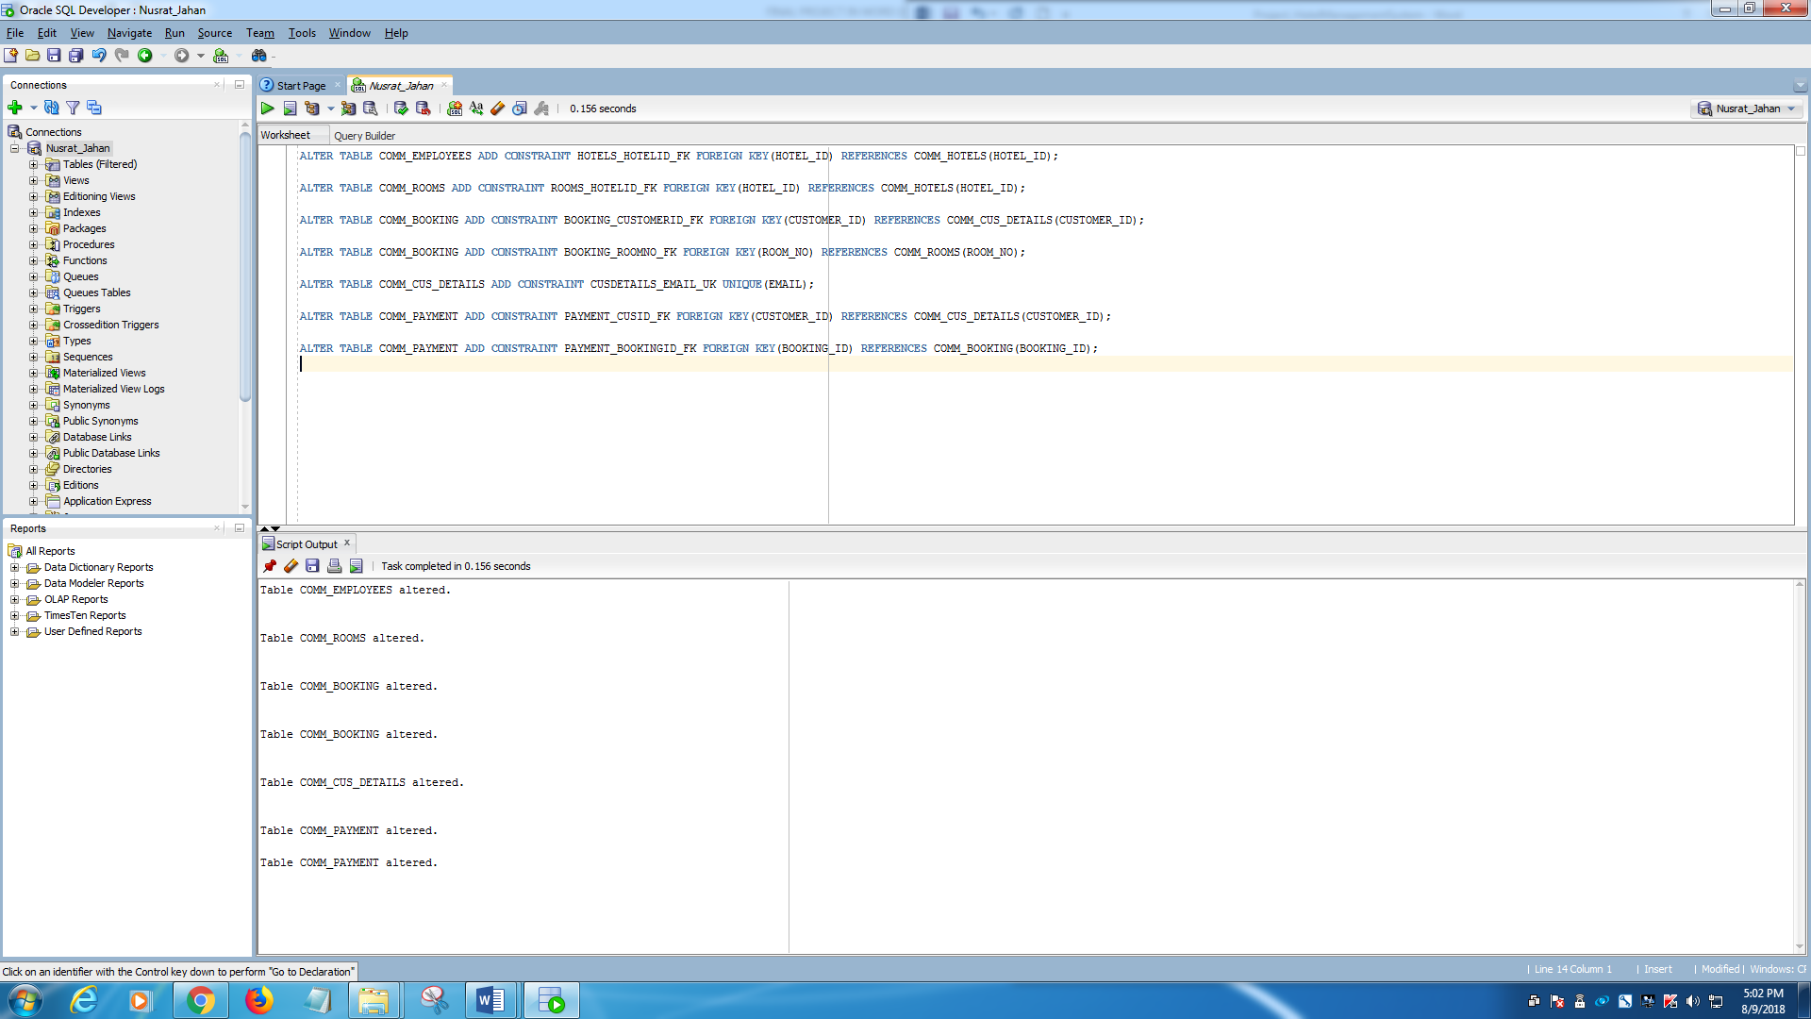

# **SHOW THE TABLES**

**=====COMM_EMPLOYEES Table=====**

SELECT * FROM COMM_EMPLOYEES;

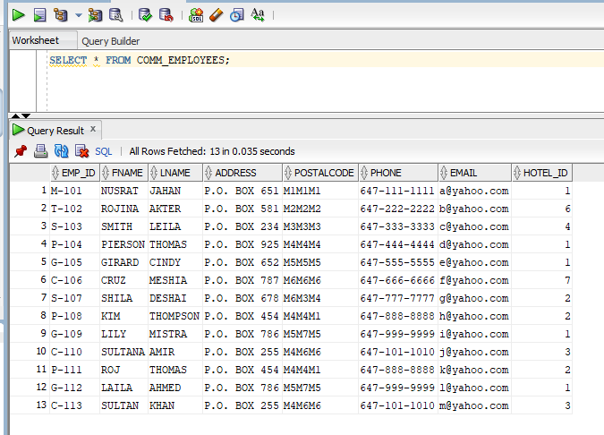

**======COMM_HOTELS Table=======**

SELECT * FROM COMM_HOTELS;

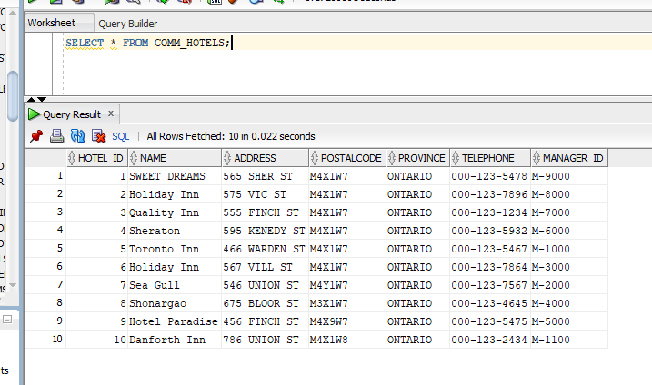

**=======COMM_ROOMS Table=======**

SELECT * FROM COMM_ROOMS;

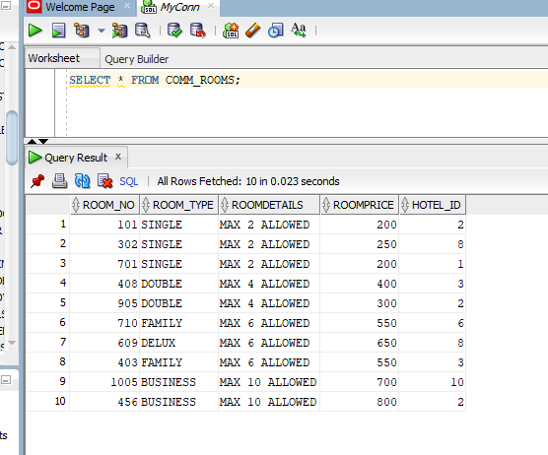

**=======COMM_BOOKING Table=======**

SELECT * FROM COMM_BOOKING;

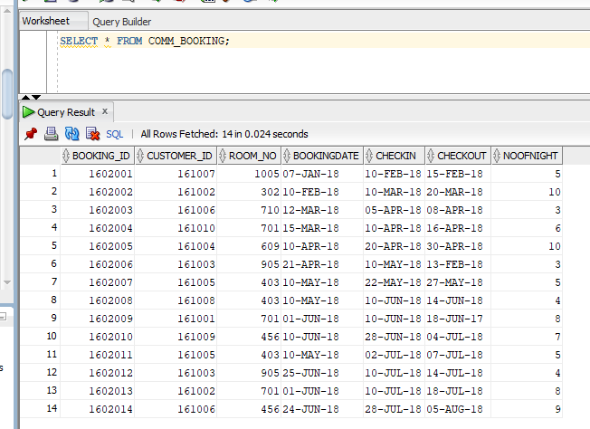

**========COMM_CUS_DETAILS Table=======**

SELECT * FROM COMM_CUS_DETAILS;

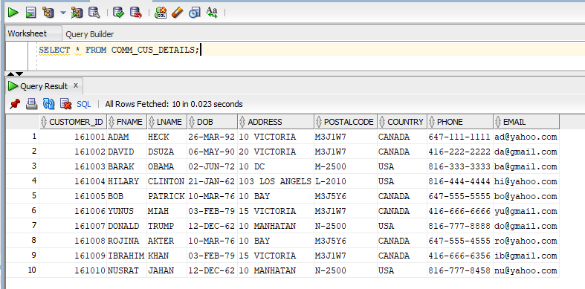

**=======COMM_PAYMENT Table=======**

SELECT * FROM COMM_PAYMENT;

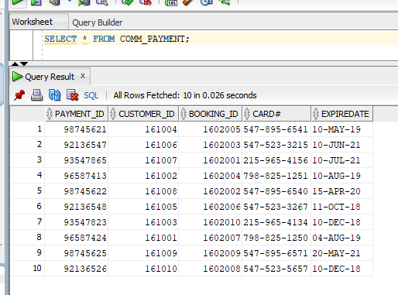

# **TESTING THE DATABASE-SQL QUERY**

## **Listing data from tables using alias for table name:**

SELECT E.FNAME || ' ' || E.LNAME AS "EMPLOYEE NAME", H.NAME, R.ROOM_TYPE, B.BOOKING_ID, B.BOOKINGDATE, P.CUSTOMER_ID

FROM COMM_EMPLOYEES E, COMM_HOTELS H, COMM_ROOMS R, COMM_BOOKING B, COMM_PAYMENT P

WHERE E.HOTEL_ID = H.HOTEL_ID AND H.HOTEL_ID = R.HOTEL_ID AND R.ROOM_NO = B.ROOM_NO AND B.CUSTOMER_ID = P.CUSTOMER_ID;

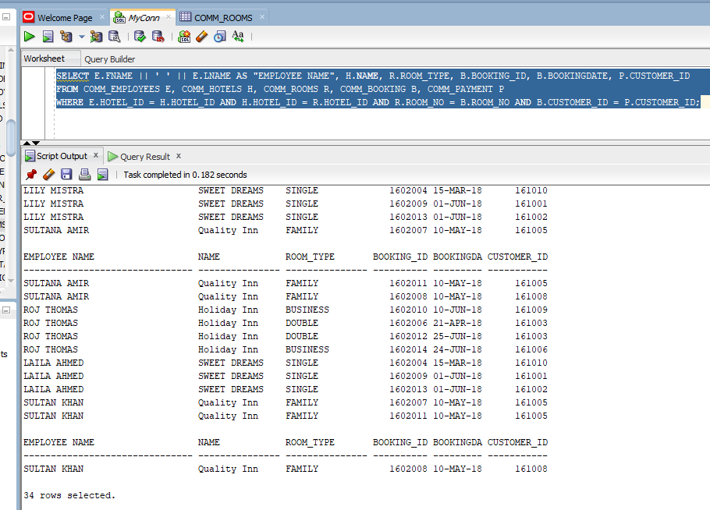

## **List of customer using alias, join, between and LIKE keyword**

SELECT E.EMP_ID, E.FNAME, E.LNAME, E.ADDRESS,H.NAME, B.BOOKING_ID, C.FNAME|| ' ' ||C.LNAME AS "CUSTOMER_NAME",

C.COUNTRY FROM COMM_EMPLOYEES E

JOIN COMM_HOTELS H USING(HOTEL_ID)

JOIN COMM_ROOMS R USING (HOTEL_ID)

JOIN COMM_BOOKING B USING (ROOM_NO)

JOIN COMM_CUS_DETAILS C USING (CUSTOMER_ID)

WHERE E.PHONE LIKE '%6%' AND E.ADDRESS BETWEEN 'P.O. BOX 500' AND 'P.O. BOX 700';

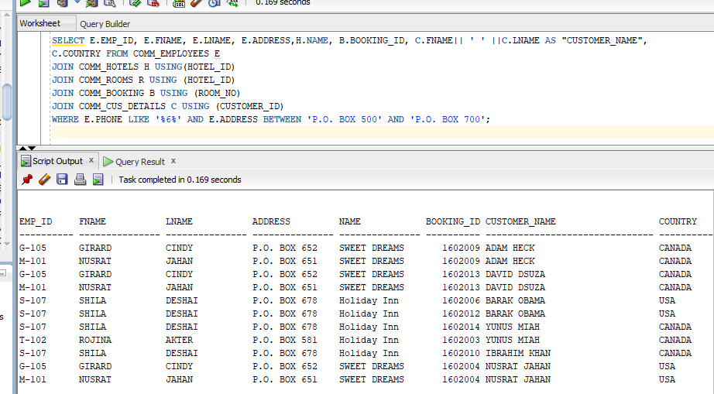

## **Retrieve customer data using between and keyword:**

SELECT C.FNAME, C.LNAME, C.COUNTRY, B.BOOKINGDATE, B.NOOFNIGHT

FROM COMM_CUS_DETAILS C

JOIN COMM_BOOKING B USING (CUSTOMER_ID) WHERE B.BOOKINGDATE

BETWEEN '01-JAN-2018' AND '30-APR-2018';

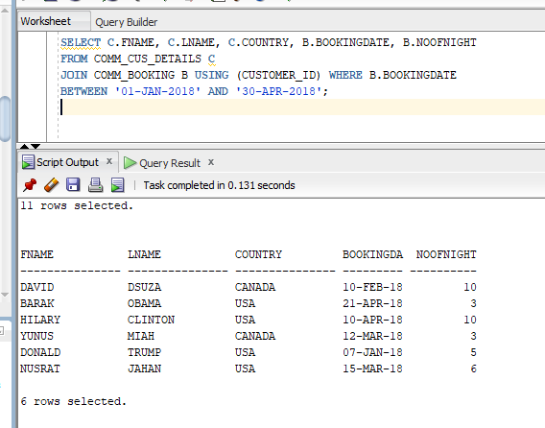

## **Listing customers’ first name, last name, Booking_ID, Room_Type, Booking date from table**

SELECT C.FNAME,C.LNAME,B.BOOKING_ID,R.ROOM_TYPE,B.BOOKINGDATE

FROM COMM_ROOMS R

JOIN COMM_BOOKING B USING(ROOM_NO)

JOIN COMM_CUS_DETAILS C USING(CUSTOMER_ID);

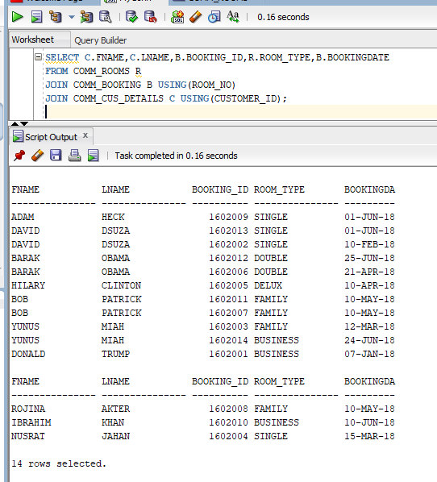

## **Listing hotel’s name, address, rooms’ description, booking date, and customers’ name if a customer’s first name is “Yunus” or “Donald” :**

SELECT H.NAME,H.ADDRESS,R.ROOMDETAILS,B.BOOKINGDATE,C.FNAME|| ' ' ||C.LNAME AS "CUSTOMER NAME",C.COUNTRY

FROM COMM_HOTELS H

JOIN COMM_ROOMS R USING(HOTEL_ID)

JOIN COMM_BOOKING B USING(ROOM_NO)

JOIN COMM_CUS_DETAILS C USING(CUSTOMER_ID)

WHERE C.FNAME = 'ROJINA' OR C.FNAME = 'DONALD' OR C.FNAME = 'NUSRAT';

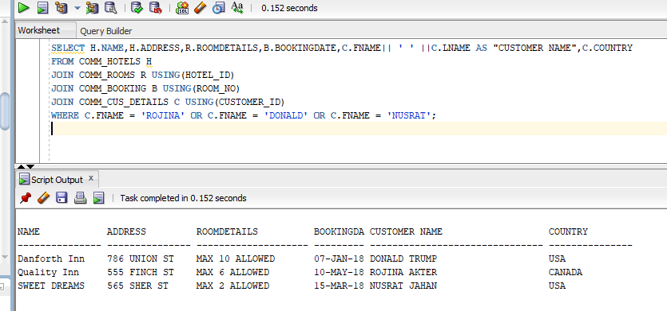

# **TESTING THE DATABASE-PL/SQL QUERY**

## **Creating a Sequence where hotel id will increment by 1**

create sequence COMM_HOTELS_HOTEL_ID#_SEQ

INCREMENT BY 1

START WITH 11

NOCACHE

NOCYCLE;

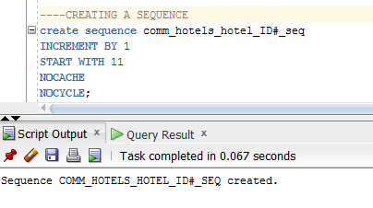

## **Inserting value using sequence- where we inserted a new hotel using the hotel id sequence**

DECLARE

lv_name_txt comm_hotels.name%TYPE := 'RUPOSHI BANGLA';

lv_address_txt comm_hotels.address%TYPE := 'Brimley Rd';

lv_pcode_txt comm_hotels.postalcode%TYPE := 'M1M1V2';

lv_province_txt comm_hotels.province%TYPE := 'ONTARIO';

lv_manid_txt comm_hotels.manager_id%TYPE := '1200';

BEGIN

INSERT INTO comm_hotels(hotel_ID, name, address, postalcode, province, manager_id)

VALUES (comm_hotels_hotel_ID#_seq.NEXTVAL,lv_name_txt, lv_address_txt,lv_pcode_txt,lv_province_txt,lv_manid_txt);

END;

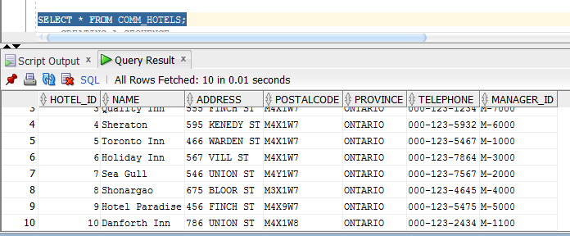

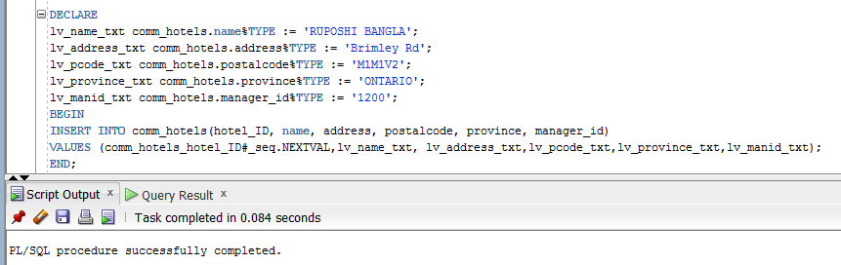

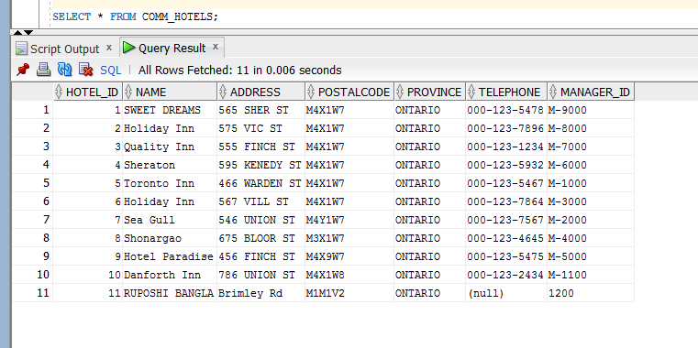

## **Use of %RowType attribute to retrieve the employee information with hotel id 6**

DECLARE

rec_comm_emp comm_employees%ROWTYPE;

BEGIN

SELECT *

INTO rec_comm_emp

FROM comm_employees

WHERE hotel_id = 6;

DBMS_OUTPUT.PUT_LINE(rec_comm_emp.fname);

DBMS_OUTPUT.PUT_LINE(rec_comm_emp.lname);

DBMS_OUTPUT.PUT_LINE(rec_comm_emp.address);

END;

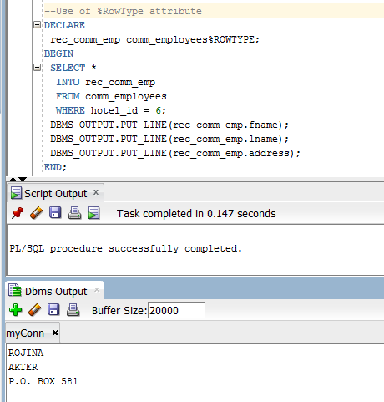

## **Data Insert Using Record – where we inserted a new employee data in the comm_employees table**

DECLARE

rec_comm_emp comm_employees%ROWTYPE;

BEGIN

rec_comm_emp.emp_id := 'S-005';

rec_comm_emp.fname := 'Teas';

rec_comm_emp.lname := 'Premium teas';

rec_comm_emp.address := 'Milady Rd';

rec_comm_emp.postalcode := 'M1MlH2';

rec_comm_emp.phone := '598374598';

rec_comm_emp.email := 'mac@gmail.com';

rec_comm_emp.hotel_id := 4;

INSERT INTO comm_employees

VALUES rec_comm_emp;

END;

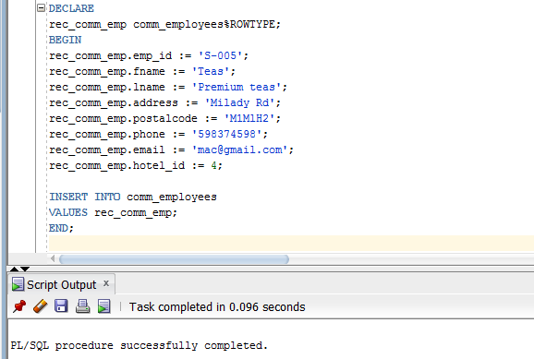

SELECT * FROM comm_employees;

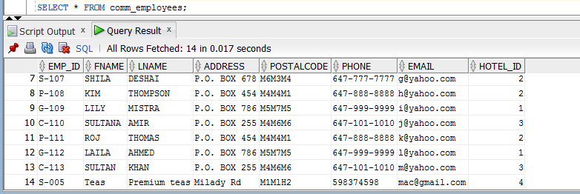

## **Create Function**

CREATE OR REPLACE FUNCTION comm_cust_f

(p_id IN NUMBER,

p_first IN VARCHAR2,

p_last IN VARCHAR2,

p_phone IN VARCHAR2,

p_email IN VARCHAR2)

RETURN VARCHAR2

IS

lv_custinfo_txt VARCHAR2(255);

BEGIN

lv_custinfo_txt := 'Customer: ' || p_id || ' - ' || p_first

|| ' ' || p_last || ' ' || 'Phone: ' || p_phone || ' ' || 'Email: ' || p_email;

RETURN lv_custinfo_txt;

END;

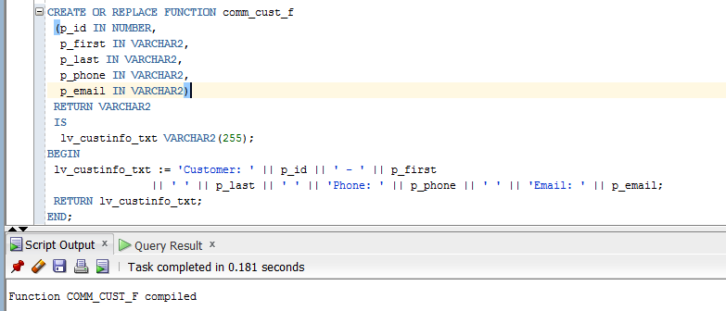

## **Display the customer details using the function created**

DECLARE

lv_cusDetail_txt VARCHAR2 (255);

lv_id_num comm_cus_details.customer_id%TYPE := 161005;

lv_first_txt comm_cus_details.fname%TYPE := 'BOB';

lv_last_txt comm_cus_details.lname%TYPE := 'PATRICK';

lv_phone_txt comm_cus_details.phone%TYPE := '647-555-5555';

lv_email_txt comm_cus_details.email%TYPE := 'bo@yahoo.com';

BEGIN

lv_cusDetail_txt := comm_cust_f(lv_id_num, lv_first_txt, lv_last_txt,lv_phone_txt,lv_email_txt);

DBMS_OUTPUT.PUT_LINE(lv_cusDetail_txt);

END;

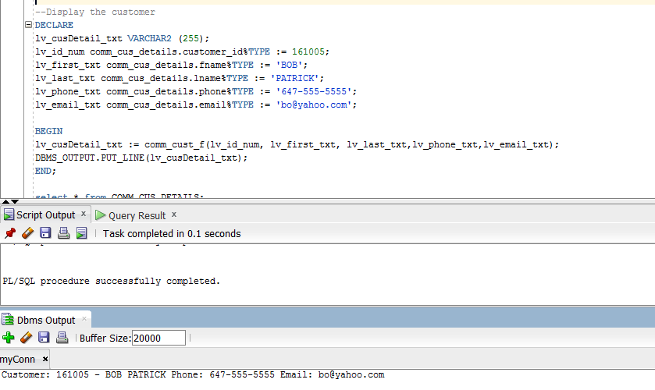

## **User define exception for room price with hotel ID 1 and 9**

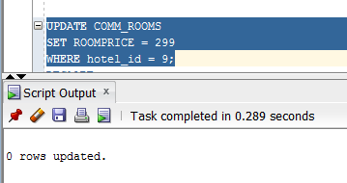

DECLARE

ex_prod_update EXCEPTION;

BEGIN

UPDATE COMM_ROOMS

SET roomprice=225

WHERE hotel_id = 1;

IF SQL %NOTFOUND THEN

RAISE ex_prod_update;

END IF;

EXCEPTION

WHEN ex_prod_update THEN

DBMS_OUTPUT.PUT_LINE('Hotel ID not found);

END;

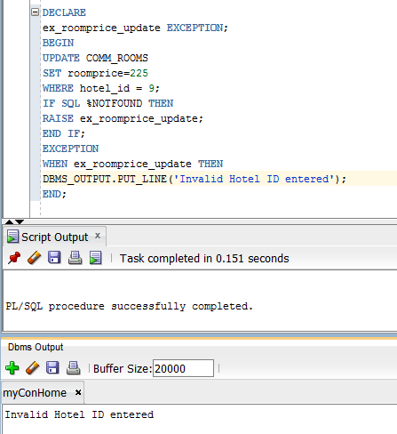

SELECT * FROM COMM_ROOMS;

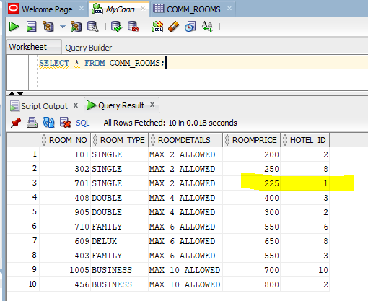

**User define exception for room price for hotel id 9**

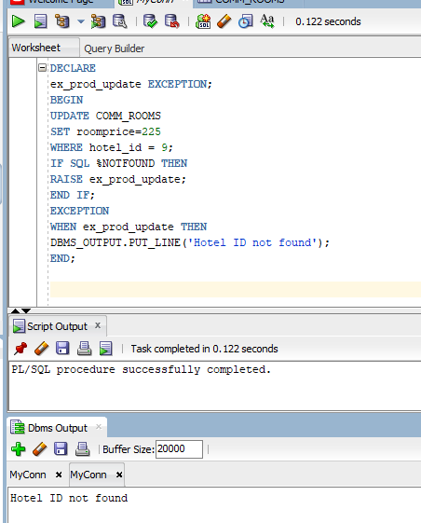

## **Creating Procedure with room type**

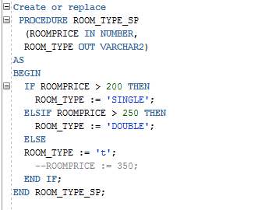

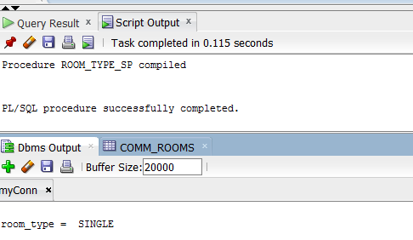

## **Creating Cursor and displaying details of rooms available in the hotel Holiday Inn**

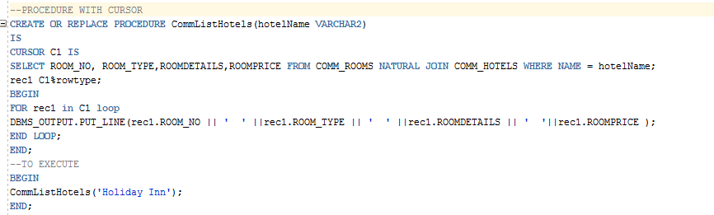

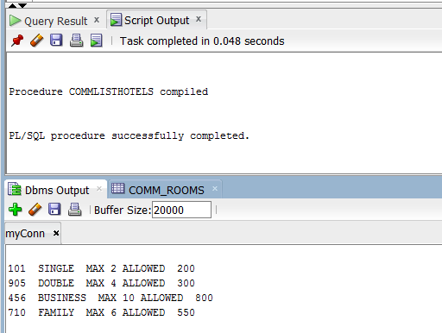

## **Creating Package and displaying customers last name according to customer id**

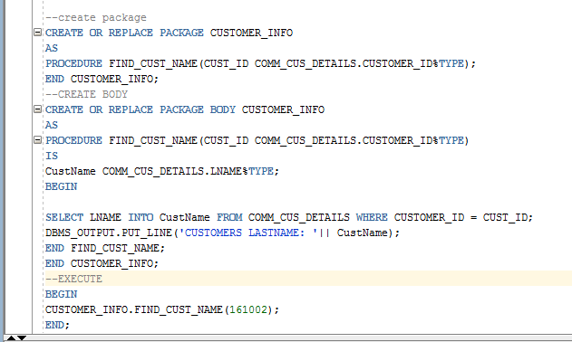

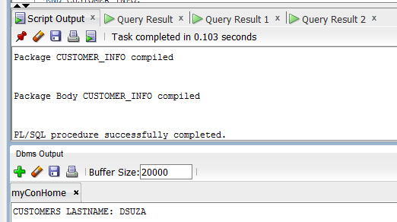

# **CONCLUSION**

From the database, any or all created tables can be deleted by DROP Clause in the following way:

DROP TABLE COMM_EMPLOYEES CASCADE CONSTRAINTS;

DROP TABLE COMM_HOTELS CASCADE CONSTRAINTS;

DROP TABLE COMM_ROOMS CASCADE CONSTRAINTS;

DROP TABLE COMM_BOOKING CASCADE CONSTRAINTS;

DROP TABLE COMM_CUS_DETAILS CASCADE CONSTRAINTS;

DROP TABLE COMM_PAYMENT CASCADE CONSTRAINTS;

**\*\*\*\*\*\*\*\*\*\*\*\*\*\*\*\*\*\*\*\*\*\*\*\*\*\*\*\*\*\*\*\*\*\*\***