**DL-IDF: Deep Learning Based Intrusion Detection Framework in Industrial Internet of Things**

This project evaluates the performance of various classical algorithms such as SVM, Random Forest and Naive Bayes etc to detect attacks on network using IDS datasets such KDD, NSL but this classical algorithms unable to predict dynamic (if attacker introduce new attacks with changes in attack parameter) attacks and need to be trained in advance to detect such attacks to overcome from this problem author has evaluate performance of Deep Neural Network (DNN) algorithm with dynamic attack signatures and detection accuracy of DNN shown to be better compare to all classical algorithms.

Here to implement this paper, KDD and NSL dataset combination is used with SVM, Random Forest and DNN algorithm with input hidden layer as 8. DNN algorithm keep filtering training algorithm with hidden layer to form most accurate model to predict testing class. DNN is a famous algorithm which has high predicting ratio in all fields such as image processing, data classification etc.

Below are the column names of dataset

duration,protocol_type,service,flag,src_bytes,dst_bytes,land,wrong_fragment,urgent,hot,num_failed_logins,logged_in,num_compromised,root_shell,su_attempted,num_root,num_file_creations,num_shells,num_access_files,num_outbound_cmds,is_host_login,is_guest_login,count,srv_count,serror_rate,srv_serror_rate,rerror_rate,srv_rerror_rate,same_srv_rate,diff_srv_rate,srv_diff_host_rate,dst_host_count,dst_host_srv_count,dst_host_same_srv_rate,dst_host_diff_srv_rate,dst_host_same_src_port_rate,dst_host_srv_diff_host_rate,dst_host_serror_rate,dst_host_srv_serror_rate,dst_host_rerror_rate,dst_host_srv_rerror_rate,label

In above dataset columns label is the name of attacks, all above comma separated names in bold format are the names of request signature

Below are the values of above dataset columns

0,tcp,ftp_data,SF,491,0,0,0,0,0,0,0,0,0,0,0,0,0,0,0,0,0,2,2,0,0,0,0,1,0,0,150,25,0.17,0.03,0.17,0,0,0,0.05,0,normal

0,tcp,private,S0,0,0,0,0,0,0,0,0,0,0,0,0,0,0,0,0,0,0,166,9,1,1,0,0,0.05,0.06,0,255,9,0.04,0.05,0,0,1,1,0,0,Neptune

Above two records are the signature values and last value contains class label such as normal request signature or attack signature. In second record ‘Neptune’ is a name of attack. Similarly in dataset you can find nearly 30 different names of attacks.

In above dataset records we can see some values are in string format such as tcp, ftp_data and these values are not important for prediction and these values will be remove out by applying PREPROCESSING Concept. All attack names will not be identified by algorithm if it’s given in string format, so we need to assign numeric value for each attack. All this will be done in PREPROCESS steps and then new file will be generated called ‘clean.txt’ which will use to generate training model.

In below line i am assigning numeric id to each attack

"normal":0,"neptune":1,"warezclient":2,"ipsweep":3,"portsweep":4,"teardrop":5,"nmap":6,"satan":7,"smurf":8,"pod":9,"back":10,"guess_passwd":11,"ftp_write":12,"multihop":13,"rootkit":14,"buffer_overflow":15,"imap":16,"warezmaster":17,"phf":18,"land":19,"loadmodule":20,"spy":21,"perl":22,"saint":23,"mscan":24,"apache2":25,"snmpgetattack":26,"processtable":27,"httptunnel":28,"ps":29,"snmpguess":30,"mailbomb":31,"named":32,"sendmail":33,"xterm":34,"worm":35,"xlock":36,"xsnoop":37,"sqlattack":38,"udpstorm":39

In above lines we can see normal is having id 0 and Neptune 1 and goes on for all attacks.

In paper author describe about Normal, R2L, DOS, U2R, DOS, Probe but in dataset we have other names but all those names comes under 5 categories such as Normal, R2L, DOS, U2R, DOS, Probe. See below screen shots

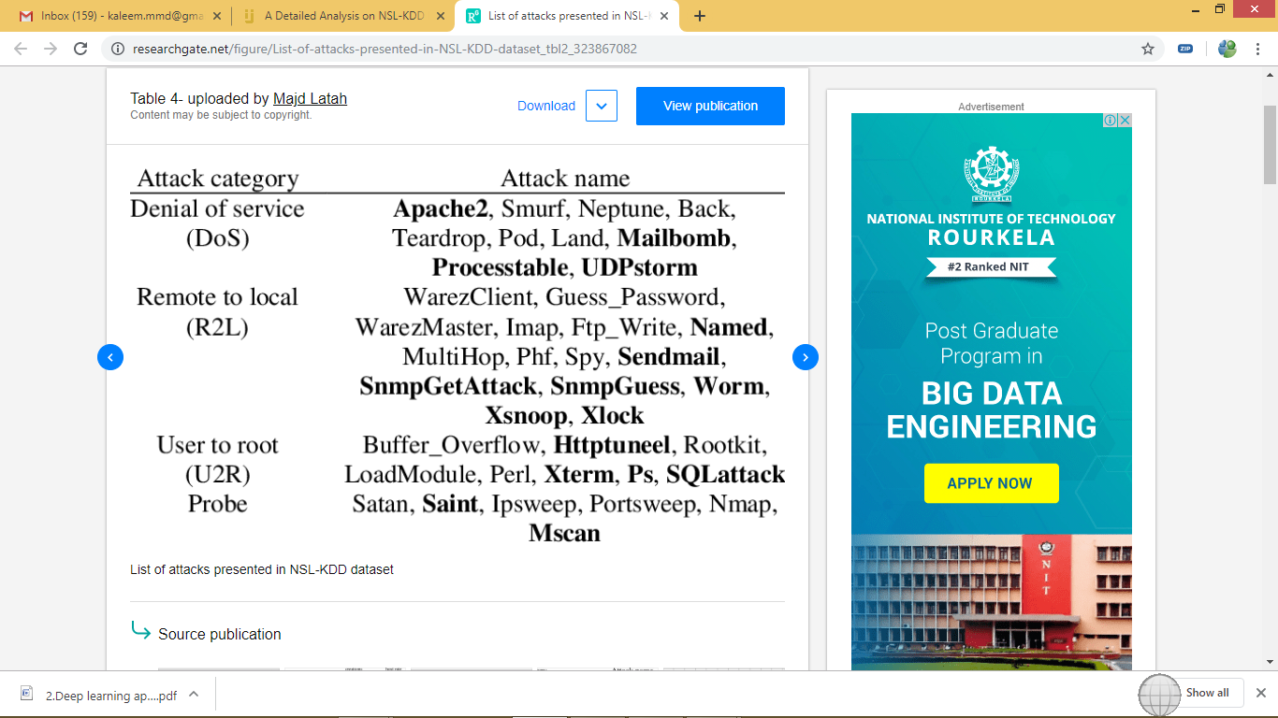

From above screen shots we can understand that Neptune attack belongs to DOS category. Similarly other attacks belong to different categories

Screen shots

Double click on ‘run.bat’ file to get below screen

In above screen click on ‘Upload NSL KDD Dataset’ button to upload dataset. After uploading dataset will get below screen

Now click on ‘Preprocess Dataset’ button to assign numeric values to each attack names as algorithms will not understand string names. Dataset size is huge so wait for some time to get below screen

In above screen we can see we assign numeric id to each attack and will get below graph which display number of different attacks.

In above graph x-axis represents attack name found in dataset and y-axis represents count of that attack type and now close above graph and then click on ‘Generate Training Model’ button to split dataset into train and test part where application used 80% dataset to train algorithms and 20% to test algorithms prediction accuracy

In above screen we can see dataset contains total 10137 records and application using 8109 records for training and 2028 records for testing algorithm prediction accuracy. Now train and test data is ready and click on ‘Run SVM Algorithm’ to get its prediction accuracy

In above screen with SVM we got 52.26% accuracy and scroll down above screen text area to get confusion matrix. Now click on ‘Run Random Forest Algorithm’ button to get its accuracy

In above screen we can see random forest got 52.31% accuracy. Now run DNN Algorithm

In above screen we can see DNN accuracy is 92.44% which is better than other two algorithms. DNN algorithm accuracy may be varied different times as it hidden layer will be chosen randomly from dataset. Now click on ‘Accuracy Graph’ button to get below graph

In above graph x-axis represents algorithm name and y-axis represents accuracy and DNN is the proposed technique which got high accuracy compared to traditional algorithms such SVM and random forest.