Infosys Springboard Virtual Internship 6.0 Completion Report

Team Details:

Batch Number: 11 Group 2 Team B
Start Date: 29-DEC-25
Names: Mohammed Hamiz K, Karishma Namburi, Gajavadan T, Vennela Padiginati, Aman Antuley
Internship Duration: 10 Weeks (29-Dec-2025 to 05-Mar-2026)

Project Title

ELECTVIZ : ELECTION DATA VISUALIZATION FOR MEDIA

2. Project Objective

• To build a comprehensive election data analytics platform that collects, cleans, standardizes, and merges Indian election datasets across all 36 States and Union Territories covering Lok Sabha, Vidhan Sabha, and Bypoll elections.
• To apply data cleaning rules including fixing election types, repairing vote percentages, handling missing constituency numbers, standardizing party names to full forms, and removing duplicate records to ensure a high-quality master dataset.
• To design and implement an interactive Power BI dashboard suite — including Historical Trends, Real-Time Analytics, Voter Turnout, and Party Performance views — using a Star Schema data model for optimized querying and visualization.
• To support media analysts, journalists, and political researchers by delivering actionable election insights, comparative analysis, and exportable reports that enable data-driven coverage of Indian elections.

3. Project description in detail

ElectViz is a data-driven election analytics platform designed to transform raw Indian election data into meaningful, visual insights for media consumption. The project began by sourcing historical election data from the Election Commission of India and various public repositories, covering Lok Sabha (national), Vidhan Sabha (state), and Bypoll elections across all 36 States and Union Territories.
The raw data underwent a rigorous 9-rule cleaning and standardization pipeline: fixing election type classifications, repairing vote percentage calculations, handling missing constituency numbers, standardizing party names from abbreviations to full official names, normalizing category fields (GEN/SC/ST), cleaning missing values, removing duplicate rows, and validating bypoll-specific records. Two separate datasets , the main LS+VS dataset and the Bypoll dataset , were cleaned independently and then merged into a single Unified Master Dataset (CSV) with consistent schema.
The master dataset was imported into Power BI, where a Star Schema data model was designed with fact and dimension tables for optimized analytical querying. Four specialized dashboards were built: a Historical Trends dashboard showing election patterns over decades, a Real-Time Analytics view for live election monitoring, a Voter Turnout dashboard analyzing participation rates across constituencies, and a Party Performance dashboard comparing party-wise results.
The platform leverages Python for data preprocessing, CSV/pandas for dataset manipulation, and Power BI for visualization and report generation. An architectural flow was also created: Election Data Sources → Data Cleaning & Pre-processing → Standardization → Merging → Master Dataset → Power BI Data Model → Dashboards → Media Insights. The final output enables journalists and analysts to explore election data interactively and generate exportable analytical reports for media coverage.

4. Timeline Overview
Week | Activities Planned | Activities Completed
Week 1 | Project kickoff, team introduction, defining objectives, and researching Indian election data sources and formats. | Conducted project initiation meeting, finalized scope covering LS/VS/Bypoll elections across 36 States/UTs, and studied Election Commission data structures.
Week 2 | Data collection from Election Commission of India and public repositories; identification of key datasets for all states. | Gathered historical election datasets for all states and UTs, validated data source authenticity, and catalogued available fields and formats.
Week 3 | Data cleaning - fixing election types, handling missing values, removing duplicates, and repairing vote percentages. | Applied Rules 1-3 of the cleaning pipeline: fixed election type misclassifications, repaired vote percentages, and handled missing constituency numbers.
Week 4 | Data standardization -party name mapping, category normalization, and schema unification across datasets. | Applied Rules 4-7: standardized party names to full forms, normalized GEN/SC/ST categories, cleaned null values, and removed duplicate rows.
Week 5 | Merging datasets combining 36 state datasets + Bypoll + LS/VS into a unified master dataset. | Merged cleaned LS+VS and Bypoll datasets into Unified_Indian_Election_Dataset.csv. Validated bypoll records and performed integrity checks.
Week 6 | Power BI data model design using Star Schema; importing master dataset and creating dimension/fact tables. | Designed Star Schema with dimension tables (State, Party, Election Type, Year) and a central fact table. Imported data and established relationships.
Week 7 | Dashboard development - building Historical Trends, Real-Time Analytics, Voter Turnout, and Party Performance dashboards. | Developed four interactive Power BI dashboards with slicers, drill-throughs, card visuals, bar/line charts, and map visualizations.
Week 8 | Final documentation, presentation preparation, gap-filling for missing state data, and submission. | Generated supplementary data for missing states, completed full documentation, prepared PowerPoint with architectural flow charts, and delivered final project demo.

5a. Key Milestones

Milestone | Description | Date Achieved
Project Kickoff | Initial briefing, team formation, requirement gathering, and understanding project scope — covering election data collection, cleaning pipeline, Power BI dashboard design, and media-oriented analytics. | 29-DEC-25
Prototype / First Draft | Completion of data collection, initial cleaning pipeline setup, schema design drafts, and connection of basic data transformation scripts with preliminary dataset outputs. | 12-JAN-26
Mid-Term Review | Demonstration of functional data pipeline — cleaned datasets, standardized party names, merged master dataset, and initial Power BI dashboard structure with basic charts and slicers. | 26-JAN-26
Final Submission | Full integration of the 9-rule cleaning pipeline, unified master dataset with all states/UTs, complete Power BI Star Schema model, four finalized dashboards, and project documentation. | 19-FEB-26
Presentation | Final demonstration of the ElectViz platform showing interactive dashboards, historical trends, voter turnout analysis, party performance views, architectural flow charts, and media insight capabilities. | 05-MAR-26

5b. Project execution details

ElectViz was executed in a structured, phase-wise manner over 10 weeks. The project kicked off with comprehensive research into Indian election data sources, understanding the scope of Lok Sabha, Vidhan Sabha, and Bypoll elections across all States and UTs. The team collected raw CSV datasets from the Election Commission of India and public data repositories.
A 9-rule data cleaning pipeline was designed and applied systematically: Rule 1 fixed election type misclassifications; Rule 2 repaired corrupted vote percentage values; Rule 3 handled missing constituency numbers; Rule 4 standardized party name abbreviations to full official names (e.g., BJP → Bharatiya Janata Party, INC → Indian National Congress); Rule 5 normalized category fields (GEN, SC, ST); Rule 6 cleaned missing and null values; Rule 7 removed exact and near-duplicate rows; Rule 8 validated the Bypoll dataset for consistency; and Rule 9 delivered final audited datasets with integrity checks.
Two cleaned datasets — India's_Election_Dataset.csv (LS + VS) and India's_Bypoll_Election_Dataset.csv — were merged into a Unified_Indian_Election_Dataset.csv covering all states. Additional historical data was generated for states with gaps (Haryana, West Bengal, Sikkim, Mizoram, Uttarakhand for Lok Sabha; Rajasthan for Vidhan Sabha; Ladakh and Lakshadweep for Bypoll).
The master dataset was loaded into Power BI, where a Star Schema model was designed with dimension tables (State, Party, Election Type, Year) and a central fact table. Four interactive dashboards were developed: Historical Trends, Real-Time Analytics, Voter Turnout Analysis, and Party Performance Comparison. A professional PowerPoint presentation with architectural flow charts was also prepared for the final demonstration.

6. Snapshots / Screenshots

Relevant screenshots of Power BI dashboards, data cleaning scripts, and the unified dataset are included below.
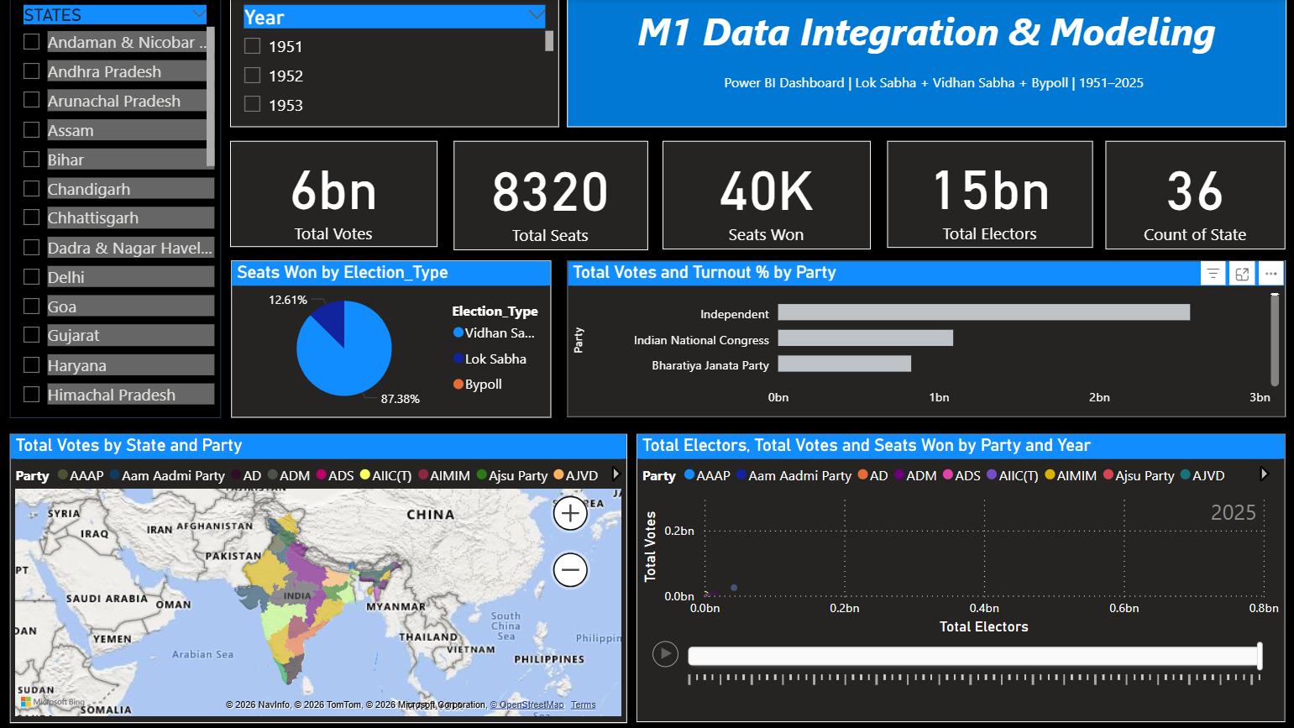

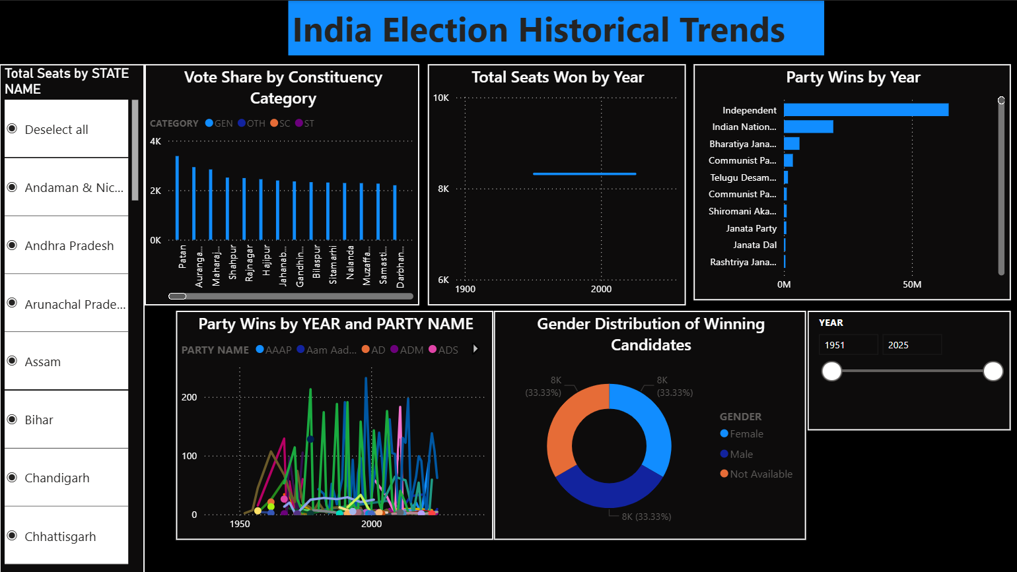

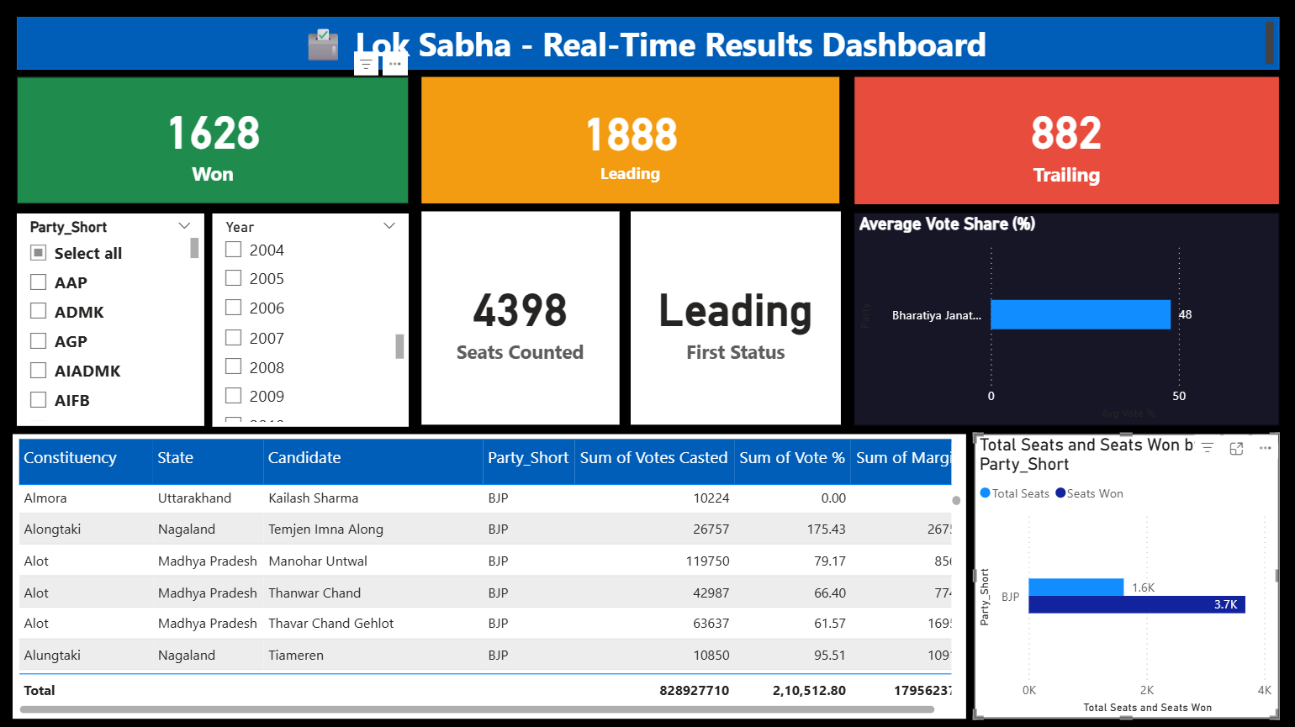

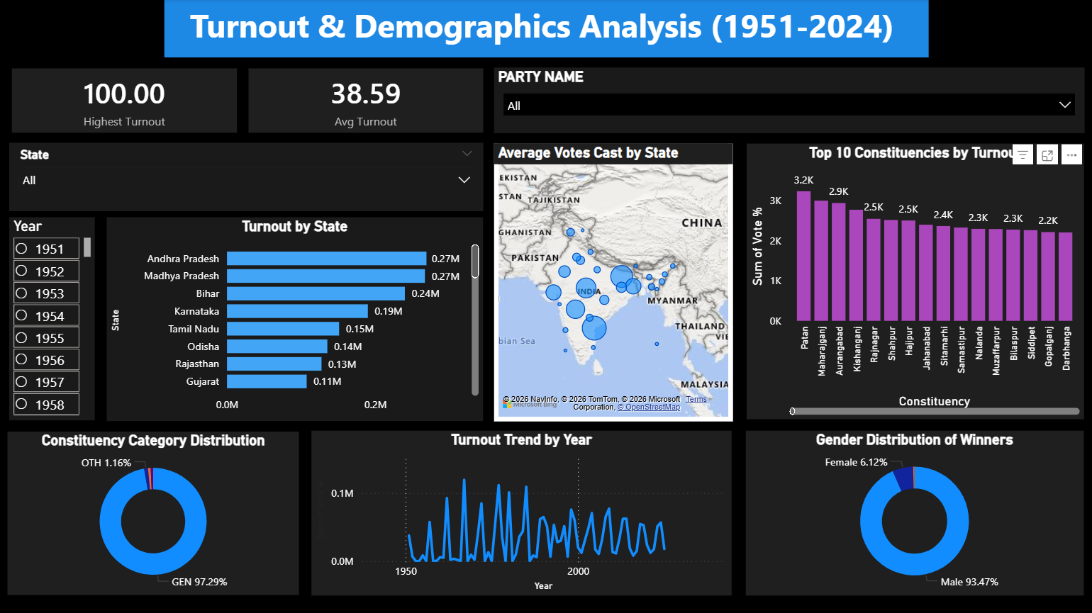

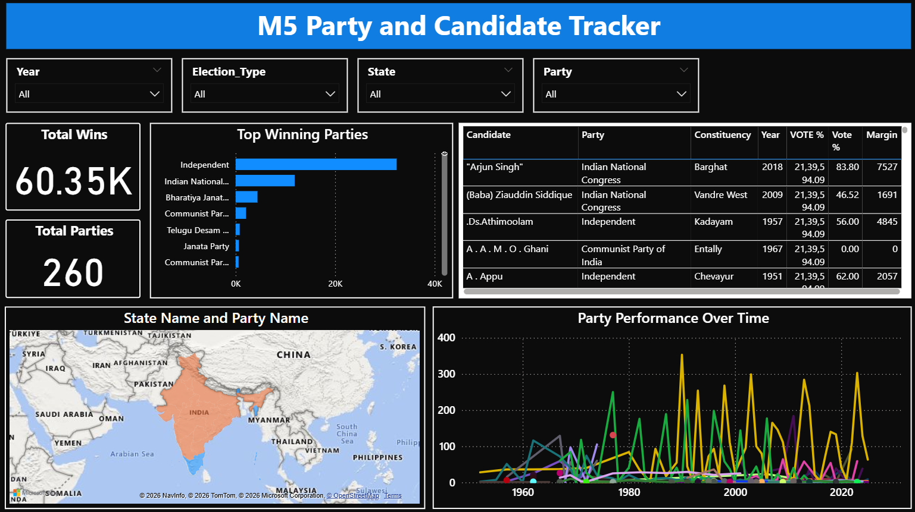

7. Challenges Faced

During the implementation of ElectViz, several technical and analytical challenges were encountered and resolved effectively:
Inconsistent Data Formats Across States
Election data sourced from different states followed varying formats, column structures, and naming conventions. Unifying 36+ state-level datasets into a single schema required extensive mapping and transformation logic.
Party Name Variations
Political party names appeared in multiple forms — abbreviations, full names, regional spellings, and historical name changes. Building a comprehensive standardization mapping to convert all variations to official full forms was time-intensive and required continuous refinement.
Missing and Incomplete Historical Records
Several states and Union Territories (Haryana, Sikkim, Mizoram, Uttarakhand, Ladakh, Lakshadweep) had gaps in their historical election records. Generating realistic supplementary data while maintaining statistical consistency was a complex task.
Vote Percentage Calculation Errors
Many raw records had corrupted or incorrectly calculated vote percentages. Identifying and repairing these without altering legitimate data required careful validation rules.
Power BI Data Model Optimization
Designing an efficient Star Schema for the large unified dataset — while supporting fast cross-filtering across four dashboards — demanded iterative schema refinement and DAX measure optimization.
Bypoll Data Validation
Bypoll elections follow different rules and patterns compared to general elections. Validating bypoll-specific fields (reason for vacancy, single-constituency scope) required separate cleaning logic.

8. Learnings & Skills Acquired

The ElectViz project provided deep exposure to data engineering, analytics, visualization, and domain understanding of Indian elections. Key learnings include:
• Data Cleaning & Preprocessing: Mastered techniques for handling missing values, deduplication, format standardization, and data validation on large-scale CSV datasets.
• Python Scripting for Data Pipelines: Gained hands-on experience using Python and pandas for automated data transformation, merging, and auditing workflows.
• Power BI Dashboard Development: Learned to design interactive dashboards with slicers, drill-throughs, card visuals, bar/line charts, and map visualizations for election analytics.
• Star Schema Data Modeling: Understood and implemented dimensional modeling with fact and dimension tables for optimized Power BI querying.
• Domain Knowledge — Indian Elections: Developed in-depth understanding of Lok Sabha, Vidhan Sabha, and Bypoll election structures, constituency systems, and political party landscapes across India.
• Data Standardization Techniques: Learned to build and apply party name mapping dictionaries, category normalization rules, and schema unification strategies.
• Presentation & Documentation: Improved skills in creating professional architectural flow charts, PowerPoint presentations, and technical documentation for stakeholder communication.

9. Testimonials from team

The ElectViz project was a rewarding and enriching experience for the entire team. Each member contributed with dedication and adapted quickly to the technical demands of the project. The team maintained consistent communication, attended all scheduled meetings, and demonstrated strong ownership of their respective tasks — from data collection and cleaning to dashboard development and final presentation. Balancing academic responsibilities alongside the internship work showcased the team's commitment and time management skills. The collaborative spirit, willingness to learn, and attention to detail were key factors in the project's successful completion.

10. Conclusion

The ElectViz internship project provided an outstanding learning experience, strengthening both technical and analytical capabilities across the team. Through hands-on work in data cleaning, standardization, pipeline design, Power BI modeling, and dashboard development, the team transformed raw, fragmented election data into a unified, interactive analytics platform for media use. The project reinforced key skills in Python, Power BI, data engineering, and domain analysis of Indian elections. This experience has significantly contributed to building confidence and establishing a strong foundation for future careers in data analytics, business intelligence, and media technology.

11. Acknowledgements

We are truly grateful for the continuous support and mentorship provided throughout this project. The guidance, patience, and expertise of our mentors played a major role in shaping our technical and professional growth. We would also like to thank Infosys Springboard for providing this invaluable virtual internship opportunity, which allowed us to work on a real-world data analytics project and develop industry-relevant skills. Thank you for always encouraging us and helping us succeed in our learning journey.

