P = [0 0 0 0.4 0.3 0 0 0.3;

0.5 0.3 0 0.2 0 0 0 0;

0 0.2 0.3 0.2 0 0.3 0 0;

0 0 0.5 0 0.4 0.1 0 0;

0 0.2 0.3 0.2 0 0.3 0 0;

0.2 0.3 0 0 0.3 0 0 0.2;

0.3 0 0 0.4 0.3 0 0 0;

0.1 0.2 0.5 0 0 0.2 0 0];

mc = dtmc(P);

figure;

graphplot(mc,'ColorNodes',true);

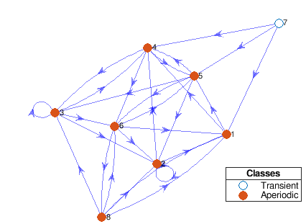

figure;

distplot(lc,X1,'Type','histogram','FrameRate',1)

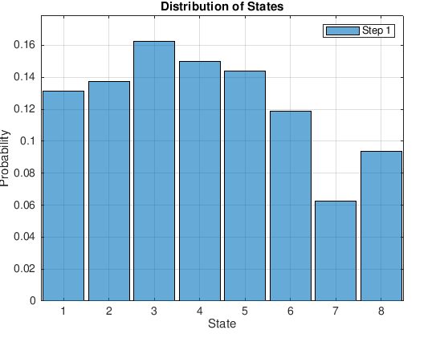

P = [0.3 0.7 0 0 0 0 0 0;

0.5 0.5 0 0 0 0 0 0;

0 0.2 0.5 0.2 0 0.1 0 0;

0 0 0.8 0 0.2 0 0 0;

0 0.6 0.3 0 0 0 0.1 0;

0 0.9 0.1 0 0 0 0 0;

0 0 0 0.4 0.6 0 0 0;

0 0.2 0.5 0 0 0.2 0 0.1];

mc = dtmc(P);

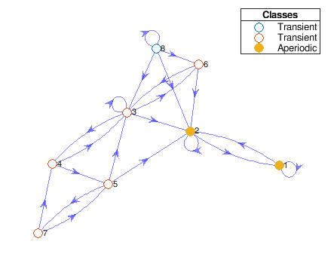

figure;

distplot(lc,X1,'Type','histogram','FrameRate',1)

xlim({'1','8'})

ylim([0.038 0.466])

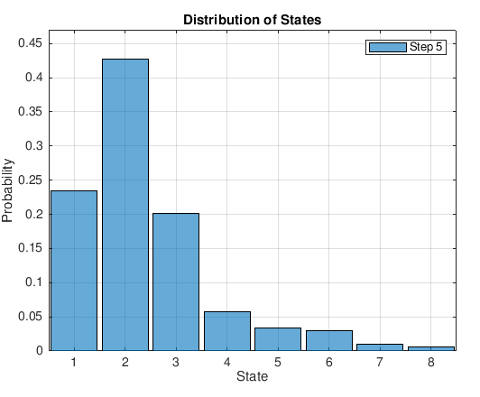

figure;

graphplot(mc,'ColorNodes',true);

xlim([-2.22 2.93])

ylim([-1.77 1.94])

P = [ 0.9 0 0 0 0 0 0 0.1;

0.5 0.3 0 0 0 0 0.2 0;

0 0 0.3 0.2 0 0.3 0.2 0;

0 0 0 0 0.4 0.4 0 0.2;

0 0.2 0.7 0 0 0 0.1 0;

0 0.3 0.5 0 0 0 0 0.2;

0.5 0 0 0.4 0.1 0 0 0;

0 0.2 0.6 0 0 0.2 0 0 ];

mc = dtmc(P);

figure;

distplot(lc,X1,'Type','histogram','FrameRate',1)

xlim({'1','8'})

ylim([0.030 0.316])

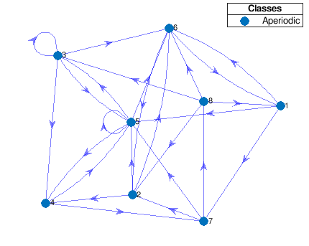

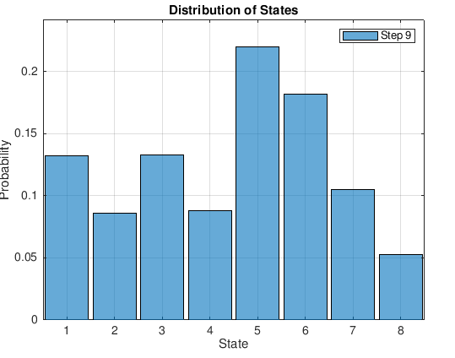

P = [ 0 0 0.3 0 0.3 0 0.4 0;

0 0.3 0 0.2 0 0.5 0 0;

0 0.2 0 0.2 0 0.3 0 0.3;

0.5 0 0 0.1 0.4 0 0 0;

0 0.2 0 0 0.5 0 0.3 0;

0 0 0.2 0 0.3 0 0.3 0.2;

0.3 0 0 0.4 0.3 0 0 0;

0 0 0 0 0 0.2 0.5 0.3 ];

mc = dtmc(P);

figure;

graphplot(mc,'ColorNodes',true);

figure;

distplot(lc,X1,'Type','histogram','FrameRate',1)

xlim({'1','8'})

ylim([0.030 0.316])

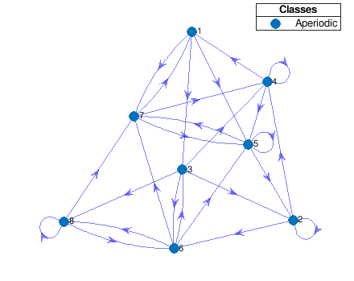

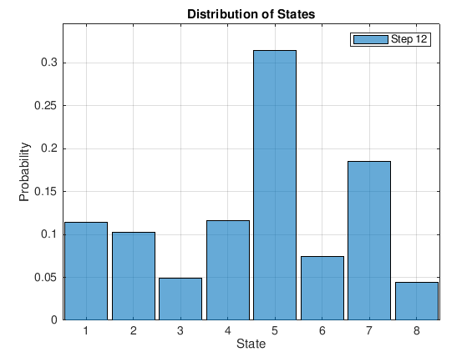

P = [ 0 0 0 0.1 0.3 0.6 0 0;

0 0.3 0.5 0.2 0 0 0 0;

0.7 0 0 0 0.3 0 0 0;

0 0 0.9 0.1 0 0 0 0;

0 0.2 0.5 0 0 0 0.3 0;

0.3 0 0 0 0.3 0 0.1 0.2;

0.3 0 0 0.7 0 0 0 0;

0 0 0.6 0 0.4 0 0 0];

mc = dtmc(P);

figure;

graphplot(mc,'ColorNodes',true);

figure;

distplot(lc,X1,'Type','histogram','FrameRate',1)

xlim({'1','8'})

ylim([0.030 0.316])

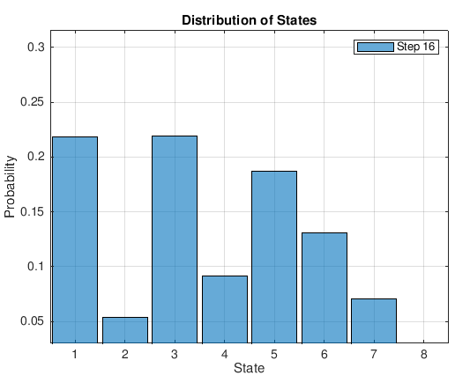

rng(150); % For reproducibility

T = 16;

sigma1 = 0.78;

sigma2 = 0.41;

phi = 0.94;

u1 = randn(T,1)\*sigma1;

x1 = cumsum(u1);

Mdl2 = arima('AR',phi,'Variance',sigma2^2,'Constant',0);

x2 = simulate(Mdl2,T,'Y0',0);

y = x1 ./ x2;

figure;

plot([x1 x2 y])

legend('busy state11','variance','utilization','Location','Best');

ylabel('Probable packet utilization');

xlabel('Busy system states on transition');

rng(150); % For reproducibility

T = 16;

sigma1 = 0.93;

sigma2 = 0.52;

phi = 0.98;

u1 = randn(T,1)\*sigma1;

x1 = cumsum(u1);

Mdl2 = arima('AR',phi,'Variance',sigma2^2,'Constant',0);

x2 = simulate(Mdl2,T,'Y0',0);

y = x1 ./ x2;

figure;

plot([x1 x2 y])

legend('busy state16','variance','utilization','Location','Best');

ylabel('Probable packet utilization');

xlabel('Busy system states on transition');

rng(100); % For reproducibility

T = 16;

sigma1 = 0.12;

sigma2 = 0.07;

phi = 0.32;

u1 = randn(T,1)\*sigma1;

x1 = cumsum(u1);

Mdl2 = arima('AR',phi,'Variance',sigma2^2,'Constant',0);

x2 = simulate(Mdl2,T,'Y0',0);

y = x1 + x2;

figure;

plot([x1 x2 y])

legend('busy state1','variance','utilization','Location','Best');

ylabel('Probable utilization');

xlabel('Busy system states on transition');

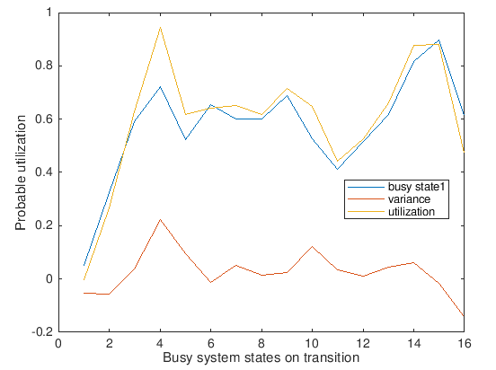

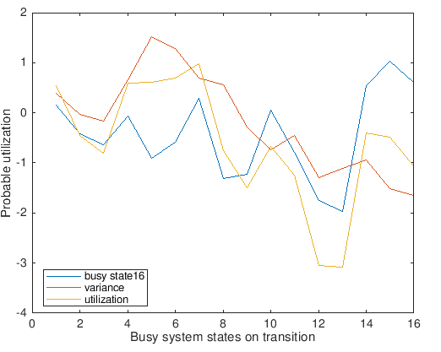

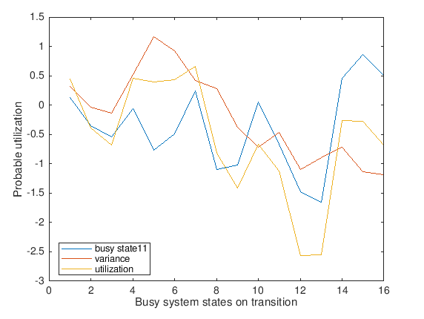

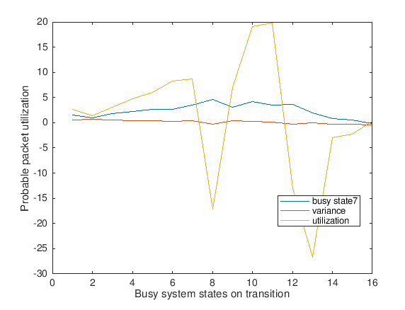

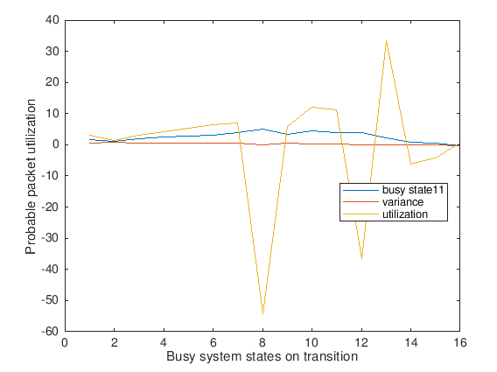

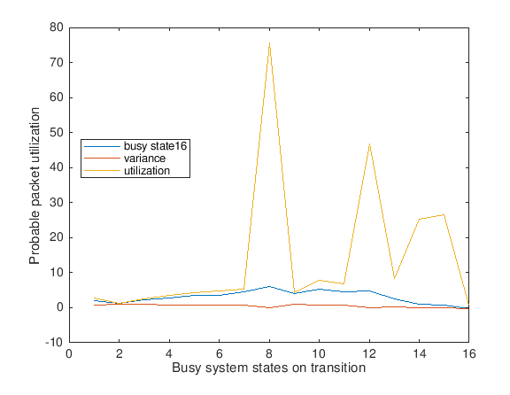

rng(100); % For reproducibility

T = 16;

sigma1 = 0.25;

sigma2 = 0.08;

phi = 0.92;

u1 = randn(T,1)\*sigma1;

x1 = cumsum(u1);

Mdl2 = arima('AR',phi,'Variance',sigma2^2,'Constant',0);

x2 = simulate(Mdl2,T,'Y0',0);

y = x1 + x2;

figure;

plot([x1 x2 y])

legend('Delay','Packet loss','Packet process','Location','Best');

ylabel('Probable Packet process in state 3');

xlabel('Probable delay in state 3');

rng(100); % For reproducibility

T = 16;

sigma1 = 0.81;

sigma2 = 0.49;

phi = 0.91;

u1 = randn(T,1)\*sigma1;

x1 = cumsum(u1);

Mdl2 = arima('AR',phi,'Variance',sigma2^2,'Constant',0);

x2 = simulate(Mdl2,T,'Y0',0);

y = x1 + x2;

figure;

plot([x1 x2 y])

legend('Delay','Packet loss','Packet process','Location','Best');

ylabel('Probable packet process in state 9');

xlabel('Probable delay in state 9');

rng(100); % For reproducibility

T = 16;

sigma1 = 0.93;

sigma2 = 0.61;

phi = 0.98;

u1 = randn(T,1)\*sigma1;

x1 = cumsum(u1);

Mdl2 = arima('AR',phi,'Variance',sigma2^2,'Constant',0);

x2 = simulate(Mdl2,T,'Y0',0);

y = x1 + x2;

figure;

plot([x1 x2 y])

legend('Delay','Packet loss','Packet process','Location','Best');

ylabel('Probable packet process in state 15');

xlabel('Probable delay in state 15');

