**East West University**

**Project Report**

Design a full-fledged network for an organization with multiple subnets.

**Course Code:** CSE405

**Course Title:** Computer Networks

**Semester:** Spring-2022

**Section:** 01

**Submitted to:**

Dr. Anisur Rahman

Associate Professor

Department of Computer Science & Engineering

**Submitted by:**

Md. Jusef

ID: 2017-2-60-160

**Date of submission:** 14th May,2022

**Title:**

Designing a Full-fledged Network for an Organization with Multiple Subnets.

**Project Statement:**

In this project, a complex network infrastructure is designed for a web server, which will reflect the University of Professional’s structure and provided facilities. Here, DHCP server is used for automatic IP allocation, and used Web Server (HTTP) and IPv4 addressing. Apart from wired internet access to all the classrooms, labs, employee PCs, library and other administrative and academic wings, the university also provides wireless internet access for everyone.

**Components:**

* DHCP Server
* DNS Server
* Web Server
* Connectors
* PC
* Switches
* Mobile Phone
* Laptop
* Wireless Routers
* Media Server

**Tools:** Cisco Packet Tracer

**Implementation and Functionality Details:**

* **Network and Subnetwork:** In my network design, I used A,B and C class Ip address. Campus 1 and 6, I used class A Ip addresses. Campus 3 and 2 I used C class Ip address. And campus 5 and 4, I used B class Ip addresses.
* **Personal Computers**: Each personal computer is connected to a switch. Each computer needs an IP address which is provided automatically by the DHCP Server. Using HTTP and DNS server we can browse in university of Professionals website**.**
* **Laptops:** Laptops and wireless device are for students, and which are connected by the wireless router and IP addresses are distributed by that wireless router.
* **Switches**: Switches are devices used on the network to transmit and receive data from one device to another or to many devices depending on the message intended. Switches are connected to multiple host server or routers. Switches also perform functions from the Data Link Layer.
* **Routers:** Routers are connected to Same Class Network. I used 6 routers for six campuses. To configure routers there are two option CLI command and config to type and save all the necessary terms (IPs, tables, routes). I mostly used CLI command for config routers.
* **Wireless Routers:** This is used to provide wireless network. Which is connected to a network by switch. Internet is configured by DHCP.
* **DHCP Server:** Dynamic Host Configuration Protocol (DHCP) server is connected to Campus 2 network. This server is used to provide IP address to all other network’s host’s. To provide IP address in same network we can configure server in config by typing all necessary IPs. To distribute IP to other network a command is required. This allows to use other network DHCP server.

IP helper-address (DHCP IP)

DHCP server provides IP addresses and also default gateway and DNS server IP address. IP address of DHCP is configure statically causes if IP changes dynamically other host won’t be able to find the server.

* **HTTP & DNS Server:** HTTP server is used to host the webpages. Here I have import our university webpages to the HTTP server. DNS server is used convert the domain name to equivalent IP address. To use domain name, I have to know DNS server IP address. So, IP of DNS fixed statically. Here I used a one server to provide HTTP and DNS service. The IP of this server is distributed by DHCP server.

**CLI Command for Router 3 Configuration:**

enable

config t

interface fa0/0

ip address 200.168.11.254 255.255.255.0

no shut

do wr

exit

interface se2/0

ip address 200.168.30.1 255.255.255.0

clock rate 64000

no shut

do wr

exit

interface se3/0

ip address 200.168.55.2 255.255.255.0

no shut

do wr

exit

interface se6/0

ip address 200.168.60.1 255.255.255.0

clock rate 64000

no shut

do wr

exit

interface se7/0

ip address 200.168.65.1 255.255.255.0

clock rate 64000

no shut

do wr

exit

interface se8/0

ip address 200.168.70.1 255.255.255.0

clock rate 64000

no shut

do wr

exit

router ospf 3

network 200.168.11.0 0.0.0.255 area 1

network 200.168.30.0 0.0.0.255 area 1

network 200.168.55.0 0.0.0.255 area 1

network 200.168.60.0 0.0.0.255 area 1

network 200.168.65.0 0.0.0.255 area 1

network 200.168.70.0 0.0.0.255 area 1

interface fa0/0

ip helper-address 200.168.23.3

exit

**Network Topology and Conceptual Modelling:**

**Figure 1:** Network model created in cisco packet tracer

**Ping Result:**

I added sample PDU to understand whether a networks pc is communicating with other networks pc/laptop/mobile/ or not.

**Figure 2:** Ping Result List

**Implementation Of DHCP:**

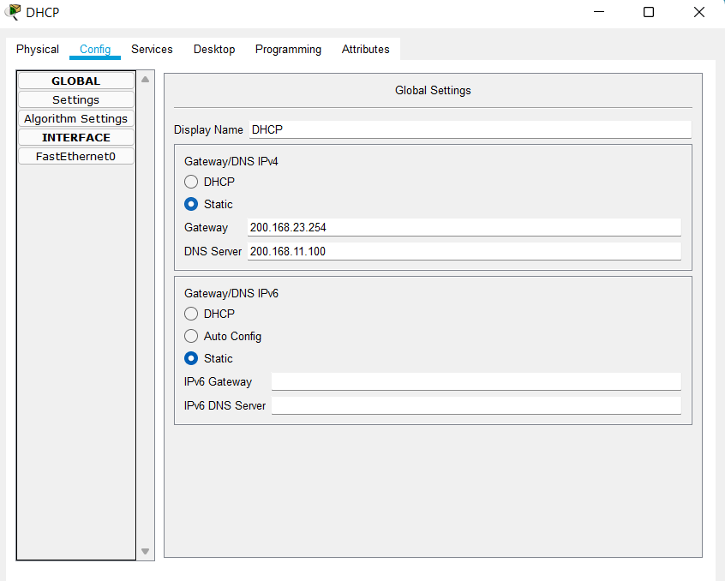**Figure 3:** IP Configuration of DHCP Server

**Figure 4:** Creating Server Pool for Different Network

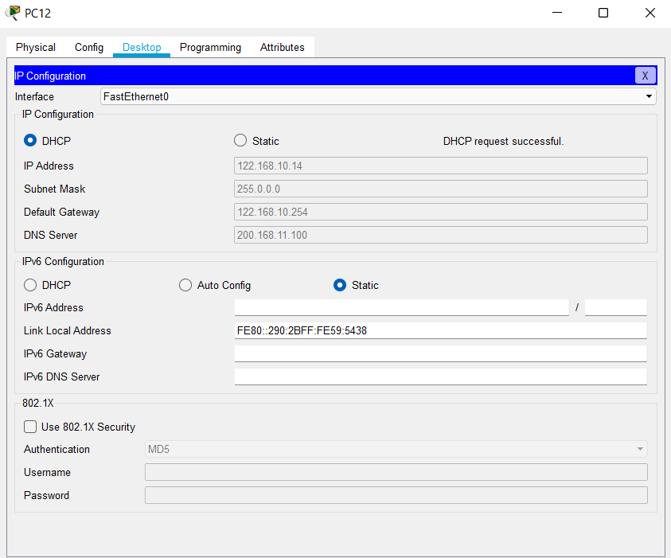**Figure 5:** DHCP auto IP config for pc

**Implementation of HTTP:**

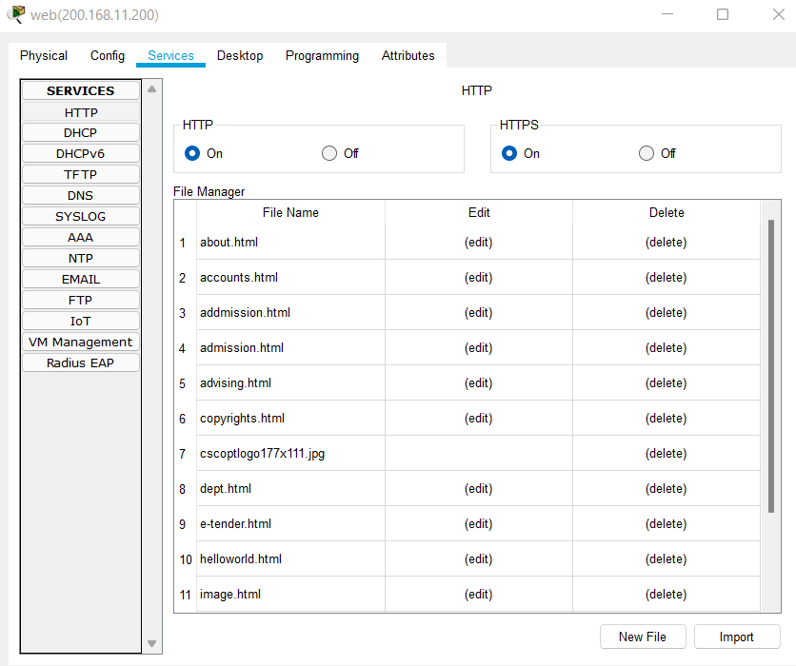**Figure 6:** HTTP Web-Server

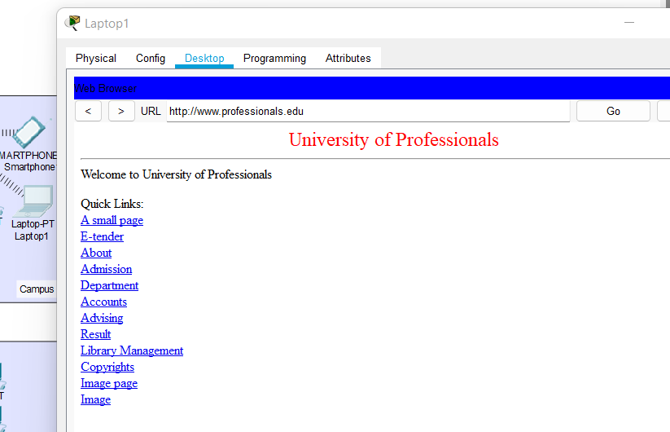**Figure 7:** Home page for University of Professionals

**Number of networks:**

In my design, I used 14 Network.

**Conclusion:** In this project, we have implemented DNS, WEB and HTTP in Cisco Packet Tracer and the webpage. The DHCP server gives the IP address in all six networks with three classes. Our web-server reflects the university’s link as the project demands.

**Reference:**

* [**https://www.youtube.com/watch?v=Yn3H3bpC2Sk**](https://www.youtube.com/watch?v=Yn3H3bpC2Sk)
* [**https://www.w3schools.com/**](https://www.w3schools.com/)
* [**https://en.wikipedia.org/wiki/Hypertext_Transfer_Protocol**](https://en.wikipedia.org/wiki/Hypertext_Transfer_Protocol)