**Expense Charts**

1. **Problem Statement:**

* Build a Simple Chart and Graph for the given Monthly expense Amount Vs categories for any specific Month.

**Example**

|  |  |  |
| --- | --- | --- |
| **Expense** | **Category** | **Amount** |
| Diesel | Travel | 4,000.00 |
| Groceries | Food | 5,790.00 |
| Petrol | Travel | 1,100.50 |
| EB Bill | House Expense | 1,000.00 |
| Internet | House Expense | 900.00 |
| Others | Others | 2,210.00 |

* Create ADD, DELETE and FINALIZE APIs.
* Create a DB and tables as given below
* /add API should insert the expense data to the table
* /delete API should remove the expense from the table
* /finalize API should read all the data from table and consolidate them to create Chart and Graph.
* Once finalized, generate different charts based on the categories and amount.
* Create a simple UI screen to show the Chart and Graph.
* Should have responsive UI
* Code coverage should be 80% or above.
* APIs can be tested using the Postman/Swagger.
* Graph and Chart UI screen should get updated upon add/remove the expense and finalize them through API.

1. **Technology Stack: Any Programming language, DB or frameworks**
2. **Features/Requirements:**

|  |  |  |
| --- | --- | --- |
| **Feature/requirement** | **Feature /Requirement Description with Business rules and design constraints** | **Expected Duration to complete** |
| Create Tables using GHCP |  | <=2 hours |
| Create API to for expense information collection | POSTà /expense  DELETE: /expense/{id}  GET: /expense/finalize |
| Validate the information | Duplicate validation |
| Generate charts | Bar Chart, Pie Chart, Timeline chart/graph. |
| Code Coverage | 80% or above |

1. **Key Points to be followed:** 
   1. **API**

|  |
| --- |
| POST /expense/  {  "expenseId": value, //DB Auto generated  "date": “08/21/2024”,  "amount": 1200.02,  "category": “Travel”  } |

* 1. **UI/UX: [This is Sample UI only; Associates can develop on their Own]**

**Graph**:

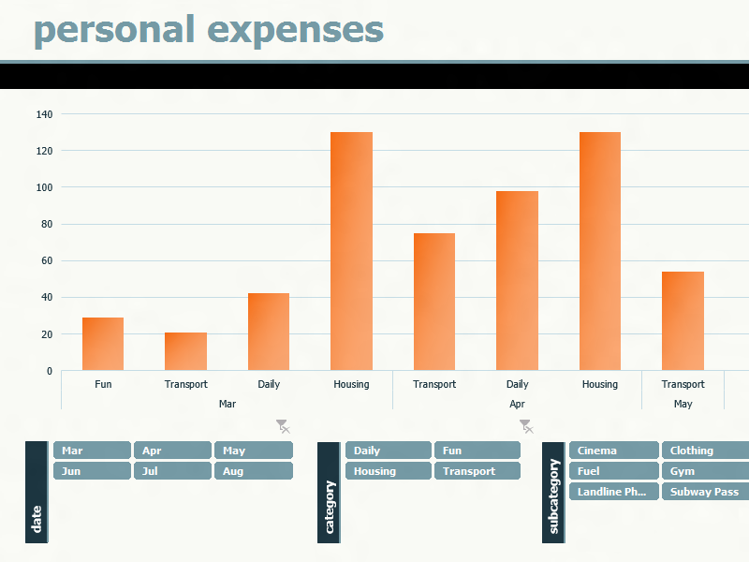

**Chart:**

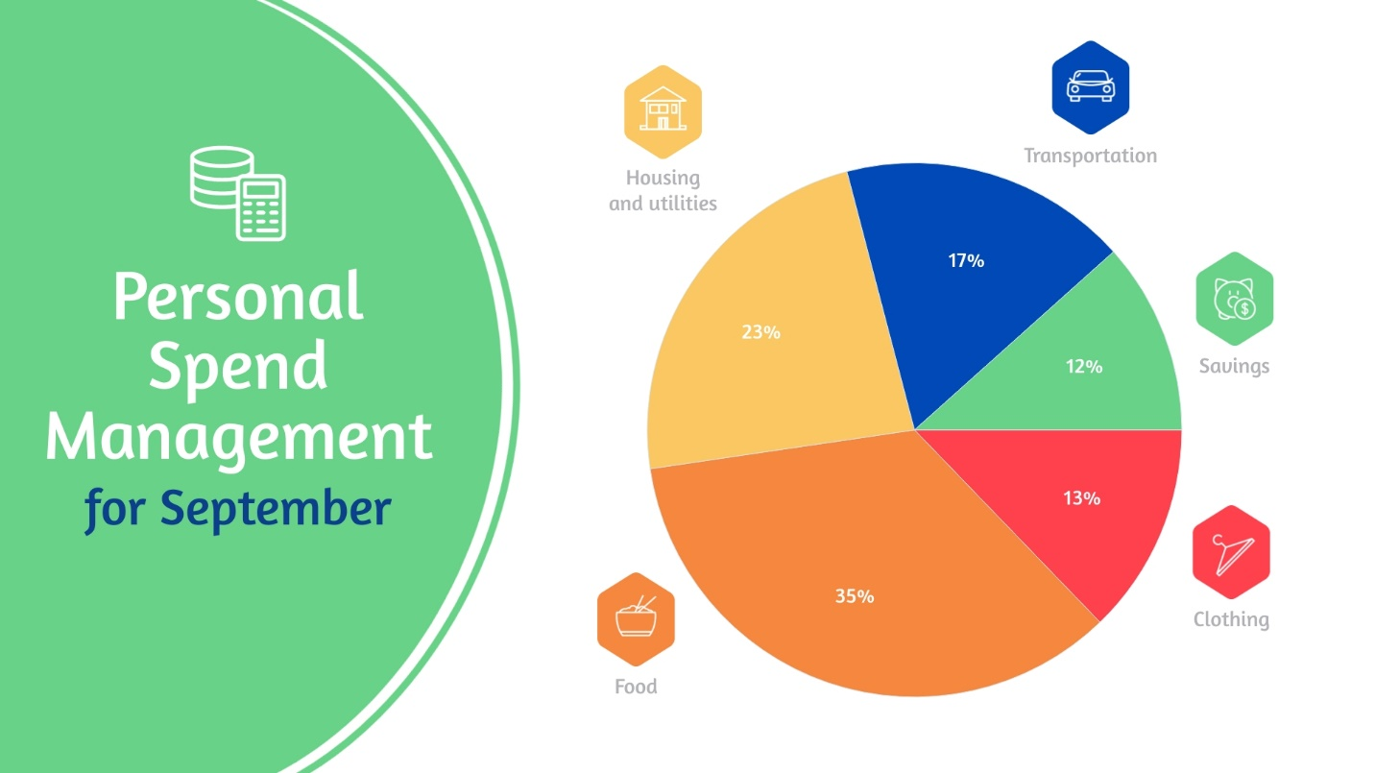

1. **Table Structure:**

|  |  |
| --- | --- |
| Table | Columns |
| Expense | * **expenseId,** * **date,** * **amount,** * **categoryId** |
| Category | * **categoryId,** * **categoryName** |
| Report | * **categoryName** * **totalAmount** |

1. **Output to be generated using GitHub Copilot:**
2. Copilot commands used in a text file.
3. History of Copilot command and code generated in a Dev tool.
4. Database scripts – Scripts to create tables
5. Scripts to load data to the tables
6. Working code.
7. Code Documentation
8. Test Plan
9. Unit test case
10. Screen shot of the output [Graph and Chart]