CSCE 5150 Section 400 - Analysis of Computer Algorithms
Project – 2
Team – 1
Team Members:
1. Mohammed, Momin Khizar Uddin - 11837335
2. Teja Nagendra Sirigineedi - 11825070
3. Chopra Sai Arani - 11807499
4. Deepthi Tanubuddi – 11842466

Project Overview
The intent of this project was to develop and implement efficient algorithms to save and search for a directed graph of air travel routes to make it possible to query paths for particular parameters. Based on the information of flight and city, the program will answer three types of queries about routing and crossing points between cities around the world.
Design Issues and Solutions
Problem 1: How to efficiently store the graph for fast query processing?
- Solution: Each city (node) in our adjacency list representation points to a list of destination cities that are directly accessible. Compared to an adjacency matrix, this method uses less memory, particularly for graphs with thin populations, such as aircraft networks.
Problem 2: How to handle cities with special characters?
- Solution: Each city (node) in our adjacency list representation points to a list of destination cities that are directly accessible. Compared to an adjacency matrix, this method uses less memory, particularly for graphs with thin populations, such as aircraft networks.
Problem 3: How to efficiently find the shortest routes under different constraints?
- Solution: Because of its natural ability to compute the shortest path in an unweighted graph, Breadth-First Search (BFS) was selected. BFS was modified to incorporate further constraints, such as the number of connections which were permitted at maximum.
- Problem 4: There were typo errors in the city.txt file
Solution: We corrected all the typos and missing letters from the city.txt and in the flight.txt file as well and its working fine now.
Data Structures Used
- Adjacency List: vector<vector<int>> adj stores the direct flights.
- City Name Mapping: map<string, int> cityToIndex maps a city name to an index for fast lookup.
- Reverse Mapping: vector<string> indexToCity allows index-to-name conversion.
- Display Mapping: vector<string> displayCity for normalized ASCII names used in outputs.
Justification:
- Adjacency lists allow O(1) access to direct neighbours and efficient traversal.
- map provides O(log n) lookup times for city name to index mappings.
Algorithms Employed
Breadth-First Search (BFS):
- Used to find the shortest paths with a queue.
- Tracks predecessors to reconstruct the path.
- Handles both unrestricted searches and those constrained by maximum number of connections.
Custom BFS Modifications:
- For Query 1, BFS stops if the connection limit is exceeded.
- For Query 2, BFS is run multiple times to traverse through intermediate cities (B and C) in either order.
- For Query 4, BFS is executed from three starting points and the best meeting city is selected by minimizing total connections.
Time Complexity
- BFS: O(V + E), where V = number of cities and E = number of flights.
- Query 1 (Single BFS): O(V + E)
- Query 2 (Three BFS traversals): O(3 * (V + E)) = O(V + E)
- Query 4 (Multiple BFS traversals for each potential meeting city): O(V * (V + E))
Optimization Issues and Future Work
Current Optimizations:
- Early stopping conditions in BFS to reduce unnecessary exploration.
- Minimal copying of paths to improve memory efficiency.
Future Optimizations:
- Implement A* search with heuristics for even faster pathfinding on large datasets.
- Use unordered_map instead of map to achieve O(1) lookup (with additional handling for collisions).
- Parallel BFS for Query 4 to reduce the computational bottleneck when searching meeting points.
Scalability Discussion
The current design using adjacency lists and BFS scales well for medium to large graphs (up to a few thousand cities). For extremely large graphs (millions of nodes and edges):
- Memory usage remains acceptable.
- BFS running time could become high for Query 4; thus, heuristic-based or approximated algorithms would be preferable.
Remarks on Design and Implementation
- The program gracefully handles invalid city names.
- User-friendly output formatting provides clear route paths.
- Detailed code comments and modular design make the codebase easy to understand and extend.
- City name normalization ensures consistent behavior across different input sources.
Test Run Screenshots (Appendix)
- Query 1 Example:
./routeSearch 1 "London, United Kingdom" "Hanoi, Vietnam" 6
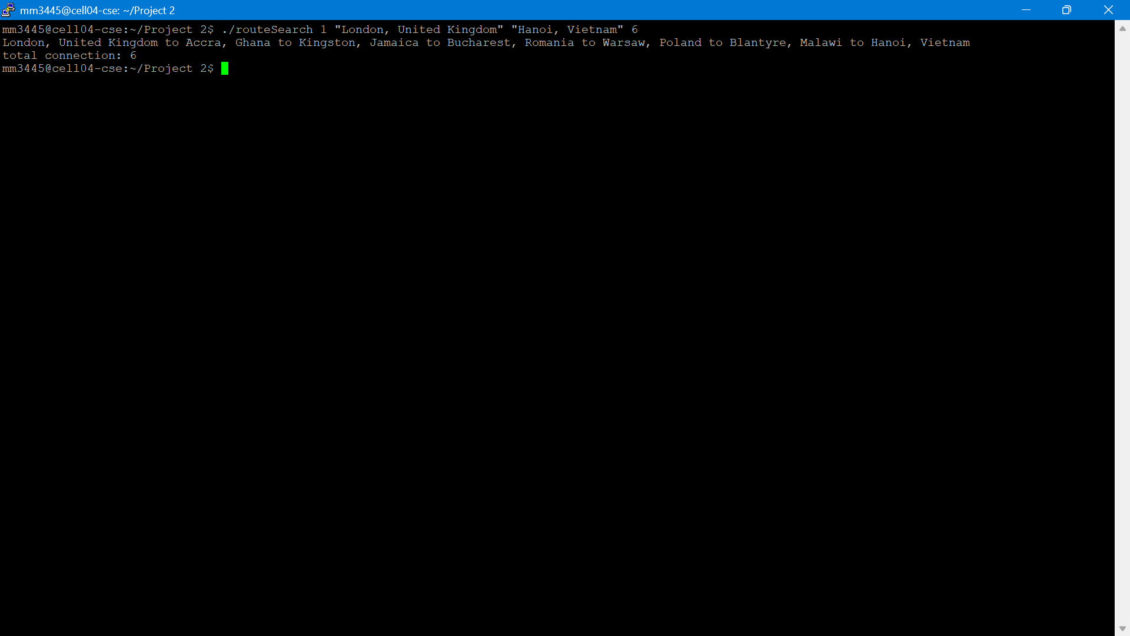
Output: Path with 6 connections.
./routeSearch 1 "Seoul, South Korea" "Toronto, Canada" 3
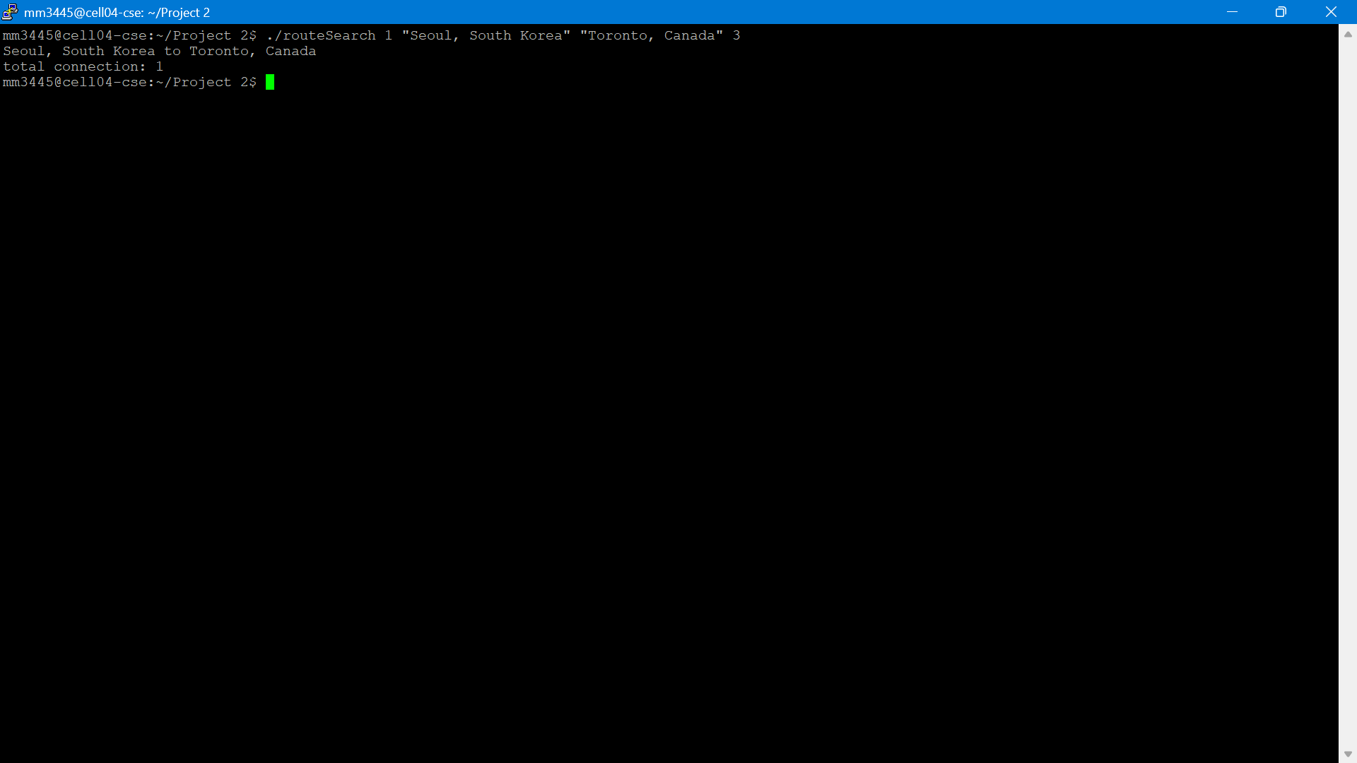
Output: Path with 1 connection.

- Query 2 Example:
./routeSearch 2 "Hong Kong, SAR" through "Dublin, Ireland" and "Vienna, Austria" to "Santiago, Chile"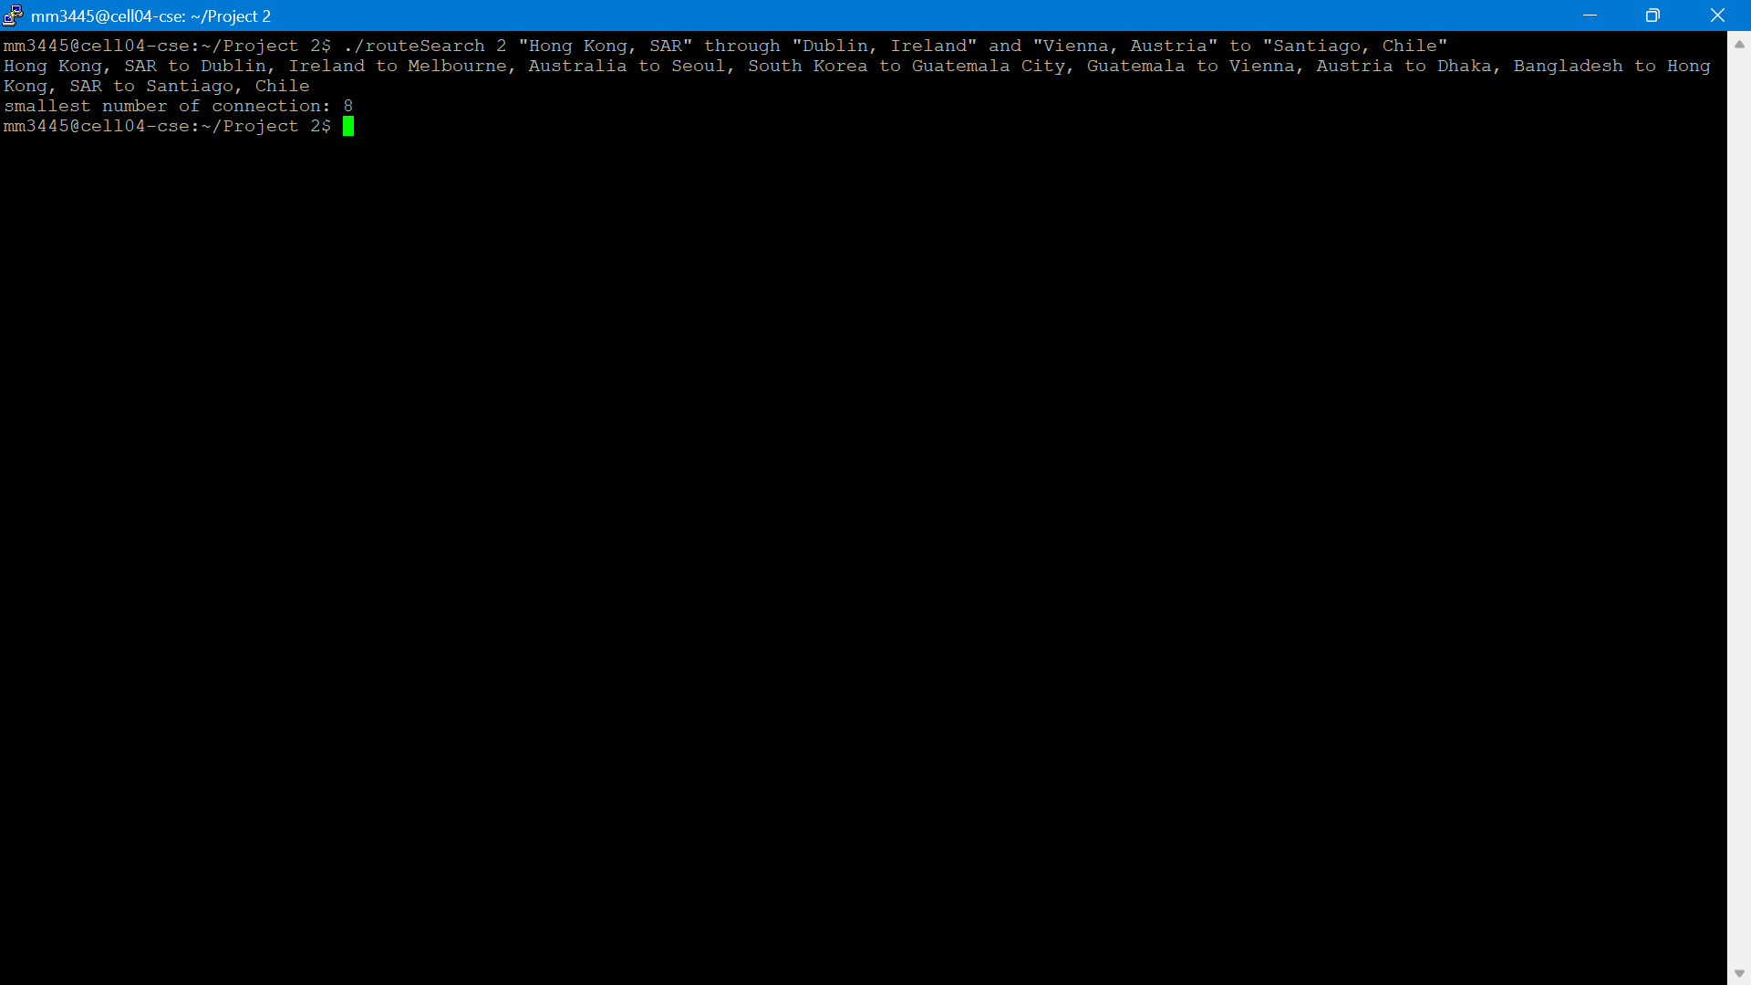
Output: Smallest number of connections: 8

./routeSearch 2 "Hong Kong, SAR" through "New Delhi, India" and "Lisbon, Portugal" to "Dublin, Ireland"
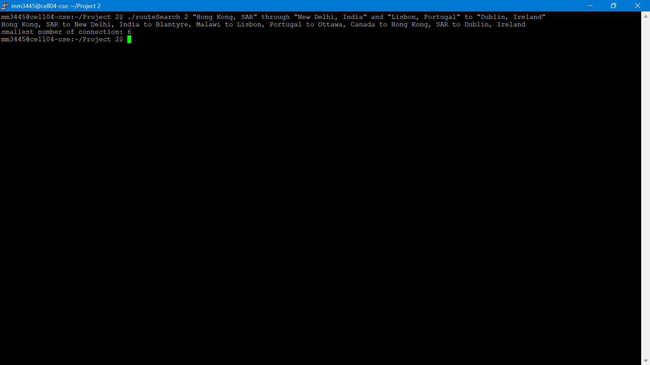
Output: Smallest number of connections: 6

- Query 4 Example:
./routeSearch 4 "Seoul, South Korea" "Toronto, Canada" "Luxembourg, Luxembourg"
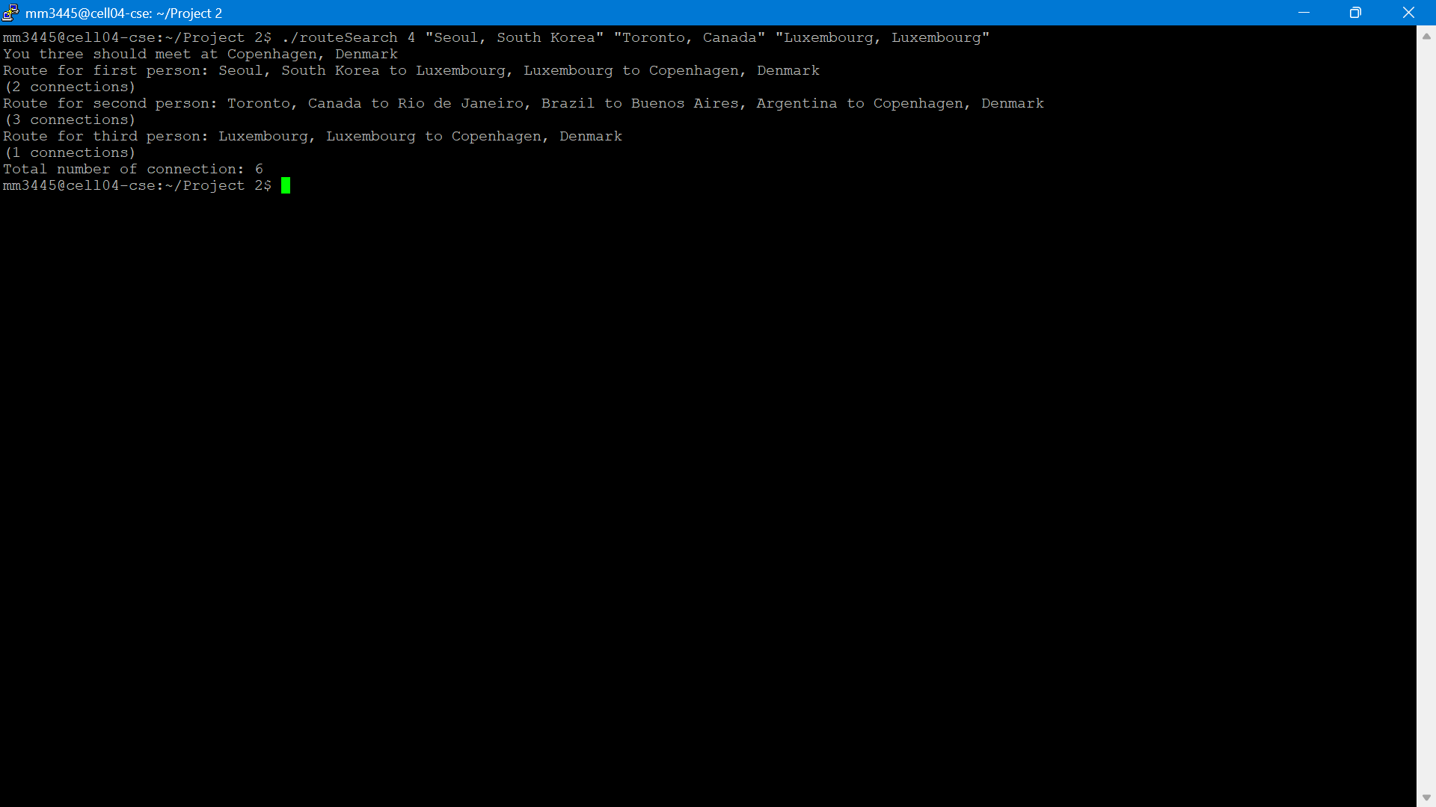
Output: Suggested meeting city and individual routes.
./routeSearch 2 "Hong Kong, SAR" through "Dublin, Ireland" and "Vienna, Austria" to "Santiago, Chile"
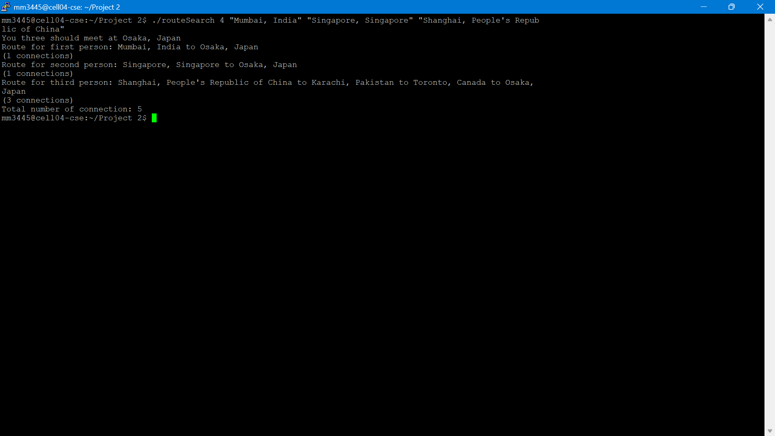
Output: Suggested meeting city and individual routes.

README File
Included separately with compilation and execution instructions.

