**Computer Graphics [E] Group Project Proposal**

**Group Members:**

1. Sayedur Rahman: 22-46418-1
2. Md. Maruf Rahaman Sikder: 22-46420-1
3. Md. Shihab Shorkar: 22-46421-1
4. Raiyan Sayeed: 22-46494-1
5. Rimon Pramanik: 22-46957-1

**Title:** The Daily Life of a Village Boy.

**Objectives:** The main objective of our project is to simulate the day-to-day life of a village boy. As we know, quite a number of students come to city areas or even move abroad to pursue higher education (whether it be college or university) from the rural parts of Bangladesh. They feel nostalgic for their village homes at times. This project aims to capture that nostalgia and represent it through the daily activities of a village boy. The project will have a day-night cycle that simulates the changing time of day from sunrise to late afternoon, from late afternoon to evening, and from evening to night visually representing the daily routine of a village boy through different scenes. These scenes will depict various aspects of the boy's day, such as waking up, going to school, studying, playing, finally going to sleep and other activities. The project is implemented using OpenGL (GLUT) in Code::Blocks.

**Features:**

[Please note that the following features are tentative, they may be changed later on.]

1. The boy will wake up early in his room in the morning when the rooster crows. The rooster starts crowing when the sun rises. In his room, there is a bed, a reading/ study table (which will have books on the shelves), a chair, a window, a door leading to the dining room, a tube light (which will turn on at night), a rotating fan and a clock. There are also his school uniform and bag in his room.
2. After he wakes, he has breakfast with his family in the dining room. The dining room contains the dining table, some chairs, a window, a door leading outside, and a door leading to the boy’s room. After having breakfast, he changes into his school uniform and goes outside his house.
3. The boy goes to school by walking on the village road. There are houses here and there. There is a small river beside the road. Boats float there. People are walking and working. There are some crop fields as well**.** The sun and some clouds can be seen clearly.
4. The boy arrives at school. The boy studies in school. In the classroom, there are many students sitting at chairs and tables. A teacher is teaching them using a blackboard. The boy has lunch in the school canteen. Students take food from the canteen counter and eat by sitting at chairs and tables.
5. The boy returns home in the late afternoon. He changes his clothes and goes to play football with his friends on the field. There are two goalposts.
6. The boy returns home in the evening. He studies at his table in his room till 10 pm. He has dinner after that with his family.
7. The boy goes to sleep at 12 pm.

**Rough Sketches:**

1. Md. Maruf Rahaman Sikder: 22-46420-1

1. A drawing of people sitting at a table

   Description automatically generatedRaiyan Sayeed
2. A drawing of a person sitting at a desk

   Description automatically generatedRaiyan Sayeed (22-46494-1)

**Code Scenes:**

1)

**Contributions:**

1. Raiyan Sayeed (22-46494-1): Ground, Sky, River, Houses, Text
2. Md.Maruf Rahaman Sikder(22-46420-1)Paddy field,big tree, Sun Translation.

**Contributions:**

1. Raiyan Sayeed (22-46494-1): Boy in Sleeping position
2. Md.Maruf Rahaman Sikder (22-46420-1): Chair,door,bedsheet,window,tubelight.

3)

**Contributions:**

1. **Raiyan Sayeed (22-46494-1) =** Everything except the humans

4)

**Contributions:**

1. Raiyan Sayeed (22-46494-1): Ground, Sky, River, Houses
2. Md.Maruf Rahaman Sikder(22-46420-1)Paddy field,big tree, Sun Translation.

**Contributions:**

1. Raiyan Sayeed (22-46494-1): Ground

6)

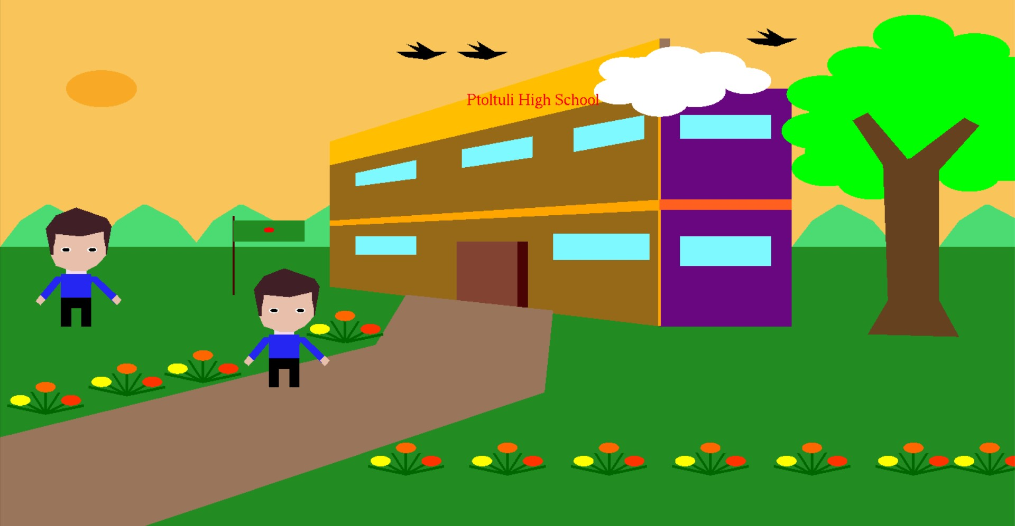

**Contributions:**

1. Raiyan Sayeed (22-46494-1): Ground

7)

**Contributions:**

1. Raiyan Sayeed (22-46494-1): Ground, Sky, River, Houses

8)

**Contributions:**

1. **Raiyan Sayeed (22-46494-1) =** Everything except the humans

9)

**Contributions:**

1. Raiyan Sayeed (22-46494-1): Boy in Sleeping position
2. Md.Maruf Rahaman Sikder (22-46420-1): Chair,door,bedsheet,window,tubelight,sound effect,translation and transition help.