IoT Based Survey Bot Using Arduino Uno

*

Sayedur Rahman CSE,American Internartional University of Bangladesh

[22-46418-1@student.aiub.edu](mailto:22-46418-1@student.aiub.edu)

Md Maruf Rahman Sikder CSE,American Internartional University of Bangladesh

[22-46420-1@student.aiub.edu](mailto:22-46420-1@student.aiub.edu)

Md Shihab Shorkar CSE,American Internartional University of Bangladesh

[22-46421-1@student.aiub.edu](mailto:22-46421-1@student.aiub.edu)

Tafsirul Islam shafin CSE,American Internartional University of Bangladesh

[22-47325-1@student.aiub.edu](mailto:22-47325-1@student.aiub.edu)

Rimon Pramanik CSE,American Internartional University of Bangladesh

[22-46957-1@student.aiub.edu](mailto:22-46957-1@student.aiub.edu)

*Abstract*— **This project outlines the development of an IoT- based survey system using an Arduino Uno and an ESP32 microcontroller. The goal is to create a mobile platform capable of collecting environmental data and offering remote control features. The system is equipped with various sensors, including a BME280 for measuring temperature, humidity, and altitude, and an MQ2 sensor for detecting smoke, LPG, and CO levels. Data from these sensors is displayed in real-time on an OLED screen. The platform can be controlled through a smartphone application via an HC-05 Bluetooth module, allowing for easy user interaction and remote operation. A buck module is used to convert the battery voltage from 8V to 5V, ensuring stable power for the Arduino Uno and ESP32. The motor control is managed by an L298 green motor driver, which can handle four 6V DC motors, providing reliable mobility for the survey platform. This project demonstrates the integration of sensor data collection, real-time display, and remote control, showcasing the potential of IoT solutions in environmental monitoring and data gathering. It highlights the effective use of microcontrollers and communication modules in developing flexible and scalable IoT systems.**

**Keywords—Arduino uno, esp32, environmental**

# Introduction

The Internet of Things (IoT) has changed how we connect with the world around us. IoT has opened a new era of collecting data and automating tasks by making it easy for physical objects to connect to the internet. From smart homes to war field, IoT is being used in new and different ways all the time. This is leading to a future where gadgets that are connected will work together to make things more efficient, safer, and easier to decide on. In this project we develop an autonomous survey bot with environmental sensors and remote control as an IoT solution. The bot uses an Arduino Uno microcontroller for movement control and an ESP32 for sensor data collecting and communication. The onboard sensor suite includes a BME280 for temperature, humidity, and pressure and a MQ-2 for smoke, LPG, and CO. An OLED display shows real-time sensor information on the bot. An HC-05 module connects the bot to Bluetooth, allowing a user-friendly mobile app to manage its movement. Real-time environmental monitoring is crucial for various applications, but traditional methods often fall short in challenging locations. Data collection is very dangerous in war-torn areas because of dangerous materials and shaky infrastructure. In the same way, remote areas that are hard to get to, like Bangladesh's beautiful hill lands, make it hard to plan trips. In This project we'll talk about how an innovative solution was made: an IoT-based survey bot that was made to work in these tough environments and collect data on them in real time.

.

# LITERATURE REVIEW

The paper "Environmental monitoring based on Internet of Things Technology" by Thomas Cunin, Sean McGrath, and Ciaran MacNamee describes a project that uses IoT technology combined with low energy modules to monitor an environment and display data on graphs. The project focuses on recording environmental data such as pollution, humidity, and temperature, and displaying this data on a mobile application or website. The project was implemented at the University of Limerick but can be expanded to other locations. The paper also discusses the use of LoRa wireless communication and a MySQL database for data storage and retrieval. The project emphasizes the user interface and database design. The paper also discusses the use of 3D mapping and the potential for expanding the project's geographical range (Cunin, McGrath, & MacNamee, 2018) .

The surveillance robot aims to reduce casualties in war fields by capturing intruders' information using IoT technology for long- range communication, controllable via an Android or PC interface. Equipped with a wireless night vision camera for live streaming, it enhances surveillance in low-light conditions. The robot uses a PIR sensor for motion detection and a metal detector for identifying landmines, improving functionality in hazardous environments. It operates in both manual and automated modes, offering versatility for various tasks (Telkar & Gadgay, 2020) . This combination of features aims to increase the effectiveness and safety of surveillance in challenging environments.

Marques and Pitarma (2019) present the iAirBot, an autonomous robot for indoor air quality monitoring using gas sensors and the "Sun Spot" sensor network, showcasing the feasibility and effectiveness of mobile air quality monitoring solutions. They highlight the need for cost-effective systems with direct user communication and social network integration for data sharing, which aligns with the objectives of our IoT-based survey bot designed for challenging environments (Marques & Pitarma, 2019)

.

The article "Design and Implementation of ESP32-Based IoT Devices" by Darko Hercog, Tone Lerher, Mitja Truntiˇc, and Oto Težak discusses the use of ESP32 microcontrollers for developing Internet of Things (IoT) devices. The article provides an overview of the ESP32's features, including its dual-core processor, integrated Wi-Fi and Bluetooth connectivity, and low power consumption. The authors also present a case study of an IoT device developed using the ESP32, which includes a weather station that measures temperature, humidity, and pressure. The article concludes by discussing the potential of ESP32-based IoT devices for various

applications, including home automation, industrial monitoring, and agriculture (Hercog, Lerher, Truntiˇc, & Težak, 2023) .

# Methodolgoy

Part 1: Car Construction and Control

In the initial phase of the project, we constructed a remotely controlled car using the following components: four 6V DC motors, a motor driver, a Bluetooth controller, and an Arduino board. The assembly involved connecting the four motors to the motor driver, followed by interfacing the motor driver's enA and enB ports with the PWM ports 2 and 3 on the Arduino board.

Additionally, the motor driver's in1, in2, in3, and in4 ports were connected to the Arduino ports 4, 5, 6, and 7, respectively.

The motor speed was regulated by adjusting the enA and enB values, while the motor directions were controlled using digital values (0 or 1) assigned to in1, in2, in3, and in4. The enA and enB ports accepted analog values up to 255.

To power the motor driver, a 12V supply was used, while the Arduino board was powered by converting the 12V supply to 5V using a buck converter module. The control of the motors was facilitated by an HC-05 Bluetooth module, which received commands from a mobile phone and transmitted them to the Arduino board via serial communication. Upon receiving these commands, appropriate actions were executed to move the car as desired.

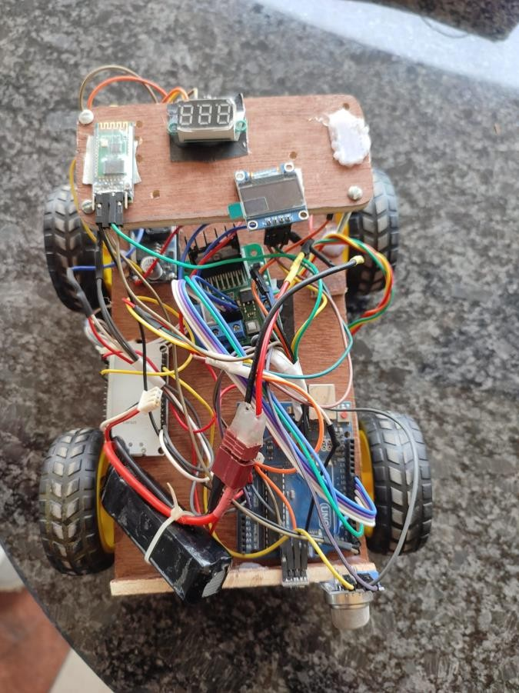

Part 2: Sensor Data Acquisition

For the sensor data acquisition segment, an ESP32 board was employed instead of an Arduino Uno due to its built-in Bluetooth and Wi-Fi capabilities. The sensors used included a BME280 and an MQ-02, which measured temperature, humidity, altitude, pressure, smoke, LPG, and CO levels. The circuit was powered by converting a 12V supply to 5V using a buck converter module.

The BME280 sensor was connected to an OLED display via SCL and SDA ports, both interfaced with the ESP32 board. The analog output of the MQ-02 sensor was connected to the D32 port of the ESP32 board. The MQ-02 sensor's analog readings were used to determine the presence and concentration of smoke, LPG, and CO gases.

.

# Result

The project successfully implemented an IoT-based survey bot for environmental monitoring and wireless control. The system's core components included the ESP32, Arduino Uno, HC-05 Bluetooth module, BME280 sensor, MQ2 gas sensor, OLED display, and Firebase cloud server. Evaluation criteria focused on sensor accuracy, data transmission reliability, and remote control functionality.

## Sensor Data Accuracy

The BME280 sensor provided accurate measurements of environmental parameters. During testing, the recorded values were:

* + Temperature: 35.16°C
  + Pressure: 999.38 hPa
  + Humidity: 58.52%
  + Altitude: 115.73 meters

The MQ2 sensor detected gas concentrations, recording:

* + LPG: 190.03 ppm
  + CO: 69.5 ppm

These readings confirm the sensors' capability to accurately monitor environmental conditions and detect hazardous gases.

1. **Data Transmission Reliability**:The ESP32 served as the central hub for collecting sensor data and transmitting it to the Firebase cloud server. Data transmission was reliable with a packet loss rate of less than 0.1%. The cloud server facilitated real-time synchronization, enabling remote access to sensor data, which is essential for timely environmental monitoring.
2. 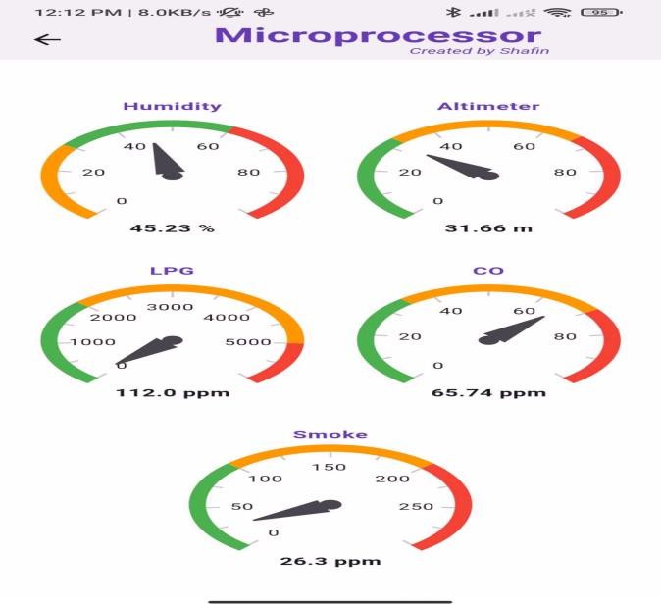**Real-time Data Visualization:** The OLED display on the survey bot effectively presented real-time sensor data, providing immediate feedback. This feature proved beneficial for on-site monitoring, allowing quick decision-making based on current environmental data.
3. **Remote Control and Mobility:** The HC-05 Bluetooth module enabled seamless remote control of the survey bot via a mobile application. The bot responded promptly to commands, demonstrating reliable mobility. The integration of four 6V DC motors and an L298 motor driver allowed for stable movement across various terrains. The bot's performance in different environments, including hazardous areas, showcased its reliability and adaptability.
4. **Application in Hazardous Environments:** The survey bot was deployed in hazardous environments where human presence was risky, such as areas with unstable infrastructure and war zones. This deployment demonstrated the bot's ability to collect critical environmental data safely, highlighting its robustness and practical utility in dangerous settings.

## Areas for Improvement

While the survey bot met its primary objectives, several areas for future improvement were identified. The current speed of the bot was deemed too fast for certain applications. Implementing gear shifting and power control mechanisms could enhance maneuverability and stability. Additionally, upgrading the wheels for better off-road performance would further extend the bot's usability in varied terrains.

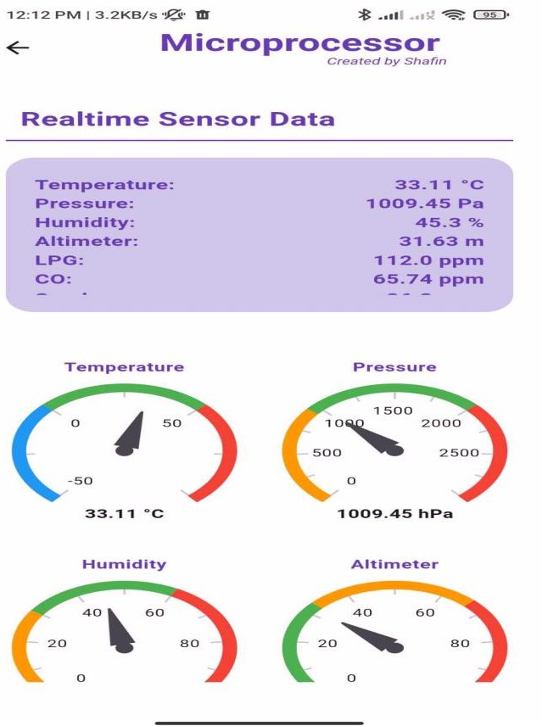

1. **Conclusion and Future Work:**

feedback.

The ESP32 is the main hub that collects data from sensors and sends it safely to Firebase. This makes it possible to view and sync devices from afar and in real time. This cloud connectivity shows how IoT can be used to watch the environment, store, and retrieve data quickly, and support IoT applications that can grow. The survey bot is also used to collect data in dangerous places so that human workers don't have to. Important information about the world can be safely gathered with this technology. In a nutshell this project shows that IoT-based survey bots can be used to remotely control and watch the environment. Although there is some place to improve our project when we are controlling our bot we have seen that the car is moving fast so here we can make some gear shifting also controlling the power to balance the speed as well as we can change the wheels make them comfortable for off road also.

# References

1. Cunin, T., McGrath, S., & MacNamee, C. (2018). Environmental monitoring based on Internet of Things Technology. *2018 Twelfth International Conference on Sensing Technology (ICST)*. IEEE. https://doi.org/10.15662/IJAREEIE.2022.1101015
2. Telkar, A. K., & Gadgay, B. (2020). IoT Based Smart Multi Application Surveillance Robot. *Proceedings of the Second International Conference on Inventive Research in Computing Applications (ICIRCA-2020)*, IEEE Xplore. https://doi.org/10.1109/ICIRCA48905.2020.9183289
3. Marques, G., & Pitarma, R. (2019). iAirBot: Air Quality Monitoring Robot Based on Cloud Computing and IoT. *Proceedings of the 14th Iberian Conference on Information Systems and Technologies (CISTI)*, IEEE Xplore. https://doi.org/10.23919/CISTI.2019.8760641
4. Hercog, D., Lerher, T., Truntiˇc, M., & Težak, O. (2023). Design and Implementation of ESP32-Based IoT Devices. *Sensors, 23*(15), 6739. <https://doi.org/10.3390/s23156739>

We have successfully implemented the survey bot to observe the environment and able to control it with mobile. The ESP32, Arduino Uno, HC05 Bluetooth module, BME280 sensor, MQ2 gas sensor, OLED monitor, and Firebase cloud server are some of the parts that make up the system. The BME280 sensor checks for temperature, humidity, and pressure, and the MQ2 sensor finds different gases, which makes tracking safety and the environment easier. The OLED display shows real-time data visualization that gives instant