**SPL-1 Project Report, 2019**

**Fourier Transform on Image Processing**

**Course: Software Project Lab**

**Course No: SE 305**

Submitted by

**Md. Mehedi Hasan Arif**

**Roll No : BSSE1036**

**Session: 2018-2019**

Supervised by

**Dr. Ahmedul Kabir**

**Institute of Information Technology**

**University of Dhaka**

**Submission Date: 29-05-2019**

Introduction:

Fourier transform is a transform between time domain and frequency domain. It decomposes a signal into sinusoids. So, it is known as the frequencydomainrepresentation of the original signal. Now-a-days we use this transform in various fields for example – digital sound processing , Image Processing etc.

We know that sound is a combination of different sine and cosine wave. Every wave has its own frequency. By using Fourier transform we can transform the signal from time domain to frequency domain and get the frequencies.

**1.1 Background Study**

**Fourier transform (FT)**

Fourier transform is a transformation between time domain and frequency domain.

The Fourier transform of a function of time is itself a complex- valued function of frequency, whose magnitude represents the amount of that frequency present in the original function.

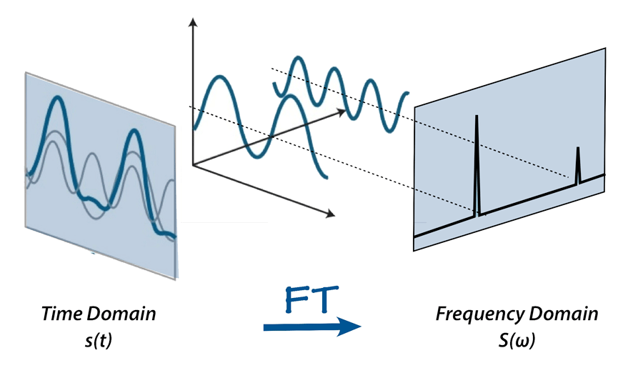 Figure 1: FT on a mixed frequency wave

**Fast Fourier Transform (FFI)**

A fast Fourier transform (FFT) is an algorithm which computes the discrete Fourier Transform (DFT) of a sequence. FFT is based on divide and conquer algorithm where we divide the signal into two smaller signals, compute the DFT of the two smaller signals and join them to get the DFT of the larger signal. The complexity of DFT is O(n^2) while that of FFT is O (n log n). So FFT is faster than DFT.

1.2. Challenges

For implementing this project there are lot of challenges that I have faced. Some of them are:

1. Handling large code for the first time
2. Learning and understanding algorithm
3. Implementing 2D FFT algorithm

**2. Project Overview**

I have divided my whole project into three different parts. They are

1. Implement FFT and 2D FFT
2. Reading and sampling an image file
3. Implementing low pass filter

**3.User manual**

1.Give an image input.

2.Apply low pass filter on it.

3.Show output.

**4.Future Goal**

In this project I implemented FFT for image processing. In future I want to add different filters to this project.

**5.References**

1. <https://en.wikipedia.org/wiki/Fast_Fourier_transform>

2.<https://betterexplained.com/articles/an-interactive-guide-to-the-fourier-transform/>

3. <http://mathworld.wolfram.com/FourierTransform.html>

4. <https://homepages.inf.ed.ac.uk/rbf/HIPR2/fourier.htm>