

American International University-Bangladesh (AIUB)  
**Department of Computer Science  
Faculty of Science &Technology (FST)  
Spring 19_20**

**E- Medication Care**

A Software Engineering project submitted

By

**Md Nabil Hossain (18-38585-2)**

**Ashraful Khan Hriday (18-37004-1)**

**Md. Torikul Islam Shanto (18-37407-1)**

**Shadman Arafin (18-36912-1)**

The project will be Evaluated for the following Course Outcomes

|  |  |
| --- | --- |
| CO3: Choose appropriate software engineering model in a software development environment | Total Marks |
|  |
| Project Background Analysis (needs, goal, benefits, etc.) [5Marks] |  |
| Appropriate Process Model Selection [5Marks] |  |
| Argumentation for model selection with Evidence [5Marks] |  |
| Completeness, Spelling, Grammar and Organization of the Answer [5Marks] |  |
|  | |
| CO4: Explain the roles and their responsibilities in the software project management activities | Total Marks |
|  |
| Content Knowledge (e.g. System Requirements, System Design) [5Marks] |  |
| Project Role identification [5Marks] |  |
| Responsibility Description [5Marks] |  |
| Completeness, Spelling, grammar and Organization of the Answer [5Marks] |  |

1. **PROBLEM DOMAIN**
   1. **Background to the Problem:**

E- medication care is the easiest way for you and your family to manage medications and doctor’s instructions. We targeted the aged people, most probably at the age of above 45. People of any age can use our app but people above 45 years old are the main audiences who require regular check up and medication. The project will get a good market value as medication and also as a social service by which we can earn both monthly and provide medical need to the people who are unable to go to the hospital at any time for some normal need as like for measuring the pressure or diabetes or if anyone have sudden fever then they can also use our app. As our app provides home services also, so it will very useful for people and will have a good market value.

* 1. **Solution to the Problem:**

Basically, the main theme of the project is to serve on a daily basis medication to the regular patients. The usual problem now a days is to go to a hospital for small problems. Like, for fever, we need a thermometer to measure the temperature but we do not possess a thermometer at our home. For this simple thing it is not always possible and also not that necessary to go to a hospital. Again, we need to push an injection immediately but the hospital is at a distance of an hour. Sometimes we need a nearby dispensary also for measuring regular pressure and diabetes or for pushing a saline. So that it is not necessary to go to a hospital all the time. In such condition we need to connect ourselves with an app that will connect us with the nearby available dispensary to take our required medication. On top of that, the old aged people are sometimes unable to go to a hospital. Then our app will provide the require services on those type of emergency situations.

This project’s purpose and basic functionality is very easily understandable. As the people of age group above 45 are the target audience so the app is very user friendly and easily useable by all. Our main target is to make the app simple and easy. The app will contain enough features and functionality and it will also have native language support.

In the perspective of our country, this type of app is not introduced yet so it helps us a lot.

Though some existing software solutions are available online to solve this problem .They keep lists of medications, dosages, refill information, and prescribing docs in their website which can be accessed from anywhere and some of them can record important health vitals and track progresses over time such as Blood Glucose, Sleep, Weight . Medication is a basic need so it is very important to introduce such an app for the people of society.

**2.PRODUCT AND PROJECT DESCRIPTION**

**2.1 System Features**

**i. In case of Patient:**  
**1. System Login:** The software shall allow users like the patient to log in with their assigned user name and password. Our software signifies some security issues. Such as if the user name and password is applied incorrect for more than three times than the system refers and security code. Again it happens multiple time than the account of the user is disrupted.In case of security login the priority level is high and each user must possess valid user id and password.

**2. Choose physician**: Patients can seek their required physician as per their requirements.

**3.Check visibility of physician:**When a patient logs in to the system, he or she can check the visibility of the physician according to his or her requirements.

**4.Select the required treatment**: Assigning to the system, the patients introduce their problems.Then according to their problem they can select their required treatment. For example If anyone has got fever than they can request the physician to measure the temperature.

**5.Payment:** Basically, the payment can be done by two procedure.They are (1) Bkash over phone (2)Manually by cash.

**ii. In case of Physician:**

**1. System Login:** The software shall allow users like the physician to log in with their assigned user name and password. Our software signifies some security issues. Such as if the user name and password is applied incorrect for more than three times than the system refers and security code. Again it happens multiple time than the account of the user is disrupted.In case of security login the priority level is high and each user must possess valid user id and password.

**2.Approval of request:** The physician as per his or her availability can accept or decline the request send by the admin.

**3.Check requirements:** The physicians can check the requirement of the patients and provide treatment as per their need.

**4. Serve required treatment:** This procedure can be done by two ways .(1)Over phone (2)Manually- by taking the required first aid tools.

**iii. In case of Admin:**

**1.Check request from patient:** The patient logs in to the system and discuss their problems. The admin check this request and takes necessary steps on behalf of the problem.

**2. Verify patient and physician:** The admin refers physician based on the requirements of the patient.

**3.Allot serial for patient:** The admin give serial number to the patient to consult with the physician

**4.Check visibility of physician:** The admin can check the visibility of the physician.

**5. Give schedule to physician and patient:** Theadmin manages the profile and provides schedule to the physicians and the patients.

**2.2 System Quality Attributes**

* List down the quality attributes that describes how well the system should perform.
* Example:  
  **Usability:** *A trained user shall be able to submit a complete request for a chemical selected from a vendor catalog in an average of four and a maximum of six minutes.*

**2.3 System Interface**

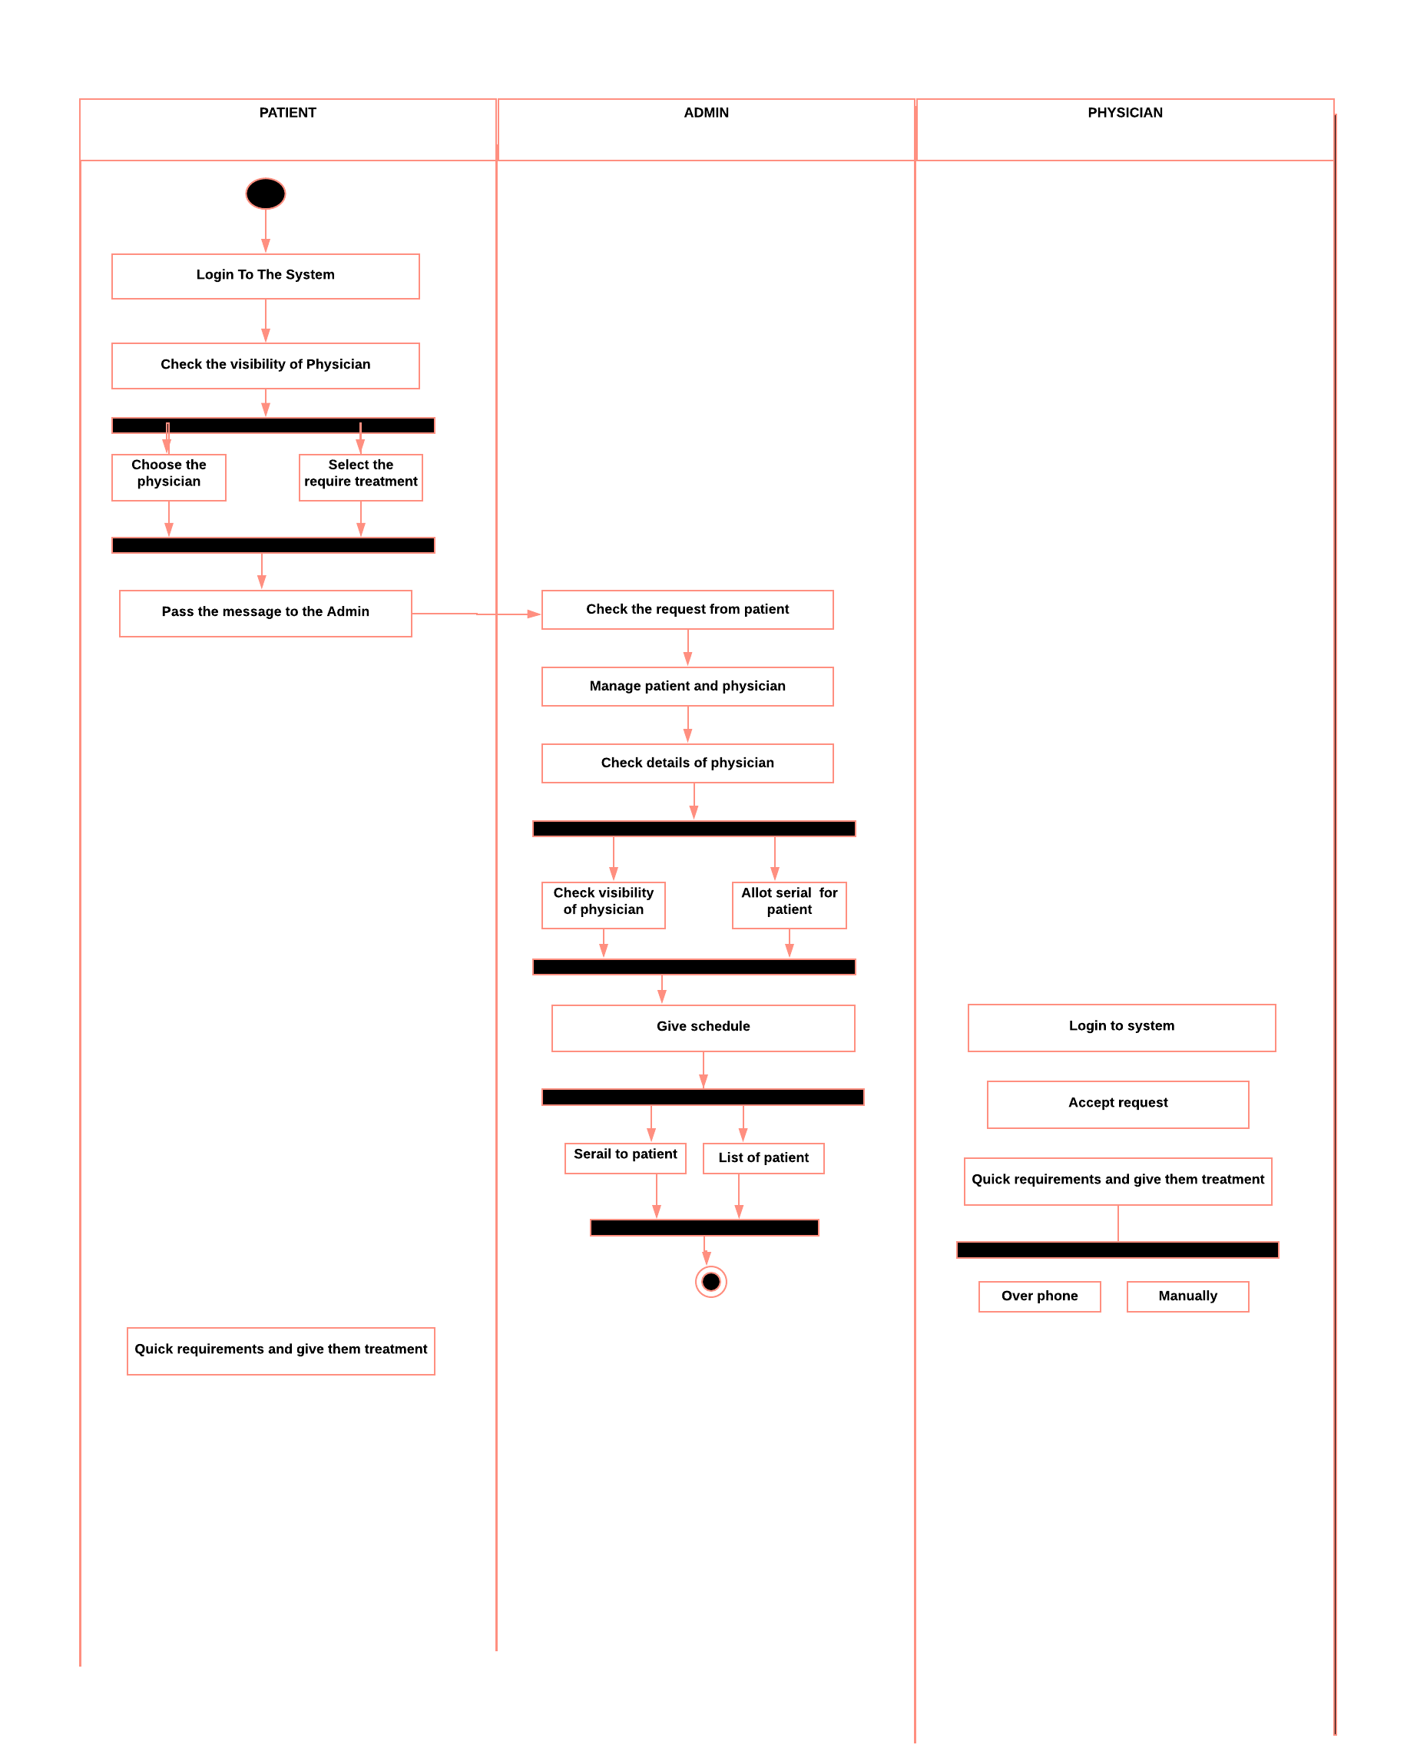

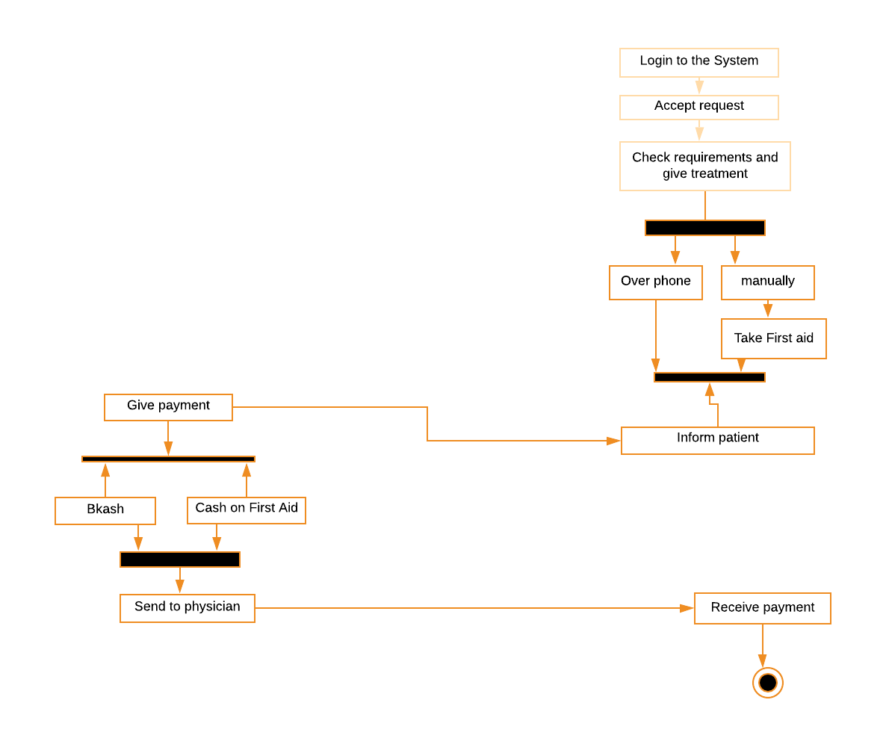

**2.4Project Requirements**

* List down the project constraints (e.g. time, budget, resources, environment, etc.) that should be followed in the project management.
* Example:

1. **SOFTWARE DEVELOPMENT LIFE CYCLE**
   1. **Process Model**

* Provide an analysis regarding the nature and environment of the software that you are going to develop and select the best suitable method(s) to develop the software.
* Present your arguments based on your analysis about why your selected method(s) is the best choice among all other methods to develop your proposed software.
  1. **Project Roll Identification and Responsibilities**
* Identify all the roles in the project management activities in software development.
* Describes the responsibilities of the role in the software development.

**Text Format:**

* Style: Times New Roman
* Size: 12
* Length: Maximum 8 pages