

American International University-Bangladesh (AIUB)  
**Department of Computer Science  
Faculty of Science &Technology (FST)  
Spring 19_20**

**Blood donor finder app**

A software Engineering project submitted

By

*Md Nabil Hossain (18-38585-2)*

*K.S Subhan Munim (18-36171-1)*

*Jannatul Ferdous Mun (18-36681-1)*

*Tanvir Rahman Tarafder (18-36894-1)*

The project will be Evaluated for the following Course Outcomes

|  |  |
| --- | --- |
| CO3: Choose appropriate software engineering model in a software development environment | Total Marks |
|  |
| Project Background Analysis (needs, goal, benefits, etc.) [5Marks] |  |
| Appropriate Process Model Selection [5Marks] |  |
| Argumentation for model selection with Evidence [5Marks] |  |
| Completeness, Spelling, Grammar and Organization of the Answer [5Marks] |  |
|  | |
| CO4: Explain the roles and their responsibilities in the software project management activities | Total Marks |
|  |
| Content Knowledge (e.g. System Requirements, System Design) [5Marks] |  |
| Project Role identification [5Marks] |  |
| Responsibility Description [5Marks] |  |
| Completeness, Spelling, grammar and Organization of the Answer [5Marks] |  |

1. **PROBLEM DOMAIN**
   1. **Background to the Problem**

Blood is one of the most important elements of human body. Blood can be defined as the fluid we have in our bodies that carries oxygen from the lungs to the rest of the body. It also carries waste to be eliminated from the body. We have between 4 and 6 liters of blood in our adult bodies depending on size. Millions of people need blood every year. There are tens of thousands of pints of blood that are needed every day to help people. Along with helping save lives, there are a number of reasons why donating blood is important. A single donation can save three lives. One blood donation provides different blood components that can help up to three different people. Blood cannot be manufactured. Despite medical and technological advances, blood cannot be made, so donations are the only way we can give blood to those who need it. Blood is needed every two seconds. Nearly 21 million blood components are transfused in the U.S. every year. Only 37 percent of the country’s population is eligible to donate blood. Your friends or family may need blood someday. In this era of technology, it’s not hard to find a blood donor but its hard to find in appropriate location and there are lots of fake groups. Therefor the purpose of the app is to simplify the process to find a blood donor.

* 1. **Solution to the Problem**

Blood donor finder app is an online web-based project. Today we can easily connect with anything through internet services. So online platform is the best choice for our project. Blood donor finder app is serving for human welfare. We have all the information; patient will ever need. Many people are here who are willing to donate blood anytime for the receiver. People have to register on this app if they are willing to donate their blood when needed. Person who need to donate blood may register on our app. The person who need the blood donor, they can search and find blood donor by using this app. After searching a list of donors, they will be displayed and user can get brief details about their conduct details. So, they can communicate. The main objective is to develop a app that can create a network of blood donors, motivate more people to join and increase the number of blood donations. There has also an existing blood donation app. American Red Cross has launched a blood donor app that makes it easier for people to track their blood donations and schedule new ones. The app is available on iOS and Android devices. The Red Cross and its partners will also send the donor "thank you" messages through the app. Then NHS Give Blood app allows to book appointments and manage details on Android or Apple iPhone device. Once a person has registered to donate and set up his/her online account, he/she can download convenient and easy-to-use app. Again, there are also some Facebook group whose are working for blood donation system.

1. **PRODUCT AND PROJECT DESCRIPTION**
   1. **System Features**

List of the system functional requirements that describes the system’s functionalities are described below.

**1. System Login  
Functional Requirements**

1.1 The software shall allow users to login with their given username and password

1.2 If the username and/or password has been inserted wrong for more than three times, the random verification code will be generated by the system to retry login.

**Priority Level:** High **Precondition:** User have valid user id and password

**2. User Registration   
 Functional Requirements**

2.1 User must have to register for using this app because the app uses the user registration data for finding a donor

2.2 Name, Email, Password, Gender, Age, Blood Group, Mobile Number and Location are the information a user have to give for registration

**Priority Level:** High **Precondition:** User have to register to use this app

* 1. **System Quality Attributes**
* List down the quality attributes that describes how well the system should perform.
* Example:  
  **Usability:** *A trained user shall be able to submit a complete request for a chemical selected from a vendor catalog in an average of four and a maximum of six minutes.*
  1. **System Interface**

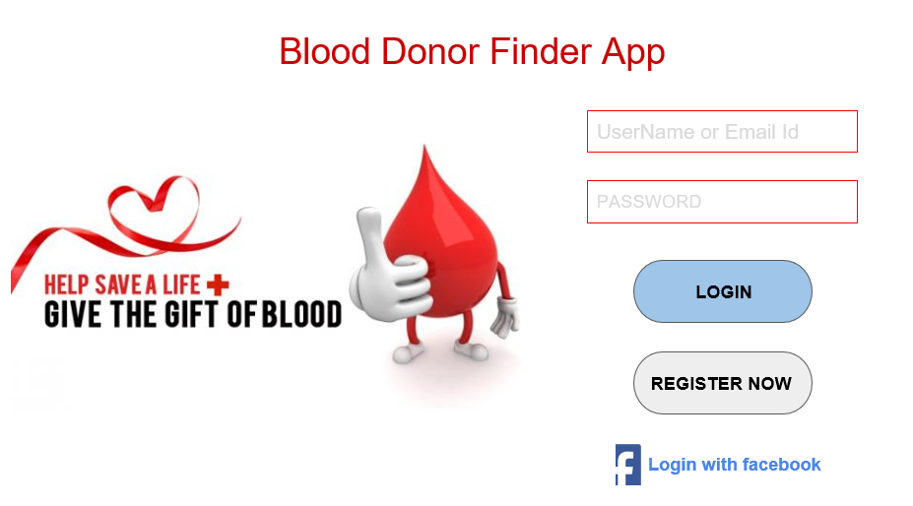

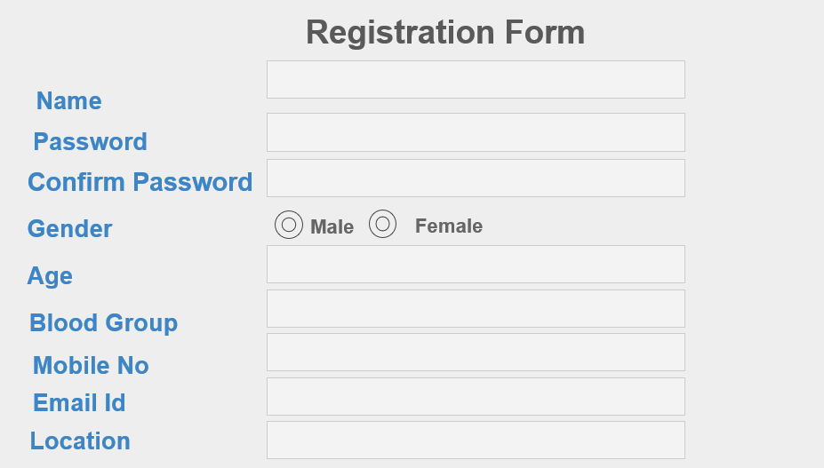

* 1. **Project Requirements**

The project contains which should be followed in the project management are given below:

* **Time:** Time is defined as the time to complete the project. Time is often the most frequent project oversight in developing projects. This is reflected in missed deadlines and incomplete deliverables.
* **Budget:** Budgetis the cost approved for the project including all necessary expenses needed to deliver the project. Within organizations, project managers have to balance between not running out of the money and not under-spending because many projects receive funds or grants that have contract clauses with a “use it or lose it” approach to project funds. Poorly executed budget plans can result in a last-minute rush to spend the allocated funds. For virtually all projects, budget is ultimately a limiting constraint; few projects can go over budget without eventually requiring a corrective action.
* **Resources:** Resources are required to carry out the project tasks. They can be people, equipment, facilities, funding, or anything else capable of definition required for the completion of a project activity.
* **Environment:**  Environment is a technical specification of requirement of software product. This specifies the environment for development, operation and maintenance of the product.
* **Scope:** Scope is what the project is trying to achieve. It entails all the work involved in delivering the project outcomes and the processes used to produce them. It is the reason and the purpose of the project.
* **Quality:** Quality is a combination of the standards and criteria to which the project’s products must be delivered for them to perform effectively. The product must perform to provide the functionality expected, solve the identified problem, and deliver the benefit and value expected. It must also meet other performance requirements, or service levels, such as availability, reliability, and maintainability and have acceptable finish and polish. Quality on a project is controlled through quality assurance (QA), which is the process of evaluating overall project performance on a regular basis to provide confidence that the project will satisfy the relevant quality standards.

**Risk:** Risk is defined by potential external events that will have a negative impact on the project if they occur. Risk refers to the combination of the probability the event will occur and the impact on the project if the event occurs. If the combination of the probability of the occurrence and the impact on the project is too high, you should identify the potential event as a risk and put a proactive plan in place to manage the risk.

**Blood donor finder app** is mainly towards people who are willing to donate blood to the patients. Through this system it will be easier to find a donor for the exact blood type and easy to build the connection between donor & the blood bank authorities. Our system encourages the blood communication between the donor and seeker.

1. **SOFTWARE DEVELOPMENT LIFE CYCLE**
   1. **Process Model**

* Provide an analysis regarding the nature and environment of the software that you are going to develop and select the best suitable method(s) to develop the software.
* Present your arguments based on your analysis about why your selected method(s) is the best choice among all other methods to develop your proposed software.
  1. **Project Roll Identification and Responsibilities**
* Identify all the roles in the project management activities in software development.
* Describes the responsibilities of the role in the software development.

**Text Format:**

* Style: Times New Roman
* Size: 12
* Length: Maximum 8 pages