

American International University-Bangladesh (AIUB)  
**Department of Computer Science  
Faculty of Science &Technology (FST)  
Spring 19_20**

**PROJECT TITLE**

A software Engineering project submitted

By

MD Nabil Hossain (18-38585-2)

Imran Ush Shahid (18-37307-1)

Ahmed, Farhat (18-36465-1)

Md. Mohiuddin ahmed Efti (18-38857-3)

The project will be Evaluated for the following Course Outcomes

|  |  |
| --- | --- |
| CO3: Choose appropriate software engineering model in a software development environment | Total Marks |
|  |
| Project Background Analysis (needs, goal, benefits, etc.) [5Marks] |  |
| Appropriate Process Model Selection [5Marks] |  |
| Argumentation for model selection with Evidence [5Marks] |  |
| Completeness, Spelling, Grammar and Organization of the Answer [5Marks] |  |
|  | |
| CO4: Explain the roles and their responsibilities in the software project management activities | Total Marks |
|  |
| Content Knowledge (e.g. System Requirements, System Design) [5Marks] |  |
| Project Role identification [5Marks] |  |
| Responsibility Description [5Marks] |  |
| Completeness, Spelling, grammar and Organization of the Answer [5Marks] |  |

1. **PROBLEM DOMAIN**
   1. **Background to the Problem**

* The population of Bangladesh is increasing and is currently 168 million. In case of outbreak of diseases there are not enough qualified doctors to treat the people in Bangladesh. It is shown in an economic survey of 2018 that there will be only one doctor available for every 2039 patients. A large number of patient is showing upto to the doctors chambers everyday. These patients have to wait in long queues to just get a serial number and to get consultation from doctor. This process is very time consuming and inefficient. If any patient fails to come at the given appointment time due to emergency situations will end up missing their appointments completely. As a result, they suffer from a loss of money and time and also have to wait once again till they get a new serial number.
* The patients will also have to carry all their documents every time they visit the doctor, for ex-old prescription, test reports etc. Therefore it is a hassle for the patients. And due to this unorganized, unfriendly management and dishonesty of people, the people are to be blamed. Therefore it is very important to consider and come up with a better and efficient solution for a densely populated country like ours where there are insufficient number of doctors.
  1. **Solution to the Problem**
* The solution being proposed is a management system for handling doctors and patients. In other words, it is a portal that helps doctor in their work and eases the work of placing appointments and viewing medical process for patients. A search engine will be provided through which users can pick suitable doctors and customize their appointment facilities. This system will allow doctors to manage their booking slots online. Each patient will be allowed to book an empty slot online and these slots will be reserved under their name. A patient can also cancel their booking in case of any inconveniences. The system will manage the appointment data for multiple doctor for various dates and times. Every time a user visits a doctor, their medical entry is stored in the database by a doctor's assistant. Every time a user logs in, he/she may view their entire medical history when needed, which will no longer require them to carry their old medical documents such as reports and prescriptions. Simultaneously, a doctor may view a patient's medical history every time they visit the aforementioned doctor. This will allow an automated doctor-patient handling system through an online interface. A feedback option will be also provided which will deal with reviews and complaints, and this will lead to rating of doctors and improvement for the portal.
* The software will contain an option for all the doctors to create a slot for themselves, when they will be available to consult with their patients. The system registers this into the database, and it will send a confirmation respond to the particular doctor. The software will initially require patients to register, and it will be updated in the main database. They will be given a confirmation and they will be asked to make a log in id and password for themselves. If it is done under the given conditions, their id and password will be confirmed. Now, the patient will be prompted to enter their desired slot, and once entered, the database will make the following booking, and send a confirmation to the patient. If the patient would like to cancel the slot they have booked already, the database will make that booked timing available once again. However, there are conditions for this. If the time elapsed after the booking is made is less than 24 hours, then the cancellation is not possible. If it is more than or equal to 24 hours, the cancellation is made and confirmed to the patient. The goal of this portal is therefore to allow ease of access to doctors - to make their available slots public, for patients - to look for their desired doctor and their desired timings.
* Taking Bangladesh into perspective, the current solution could be usuage of emails, direct phone calls, or usage of different social media websites. For example- If a patient wants to book an appointment , they can directly make a call to the doctor or to the hospital where the doctor works to file an appointment under their name. Patients may also use emails as an alternative of phone calls. However, if a huge number of patients sends emails for placing appointments then it will be very inefficient and time consuming to read email of each patient one by one and sort out their suitable appointment dates and their preffered doctor. Thus, the existing solutions are extremely time consuming and inefficient.

1. **PRODUCT AND PROJECT DESCRIPTION**
   1. **Short Description of the Software**

The software will contain an option for all the doctors to create a slot for themselves, when they will be available to consult with their patients. The system registers this into the database, and it will send a confirmation respond to the particular doctor. The software will initially require patients to register, and it will be updated in the main database. They will be given a confirmation and they will be asked to make a log in id and password for themselves. If it is done under the given conditions, their id and password will be confirmed. Now, the patient will be prompted to enter their desired slot, and once entered, the database will make the following booking, and send a confirmation to the patient. If the patient would like to cancel the slot they have booked already, the database will make that booked timing available once again. However, there are conditions for this. If the time elapsed after the booking is made is less than 24 hours, then the cancellation is not possible. If it is more than or equal to 24 hours, the cancellation is made and confirmed to the patient. The goal of this portal is therefore to allow ease of access to doctors - to make their available slots public, for patients - to look for their desired doctor and their desired timings.

**Purpose of the Software**

* Allow patient to book or cancel slots.
* Allow patient to visit doctor without bothering about carrying necessary documents.
* Allow doctor to manage slots easily.

**Benefits of the Software**

Benefits of the Software

1. The software will minimize the time of booking and cancellation of slots.

2. The software will maximize the probability of finding doctors and their slots.

**System Features**

There are many user associated with our system. Different user need different functionalities.

**Features for all users:**

Log in

Sign Up

**1.1 Features provided to doctor:**

Create slots

Patient History

Appointment Request

Feedback

**1.2 Feature provided to patients:**

Book an Appointments

Search Doctors

Cancel Slot

View medical history

Provide feedback

**1.3 Feature provided to Doctor’s assistant**

Update patient’s medical history

**Priority Level:** High **Precondition:** user have valid user id and password

* 1. **System Quality Attributes**
* Log in: integrity
* Book/Cancel/Create slot: reliability/ usability/ robustness/ availability
* View/Update medical history of patient: usability
* Doctor: efficiency
* Create account: reliability/ usability/ availability Contact
* **Usability:** As our system will be web based, the whole system must ensure availability quality of maximum so that the patients can book or cancel slot anytime and other type users also can do their work without any problem. Besides the system also need to ensure usability so the users don’t need to sweat at all to do their desired work.*.*
  1. **System Interface**

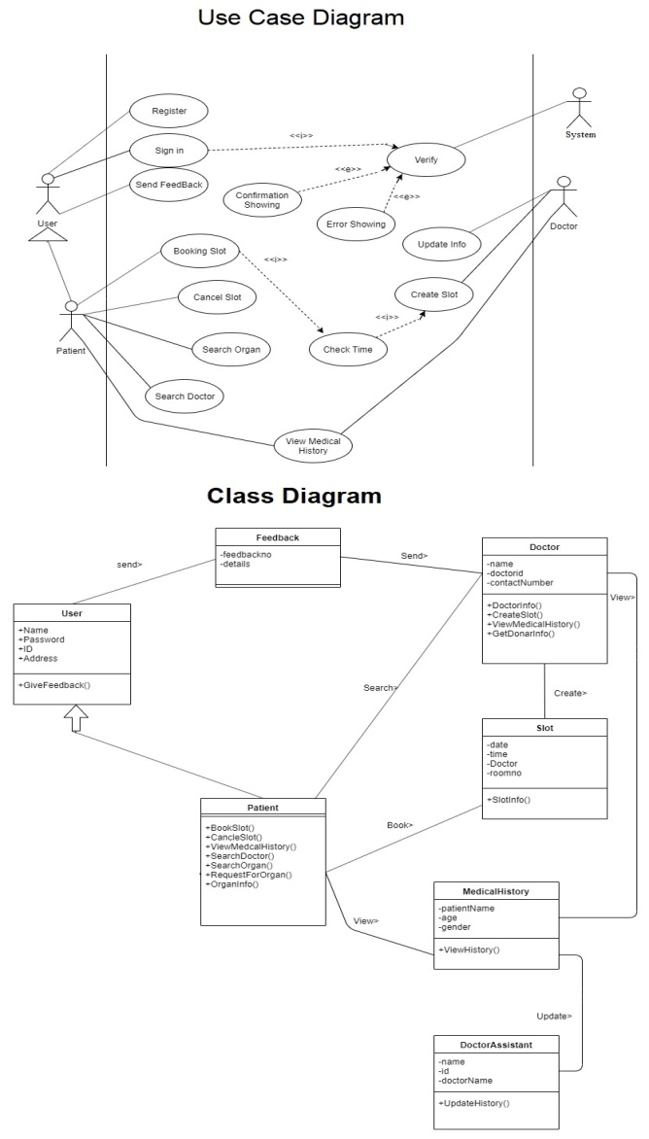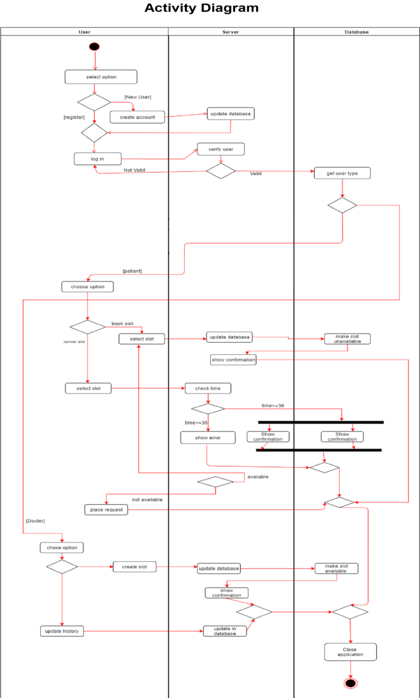

**User Interface**

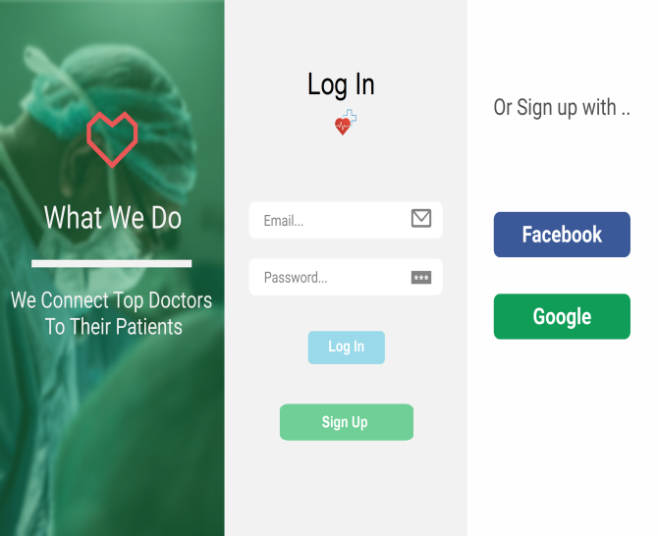 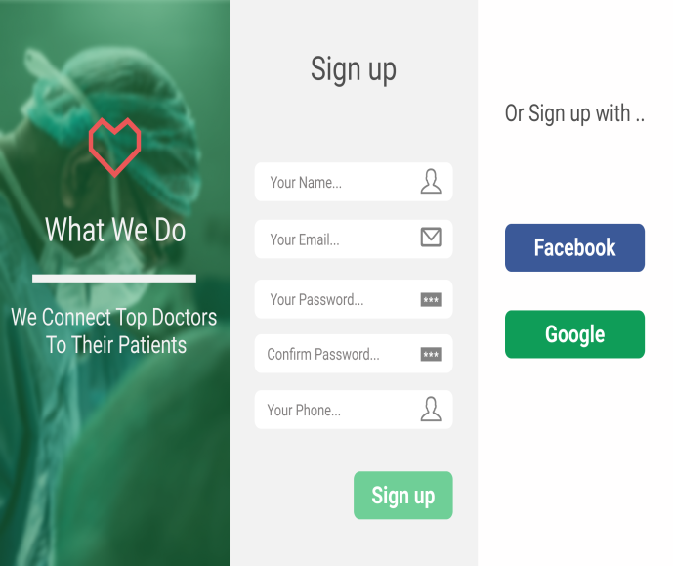

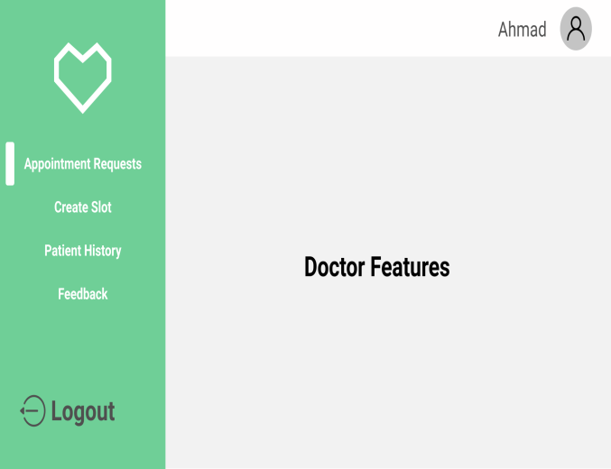 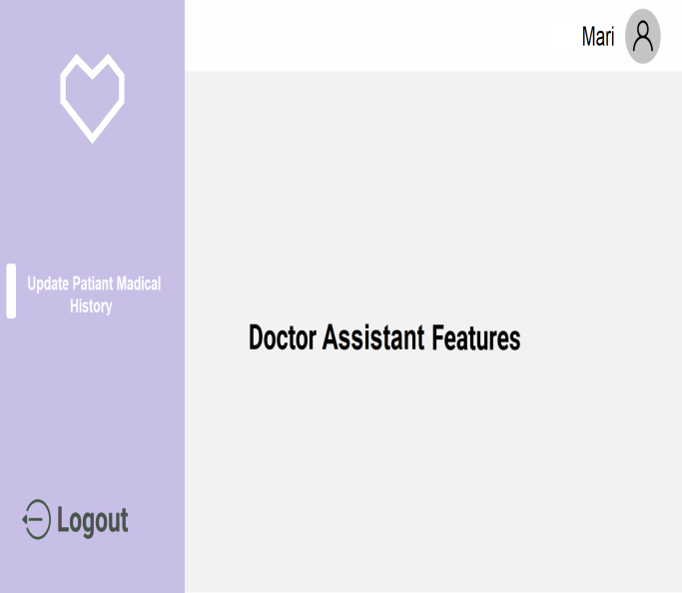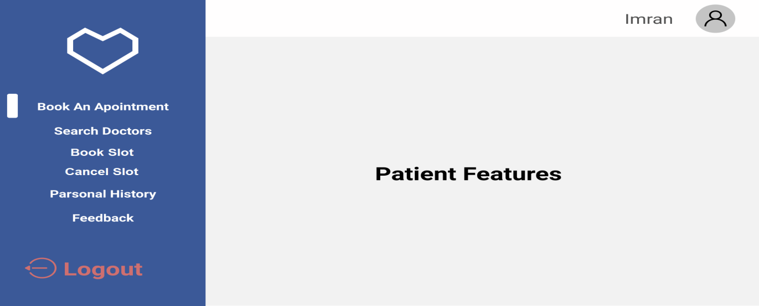

* 1. **Project Requirements**
* List down the project constraints (e.g. time, budget, resources, environment, etc.) that should be followed in the project management.
* **Time**

Development time = DM = 2.50*(PM) ^T

=2.50*(12) ^.38

=6.43

* **Budget**

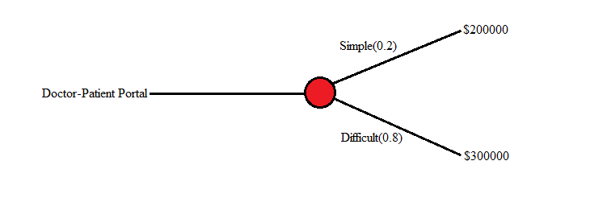

The expected cost to build is: expected cost = ((0.20 ($200K)) + (0.80 ($300K))) = $280k.

So we build the system and our expected budget is $280000.

* **Effort**

Effort = PM = Coefficient<Effort Factor>*(SLOC/1000) ^P

=2.4*(10000/1000) ^1.05

=26.93

* **Required People**

Required number of people = ST = PM/DM

=26.93/6.43

=4

* **Scheduling:**

|  |  |  |  |  |  |  |  |  |  |  |  |  |
| --- | --- | --- | --- | --- | --- | --- | --- | --- | --- | --- | --- | --- |
| Task’s to  do | Week-1 | Week-2 | Week-3 | Week-4 | Week-5 | Week-6 | Week-7 | Week-8 | Week-9 | Week-10 | Week-11 | Week-12 |
| Meeting |  |  |  |  |  |  |  |  |  |  |  |  |
| Design |  |  |  |  |  |  |  |  |  |  |  |  |
| Coding |  |  |  |  |  |  |  |  |  |  |  |  |
| Testing |  |  |  |  |  |  |  |  |  |  |  |  |
| Release |  |  |  |  |  |  |  |  |  |  |  |  |
| Documentation |  |  |  |  |  |  |  |  |  |  |  |  |

1. **SOFTWARE DEVELOPMENT LIFE CYCLE**
   1. **Extreme Programming (XP) Model**

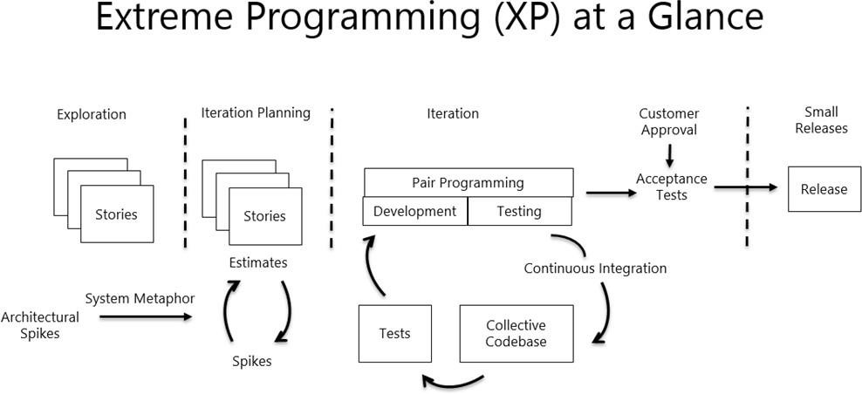

* Though our group is small and inexperienced, there is option of having high experienced personnel with us who can help us in all aspects. So, that way we can also use agile method to increase our productivity, output of incremental model, and we also can gather more experience. From the agile methods XP is the best suited option for us as it requires small group, allows incremental release, prioritization, simple design. It will also maximize our development and testing speed through pair programming.
* Choosing XP over other agile process is best for us because other process requires more manpower, tools, high experience, frequent professional meetings which are out of our reach.
  1. **Project Roll Identification and Responsibilities**
* Identify all the roles in the project management activities in software development.
* A project management consists of some very important roles. There are 7 of them

1. THE CUSTOMER
2. THE DEVELOPER
3. THE TESTER
4. THE TRACKER
5. THE COACH
6. THE CONSULTANT
7. THE MANAGER

There is a description of how roles typically found in more traditional projects behave on Extreme Programming projects. Here are saven most common roles associated with extreme programming.

* The Customer: The customer is responsible for writing user stories, setting priorities and formulating the product backlog.
* The DEVELOPER: The DEVELOPER is the person who is an ordinary programmer. Writing the code and performs the entire amount of project task is done by him.
* THE Tester: The tester is responsible for product testing. The quality of the final product strongly depends on his work.
* THE Tracker: The tracker is the person whose main task is to monitor the progress of software development and to solve problems in it.
* THE Coach: The coach who watches the team’s work, controls it, and teaches its members to implement the most effective practices.
* THE Consultant: the consultant will suggest some Specific knowledge.
* THE Manager: The man who take all the dicision is manager.