Database Project

Online Bank Management

A online bank named CyberOnline has created their database recently. Here customers can open their accounts through mobile application. There are some employees in the bank who manages the customers through app. Some of the table of the bank database is given below-

Table: Account

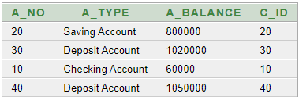

Table: CustomerInfo

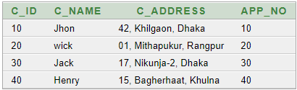

Table: Loan

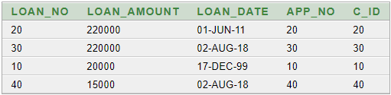

Table: Employee

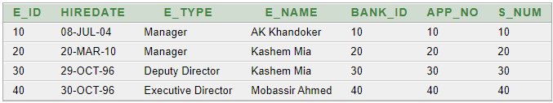

Table: Salary

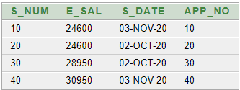

1. Create a view named “EmpWorkBase” for employees so that they can add new customers and create their accounts.
2. The account table has “Account_sq” and customerInfo table has “Customer_sq” named sequences. Modify these two sequences with new starting value of 100 and increment by 5.
3. Insert two new customer into “EmpWorkBase” view with following details :
4. Fariha, 30 Baily Road Dhaka, Saving account, 40000
5. Karim, Malibag Dhaka, Deposite account, 1000
6. Show the customers name and address who have deposit account and has taken a loan on '02-08-2018'.
7. Show employee name, total working weeks as “Worked Weeks”, reducing 7 months from total worked months as “Without Vacations”.
8. Show employee name and employee type who has ‘a’ in their name and salary is greater than 30000.
9. Show all the customers name, loan amount who have taken minimum loan than 20000 and grouping by their name and display in descending order.
10. Check constraints of loan table. If there is any (without pk and fk), disable the constraint and add following values: Loan amount=500, loan date=today’s date. Remember the loan table has a sequence as loan_sq.
11. Show the employees id and hire date where employee type is same but name is different.

10.Show balance digit count of all the customer and their name in lower case.