
BSc (Hons) Computing Systems
COM367 (75560) - Professional Practice
(2025-26)

Project Report

Author
Name: Md Nasif
ID: B00957996

Table of Contents
Introduction 2
Project Overview 3
Technology Stack 4
Month-by-Month Development Breakdown 5
Month 1: Planning, Research & Project Setup 5
Month 2: Database Design & Core Models 7
Month 3: Building the Bidding & Property System 9
Month 4: Contracts, Messaging & Real-Time Features 11
Month 5: Notifications, Reviews & Frontend Polish 13
Month 6: Testing, Bug Fixing & Final Review 15
Critical Evaluation 16
Personal Reflection 17
Conclusion 18
References 19

Introduction

This report documents my individual development of BidNest, a full-stack web platform designed to address the challenges students face when searching for off-campus accommodation in the United Kingdom. The idea came from observing how fragmented and stressful the student housing process tends to be. Existing platforms such as Rightmove and SpareRoom are built for the general rental market and offer very little that is tailored to students specifically. There is no structured negotiation process, no student-specific verification, and no integrated contract management. Students are largely left to navigate a process that was not designed with them in mind (Rugg et al., 2002).

BidNest aims to change that. The platform gives students the ability to bid on properties, negotiate directly with landlords through a counter-offer system, sign digital contracts, communicate through a built-in real-time messaging system, and post accommodation seeking advertisements. Landlords benefit from a structured bid management workflow, automated contract generation, and a review system that builds their reputation on the platform. Administrators can oversee all activity through Django's built-in admin panel.

As the sole developer on this project, I was responsible for every layer of the system — database design, backend logic, frontend templates, real-time features, background tasks, and deployment configuration. This report walks through how the project evolved over six months, the technical decisions I made at each stage, the problems I encountered and how I resolved them, and what I took away from the experience as a developer.

Project Overview

BidNest is a web application built specifically for the UK student housing market. It supports three distinct user roles — students, landlords, and administrators — each with their own set of features and access permissions.

Students can register and complete a profile with their university and course details, search and filter properties using a wide range of criteria, place bids on listings, respond to counter-offers from landlords, sign contracts digitally, save favourite properties, send and receive real-time messages, post accommodation seeking advertisements, and leave reviews for landlords they have rented from. Landlords can create and manage property listings with multiple images, view and respond to incoming bids, generate contracts from accepted bids, communicate with students through the messaging system, respond to reviews, and monitor their activity through a dashboard. Administrators have access to a Django admin panel where they can manage all users, properties, bids, contracts, notifications, and contact form submissions.

The most distinctive feature of the platform is the bidding and counter-offer system. Rather than a fixed rent price, landlords set a starting bid and students place offers at or above that amount. The landlord can then accept the bid — which triggers automatic contract generation — reject it with an optional reason, or make a counter-offer proposing a different amount. If the student accepts the counter-offer, the contract is generated at the counter amount. If they reject it, they can place a new bid or walk away. This negotiation model is not something found in any mainstream student housing platform, and it was one of the most interesting parts of the project to design and implement.

Beyond bidding, the platform includes a full contract lifecycle — from auto-generation through digital signing to expiry and early termination. There is a real-time messaging system built on WebSockets, an in-app notification system that covers all key events across the platform, and a review system that allows students to rate and comment on landlords after a tenancy. It is worth noting that three features — Stripe payment processing, DocuSign e-signatures, and Onfido document verification — are planned for future implementation. The configuration, environment variables, and installed packages for all three are already in place in the codebase, but the actual functionality has not been built out yet, as it requires live API credentials and planned for a future release.
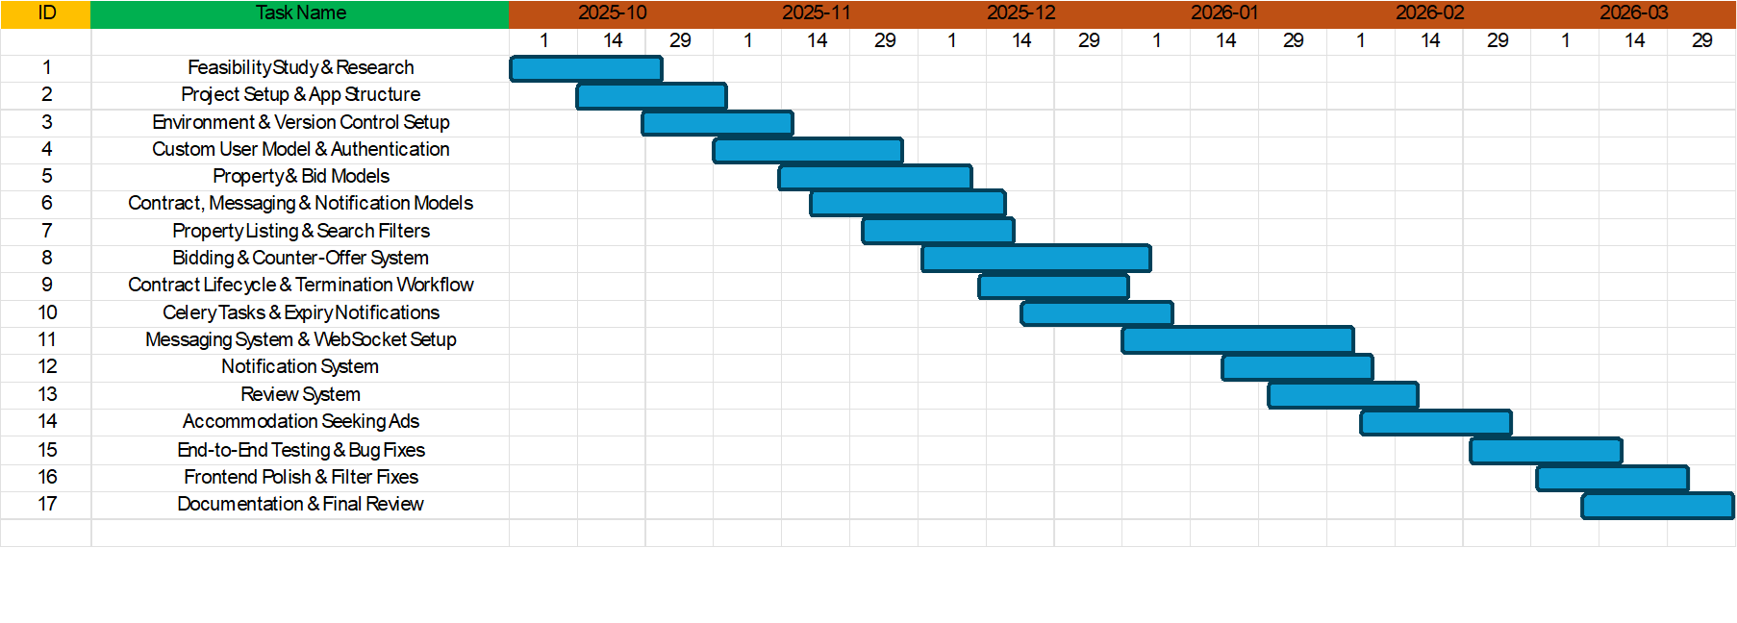
Fig: Overall view of the project in Gantt Chart

Technology Stack

The backend is built with Django 5.1.5 (Django Software Foundation, 2024), using Python as the primary language. Django was chosen for several reasons: its built-in admin panel, its ORM for database interaction, its session-based authentication system, and the speed at which a well-structured project can be assembled. For a solo developer managing a system with many interconnected parts, Django's "batteries included" approach was genuinely valuable. It meant I could focus on building the application logic rather than spending time configuring infrastructure from scratch.

The database is SQLite for development, which requires zero configuration and is built into Python. PostgreSQL configuration is available in settings.py for production deployment. The frontend uses Django's template engine with plain HTML, CSS, and vanilla JavaScript.

Real-time messaging is handled through Django Channels (Django Channels, 2024) with WebSockets, using Redis as the channel layer. This allows messages to be delivered instantly without the user needing to refresh the page. Background tasks — specifically the automated contract expiry notifications sent at 30, 7, and 0 days before a contract ends — are managed with Celery (Celery open-source project, 2024) and Redis, scheduled using django-celery-beat. Static files are served in production using WhiteNoise (Evans, 2024), and the project is configured for deployment with Gunicorn as the WSGI server.

Django REST Framework is installed and configured, with session-based authentication and pagination set up in settings.py. However, the api app currently has no active endpoints — it is in place as a foundation for a future mobile application or third-party integrations.

Third-party integrations planned for future implementation include Stripe for payment processing (Stripe Inc., 2024), DocuSign for e-signatures (DocuSign Inc., 2024), and Onfido for identity and student document verification. The packages for all three are installed and their API keys are configured in settings.py and the .env file, but none of the actual integration logic has been implemented yet. These are scoped out of the current version and marked as future development work.

The full list of key dependencies includes:
Django 5.1.5, djangorestframework 3.15.2, channels 4.2.0, channels-redis 4.2.1, daphne 4.1.2, celery 5.4.0, django-celery-beat 2.8.0, redis 5.2.1, stripe 11.3.0, docusign-esign 6.0.0, whitenoise 6.8.2, gunicorn 23.0.0, Pillow 11.1.0, python-decouple 3.8, and django-filter 24.3.

Month-by-Month Development Breakdown

Month 1: Planning, Research & Project Setup

The first month was spent establishing a solid foundation before writing any application code. I started by producing a feasibility study that examined the project from technical, economic, legal, and operational perspectives. This was more useful than I initially expected — it forced me to be specific about what the system needed to do, who it was for, and what risks were involved before any code was written.

The legal section of the feasibility study was particularly important. It required understanding the validity of digital contracts under the Electronic Communications Act 2000 (UK Government , 2000) , the data protection obligations imposed by the UK GDPR and Data Protection Act 2018 (Information Commissioner's Office, 2024), and the requirement to use FCA-authorised payment processors rather than handling funds directly. These legal considerations shaped several design decisions — for example, the plan to integrate Stripe and DocuSign in a future phase rather than building custom payment or signature handling, and the inclusion of a clear privacy policy and terms of use in the platform templates.

After the feasibility work, I set up the Django project and structured it into seven separate apps from the start: accounts, properties, bidding, messaging, payments, contracts, and notifications. This separation was a deliberate architectural decision. Keeping each area of functionality self-contained makes the codebase easier to navigate, debug, and extend over time (Greenfeld and Roy, 2022). I had seen projects where everything was placed in a single app and it became very difficult to manage as the codebase grew, so I wanted to avoid that pattern from the beginning.
I also configured environment variables using python-decouple, created the .env.example file documenting all required configuration values, set up Git version control, and prepared settings.py to support both development and production environments. By the end of the month, the project skeleton was in place and I had a clear picture of what needed to be built.

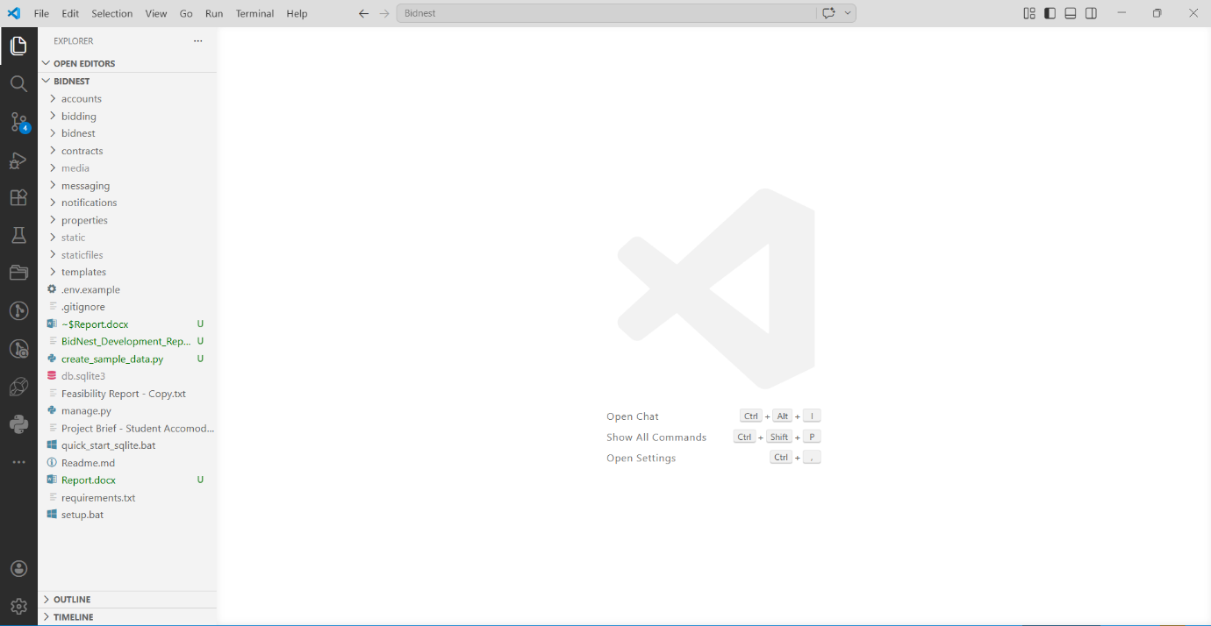
Fig: Project Setup
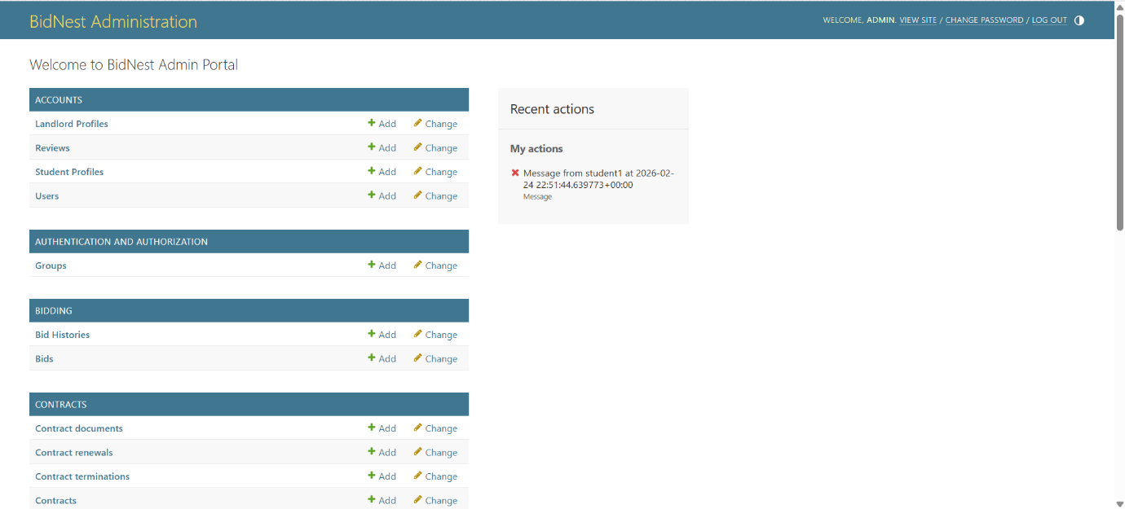
Fig: Site Administration

Month 2: Database Design & Core Models

Month two was focused entirely on designing and building the database layer. Getting the data models right early is one of the most important things you can do in a project — poor schema design creates problems that compound throughout development and become increasingly expensive to fix (Fowler, 2002). I spent a significant amount of time thinking through the relationships between models before writing any code.

The first model I built was a custom User model in the accounts app. Django's default User model does not support multiple user types, so I extended AbstractBaseUser to add a user_type field with choices of student, landlord, and admin, and made email the primary login identifier rather than username. This decision affected almost every other model in the system, since all other models reference the User model in some way. Related profile models — StudentProfile and LandlordProfile — were linked via OneToOneField, storing role-specific information such as university and course for students, and business name and registration details for landlords.

The Property model was the most complex to design. It needed to capture everything a student might want to filter on: property type (whole property or room), room type (single, double, ensuite, semi-double), bedrooms, bathrooms, furnishing (furnished, unfurnished, part-furnished), amenities (WiFi, parking, garden, disabled access, gym, laundry), bills included, pets allowed, location details including postcode, and pricing fields for starting bid, current bid, rent per month, and deposit. I also added a views_count field and an is_active flag so landlords could deactivate listings without deleting them.

The Bid model was designed to support the full negotiation flow. It stores the bid amount, a status field with choices of pending, accepted, rejected, withdrawn, and counter_offered, an optional message from the student, and a counter_offer_amount field for when the landlord proposes a different price. A BidHistory model was also created to maintain a complete audit trail of every action taken on a bid.

The Contract model uses on_delete=models.PROTECT on the property foreign key. This was an intentional design decision — it means a property cannot be deleted if it has an active contract, protecting data integrity and preventing a landlord from accidentally removing a property that a student has a live tenancy on. Other models built this month included Conversation and Message for the messaging system, Notification for in-app alerts, Review for the landlord rating system, AccommodationRequest for accommodation seeking ads, SavedProperty for bookmarking listings, and ContactMessage for the contact form.

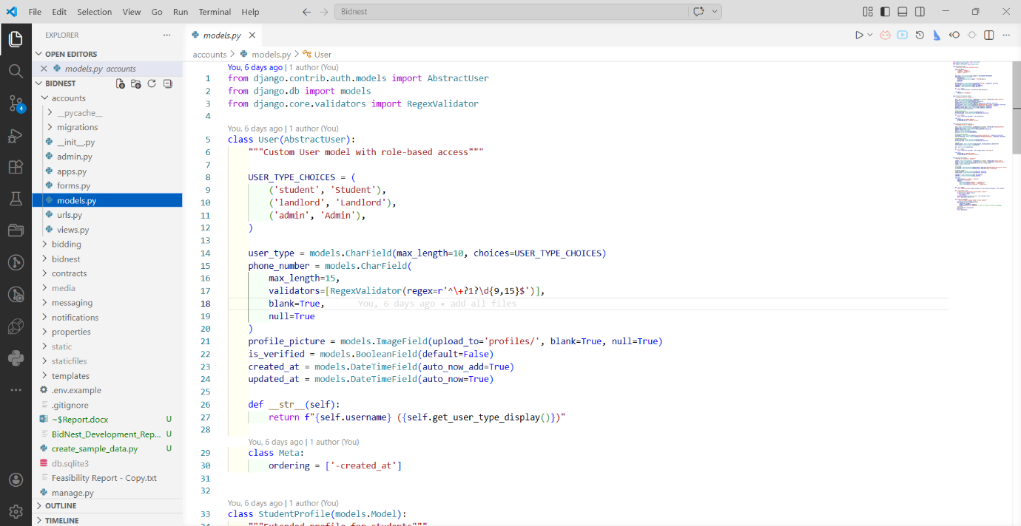
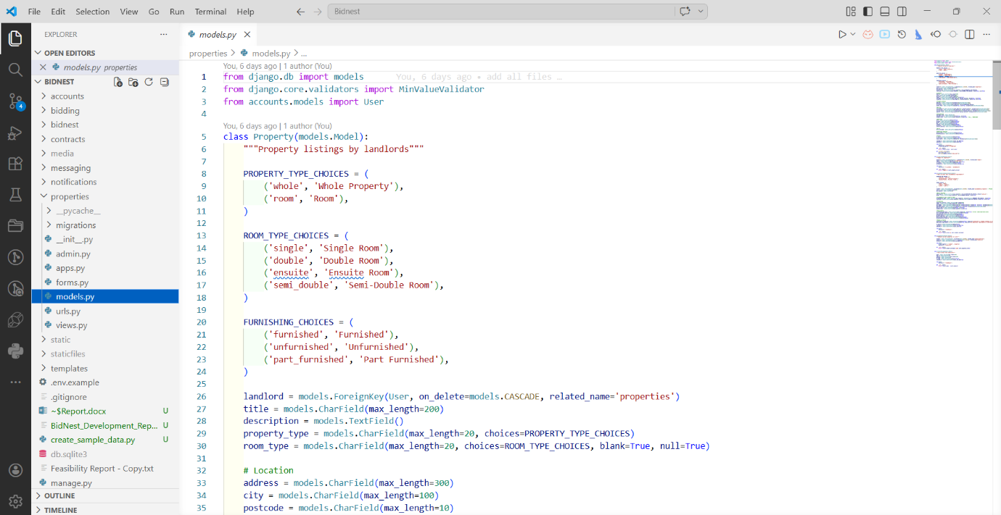
Fig: Models

Month 3: Building the Bidding & Property System

Month three was where the platform started to feel like a real product. I built the two most central features: the property listing and search system, and the complete bidding and negotiation workflow.

The property list view supports a wide range of filter parameters — location (searching address, city, and postcode), price range, bedrooms and bathrooms (min and max), property type, room type, furnishing, amenities, bills included, and pets allowed. All filter values persist across page loads by reading from request.GET and passing values back to the template, so the form fields stay populated after a search is submitted. The view only returns results when at least one search parameter is present, which avoids loading every property in the database on the initial page load and keeps the experience clean.

The bidding system validates three things before accepting a bid: the amount must be at or above the property's starting bid, the property must not already have an active contract, and the student must not already have a pending bid on the same property. When a bid is placed, a notification is automatically sent to the landlord. The landlord can then accept, reject, or counter-offer. Accepting a bid triggers automatic contract generation — a Contract record is created linked to the bid and property, and notifications are sent to both parties. Counter-offers set the bid status to counter_offered, store the proposed amount, and notify the student.

A bug discovered during this phase was that when a student accepted a counter-offer, the property's current_bid field was not being updated. This meant the listing still showed the old bid amount, which was misleading. The fix involved explicitly updating the property's current_bid in the accept_counter_offer view and also rejecting any other pending bids on the same property at that point — which is the correct behaviour, since once a bid is accepted, competing bids should no longer be active.

I also built the accommodation seeking ads feature this month — a public listing where any user can post what they are looking for, including budget range, preferred location, room type, furnishing preference, and a "buddy up" option for students interested in finding flatmates to share with. These ads display on a paginated listing page with clickable cards and a detail view.

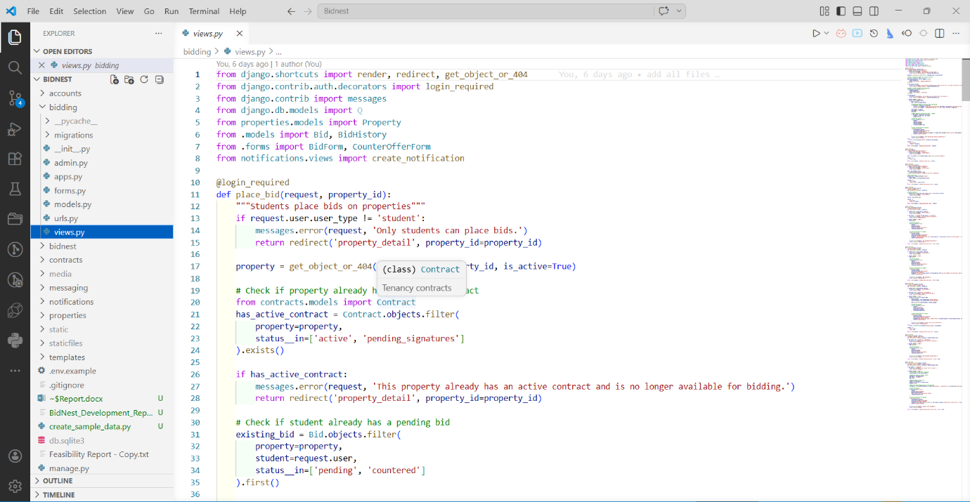
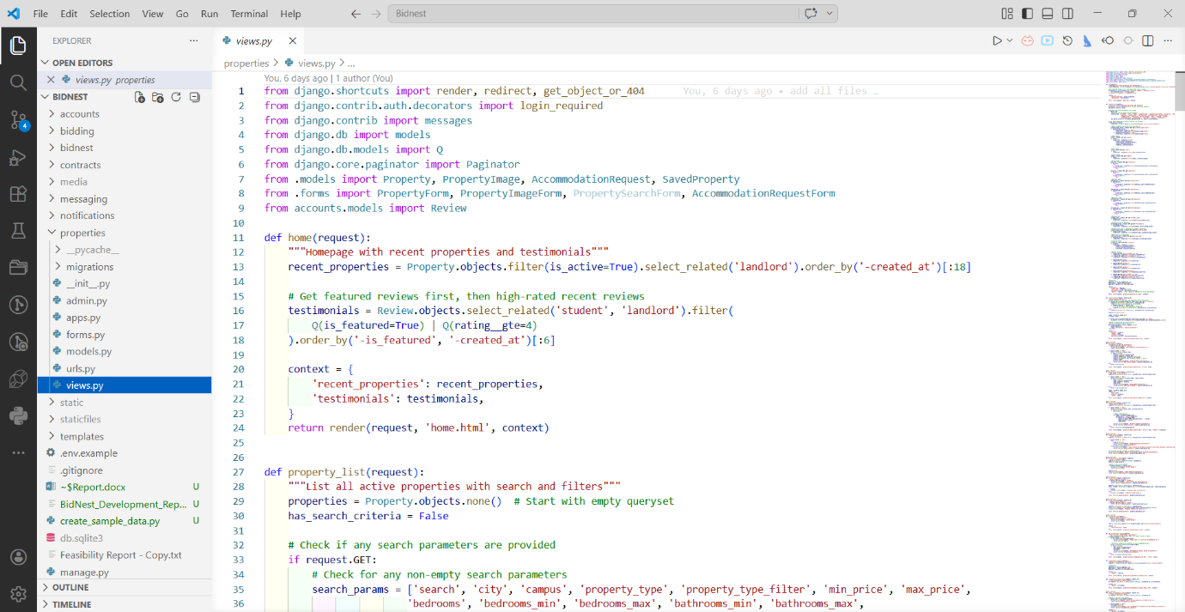
Fig: Bidding & Property System

Month 4: Contracts, Messaging & Real-Time Features

Month four covered two of the more technically challenging parts of the project: the contract system and real-time messaging.

The contract system handles five states: draft, pending_signatures, active, terminated, and expired. Contracts are auto-generated when a landlord accepts a bid, pre-filled with the property details, bid amount, and both parties' information. Both the landlord and student then sign through a sign_contract view that records the signature and updates the contract status. When both parties have signed, the status moves to pending_signatures, awaiting payment activation. Payment processing via Stripe is planned as a future implementation — the payments app and model structure are already in place, but the Stripe integration logic itself has not been built yet.

The contract termination workflow allows either party to request early termination by providing a reason, a proposed termination date, and a notice period. The other party receives a notification and can approve or reject the request. If approved, the contract status changes to terminated. The termination date is validated to fall between the contract start and end dates, enforced on both the frontend and backend.

Automated contract expiry notifications are handled by Celery tasks that run daily, checking for contracts expiring in 30, 7, and 0 days and sending in-app notifications to both the landlord and student at each interval. This required configuring Celery with Redis as the message broker and using django-celery-beat for task scheduling.

The messaging system was built using Django Channels and WebSockets. The consumer class handles connecting to a conversation group, receiving messages, saving them to the database, and broadcasting to all connected clients in the group. One issue encountered was a variable name conflict — Django's messages framework uses the context variable name messages, which clashed with the chat messages queryset in the conversation template. This was resolved by renaming the queryset to chat_messages in the view context. The unread message count badge in the navigation bar updates via an AJAX call to a dedicated endpoint every 60 seconds, so users can see when new messages arrive without being in the inbox.

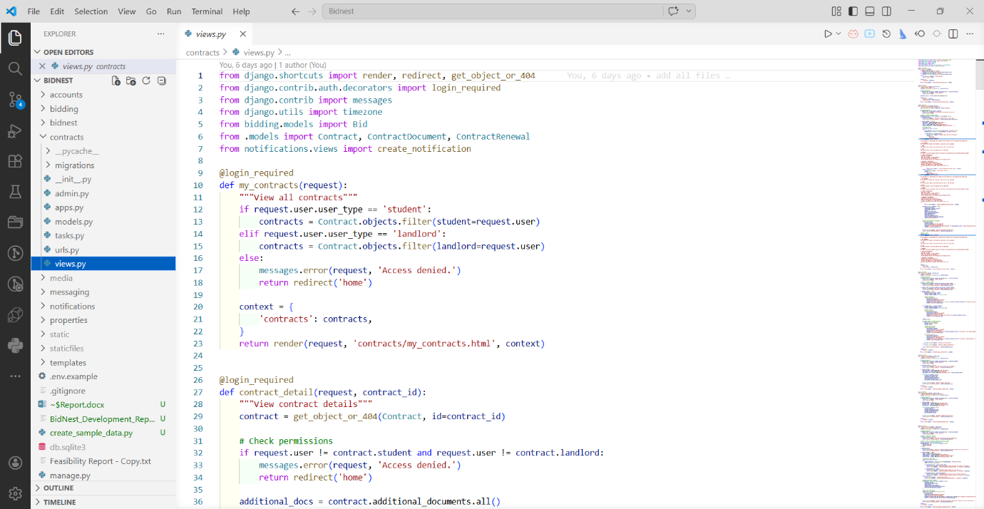
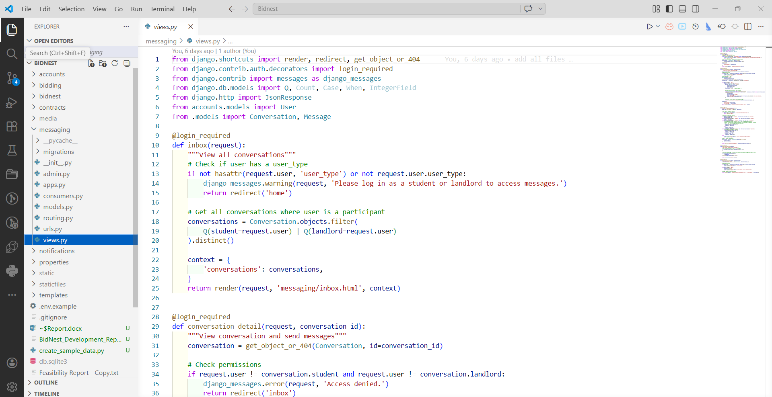
Fig: Contracts & Messaging Features

Month 5: Notifications, Reviews & Frontend Polish

By month five, the core functionality was working. This month was about completing the remaining features and making the frontend consistent and usable.

The notification system was built to support a comprehensive set of event types: bid received, bid accepted, bid rejected, counter-offer received, contract generated, contract signed, contract expiring, termination requested, termination approved, termination rejected, review received, review responded, and message received. Each notification stores a direct link to the relevant page so users can navigate straight to the context. The bell icon in the navigation shows an unread count badge that updates via AJAX, styled consistently with the messaging badge — a red circular badge positioned top-right of the icon.

The review system allows students to rate and review landlords after having an active or completed contract with them. Reviews include a 1–5 star rating and a written comment. Landlords can respond to reviews, and students receive a notification when a response is posted. The star rating interaction is handled in JavaScript — stars highlight on hover and the selected rating is stored in a hidden input field. Reviews display on the landlord's public profile page, and the landlord's average rating is calculated and shown alongside their profile information.

Frontend work this month included fixing filter persistence on the property listing page. Several filter fields — location input, property type checkboxes, room type checkboxes — were resetting after the user applied filters, even though they had not clicked "Clear Filters". This was caused by missing hidden inputs in the property type radio form and the main search form. Adding the missing hidden inputs to all three forms resolved the issue. The navigation "How it Works" link was updated to use a full URL with an anchor so it works correctly from any page, not just the homepage.

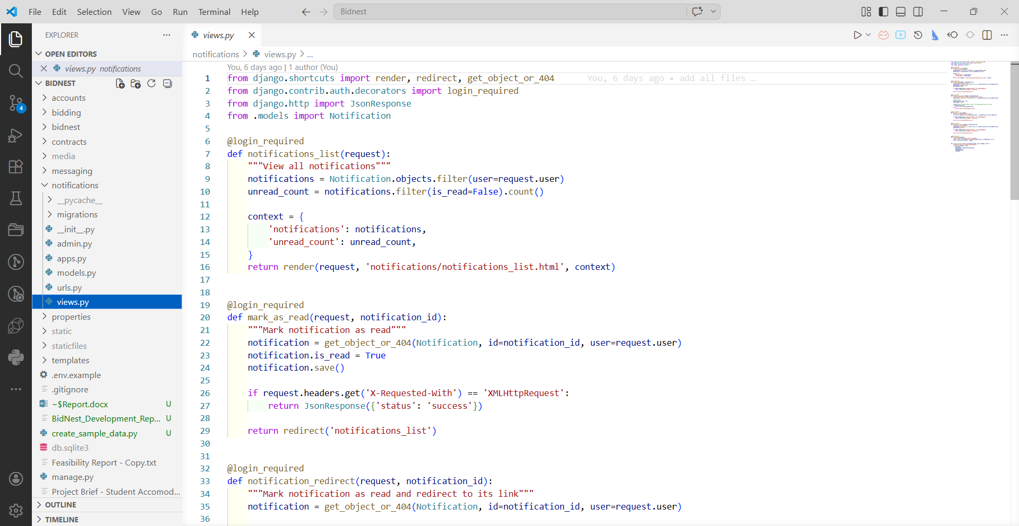

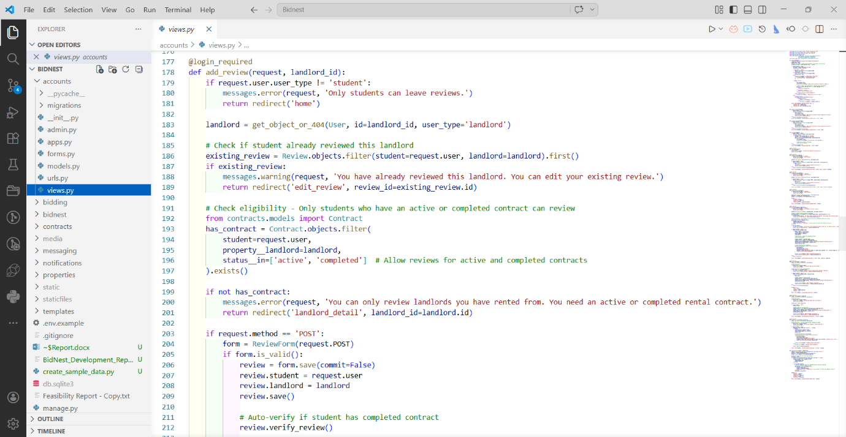

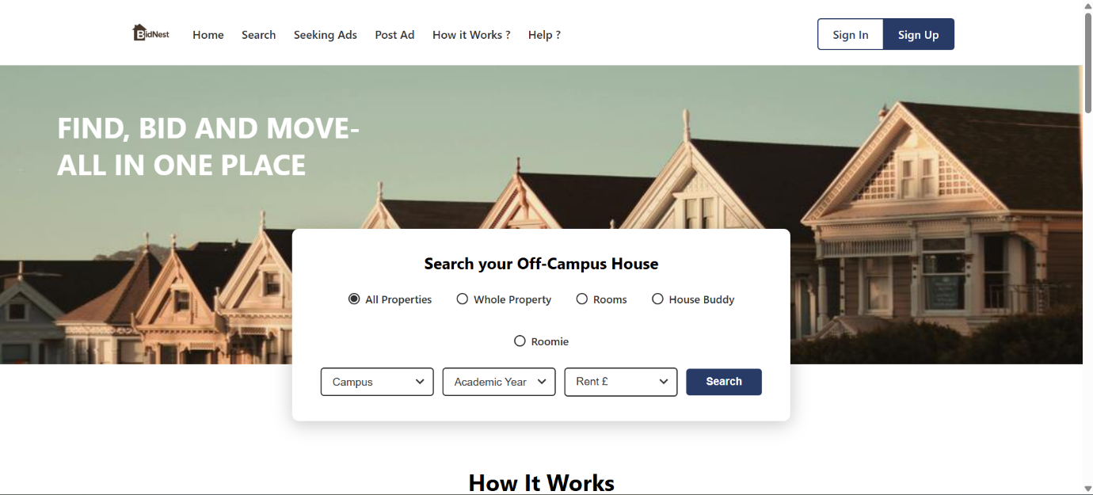
Fig: Notifications, Reviews & Frontend

Month 6: Testing, Bug Fixing & Final Review

The final month was dedicated to end-to-end testing, fixing the issues that surfaced, and making sure the codebase was clean and well-documented.

I went through every major workflow manually: registering as both a student and a landlord, posting a property and uploading images, placing a bid, going through the counter-offer flow, generating and signing a contract, requesting and approving a termination, sending and receiving messages, writing a review and responding to it, posting an accommodation seeking ad and deleting it. This process was time-consuming but necessary — it surfaced several issues that had not been caught during development.

I also cleaned up the documentation at this stage. A number of markdown files had accumulated during development — session summaries, feature-specific notes, quick-start guides — and the workspace had become cluttered. I deleted the redundant files and replaced them with a single comprehensive COMPLETE_GUIDE.md covering setup, architecture, all workflows. Static files were collected using python manage.py collectstatic after every significant change to ensure the browser was serving the latest versions.

Critical Evaluation

Looking back at the project as a whole, the strongest aspect is the bidding and negotiation system. The flow from placing a bid through counter-offer to automatic contract generation works reliably, and the BidHistory model provides a complete audit trail of every action. This was the most original part of the platform and the feature that most clearly differentiates BidNest from existing student housing sites.

The database architecture also held up well throughout development. Separating the project into seven apps from the start meant that changes in one area rarely caused problems elsewhere. The use of on_delete=models.PROTECT on the contract-to-property relationship was a good decision that prevented data integrity issues. The custom User model with role-based access gave a clean foundation for permission checks throughout the system.

The decision to use Django templates with vanilla JavaScript rather than a frontend framework kept the stack simple and allowed faster development. For a solo project of this scope, it was the right call. However, there are parts of the UI — particularly the filter sidebar with its three interconnected forms, and the real-time message updates — where a component-based approach would have been cleaner and more maintainable (Dodson et al., 2018). The filter system in particular went through several iterations because the interaction between the three forms was not fully mapped out before development began. Better upfront planning of that specific component would have saved a significant amount of debugging time.

The real-time messaging requires Redis to be running locally, which adds a setup dependency that is not ideal for a development environment. Using Django's in-memory channel layer for development and only requiring Redis in production would have made the project easier to run out of the box for anyone else setting it up.

The most significant gap in the current version is that payment processing, e-signatures, and document verification have not yet been implemented. Stripe, DocuSign, and Onfido are all installed as packages and their configuration keys are set up in settings.py, but the actual integration code — payment views, webhook handlers, signature workflows, and document verification flows — has not been built. These are explicitly scoped as future development work. The escrow payment system in particular is important for user trust — without it, the financial side of the rental process still happens outside the platform.

Personal Reflection

This was the most substantial piece of software I have built independently, and it pushed me further than I expected. Going into the project, I had a reasonable understanding of Django and had built smaller applications before, but BidNest was the first time I had to design and build a complete system from scratch — one with multiple user roles, real-time features, background tasks, and a non-trivial business logic layer.

The biggest challenge was not any single feature but understanding how everything connects. When building the bidding system, I was not just writing a view that saves a form — I was also thinking about what notifications needed to be sent, what the contract system needed to know, how the property listing should update, and what should happen to competing bids. Keeping all of those threads in mind at once, and making sure changes in one part of the system did not break something else, required a level of systems thinking I had not needed in smaller projects. This aligns with what (Fowler, 2002) describes as the challenge of managing dependencies in enterprise application design — even at a smaller scale, the same principles apply.

I also learned the value of testing incrementally rather than leaving it to the end. Several of the bugs found in month six — the counter-offer not updating the property bid, the filter values resetting, the property type checkboxes containing wrong values — would have been caught much earlier with more systematic testing after each feature was built. Going forward, I want to build the habit of writing manual test cases for each feature before moving on to the next one, rather than relying on end-of-project testing to catch everything.

Working solo gave me a complete view of the system but also meant there was no one to catch mistakes early. In a team environment, code review would likely have caught variable name conflict and filter form issues before they became bugs to fix later. The experience has given me a new appreciation for collaborative development practices, even when working on a project that is technically manageable alone.

On the positive side, I am genuinely proud of what the platform does. The bidding flow, the contract lifecycle, the real-time messaging, the notification system — these all work together in a way that feels like a real product rather than a university exercise. That has given me a lot of confidence going into future projects, and the experience with Django's full ecosystem — custom models, complex ORM queries, WebSockets, background task scheduling, REST framework configuration, and production deployment setup — has been a meaningful step forward in my development as a software engineer.

Conclusion

Over six months of solo development, BidNest grew from an initial concept into a functioning full-stack web platform covering the complete student accommodation journey — from searching and filtering properties, through bidding and negotiation, to contract management, digital signing, and real-time communication between students and landlords.

The project gave me hands-on experience across the full Django ecosystem and reinforced the importance of early architectural decisions, incremental testing, and clear documentation. The core system is fully operational. Payment processing via Stripe, e-signatures via DocuSign, and document verification via Onfido are planned future implementations — the configuration and installed packages are already in place, making them straightforward to build out in the next phase of development. The REST API foundation is also ready for a future mobile application.

BidNest is a solid foundation that could be extended into a production-ready product with further development. More importantly, the process of building it has been a significant step forward in how I approach designing and building software systems — from thinking through data models before writing code, to understanding how backend decisions ripple through the entire application.

References
Celery open-source project (2024) Celery: Distributed task queue documentation Available from: https://docs.celeryproject.org/ [Accessed December 2025].
Django Channels (2024) Channels documentation: WebSocket support for Django Available from: https://docs.djangoproject.com/ [Accessed November 2025].
Django Software Foundation (2024) Django Documentation Available from: https://docs.djangoproject.com/ [Accessed 2025-2026].
DocuSign Inc. (2024) DocuSign eSignature REST API documentation Available from: https://developers.docusign.com/ [Accessed January 2026].
Dodson, R., Cole, A., Osmani, A. and Gaunt, M. (2018) Web Fundamentals: Modern web development best practices. Google Developers. Available from: https://developers.google.com/web/fundamentals [Accessed February 2026].
Evans, D. (2024) WhiteNoise documentation: Simplified static file serving for Python web apps Available from: http://whitenoise.evans.io/ [Accessed January 2026].
Fowler, M. (2002) Patterns of Enterprise Application Architecture. Boston: Addison-Wesley.
Greenfeld, D. and Roy, A. (2022) Two Scoops of Django 3.x. Two Scoops Press.
Information Commissioner's Office (2024) Guide to UK GDPR. United Kingdom: ico.org.uk. Available from: https://ico.org.uk/for-organisations/guide-to-data-protection/ [Accessed October 2025].
Rugg, J., Rhodes, D. and Jones, A. (2002) Studying and renting: A review of the student housing market. Full House? Towards a Housing Agenda for Floating Populations. london: Shelter. pp.17-46.
Stripe Inc. (2024) Stripe API documentation Available from: https://stripe.com/docs [Accessed January 2026].
UK Government (2000) Electronic Communications Act 2000. United kingdom: Available from: https://www.legislation.gov.uk/ukpga/2000/7/contents [Accessed October 2025].

