Type I Interferon Immunotherapy Response
Single-Cell RNA-Seq Analysis of Baseline PBMCs
Project 3 — Final Report Draft
GEO accession: GSE199994
Analysis performed with Python / Scanpy / GSEApy
Prepared for final submission

Abstract
Type I interferons (IFN-I) have context-dependent effects in cancer immunity: acute signaling can support anti-tumor immune activation, whereas persistent or excessive responsiveness may be associated with dysfunctional immune states. This project analyzed baseline peripheral blood mononuclear cell (PBMC) single-cell RNA-seq data from two healthy donors and eight cancer patients undergoing anti-PD-1 therapy, with emphasis on an IFN-I response-capacity (IRC) gene module derived from six interferon-stimulated proteins (ISPs): BST2, EIF2AK2, ISG15, MX1, IFIT3, and IRF7. The computational workflow retained 94,513 cells after quality-control filtering, identified 32 Leiden clusters, and assigned immune cell-type annotations using canonical markers. A Scanpy transcriptomic gene-set score was then calculated and analyzed in T cells, yielding 20,315 T cells. T-cell IRC-high and IRC-low groups were defined by the T-cell-specific median score. Differential expression identified 354 genes at FDR < 0.05, with 285 higher in IRC-high cells and 69 higher in IRC-low cells. Hallmark GSEA identified significant enrichment of interferon-alpha response, interferon-gamma response, allograft rejection, oxidative phosphorylation, and MYC targets V1. Subtype-aware analyses showed that the six IRC genes were consistently higher in IRC-high cells within each analyzed T-cell subtype. These results support the presence of transcriptional heterogeneity in IFN-I responsiveness across circulating immune populations, particularly T-cell states. However, the present analysis does not reproduce the original paper's experimental protein-based IRC measurement or establish patient-level clinical response prediction; the IRC-high/low comparisons are also intrinsically non-independent because the six signature genes define the score itself.
Keywords: single-cell RNA-seq; PBMC; type I interferon; IFN-I response capacity; IRC; T cells; anti-PD-1; GSEA.

1. Introduction
Immune checkpoint blockade targeting PD-1 can produce durable responses in cancer, but therapeutic benefit varies substantially between patients. Type I interferons are important regulators of anti-tumor immunity, yet the same signaling system can contribute to feedback inhibition and dysfunctional immune states when activation is sustained. The primary study motivating this project reported that pre-therapy IFN-I responsiveness in peripheral effector T cells was associated with outcome after PD-1 blockade and that IFN-I responsiveness was a pre-encoded cellular state.
The reference study used single-cell mass cytometry to quantify IFN-I-stimulated protein expression and defined the experimental IRC phenotype from induction of six core interferon-stimulated proteins (ISPs): BST2, PKR/EIF2AK2, ISG15, MX1, IFIT3, and IRF7. The project guide asks whether a practical scRNA-seq workflow can recover major immune lineages and investigate a transcriptomic analogue of this IFN-I response state.
The present analysis therefore had three objectives: (1) construct and annotate a PBMC single-cell atlas; (2) quantify a six-gene transcriptomic IRC score and characterize its distribution, with emphasis on T-cell subtypes; and (3) compare IRC-high and IRC-low T cells using differential expression and pathway enrichment.

2. Materials and Methods

2.1 Dataset and study design
The analysis used 10x Genomics-style count matrices from 10 samples: healthy donors HD1 and HD2 and cancer patients P1–P8. The project guide identifies the source dataset as GEO GSE199994 and describes the samples as baseline PBMCs collected in the context of anti-PD-1 therapy.

2.2 Data loading and integration
Samples were loaded with Scanpy's 10x matrix reader and combined into one AnnData object. Sample identity and donor type (Healthy versus Patient) were retained as cell-level metadata. Gene names were made unique after concatenation.

2.3 Quality control and filtering
QC metrics included genes detected per cell, total counts, mitochondrial transcript percentage, ribosomal transcript percentage, and hemoglobin transcript percentage. Cells were filtered to retain cells with at least 300 detected genes, mitochondrial percentage below 15%, and hemoglobin percentage below 5%. Genes detected in fewer than five cells were removed. Ribosomal percentage was calculated and reported but was not used as a filtering criterion.

2.4 Normalization, highly variable genes and dimensionality reduction
Raw counts were stored in an AnnData layer, followed by total-count normalization to 10,000 counts per cell and log1p transformation. The top 2,500 highly variable genes were selected using the Seurat flavor. The analysis then scaled the HVG matrix with a maximum absolute value of 10, calculated 30 principal components, constructed a 20-nearest-neighbor graph using 30 PCs, generated UMAP coordinates, and performed Leiden clustering at resolution 1.0 with a fixed random seed.
Importantly, the executed normalization script did not use batch-aware HVG selection, did not regress total counts or mitochondrial percentage, and did not set AnnData.raw. This report describes the executed pipeline rather than the optional steps shown in the project guide.

2.5 Cluster annotation
Clusters were annotated manually using canonical immune markers. Marker groups included T-cell markers (CD3D, CD3E, TRBC1, IL7R, CCR7), cytotoxic/NK markers (NKG7, GNLY, PRF1, GZMB, KLRD1), B-cell markers (MS4A1, CD79A, CD74, HLA-DRA), myeloid markers (LYZ, LST1, S100A8, S100A9, CTSS, FCGR3A), dendritic/pDC markers, platelet markers, and cycling markers.

2.6 Transcriptomic IRC scoring
The six-gene IRC module was defined as BST2, EIF2AK2, ISG15, MX1, IFIT3, and IRF7. Scanpy's sc.tl.score_genes was used to calculate a relative gene-set score. The score was then classified as IRC-high or IRC-low using the median score. For the final T-cell analysis, a T-cell-specific median cutoff was used.
This transcriptomic score is an operational analogue of the paper's IRC concept, not the same measurement. The publication quantified IFN-I-stimulated protein induction by mass cytometry, whereas this project scores RNA expression from a six-gene module in unstimulated scRNA-seq data.

2.7 Differential expression and subtype validation
Within the 20,315 T cells, IRC-high versus IRC-low cells were compared using Scanpy's Wilcoxon rank-sum test. Multiple testing was controlled using adjusted P values, with FDR < 0.05 considered significant. Differential expression was also performed separately within each of six T-cell subtypes when both IRC groups contained at least 10 cells.

2.8 GSEA
Pre-ranked GSEA was performed with GSEApy using the MSigDB Hallmark 2020 collection, 1,000 permutations, minimum gene-set size 10, maximum size 500, and seed 42. The ranking statistic used by the executed script was the Wilcoxon score rather than log fold change. Pathways with FDR < 0.05 were considered significant.

3. Results

3.1 PBMC dataset and quality control
After the defined QC and filtering steps, 94,513 cells and 31,120 genes remained. The normalized/HVG object retained the same cell and gene dimensions, while the dimensionality-reduction object contained the 2,500 selected HVGs. These cells formed the basis for downstream clustering and annotation.
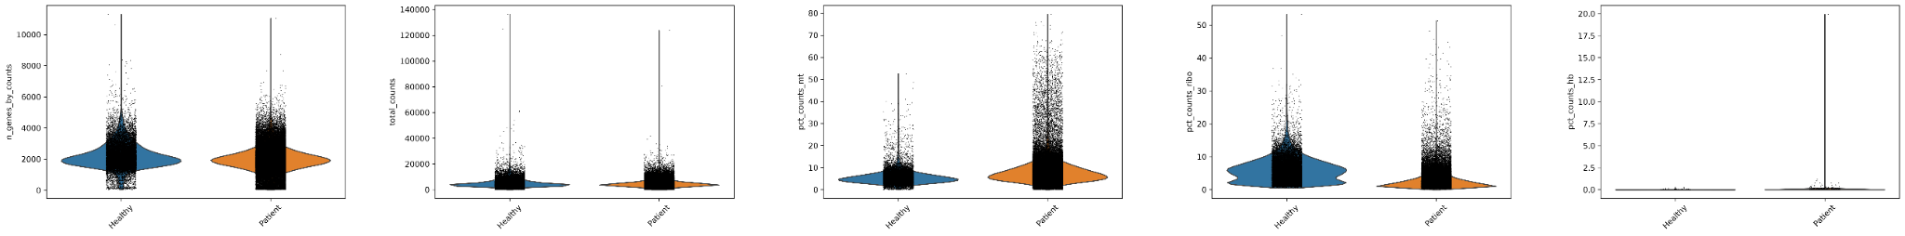
Figure 1. Quality-control distributions before filtering. Metrics shown are genes detected, total counts, mitochondrial percentage, ribosomal percentage, and hemoglobin percentage in Healthy and Patient cells.

3.2 Global cell landscape and immune annotation
Leiden clustering at resolution 1.0 produced 32 clusters (labels 0–31). The annotated atlas contained major T-cell, NK, B-cell, myeloid, dendritic/pDC, platelet, and cycling populations, together with several mixed or uncertain clusters. High-confidence annotations were assigned to many major populations, while low-confidence labels were retained for clusters that could not be resolved confidently.
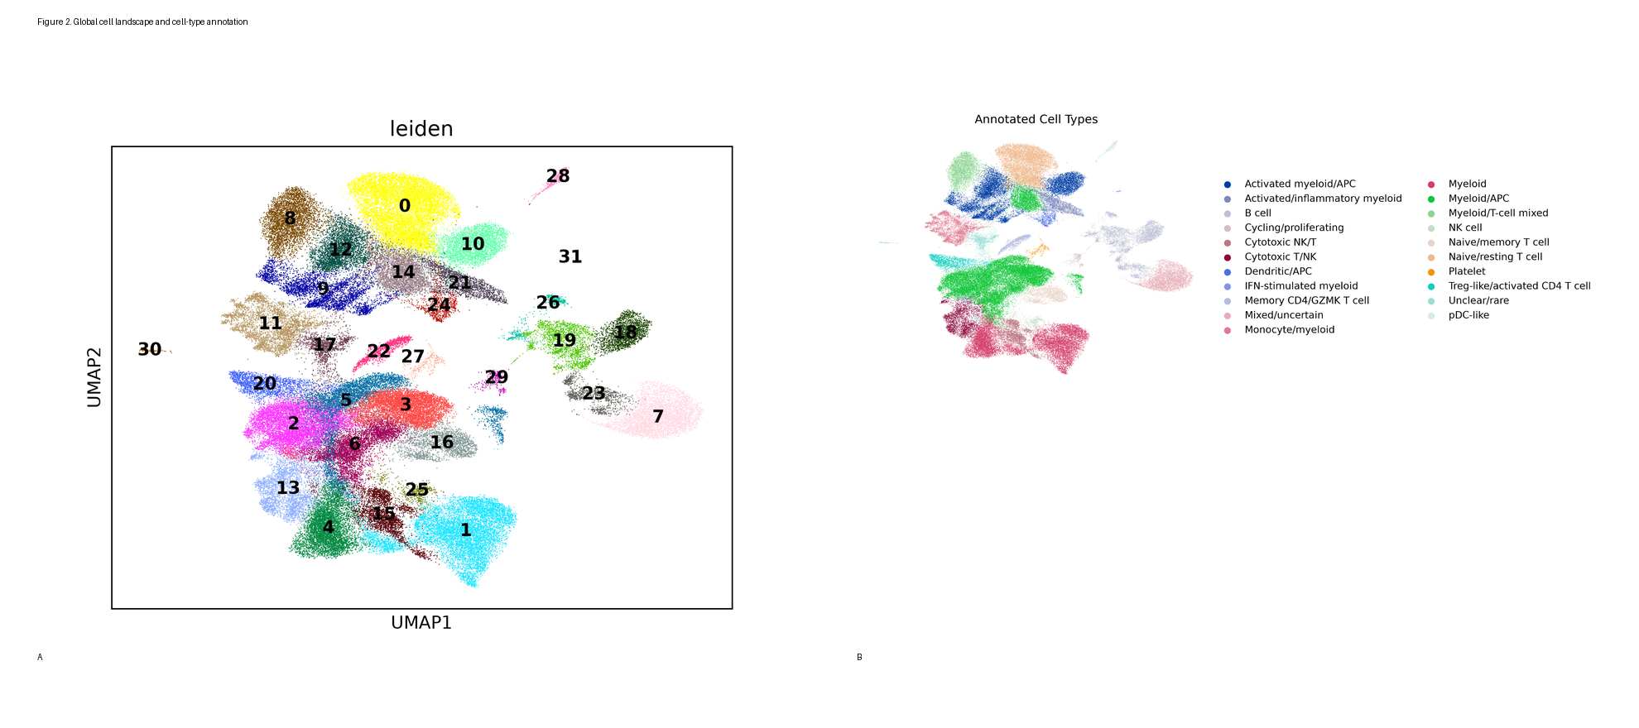
Figure 2. Global PBMC landscape. (A) 32 Leiden clusters across 94,513 cells. (B) Manual cell-type annotations based on canonical marker expression.

3.3 Marker-based validation
The marker dot plot showed coherent enrichment of canonical lineage markers across the major clusters. T-cell clusters expressed CD3D/CD3E/TRBC1, cytotoxic populations showed NKG7/GNLY/PRF1/GZMB patterns, B-cell clusters showed MS4A1/CD79A/CD74/HLA-DRA, and myeloid/APC clusters showed LYZ/LST1 and inflammatory/APC-associated markers.
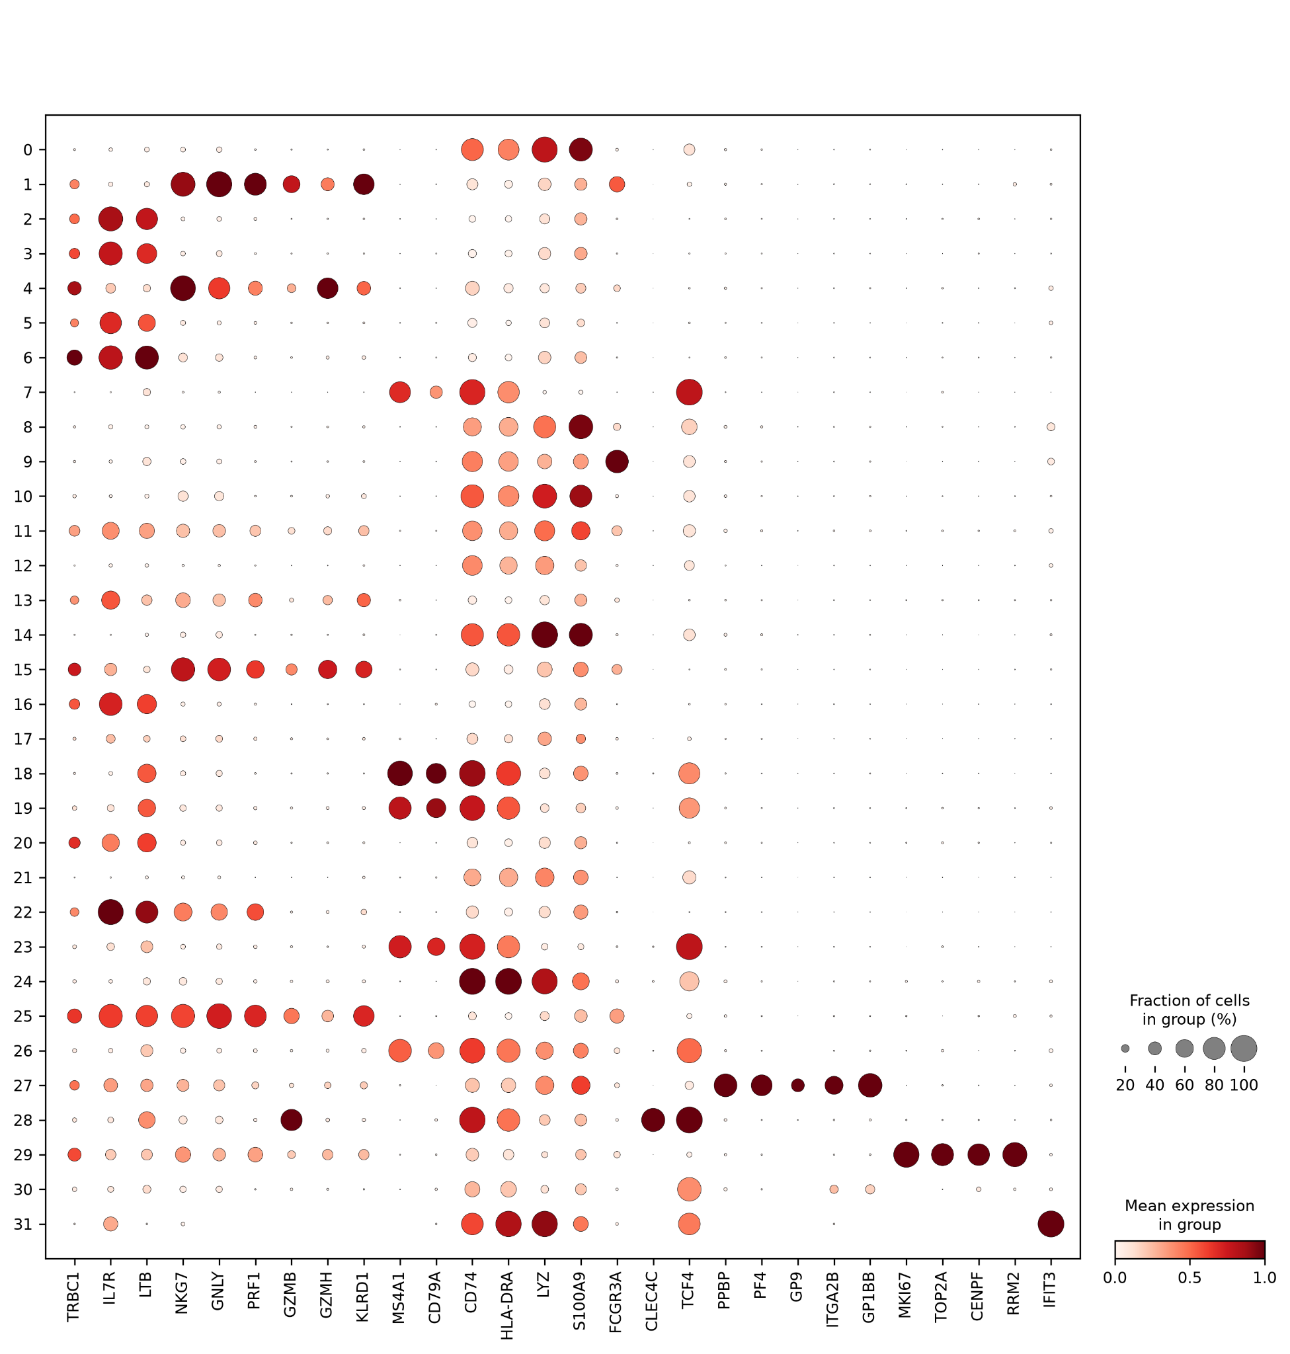
Figure 3. Marker-gene validation of cluster annotations. Dot size represents the fraction of cells expressing a marker and color intensity represents mean expression.

3.4 Transcriptomic IRC landscape
IRC scores varied substantially across annotated populations. The highest mean score occurred in the small IFN-stimulated myeloid population (n=38; mean 1.405; median 1.427), followed by the myeloid/T-cell mixed population (n=3,919; mean 0.197) and pDC-like cells (n=408; mean 0.145). Most conventional T-cell and B-cell populations had negative mean scores. Because Scanpy's gene-set score is relative, negative values do not represent absence of IFN-I signaling and should not be interpreted as percentages.
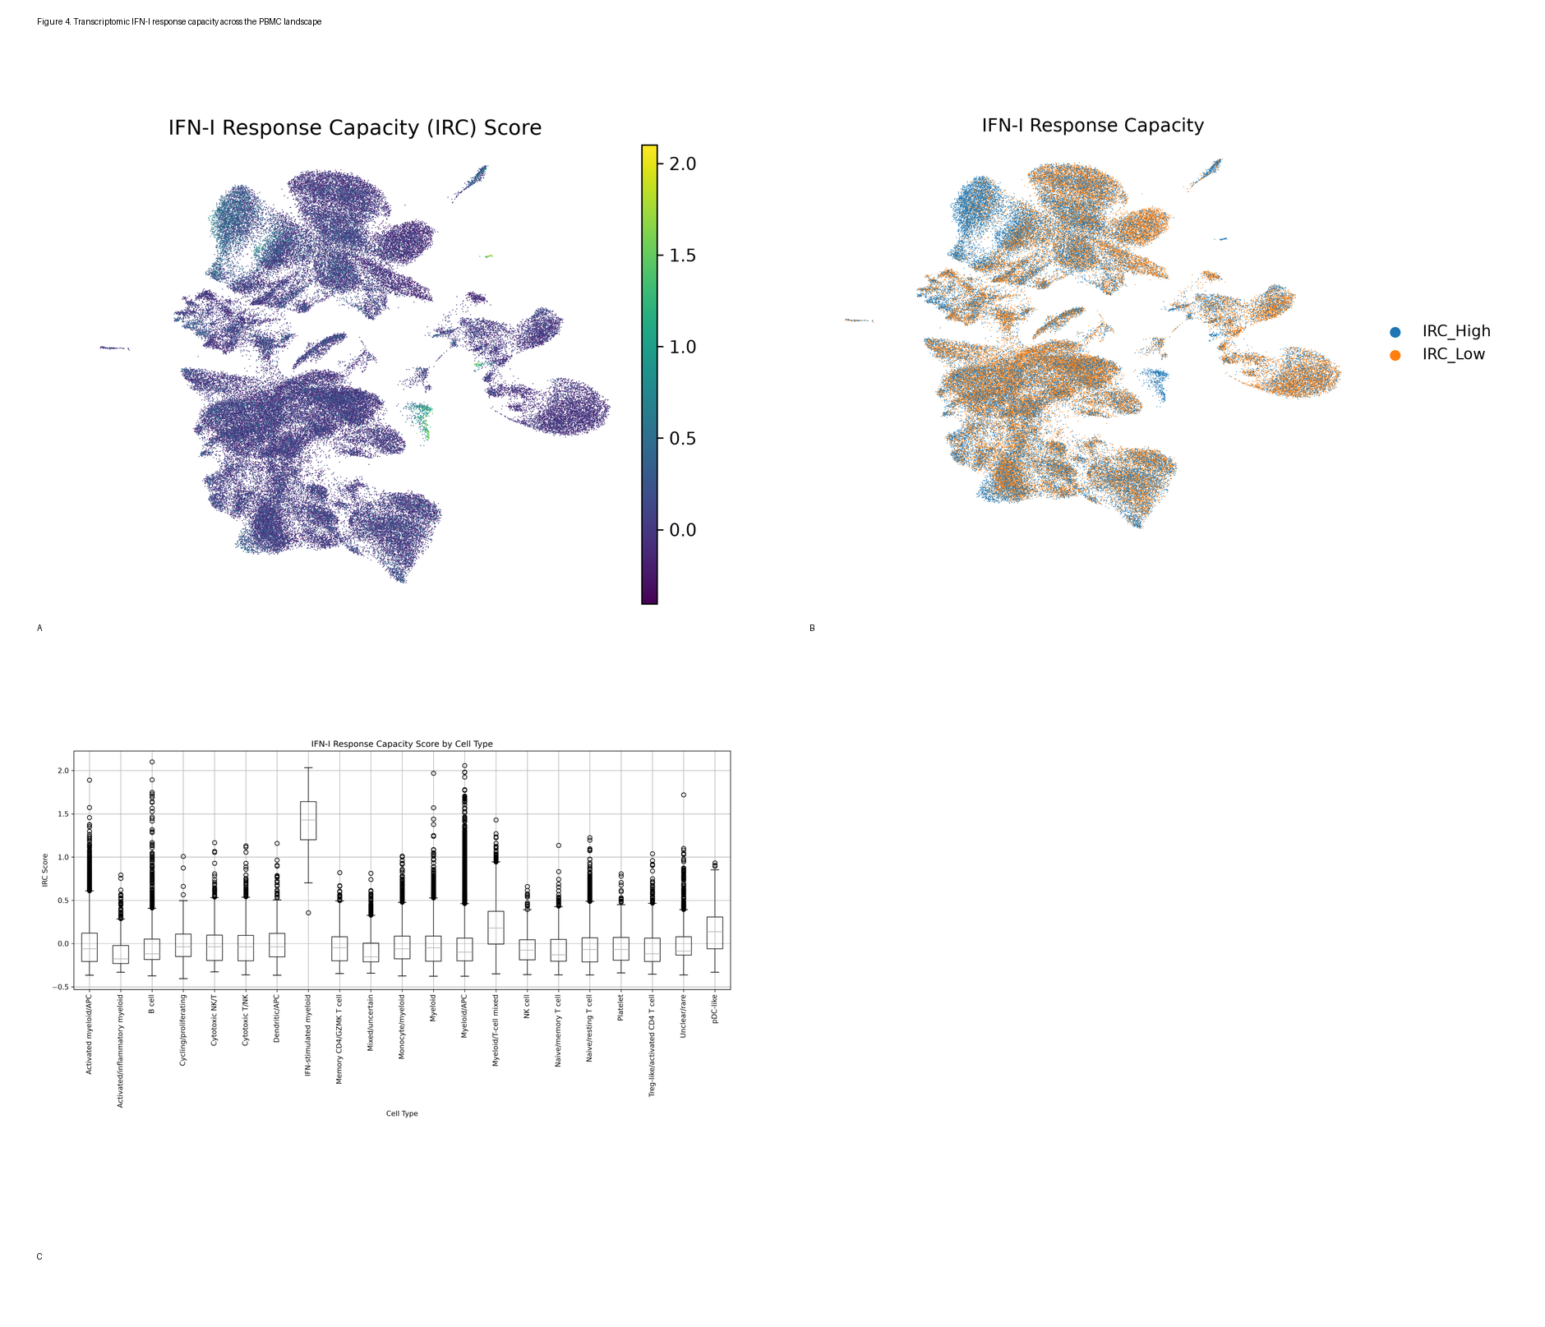
Figure 4. Transcriptomic IFN-I response capacity. (A) Continuous six-gene IRC score. (B) IRC-high versus IRC-low classification. (C) Score distributions across annotated cell types.

3.5 T-cell IRC analysis
The T-cell subset contained 20,315 cells across six annotated subtypes. A T-cell-specific median split produced 10,158 IRC-high and 10,157 IRC-low cells. Cytotoxic T/NK cells comprised 3,201 cells, cytotoxic NK/T 2,691, memory CD4/GZMK T cells 1,357, naive/resting T cells 9,105, naive/memory T cells 2,135, and Treg-like/activated CD4 T cells 1,826.
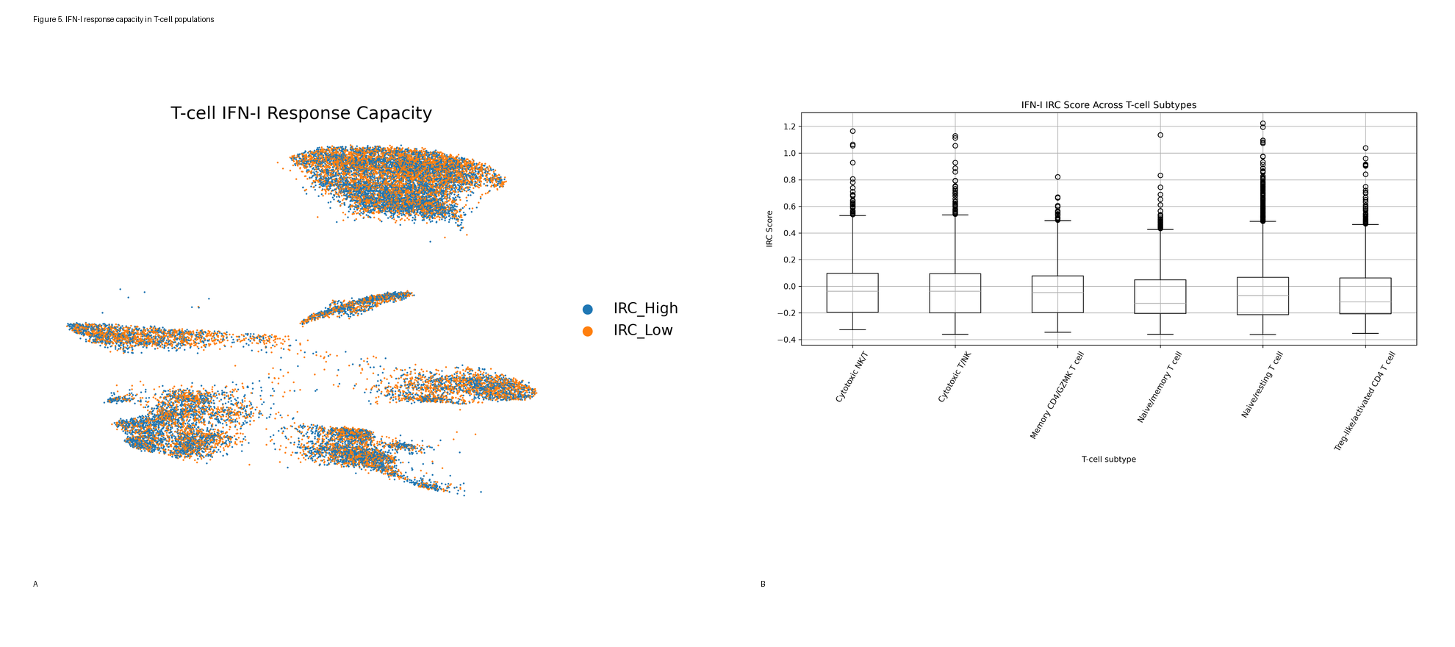
Figure 5. T-cell IRC analysis. (A) T-cell UMAP colored by IRC status. (B) IRC score distributions across six T-cell subtypes.
Table 1. T-cell subtype composition by IRC status.
T-cell subtype | IRC-high | IRC-low
Cytotoxic NK/T | 1435 | 1256
Cytotoxic T/NK | 1755 | 1446
Memory CD4/GZMK T cell | 716 | 641
Naive/memory T cell | 968 | 1167
Naive/resting T cell | 4468 | 4637
Treg-like/activated CD4 T cell | 816 | 1010

3.6 Differential expression between T-cell IRC-high and IRC-low states
The T-cell IRC-high versus IRC-low comparison tested 31,120 genes. 354 genes met FDR < 0.05, including 285 higher in IRC-high cells and 69 higher in IRC-low cells. The most statistically prominent genes included EIF2AK2, BST2, MX1, ISG15, IRF7 and other interferon-associated genes.
A critical interpretive limitation is that the six IRC genes are components of the score used to define IRC-high and IRC-low status. Their strong differential expression is therefore expected and is not independent validation. Subtype-aware consistency and pathway-level enrichment are more informative checks, although they remain partly dependent on the same score definition.
Table 2. Selected top differential genes by adjusted P value.
Gene | Log2 fold change | Adjusted P
EIF2AK2 | 4.003 | <1×10⁻³⁰⁰*
BST2 | 3.211 | <1×10⁻³⁰⁰*
MX1 | 4.114 | <1×10⁻³⁰⁰*
ISG15 | 3.941 | <1×10⁻³⁰⁰*
RNF213 | 0.309 | <1×10⁻³⁰⁰*
STAT1 | 0.450 | <1×10⁻³⁰⁰*
PARP14 | 0.410 | <1×10⁻³⁰⁰*
ACTB | 0.217 | <1×10⁻³⁰⁰*
HLA-B | 0.250 | <1×10⁻³⁰⁰*
EPSTI1 | 0.600 | <1×10⁻³⁰⁰*
B2M | 0.197 | <1×10⁻³⁰⁰*
XAF1 | 0.637 | <1×10⁻³⁰⁰*
HLA-A | 0.236 | <1×10⁻³⁰⁰*
TMSB4X | 0.215 | <1×10⁻³⁰⁰*
IFI44 | 0.881 | <1×10⁻³⁰⁰*
*Adjusted P values reported as 0 in the CSV reflect numerical underflow; they are not exact mathematical zeros.

3.7 Hallmark pathway enrichment
Pre-ranked GSEA identified five Hallmark pathways significantly enriched toward the IRC-high side at FDR < 0.05. Interferon Alpha Response showed the strongest enrichment (NES 1.882), followed by Interferon Gamma Response (NES 1.834), Allograft Rejection (NES 1.614), Oxidative Phosphorylation (NES 1.565), and Myc Targets V1 (NES 1.481). No significant negative-enrichment pathway was identified in the reported significant set.
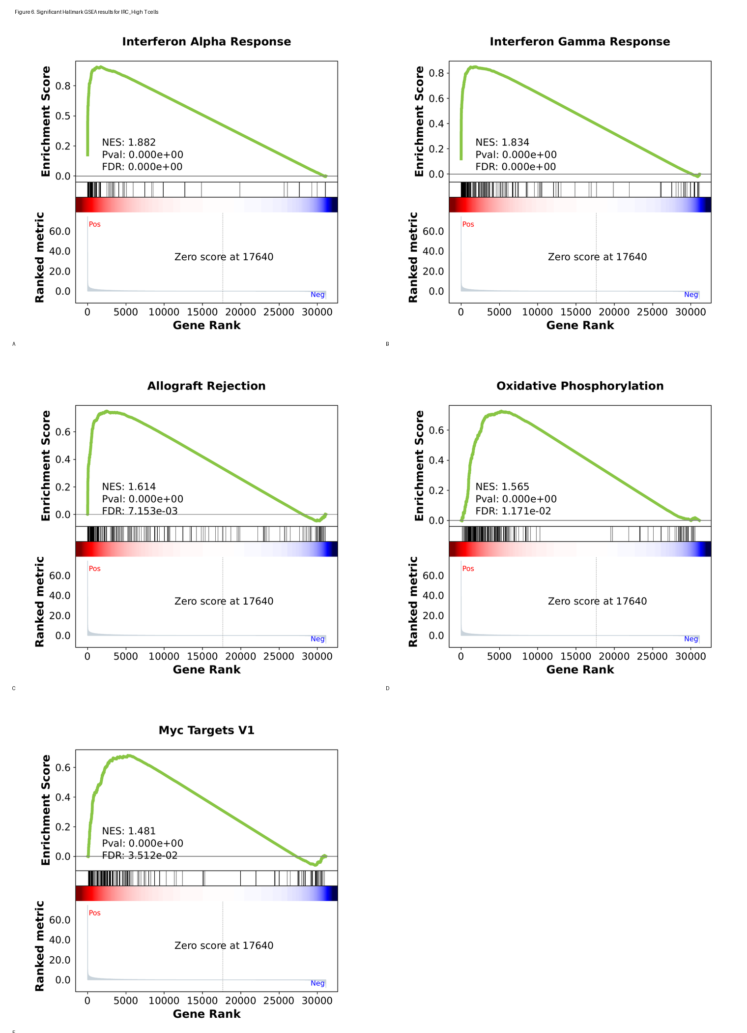
Figure 6. Significant Hallmark GSEA results for the IRC-high T-cell state. The five significant Hallmark pathways are shown in the figure; individual enrichment reports are retained as supplementary materials.
Pathway | NES | FDR
Interferon Alpha Response | 1.882 | 0.000
Interferon Gamma Response | 1.834 | 0.000
Allograft Rejection | 1.614 | 0.007
Oxidative Phosphorylation | 1.565 | 0.012
Myc Targets V1 | 1.481 | 0.035
The GSEApy run completed successfully, but its log reported duplicated values in the preranked statistic for 38.66% of genes. Because tied ranking statistics can make the order of tied genes arbitrary, this should be treated as a limitation of the enrichment analysis and supports cautious interpretation of pathway ranking.

3.8 Subtype-aware IRC validation
Within each of the six analyzed T-cell subtypes, IRC-high and IRC-low cells were compared separately. All six subtypes had sufficient cell numbers for the analysis. The number of significant genes ranged from 4 to 361. The six IRC genes were significantly higher in IRC-high cells within every subtype analyzed, although this finding is expected because the same genes define the IRC score.
Subtype | High | Low | Significant genes | Higher in High | Higher in Low
Naive/resting T cell | 4468 | 4637 | 361 | 202 | 159
Naive/memory T cell | 968 | 1167 | 4 | 4 | 0
Memory CD4/GZMK T cell | 716 | 641 | 4 | 4 | 0
Treg-like/activated CD4 T cell | 816 | 1010 | 14 | 11 | 3
Cytotoxic T/NK | 1755 | 1446 | 16 | 16 | 0
Cytotoxic NK/T | 1435 | 1256 | 4 | 4 | 0

4. Discussion
This analysis established a reproducible PBMC single-cell workflow and identified substantial immune-state heterogeneity across 94,513 retained cells. The 32-cluster UMAP resolved major circulating immune lineages, and canonical marker expression supported the broad manual annotations. The dataset therefore provides a useful cellular framework for examining IFN-I-associated transcriptional states.
The six-gene transcriptomic IRC score was highest in a small IFN-stimulated myeloid population and in several APC-associated populations, while conventional lymphocyte populations generally showed lower relative scores. Within T cells, the score varied across subtypes, demonstrating that IFN-I-associated transcriptional state is not uniform across the T-cell compartment.
The strongest pathway-level result was enrichment of interferon-alpha and interferon-gamma response programs in IRC-high T cells. This is biologically coherent with the intended IFN-I module and is consistent with a broader interferon-associated transcriptional state beyond the six input genes. Allograft rejection enrichment is also compatible with an immune-activation program, while oxidative phosphorylation and MYC-target enrichment suggest additional metabolic or proliferative features of the IRC-high state.
The reference paper reported that high pre-therapy IFN-I responsiveness in effector T cells was associated with poorer outcome after anti-PD-1 therapy and linked this state to dysfunctional and epigenetically programmed T-cell features. The present project is directionally related to that biological question, but it does not reproduce the paper's experimental design. In particular, this analysis uses baseline scRNA-seq expression and a Scanpy gene-set score, whereas the publication measured IFN-β-induced protein responsiveness using mass cytometry and related cellular phenotypes to patient survival. Therefore, the current results should be interpreted as computational evidence of an IFN-I-associated transcriptional state, not as a direct replication of the clinical IRC predictor.

5. Limitations
- The transcriptomic Scanpy score is not equivalent to the original protein-based, stimulation-induced IRC measurement.
- IRC-high/low groups are defined directly from the six-gene signature; therefore differential expression of those same genes is circular and cannot be considered independent validation.
- Cells were treated as the units of the IRC-high/low comparison; patient-level aggregation and mixed-effects modeling were not performed.
- No clinical response labels, survival modeling, or patient-level prediction analysis was performed in this project, so therapeutic response prediction cannot be claimed.
- The executed normalization/HVG script did not use batch-aware HVG selection or regression of total counts/mitochondrial percentage, despite those options appearing in the mentor guide.
- Several clusters were annotated as mixed, uncertain, or rare, reflecting limits of manual annotation.
- The GSEA ranking contained substantial tied statistics (38.66% duplicated values according to the GSEApy log), which may make the order of tied genes arbitrary.
- The GSEA collection and parameters used in the executed pipeline differ from the example enrichment workflow shown in the project guide; the report documents the actual executed GSEApy pre-ranked Hallmark analysis.

6. Conclusion
The project successfully generated a 94,513-cell PBMC atlas, resolved 32 Leiden clusters, annotated major immune populations, and quantified a six-gene transcriptomic IFN-I response score. T-cell IRC-high cells showed broad interferon-associated pathway enrichment, including strong interferon-alpha and interferon-gamma responses, and IRC-associated transcriptional differences were observed across multiple T-cell subtypes. These findings are consistent with the concept that circulating immune cells can occupy distinct pre-existing IFN-I-associated states. However, because the score is transcriptomic and derived from the same six genes used in downstream comparisons, and because no patient-level outcome analysis was performed, the results should be presented as a computational characterization of IFN-I-associated cell states rather than as a validated clinical predictor of anti-PD-1 response.

7. References
1. Boukhaled GM, Gadalla R, Elsaesser HJ, et al. Pre-encoded responsiveness to type I interferon in the peripheral immune system defines outcome of PD1 blockade therapy. Nature Immunology. 2022;23:1273–1283. doi:10.1038/s41590-022-01262-7.
2. Project 3 Student Project Guide. Type I Interferon Immunotherapy Response — Single-Cell RNA-Seq Analysis. Provided project source document; GEO accession GSE199994.
3. Wolf FA, Angerer P, Theis FJ. SCANPY: large-scale single-cell gene expression data analysis. Genome Biology. 2018;19:15.
4. Subramanian A, Tamayo P, Mootha VK, et al. Gene set enrichment analysis: a knowledge-based approach for interpreting genome-wide expression profiles. Proceedings of the National Academy of Sciences. 2005;102:15545–15550.

Appendix A. AI Usage Disclosure
Exact prompt history: the Project 3 guide requests disclosure of the exact prompts used with AI. Only prompts that can be verified verbatim from the retained Project 3 conversation should be presented as exact quotations. Reconstructed or summarized prompts should not be labeled as exact. If the mentor requires the complete prompt history, it should be copied directly from the student's Project 3 ChatGPT conversation.
The student remains responsible for understanding, reviewing, and approving the analysis code, parameter choices, quality-control decisions, cell-type annotations, IRC scoring, differential-expression analysis, GSEA, figures, tables, biological interpretation, and final report.
Numerical results in the final report were checked against the actual Project 3 analysis outputs, including retained cell/gene counts, Leiden cluster count, annotations, T-cell counts, IRC-high/IRC-low counts, differential-expression results, GSEA results, and subtype validation results.
The AI-assisted analysis and documentation were checked against the Project 3 Student Project Guide, the primary Nature Immunology paper, the executed Project 3 Python scripts, generated result tables, generated figures, and GSEA outputs. The experimental IRC measurement in the primary paper was kept distinct from the transcriptomic Scanpy IRC score used in this project.
Project 3 workflow areas supported by AI included 10x data loading and validation, sample combination, QC filtering, normalization/HVG selection, PCA, nearest-neighbor analysis, UMAP, Leiden clustering, marker-gene analysis, cell-type annotation, six-gene IRC scoring, T-cell IRC validation, IRC-high versus IRC-low differential expression, Hallmark GSEA, subtype-aware validation, figure organization, and report preparation.
AI assistance was limited to activities directly related to this Project 3 analysis, including learning the single-cell RNA-seq workflow, understanding the Project 3 Student Project Guide and practical workflow, explaining Scanpy/Python steps, troubleshooting and debugging Project 3 scripts, checking analysis outputs, organizing results and figures, documenting the executed pipeline, interpreting IRC results in relation to the Project 3 guide and primary paper, and drafting/proofreading the final report.
Generative AI was used specifically as an assistant for Project 3: Type I Interferon Immunotherapy Response — Single-Cell RNA-Seq Analysis.

Appendix B. Supplementary Materials
Supplementary figures include highly variable gene selection (Figure S1), PCA variance-ratio diagnostics (Figure S2), and sample distribution across the UMAP (Figure S3). All individual GSEA enrichment reports supplied during the project are retained in the supplementary GSEA report folder within the final figure package.

