Experiment 2: Heterogeneous Validators
In this experiment the 15 validators were given unequal computing power - a heterogeneous network - to model a realistic consortium where member organizations run different hardware. The nodes were divided into three tiers: five with 2.00 CPU cores, five with 0.75 cores, and five with 0.30 cores. Each run offered 5 tx/s for 150 seconds, and validator failures were injected from 0 to 3 nodes. We ran 3 repetitions per protocol at zero faults and 5 repetitions at each fault level, comparing CB-BFT against QBFT under identical conditions.
Results. With no failures, the two protocols performed the same: QBFT averaged 2.067 s per block and CB-BFT 2.109 s. The 2% difference is smaller than the run-to-run variation, so it is a tie. Under failures, CB-BFT was clearly faster, and the gap grew with each failed validator: 7.2% at one fault (2.158 s vs 2.325 s), 16.0% at two faults (2.226 s vs 2.650 s), and 30.7% at three faults (2.540 s vs 3.665 s). Block production shows the same pattern: at three faults QBFT produced only about 41 blocks per run while CB-BFT produced about 60. Throughput is the most practical measure - at three faults QBFT confirmed only 4.37 tx/s of the offered 5 tx/s, while CB-BFT held 4.73 tx/s. In short, when validators fail, QBFT starts dropping the application's transactions and CB-BFT does not.
Table 1. Mean block interval by fault level (heterogeneous network).
Faults | QBFT (s) | CB-BFT (s) | CB-BFT advantage
0 | 2.067 | 2.109 | -2.0% (tie)
1 | 2.325 | 2.158 | +7.2%
2 | 2.650 | 2.226 | +16.0%
3 | 3.665 | 2.540 | +30.7%

Negative result. We also tested whether CB-BFT would prefer the stronger validators in a healthy network. It did not. Tier A received 49% of proposals while tiers B and C received 26% and 25% - nearly equal despite very different CPUs. Even the 0.30-core nodes sealed their blocks within the 2-second block period, so the latency measurements were nearly identical across all tiers and gave the scoring nothing to separate them with. We therefore claim only that CB-BFT excludes failed validators; we do not claim it selects the most capable ones. Detecting capability differences would likely need a heavier transaction load or a shorter block period, which we leave as future work.
Trade-offs. Four costs come with CB-BFT's fault tolerance in this setting. First, there is no benefit while the network is healthy - the scoring machinery only pays off when validators fail. Second, proposals become concentrated: CB-BFT routed 96.7% of proposals through 4 of the 15 nodes, while QBFT rotates through all 15, so fault tolerance is gained at the cost of proposer diversity. Third, CB-BFT's block timing was more variable at low fault counts (standard deviation 0.144 s versus QBFT's 0.063 s at zero faults). Fourth, the mechanism distinguishes failed validators from working ones but cannot rank the working validators by capability under this workload.
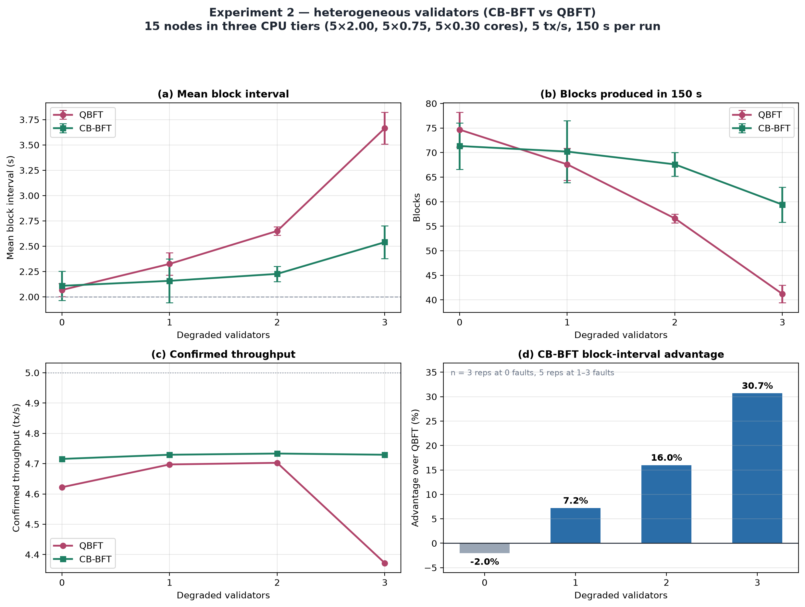
Figure 1. Experiment 2 - heterogeneous validators: (a) mean block interval, (b) blocks produced, (c) confirmed throughput, (d) CB-BFT block-interval advantage over QBFT.
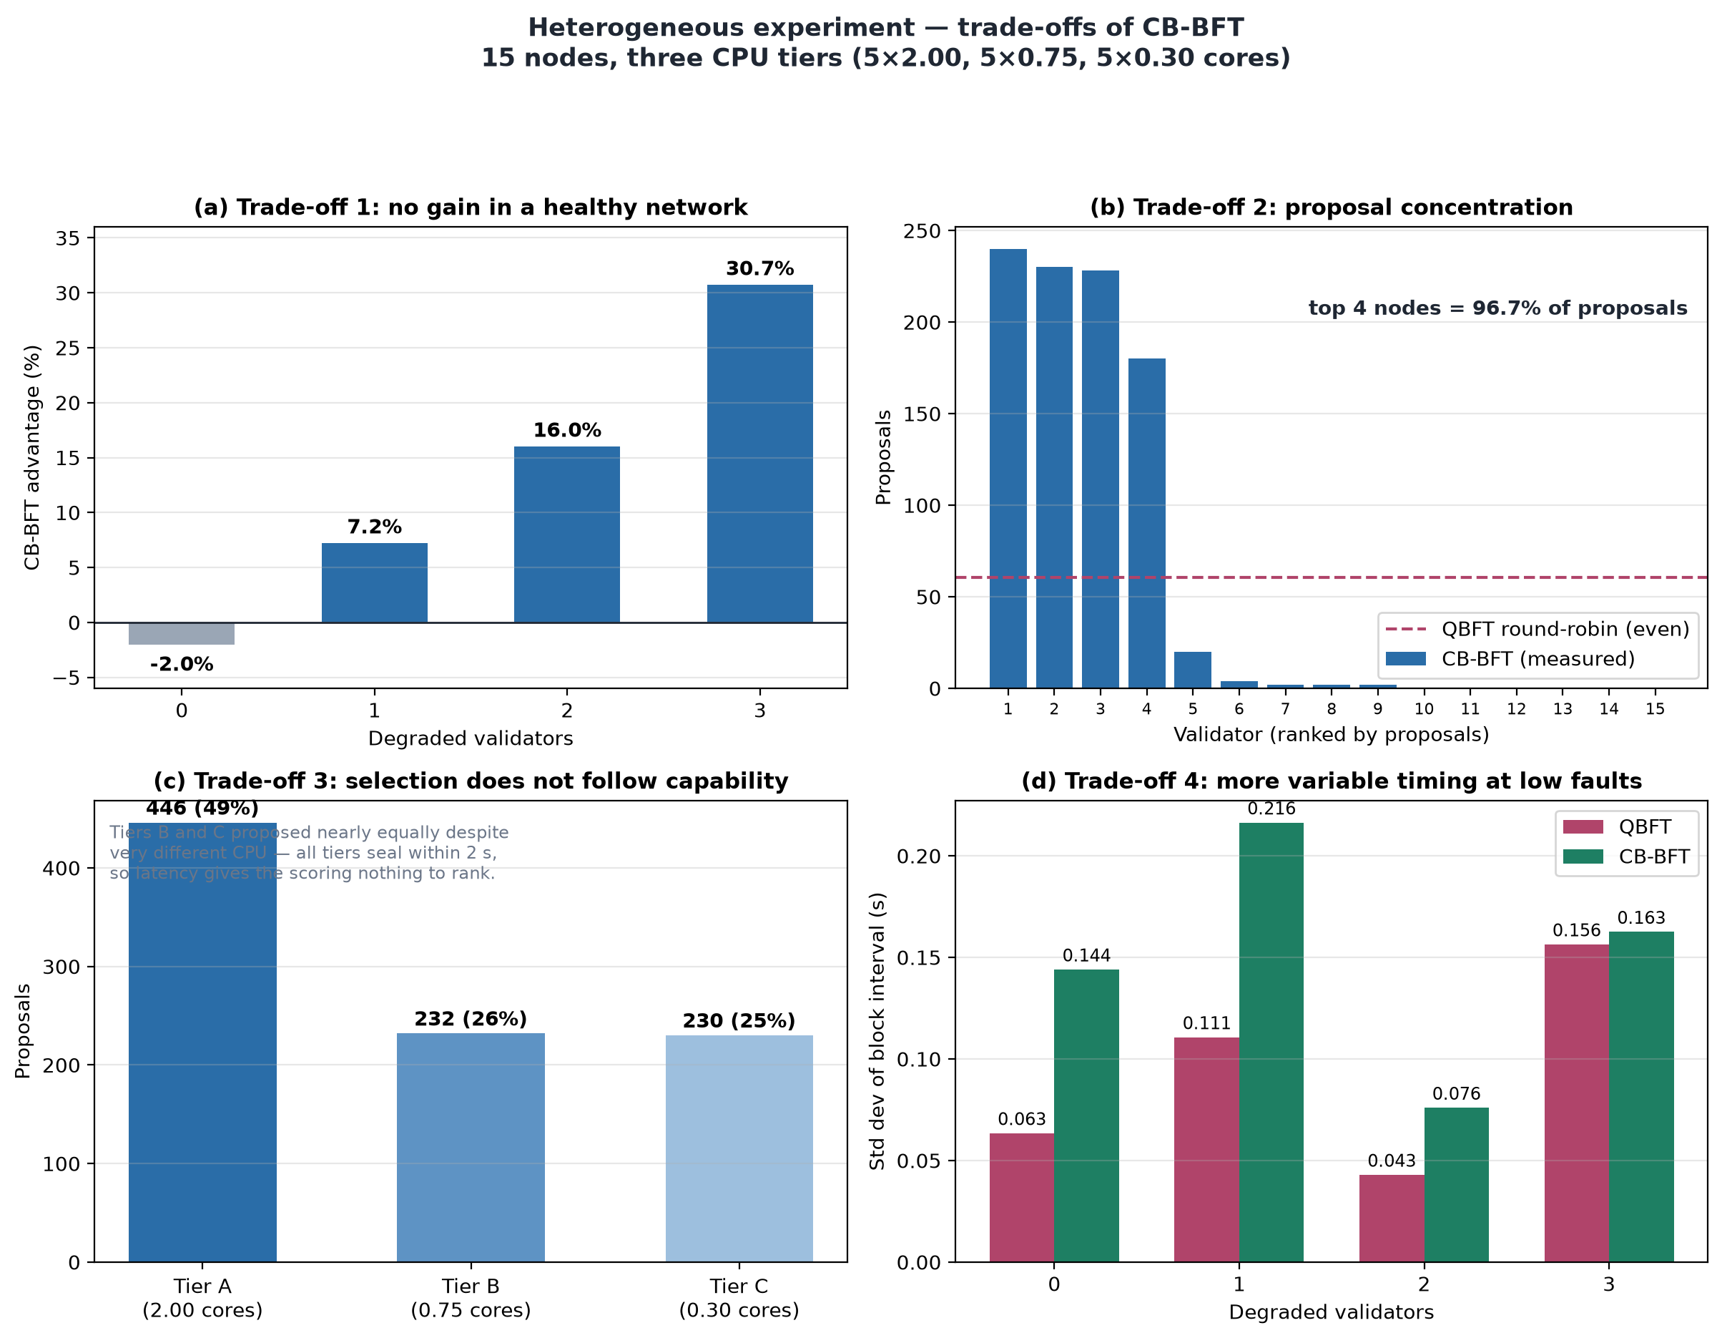
Figure 2. Trade-offs: (a) no gain in a healthy network, (b) proposal concentration, (c) selection does not follow capability, (d) higher timing variability at low faults.

