# SALARY MANAGEMENT

Salary management system will be able to perform all the management activities which is required to perform the accounting operations for a particular organization such as maintain attendance of the working employees by Inserting and editing their record .We can also Delete a Record of employees and easily can Search any Record. Besides we can check the List including all of The Employee. We can also Print Employee PaySlip and Quit Program.

This system will able to perform salary processing task and prepares monthly salary report for each employees.

Instructions:

=>Firstly we must have to finish our login process.

Here we will use those informations.

User Name:group_5

Password:9103435

After logged in we will be able to see this configuration

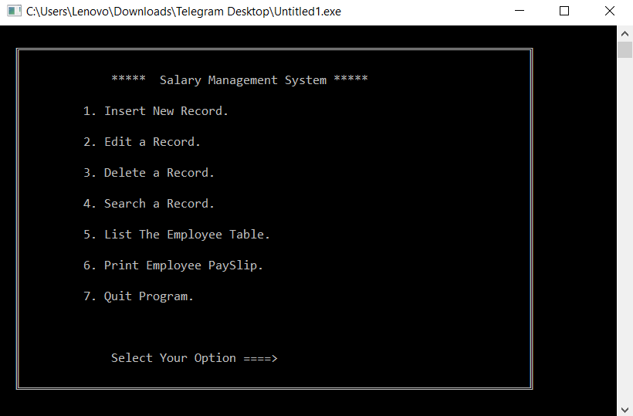

Here we can use any option as per as our need

**Such as we can Insert an employee’s data like this-

=> Press 1 then add all the informations required

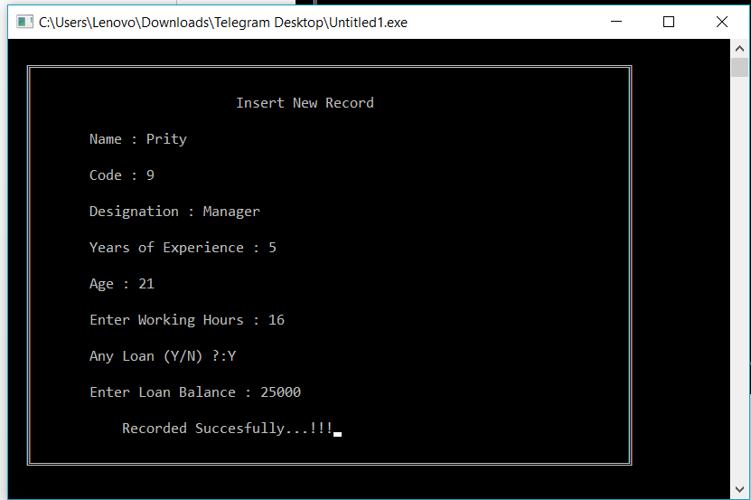

Here we have added an employee’s Record.

**We can Edit any of employee’s Record by pressing 2(go with Edit record option)

**We can Delete any of their records by pressing 3(go with the delete record option)

**We can Search any information of them those are being recorded ,We can access them by pressing 4 (go with the Search a record option)

**We can easily make a short list and Check the list of all the employees working under the organization by pressing 5 (Go with the List the employee table)

**We can Print Employee PaySlip by pressing 6(go with the Print Employee PaySlip option)

Showing an example:

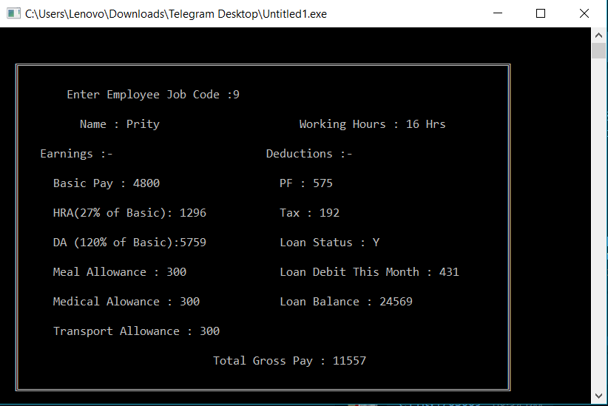

**Then we can quit our program any time by pressing 7.

N:B: We must enter the correct user name and password if we want to access the salary management Program.