

American International University- Bangladesh

CSC 3222: Web Technologies

CO1.1 and CO2.1 Evaluation

Project Report

Spring 21-22

Project Title: EZ Learning

Section: I

|  |  |
| --- | --- |
| Student Name | Student Id |
| MUNIRA ZEBIN | 19-41014-2 |
| MD. REYAD HOSSAIN | 20-43373-1 |
| NAZIA HASSAN | 19-41259-3 |
| Faisal Wahiduzzaman | 19-40134-1 |

**Introduction:**

*The EZ Learning Institute is an online-based educational website that serves as a platform for an educational institution to conduct online academic activities such as academic registration, access to study materials, student performance and progress management etc. with precision. Currently, it consists of four independent users including admin, teacher, student and guardian.*

**Background Study:**

*An educational institution usually deals with problems related to student registration offline. However, in some cases, the offline registration process takes a lot of time for students coming from afar. Therefore, to lessen harass of long journey, ease up the registration process and avoid unnecessary wastage of time and create a student friendly online platform to access study materials with proper authentication.*

**Requirement Analysis:**

1. User Category:

There are 4-types of Users here. They are:

* Admin
* Teacher
* Student
* Accountant

1. Feature List:

In this project the User Type “Admin” has the following features:

* Registration
* Login
* View and Update Profile
* Change Password
* View + Add teacher and Delete
* View + Add Student and Delete
* Query Session
* Upload news and events
* Registration Approval
* Student's Fee
* Teacher's salary report
* Update Terms & Conditions

In this project the User Type “Teacher” has the following features:

* Registration
* Login
* View and Update Profile
* Change password
* Add Student and Delete
* Upload Class Material
* Update Notice Board
* Upload Query
* Admission Control Panel
* Assignment Section
* Question creates
* Grade report generate

In this project the User Type “Student” has the following features:

* Registration
* Login
* View and Update Profile
* Change Password
* View Class Materials
* View Grade Report
* View and Upload Assignment Section
* View Notice Board
* Post Query
* View Notice Board
* Attend Quiz

In this project the User Type “Accountant” has the following features:

* Registration
* Login
* View and Update Profile
* Change Password
* Forget Password
* Student's fee confirmation
* Teacher's salary confirmation
* News and information
* Transactions History

**Design:**

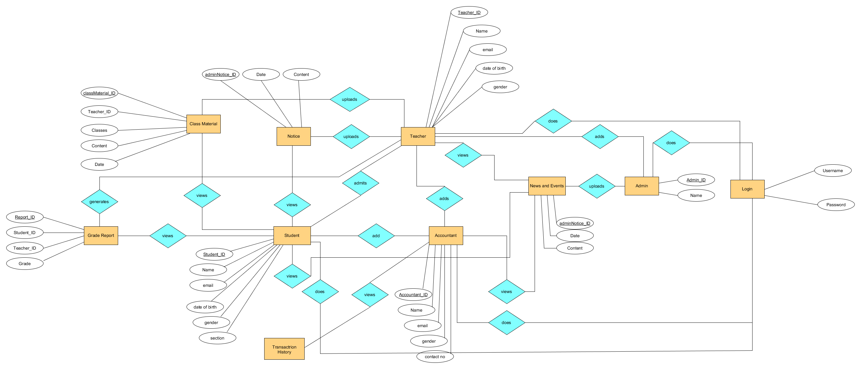

Diagram 1.1: ER diagram (on progress)

**Tools Used:**

To develop this project, we have used the following:

• Umlet

• Sublime text editor and VS code

• Xampp

• Browser

**System Images against the Specification:**

* **Admin**

|  |  |
| --- | --- |
|  |  |
|  |  |
|  |  |
|  |  |
|  |  |
|  |  |
|  |  |

* **Teacher**

|  |  |
| --- | --- |
|  |  |
|  |  |
|  |  |
|  |  |
|  |  |

* **Student**

|  |  |
| --- | --- |
|  |  |
|  |  |
|  |  |
|  |  |
|  |  |
|  |  |
|  |  |
|  |  |

* **Accountant**

|  |  |
| --- | --- |
|  |  |
|  |  |
|  |  |
|  |  |
|  |  |

**Impact of this Project:**

*The impact of this project is increasingly dominating the current educational system as the impact of technology continuously dominates our everyday activities worldwide. It is to increase accessibility of education and reducing time as well as improving student’s academic performance. Students can view their lecture notes anytime by this, they don’t have to go outside from for this.*

**Limitations and Possible Future Improvements:**

*EZ Learning is an online based learning Institute. Where teacher, student and accounts can easily perform and access their part individually. But here we have some limitations. Like if any teacher uploads any grade of any students, then all teacher can access the grade report sheet and if any teacher wants to change then they have the policy to change it. This can be big issue in future. So, in future we’ll look forward to solve it and also, we have some more possible future improvements on this website. In future we are thinking to add live chat system between teachers and student personally along with in general session. And a quiz panel where teacher set will set their question paper and student can access it and solve the questions.*

*[Note: Make sure that your report is maximum 10 pages (including cover page). Print (Colored) the report and submit it with spiral bind.]*

|  |  |  |  |  |  |
| --- | --- | --- | --- | --- | --- |
| CO1.1 and CO2.1 Evaluation: Project Report Evaluation | | | | | |
| Project Proposal  (5) | Background  Study  (5) | Requirement Analysis  (5) | Entity  Diagram  (5) | System Images  against the  Specification (5) | Total (25) |
|  |  |  |  |  |  |
|  | | | | | |