

Design of 4 Bit Asynchronous Counter
Group 05

Md. Rakib Hasan | (17-35078-2)
Md.Risalat Bhuiyan | (17-35182-2)
Md. Rifat khan | (17-34556-2)
MD. Jawad-Al-Mursalin Hoque | (17-34703-2)
Md. Shahriar Kabir Supto | (17-34672-2)

NIRJHOR ROUF
Lecturer, American International University Bangladesh (AIUB)

(Spring 19-20 Submission)

Design of 4 Bit Asynchronous Counter
Up Counter using JK flip flop

¹Rakib Hasan , ²Risalat Bhuiyan , ³Rifat khan, ⁴Jawad-Al-Mursalin Hoque, ⁵Shahriar Kabir Supto ^{1,2,3,4,5}Dept. of EEE, American International University –Bangladesh (AIUB)

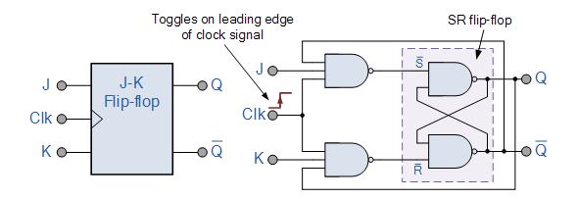
Abstract—JK flip flops are the basic memory element which is used in many of the applications. A master-slave flip-flop is constructed from two seperate flip-flops. One circuit serves as a master and the other as a slave..The master flip-flop is enabled on the positive edge of the clock pulse CP and the slave flip-flop is disabled by the inverter. The information at the external R and S inputs is transmitted to the master flip-flop. When the pulse returns to 0, the master flip flop is disabled and the slave flip-flop is enabled. The slave flip-flop then goes to the same state as the master flip-flop.
Index Terms—Clock Gating, JK flip flop, Master - Slave Configuration.

Introduction
A counter is a device which can count any particular event on the basis of how many times the particular event(s) is occurred. In a digital logic system or computers, this counter can count and store the number of time any particular event or process have occurred, depending on a clock signal. Most common type of counter is sequential digital logic circuit with a single clock input and multiple outputs. The outputs represent binary or binary coded decimal numbers. Each clock pulse either increase the number or decrease the number.

Implementation of Asynchronous Counter
To count or store the data depending on clock signal, we use master-slave flip-flop. We know at the output of the JK flip-flop circuit is toggling frequently in one clock cycle. For this reason, output isn’t identical whether it is 0 or 1. To avoid this problem, master-slave circuit is introduced. In this logic design we used same JK circuit twice and we take our feedback from last circuit into the first one. By this method we can hold our output data until the next clock cycle is arrived. In this circuit first portion acting as a master and next portion is a slave. From our JK flip-flop knowledge, we know that if we set clock pulse 0, the circuit remain unchanged. That’s mean it store its previous data. And if we set our clock pulse 0 to 1, the output of the circuit will depend on the input of J and K. In this section, we use this same technique on our master-slave circuit. If we initially set the clock pulse 1, the output of the master will change depending on the inputs and the slave circuit remain unchanged due to inversion of clock pulse into 0. And circuits output will remain unchanged until the next clock pulse. As soon as we change our clock pulse, the output of slave circuit will change and master circuit remain unchanged. In this process we can store 1 bit data for one clock cycle. So our goal is to establish a 4 bit asynchronous counter which starts count to repeatedly 0-15. For this purpose, we use four flip-flop for 4-bit data.

A. J-K Flip Flop
JK flip flop is a basic memory element like SR latch. SR latch switching problem was improved by Jk flip flop. The operation of the JK flip flop is exactly a similar as for the SR flip-flop with a similar “Set” and “Reset” inputs. The different is that the “JK flip flop” has no invalid input states of the SR latch, even S and R both at logic “1”.
Fig. 2(a): JK flip flop symbol and schematic
JK flip flop has four state output for different type of input. State are “No change”, “Set”, “Reset”, “Toggle”.
Fig. 2(b): JK flip flop truth table
JK flip-flop has a drawback of timing problem known as race which occur if the output changes its state before the timing pulse of the clock input has HIGH to LOW state
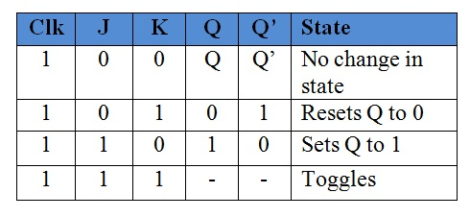

B. Master Slave Configuration
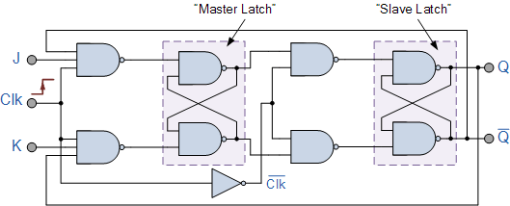
For avoid timing problem of JK flip flop used master slave flip flop adding two SR flip flop connected together in series configuration. Master latch section being enable during positive half cycle and slave latch section being enable during negative half cycle.

Fig. 2(c): JK Master Slave flip flop
When the clock is LOW, the outputs from the master flip flop are locked and any extra changes to its inputs are neglected. The gated slave flip flop currently responds to the state of its inputs ignored by the master section. Low-to-High transition of the clock pulse the inputs of the master flip flop are fed through to the gated inputs of the slave flip flop and on the High-to-Low transition a similar input are reflected on the output of the slave creating this sort of flip flop edge or pulse-triggered. Then, the circuit accepts input data once the clock signal is “HIGH”, and passes the data to the output on the falling-edge of the clock signal.

Operation of counter.
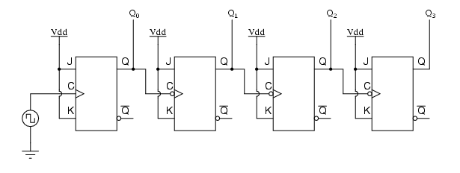
J-k flip flop both input connected with HIGH to always be in the toggle mode. The output of each flip flop served as binary bits of the final. So, four flip flop needed for 4-bit counter.
Fig. 3(a): 4-bit JK flip flop up counter
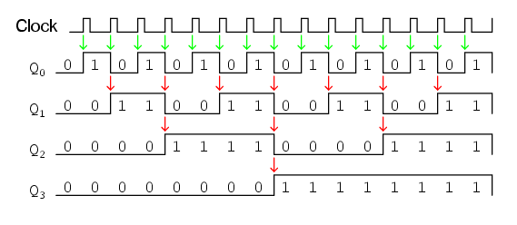
Four flip flop connected such a way that each flip flop toggling frequency decreased by two. Since flip flop frequency
Fig. 3(a): 4-bit up counter Sequence
decrease by using toggling mode and cascade every flip flop output as clock input next flip flop get 4-bit counter. All flip flop clock frequency is not same that’s why it is called asynchronous.

Simulation Result and Discussion
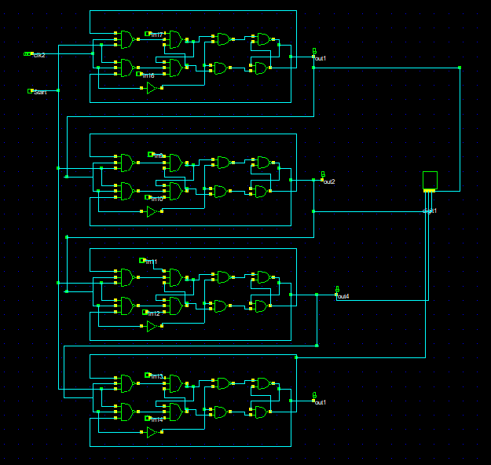
For designing of proposed counter used DSCH 2 software and observe the result from timing diagram. At first schematic was implemented as Fig 1 in DSCH2 Software, but output get crowbarred (or contention) X level. This is not desirable. For this reason, use three input NAND gate instant of two input NAND gate at second stage of master JK flip flop extra two pin work as
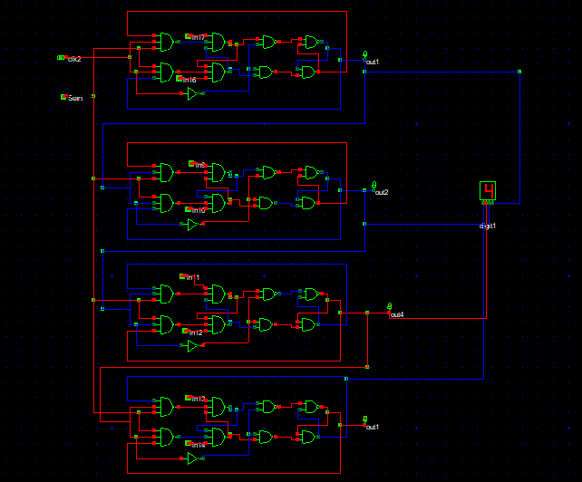
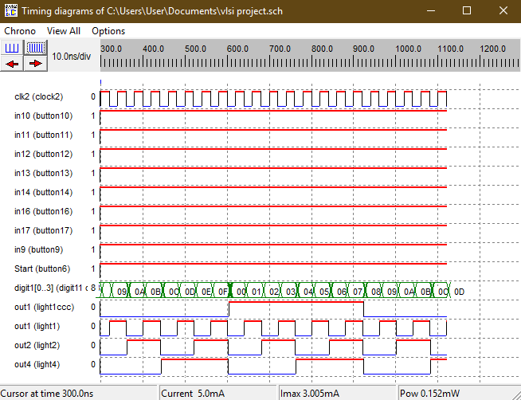

Conclusion
In this project we have designed 4-bit asynchronous up counter has been designed and simulated with DSCH2 tool. From the timing diagram it is clear that the proposed design has meet required timing diagram.

References
- Thomas L. Floyd, “Digital Fundamentals,” United state : Pearson Education, pp. 509–529, April 2015.
- https://www.electronics-tutorials.ws/sequential/seq_2.html.
- https://www.allaboutcircuits.com/textbook/digital/chpt-11/asynchronous-counters/.
- https://www.electronicshub.org/flip-flops/.
- https://circuitglobe.com/jk-flip-flop.html.
www.optics.rochester.edu/workgroups/agrawal/publications/papers/paper_2005_
PRESET & RESET which always keep HIGH for desire output
and get output matched.

