**ROOM RENT WEB APPLICATION WITH GPS TRACKING SYSTEM**

**by**

**MD RAKIBUL ISLAM**

**ID: 201-15-13996**

This Report Presented in Partial Fulfillment of the Requirements for the Degree of Bachelor of Science in Computer Science and Engineering

Supervised By

**Tanvirul islam**

Lecturer

Department of CSE

Daffodil International University

Co-Supervised By

**Sharmin Akter**

Senior lecturer

Department of CSE

Daffodil International University



**DAFFODIL INTERNATIONAL UNIVERSITY**

**Dhaka, Bangladesh**

**December 2023**

**APPROVAL**

This Project titled “**Room Rent web Application With GPS Tracking System**”, submitted by **Md Rakibul Islam** ID No:**201-15-13996** to the Department of Computer Science and Engineering, Daffodil International University, has been accepted as satisfactory for the partial fulfillment of the requirements for the degree of B.Sc. in Computer Science and Engineering and approved as to its style and contents. The presentation has been held on *date*.[**Font-12**]

**Board of Examiners**

**(Name)** [**Font-12, Bold**] **Chairman**

**Designation**

Department of CSE [**Font-12**]

Faculty of Science & Information Technology

Daffodil International University

**(Name) Internal Examiner**

**Designation**

Department of CSE

Faculty of Science & Information Technology

Daffodil International University

**(Name) External Examiner**

**Designation**

Department of -------

Jahangirnagar University

**Declaration**

We hereby declare that, this project has been done by us under the supervision of **Name, Designation, Department of CSE** Daffodil International University. We also declare that neither this project nor any part of this project has been submitted elsewhere for award of any degree or diploma.

**Supervised by:**

**Tanvirul islam**

Lecturer

Department of CSE

Daffodil International University

**Co-Supervised by:**

**Sharmin Akter**

Senior lecturer

Department of CSE

Daffodil International University

**Submitted by:**

**Md. Rakibul Islam)**

ID: **201-15-13996**

Department of CSE

Daffodil International University

**ACKNOWLEDGEMENT  
[**capital letter, Bold, Font-16, Alignment-middle**]**

First we express our heartiest thanks and gratefulness to almighty God for His divine blessing makes us possible to complete the final year project/internship successfully.

We really grateful and wish our profound our indebtedness to **Tanvirul islam**, **Lecturar**, Department of CSE Daffodil International University, Dhaka. Deep Knowledge & keen interest of our supervisor in the field of “Web Application Development” to carry out this project. His endless patience ,scholarly guidance ,continual encouragement , constant and energetic supervision, constructive criticism , valuable advice ,reading many inferior draft and correcting them at all stage have made it possible to complete this project.

We would like to express our heartiest gratitude to Professor Dr. Touhid Bhuiyan, andHead**,** Department of CSE, for his kind help to finish our project and also to other faculty member and the staff of CSE department of Daffodil International University.

We would like to thank our entire course mate in Daffodil International University, who took part in this discuss while completing the course work.

Finally, we must acknowledge with due respect the constant support and patients of our parents.

**Abstract**

“BariBazarBd” is a room rental web application this application developed by using MongoDB, Express.js, React.js, Node.js MERN stack and also using Bootstrap for responsive. This Application offers users streamlined platform for users to search accommodation post property listing engage with property owners. The Application organized into six distinct categories, catering to wide range of user’s needs. One of the features of this application is its integrated real-time location tracking GPS functionality, that’s enables user to view properties as popup on maps, plan shortest path and locate places to stay efficiently. A user friendly comment section allows to share their opinion on properties. Also offers an impressive properties exploration experience providing with 360 degree image views for a better understanding of the listed rooms on properties. Users can easily share their favorite listing on various social media platforms. User security and authentication are important, with the implementation of JWT tokens and other middleware are used for data security. The Application supports both users and publishers role and allowing properties owners to manage listing accept booking requests and track earning per month through personalized dashboard. This Application represents an innovative and user friendly solution in the competitive field to property rental and sales platforms. Future enhancements aim to further elevate the Application capabilities and user experience.

**TABLE OF CONTENTS**

|  |  |
| --- | --- |
| **CONTENTS** | **PAGE** |
| Board of examiners | i |
| Declaration | ii |
| Acknowledgements | iii |
| Abstract | iv |
| **CHAPTER** |  |
| **CHAPTER 1: CHAPTER NAME** | **1-6** |
| 1.1 Infrastructure Mode | 1 |
| 1.2 | 2 |
| **APPENDIX** | **50-55** |
|  |  |
| **REFERENCES** | **56-57** |

**LIST OF FIGURES**

|  |  |
| --- | --- |
| **FIGURES** | **PAGE NO** |
| Figure 1: Cabling and Computer Hardware | 4 |
| Figure 2.1.1: Numbering according to sub sections | 11 |

**CHAPTER 1**

**Introduction**

* 1. **Introduction**

In an era defined by modern transformation the property rental market has undergone a significant shift towards online platforms. My project represents a significant contribution to this evolving landscape offering a feature rich and user-centric room rental web App. The development of app stems from the growing need for a versatile and efficient platform that simplifies the process of searching reliable accommodations and property listings in Bangladesh. Challenges associated with the room rental and sales properties we embarked on a mission to create a comprehensive and intuitive solution that would address the diverse needs of both property seekers and owners. The GPS tracking feature empowers users to explore properties on an interactive map showing shortest route and pinpoint accommodations accurately enhancing their overall search experience. I have used for security rate limiter JWT (Json Web Token) and other most important middleware are included in this web application .My aim to contribute to the continued evolution online property rental solutions while providing a valuable resource for people looking for accommodation in Bangladesh.

* 1. **Motivation**

I was motivated to this project, it is very difficult to find bachelor house or room in our country. Another big challenge for finding home road. The problem resonated with many individuals. Mainly in densely populated urban areas, where finding suitable housing can be a daunting task.

* 1. **Objective**

The main objective of this application is to builds user friendly solution to address the challenge with finding and sell or rent properties room of any category of our country and navigating the streets of these residence. My dream to build the application to streamline to process and secures rental application to provide a centralized application where user easily access a wide range of properties listings. I also want to help them easily figure out how to get specific place because finding your way in a new area tricky. So create a web application to make every process is simple. The application will have a lots of different categories homes and rooms for rent, user can easily see them all in one place. I want to make sure that every person can use it and understand easily, even add a features that show you exactly where these places are on a map, So Yah you won’t get lost. My aim is helps to every person find reliable places to live without any problems and making it a lots of easier.

* 1. **Expected Outcome**

The Expected outcome of this project, to create a modern functionalities and user friendly we application, that significantly simple the process of finding rental accommodation for individuals or student in our country. I hope that will attract property owners and publisher to list their accommodations on the platform due to its user-friendly interface and potential for broader visibility. This will contribute to the growth of the platform's property database, providing users with an even wider array of choices. Ultimately, expected outcomes of this project is to create a digital solution that, not only eases the challenges of searching rental accommodation but also brings a positive impression on the rental market in our country.

* 1. **Report Layout**

Chapter 1: I display about Introduction, Motivation, Objective, and Its Expected Outcomes.

Chapter 2: I will show this project scope of the problem and related work.

Chapter 4: I will display design specification, implementation and testing to show front-end and back-end design.

Chapter 5: I exhibited the future development of the project.

Chapter 6: I will discuss the conclusion and the scope for future development of the project.

**CHAPTER 2**

**Background**

* 1. **Introduction:**

I have faced by individual seeking rental accommodation in our country. My mission is to simplify all over process of finding reliable rental properties especially for student and job holder. This Application offers a user friendly platform that aggregates a wide range of rental options in one place. Real time location tracking and mapping features will aid users in precisely locating properties and navigating roads. Transparency is a key focus, with detailed property information and user reviews fostering trust within the property rental market.

* 1. **Related Works:**

I have Research a lot of archives related with this project perspective in Bangladesh. Example: BdTo-Let , THE TOLET , Baribodol , RentalHomeBD , RENTS etc. I build this web application on my own pattern and took some help from above mentioned application. I have checked the functionalities how to work with it appropriately. This application is profoundly decorated with functionalities.

* 1. **Scope of the problem:**

The main focus of this project is making a system that can finding suitable rental accommodations in our country making it more accessible for individual living along or students. There will be some scope of problem like:

* When user use GPS tracking system on laptop, he will get low accuracy.
* It has no notification system when user send booking request.
* Set properties location manually on map, Can’t automatically.

**CHAPTER 3**

**Requirement Specification**

A system's requirements specify what it must do. The criteria specification outlines what

must be accomplished in order for the company to achieve its goal.

* 1. **Business Process Modeling :**

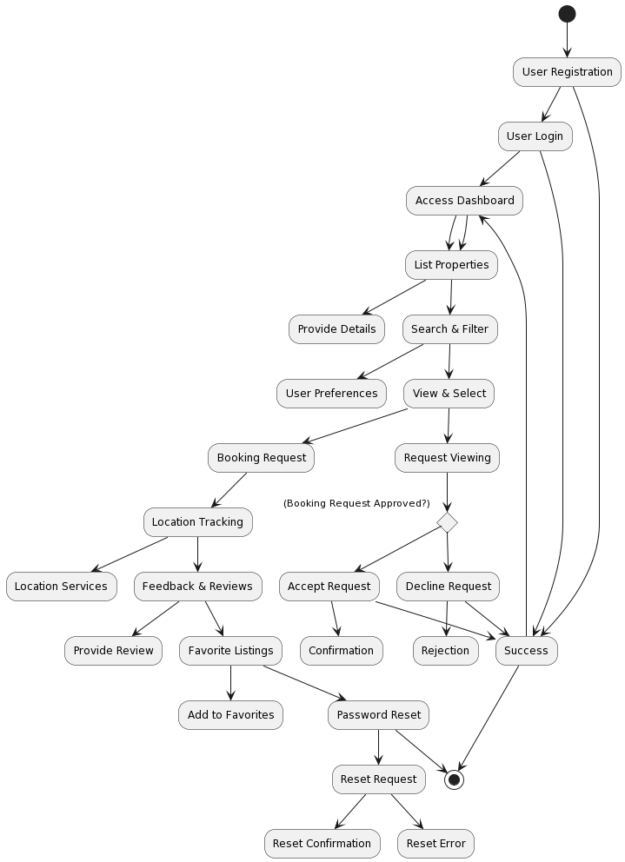

Figure 3.1: Business processing model

It start with user registration and login leading to dashboard access. User can list properties search and make selections. The Booking request point demonstrates a decision making process, where a request is either accepted or declined. The diagram also location tracking feedback and reviews favorite listing and password reset functionality all culminating in a successful outcome or errors.

**Flowchart:**

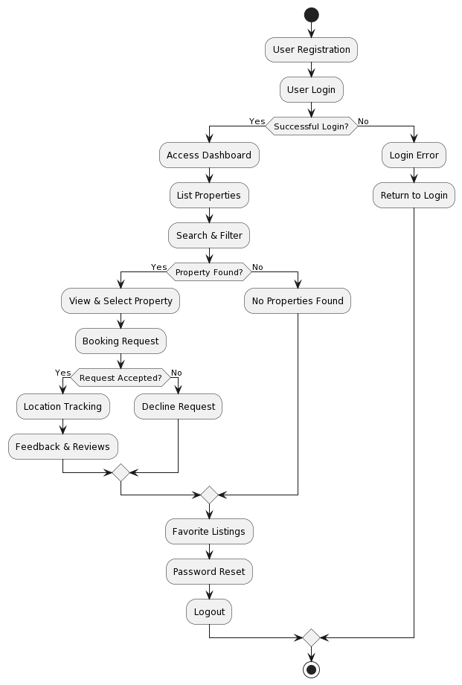

Figure 3.2.1: Flow chart for system

It start with user registration and login with a decision point checking for successful login. If it successful user access to the dashboard where they can list properties search and filter. The flowchart accommodation property availability enabling users view select and make booking request. User can still explore favorite listing reset their passwords or log out, in case of login errors users can return to the login process.

**Dataflow Diagram:**

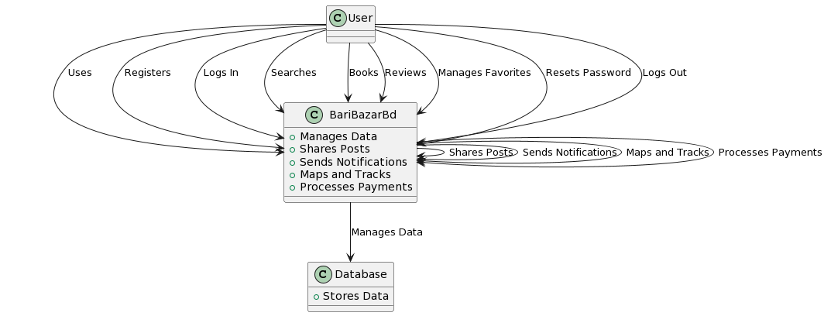

Figure 3.2.2: Data Flow Diagram for System

This program necessitates a very basic configuration for smooth operation.

Configuration of hardware required:

This web application requires registration for users, and publisher to post

and user comment from his expreance.

Configuration of software is needed :

• Application: Web site (web-based)

• Tool: Visual studio,Notepad

• Front in design: React.js , React-bootstrap

• Back end design: Node js, Express.js

• Database: MongoDB

It also specifies the specifications that must be met:

• Data accuracy

• Efficiency of working

• Real-time data show

• User friendly

• Effective

* 1. **Use Case Modeling and Description**



Figure 3.3.1: use case model

It depict ‘user’ and ‘publisher’ actor and show the use case associated with each. Users can perform actions like registration login and property related activities while publisher have use case for property management and statistics. This diagram offers a clear view of user-system interactions and the roles of different actors within the project.

* 1. **Activity Diagram**
     1. **Registration & login**

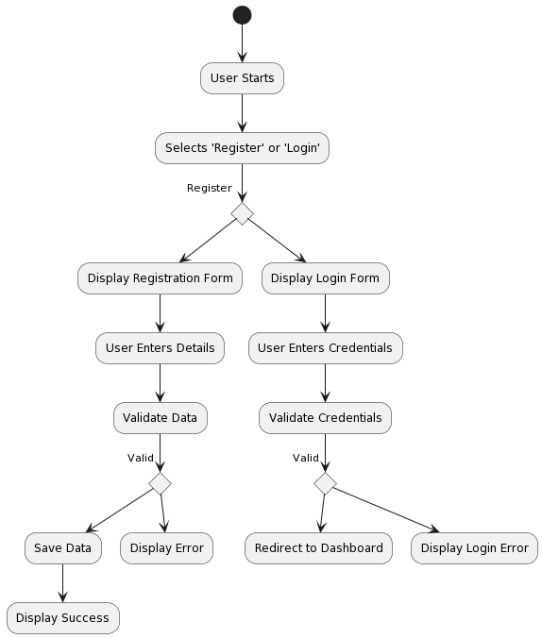

Figure: Registration & login

User start by choosing either Register or login leading to the display of the respective from data validation and response based on the validity of input either leading to data saving and success messages or displaying errors and login redirection.

* + 1. **Create Post**

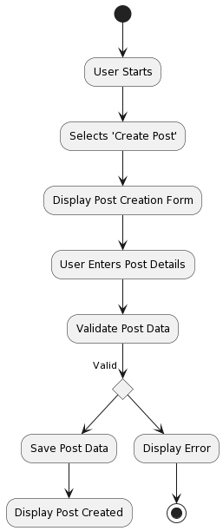

Figure: Create post

Users begin by selecting create post leading to the display of a post creation form user data input and validating if the input valid the post data is saved resulting in a post created message otherwise an error is displayed.

* + 1. **Booking Request and Accept**

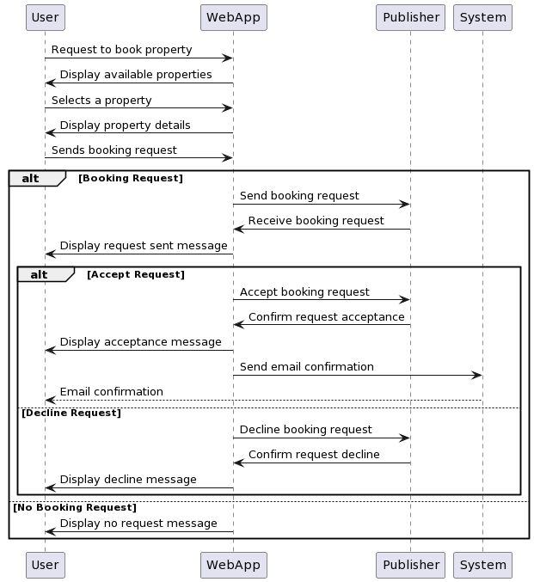

Figure: UML sequence diagram Booking

It includes interactions with the web application, property selection, request transmission to the publisher, and two possible outcomes: acceptance with email confirmation or decline with a message to the user. In the absence of a booking request, a "No Booking Request" message is displayed to the user.

**CHAPTER 4**

**Design Specification**

**Instructions for figures:**

a. Caption of every figure must insert at the bottom of the figure with center alignment.

b. Figure’s number and description must need to be mentioned in the main documents about what it actually illustrates and what it explains.

c. Figure’s number must be sequenced according to the section numbers and arranges with sub sections accordingly if needed.

d. All the figures must need proper citation if it used from other resources.

**Sample:**

The following figure 1 shows basic multicast service.

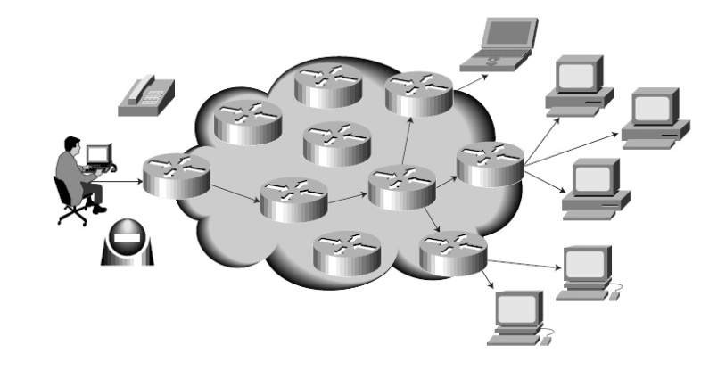

Figure 1: Basic multicast service [font-10, Alignment-center]

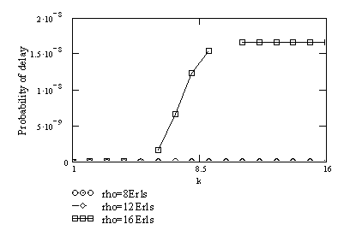

Figure 2.1.1: Probability of delay as a function of the fold number under different offered traffic (N=50, n=14, q= 5,[font-10, Alignment-center]

**LIST OF TABLES** [**Font-14, Bold**]

|  |  |
| --- | --- |
| **TABLES**[**Font-12,Bold**] | **PAGE NO** |
| Table 1: Cabling and Computer Hardware[**Font-12**] | 12 |
| Table 2.1: Numbering according to sub sections | 14 |

**Instructions for Table:**

1. Caption of every table must insert at the top of the table with center alignment.

2. Table’s number and description are must be mentioned in the main documents for what it actually shows and what it explains.

Table 1: The relationship between gaze targets and proxemics from case 1 **[font-10, Alignment-center]**

|  |  |  |  |  |  |  |
| --- | --- | --- | --- | --- | --- | --- |
|  | Objects | | | Persons | | |
| Proxemics Area | Time of Target | % | Avg. Dur. | Time of Target | % | Avg. Dur. |
|  |  |  |  |  |  |  |
|  |  |  |  |  |  |  |
|  |  |  |  |  |  |  |
|  |  |  |  |  |  |  |

**List of Figures and List of Tables must be in separate pages.**

**Chapter writing style:**

**CHAPTER 1**

**Introduction**

**Some Other Instructions:**

**Thesis/Project Size**: Minimum 30 page limit for Bachelor program

**Page Setup**: Left- 1.25"

Right-1.25"

Top: 1.0-1.25"

Bottom-1.0-1.25"

Orientation- Portrait

**Paragraph Line Spacing**: 1.5

**Column:** Single column

**Font**: Time New Roman

**Header**: Bold, Capital letter, Alignment-Center, Font-14

**Inner Text**: Font-12, Plain text

**Text Alignment:** Justify  
**Figure caption**: Font-10, Bottom, Center  
**Table caption**: Font-10, Top, Center

**Figure numbers for Appendix**: It should be mentioned according to Appendix number such as Figure A1, Figure B2 and so on.

**Reference**: Font-10

All references to books, papers, and other publications must be fully and correctly quoted. There are several methods of quoting references. One is to state the name of the author and a serial number in the main text with the full details of the reference in the Reference section of the report, for example:

In the text:

*....The analysis of the algorithms has been extensively reviewed by Yorozu et al. [1]*

*and will ....*

In the References section:

[1] Y. Yorozu, M. Hirano, K. Oka, and Y. Tagawa, “Electron spectroscopy studies on magneto-optical media and plastic substrate interface,” IEEE Transl. J. Magn. Japan, vol. 2, pp. 740–741, August 1987.

***Conference/Journal Papers:***

[1] Author1, Author2, and Author3, “Paper Title”, Conference/Journal, Volume, page number, Month and year.

**Example:**

[1] Y. Yorozu, M. Hirano, K. Oka, and Y. Tagawa, “Electron spectroscopy studies on magneto-optical media and plastic substrate interface,” IEEE Transl. J. Magn. Japan, vol. 2, pp. 740–741, August 1987.

***Books:***

[2] Author, Book Title, Edition/Volume, Publisher, Year, Page number

**Example:**

[2] T. H. Cormen, C. E. Leiserson, R. L. Rivest, C. Stein, Introduction to Algorithms, 3rd Edition, The MIT Press, 2009, pp. 120-122.

***Websites:***

[3] Name/Title of the Website, available at << https://URL>>, last accessed on Date at Time.

**Example:**

[3] Learn about Wikipedia, available at << http://www.wikipedia.org/>>, last accessed on 06-06-2019 at 12:00 PM.

Thank You!

Best of Luck